

Counselling Studies & Psychology
Current Debates in Counselling
M6X00963

The field of professional ethics has developed over the last thirty years, with an emphasis on analysing ethical behaviour. If you were a professional ethicist, how would you put together an ethical framework for the field of health and social care.

Ethical Framework for Nursing

Table of Contents
Page NO.

3. Ethics & origins
4. Professional Ethics
4. Behavioural Ethics
5-6. Values
7-9. Principles
9-11. Personal Moral Qualities
12. When an ethical dilemma occurs
13. Reference list

Ethics has continued to evolve due to the change in both a sociological and political aspect. From an historical perspective, ethics was originally developed by ancient Greek philosophers and had been a major topic of discussion during the European medieval generation and ever since, (H. & Rogers, 1912). Previous philosopher of ethics Thomas Hobbes has been noted by many as the founder of modern ethics, defining it as the ‘knowledge of effects by means of the concepts of their causes’, (H. & Rogers, 1912). Within the nursing profession, there are many ethical considerations that will all need to be considered. These ethical considerations involve key elements that really illustrate the moral principle of ethics. These elements include, but are not limited to

- Values

- Principles

- Moral qualities

An example to illustrate these specific elements that has been taken into context previously was concluded within professional ethicist Tim Bond’s ‘Standards and Ethics for Counselling in Action’. He provides an example within the ‘personal ethics’ element stating that a counsellor had received information that his friend had been considering dating a woman carrying a contagious infection and the counsellor feels obliged to warn his friend of the risk involved. However, if the counsellor had learnt this piece of information within his working environment, we would feel obliged to remain neutral and silent, (Bond, 1996).
This example indicates the importance of segregating both personal beliefs and professional ethics and that it should simply be a guaranteed case of the counsellor adapting to his professional role. In the field of health and social care, behavioural ethics are considered an extremely important factor for both the professional and the patient. This essay will attempt to explore the ethical framework used within the nursing profession and identify the key features related. It will explore ethics and behavioural ethics, identifying what they are and providing examples. This framework will also be going into significant detail regarding the values, principles and moral qualities, all connecting to two key ethical aspects of nursing which is bioethics and the ethics of care. Each of the aspects within this ethical framework will all be supported within the relevant literature.
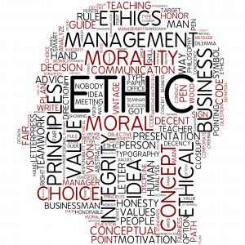

In accordance with the business dictionary, professional ethics, in its simplest form, is best defined as the professionally accepted standards of personal and business behaviour, values and guiding principles, (Collin, n.d.). In other words, professional ethics is a format governed by moral principles, which as a result, allow professional organisations to determine the distinction between what is right and what is wrong. In some ways, ethics can also be described as moral philosophy and covers a number of situations including decision making and the ethical language of what can be defined as right and/or wrong. According to the ‘Ethics for Dummies’ book, ethical vocabulary is of extreme importance and consists of the words ‘ought’ and ‘should’, (Potthast & Panza, 2013). Both these words can have the ability to address a range of concepts in relation to ethics.

An example of the importance of ethical vocabulary is also provided within the ‘Ethics for Dummies’ book stating ‘Ethics isn’t just about the way the world is. Sure, you have to know a lot about how the world works to answer ethical questions, but ethics is about something a little more ambitious than science. It’s about the way the world ought to be or should be’. This example identifies that even though a specific situation appears to be accurate, does not however equal to how the situation should be.


Behavioural ethics is best described as the exploration as to why individuals make ethical and unethical decisions, (Prentice, 2019). As a result, this form of ethics allows the individuals to have a much better understanding of how they can improve upon the ethical decisions for future reference. In addition, behavioural ethics differs from standard ethics as it attempts to identify why individuals decide to act and conduct themselves in the ways that they do, rather than how they should/ought to conduct themselves. According to (Prentice, 2019), A number of ethical choices made by the individual are based off of natural instinct, being current emotions and as a result of this, the individual will have not carefully analysed the situation.
For example, in most cases, individuals making unethical decisions are unconsciously affected by their inner biases and can therefore be affected by factors such as the pressure to conform for example. Furthermore, the overall aim of behavioural ethics is to understand why individuals make the decisions that they do and from a specific aspect, why their great ideas can, in turn, result into an unethical idea.

Within ethics, values are a set of beliefs governed by an individual that drive them to conduct themselves in a certain way and are a useful way of individuals expressing a set of standard ethical commitments, within any given vocation, (Saunders & Elsevier, 2007). Nursing is a vocation that has its roots deeply embedded into ethical values and an individual nurse’s performance is based on a set of specific values. From a global perspective, these specific ethical values are viewed equally, (Poorchangizi, Borhani, Abbaszadeh, Mirzaee & Farokhzadian, 2019). Furthermore, ethical values in the field of nursing can at times be affected by a number of factors such as economic, cultural and religious circumstances. Within the nursing profession, values are identified through ethical codes, and these refine nursing practices and the professional quality of care. A number of other professional standards are also included, many of which would be relevant in any professional workplace, (Weis D, Schank MJ, 2009). These specific ethical values are supported and implemented in the NHS institute, ("The NHS constitutional values hub", 2019). An example of these would include, but is not limited to,

- Empathy – ‘the ability to understand and share the feelings of another’ (Wilson & Wilson, 1995)

- Teamwork – ‘the combined action of a group, when effective and efficient’ (Wilson & Wilson, 1995)

- Respect – ‘due regard for the feelings, wishes, or rights of others’ (Wilson & Wilson, 1995)
According to (Rogers, 1975), empathy should be identified as an extremely important and necessary factor for the progression of relationship between both the patient and nurse. Rogers also identified being empathetic as “having the ability to perceive the internal frame of reference of another with accuracy and with the emotional components and meanings which pertain thereto as if one were the person”, (Rogers, 1975). This statement becomes very much relevant as it identifies that nurses can and most certainly should connect with all of their patients, enabling them to have a significant understanding as to exactly what circumstances they have been faced with and having the acknowledgement of their physical and mental state. As a result of this, the nurses would have fully engaged with the patient and motivate them to take full control of their mental state and also physical where applicable.

All areas of the nursing profession require an extensive amount of teamwork among both nurses and patients. Teamwork allows nurses to understand the importance of patient’s necessary needs of care, maintain an efficient level of safety standards applied to each patient and also how the nurses can improve the patient’s current standard of living, (Goosen. S, 2015). According to (Babiker, A, et al. 2014), within a nursing practise, a lack of effective teamwork can potentially result in high risk to the patient. There are a number of circumstances where this may occur within nursing. An example of this may be that a lack of communication between nurses and patients may possibly result legal action being taken from the patient to the nurse/institute, (World Health Organization. Being an effective team player, 2019).

Respect within the nursing field is also a major factor, it identifies that the nurses are able to acknowledge another individual’s personality, their self-pride and also their decision making. Overall, respecting another individual is to consider the safety of their well-being. According to (Cummings and Bennett, 2012), respect in the field of nursing is the viewed as the culture of compassionate care. Some may deem compassion as an ineffective attribute within nursing. However, if compassion is the result of being meaningful, it must therefore be a relevant trait, requiring a range of values and behaviours applicable in nursing, in accordance with, (Department of Health, 2012). An example of respect within the field of nursing may be that nurses respect and defend each stage of life within a patient, ("NMBI - The Code - Principle 1: Respect & dignity", 2019). This example suggests to us that, likewise to each of the other values in nursing, is that it should be maintained at all times, no matter the circumstance of the patient or situation.



An ethical principle is best defined as an objective method that sets out to directly or indirectly result in an ethical standard, (Weissman & Debow, 2003). According to, (Potthast & Panza, 2013), ethical principles should be identified as personal laws set by an individual. From a general ethical principle’s perspective, these principles include, but are not limited to trustworthy, self-respect, justice and so on. Despite values and principles relating in a number of similar ways as values are viewed as the acting starting point for an individual’s principles, it is important to identify the difference between the two. Values are an example of one’s standards of behaviour, whereas principles are an individual’s beliefs controlling one’s behaviour, (Petrova, M, et al. 2006). Within the nursing profession, there are a set of principles that are of tremendous importance which include; (Fry, S, et al. 2010).

- Justice – ‘just behaviour or treatment’ (Wilson & Wilson, 1995)

- Autonomy – ‘the right or condition of self-government’ (Wilson & Wilson, 1995)

- Fidelity – ‘faithfulness to a person, cause, or belief, demonstrated by continuing loyalty and support’ (Wilson & Wilson, 1995)

In many cases within nursing, justice Is viewed as an act of fairness and each nurse must act in a fair manor whilst contributing to the patient’s health and well-being. An example of this may be that whilst a nurse is working with a group of patients, each should be treated equally and fairly throughout the course of their treatment. This is a form of ‘justly’ behaviour, (Ethical practise – NCLEX-RN, 2019). Treating patients justly within the nursing sector is extremely important as it is of each of the nurse’s utmost importance to ensure that no patients are unfairly disadvantaged in relation to receiving healthcare and also gaining the appropriate access to healthcare. According to, (Cookson, R., & Dolan, P. 2000), justice can be viewed as a complex issue as each individuals concept of justice/fairness may differentiate. However within the field of nursing, the aspects that should be maintained and followed are whether or not their actions are legal, do they contradict a patient’s rights, do they prioritise the majority and not the selected few and finally, if these actions do take priority over the selected few, can they be justified. For example, potential cancer patients would take priority on the NHS waiting list as appose too an individual with less minor circumstances, ("Medical Ethics Explained: Justice - The Medic Portal", 2019).

Autonomy in nursing is having the correct understanding and authority to make the correct decisions in accordance with their own professional stored knowledge, (Weston, M. J. 2008). According to, (Skår, 2009), to be knowledgeable is found to be the logical meaning of autonomy within nursing. This suggests that in order for a nurse to behave in such a manner, they would require a substantial amount of knowledge in order for it to be effective. As a nurse, it is their responsibility to support the patient’s rights in their own decision making. An example of this may be that a nurse could decide whether they should progress for an educational teaching plan with a mother who is trying to initiate breast feeding for her child and is lacking in consistency, (Lewis, Sanders, Murphy, Haberman & Lewis, 1984). Autonomy is an important element of this ethical framework as it identifies that the nurses are capable enough to take complete control in any given situation they encounter, therefore motivates each nurse in any healthcare environment.

Fidelity is another example of an ethical principle in nursing where in which a nurse, for example, would be required to maintain an appropriate level of honesty and keeping promises, specific to the individual patient, (Smith, K. V. 2012). According to, (Role-Fidelity-Nursing-Ethics, 2019), fidelity is the important aspect of ethical principles as it has an impact on each of the other ethical principles. As a result of fidelity within the nursing profession, nurses are required to treat each patient with a high level of respect, whether or not the patient is being uncooperative and or awkward. The nurses will be required to set any potential negative thoughts towards patients in order to maintain their standards of professionalism. Fidelity can be a complex issue as it can come down to what the nurse feels is right for a patient and what the patient feels is right for themselves, which can both differentiate at times. An example of fidelity in nursing may be that a patient wants to keep the results of his diagnosis to his family to limit the upset. Whether the nurse feels this is right or wrong, they have a duty to fulfil the patient’s wishes and remain completely honest and trustworthy of them. Fidelity is an important aspect of nursing as it allows the nurses to understand the importance of having a trustworthy relationship with the patient, limiting the probability of any discomfort to the two. It is important to note that if any point a nurse feels in any way that their feelings and emotions towards the patient could have a negative outcome on their treatment, they should speak to a senior member of the team to resolve the issue, (Edwards, S. D. 2009)

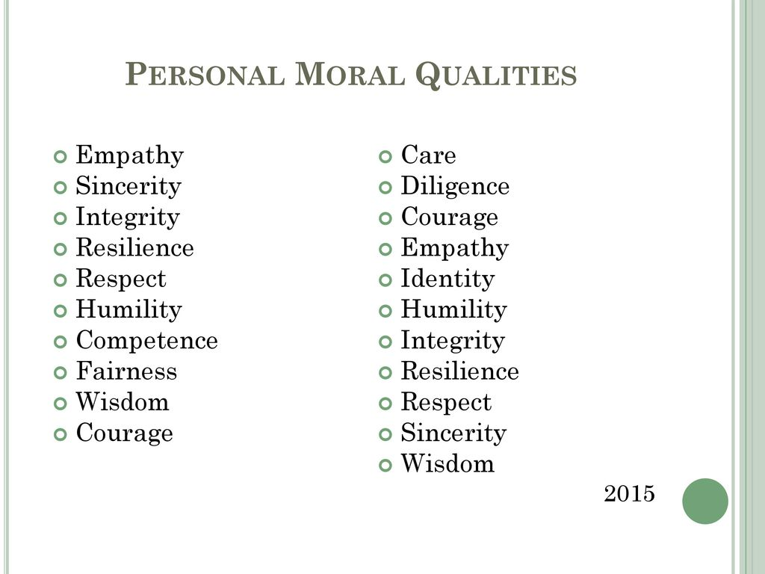

The personal moral qualities of a nurse are of the utmost importance, (Thompson, 2017). Many of the personal qualities within a nurse is considered ethically appropriate and allot of these are deeply embedded in them outside of their professional nursing workplace, not just within the workplace. Furthermore, Personal moral qualities can represent themselves unconsciously, mostly beneficially and a result of their presence and absence from the patient can be up major significance as to the outcome of the pairs relationship, (Chao, R. 2010). The moral qualities that nurses should adopt would include, but are not limited to;

- Ethics of Care

- Critical Thinking

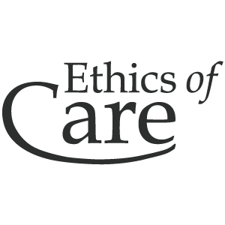

The ethic of care is a common and important factor within nursing and represents itself as a personal moral quality. According to, (Tronto, J. 1993), the definition of the ethics of care is a shared experience between both a patient and nurse where in which the nurse will continuously maintaining their professional care for the patient. This suggests that the ethics of care is a principle of care that focuses upon, in this ethical framework case, the relationship between the nurse and the patient. It also indicates that its importance of focusing on supporting the professional caring relationship that the nurse has with the patient. An example of the ethics of care may be that in order for the nurse to ‘care’ for the patient would depend on their attitude, feeling and state of mind, (Blustein 1991; Walker 1998). This suggests that the nurses investing care towards the patient demonstrates itself in a number of ways.

For example, nurses aim to offer the patient a range of caring skills in a logical and compassionate way and nurses care for the patient as they have understood and accepted the deep-rooted moral commitment of caring, (Woods, 2011). Therefore, the ethics of care is required as it demonstrates that the care of each patient is not only based upon the medical factors of nursing but also the personal conditions, such as recovery, for example. The element of care within nursing pays major contribution towards the recovery and well-being of the patient.

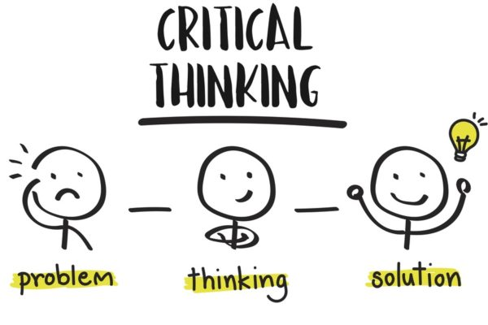

Another personal moral quality within nursing would be critically thinking. Within nursing, critical thinking is defined as a process of thought used by nurses for clinical decision-making, (Martin, C. 2002). Nurses are required to make accurate and appropriate professional decisions and must also critically think and make effective decisions. For example, when a patient presents the nurse with an unclear situation, the nurse must critically think of a way in which they will solve the situation and would need to consider, explore and identify the most effective solution for the specific patient, ("Critical Care Nursing-Critical Thinking", 1996). Much of critical thinking from a nurse is usually due to previous experiences, independent thinking and learning/knowledge and also the persistent ability to overcome difficult situations.

An example of this may be that a nurse has recognized that a patient is behaving unordinary, not reacting to simple commands and is passing in and out of consciousness. The nurse immediately recognises the patient’s medical history and quickly applies a specific set of medication to the patient in order for the patient to come back to their normal state, (Fero, L. J. et al, 2010). Therefore, critical thinking will be included within this ethical framework as it identifies that nurses need to use this element to have a significant impact on the patients recovery and well-being, to recognise the potential change in pattern of a patients recovery and finally because it allows nurses to utilise their decision making process.

Collin, P. Dictionary of business.

H., T., & Rogers, R. (1912). A Short History of Ethics. The Irish Church Quarterly, 5(19), 256.

Bond, T. (1996). Standards and ethics for counselling in action. Behaviour Research And Therapy, 34(4), 397.

Potthast, A., & Panza, C. (2013). Ethics for dummies. Hoboken, N.J.: John Wiley & Sons.

Prentice, R. (2019). Intro to Behavioral Ethics - Ethics Unwrapped - UT Austin. https://ethicsunwrapped.utexas.edu/video/intro-to-behavioral-ethics

Poorchangizi, B., Borhani, F., Abbaszadeh, A., Mirzaee, M., & Farokhzadian, J. (2019). The importance of professional values from nursing students’ perspective. BMC Nursing, 18(1). doi: 10.1186/s12912-019-0351-1

Chitty KK, Black BP. Professional nursing: Concepts and challenges. 5rd ed. St. Louis, Mo: Saunders/Elsevier; 2007.

Weis D, Schank MJ. Development and psychometric evaluation of the nurses professional values scale-revised. J Nurs Meas. 2009;17(3):221–31.

Rogers, C. (1975). Empathic: An Unappreciated Way of Being. The Counseling Psychologist, 5(2), 2-10.

The NHS constitutional values hub. (2019). https://www.hee.nhs.uk/about/our-values/nhs-constitutional-values-hub-0

Goosen, S. (2015). The importance of teamwork in nursing. Professional Nursing Today, 19(3), 4-6.

Babiker, A., El Husseini, M., Al Nemri, A., Al Frayh, A., Al Juryyan, N., Faki, M. O., ... & Al Zamil, F. (2014). Health care professional development: Working as a team to improve patient care. Sudanese journal of paediatrics, 14(2), 9.

World Health Organization. Being an effective team player; http://www.who.int/patientsafety/education/curriculum/who_mc_topic-4.pdf

Cummings J, Bennett V (2012) Developing the Culture of Compassionate Care. Creating a New Vision for Nurses, Midwives And Care-Givers. Leeds: Department of Health.

Department of Health (2012) Compassion in Practice.

NMBI - The Code - Principle 1: Respect & dignity. (2019). https://www.nmbi.ie/Standards-Guidance/Code/Respect-Dignity.aspx

Weissman, H. N., & Debow, D. M. (2003). Ethical principles and professional competencies. Handbook of psychology, 33-53.

Petrova, M., Dale, J., & Fulford, B. K. (2006). Values-based practice in primary care: easing the tensions between individual values, ethical principles and best evidence. Br J Gen Pract, 56(530), 703-709.

Fry, S., Veatch, R. M., Taylor, C., & Taylor, C. R. (2010). Case studies in nursing ethics. Jones & Bartlett Learning.

Ethical practise – NCLEX-RN. (2019). https://www.registerednursing.org/nclex/ethical-practice/

Cookson, R., & Dolan, P. (2000). Principles of justice in health care rationing. Journal of medical Ethics, 26(5), 323-329.
Medical Ethics Explained: Justice - The Medic Portal. (2019). https://www.themedicportal.com/blog/medical-ethics-explained-justice/

Weston, M. J. (2008). Defining control over nursing practice and autonomy. JONA: The Journal of Nursing Administration, 38(9), 404-408.

Skår, R. (2009). The meaning of autonomy in nursing practice. Journal Of Clinical Nursing.

Lewis, F., Sanders, S., Murphy, S., Haberman, M., & Lewis, F. (1984). Concept Development in Nursing. Western Journal Of Nursing Research, 6(3), 119-120.

(2019). https://careertrend.com/facts-6820571-role-fidelity-nursing-ethics.html
Edwards, S. D. (2009). Nursing ethics: a principle-based approach. Macmillan International Higher Education.

Tronto, J. (1993). Moral boundaries: A political argument for an ethic of care. New York, NY: Routledge.

Blustein, J. (1991) Care and Commitment, Oxford University Press, London. Boykin, A. & Schoenhofer, S. (1993) Nursing as Caring: A Model for Transforming Practice, National League for Nursing Press, New York.

Woods, M. (2011). An Ethic of Care in Nursing: Past, Present and Future Considerations. Ethics And Social Welfare, 5(3), 266-276.

Martin, C. (2002). The theory of critical thinking of nursing. Nursing education perspectives, 23(5), 243-247.

Critical Care Nursing-Critical Thinking. (1996). CIN: Computers, Informatics, Nursing, 14(4), 203.

Fero, L. J., O’Donnell, J. M., Zullo, T. G., Dabbs, A. D., Kitutu, J., Samosky, J. T., & Hoffman, L. A. (2010). Critical thinking skills in nursing students: comparison of simulation‐based performance with metrics. Journal of advanced nursing, 66(10), 2182-2193.

Wilson, F., & Wilson, J. (1995). The Oxford dictionary of English proverbs. London: Oxford Univ. Press.

Ethics - Horizon 2020 - European Commission. (2019). https://ec.europa.eu/programmes/horizon2020/en/h2020-section/ethics

Professional Ethics. (2019). https://itgirls1426.wordpress.com/attend-event/third-year/professional-ethics/

Behavioral Ethics - Ethics Unwrapped. (2019). https://ethicsunwrapped.utexas.edu/glossary/behavioral-ethics

Chao, R. (2010). J. L. Kupperman, Ethics and Qualities of Life. Journal Of Moral Philosophy, 7(4), 537-539.

