University of Wales Trinity Saint David
London Campus


Assignment 1
Programme: BA Business Management
Module: Management Economics
Module Code: LCBB5003
Lecture: Dr Taye Timothy Osadiya
Student: Basiul Vlada ( 2028043 )

Table of Contents
Business Description 2
Identification of the demand and market equilibrium 3
Factors which influence the Price Elasticity of Demand 5
Reference List 10

Business Description
The company Procter & Gamble is an American-based company. These companies provide a wide range of products related to “personal care and hygiene products '. The company Procter & Gamble was “founded in 1837 by William Procter” (Pg.com, 2022). For this case study, the product which has been chosen by Procter & Gamble is “Baby Wipes”.
In these case studies, baby wipes have been chosen by Procter & Gamble because the company is able to make a well-known face in the industry of diapers. The company has a competitor who also makes a great reputation in the field of diapers. That company is known as Kimberly Clark. Both companies are giving great competition to each other. The company Procter & Gamble sells its baby products by the name of “Pampers' ' which has been the most preferred brand by mothers for their little ones. By selling baby care products the company Procter & Gamble gets a yearly revenue of $80.187B according to the annual report 2022. From the annual report of the company, it has been seen that compared to the revenue of the annual report 2021 the revenue of the company has increased by 5.35%. Whereas the share price of the company in the UK is 134.55 USD.
This case study has the motto that it will show the effects of the factors which affect the demand and supply of their products and also try to make the identification of the factors which influence the price of the products. Due to the change in the demand for the products of the company, the company becomes able to see the changes in its revenue. When the demand for the product increases the revenue of the company increases and when the demand for the product decreases then the revenue of the company also decreases.
With the help of the graph, it can be said that in the last few years the revenue of the company has increased. With the help of the graph, it has also been seen that in the coming years the revenue of the company is also going to increase. It will happen because the demand for baby wipes is going to increase. Due to which the company is getting the opportunity to target the revenue of the company will also increase.
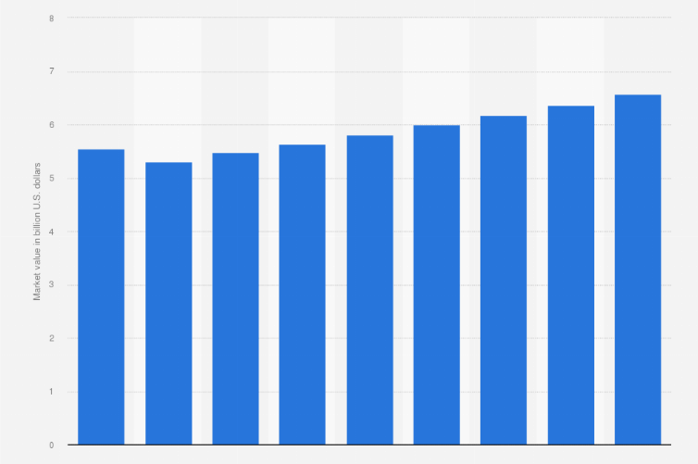
Figure 1: Business Description of Procter & Gamble
(Source- Statista.com, 2022)

Identification of the demand and market equilibrium
Price of substitutes
The price of substitute products plays an important role in the demand for the product. If the price of the substitute goods is less and the company is providing to the customers the same quality and quantity of the products then the customers will prefer the product whose price is less (Garcia-Muiña et al.2019, p.9). It is also having the opposite effect when the price of the substitute product increases then the demand for the product increases. That's why the price of substitute products plays an important role in the demand for the product.
In the case of Procter & Gamble, the substitute product has been produced by the company Kimberly Clark which is known as “Huggies”. The costumes are required to pay $30.49 for the 11 wipes of the Huggies whereas for the Pampers which is produced by Procter & Gamble the customers are required to pay $ 19.99 for 11 wipes. So, the price of the substitute product which is Huggies is high. Due to this, the demand for Pampers has increased. Due to these, the company becomes able to see an increase in revenue of the company.
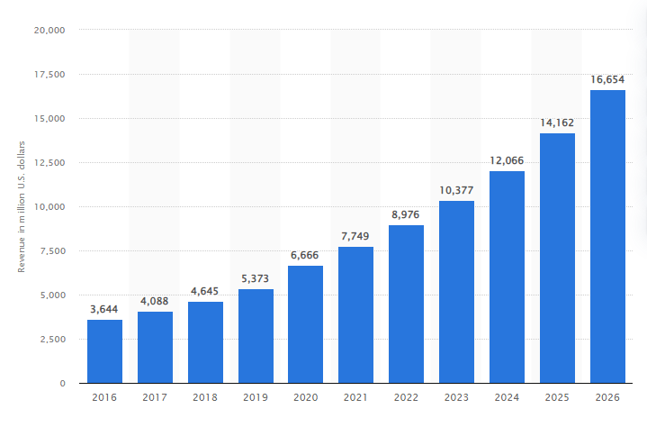
Figure 2: Effects of Price of substitute goods
(Source- Statista.com, 2022)
With the help of the figure, when the price of the first goods increases then the demand for the substitute goods increases. With the help of the figure, it can be seen that the demand for substitute goods is going to increase in the future
Price of complements
The complemented goods follow the rule of the “negative cross elasticity” of demand. When the price of the complementary goods changes then the demand for the product also changes. When the price of the complementary goods decreases then the demand for the one increase and the demand for the other also increases. It means both the goods are heaving the opposite relationship (Kim et al. 2020, p.4). This means when the price of good X increases then the demand for good Y decreases. Whereas when the price of the good X decreases then the demand for good Y increases.
In the case of Procter & Gamble, the complementary product of the baby wipes is Pampers. In this case, the price of the complementary products has been decreasing which means the price of the Pampers has decreased because of this the demand for baby wipes has increased. Due to this, the company was able to see an increase in the demand for wipes and pampers.
Consumer income
The income of the consumer plays an important role in the quality of the product and in the types of products which are purchased. When the income of the consumers increases then they need the products which is having the good quality that time cost does not matter for them (Liguori et al. 2022, p.1). When the income of the consumer increases then the chances and power of the customers to purchase good quality product increase or it also increases the chances that the goods the consumer was not able to buy because of the high price they can buy those products (Galichon and Salanié, 2022, p.24). They can purchase those goods, when the real income of the costumes increases then the consumption of luxury goods increases. But it also has the reverse effect when the income of the consumer decreases then the demand for good quality products decreases because of the decrease in the income they were not able to purchase those products.
In the case of Procter & Gamble, the revenue of the company has increased which means the income of the costumes increased. Due to an increase in income, consumers were able to buy the baby wipes which have been manufactured by Procter & Gamble because of this the demand for baby wipes has increased and the revenue of the company increased.
Consumer tastes and preferences
Nowadays advertisements play an important role in influencing people from their buying habits. The factors like “Moral and Psychological” make an effect on the pattern of the demand for particular goods. When it has been seen that the taste of the consumers changes in favor of a particular commodity then the demand for another commodity increases (Cotti et al. 2022, p.3). Whereas the tastes of the consumer change in favor of the other commodity then the demand for the first commodity decreases. Taste and preferences of the consumers changes according to the income also if the income of the consumers increases then they prefer to buy expensive products with good quality (Hovhannisyan et al. 2020, p.02). That's why the tastes and preferences of the consumers play an important role in the demand for the product.
In the case of Procter & Gamble, consumers more prefer the product of the company compared to the product of Kimberly Clark that's why the demand for the baby wipers of Procter & Gamble, increased compared to Kimberly Clark.
Consumer expectations of price
Consumers make observations of the price of the product and gather information on the price of the product from different sources from which they become able to develop the rules of the decisions. Price change and the purchasing behaviors of the consumers are strongly interconnected. Thus, the expectation of the price may change the purchasing behavior of the consumers because if the price of the commodity decreases then the demand of that product increases (Burke and Abayasekara, 2018, p. 2). The consumer expects that the company will reduces the price of the product so that it will be able to buy more products with pending less price (Khan, et al. 2018, p. 3). These can influence the consumers to buy their products or may influence them to buy other products. The customers set a particular amount for purchasing the product. They choose those products which they get in their budget. So, it increases or also decreases the demand for the product.
In the case of Procter & Gamble, the customers are expecting the price of the product to decrease. When the price of baby wipes decreases then the demand for baby wipes increases. This means the company will get more consumers who prefer their products which will increase the revenue of the company.
Demographics
The number of buyers makes a huge impact on the quantity of demand for the products and services. When the number of consumers has increased for the product then the quantity of the demand also increases and when the number of customers decreases for the product then the quantity of the demand for the product also decreases because the customers of the company decrease who buy their products to satisfy their needs (Campbell, 2018, p.3). That's why the company uses different tricks to influence customers to buy its products. For these, the companies keep the price of the product less compared to their competitors and the company also introduces different types of offers to their customers which help them to attract customers. It has been observed that when customers start buying their products then the demand curve of the company changes in a positive direction. Due to the increase in the number of customers the sales of the company increase because of which the company becomes able to earn more revenue.
In the case of Procter & Gamble, the revenue of the company will increase in 2022 compared to the revenue of 2021. This means the number of customers or buyers has increased. When the number of customers for the product baby wipes increased then the demand for the product of the baby wipes increased. This means due to an increase in the number of consumers the demand for baby wipes increases and it increases the revenue of the company Procter & Gamble.

Factors which influence the Price Elasticity of Demand
“Relative need for the product”
The need of all individuals for the same product is not the same. For some people, some products can be luxury but for some people, they can be a necessity. For example- according to the point of view of ordinary people the laptop is a luxury product but according to the view of the computer engineer, it is a necessity because the computer engineer will not be able to do their work without the laptop. Thus “the price elasticity” is different according to the requirements of the people.
Like these in the case of Procter & Gamble, for some ordinary people using wipes or Huggies is a luxury. Whereas the point of view of other people is a requirement for their little ones, Huggies provide them protection whereas the wipes they can use any time to clean the body parts of their little ones. Like hands, face, mouth etc. in this case “the price elasticity” of the product is different because it is based on the needs of the consumers.
“Availability of substitute goods”
“Availability of substitute goods” makes a huge impact on the demand for the product. The main reason behind the change in the price of the product is linked with the availability of substitute goods in the market. The elasticity of the goods becomes greater when there is the availability of close substitutes goods in the market.
Coffee is a substitute for tea. When the price of tea increased then the customers started to buy coffee. Due To this the demand for tea decreases and the demand for coffee increases. The goods which do not have close substitutes are inelastic. This means it is irrespective of when the price of it increases or decreases.
Like these in the case of Procter & Gamble, the substitute of the wipes is Handkerchief or tissues. This means when the price of the wipes increases then the consumption of the tissue or the handkerchief increases. Therefore, it can be said that the “elasticity of the demand” for both products will be high.
“Impact of income”
Income plays an important role in the “Price Elasticity of demand”. The amount of money from their income that consumer is willing to spend to buy a particular product makes the effect in the “Price Elasticity of demand”. If the customers are willing to spend a good amount of income on purchasing a particular product, then the demand for the product would be considered elastic.
For example- when the price of salt increases then the demand for salt will not decrease, which means the demand for salt would be inelastic because the consumers are required to buy the salt and that's why they will purchase it (Campbell, 2018, p.6). When the price of cell phones increases then the demand for cell phones will decrease. Which means the demand for cell phones becomes more elastic.

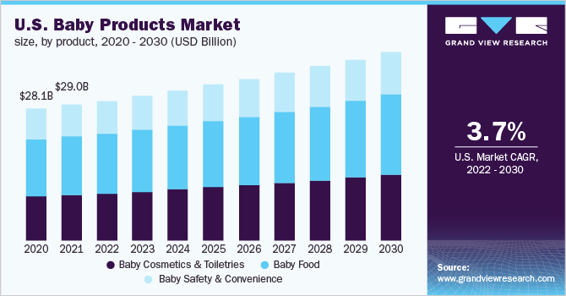
Figure 3: Impact of income on baby products
(Source: grandviewresearch.com, 2022)
With the help of the figure, it can be seen that due to a decrease in the income of the consumers the demand for baby products decreased in the year 2020. But till 2021 the sales of baby products were high because the income of the customers was good. In the above figure forecasted revenue has been provided. Therefore, with the help of the figure, it can be seen that the income of the customers makes a huge effect on the demand of goods and services.
Like in the case of Procter & Gamble when the price of the baby wipes increases then the demand for the baby wipes would be decreased. Due to the decrease in the demand for baby wipes becomes more elastic. It will happen because it is not the necessary thing which the consumers are required to buy. Consumers can use the alternative products of baby wipes which are available in the market.
“Time under consideration”
The “Price Elasticity of demand” depends upon the time which is taken by the customers of the product to make them adjust to the new price of the product. Time makes the huge impact in the demand of the goods like medicines comes with the expiry dates that’s why peoples see the expiry dates then by the medicine or the dresses which buy by the consumers according to the fashion that’s why the time makes the huge impact in the fashion (Fan et al. 2019, p. 4). If the time taken by the consumers is higher than the “Price Elasticity of demand” would be higher. This happens because of the fact that with the passing of time the consumers of the products snake them and adjust themselves to the changes which happen in the price of the product or with the new prices.
Like when the price of petrol decreases it does not mean that the demand for petrol also increases. The demand for petrol will not increase till people have not started consuming the vehicles. Which means when the demand of the vehicles increases then only the demand of the petrol wills increases (Walelign et al. 2019, p. 4)? However, the consumers were able to manage their expenditures and made changes in the pattern of consumption So that they will be able to buy the vehicles which make the demand for petrol increase.
Like in the case of Procter & Gamble when the price of the baby wipes decreases then the company will be able to see that the company is able to add new customers who prefer these products due to which the demand for the product increases. However, it can be said that when the price of the product falls then the demand for the product increases in the long run.
“Perishability of the product”
If the nature of the product is perishable, then the demand for those products will be inelastic in nature because consumption of those products has not been postponed. For, example- when the price of vegetables has increased (Bohlmann and Inglesi-Lotz, 2021, p.4). Vegetables are used by people regularly. Then the consumption of vegetables decreases. Thus, the demand for vegetables will be inelastic. Like the medicine, which is used in an emergency for those products, the demand will not decrease.
Like in the case of Procter & Gamble, the usage of baby wipes will decrease. Due to this the demand for baby wipes also decreases. Thus, the demand for baby wipes will be inelastic.
“Addiction”
Some products are there whose demand would be the same when the price of those products increases. It happens due to addiction. Addiction means a habit which has been adopted by the consumers and has become a necessity for them (Mahajan and Diatha, 2018, p.23). For those people who become addicted to “cigarettes or alcohol, 'it becomes a necessity for them to make the consumption of those. That's why if the4 price of those products increases then also the demand for those products will not decrease. That's why the companies get the advantage that they keep the price of those products high because companies know that they will buy those products if the price rises.
Like in the case of Procter & Gamble, the usage of Huggies becomes a necessity for consumers. That's why if the company raises the price of it then also consumers will buy it. This means the “Price Elasticity of demand” would be inelastic.
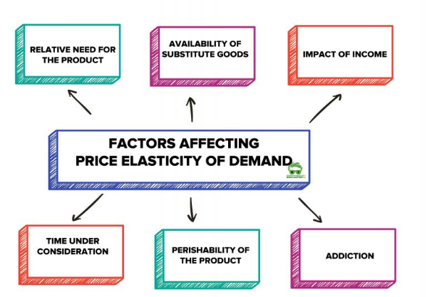
Figure 4: Factors affecting the price Elasticity of demand
(Source: Pierce and Shoup, 2018, p.7)

Reference List
Journals
Bohlmann, J.A. and Inglesi-Lotz, R., 2021. Examining the determinants of electricity demand by South African households per income level. Energy Policy, 148, p.111901.
Burke, P.J. and Abayasekara, A., 2018. The price elasticity of electricity demand in the United States: A three-dimensional analysis. The Energy Journal, 39(2).
Campbell, A., 2018. Price and income elasticities of electricity demand: Evidence from Jamaica. Energy Economics, 69, pp.19-32.
Cotti, C., Courtemanche, C., Maclean, J.C., Nesson, E., Pesko, M.F. and Tefft, N.W., 2022. The effects of e-cigarette taxes on e-cigarette prices and tobacco product sales: evidence from retail panel data. Journal of Health Economics, 86, p.102676.
Galichon, A. and Salanié, B., 2022. Cupid’s invisible hand: Social surplus and identification in matching models. The Review of Economic Studies, 89(5), pp.2600-2629.
Garcia-Muiña, F.E., González-Sánchez, R., Ferrari, A.M., Volpi, L., Pini, M., Siligardi, C. and Settembre-Blundo, D., 2019. Identifying the equilibrium point between sustainability goals and circular economy practices in an Industry 4.0 manufacturing context using eco-design. Social sciences, 8(8), p.241.
Mahajan, S. and Diatha, K.S., 2018. Minimizing the discounted average cost under continuous compounding in the EOQ models with a regular product and a perishable product. American Journal of Operations Management and Information Systems, 3(2), pp.52-60.
Pierce, G. and Shoup, D., 2018. Sfpark: Pricing parking by demand. In Parking and the City (pp. 344-353). Routledge.
Walelign, S.Z., Nielsen, M.R. and Jakobsen, J.B., 2019. Price elasticity of bushmeat demand in the Greater Serengeti ecosystem: Insights for managing the bushmeat trade. Frontiers in Ecology and Evolution, 7, p.162.
Kim, S. and Miller, M., 2020. Trisections of surface complements and the Price twist. Algebraic & Geometric Topology, 20(1), pp.343-373.
Liguori, J., Trübswasser, U., Pradeilles, R., Le Port, A., Landais, E., Talsma, E.F., Lundy, M., Béné, C., Bricas, N., Laar, A. and Amiot, M.J., 2022. How do food safety concerns affect consumer behaviors and diets in low-and middle-income countries? A systematic review. Global Food Security, 32, p.100606.
Hovhannisyan, V., Kondaridze, M., Bastian, C. and Shanoyan, A., 2020. Empirical evidence of changing food demand and consumer preferences in Russia. Journal of Agricultural and Applied Economics, 52(3), pp.480-501.
Khan, M. and Verstraete, M., 2018. Personal experiences and house price expectations: Evidence from the Canadian survey of consumer expectations (No. 2018-8). Bank of Canada.
Fan, C., Lu, Z. and Shi, Y., 2019. Time-dependent failure possibility analysis under consideration of fuzzy uncertainty. Fuzzy Sets and Systems, 367, pp.19-35.
Websites
grandviewresearch.com, 2022, overview of baby products, available at: https://www.grandviewresearch.com/industry-analysis/baby-products-market [Accessed on 8th November, 2022].
Pg.com, (2022), ’About Us’ available at:https://in.pg.com/ [Accessed on: 3rd November, 2022]
Statista.com, (2022), ‘Price of baby wipes’ available at: https://www.statista.com/statistics/876480/global-baby-wipes-market-size/ [Accessed on 8th November 2022]
Statista.com, (2022), ‘Price of substitutes goods’ available at: https://www.statista.com/forecasts/877369/global-meat-substitutes-market-value [Accessed on 8th November 2022]

