

Management Economics
LCBB5003
Assessment 1

Student Name: Nedelcu Georgiana Loredana
Student ID:2018584

Contents
Introduction 3
Task 1: Description of the business and its products; McDonald (Fast food) 4
Product: Big Mac/ Hamburger 4
Task 2: Identify Demand and Market Equilibrium 5
Price of Substitutes 5
Price of Complements 6
Consumer Income 7
Consumer expectations of price 9
Consumer tastes and preferences 10
Demographics 11
Task 3: Big Mac’s Demand- Elastic or Inelastic 12
Substitution effects 12
Recommended pricing policy 14
Conclusion 16
References 17

Introduction
In this research, we'll analyse a single company and one product to determine the demand and market equilibrium. We will also determine what variables affect demand and if that demand is rising or falling. It will also be determined whether or not demand is elastic.

Task 1: Description of the business and its products; McDonald (Fast food)
The McDonald brothers, Richard and Maurice, started their fast food empire in California in 1937, and they've since seen it grow into a global powerhouse (Mcdonalds, 2019a). McDonald's, the trade name for The McDonald's Corporation, is a major player in the fast food industry. McDonald's has over 30,000 locations worldwide and is known for serving freshly made hamburgers, French fries, and soft drinks. McDonald's is well-known for its extensive offering of such foods. Remember that McDonald's restaurants in the UK are mostly franchised, not owned or operated by McDonald's UK (Mcdonalds, 2019a).

Product: Big Mac/ Hamburger
I have settled on McDonald's iconic Big Mac as the subject of my study. That is, a burger sold by McDonald's, which owns and runs fast food franchises in a large variety of nations throughout the world. The Greater Pittsburgh region had access to it in 1967, but the rest of the nation didn't have it until 1968. The McDonald's 2019b annual report states. The product and the meal are hailed as two of the company's most successful innovations to date. Served on a special three-piece sesame seed bread and topped with two beef patties, lettuce, cheese, pickles, and onions, plus special Big Mac sauce, the Big Mac is a fast food hamburger that has become iconic (Mcdonalds, 2019b). Considering that it is one of McDonald's most recognisable offerings, I went with that.
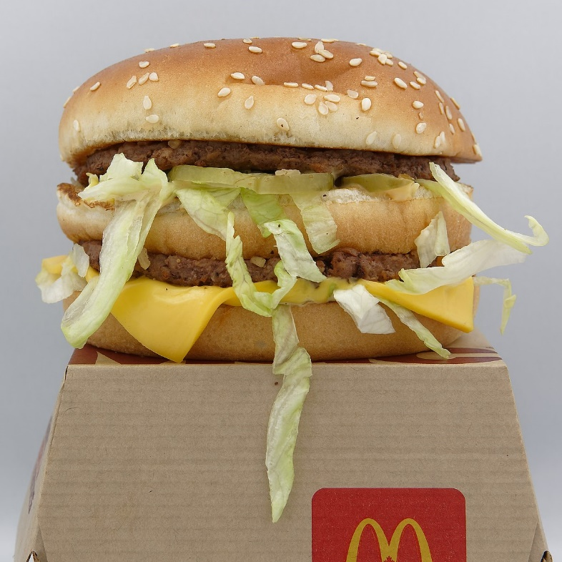
Product: Big Mac (Mcdonalds, 2019b).

Task 2: Identify Demand and Market Equilibrium

Price of Substitutes
Burger King's Whooper burger, which can be found at both McDonald's and Burger King, is a superb substitute for McDonald's ubiquitous Big Mac. In each of 2014, 2015, and 2016, the cost of a Big Mac was more than that of a Whooper. This was a major contributing element to their sales decline in comparison to Burger King. However, Burger King has raised prices across the board as of 2016. In the year 2022, a Big Mac would cost £4.09, while a Whooper from Burger King will cost £4.99. I. Background (Stocklight, 2022). We are well known that the demand for a replacement product increases as its price decreases, while the demand for the product it is meant to replace decreases. This is because the other product's price has dropped, making it more affordable. Burger King's competitors in the UK market are very price-competitive due to the wide variety of goods and services they provide (Mcdonalds, 2019b). This resulted in £594,000,000.00 in sales for Burger King in the UK in 2021, an increase of 8% over the previous year. McDonald's brand is valued 2.068 billion pounds, or almost four times as much as Burger King's (Stocklight, 2022).
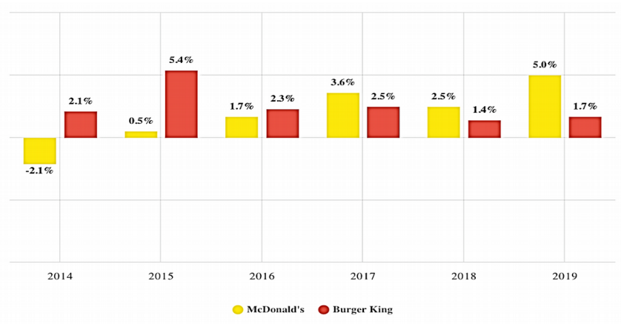
Figure 1: Burger King and McDonald growth sales (The Drum, 2020).

Price of Complements
Fries and cold drinks are great additions to a Big Mac. It is common known that when the demand and supply curves in a market are equalised, the market price (P) and the market quantity (Q) are determined. In contrast to the upward slope of the SS curve, the DD curve points downwards. Many links between price and QD are shown on the DD curve, whereas multiple connections between QD and QP are shown on the SS curve (QS). Changes in factors other than price (P) cause shifts in the demand curve, or DD. There are a wide variety of factors that might affect a business's success. Because of the new pricing structure, there has been a little shift in the desired quantity (QD). It is said that two foods are complementary to one another if they are consumed together. For every increase (decrease) in the price of one complementary item, there is an equivalent decrease (increase) in the DD of another one (Griffith, 2013).
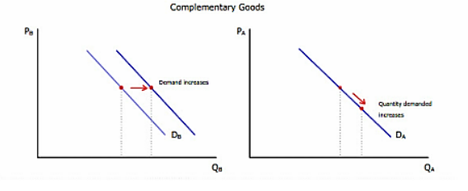
Figure 2: Complementary goods prices and the demand of goods curve (Investopedia, 2017).
Fried potatoes are a delicious addition to burgers. When it happens, eating burgers and fries at the same time will be the norm. French fry output has gone up recently. As a consequence, there is less of a need to stock as many fry supplies, which helps keep costs down. There has also been a decline in the frequency with which people order two hamburgers. The change in the burger's DD curve in response to a shift in the price of a complementary good is driven in part by factors external to the market (Shaiparo, 1987). The burger will have less DD overall, and the DD curve will shift to the left or the inside as a consequence. Since there will always be the same number of burger suppliers (SS), growing competition among suppliers for a diminishing number of customers would lead to a continuous decline in the total market price of burgers. In turn, this means that when the market is balanced, supply and demand are both at their minimums.

Consumer Income
In the last year of the fiscal year 2021, which will coincide with the first year of the coronavirus (COVID-19) pandemic, the Office of National Statistics (2022) estimates that the median household income in the United Kingdom will be £31,400. There was a 2% rise from last year's figures to this year's. The median income increased by 2.0% during Fiscal Years 2020 and 2021. The median salary increased by 14.2% between FYE 2012 and FYE 2021. While it did decrease by 0.6% between FYE 2020 and FYE 2021, typical income climbed by 10.1% overall from FYE 2012 and FYE 2021.
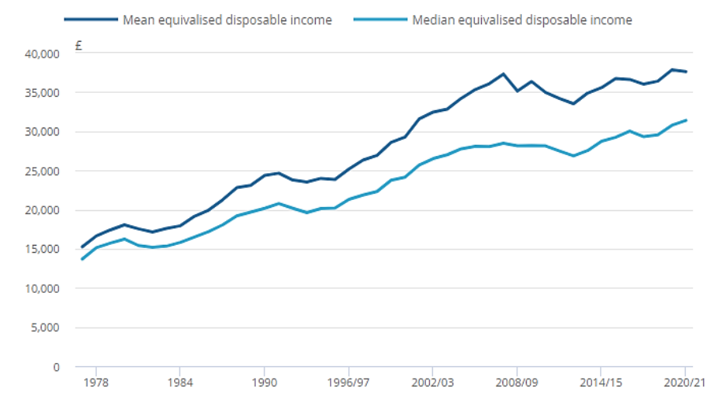
Figure 3: Median and mean real equivalised household disposable income (Office for National Statistics, 2022).
Therefore, it seems that the standard of living of the British people as a whole is rising. People with lower incomes considered fast food restaurants to be "regular things," while those with higher incomes considered them to be "inferior items." In contrast, people of all income brackets saw full-service restaurants as "typical" (Andreyeva et al., 2010). An increase in purchasing power will have varying effects on Big Mac consumption due to the wide range of potential demand responses. The desire for cheap goods decreases as people's earnings do likewise. It seems that as income rises, demand falls, but when income falls, demand rises (Economics online.co.uk, 2020).
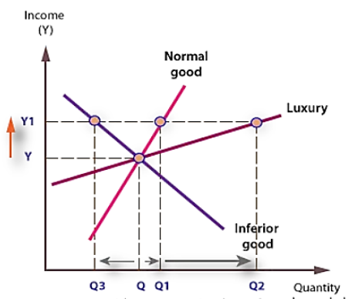
Figure 4: Consumer demand and income (Economics online.co.uk, 2020).

Consumer expectations of price
Potential buyers should constantly keep in mind that they can get a price cut. It's clear that inflation is having an effect, since the cost of everything from rent to a Big Mac has increased recently. Whenever customers anticipate a price drop for fast food, the demand curve will move to the left. But it's common knowledge that when consumers wait to buy something in the hopes that the price will drop in the near future, demand for that goods drops. You may anticipate the inverse to occur if clients anticipate a price hike in the near future. Sales won't rise despite this, since fast food is what it is (Cranefield, 2020). A sharp decline in Big Mac sales is likely if prices keep rising at their current pace.
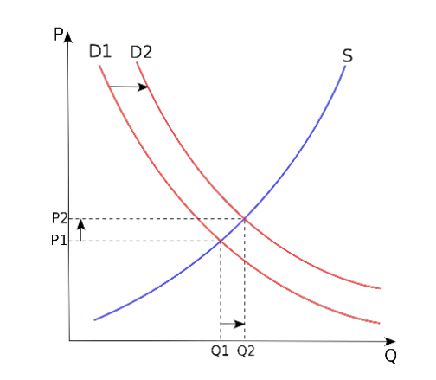
Figure 5: Price and Demand Curve (Khan academy, 2021).

Consumer tastes and preferences
Now that fast food has become an integral part of modern life, more and more individuals are include it in their regular meal plans. Customers' tastes have shifted in response to the rising awareness of the importance of personal health. Consumers are getting more picky as a direct consequence of this when it comes to purchasing home furnishings. Many health issues, including obesity and high cholesterol, have been linked to frequent fast food consumption. A good example would be: The modern shopper gives careful thought to the quality of the food on the market before making a purchase for personal use. Customers have second thoughts about the things they were about to purchase due to concerns about hygiene and safety. Customers are ready to pay a higher price for higher-quality meals (Shaiparo, 1987). As people seek ways to counteract the growing pollution and the presence of dangerous chemicals, they are increasingly choosing to dine at establishments that provide higher quality food. Customers did not attribute a substantial percentage of their satisfaction to the speed with which they were served. The evaluation obviously has a negative impact on the present circumstance. Those under the age of 40 don't need to watch what they eat as closely as those over the age of 40. (Griffith, 2013)
People who regularly partake in the consumption of fast food, beverages with added sugar, and carbonated drinks may consume more calories per day as a result. This is owing to the high calorie content of fast food, sugary drinks, and carbonated drinks (Bowman, 2005), and the widespread belief that fast food is less nutritious than other dining options due to its high calorie content and the possibility of the inclusion of hazardous chemicals. Sales of the McDonald's Big Mac and similar fast food meals are therefore relatively immune to changes in customer demand.

Demographics
More than 2.4 million Big Macs are sold every single day, for an annualised total of an estimated 900 million Big Macs served across the globe. Every every day, people in the UK buy and eat more than 1.5 million Big Macs (McDonalds, 2019a). Day after day, the number of buyers increases. It reduces people's cravings for Big Macs, which is a good thing.

Task 3: Big Mac’s Demand- Elastic or Inelastic

Substitution effects
Demand elasticity in light of price is being employed in lieu of the original concept. Whenever the cost of a staple item rises, it's easy to find a suitable alternative. Thus, consumer demand for products would become more malleable. Consumers are less likely to be ready to pay a premium price for a product if they have few or no other options. Something is a necessity if you can't live without it, no matter how much it costs. An item is considered a luxury if it adds to one's standard of living but isn't necessary for one's existence (Griffith, 2013).
A product's price is less likely to fluctuate in response to changes in supply and demand, and customers are more likely to desire to acquire it, the more essential it is to their daily lives. The market is more malleable and receptive to novel ideas when the product in issue is considered a luxury good (Andreyeva et al., 2010).
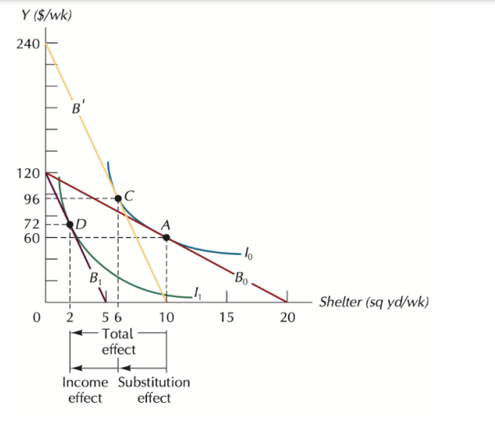
Figure 6: Substitution effect (Economics Stack Exchange, 2017).
Products that function in an environment favourable to company innovation are subject to elastic market pressure, whereas those whose demand is inelastic are subject to the constraints of a single manufacturer. Supply-side price elasticity tends to be lower in the short run than in the long run, when consumers have more time to respond and more options to choose from (Aigner-Walder, 2015). This is due to the fact that in the long term, consumers have more time to adjust their spending habits in response to price increases or decreases. Price changes don't always lead to increases or decreases in production that are roughly proportional to the price change. A rise in price inelastic growth may be anticipated if consumers spent less of their disposable income on a product. This is because when competition is high, more alternatives become available to the consumer.
Big Mac is a luxury item that operates in highly competitive marketplaces; a significant price increase would likely lead to a drop in demand that would outweigh the income gain. Companies will charge as much as they can get away with in the face of inelastic demand. However, in order to maximise profits from increased demand, it is prudent to lower prices for elastic goods. Because of this, we may argue that Big Mac consumption is more elastic.

Recommended pricing policy
Since the price of a product or service reflects the marketer's estimation of how much money customers are willing to pay, it is no surprise that pricing is given a great deal of attention by those in the marketing industry. Economic growth might be stifled by excessively high or cheap prices. Mistakes in pricing may have a significant impact on revenue and profitability (AignerWalder, 2015).
McDonald's, the Big Mac's parent business, may charge whatever it likes, provided it covers its costs. Companies should use the cost-plus pricing method. Both the variable and fixed expenses associated with a product may be calculated using cost-based buying (Heien, 1989). Managers calculate the intended gross profit per unit by adding the entire gross expenses for the goods and services to a markup percentage of five or ten percent. If you choose a cost-benefit analysis method, you can consider your venture successful if you have recouped your initial investment in the project, plus any additional revenue from sales. Managers may move on to the process of developing pricing strategies after they have finished an examination of the business's price goals, which may include enhancing long-term and short-term profitability, managing expenses, expanding working capital, and combating competition. Managers should analyse the current situation of the market and establish prices accordingly (Griffith, 2013). Other factors that should be included into an effective pricing strategy besides the market include the product, the competition, and the different types of consumers. Determining how much of a product to make and how much to sell a product depends in part on how much of a premium customers are willing to pay for that product. If McDonald's were to compare the rates it could pay to the prices its customers were willing to spend, it would likely figure out whether it should thrive in the high-end market, where customers are primarily concerned with quality and service, or the low-end market, where consumers are primarily concerned with cost. They may do this by contrasting the rates they're ready to pay with the prices their clients are prepared to pay (Cranefield, 2020). McDonald's may use this data to choose their target audience more wisely in the future. This method is basic and easy to understand since it does not need managers to use their best estimations when estimating expenditures (they need just study accounting and financial facts). This method of pricing disregards supply and demand as well as other factors that may have an effect on prices in the market (Andreyeva et al., 2010). To maximise profits, many companies employ a tried-and-true pricing technique based on easily available internal data: cost-based pricing. This is another justification for using cost-based pricing. One of the reasons for its widespread popularity may be attributed to this: In order to defend an inflation-based pricing strategy, a corporation must demonstrate that the prices it charges cover all costs related with the product or service while still yielding a reasonable gross profit (Aigner-Walder, 2015).

Conclusion
As per the conclusion, McDonald should use the cost-plus pricing method. Both the variable and fixed expenses associated with a product may be calculated using cost-based buying.

References
Aigner-Walder, B. (2015) Effects of the Demographic Changes on Private Consumption: An Almost Ideal Demand System Analysis for Austria. Journal of Economic and Social Studies, 5, 1, 33-57.
Andreyeva, T., Long, M.W. and Brownell, K.D. (2010). The Impact of Food Prices on Consumption: A Systematic Review of Research on the Price Elasticity of Demand for Food. American Journal of Public Health, [online] 100(2), pp.216– 222. doi:10.2105/ajph.2008.151415.
Baker, J. (2003) Competitive Price Discrimination: The Exercise of Market Power Without Anticompetitive Effects (Comment on Klein and Wiley). Articles in Law Reviews & Other Academic Journals. Paper 278.
Borland, B. (2022). Big Mac price map for 2022... and UK could hit £4.50 by the end of the year! [online] scottishdailyexpress. Available at: https://www.scottishdailyexpress.co.uk/lifestyle/food/big-mac-world-price-index27002554 [Accessed 07 Dec. 2022].
Cigliano, J. (1980) Price and Income Elasticities for Airline Travel: The North Atlantic Market, Business Economics, pp. 17–21.
Cranfield, J.A. (2020). Framing consumer food demand responses in a viral pandemic. Canadian Journal of Agricultural Economics/Revue canadienne d'agroeconomie, 68(2), pp.151-156.
Economics online.co.uk (2020). Demand and Income. [online] Economics Online. Available at: https://www.economicsonline.co.uk/competitive_markets/demand_and_income.ht ml/#:~:text=In%20the%20case%20of%20normal [Accessed 07 Dec. 2022].
Ellickson, P. (2013) Market Structure and Performance. International Encyclopedia of the Social & Behavioral Sciences, Forthcoming; Simon School Working Paper No. 13-21.
Griffith, G. (2003) The Impact of Supermarkets on Farm Suppliers. The Australian Economic Review, 37, 3, 329–336
Heien, D. and Pompelli, G. (1989) The Demand for Alcoholic Beverages: Economic and Demographic Effects, Southern Economic Journal, pp. 759–769.
Jensen, H.H. (2006). Consumer issues and demand. Choices, 21(316-2016-6234), pp.165-170.
Mcdonalds (2019a). Big mac®: Calories and nutrition | mcdonald’s. [online] Mcdonalds.com. Available at: https://www.mcdonalds.com/us/en-us/product/bigmac.html [Accessed 07 Dec. 2022].
Mcdonalds (2019b). Big mac®: Calories and nutrition | mcdonald’s. [online] Mcdonalds.com. Available at: https://www.mcdonalds.com/us/en-us/product/bigmac.html [Accessed 07 Dec. 2022].
Ni Mhurchu, C., Eyles, H., Schilling, C., Yang, Q., Kaye-Blake, W., Genç, M., & Blakely, T. (2013). Food prices and consumer demand: differences across income levels and ethnic groups. PloS one, 8(10), e75934.
Rauch, D. and Schleicher, D. (2015) Like Uber, But for Local Governmental Policy: The Future of Local Regulation of the 'Sharing Economy'. George Mason Law & Economics Research Paper No. 15-01. Available at: http://ssrn.com/abstract=2549919.
Shapiro, M. (1987) Measuring Market Power in U.S. Industry, NBER Working Paper, No. 2212.
Stocklight (2022). Form 10-K (NYSE:MCD). [online] Available at: https://stocklight.com/stocks/us/accommodation-and-food-services/nysemcd/mcdonald-s/annual-reports/nyse-mcd-2022-10K-22671248.pdf [Accessed 07 Dec. 2022].

