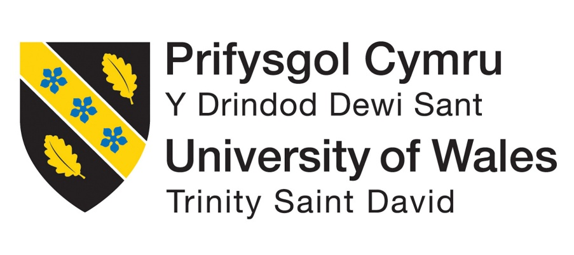
Reflective essay
Course: Effective teamwork ingredients and communication (BMSW4009)
Lecturer: Melanie Squire
Name: Florina Alexandra Pivoda
Student Number: 2330382
Word count:981

Introduction
A team is a group of people having the same vision, that work together to achieve a set goal.
During this course, I had the chance to expand my knowledge about the best ways to be a part of, and work, in a team. In my work place, I am part of a great team, having the position of a leader, so this course held a lot of importance for me.
One of the most important steps to create, work and lead a team is to first find the right people. One must make sure that all individuals can form a balanced whole, that can work as an unit to achieve their goals. (Belbin and Brown, 2022)
It came as a surprise for me, that after using Belbin’s Team Role Model, I realised that my primary role in a team was as a Coordinator, and my secondary one was a Shaper. Using this as an example, I managed to recognise the roles of the individuals that are part of my current team and it really helped us develop and grow exponentially.

Findings
As we got in depth during the course, many aspects of my work that I did not quite knew how to resolve as a team member and leader, found positive results after using the models and theories that were presented in the class.
I took a step back and for a period of time I tried to analyse what kind of relationships we have between ourselves as individuals and as a team, and also the attitudes and behaviours we use amongst each other. This action allowed me to realise that we are great as a team, each one being a very important asset to it, and the most important thing, being the support we offer each other, always listening and coaching one another, always finding new ways to improve the work and the resulting products. “ They have recrafted their job from sometimes mechanical to one that is streamlined and aesthetic. “ (Seligman, 2011).
Moreover, using Betari’s box, I managed to comprehend better the teams dynamic and also any internal problems that the members of the team might have difficulties with.
I reflected about how I can improve myself in order to offer my team the best leadership and guidance, but most of all, to build the trust that can make one’s relationships grow and reach all the future goals. To develop the best relationships in a team, especially as a leader, always offer open communication, always strive to be fair and consistent, offer loyalty, build a motivational environment, involve and value everyone and encourage the team members at all times. “...the story of human beings treating each other so well they generate superb thinking in each other. “ (Kline, 2015)
Ad everyone is different and unique in their own way, it is impossible not to have conflicts from time to time. Some of them may appear unconsciously, especially if one is working in a very diversified environment.
My work team is formed of individuals coming from different cultures, backgrounds, that possess more or less social skills then others. A helpful tool for me to resolve this frictions, is the Thomas Kilmann’s Conflict Mode Instrument ( Resolving Conflict).
The goal of it is to reach a stage of collaboration, communicating and admit that all parties involved might be right, agree to disagree, and find ourselves in a win- win situation.(Covey, 2015)
The Effective Teamwork course had a very important impact on my personal and professional development, equally. I realised that reaching the stage that me and my team are currently in, was done following the steps described by Tuckman. Although at the time we have not realised it, we became the performing team that we are today, from a group of individuals that did not knew each other. We had our disputes and disagreements, which we managed to overcome and are now performing at our full potential. (Tuckman, 1965)
If at the beginning our team was formed by people with a very strong potential of reaching their goals, in the present, I am proud to be a part of a team that has achieved performance as a unit, relying on trust, communicating with efficacy and composed of members that are identifying themselves as part of the team. (Dunham and Griffith, 2015).

Conclusion

As we are now approaching the end of this course, I am aware of how much it helped me, either being a part of a team or leading one. I learnt to be more attentive, get involved and become a more active part of my team. I realised now what being a leader truly means and I will strive to reach the expectations of my team members and lead them always y example, helping all of us to thrive as a whole.
Like Adair(2009) said “ Humanity knows what it expects in its leaders. Enthusiasm, integrity, toughness or demandingness, fairness, warmth, humanity and humility are the commonly found moral characteristics of effective leaders.”

References
1. Adair, J.(2009) Effective Leadership- How to be a successful leader, Pan Books, London
2. Belbin,M. and Brown, S.(2022) Team Roles at Work 3rd ed. Routledge Available at: https://www.perlego.com/book/3549750/team-roles-at-work-pdf Accessed 26 Nov 2024
3. Covey, S.R.(2013) The 7 Habits of Highly Effective People
4. Dunham, E.B and Griffith, B.A(2015) Working in Teams: Moving from high potential to high performance p6, Sage ,London
5. Klive, N.(2015) Time to Think. Octopus Publishing Group Ltd., London
6. Seligman, M.(2011) Authentic Happiness. Nicholas Brealey Publishing Available at: https://www.perlego.com/book/3178802 (Accessed on: 26 Nov 2024)
7. Tuckman, Bruce W.(1965) “Developmental sequence in small groups”, Psychological Bulletin 63, p 384-399 (accessed on 28 Nov 2024)
8. Resolving Conflict-The TKI Model available at: https://youtu.be/sH2N9yQX_so?si=OuMKG-Hc02CuOGU- (accessed on 29 Nov 2024)

