Student Name: Naveeda Aziz
Student Number: 2128414
Module: Introduction to Physiology BMHP5003
Lecturer Name: Gillian Weaver, Raheela Shaikh
Assignment Title: Individual Academic Poster Presentation
Subject: Digestive System

Digestive System
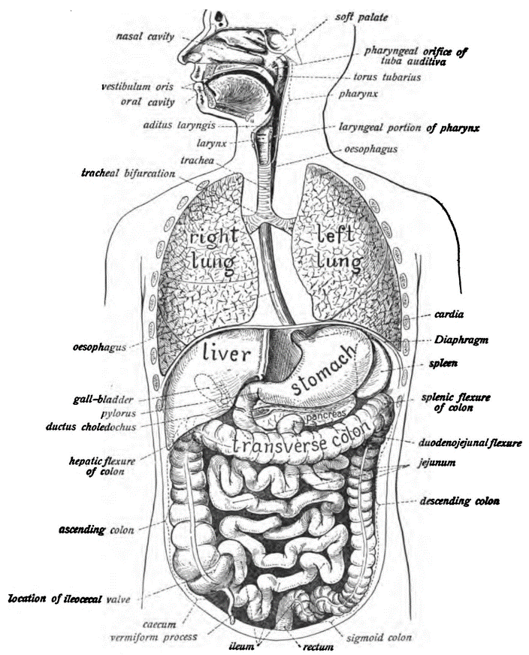  This Photo by Unknown Author is licensed under CC BY-SA | INTRODUCTION  The digestive system is the part of the human body responsible for processing food and extracting nutrients This system comprises a series of organs and structures that work together to break down food into smaller molecules that can be absorbed and used by the body.  Its primary function is to break down the food we consume into nutrients that can be absorbed and used to fuel our bodies, support growth, and maintain overall health.
FUNCTION  The journey of digestion begins in the mouth, where food is broken down mechanically by chewing and mixed with saliva, which contains enzymes that initiate the digestion of carbohydrates. From there, it travels down the oesophagus to the stomach, where stomach acid and enzymes continue to break down the food. | IMPORTANCE  Diabetes can cause delayed stomach emptying (gastroparesis), which can result in nausea, vomiting, and bloating. It can also have an effect on the pancreas, which produces digestive enzymes, potentially leading to nutrient malabsorption. Uncontrolled blood sugar levels might cause gastrointestinal problems such as diarrhoea or constipation. Diabetes must be managed properly in order to avoid these digestive issues.
In conclusion, the digestive system is critical for our survival and good health because it is responsible for breaking down food, absorbing nutrients, and removing waste. Understanding its functions and taking actions to keep it healthy will help you live a healthier and happier life.

References:
(citation)
General References:
- Tortora, G. J., & Derrickson, B. H. (2017). Principles of Anatomy and Physiology. John Wiley & Sons.

- Guyton, A. C., & Hall, J. E. (2015). Textbook of Medical Physiology. Saunders.

- Moore, K. L., et al. (2018). Clinically Oriented Anatomy. Wolters Kluwer.

- Johnson, L. R. (Ed.). (2016). Physiology of the Gastrointestinal Tract. Academic Press.

Journal Articles:
- Hooper, L. V., Littman, et al. (2012). Interactions between the microbiota and the immune system. Science, 336(6086), 1268-1273.

- Mayer, E. A., et al. (2014). Gut microbes and the brain: Paradigm shift in neuroscience. Journal of Neuroscience, 34(46), 15490-15496.

- Kau, A. L., et al. (2011). Human nutrition, the gut microbiome, and immune system: envisioning the future. Nature, 474(7351), 327-336.

- Turnbaugh, P. J., et al. (2006). An obesity-associated gut microbiome with increased capacity for energy harvest. Nature, 444(7122), 1027-1031.

