
Engine Dyno Testing
University of Wales Trinity Saint David
M4X02196
Jonathan Bennett 1807543
2020
Contents
Introduction 2
Experimental procedure 3
Results 4
Conclusion 6
References 7

Introduction

Where the chassis dyno differs from the previous tested dynamometer, the chassis dyno is a in situ apparatus designed to test the entire vehicle including the drivetrain and road wheels giving a real world representation of how the vehicle actually performs as opposed to the engine dyno giving near lab conditions to just the engine alone, particularly where power and torque is “pure” to the engines flywheel, the chassis dyno, or commonly referred to as a rolling road, gives a real world reading of the power that is actually delivered to the road from the contact patches beneath each tyre.
Fuller (2012) Was a useful source of information

Experimental procedure

Using the super bike BMW S1000 RR, BMW’s latest and greatest superbike on the motorcycle chassis dyno to measure its performance, the bike is strapped down and the extraction conduit is set against the exhaust pipe with a lambda probe fitted to measure the O2 readings. With the rear wheel set in place on the roller the bike is then run through the gears to get a starting point for the gear run to give the power readings from the engine.

The readings given were measured by the software and recorded for later calculations, however certain information needed was researched via official BWM service sheets supporting the weight and gear ratios of the drivetrain, the stated power and torque figures of the engine, and when peak power is produced which can be compared to the calculated results from the actual test runs.

Finding the transmission efficiency is a simple formula of power at the wheel divided by power at the engine for a given engine speed, this figure then tells how much power is being lost through the drivetrain, known as transmission loss, some drivetrain layouts suffer this loss greater than others, with cars front wheel drive cars usually suffer approximately 15% loss, where a four wheel drive car has far greater losses due to driving more components to more wheels.
“A portion of the power produced by internal combustion engines is lost due to friction in the vehicle’s transmission. As a result, the overall powertrain efficiency decreases.” (IRIMESCU, MIHON, PÃDURE, 2011, P555).

Motorbikes however have far less moving parts that weight much less also meaning the loss is far less than that of most cars, the calculations for this efficiency is laid out and theoretical and actual results are shown.

Results

Fig 1

Fig 2

Fig 3
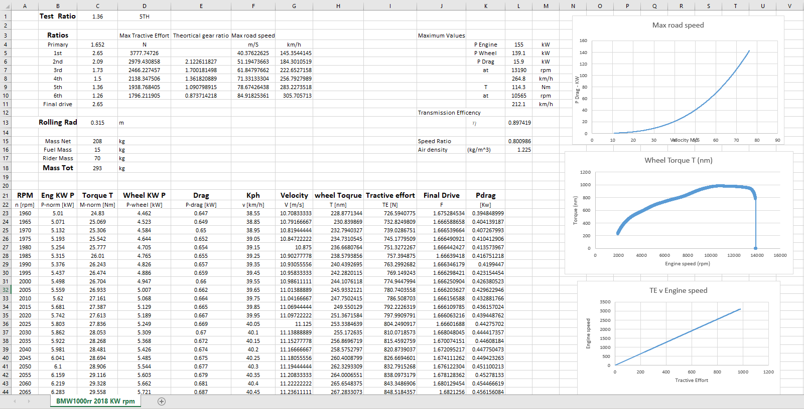
Fig 4

Conclusion

Gear ratios are a varied practice due to the fact that when specifying a ratio between gearing the manufacturer for these parts cannot maintain a constant manufacturing process that can make every gear within such a close tolerance with each batch of gear made, the machines and human error just do not allow for such a constant effort therefore the gaps between the gear teeth and the size of the gears themselves will never be identical for every part on every gearbox and engine.
It is therefore necessary to make a close rough guide figure for each vehicle with its engine and gearbox range that will at least in general demonstrate a close likeness to what the end result will be.

However on the other end of the spectrum the measuring apparatus is not 100% accurate in measuring the torque figures of the wheel figure, so inherently the calculations for the engine figure is then drastically put further out of likelihood by this initial inaccuracy.
Various different factors can influence this power figure such as tyre pressures not being the same as the manufacturer used or the oil being worn in the engine and gearbox or indeed the oil could be a different grade or manufacturer creating a higher viscosity and thus absorb more power to displace the oil between the gearing and bearings, there is also the tyre which could be of a different compound, meaning more or less grip could be available to the roller, the tread could be worn giving a marginally smaller rolling radius of course assuming the manufacturer used a brand new road tyre during testing.
Last of which the dyno could very well be not only a different brand from the ones used by the manufacturer but it could also have varying setups and calibrations or even use a breaking method or generative method to calculate results.

All of which can give a plethora of different results from the power level to the gearing ratio and tractive efforts recorded during the testing.

The gearbox on the bike is a simple 3 gear ratio system where the input shaft has a gear, the output shaft has a gear, and then the final drive has a gear which is located at the back wheel on the end of the chain/belt.
The number of teeth each pulley has, and the diameter of the gears is what determines the ratio between the gear sets, using progressively larger gears allows the engine to reach higher speeds, while the smaller ratios allow the engine to produce more torque for moving off from standstill, and for accelerating quickly.

References

Fuller. D (2012) Dyno Duel: Engine vs. Chassis Dynos & What You Should know. Available at: https://www.onallcylinders.com/2012/05/11/dyno-duel-engine-vs-chassis-dynos-what-you-should-know/
(accessed 18/4/2020)

A. IRIMESCU* , L. MIHON and G. PÃDURE, (2011). AUTOMOTIVE TRANSMISSION EFFICIENCY MEASUREMENT USING A CHASSIS DYNAMOMETER P555-559
(accessed 19/4/2020)

