Management Economics
Assessment 1
LCBB5003

Lecturer name: Taye Osadiya

Student name: Sandrina Rangelova

Student ID: 1917133

Table of Contents

Introduction 4
Description of Domino’s Pizza 5
Demand and Market Equilibrium 6
Substitutes 6
Price Increasing 7
Price Decreasing 7
Complements 8
Consumer’s Income 10
Consumer Taste and Preferences 12
Consumer Expectation of Price Effect on Demand 13
Demographics 14
An increasing number of buyers 14
Decreasing Number of Buyers 14
Price Elasticity of Demand of Domino’s 15
The number of available substitutes 15
The share of disposable income devoted to the purchase 15
The need for the good or service: 15
Period: 15
Critical Evaluation of the Pricing Policy of Domino's 16
Conclusion 18
References: 19

Introduction

Management economics is the application of economic ideas and methodologies to business organizations' analysis and decision-making processes, specifically the management of resources (such as money, labor, and raw materials) to fulfill the organization's goals (Forgang and Einolf, 2007). In the case of Domino's Pizza, management economics plays a vital part in the company's operations, as it is responsible for making choices relating to pricing, production, distribution, and other aspects of the business. This includes examining market demand and supply, evaluating the costs and benefits of potential courses of action, and adopting methods to maximise efficiency and profitability. By employing concepts of management economics, Domino's Pizza can make educated decisions that help ensure the firm's success and growth.

Description of Domino’s Pizza

In 1960, the worldwide chain of pizza restaurants known as Domino’s Pizza was established. The business has more than 17,000 outlets worldwide and is based in Ann Arbor, Michigan. Dominos is renowned for its quick service, extensive pizza selection, and other menu items like spaghetti, sandwiches, and desserts (Syed, 2016). The company's signature item is Pizza, which comes with various toppings, including meats, vegetables, and other sauces. Additionally, Domino's provides a variety of crust types, including hand-tossed, deep dish, and thin crust. In some regions, Domino's also provides carryout and dine-in options in addition to delivery.
Domino's Pizza is an excellent case study for a managerial economics course or project for several reasons: Domino's is a household name, and familiarity can help students learn more about the firm and how it runs. The fact that Domino's is a global behemoth with a lengthy track record means that a plethora of information is available about the company's success and methods over the years. This might help one examine patterns and compare his business to the competition. Additionally, given that it operates in the fast food industry, which is notoriously cutthroat, Domino’s can serve as a compelling case study of a business that has managed to thrive despite intense competition. Domino's is a great candidate for management economics study due to its size, fame, and leadership.

Demand and Market Equilibrium

Demand is the quantity of a specific commodity or service that consumers can buy at a particular price. When consumers are ready to purchase the same amount of a good or service as businesses are eager to sell, this is known as the market equilibrium. There is no oversupply or under-demand, and the market price of the commodity or service is currently stable. As a result of the forces of supply and demand being in balance, a market is said to be in an equilibrium state. There is no incentive for either buyers or sellers to modify their behavior when the quantity of a good or service consumers desire to purchase equals the amount that businesses are willing to sell. The market price of the product or service stays constant as a result.

Substitutes
There are a lot of Domino's Pizza substitutes to choose from. Here are several possibilities:
For instance, consider Pizza Hut, Papa John's, Little Caesars, Marco's, or Your Local Pizzeria (Sharp, 2018). Pizza Hut is another sizable pizza company that provides a wide selection of pizzas, including gluten-free and vegan versions.

Price Increasing
If the price at Pizza Hut increases, this could lead some customers to switch to Domino's. As a result, the demand for Domino's will increase.

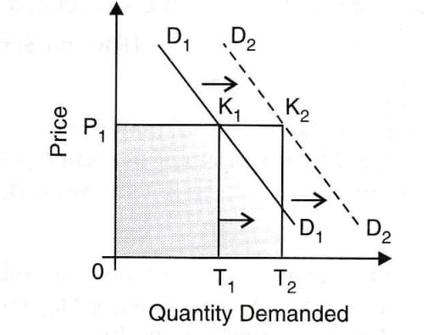
Figure 1: Price Increase Effect of Substitute in Quantity Demand ((N Gregory Mankiw, 2016)

Price Decreasing
If the price at Pizza Hut decreases, the demand for Domino's will fall.

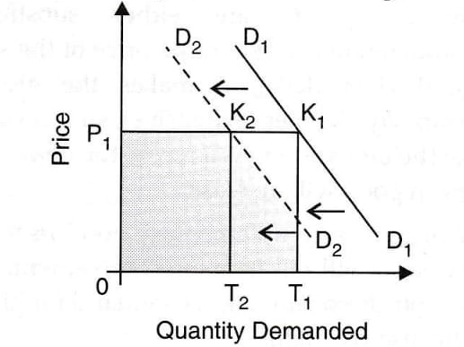
Figure 2: Price Decrease Effect of Substitute in Quantity Demand ((N Gregory Mankiw, 2016)

Complements
A good or service commonly consumed alongside another is said to be the complement of the other (Mount, 2018). For example, a standard accessory of Domino's might be soda or beer, as these items are often ordered along with Pizza.

Price Increasing

If the price of beer increases, demand for Domino's Pizza will decline. Beer is frequently drunk with Pizza, and if the price of beer increases, some individuals may opt to purchase less or avoid it altogether.
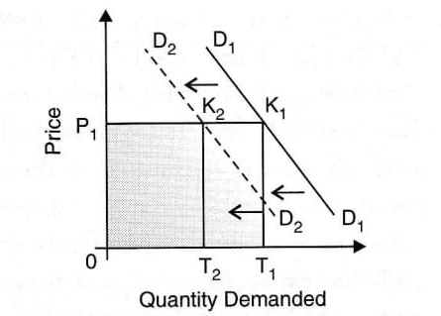
Figure 3: Price Increase Effect of Complement in Demand ((N Gregory Mankiw, 2016)

Price Decreasing:
If the price of beer declines, the demand for Domino's Pizza will increase.
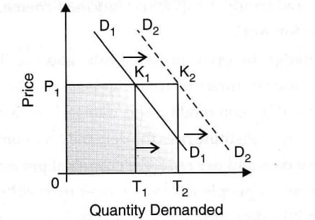
Figure 4: Price Decrease Effect of Complement in Demand ((N Gregory Mankiw, 2016)

Consumer’s Income
Consumer income is the total amount of money households spend on goods and services (N Gregory Mankiw, 2016).

Income Increasing
If a consumer's income increases, their demand for Domino's Pizza would likely increase. As a person's income increases, they often have more disposable income to spend on non-essential goods and services such as dining out. Additionally, an increase in income may increase consumer confidence and willingness to spend money on discretionary items such as Pizza. An increase in revenue could lead to a change in consumer preferences, and a person may purchase more expensive or higher-quality products, such as premium pizzas. However, it is essential to note that the relationship between income and demand is only sometimes straightforward. Other factors, such as consumer tastes, preferences, and the availability of substitutes, can also influence direction.

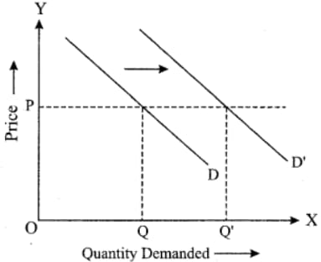
Figure 5: Consumer’s Income Increase Effect on Demand ((N Gregory Mankiw, 2016)

Income Decreasing
If consumers' income decreases, the demand for Domino's pizzas will likely fall. Consumers will need more disposable income to spend on non-essential items like pizzas. Additionally, consumers may be more inclined to cook at home rather than order takeout or delivery if they are trying to save money. However, it is worth noting that the impact on Domino's pizza demand could vary depending on the specific circumstances of the decrease in income and the preferences of individual consumers.
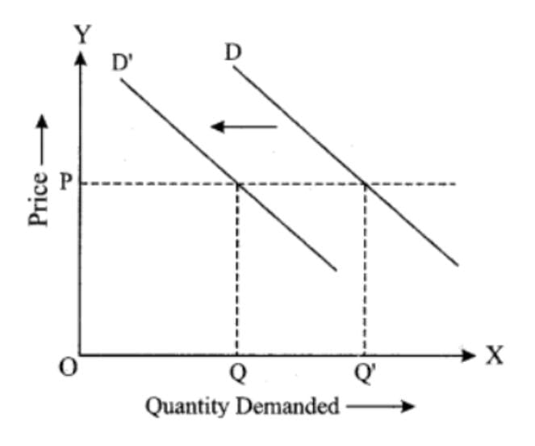
Figure 6: Consumer’s Income Decrease Effect on Demand ((N Gregory Mankiw, 2016)

Consumer Taste and Preferences
Customers' unique wants, likes, and dislikes for goods and services are referred to as consumer tastes and preferences (N Gregory Mankiw, 2016). Numerous things, such as individual experiences, cultural and social influences, and marketing initiatives, might impact these choices.

Change in Consumer Taste and Preferences
It is challenging to make generalizations regarding shifts in consumer preferences because they differ greatly depending on several variables such as region, age, wealth, and personal beliefs. Some general trends have been seen in recent years, such as a greater emphasis on sustainability and environmentalism, a preference for practicality and ease of use, and a need for goods and services that provide individualized and adjustable experiences. In addition, as consumers have grown accustomed to making purchases and getting information online, the explosive expansion of e-commerce and the proliferation of mobile devices has significantly impacted consumer behavior.
Consumer preferences and tastes can strongly impact demand for Domino's Pizza. Demand for Domino's Pizza will increase if people in general favor the flavor of Domino's Pizza over that of other brands or varieties of Pizza. The need for Domino's Pizza will be reduced, though, if customers dislike the flavor of the Pizza or prefer different kinds of cuisine. Additionally, the demand for Domino's Pizza may rise if the company successfully markets its goods and educates people about what it has to offer. A successful advertising campaign or introduction of a new pizza type by Domino's, for instance, that appeals to a particular market segment, might boost demand for the company's goods. It's essential to remember that other elements like cost, accessibility, and convenience can also influence the direction of Domino's Pizza. For instance, if Domino's increases the price of its Pizza, this could reduce demand, whereas promotions or discounts could improve it.

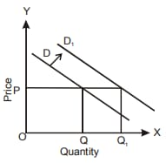
Figure 6: Consumer’s Taste and Preferences Effect on Demand ((N Gregory Mankiw, 2016)
Consumer Expectation of Price
Consumers' expectations of price can vary significantly based on several factors, such as the product or service's perceived value to the customer, the consumer's financial status, and the costs of comparable goods and services provided by rivals.

Consumer Expectation of Price Effect on Demand
Demand for a good or service, like Domino's Pizza, can be impacted by consumer price expectations. Customers may be less likely to buy a good or service if they anticipate paying a high price. However, consumers might be more inclined to buy it if they expect to pay less. In the example of Domino's Pizza, customers may be less likely to place an order if they anticipate paying a high price for the Pizza but may be more likely to do so if they expect to pay a lesser fee. The cost of comparable goods or services, the state of the economy, and the consumer's financial condition are all variables that affect consumer price expectations (N Gregory Mankiw, 2016).

Demographics

A population's demographic traits can influence the demand for a good or service. Age, gender, income, education, occupation, and family size are a few examples of these variables. For instance, a business selling sports equipment would have greater demand from younger demographics than a business selling retirement homes might experience. Companies can customize their marketing and product development efforts to fit the needs and preferences of their potential customers by having a thorough understanding of the demographics of a target market.

An increasing number of buyers
If more buyers want to purchase Domino's Pizza, the demand for the product will increase. (N Gregory Mankiw, 2016)

Decreasing Number of Buyers
On the other hand, if fewer buyers want to purchase Domino's Pizza, the demand for the product will decrease. (N Gregory Mankiw, 2016)

Price Elasticity of Demand of Domino’s
The price elasticity of demand measures how much a product's demand shifts in response to changes in its selling price. Among these are the following:
The number of available substitutes:
When consumers have several options, their demand for a product or service is more elastic since they may quickly shift to a different one if the price changes (Lawrence Robert Klein, 1983).
The share of disposable income devoted to the purchase:
Consumers' sensitivity to price fluctuations increases if a good or service accounts for a sizable amount of their disposable income (Forgang and Einolf, 2007).
The need for the good or service:
If a good or service is regarded as a necessity, demand for it may be less elastic since consumers may continue to purchase it even if the price increases (Lawrence Robert Klein, 1983).
Period:
The longer the period, the more elastic demand is likely since customers have more time to adapt their buying behavior in reaction to price fluctuations (Lawrence Robert Klein, 1983).
Regarding Domino's Pizza, the demand for its products may be elastic, given numerous substitutes available in the form of other pizza chains and restaurants selling comparable food. And while Pizza may be regarded as a need by some, it is less necessary than food and shelter. Therefore the price of a Domino's Pizza may not account for a sizable amount of most consumers' budgets. Finally, the time range for considering the demand for Domino's Pizza is likely to be long, as consumers may have many different options for where to get their Pizza and may be able to adjust their shopping patterns over time in reaction to price changes.
Time: The Cost Because consumers may be more prepared to pay more upfront for the convenience of a quick lunch, the elasticity of demand for Domino's Pizza may be less elastic in the near run. The long-term market, however, is more flexible since consumers have more time to think about other possibilities or prepare meals in advance.
Availability of alternatives: If there are many alternatives, such as other pizza chains or handmade Pizza, the price elasticity of demand for Domino's Pizza may be higher. However, the market could be more rigid if fewer alternatives are accessible.
The necessity of luxury: Domino's Pizza may have a lower price elasticity of demand if it is viewed as a need, such as for a family with young children who depend on quick and simple meal options. The market, however, might be more flexible if it is viewed as a luxury good.
Income percentage: If Domino's Pizza accounts for a sizable portion of a consumer's income, their price elasticity of demand may be higher since they may be more sensitive to price changes. The demand, however, can be more rigid if a tiny portion of their revenue comes from it.
Habit or addiction: If a consumer has an addiction to Domino's Pizza, their willingness to alter their behavior in response to price changes may be lower. As a result, the price elasticity of demand for
Domino's Pizza may be less elastic. The need might be more flexible if it is not a habit or addiction, though

Critical Evaluation of the Pricing Policy of Domino's

Since I cannot access Domino's unique business data and market conditions, I cannot recommend with any precision the price strategy that the restaurant should implement. However, there are a few fundamental guidelines that businesses frequently take into account when determining prices for their goods or services:
Cost-based pricing is determining the price at a level that includes the costs of producing the good or service and the targeted profit margin. This strategy can benefit companies with a high fixed cost base because it ensures that they are paying their expenses and turning a profit (K.Juman, 2021).
Pricing determined by what rivals ask for comparable goods or services is known as "competition-based pricing." Using this strategy might benefit companies that compete fiercely with customers because it keeps them competitive (K.Juman, 2021).
Value-based pricing entails determining the price based on the customer's perception of the worth of the good or service. This strategy can be beneficial for companies that provide exceptional or high-quality goods or services as it enables them to capture a higher portion of the value they generate (K.Juman, 2021).
A few elements could be taken into account:
- Market Factors: Factors like the cost of ingredients and the intensity of competition from rival pizza restaurants may impact the price of Domino's pizzas in a given area.
- Ingredient Caliber: Domino's has previously come under fire for utilizing subpar ingredients in its pizzas. The corporation may be able to charge more if it employs better-quality components.
- Menu Options: Domino's offers a selection of pizzas in different sizes and styles, as well as sides and desserts. These items' prices can be assessed separately.
- Pricing Strategy: To cater to various client segments, Domino's may utilize different pricing methods, including discounts, promotions, and bundling.
- Customer Value: In the end, a company's pricing strategy should be assessed in light of its value to customers. The pricing strategy may be successful if customers believe Domino's pizzas are high quality and competitively priced.

Conclusion
Domino's Pizza has successfully managed its operations and adjusted to the various facets of the market's changing economic climate. To ensure that it remains the industry leader in pizza delivery, the firm has pursued several different tactics, including ordering alternatives via the internet and mobile devices, expanding its operations into new countries, and developing new menu items (Syed, 2016). In addition, Domino's has consistently worked on enhancing both the quality of its customer service and the happiness its employees enjoy to promote growth and profitability (Sharp, 2018). Domino's success and continuous expansion in the highly competitive pizza sector can be attributed, in large part, to the managerial and economic strategies that the company has put into practice.

References:
- Ahuja H.L (2018). Managerial Economics (Analysis of Managerial Decision Making), 9th Edition. S. Chand Publishing.
- Alvarez (2020). FBS Farm Business Survey. [online] www.farmbusinesssurvey.co.uk. Available at: http://www.farmbusinesssurvey.co.uk/.
- Forgang, W.G. and Einolf, K.W. (2007). Management economics: an accelerated approach. Armonk; London: M. E. Sharp, Cop.
- Julian (2021). Economy - OECD. [online] www.oecd.org. Available at: http://www.oecd.org/economy/.
- K.Juman (2021). Personalized Pricing. A comprehensive and critical examination of first-degree price discrimination. GRIN Verlag.
- More, M. (2018). Market Realist: News, Analysis, Company Overviews. [online] marketrealist.com. Available at: http://marketrealist.com/page/12/?tx=content-type&tm=overviews#article-919858 [Accessed 9 Jan. 2023].
- Mount, P. (2018). RetailDetail. [online] RetailDetail. Available at: https://www.retaildetail.eu/en [Accessed 6 May 2019].
- N Gregory Mankiw (2016a). Macroeconomics. New York: Worth Publishers.
- N Gregory Mankiw (2016b). Principles of microeconomics. Australia: Cengage Learning.
- Sharp, L. (2018). Statista - The Statistics Portal. [online] Statista. Available at: http://www.statista.com/.
- Syed, I. (2016). SWOT analysis and operation management decisions of Domino's Pizza. GRIN Verlag.

