Paul Evans (2114255)

Curricculum Adventure
BMOE6002

Problem Based Learning: Developments for Cynefin

Introduction
As a child growing up in the 1970s, outdoor play/adventure was all we knew, because that’s all there was! We went out in the morning and came home when it was dark, all the children on the estate would all meet up and then decide what the day’s activities would be. It could be just football/rugby/cricket or climbing trees, running through fields, wading through rivers, making a rope swing, riding a bike, the list is endless and that’s how it was. No computers phones or Xbox etc. According to Collins (2008), the rates of sickness and obesity were lower. My idea for the project at Cynefin would be to try and replicate as much as possible, the type of activities and the lifestyle that the children of the 70s/80s had, with days of adventure in the outdoors, building resilience and physical literacy and social interaction skills, which in turn, could afford better motor skills, which hopefully will develop into a lifetime of better physical and mental health.
According to Scully et al., (1999, pp.111-120.) physical literacy and “physical activity can positively improve both physical and psychological wellbeing”. However, there is a growing body of evidence that sates “Americans today spend at least 90% of their waking hours indoors” (Samet and Spengler 2003). Over the course of five years, from 2001 to 2006, children's outdoor play significantly decreased, according to a population-based study. (Cleland et Al. 2010). According to survey results, less than half of children (40% and 55%, respectively) spend less than an hour outside every day, including on the weekends (Larson et al. 2011).
What is Physical literacy?
“Mens sana in corpore sano,” the notion that holistic mind–body wellness is essential to full human flourishing, is an old idea periodically revisited. A recent iteration is the concept of physical literacy (PL), advanced by Whitehead (2010) as a path to heightened embodiment and being. The term is based on a metaphor that likens movement fluency to language literacy. The ability, self-assurance, drive, and comprehension of movement and physical activities throughout life are referred to as physical literacy. It involves possessing the abilities and knowledge necessary to move efficiently, engage in physical activity, and take part in a variety of physical activities.
There are specific worries regarding children's detachment from the natural world, which have been highlighted by Louv (2005) “at the very moment that the bond is breaking between the young and the natural world, a growing body of research links our mental, physical and spiritual health directly to our association with nature”. For a variety of reasons, time spent outdoors appears to be diminishing, especially in affluent countries, so unplanned contact with nature occurs less often (Layard, 2006). Advances in technology and increased accessibility to computers and communication devices at a much earlier age may mean children are less likely to engage in outdoor play and recreation (Pretty et al, 2015). Today's children frequently learn more about nature and the environment from the internet and television than they do from first-hand experience. Bird, (2007) states children and young people in this generation are more confined to indoor and urban environments because they spend less time in nature than those in previous generations. This is true even though there is growing proof that exposure to nature improves emotional and cognitive functioning, social skills, academic performance, and even one's course in life. This growing gap can be addressed by using the outdoors as a learning space, which is a compelling case for including outdoor learning into the curriculum. Studies reveal that walking and forest bathing lower cortisol and blood pressure (Park et al., 2010). Nature is thus also a learning resource that promotes resilience in young people and positively affects their future life course opportunities. It is not just green space that is important to health, blue environments by rivers, lakes and coasts seem to have intrinsic qualities that promote restoration and improved mental health and wellbeing (Poulsen et al., 2022).

Why are motor skills important?
The ability to sit still, the development of hand-eye coordination required for writing, and the eye movements required to support reading, writing, copying, and catching a ball are all made possible by motor skills. Even though speech develops in the context of social interaction, speech is a task with motor components (Green, J.R.,2010, pp171-188). According to research conducted in schools in the UK and Northern Ireland, a sizable portion of students were enrolled in the educational system with immature motor skills, and there was a link between these deficiencies and poorer academic achievement as measured by baselines in education (NEELB, 2004; Goddard-Blythe, 2005). Sheard and Golby (2006) noted improvements in mental toughness, self-efficacy, self-esteem, and positive attitude following outdoor adventurous activities. The positive effect of nature has been labelled “The Biophilic Hypothesis” a term coined by Havard Biologist Edward O Wilson (1984, 2015).
Curriculum to Wales (2022) guidelines clearly state what is important in providing broad and balanced education. The collective vision is four purposes, and this is the aspiration for every child and young person. In realizing these, high expectations are set for everyone, promote personal and national well-being, challenge ignorance and stage of knowledge, and encourages learners to play their part as alert and critical citizens (Welsh Government, 2023).
Cynefin Grounds
Based on the evidence above, Cynefin grounds can be developed in the following ways, to support physical literacy and health and wellbeing.
Cycling skills: The first and maybe the most important activity would be bike skills, whether it be learning to ride a bike for beginners or advanced riding with a progression form basic riding skills to slalom courses (see Fig. 1 & 2), then advancing onto ramps and jumps (Fig. 3) and then onto the pump track (Fig. 4). The children could also be taught bike maintenance, which will give them the skills and confidence to go out by themselves and be able to fix punctures, chains issues, seat, and handlebar adjustment for example, which can also support motor skills, as they will need to use their hands whilst using tools. Cycling is an important and enjoyable skill for everyone to learn, it builds motor skills (Schmidt, 2008) using hands and legs at the same time plus having a cardio and physical workout at the same time (Ayers, 2011). Learning to cycle allows children the opportunity to cycle to school or, meet up with friends and go for rides along the various surrounding cycle paths. It’s a massive opportunity just to get out of the house and just be outdoors.
(Fig 1)
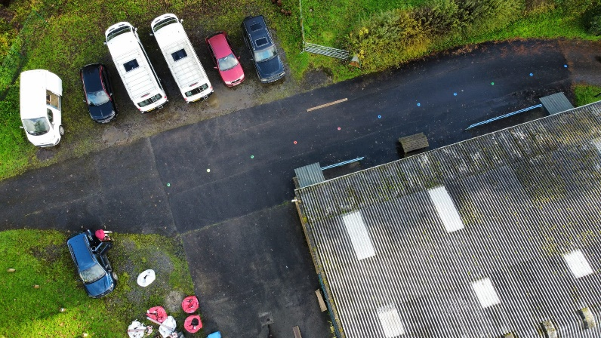
(Fig 2)
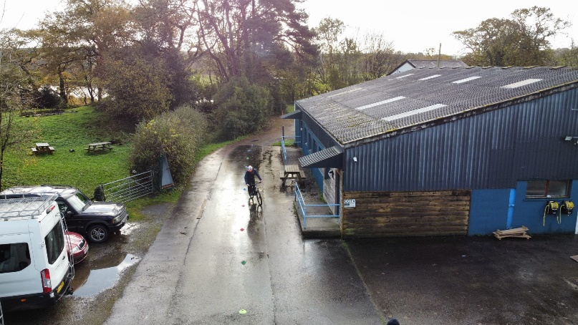
(Fig 3)
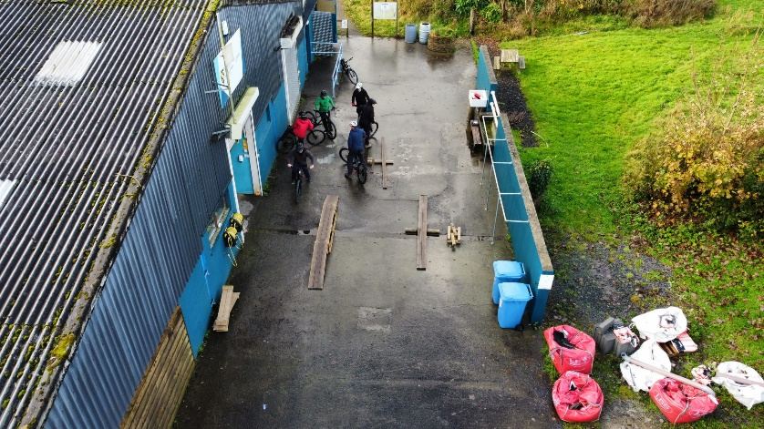
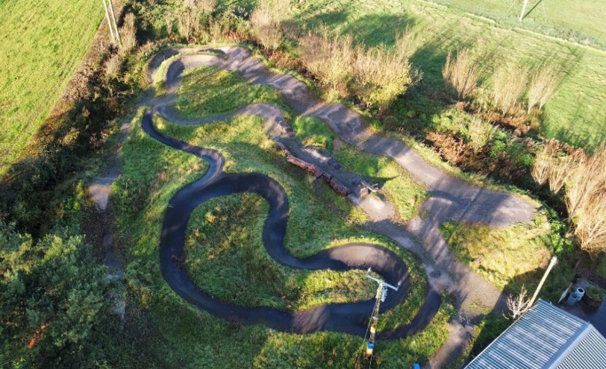
(Fig 4)

The off-road track, alongside the pump track (Fig 4) can also be used for walking, with its varying undulations, slopes and general unevenness affords stability skills for less mobile children, whist increasing muscle and joint strength, (Adolph, and Hoch, 2019) also it can add a fun and social element, if done in small groups.

(Fig 5)
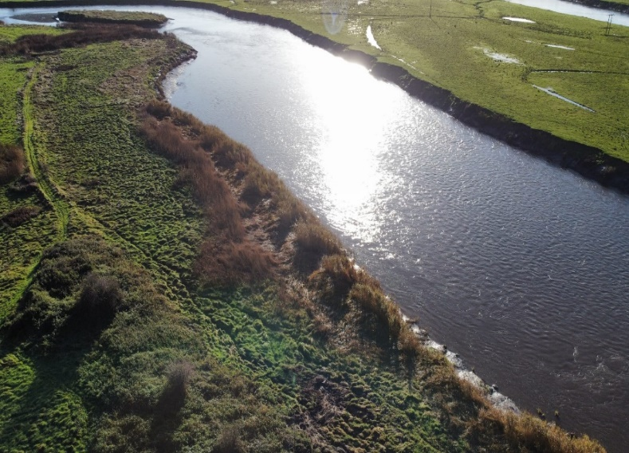

(Fig 6)
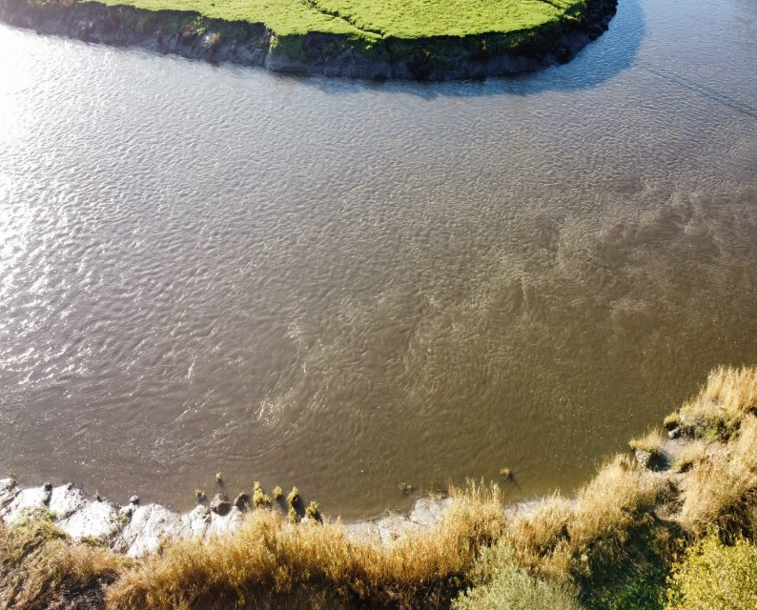

The next important part for the project at Cynefin is the river and access to the river. (Fig 5 & 6). This is a superb resource to have on its doorstep and offers the potential to many adventurous activities. (Fig 7) shows the geographical location of the river in proximity to Cynefin. To make this more viable, it needs better access, so a road or wide path with a sound surface would make this possible, then maybe a pontoon jetty, to launch boats, kayaks, SUPs etc.

These offer range of opportunities to introduce children to water sport activities, who might never get the chance otherwise, and encourages the children to increase their confidence around water and enhancing resilience (Lee, Macvarish and Bristow, 2010). Life vests, helmets, and kayaks etc are already available at the site, so the children could start with introductory courses. Cost/affordability / accessibility / equity, which could cause some obstacles for participation, which Kirk, (2021) talks about in “Precarity, The Health and Wellbeing of Children and Young People”. Being involved on a regular basis children will slowly build variety of skills in terms of confidence and competence. Also paddling is a great way to build fitness, strength, and physical literacy etc. (Whitehead, 2013). Alongside this there will water safety skills, first aid and various methods of lifesaving from land and from a boat. (www.rlss.org.uk) The river can also be used as just a nice relaxing place to walk along and/or just sit and watch, whilst listening to the sounds of nature, for sensory enjoyment.
“Current Australian research from the Black Dog Institute (2016) revealed just under one in four (22.8%) of young, aged adolescents (15 – 19 years) had a probable serious mental illness. Statistics such as these are cause for alarm, especially for the helping professionals such as councillors, psychologists, teachers, and social workers”.
(Black Dog Institute, 2016)

(Fig 7)
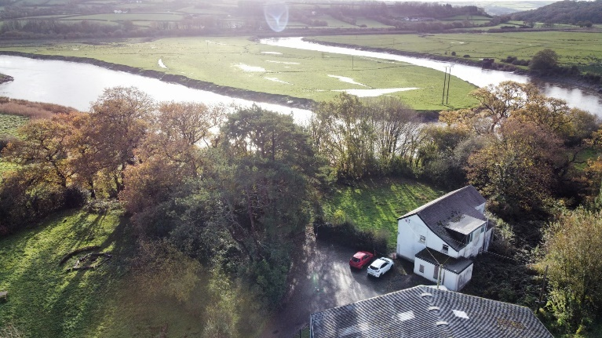

The Yurt: The outdoor classroom and social hub.

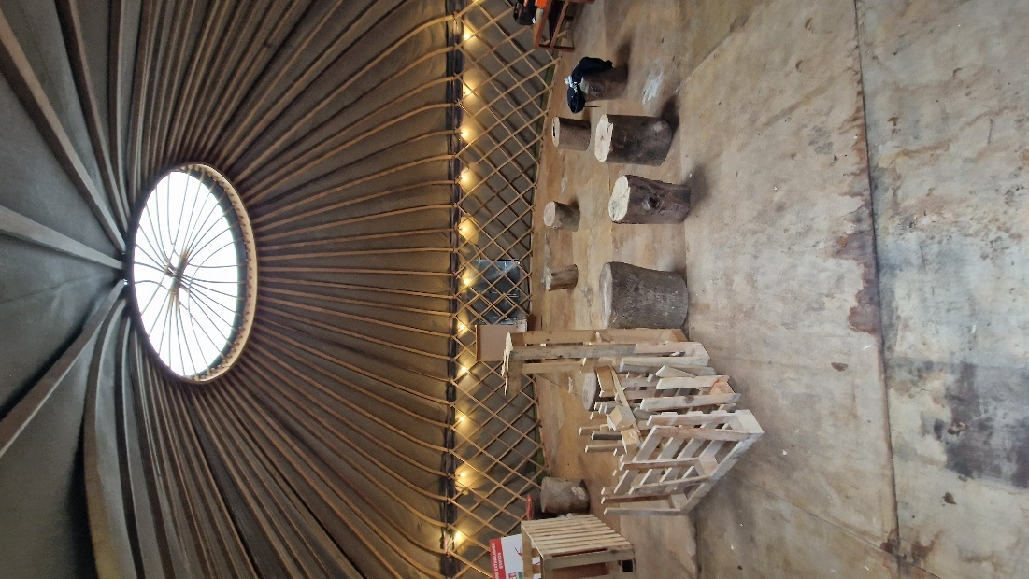

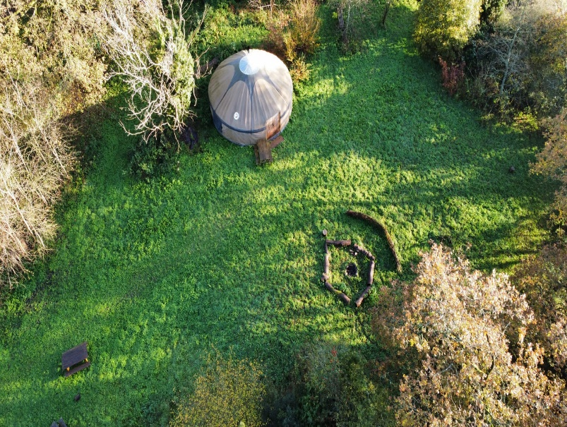
“School-aged children, spend less time outdoors than at any other time in history. In a population-based study, children’s time spent outside significantly declined over 5 years from 2001 to 2006” (Cleland et al. 2010). So, I feel the Yurt would be perfect for an “outdoor classroom” where the children could have discussions and studies, regarding fauna & flora, various local wildlife, and birds etc. This will allow the children to become more familiar with the outdoor surroundings, which will allow them to be more comfortable, so easing anxieties and unfamiliarity’s. “Children disconnect with the outdoors was brought to national attention in 2005 by the well cited book” entitled Last Child in the Woods: Saving our children from nature deficit disorder (Louv 2005).
The idea of outdoor classrooms is becoming more prevalent, outdoor classrooms are more popular due to more studies and research. Core subjects such as Maths, reading etc show enhanced optimism and show the outdoor classrooms can be fit for purpose and meet educational demands for modern curriculums (Kenny et al. 2003).
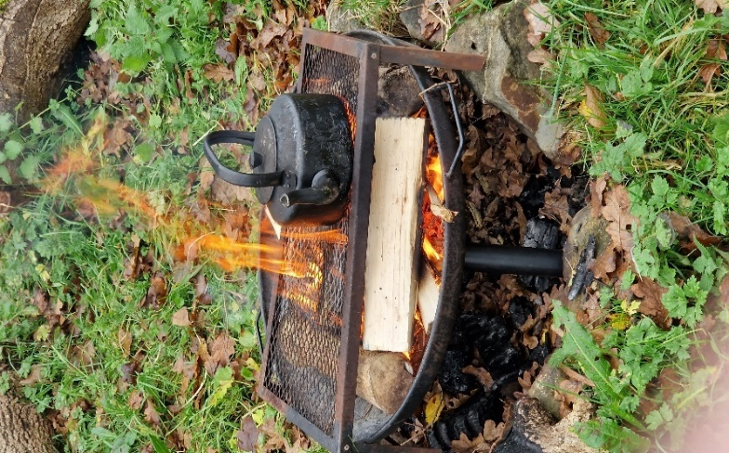
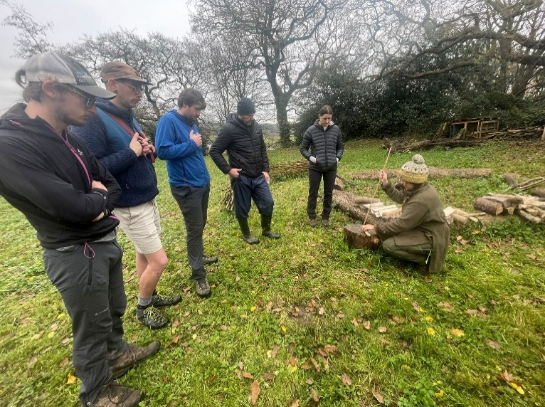
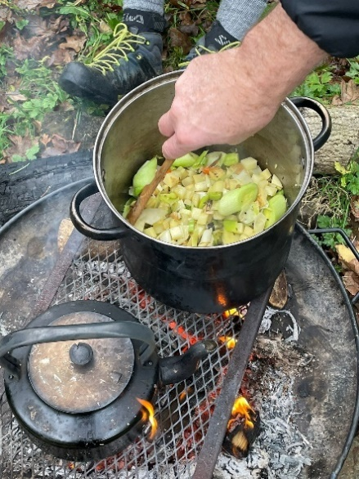
The Firepit: Here is the social hub, where the children can all learn to make a fire using a bow and dry tinder, then cook their own food, which is one of life’s main essential skills (Campbell, 1999). The ability to cook natural healthy food has numerous benefits for good health and takes away the need for “fast junk food” with its many health issues and connection with obesity (Kaur et al., 2014). Learning to cook one’s own food also affords independence and fortitude.
Willow Maze Sensory Walk: This area I feel will be helpful for children who are wheelchair bound or visually impaired, so everyone can feel included and get involved in an outdoor activity. Louv (2005) “the importance of being involved in nature to counteract what he calls the nature deficit disorder”. “Detailed scientific evidence has confirmed there are direct health benefits of light, colour, whole views, bird song and scents” (Pretty et al; 2005. Joye et al; 2013. Ratcliffe et al; 2013).

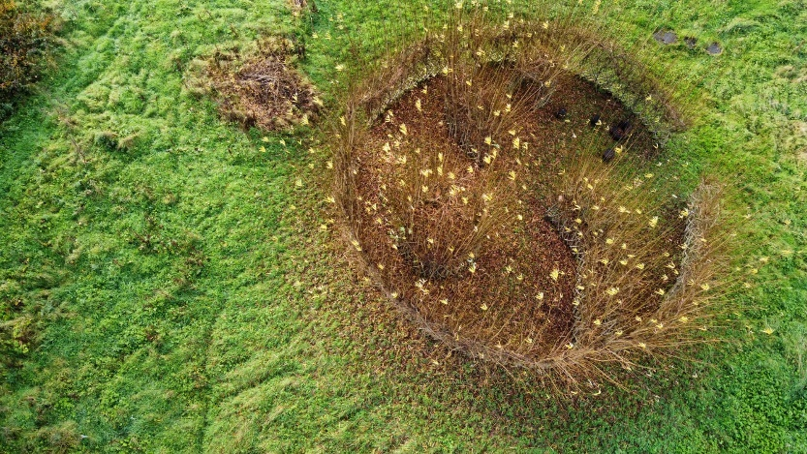

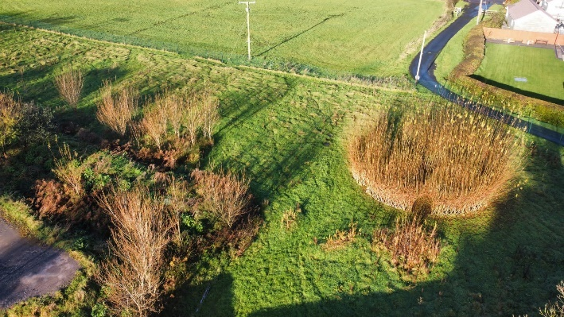

Obstacle course field: This field I feel can offer many valuable opportunities. If drainage can be installed, then the field can have many options for activities. I would like to see a mini assault/commando style obstacle course with water features to wade through, rope climbs, wooden walls, and low rope areas. This will help improve physical/mental resilience attributes as well have cardiovascular benefits. “One of the hallmarks of education is to build students emotional, psychological, and physical resilience (Booth 2015; Haggerty et al. 1996). There is the option for ball sports and team problem solving activities (outward bounds centre style activities, Kurt Hahn) (James, T., 1990). which will afford teamwork, communication skills and enhancing their physical literacy skills. A small pond could be positioned at the bottom corner to help with the drainage runoff, which will intern help encourage wildlife in the area, also adding another sensory aspect.

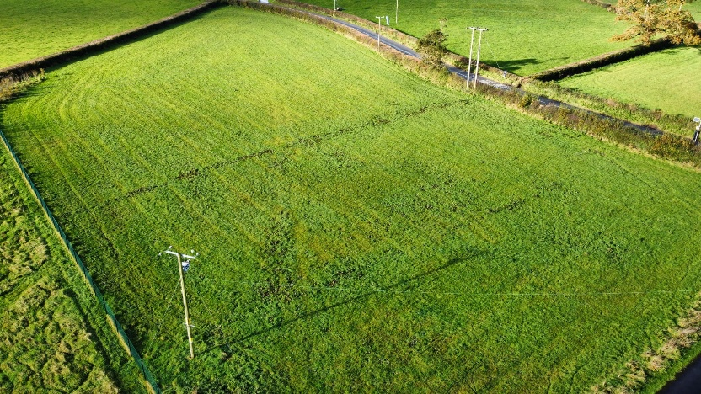

Low Rope Area
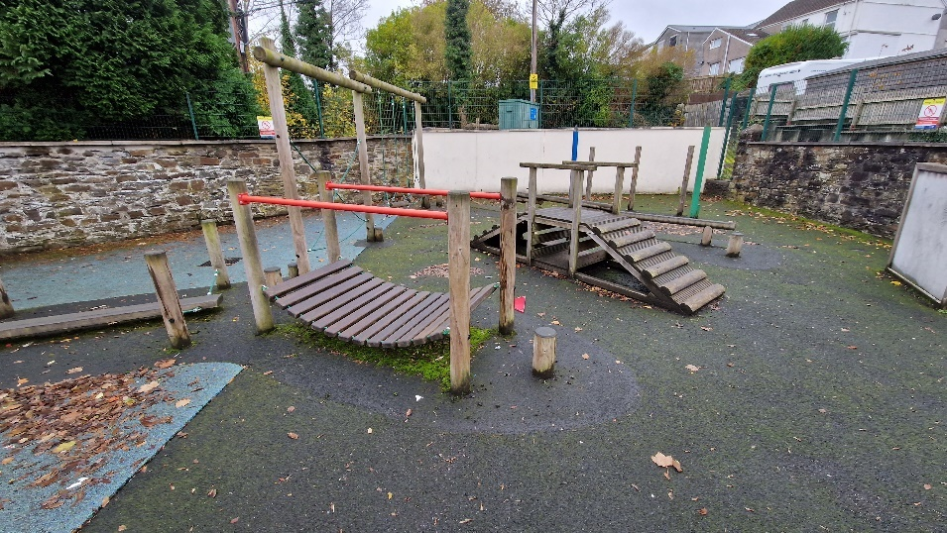

Risks: Wider changes in children's daily lives make the need for a balanced approach even more critical. The amount of time children spends outside on their own has decreased over the past few decades. They consequently have fewer opportunities to experience and acquire self-management skills related to risk. Giving kids supervised opportunity to take chances makes up for this loss of autonomy. “Play outdoors teaches young people how to deal with risk and without this they are ill equipped to deal with working life”. (Judith Hackitt, former chair of the Health and Safety Executive).
Why Risk is important: One could argue that adults undervalue children's capacity for risk management. Even so, children frequently make mistakes when they are allowed a little room to explore and learn. These can then result in mishaps, particularly in demanding and exciting circumstances. On the other hand, minor injuries and accidents from which children fully recover are not problematic in and of themselves. In fact, children frequently pick up a lot from them. Playing and learning outside is generally safer than participating in many other sports or recreational activities because outdoor environments are generally safer than indoor ones (Tim Gill, 2010).
What Does the Law require? “In simple terms, the law requires those responsible to take reasonable steps to ensure that risks are at an acceptable level. There is no legal requirement to eliminate or minimize risk. The key task is to carry out a “suitable and sufficient risk assessment” and to act on its findings. What counts as “suitable and sufficient” – for instance, the type of risk assessment, the level of detail and whether or not it is written down – depends on the circumstances. However, what is expected is a proportionate approach. The HSE makes it clear that health and safety is not about generating excessive paperwork”. (www.hse.gov.uk/entertainment/childs-play-statement.htm).

(See risk assessment form in the appendices)

Conclusion: So, to sum up what the Cynefin project is about and hopefully what it will become for years ahead, is a place for children to escape from the indoor environment and spend some quality adventurous time in the outdoor environment. “Knowing that both physical activity and nature independently enhance health, the term Green Exercise was coined to signify the synergistic health benefits derived from being active in green or natural places” (Pretty et al.,2005). So, the facilities on offer at Cynefin will afford better physical and mental health for the children through the many activities. The term “health” is generally taken to incorporate physical health, mental or emotional health, social health, spiritual health, lifestyle, and functionality (The World Health Organization 1948). The various activities on offer and with more to come in the future, should give a bit of adventure, some new skills, and a bit of calmness and relaxation, so something for everybody. This adventurous outdoor learning centre will give children the opportunity to acquire skills to help develop resilience, which affords them qualities which can carry over into all aspects of their future lives.
Hopefully this project will grow as more children get involved, which will attract more funding, to create a snowball effect. In the book Last child in the woods, Louv (2005) highlights the importance of interactions with nature to counteract what he calls, nature deficit disorder. Interaction with nature is recognised as supporting emotional well-being.

2525 words.

References

Admin (2017) New guidance from ROSPA: Planning and leading visits and adventurous activities - guidance for schools and Colleges, SAPOE. Available at: https://www.sapoe.org.uk/news/new-guidance-from-rospa-planning-and-leading-visits-and-adventurous-activities-guidance-for-schools-and-colleges/ (Accessed: 05 December 2023).

Adolph, K.E. and Hoch, J.E., 2019. Motor development: Embodied, embedded, enculturated, and enabling. Annual review of psychology, 70, pp.141-164.

Ayers, S.F., 2011. Physical education for lifelong fitness: the physical best teacher's guide. Human Kinetics.

Bird, W., 2007. Natural thinking. Royal Society for the Protection of Birds.

Black Dog Institute, Australia, M., 2017. Youth mental health report: youth survey 2012-16.

Booth J. (2015). Coping strategies and the development of psychological resilience in outdoor education. Honours Thesis, University of Canberra. http://www.canberra.edu.au/researchrepository/items/4cc8017a

Campbell, P., 1999. Survival skills of native California. Gibbs Smith.
Children’s play and leisure: Promoting a balanced approach. Available at: https://www.hse.gov.uk/entertainment/childs-play-statement.htm (Accessed: 05 December 2023).

Cleland V, Timperio A, Salmon J, Hume C, Baur LA, Crawford D. 2010. Predictors of time spent outdoors among children: 5-year longitudinal findings. J Epidemiol Community Health. 64:400-406

Collins, A., 2008. Where Did it All Go Right? Growing Up Normal in the 70s. Random House.

gov.wales/cwricwlwm-i-gymru/cyflwyniad/#gweledigaeth-ar-gyfer-cwricwlwm-pob-ysgol

Green, J.R., Nip, I.S., Maassen, B. and Van Lieshout, P., 2010. Some organization principles in early speech development. Speech Motor Control: New developments in basic and applied research, 10, pp.171-188.

Health and Safety Executive materials for schools: www.hse.gov.uk/services/education

James, T., 1990. Kurt Hahn and the aims of education. Journal of Experiential Education, 13(1), pp.6-13.

Joye, Y. Pals, R. Steg, L. and Evans, B L. (2013). New methods for assessing the fascinating nature of nature experiences. PLoS ONE, 8(7); e65332.

Kaur, R., Preet, K.B., Verma, R.K. and Kiran, U.V., 2014. Fast Food and Junk Food Culture, Nutritional Status and Cognitive and Abnormal Behaviour among Teens. International Research Journal of Social Sciences, 3(9), pp.46-49.

Kellert, S.R. and Wilson, E.O. eds., 1993. The biophilia hypothesis. Island press.

Kenny JL Et Al. 2003. Helping teachers to use their school’s backyard as an outdoor classroom: a report on the watershed learning centre programme. J Environ Educ. 35(1):18-26

Kirk, D., 2021. Precarity, the health and wellbeing of children and young people, and pedagogies of affect in physical education-as-health promotion. Éducation et didactique, 15(15-3), pp.165-178.

Larson, L.R., Cordell, H.K., Betz, C.J. and Green, G.T., 2011. Children's time outdoors: Results from a national survey.

Layard, R., 2011. Happiness 2/e: Lessons From A New Science. Penguin UK.

Lee, E., Macvarish, J. and Bristow, J., 2010. Risk, health and parenting culture. Health, risk & society, 12(4), pp.293-300.

Louv, R., 2005. Last child in the woods: Saving our children from nature-deficit disorder. Algonquin books.

Louv, R., 2008. Last child in the woods: Saving our children from nature-deficit disorder. Algonquin books.

Park, B.J., Tsunetsugu, Y., Kasetani, T., Kagawa, T. and Miyazaki, Y., 2010. The physiological effects of Shinrin-yoku (taking in the forest atmosphere or forest bathing): evidence from field experiments in 24 forests across Japan

Pellegrini, M., Ponzo, V., Rosato, R., Scumaci, E., Goitre, I., Benso, A., Belcastro, S., Crespi, C., De Michieli, F., Ghigo, E. and Broglio, F., 2020. Changes in weight and nutritional habits in adults with obesity during the “lockdown” period caused by the COVID-19 virus emergency. Nutrients, 12(7), p.2016.

Poulsen, M.N., Nordberg, C.M., Fiedler, A., DeWalle, J., Mercer, D. and Schwartz, B.S., 2022. Factors associated with visiting freshwater blue space: The role of restoration and relations with mental health and well-being

Pretty, J. et al. (2005) ‘The mental and physical health outcomes of Green Exercise’, International Journal of Environmental Health Research, 15(5), pp. 319–337. doi:10.1080/09603120500155963.
Samet JM, Spengler JD. 2003. Indoor environments and health: moving into the 21st century. AM J Public Health. 93(9):1489-1497

Schmidt, R.A. and Wrisberg, C.A., 2008. Motor learning and performance: A situation-based learning approach. Human kinetics.

Scully, D., Kremer, J., Meade, M.M., Graham, R. and Dudgeon, K., 1998. Physical exercise and psychological wellbeing: a critical review. British journal of sports medicine, 32(2), pp.111-120.

Sheard, M. and Golby, J., 2006. The efficacy of an outdoor adventure education curriculum on selected aspects of positive psychological development. Journal of Experiential Education, 29(2), pp.187-209.

Tim Gill (2010) Nothing Ventured. Balancing risks and benefits in the outdoors: www.educationscotland.go.uk/resources/n/genericresource_tcm

urbala, P. (2015) ‘What is physical literacy, really?’, Quest, 67(4), pp. 367–383. doi:10.1080/00336297.2015.1084341.

Whitehead, M. (2013). Definition of physical literacy and clarification of related issues. Journal of Sport Science and Physical Education,

Whitehead, M. ed., 2010. Physical literacy: Throughout the lifecourse. Routledge.

World Health Association, 1948. Preamble to the constitution of the World Health Organization. In International health conference (p. 100).
www.rlss.org.uk

Appendices
Risk Benefit Assessment Form

Location / Activity: | Cynefin Outdoor center | Date:
Assessor: | P. Evans | Review date:

Your overall risk rating – Low, medium or high – is based on your judgement about whether the BENEFITS of the activity or opportunity outweigh the RISKS.

Activity | How will young people BENEFIT from this activity? | Possible hazards | Who is at risk? | PRECAUTIONS in place to reduce the risk of injury | Overall risk RATING: L/M/H
Bike skills | Physical literacy, multi limb mechanical movement, hand/eye coordination, balance skills. | Falling off, collisions | The rider, other riders, pedestrians. | Supervised, designated area, controlled tuition. | M
River/water skills | Water kills and safety, improve water confidence | Drowning, Getting wet | everyone | Water based PPE. Life jackets, wetsuits, helmets, throw lines etc. | M
Fire pit | Cooking skills self sufficiency | Burns | Children around firepit | Proper supervised sessions, cooking gloves, utensils. | M
Willow Maze sensory walk | Disabled/visually impaired, nature connectivity. | Slips/falls | The children | Supervised groups, pre check ground for debris | L
Low Rope area. | Improve balance, motor skills, strength, cognitive skills. | Slips/falls | The Children | Supervised groups, check condition of ropes etc. | M
Multi-purpose field/Obstacle course. | Fitness, strength, motor skills, cognitive, resilience. | Trips/Falls, Bumps, Wet. | The Children | Small managed groups, prior safety brief. | M

