Array exercises

1a. Create an integer array of 8 elements. Store (hard-code) a number in each element.

1b. Print the array on the screen using a for loop (avoid overflow!)

Sample output:

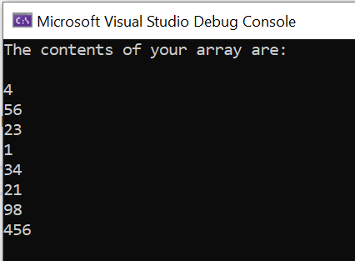

1c. Print the array on the screen in reverse order (starting with element 7 and go down to element 0).

Sample output:

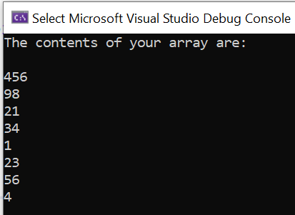

1d. Remove the hardcoded-values and instead allow the user to enter the values for the 8 elements (via scanf)

Sample output:

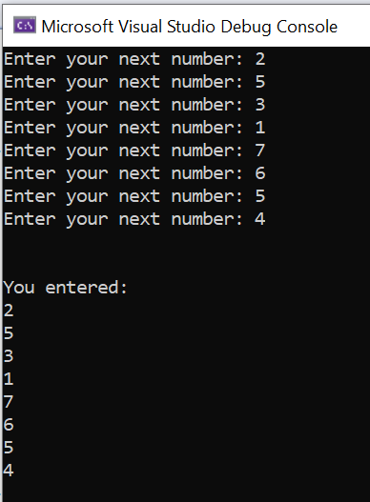

1e. Declare a variable (int total). Loop through the array, multiply each value by 3 and print the result of each calculations on the screen.

Sample output:

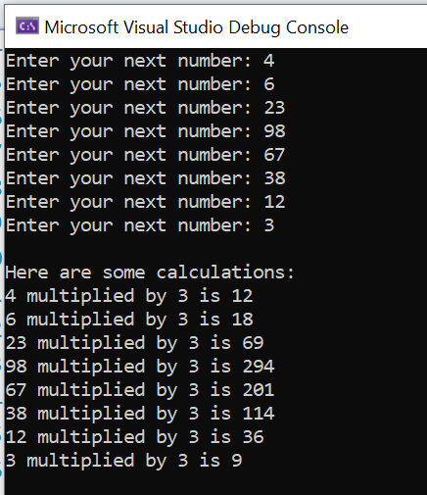
2a. Create a float array of 12 elements which will hold temperature measurements (eg 24.2, 26.3 etc). No need to put any values in, just declare the array

2b. Allow the user to enter values for the 12 elements (via scanf)

Sample output:

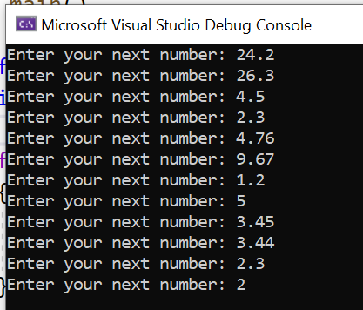

2c. Print the stored values on the screen.

Sample output:

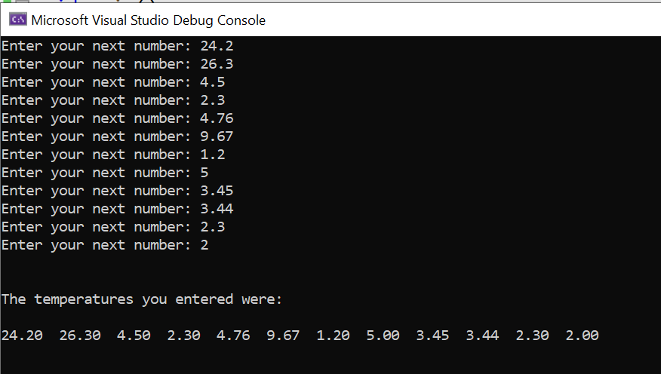

2d. Allow the user to print out one element of their choice. For example, ask them "Which array element would you like to see?" If the user enters 3, show element 3 and so on.

Sample output:

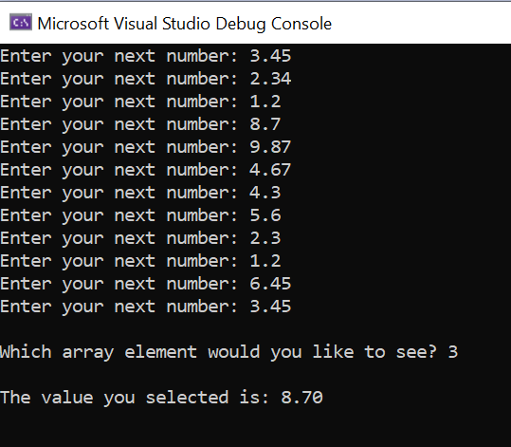

2e. (Harder) Find the average temperature (ie add the values stored in the array and divide by 12)

Sample output:

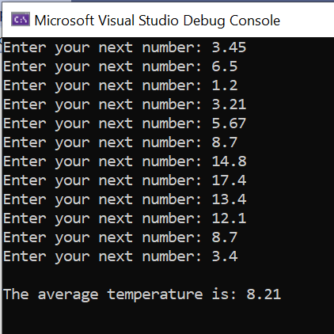

3a. Create a 2D character array to hold 10 names. Store 10 names of your choice (avoiding overflow)

3b. Create an integer array to hold 10 short office telephone extension numbers eg 4234, 4235, 4111 etc. (These numbers will correspond to the names in the character array.) A 1D array is fine here.

3c. Print out the names with the extension numbers next to them

Sample output:

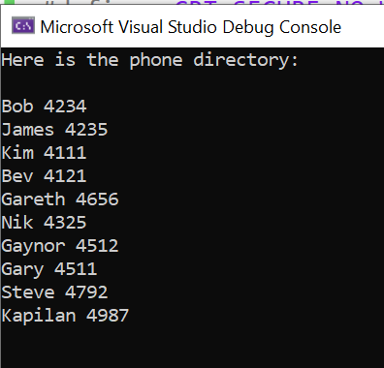

d. (Harder) Allow the user to enter an extension number into a variable (eg int choice). Search for the number in the array. When (if) you find the number, print out the name associated with that extension number.

Sample output:

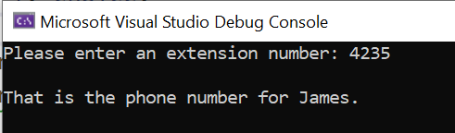

e (Even harder) Allow the user to enter the name and retrieve the extension number. Note: you will need use strcmp() from the string.h library.

Sample output:

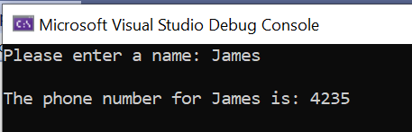

4. (Very challenging) For those who would like an extra challenge, try a simple noughts and crosses game with a 2D character array (or at least set up the board and allow users to choose a coordinate)

You could start by setting up a 2D array for the board:

#define _CRT_SECURE_NO_WARNINGS
#include <stdio.h>

void main()
{
char board[3][4] = { "---", "---", "---" };
}

Build up in stages – for example, print out the board first, then go on to ask the user to enter their required space.

Sample output:
:

