

Master of Business Administration
Marketing Management - LCMB7024

“ Marketing Environment Analysis of Uber Eats and Deliveroo ”

Student ID: 2413602
Student Name: Raj Kanubhai Hirpara

Lecturer’s Name : Dian Mayasari and Laila Maazouz
Words Count: 2600

Table of Contents
1. Introduction 4
1.1 Background of the Food Delivery Industry 4
1.2 Overview of Uber Eats and Deliveroo 4
1.3 Aim and Objectives of the Report 5
2. Macro Marketing Environment Analysis 6
2.1 Overview of Macro Environment 6
2.2 Technological Factors 6
2.2.1 Impact on Uber Eats 6
2.2.2 Impact on Deliveroo 7
2.2.3 Comparative Analysis of Technological Influence 7
2.3 Economic Factors 8
2.3.1 Impact on Uber Eats 8
2.3.2 Impact on Deliveroo 8
2.3.3 Comparative Analysis of Economic Influence 9
3. Strategic Response and Evaluation 10
3.1 Overview of Strategic Approaches 10
3.2 Application of Porter’s Generic Strategies 10
3.2.1 Strategy of Uber Eats 10
3.2.2 Strategy of Deliveroo 10
3.2.3 Comparative Evaluation of Competitive Positioning 11
3.3 Application of Ansoff Matrix 12
3.3.1 Growth Strategy of Uber Eats 12
3.3.2 Growth Strategy of Deliveroo 12
3.3.3 Comparative Evaluation of Growth Strategies 12
4. Conclusion 14
4.1 Summary of Key Findings 14
4.2 Evaluation of Competitive Advantage 14
4.3 Final Judgement on Strategic Effectiveness 14
Reference list 15

List of Figures
Figure 1 Global Online Food Delivery Market Growth Trend 4
Figure 2 PESTLE Factors Affecting Online Food Delivery 6
Figure 3 Comparative Analysis of Technological Influence 8
Figure 4 Comparative Evaluation of Competitive Positioning 11
Figure 5 Comparative Evaluation of Growth Strategies 13

1. Introduction

1.1 Background of the Food Delivery Industry
Online food delivery industry has developed in the first half of the 2010s and changed the existing forms of aggregator sites to complex platform-to-consumer models, which prevail. First movers took advantage of the ride-hailing infrastructure to scale fast, whereas the second movers were centred around niche logistics and premium relationships. UK is one of the most important European markets with the industry estimated to reach USD 9.3 billion in 2025 before reaching USD 20.7 billion in 2034 due to the dense population along with technological usage in the urban areas (Li, Mirosa and Bremer, 2020). The opportunities and threats are influenced by macro factors such as technology (AI routing, apps) and economic forces (inflation, gig economy) and impact the competitive dynamics.
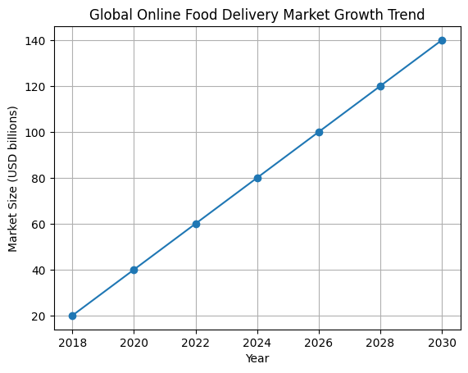
Figure 1 Global Online Food Delivery Market Growth Trend

1.2 Overview of Uber Eats and Deliveroo
In 2015 (and as a separate application since 2016), Uber Eats was the first company to utilise the scalability of food delivery by using the Uber driver network and data analytics to expand to multi-cities. It has an extremely large scale, 500,000+ restaurant partners in the entire world, with the focus on dynamic pricing and extensive coverage as a first-mover. Deliveroo was a late entrant in London in 2013 and focused on higher-end restaurant deals (140,000 and up partners) and rider fleets with faster and more quality services (TechCrunch, 2023). It is a Europe and Asia-based company that differentiates through loyalty programmes but has a low global presence.

1.3 Aim and Objectives of the Report
This report is a critical analysis of how technological and economic macro factors present opportunities and threats to Uber Eats (pioneer) and Deliveroo (follower) in the food delivery industry, and the strategies of both companies in responding to the opportunities and threats by using Porters Generic Strategies and Ansoff Matrix.
Objectives:
(1) Study macro influences on competitive positions
(2) Comparison of growth strategies
(3) Measure sustained advantage.

2. Macro Marketing Environment Analysis

2.1 Overview of Macro Environment
The political regulation of the gig work, the economic cycles related to demand of consumers, and the sociocultural demand of convenience and app based services shape the macro marketing environment of online food delivery. Smartphone technology, AI, navigation and online payment platforms are the core of platform-to-consumer models, whereas legal and environmental factors are bringing more pressure on data protection, labour standards and eco-friendly logistics (Makos, 2024). In the case of platforms, such as Uber Eats and Deliveroo, these PESTLE forces are not directly controlled by the management, and their impact on the development of the market, the pricing models and competition levels, are both opportunity-generating and threatening and should be considered in the strategy (Lab, 2026).
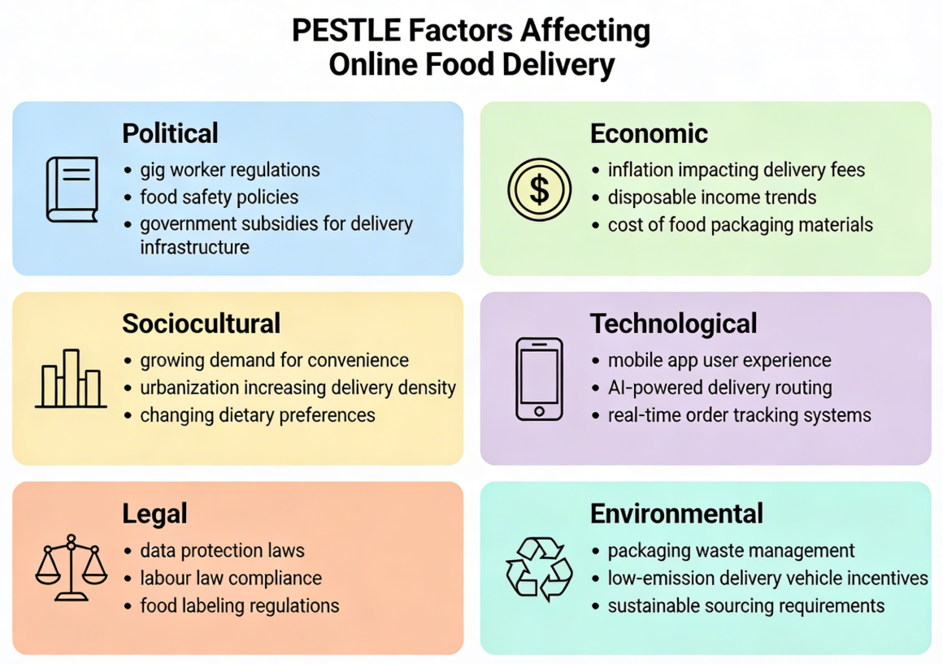
Figure 2 PESTLE Factors Affecting Online Food Delivery

2.2 Technological Factors

2.2.1 Impact on Uber Eats
The model of business of Uber Eats is profoundly rooted in progressive digital infrastructure, relying on Uber global platform, real-time GPS positioning, mobile app ecosystem to scale riders, restaurants and customers at large. To improve order density and utilisation of couriers, AI and machine-learning algorithms examine the volume of orders, preparation time, and traffic data to optimise the route and minimise delivery time. Big data analytics make it possible to predict demand and tailor recommendations, expand the size of the basket and the number of repeat uses within a variety of urban markets (Madani and Alshraideh, 2021). Combination with frictionless online payments and in app promotional services can further reduce the transaction costs and increase user experience contributing to the reputation of Uber Eats as an innovator that can roll out into multiple countries in a short amount of time (Williams, 2018). Nonetheless, a large amount of investment in proprietary technology, cybersecurity, and the continued addition of new features (like live order editing and retail integrations) increases the fixed costs and the level of scale required to achieve profitability.

2.2.2 Impact on Deliveroo
Deliveroo uses a very streamlined logistics system that involves its Frank algorithm, a machine learning-based system that assigns riders, predicted preparation time and optimal routes by neighbourhood. This technology orientation helps it achieve its strategic value of speed and reliability especially in high density urban locations and in its high end restaurant customers. AI-based demand forecasting is useful in controlling demand supply, minimising idle hours and the empty box phenomenon, and enhancing its utilisation, as well as minimising the per-order delivery price (Belanche, Flavián and Pérez-Rueda, 2020). Its data-driven culture also uses mobile applications, real-time tracking and online payments to provide a smooth user experience, and experimentation and A/B testing are part of it. However, Deliveroo has less wide-ranging presence and is smaller than Uber Eats, which means that this narrows the data base and can restrict the rate at which it can roll out frontier technologies like the use of drones or autonomous delivery in scale (Davies, 2025).

2.2.3 Comparative Analysis of Technological Influence
The scale-based advantage is also presented by the technological capabilities which allows Uber Eats to expand to numerous countries quickly and to maintain high rates of transactions, spreading the fixed costs of the technologies. The technology of Deliveroo, in its turn, is more operations-oriented, and concentrates on the performance and quality of the services in chosen markets, instead of the global connectivity. Although both of them make use of the same tools, which are apps, routing, and digital payments, Uber Eats is using cross business synergies with ride-hailing and wider data assets, whereas Deliveroo is using technology as a differentiator based on speed and curated experience (Sudra, 2023). Therefore, the technology strengthens Uber Eats as a pioneer in terms of coverage and convenience and Deliveroo as a follower in terms of operational excellence and niche premium segments.
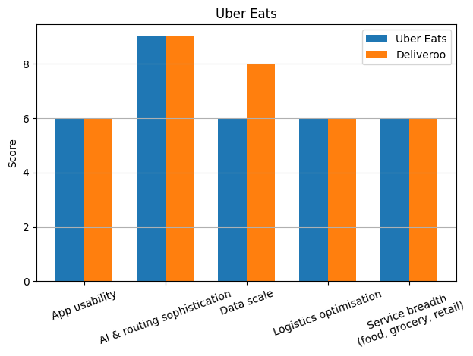
Figure 3 Comparative Analysis of Technological Influence

2.3 Economic Factors

2.3.1 Impact on Uber Eats
Economic conditions have a direct impact on Uber Eats in terms of consumer spending, food prices inflation, and the attitude of high-growth platforms in the capital market. The pressure of cost of living in the major markets has made customers more price sensitive which has enhanced the demand of discounts at the expense of margins (Lord et al., 2022). Meanwhile scale allows Uber Eats to distribute fixed platform, marketing and regulatory costs over large volume of orders, facilitating its transition to profitability, Uber Eats has gathered about US 13.7 billion in revenue in 2024 and became EBITDA profitable in 2023. Nevertheless, an increase in labour demands and the risk of regulating the earnings of gig workers in Europe may increase the costs of deliveries, which would need to redistribute the fees, commissions, and boosters (Wathanakom and Juicharoen, 2023).

2.3.2 Impact on Deliveroo
Deliveroo is extremely sensitive to the regional economic cycles, food inflation, and consumer confidence having a significant presence in UK and Europe. Frequency of order is curtailed by cost of living pressures which pressure customers to less expensive choices or direct restaurant ordering, aggravated competition (Mitra et al., 2023). Nonetheless, the initial preliminary results of 2024 indicate that Deliveroo has been resilient as the managerial company has increased its orders to 296 million and revenues to approximately 2.07 billion pounds alongside increasing its profit to 3 million pounds and adjusted EBITDA margin to 1.7% GTV (markets, 2025). The economic headwinds thus encourage Deliveroo to diversify its operations to grocery and quick commerce, to capitalise on the revenue generated through advertising and focus on the efficiency of its delivery networks as the demand tightens to secure profitability.

2.3.3 Comparative Analysis of Economic Influence
Economically, Uber Eats enjoys the diversification opportunities in the global markets that distribute the risk amongst markets with divergent rates of inflation and growth, at the expense of currency fluctuations and disparate regulatory cost structures. The more focused presence of Deliveroo increases the effects of the UK and European crises of living, but permits a greater cost management and price adjustment to the local environment (Stanley, 2023). The similarities between the two platforms are that both have high commissions that restaurants are complaining about, increasing labour and compliance expenses and investor expectations of sustainable profitability as opposed to raw growth. In general, both companies have opportunities to grow positively in the long term market, although the size of Uber Eats provides a better economic shock absorber, whereas Deliveroo has to be more efficient and position in niche to maintain margins (Stanley, 2023).

3. Strategic Response and Evaluation

3.1 Overview of Strategic Approaches
Uber Eats and Deliveroo are both in a very dynamic market based on platform where competitive advantage is determined by scale, network effects and quality of service. Their strategic approaches may be explained by the costs leadership, differentiation and focus as the Generic Strategies developed by Porter. The Uber Eats strategy is a hybrid between cost leadership and broad differentiation, with the company taking advantage of global scale and technology to provide broad variation and convenience to mass-market segments. Deliveroo aims at differentiation and greater focus in a narrower range, concentrating on carefully selected premium restaurants, faster delivery and hyperlocalisation of selected geographies and not maximum global presence (University Of Cambridge, 2020).

3.2 Application of Porter’s Generic Strategies

3.2.1 Strategy of Uber Eats
According to the framework proposed by Porter, firms can benefit by cost leadership, differentiation or focus, and numerous digital platforms use a combination of both theories in reality. Uber Eats displays aspects of cost leadership by utilising the worldwide rider network of Uber, algorithmic dispatch and route optimisation to reduce the unit delivery costs and facilitate competitive pricing and regular promotions. Its size facilitates the bargaining power over restaurants and marketing partners, and it can have commission structures and campaigns, which small competitors cannot afford (University Of Cambridge, 2020). Concurrently, Uber Eats engages in wide differentiation with wide variety of restaurants, built-in grocery and shopping and application functionalities like real time tracking, customizable suggestions and loyalty plans like Uber One. This alliance is intended to appeal to a broad range of customers who demand convenience and diversification as opposed to a niche and makes Uber Eats a one stop shop of on demand food and daily necessities.

3.2.2 Strategy of Deliveroo
The strategy of Deliveroo is closer to differentiation focus as it is aimed at urban, or in many cases more well-incomes customers, who appreciate speed, reliability and high restaurant selection. The company has traditionally been focused on collaborating with established brands and quality independents and invests in logistics (e.g., its rider allocation algorithm and Editions dark kitchens) so that delivery experiences can be quicker and more consistent. Instead of competing based on the lowest price, Deliveroo focuses on differentiation based on the curation, quality of service and membership offerings, including the Deliveroo Plus levels, which include free delivery and benefits to the regulars (Lumina Intelligence, 2025). The fact that its niche dimension is shown by a hyperlocal approach that maximises individual cities and neighbourhoods where density favour short delivery times and high order frequency is clear. This reduced geographical and segment coverage enables greater customization of offers and marketing, but reduces the benefits of diversification in contrast to a geographically global player such as Uber Eats.

3.2.3 Comparative Evaluation of Competitive Positioning
Uber Eats, according to Porters definition, is in competition with the hybrid of cost leadership and broad differentiation, where the global scale and technology are used to achieve balance between competitive prices and wide variety and convenience. This is a very strong position where mass market adoption and cross selling (ride hailing, grocery, retail) are driving forces of value. Deliveroo, in its turn, is biassed towards differentiation focus, focusing on better service and high quality curation in limited markets, which can drive to higher willingness to pay and loyalty but is susceptible to local economic changes and competitive environment in neighbouring markets (Ali and Anwar, 2021). Although the standard Porter logic cautions that hybrids are doomed to be in the middle, recent studies have shown that properly executed hybrid strategies can work in the digital realm, which means that the ambivalent approach adopted by Uber Eats can be viable as long as it is efficient and has a clear value source.
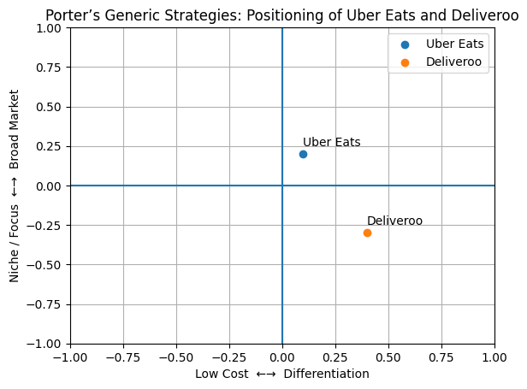
Figure 4 Comparative Evaluation of Competitive Positioning

3.3 Application of Ansoff Matrix

3.3.1 Growth Strategy of Uber Eats
The Ansoff Matrix recognises four growth options including market penetration, market development, product development and diversification. Uber Eats is aggressively expanding its market penetration by growing frequency of orders and share at existing markets by promoting heavily, offering subscriptions (Uber One) and greater integration with restaurants. It is also aligned to market development, constantly penetrating cities and countries and extending roots in suburbs through alliances and local advertising. Another way in which Uber Eats spends on product development and associated diversification is by going beyond restaurant meals to grocery, convenience and retail delivery with alliances with chains such as Aldi and various local grocers, with new categories being added to the same app experience (The Strategy Institute, 2024).

3.3.2 Growth Strategy of Deliveroo
The geographical coverage is more selective as well, which fits the multiple Ansoff quadrants in which Deliveroo would grow. It lays focus on market penetration in key markets including UK and Western Europe through enhanced service quality, memberships (Deliveroo Plus) and focused promotions to increase share with current customers and restaurants. The product development has provided Editions dark kitchens and technology features that have given Deliveroo the opportunity to offer new virtual brands and menu concepts to known markets, without the need of new high street locations. Deliveroo has been pursuing related diversification and market development in recent years through the high growth of grocery and non food retail delivery, as at end 2024, around 16% of group GTV was represented by grocery and partnerships with other retailers including Wilko and B&Q (Ackerman, 2021).

3.3.3 Comparative Evaluation of Growth Strategies
Both platforms utilise a hybrid of Ansoff strategy, however, the strategy deployed by Uber Eats is breadth-based, aiming to gain scale by developing a large geographic market and by diversifying products in terms of food, grocery and retail. This general trend encourages the spread of risks and cross selling but complicates and relies more on worldwide execution capacity. The expansion of Deliveroo is more depth based, focusing on market penetration and product development within a more limited range of markets, which is complemented by specific diversification in the areas of grocery and select shops (Ackerman, 2021). This means that Uber Eats is in a better situation to take advantage of global growth opportunities and network effects, and that the strategy of Deliveroo can benefit greater local relationship and operational control at the expense of greater exposure to regional economic and regulatory shocks.
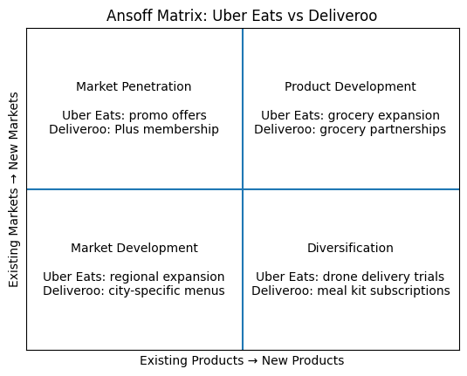
Figure 5 Comparative Evaluation of Growth Strategies

4. Conclusion

4.1 Summary of Key Findings
The analysis indicates that the online food delivery environment of Uber Eats and Deliveroo is essentially influenced by technological and economic forces, affecting the cost structures, the demand and the competitive environment. Uber Eats uses global scale, sophisticated algorithms and diversified categories to capitalize on technology and partially hedge economic shock, whereas Deliveroo is concentrated on logistics excellence, partners and regional optimisation. The position of Uber Eats is a hybrid cost leadership/broad differentiation position, with extensive market and product coverage, and Deliveroo focuses on differentiation focus in high density markets that are selected. They both use multi quadrant Ansoff growth paths, yet Uber Eats is breadth based and Deliveroo depth based.

4.2 Evaluation of Competitive Advantage
The primary competitive advantages of Uber Eats are its global network effects, its scale and capability to distribute technology and regulatory expenses among numerous markets and verticals. This helps to have high bargaining power and enduring innovation, but it increases complexity and execution risk. The competitive advantage of Deliveroo is more local, and it is developed on the basis of high-quality performance on the last mile, relationships with restaurants of high quality and customised operations at the city level contributing to the delivery of perceived quality and loyalty (Leo, 1982). Nevertheless, its smaller presence makes it more vulnerable to local economic declines and to changes in regulations of the gig economy.

4.3 Final Judgement on Strategic Effectiveness
Generally, the hybrid Porter strategy and expansive Ansoff growth strategy of Uber Eats is more viable in the long term, global competitive advantage, especially when the investors require profitable scale and category diversification. The deep and narrow differentiation strategy of Deliveroo can help secure a high position in the targeted markets, however, it might limit the capacity to compete with more resilient and bargaining-power competitors. In the future, the success of Deliveroo will lie in the enrichment of high value niches and partnerships, and Uber Eats will have to remain efficient not to fall into an unsustainable hybrid.

Reference list
Ackerman, N. (2021). Deliveroo opens giant new ‘dark kitchens’ in three London areas. [online] www.standard.co.uk. Available at: https://www.standard.co.uk/business/deliveroo-open-dark-kitchens-london-areas-acton-dulwich-brent-cross-b973340.html.
Ali, B.J. and Anwar, G. (2021). Porter’s Generic Competitive Strategies and Its Influence on the Competitive Advantage. International Journal of Advanced Engineering, Management and Science, [online] 7(6), pp.42–51. doi:https://doi.org/10.22161/ijaems.76.5.
Belanche, D., Flavián, M. and Pérez-Rueda, A. (2020). Mobile Apps Use and WOM in the Food Delivery Sector: The Role of Planned Behavior, Perceived Security and Customer Lifestyle Compatibility. Sustainability, [online] 12(10), p.4275. Available at: https://www.mdpi.com/2071-1050/12/10/4275.
Davies, J. (2025). Best Food Delivery Apps UK 2026 | Compare Uber Eats vs Just Eat vs Deliveroo. [online] BOZU. Available at: https://bozu.co.uk/blogs/news/best-food-delivery-apps-uk-2026-compare-uber-eats-vs-just-eat-vs-deliveroo [Accessed 26 Mar. 2026].
Lab, F.M. (2026). Food Delivery Service PESTEL Analysis. [online] Financial Models Lab. Available at: https://finmodelslab.com/products/food-delivery-pestel [Accessed 26 Mar. 2026].
Leo, J.E. (1982). Competitive strategy: Techniques for analysing industries and competitors. Industrial Marketing Management, 11(4), pp.318–319. doi:https://doi.org/10.1016/0019-8501(82)90025-6.
Li, C., Mirosa, M. and Bremer, P. (2020). Review of online food delivery platforms and their impacts on sustainability. Sustainability, [online] 12(14), pp.1–17. Available at: https://www.mdpi.com/2071-1050/12/14/5528.
Lord, C., Bates, O., Friday, A., McLeod, F., Cherrett, T., Martinez-Sykora, A. and Oakey, A. (2022). The sustainability of the gig economy food delivery system (Deliveroo, UberEATS and Just-Eat): Histories and futures of rebound, lock-in and path dependency. International Journal of Sustainable Transportation, [online] 17(5), pp.1–13. Available at: https://doi.org/10.1080/15568318.2022.2066583.
Lumina Intelligence (2025). Aggregator Share of Total Delivery Occasions (2022–2024). [online] Lumina Intelligence. Available at: https://www.lumina-intelligence.com/blog/foodservice/uk-food-delivery-market-growth-share-size-statistics-2025/.
Madani, B. and Alshraideh, H. (2021). Predicting Consumer Purchasing Decisions in the Online Food Delivery Industry. Advances in Machine Learning. [online] doi:https://doi.org/10.5121/csit.2021.111510.
Makos, J. (2024). PESTLE Analysis of the Food Industry. [online] PESTLE Analysis. Available at: https://pestleanalysis.com/pestle-analysis-of-the-food-industry/.
markets (2025). Deliveroo FY2024 Preliminary Results – Company Announcement - FT.com. [online] Ft.com. Available at: https://markets.ft.com/data/announce/detail?dockey=1323-16938405-5T5CD1PBQVMF3H5IUDTPPAT78A.
Mitra, P., Zhang, Y., Mitra, B.K. and Shaw, R. (2023). Assessment of Impacts and Resilience of Online Food Services in the Post-COVID-19 Era. Sustainability, [online] 15(17), p.13213. doi:https://doi.org/10.3390/su151713213.
Stanley, M. (2023). Global Food Delivery to Expand in 2024 | Morgan Stanley. [online] Morgan Stanley. Available at: https://www.morganstanley.com/ideas/food-delivery-platforms-growth.
Sudra, A. (2023). Deliveroo vs Uber Eats – A Comprehensive Analysis. [online] Deonde. Available at: https://deonde.co/blog/deliveroo-vs-uber-eats/.
TechCrunch (2023). UberEATS’ standalone food delivery app launches in its first U.S. cities. [online] TechCrunch. Available at: https://techcrunch.com/2016/03/15/ubereats-standalone-food-delivery-app-launches-in-its-first-u-s-cities/.
The Strategy Institute (2024). The Ansoff Matrix: a Powerful Tool for Business Strategy and Growth. [online] The Strategy Institute. Available at: https://www.thestrategyinstitute.org/insights/the-ansoff-matrix-a-powerful-tool-for-business-strategy-and-growth.
University Of Cambridge (2020). Porter’s Generic Competitive Strategies (Ways of Competing). [online] University of Cambridge. Available at: https://www.ifm.eng.cam.ac.uk/research/dstools/porters-generic-competitive-strategies/.
Wathanakom, N. and Juicharoen, N. (2023). A Deep Dive Analysis of Online Food Delivery With 6 Ps of The Digital Marketing Mix-Based Framework. Sri Lanka Journal of marketing, 9(1), pp.144–167. doi:https://doi.org/10.4038/sljmuok.v9i1.108.
Williams, R. (2018). Uber Eats harnesses AI for $6B in annual bookings. [online] Restaurant Dive. Available at: https://www.restaurantdive.com/news/uber-eats-harnesses-ai-for-6b-in-annual-bookings/538770/ [Accessed 26 Mar. 2026].

