Roxana-Oana Imbrea
2124855
Assignment 2
LCCB4005 – Global Business Environment
10th of May 2022

Content
Introduction…………….…………….…………….…………….…………….…….. ..…3
Problems encountered by BMW Group during the global pandemic …………..….3
  - People could not afford premium automobile purchases…………….…3
  - Less effective work environment due to working from home…….….….3
PESTEL analysis on BMW during Covid-19 pandemic…………….…….……...4
- Political…………….…………….…………….…………….……………………4
- Economical…………….…………….…………….…………….………….…….4
- Social…………….…………….…………….…………….……………....………5
- Technological…………….…………….…………….…………….…….….…….5
- Environmental…………….…………….…………….…………….……….…….5
- Legal…………….…………….…………….…………….…………….…….……5
Measures taken by the company to survive through the outbreak ……………….….6
- Employees and customer’s safety…………….…………….……………….….6
- Reduction in investing…………….…………….…………….…………………..6
- Focusing on the post-coronavirus period…………….…………….………...…6
Recommendations on how BMW could have coped better in the given situation…..6
Has BMW fully recovered or are they still feeling the impact of coronavirus? ………7
Conclusion…………….…………….…………….…………….…………….…………….8
References…………….…………….…………….…………….…………….…………….9

Introduction
In this report I will be evaluating and analysing the effects of the Covid-19 pandemic on one brand of the automobile industry which is the BMW Group.
Covid-19 or Coronavirus pandemic occurred when an unknown virus suddenly appeared in Wuhan, China and it showed signs of rapid transmission from a person to the other. The symptoms of the new virus are a high body temperature, change or complete loss of sense of taste or smell or both, muscle aches, an aggressive constant cough accompanied by a shortness of breath, loss of energy and appetite and generally feeling sick.
The virus erupted in December 2019 and travelled all around the globe, reaching UK in March 2020.
As a result of the global pandemic most countries introduced quarantine, isolation, and the option to work from home which was mandatory in some places and a choice in others, whilst some places were fully closed for a period of two years.
The Coronavirus spread has impacted businesses, economies of the majority of the countries, separated families, minimalized socialization and changed the way people lived their lives.
Problems encountered by BMW Group during the global pandemic
- People could not afford premium automobile purchases
Due to the impact on the economy and the working environment, the population has suffered a crisis on the ratio between the income and the expenses they had, therefore making it hard for some customers to purchase any items from the company. Moreover, limitation in socializing and travelling has even made it pointless to the public to make this type of purchases as they were not able to benefit from them in any way.
- Less effective work environment due to working from home
A lot of BMW employees had to work from home in many countries and even if the company has integrated a good system to make an approachable way to work from home, it still had an impact on the performance of the workers.
Firstly because of the limited resources such as space, technology or office equipment and secondly due to the mental health of the team. Living in an environment exposed and threatened by a new virus with a rate of death of 8% can be a challenge on the mental health which can lead to stress and then to less effectiveness related to work environment.
PESTEL analysis on BMW during Covid-19 pandemic
- Political
BMW had to face political impacts such as disputes of obligations regarding vaccination among employees who wish to come back to the workplace. In theory this aspect would not have been a problem as everybody wants to return to work as soon as possible if it provides a safe environment to work on. However, there have been some disputes regarding the danger that Covid-19, where people started to believe that has been overrated. This caused a lost of credibility and population, including BMW employees, started to question the effectiveness and purpose of vaccination as they were feeling pressured.

- Economical
From an economical point of view, BMW Group went through a set of challenges and faced a minimalization regarding the total costs and profits right from the beginning of the coronavirus outbreak in 2020. Despite the unannounced outbreak, BMW has had an increase in sales and profits in the first quarter of the year, before the virus took over, due to their newly implemented electric cars and other new models.
Even though the company has predicted the seriousness of the situation by implementing ‘corona competence team’ and looking into protecting their employees during the pandemic, data statistic shows a drop of €1,165 million in 2020 compared to 2019, before the virus was installed.
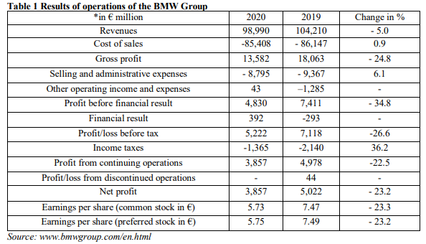
Not only profits were impacted by Covid-19 but investments as well as BMW decided to reduce the amount that was assigned to this purpose. The company decided to stop or at least delay a few projects worth 4billion euros and developed a efficiency plan on saving money for the period.
- Social
During the coronavirus outbreak, BMW Group has focused mainly on the employees and customers’ satisfaction and happiness. The company ensured to adapt to the social change and introduced few features to help customers and partners feel the consequences as little as possible. BMW Group introduced a range of online services for easy accessibility and have made sure that in cases where customers and associated needed to come to the branch in person, they will provide a clean, sanitized, and safe environment to be in.
- Technological
As mentioned above, the automobile company has introduced a range of online services for their customers to use for an easy experience throughout the challenging times. These services include booking to view and test cars and motorcycles at home, virtual product genius and booking appointments.
- Environmental
Even with the new threatening virus spreading rapidly at a global scale, BMW Group did not take any action in reducing their CO2 emissions any further than they already had regarding their new vehicles, as the company said they already meet the EU CO2 targets. It is worth to mention that they have introduced and sold a large number of electric cars in the first few moths of 2020 which are emission free.
- Legal
As a consequence of the coronavirus pandemic, BMW was legally pressured to close down branches in some places in Europe as they were not ‘essential’. It created a loss of profits for the company as well as delay in business projects.
Moreover, in terms of legislation for the Covid-19 period, BMW had to make sure that their employees are periodically tested for coronavirus and any person in the company to come back positive had to work from home as they were banned from going outdoors.

Measures taken by the company to survive through the outbreak
- Employees and customer’s safety
BMW Group’s first aspect to consider when the new virus took over the first countries in late 2019 was to protect its customers as well as providing a safe workplace for their employees. Having a clean and sanitized environment to work one was on top of the list to ensure that the virus is stopped from spreading through the company as well as outside of the company.
Moreover, BMW has made sure that their customers are aware of the efforts they are putting in providing a safe place, as many people feared infection in that period.
- Reduction in investing
The automobile company had temporarily reduced investing in that period in some areas such as the project of plant in Hungary which was delayed for indefinite time.
However, the company had investment in China’s projects still ongoing as China was the first country to be affected by Covid-19 but also the first one to start healing and getting back to normal. Therefore, BMW realized that it will actually be effective to carry on with their in initial projects, such as introducing the hybrid models, which are electric, at a global scale in sales.
- Focusing on the post-coronavirus period
BMW Group was prepared for the worst and had not only focused on the Covid-19 pandemic period but also on the post-pandemic period to ensure that they get back on track as soon as possible. They implemented strategies to have control over liquidation and have worked on continuous development of the electric automobiles and investment in China plant to reduce impacts as much as possible.
In addition, the company has also considered increasing investments in China by according a company executive, local authorities say.
Recommendations on how BMW could have coped better in the given situation
One of the best decisions that the automobile company, BMW has taken during Covid-19 pandemic was to continue their projects in China and developing their hybrid models and electric cars because it helped the company stay on the top positions. This does not mean that the sales dropped, but rather they focused on sales of high-priced products instead to help their profits stay as positive as possible.
However, throughout this period BMW has donated a lot of their funds towards communities and businesses, helping in easing the situation for them and for the rest of the world. While they have done a remarkable move towards society, it is not necessarily good for their profits as well. What is meant in this statement is that the money given to The Red Cross or the department of health could have been used in their own advantage.
On a different note, this is not necessarily a recommendation as BMW Group has shown support and attracted customers through their kind actions, and this statement is just a point of view on how things could have been done instead with a possible similar outcome or even a better one.
Has BMW fully recovered or are they still feeling the impact of coronavirus?
BMW Group quickly recovered after Covid-19 and remained the leader company in the automobile market due to its competent employees and dedicated contractors and suppliers.
The statistics show that BMW has had a total of 2,324,809 cars sold, including BMW, MINI and Rolls Royce models at a global scale in 2020 which is -8,4 percent than the previous year and has made a profit of 111.24 billion dollars in 2021, which is 12 percent higher than profits made in 2020.
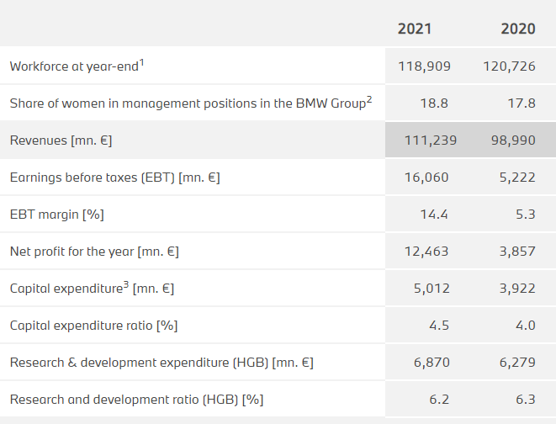
Table 2 results of operation of BMW

Conclusion
In Conclusion, BMW Group has been going through a challenging situation, which is worth to mention that was unannounced, which they handled extremely well and managed to remain on the top position in the automobile sector throughout the whole period of pandemic as well as the period after.
Although the company would not have known to prepare for this kind of situation of crisis that affected every aspect of population’s life and the company, BMW Group has successfully shown that they are strong and competent to introduce new strategies and maintain their targets even in the most challenging situations, proof stands their statistics and profits made from late 2019 to today.

References

Journal of the Chinese Medical Association: March 2020 - Volume 83 - Issue 3 - p 217-220
Ionel - Gabriel Dobrin Drăgan, 2021, European University Lugoj, Lugoj, Romania
https://europe.autonews.com/automakers/bmw-cuts-outlook-coronavirus-impact - May 06, 2020
https://autovista24.autovistagroup.com/news/covid-19-impact-bmws-earnings-and-emissions/ -15 April 2020
https://www.accenture.com/_acnmedia/PDF-121/Accenture-Covid-19-Impact-Automotive-Industry.pdf - April 2020
https://www.mybusiness.com.au/marketing/6921-bmw-adapts-business-operations-during-covid-19-pandemic - 8 May 2020
https://www.just-auto.com/news/bmw-to-step-up-investment-in-china-despite-recent-market-decline/ - 23 March 2020
https://www.press.bmwgroup.com/global/article/detail/T0323950EN/bmw-group-concludes-year-marked-by-corona-pandemic-with-strong-fourth-quarter-and-leads-premium-segment-worldwide-for-17th-consecutive-year?language=en -12 January 2021
https://www.bmw.co.za/en/topics/fascination-bmw/corporate-social-investment/covid-19-response.html
https://www.bmwgroup.com/en/investor-relations/facts-and-figures.html
https://www.emerald.com/insight/content/doi/10.1108/S1535-120320220000014015/full/html - 26 January 2022
https://www.automotivemanufacturingsolutions.com/zipse-blog-sets-out-bmws-response-to-the-coronavirus-crisis/40434.article - 3 April 2020
https://www.business-standard.com/article/current-affairs/bmw-announces-rs-8-crore-aid-for-coronavirus-relief-efforts-in-india-121052500759_1.html - 25 May 2021
https://www.cnbc.com/2022/03/10/bmw-says-2021-profit-surged-as-it-favored-higher-margin-vehicles-during-chip-shortage.html - 10 March 2022

