The relevance of ethics within marketing decisions for contemporary business

Introduction

This paper will explore the ethical considerations surrounding advertising within contemporary business. It will review marketing frameworks, concepts, and techniques and how marketing can create value, which can be applied to social problems. Key stakeholders will be identified with analysis of how modern business marketing practices and decisions impact upon them. Academic theory and industry examples will be used to support the critical analysis of marketing processes, concepts, and techniques and how they are used and applied, paying consideration to key ethical considerations.

Marketing

“Marketing is the activity, set of instructions, and processes for creating, communicating, delivering, and exchanging offerings that have value for customers, clients, partners, and society at large (American Marketing Association, 2021). Historically, defined as the action of promoting and selling products or services, including market research and advertising, marketing was not defined as a practice until the 1950’s. McCarthy (1960) defined four principle rules of marketing: product, price, place, and promotion. These basics are still as important today within the marketing mix; however, they have extended to seven P’s and latterly 10 P’s; product, price, place, promotion, people process, physical evidence, packaging, partnership, and policy perspective (Lim, 2021).

Marketing ethics

Business marketing ethics are a set of moral guidelines which influence how a company markets their goods and services, paying attention to how they treat their customers, employees, sustainability, and the environment. The World Fair Trade Organization lists ten ethical principles which businesses should consider within their marketing (Figure 1).

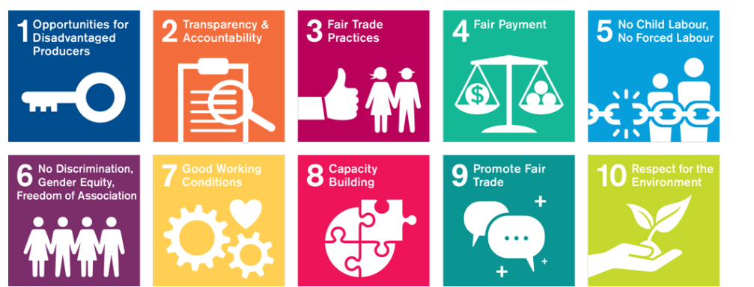
Figure 1 – 10 Fair Trade Principles. (World Fair Trade Organization, 2021)

Laczniak and Murphy (2019) define marketing ethics as: “The systematic study of how moral standards are applied to marketing decisions, behaviors and institutions”.
Gov.uk (2021) defines two advertising codes of conduct, covering both non-broadcasting and broadcasting advertising. ASA & CAP (2021a) and ASA & CAP (2021c) protect consumers against most ethical issues surrounding the law, social responsibility, and fair competition. Their regulatory codes cover such items as advertising to children, political, privacy, accuracy and honesty, harm and offence, and product placement and scheduling.

Consumer pressure and changes within marketing

The mediums of marketing have evolved historically from print-based, radio, and television broadcasting to digitally based formats within contemporary society. Consumer behaviour has also changed over time, which has affected marketing decisions, below are some examples.

Tobacco

The key ethical considerations surrounding tobacco advertising has often revolved around the harm caused to health and the risks brought about by marketing decisions surrounding product placement, notably the risk of being viewed by children. The use of televised advertising of tobacco products was banned in the UK in 1965 (Adekola, 2020). It took many years however for public health officials and consumer pressure to extend the ban of tobacco within sporting arenas, this came into effect in 2005 (Barker., et al (2019). The complete ban of tobacco advertising came a few years later in 2010 which prohibited the display of products within shops and vending machines. (Laverty., et al (2019). Campaigners are pushing for a comprehensive ban of tobacco advertising, claiming it encourages smokers to increase their intake rather than seeking to reduce it, thus demotivating them to quit; additionally reducing the influence upon young people who risk becoming long-term smokers (Zheng, Xiao, Wang, and Yang, 2018). The ethical decisions should also extend to e-cigarettes, as these still cause harm and have the potential to encourage young people to use (Dyer, 2019).

Unhealthy snacks

Consumer pushback over the years has seen many shops remove impulse buy items, deemed unhealthy, from their tills, as well as easily accessible items removed from the reach of children (Ford., et al (2020). Although food labelling now displays the levels of sugars, salts, and fats, research completed by Whalen., et al (2018) found a shift in advertising to children being used to promote unhealthy foods. There are a few ethical decisions marketers should consider, which include: product placement, children, harm, and recently political factors due to the change of U.K ruling surrounding the advertising of unhealthy foods. The ruling was passed due to the harm caused to health, the ruling was passed during the summer and will come into force from the end of 2022 (Thomas, Sheehan, and Rayner, 2021).

Stereotypes


Figure 2 – Stereotype. (Lily News, 2019)
(Figure 2) displays a vintage advert portraying gender stereotyping, these types of adverts would have been common within their time. There have been numerous campaigns and petitions regarding advertising which portray stereotyping, this extends to unrealistic body imagery. The U.K passed a new ruling which prohibits advertising deemed more stereotypically specific, as well as derogatory portrayals of body image (ASA and CAP, 2021b). The key ethics which marketers should consider when deciding upon advertising campaigns, should include consideration if it will cause harm or widespread offence. Children should also be considered, as harmful stereotyping could restrict the choices, aspirations and opportunities of children and young people.

The use of Influencers within marketing

An influencer within marketing is a key individual, with the potential to target a direct audience to engage and entice consumers to purchase products (Ranpariva, Chu, Fathy and Lipoff, 2020). The use of influencers within marketing has grown in recent years, Ye, Hudders, De Jans and De Veirman (2021) conclude this to be an effective type of marketing due to its reach and that consumers do not regard as advertising. Yesiloglu and Costello (2020), support these findings and describe how the influencer phenomenon is key to modern day marketing. Johansen and Guldvik (2017) comment on how influencers are perceived to be credible. With consumers three times more likely to follow specific influencers concerning brands (Taylor, 2020), Osatuyi and Love (2021) state how there are several ethical considerations that businesses should consider when using this form of marketing, one of these being manipulation.
One of these manipulation areas are found within advertising imagery, more commonly within digital marketing (An, Lee, Kim, and Youn, 2020). Photo enhancing and the use of filters is common to give the perception of flawless skin, fuller hair, stereotypical body image types and even longer eyelashes. Antoniou (2021) highlighted recent cases of deceit within the company “Skinny Tans” advertising, which gave the appearance of enhanced skin tone and smoother complexions. Lazard, Bock and Mackert (2020) experimental research concluded that digitally altered photos positively influenced consumer choices and attitudes towards products and brands.

These ethical decisions within modern day marketing extend to advances within technology and the use of computer-generated images (CGI). These images create unrealistic expectations about what beauty, style, culture, and social responsibility look like. An example is that of “Lil Miquela” (Figure 3) a Brazilian American fashion influencer with 3 million Instagram followers and “Shudu Gram” (Figure 4) the first black digital supermodel, these are both in fact CGI characters.

Figure 3 – Lil Miquela. (Murphy-Bates, 2018)


Figure 4 – Shudu. (Semic, 2019)
Brands such as Prada, Chanel, Diesel and Moncler have used these avatars as influencers to advertise their products. Walter (2020) states the use of CGI creates negative purchase behaviours and branding within consumerism. While other critics such as Jackson (2018) and Rockwood (2021) expand further, claiming Shudu depicts an image of a black woman which negatively impacts the black lives matter movement, and could heighten the pressure faced on black models seeking recognition within the fashion industry.
Most key regulatory codes surrounding ethics should be considered within advertising involving the use of imagery, and influencers. Children, especially those with media devices, are exposed to these types of material content, which could then be perceived as normal. Enhanced imagery is depicting an inaccurate and dishonest portrayal of the products being advertised, which could lead to harm and widespread offence. The use of product placement should also be considered as influencers are seen as trustworthy and credible to many consumers.

The use of body diversity within advertising

Shakespeare (2020) states Boohoo’s understanding of its target market has boosted sales, their marketing is structured around affordable clothing for teenagers to early twenties. Analysis of their data shows that 11 percent of this age bracket had purchased from them within the last three months, spending on average £30. They attribute this to Boohoo’s high social media presence, with over half 53% of social media followers buying products after seeing them advertised.
Boohoo, displays incredibly good ethics surrounding their advertising, by using real life models which portray real life and untouched bodies of all shapes and sizes including those with scars, cellulite and stretch marks (Figure 5)


Figure 5 – Models with “bellies” and stretch marks. (Law, 2020)

In contrast to Boohoo’s ethical marketing stance regards to body image, is Victoria Secrets. An American based company, who specialise in lingerie and lounge wear. Unlike Boohoo, they use supermodels who they term “angels,” who feature in their advertising campaigns, in addition they do not cater for plus sized women within their products. MBA Skool Team (2019) state how Victoria Secrets hold their own fashion shows, which include star performers and celebrities’ who are utilised as influencers, they also have YouTube videos targeted at teenage girls aspiring to become the next supermodel.
Victoria Secrets decision to run an advert, featuring thin supermodels with the slogan “The Perfect Body,” faced criticism (figure 6 & 7). The pushback from consumer groups who claimed their advertising was not ethical as it did not give a true reflection of women's bodies. Consumer groups claimed the advertising depicted unethical selling of an impossible beauty image, and lacked body diversity and its representation aligns with hegemonic beauty beliefs.
Campaigners took to petitions to change the advertising, and with over 32,000 signatures, Victoria Secret did so (Change.org, 2021). However, it was only the slogan they changed, and they stuck by the imagery of the super models. Feng (2019) review of Victora Secrets 2019 annual report, concludes that their marketing campaigns are no longer customer focused, and how they should use more body diverse models within their advertising and demonstrate more realistic products.

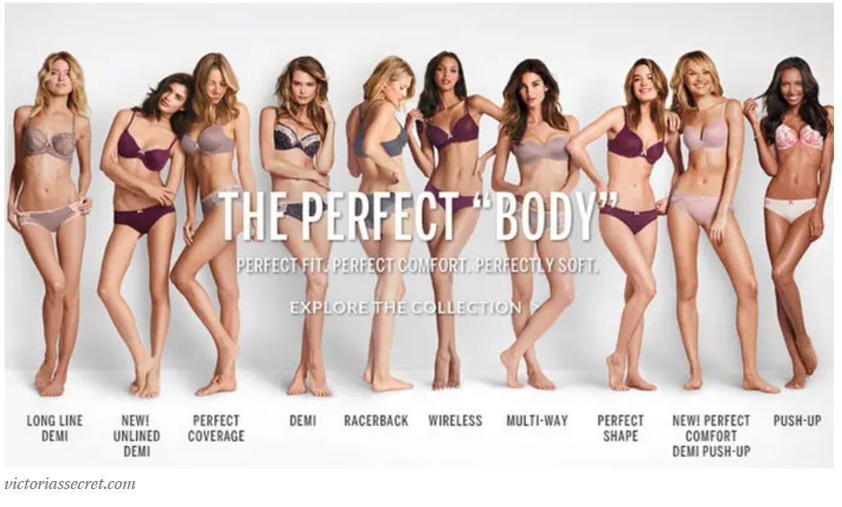
Figure 6 - “The Perfect Body” campaign. (Passmore, 2020a).

The original advertisement seen above displays the slim models with the words “The Perfect Body” and the amended advertisement below, which reads “A Body For Every Body”
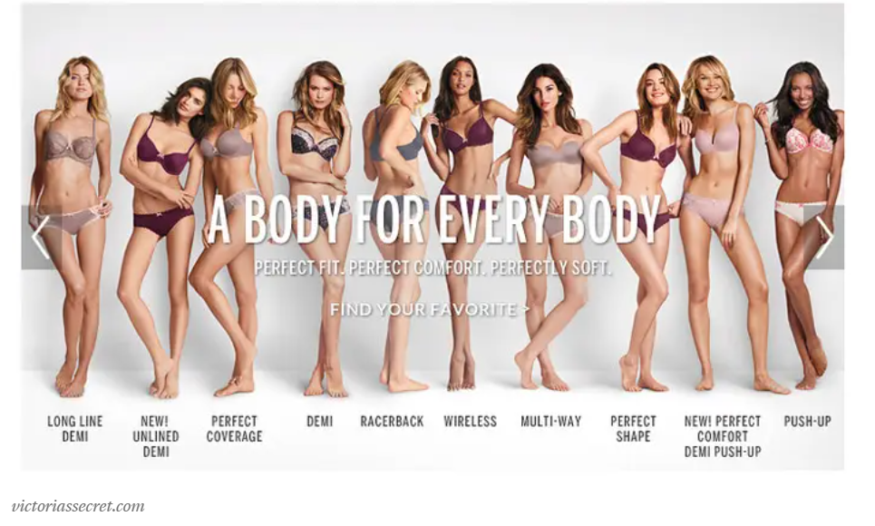
Figure – 7 - “The Perfect Body” campaign. (Passmore, 2020b).

These unethical decisions within Victoria Secrets advertising, caused widespread offence and harm, especially within diverse groups, in addition, their advertising is not an accurate and honest.

Despite Victoria Secrets changing the slogan, consumer groups continued with their pressure to change the ethical marketing commonly portrayed within the fashion industry. They claimed the change of slogan was not enough, and sought an apology and pledge from the business confirming that they will not use harmful marketing in the future (Change.org, 2021). Competitor brands Curvy Kate Lingerie and Dear Kate, recreated the advertising, representing women of body diversity to promote body positivity (Brown, 2014a). (Figure 8)

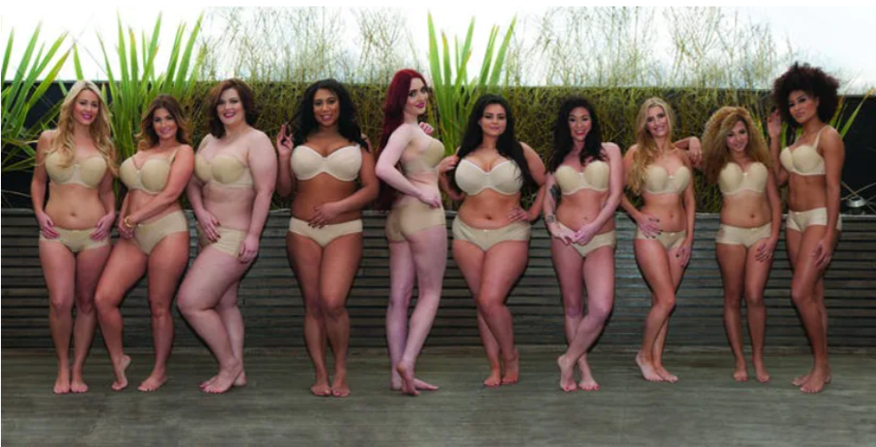
Figure 8 - Victoria’s Secret Changes Controversial “Perfect Body” Slogan. (Brown, 2014b).

The ethics of Christmas marketing

Before the surge of the big supermarkets and retail stores of today, customers used to take a shopping list into their local much smaller shops. Store assistants would pick and bag the items for them, usually with a limited brand of choice. Sensory marketing in the form of visual and sound stimulation was already in place through the concept of window displays and music, with shops making store windows a grand display to draw attraction (Figure 9). With many stores creating theatrical displays, especially during holiday celebrations, Eldridge and Pappalepore (2019) state that shop window displays form part of shopping history and culture is seen as an entertainment value which increases tourism. As far back as the Victorian era, the draw which window displays offer during the festive period established Christmas marketing and shopping as important, (Hosgood, 2019).

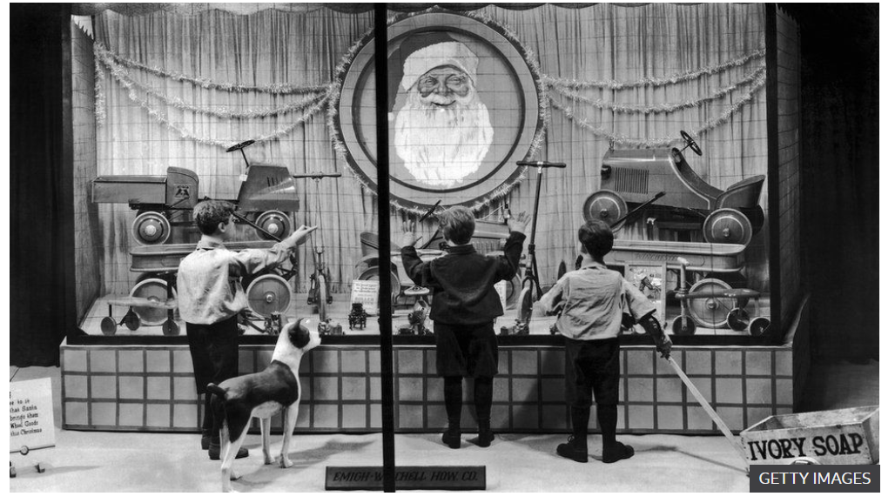
Figure 9 - 1930’s Christmas window display. (BBC, 2021).
There is an ethical question regarding the use of stimulating shop marketing, Miao, Jalees, Qabool and Zama (2019) completed a study and found contributing phycological factors which enabled neuroticism, leading to impulsive buying, however, conclude that from a marketing perspective targeting these types of consumers increase sales.

The iconic Christmas Television advert for John Lewis (Figure 10), which took a socially ethical steer to raise awareness for Age Concern U.K was analyzed by Hooton (2015) who felt the £1million advert's intention was to raise brand awareness through digital sharing and manipulation, drawing on people's emotions. This increased the business revenue by 5.1 percent to £1billion, yet a share of profit from only three distinct product purchases went to Age Concern U.K (Shapland, 2016).


Figure 10 – “Man on the moon” advert. (Ideal Home, 2015)


Figure 11 - Help Brighten a Million Christmases. (Sainsbury’s, 2020)
Another example of a business using the draw of positive ethics and giving back within their marketing campaign, is that of Sainsbury’s (Figure 11). The ethical decision Sainsbury’s made within their advertising style, was to give back to society and those in need. The marketing was clear and transparent, with the promise of matching customer donations up to the value of £4 million with the hopes to raise £8 million. Furthermore, supporting local charities and good causes, including helping families financially struggling to purchase Christmas presents. On their website, they list all charities they give to, and follow up on various social media platforms with the results, detailing their partnership with “FareShare” and a breakdown of funds, along with other aspects of their campaign (Sainsbury, 2020)
The ethical decisions contemporary businesses should consider within their Christmas advertising, should be the heightened materialism, and compulsive buying by consumers, who risk getting into debt. Statistics published by Kentic (2021) state how Brits spend 40 percent more than other Europeans during Christmas, and that 46 percent of millennials or parents with children under 18 are willing to get into debt. The ethical questions here are, is it right that retailers are spending hundreds of thousands on advertising campaigns when 9.2 percent of the world lives in poverty, and further population driven into financial poverty due to consumer materialism (World Vision, 2021).

Conclusion

The controls surrounding marketing have evolved over the years, from the introduction of definitions and regulatory bodies. Consumers are also more aware of ethical matters, which is why advertising products and services need correct moral and ethical decisions applied. The role of marketing is under fire for its focus on profits and its brands positioning and visibility, over ethical interests in people, society, and the environment.
The advancement within technology could extend further, so too will regulatory controls, this could lead to financial fines and loss of reputation to business. Therefore, it is important for modern day businesses to stay up to day with regulatory guidance, political and social aspects. A modern-day business should also be transparent, this will instill honesty and credibility into their brand which will drive loyalty and sustainability.

