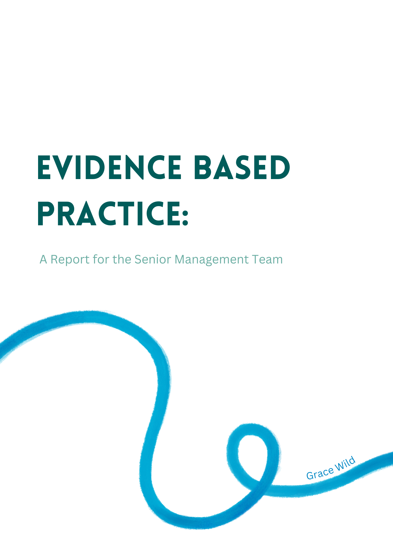

AC1.1
There are many definitions of evidence-based practice (EBP), one of the best known being proposed by Sackett et al (1996), as ‘‘The conscientious, explicit, and judicious use of current best evidence in making decisions”. Sackett was referring to medicine, but the definition applies itself well to Human Resource (HR) activities. In the context of HR, this definition has been adapted to guide decision-making and practices that aim to improve workforce management, employee relations, and organisational effectiveness.

Decisions in HR can be minor or major, with some having far-reaching consequences (Waite et al., 2021, p. 46). EBP is a systematic approach which aims to ensure that decisions are based on reliable evidence rather than purely on tradition, intuition, or individual experiences (Oxford Review, 2023).
Evidence consists of information, facts or data which supports or contradicts a claim, assumption, or hypothesis (Barends and Rousseau, 2018).

According to the CIPD (2023a), there are four types of evidence that can be used in decision-making:
- Professional Expertise – The professional experience and judgement of practitioners
- Scientific Literature – Findings from empirical studies published in academic journals.
- Organisational Data – Data, data gathered from the organisation.
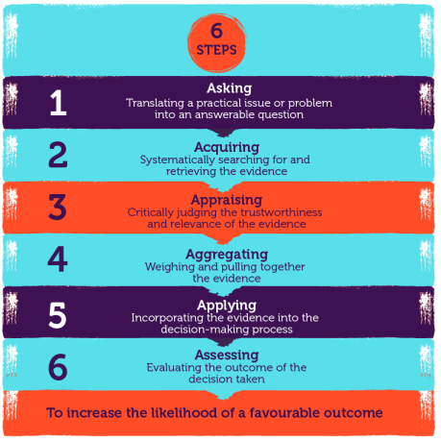
- Stakeholder Views – The values and concerns of the people who may be affected by the decision.

EBP encourages the integration of these four sources of evidence to make well-informed decisions and assist in implementing effective people practices.

To enhance the likelihood of favourable outcomes, organisations can adopt the Evidence-Based Management Skills Framework.

This framework guides decision-makers through a structured process involving six key steps (Fig.1).
Figure 1. 6 Steps of Evidence Based Practice, CIPD
EBP reduces biases in decision-making through its emphasis on using standardised assessments and data-driven approaches. When HR professionals adopt these, the reliance on personal judgments can be reduced. The objective nature of these tools allows for a more equitable assessment of individuals, regardless of factors such as gender, race, or personal preferences (CIPD, 2023a).

EBP promotes transparency and accountability in decision-making processes. It requires clear documentation of the evidence and rationale behind each decision. This documentation serves as a safeguard against biases and provides a mechanism for scrutiny and validation (Waters, 2019).

A typical criticism of people practices, or HR, is that it does not significantly align with what the organisation is trying to achieve (Broomfield, 2023). EBP tackles this directly, says Briner (2023), by offering a structured approach to establish and strengthen this crucial connection while addressing bias within the organisation.

One example of success in leveraging the application of EBP is when a British Telecoms organisation sought evidence from their stakeholders as to why so many employees did not complete a company-wide survey. The survey intended to assess their employee’s satisfaction with their supervisors, to which they received a response rate of less than 5%. By holding a focus group discussion with employees from different areas of the organisation, they found out that due to the organisation requesting potentially identifiable information such as date of birth and postcode, many staff felt that they may be able to be personally identified, and therefore they declined to participate. As a result of the focus group and evidence gathered, the survey was subsequently modified to remove the postcode and adjusting the date of birth with ‘age range.’ This resulted in a much higher response rate of 67% (Barends and Rousseau, 2018).

AC.1.2
There are various analysis methods used in people practice, such as workforce analytics for tracking and improving employee performance and engagement and SWOT analysis to assess organisational strengths, weaknesses, opportunities, and threats. I will be evaluating how two methods can be applied to diagnose organisational issues, challenges, and opportunities, and I will look at PESTLE analysis and HR Benchmarking.

A PESTLE analysis looks at the key external factors that influence an organisation (CIPD, 2023b). These factors are Political, Economic, Sociological, Technological, Legal and Environmental.

The PESTLE analysis features on the CIPD Profession Map, and forms part of the core knowledge expected to be used in EBP for professionals (CIPD, 2023c). PESTLE can be used to reduce threats to the organisation and maximise opportunities. By having a clear understanding of the potential threats, organisations can align decision-making processes to achieve more favourable outcomes.

There are notable advantages to a PESTLE analysis. According to the CIPD (2023b), it is a straightforward framework that aids in understanding the wider business environment and fosters the development of strategic thinking. PESTLE can help organisations to anticipate future threats and avoid or minimise their impact. The tool can reveal the direction of change within an organisation, so adaptations can be made in the direction of change rather than against it (Mindtools, 2023).

However, some organisations can oversimplify the amount of data used for decisions and lack depth of analysis as a result. The PESTLE model is limited by external uncertainties, says Buye, 2021. To be effective, the process needs to be repeated on a regular basis.

Benchmarking for Comparisons:

Benchmarking is a method of comparison, where organisational performance metrics, both qualitative and quantitative, are held against industry standards to pinpoint improvement areas (Inspired Economist, 2023). Benchmarking aligns with the objective decision-making of EBP, ensuring decisions are influenced by concrete organisational data and not solely by professional intuition or past practices (HiBob, 2023a).

Internal Benchmarking
Comparing how different departments have adapted to the pandemic allows organisations to identify best practices and areas for improvement.

External Benchmarking
Assessing the pandemic response against other companies highlights areas where organisations lack or succeed in areas such as employee safety, remote working, and support systems. This offers a chance to adopt best practices from other high-performing organisations.

Amongst the various advantages to benchmarking, is its ability to identify business trends, promoting innovation and continuous improvement. Thinking about staff experience, benchmarking can improve existing practices which will have a positive impact on employer brand, potentially increasing reputation and recruitment (Van Vulpen, 2023).

However, benchmarking also has its disadvantages. It can be difficult to compare organisations that have fundamental differences, and as there are so many components that make up a business, raw data does not always give an accurate holistic view of the organisation (HiBob, 2023).

Benchmarking is also limited by the reliability of data. For example, organisations cannot be certain that data is trusted, or that collection methods are always robust and reliable (CIPS, 2023).

In conclusion, both PESTLE analysis and benchmarking are valuable tools for diagnosing organisational issues, challenges, and opportunities. They provide a comprehensive view of the internal and external environment, helping organisations to make informed decisions and develop effective strategies. However, they are not without their limitations and should be used in conjunction with other tools and methods to ensure a holistic understanding of the organisational context. Regular review and updating of the analysis tools and outcomes are also needed to maintain effectiveness.

AC.1.3
In HR, EBP is enhanced by critical thinking. ‘Critical’ in this context does not mean negative; it is an evidence-driven analysis to inform beliefs and actions (Armstrong, 2014). Critical thinkers, as Brooks and Kenny highlight, test claims and assumptions to understand broader contexts and implications (Brooks and Kenny, n.d.). For example, an uncritical thinker would accept what they are told on face value, whereas a critical thinker would evaluate the evidence by asking questions.

Howlett (2019), identifies critical thinking's key areas as: critiquing others' ideas and arguments; constructing one’s own arguments and recognizing critical thinking in decision-making. This perspective resonates with Armstrong's emphasis on recognising problems, gathering relevant information, and discerning hidden values (Armstrong, p. 572).

Coburn (CIPD, 2019) stresses the importance of critical thinking in today’s complex world, where challenges often extend beyond intuitive solutions.

Organisations must ensure clarity in decision-making, echoing Armstrong's assertion on the need for precise understanding and articulation of issues (Armstrong, p. 571). Accuracy of information is vital; organisations must verify data and sources' credibility; this scrutiny helps prevent misinformation and ensures decisions are made on fact.

In applying critical thinking to our own and others’ ideas within organisations, businesses must adhere to the following principles:

Analysing and Evaluating Ideas
Following the guidance of Brooks and Kenny, they must critically analyse and evaluate HR policies and practices, ensuring they are evidence-based and unbiased​.

Reflecting on Data and Drawing Conclusions
They should use critical thinking to interpret HR data and research, leading to well-founded decisions and strategies.

Identifying Assumptions
Recognising and challenging underlying assumptions in our practices is required for objective decision-making.

Testing Assumptions
They should test the validity of assumptions made to explore the bigger picture and make informed decisions​.

In conclusion, critical thinking is an essential skill in HR, enabling individuals and organisations to make informed decisions based on evidence and thorough analysis. Through applying these principles to organisations ideas, they can challenge the status quo and make significant improvements.

AC.1.4
In HR, decision-making processes are essential in shaping organisational outcomes (Sinnaiah, Adam and Mahadi, 2023). De Bono's Six Thinking Hats, Lateral Thinking, and Stakeholder Analysis are three methodologies that, when applied to HR practices, can enhance decision quality and effectiveness.

De Bono's Six Thinking Hats process is an approach to decision-making that examines situations from multiple perspectives, symbolised by different coloured hats (Libretexts, 2020). This methodology allows for comprehensive analysis by separating thought processes. Each 'hat' represents a distinctive style of thinking: white for facts, red for emotions and feelings, black for critical thinking, yellow for optimism, green for creativity, and blue for process control. This method is designed to direct focus, allowing for a more rounded view of a situation and allows teams to move forwards with only the most viable ideas. By considering each perspective, teams can avoid common decision-making biases like confirmation bias or tunnel vision and can make the switch from negative to positive thinking (Debono, 1985).

In HR, and example of this is when practitioners are developing a staff well-being programme. They could us the:

- White Hat to gather data on current employee health trends, feedback on existing wellness initiatives, and budget considerations.
- Red Hat to understand employee feelings and attitudes towards wellness.
- Black Hat to assess potential challenges and risks in implementing the programme.
- Yellow Hat to focus on the potential positive impacts on employee health and productivity.
- Green Hat for brainstorming wellness activities and incentives.
- Blue Hat to structure the discussion, ensure all perspectives are considered, and develop a comprehensive plan.

Lateral thinking is a concept also developed by Edward de Bono which emphasises creative problem-solving (de Bono, 1992). In addition to critical thinking, lateral thinking also plays a crucial role in EBP. Lateral thinking refers to the ability to think ‘outside the box’ to solve problems. It involves looking at situations from a variety of angles and finding solutions that may not be immediately apparent. This can be useful in HR, where unique challenges often need innovative solutions.

In HR, this approach can be used in processes like talent management. By adopting lateral thinking practitioners can create innovative recruitment strategies to discover candidates with unique skill sets or unconventional career paths. For example, muti-stage development centres where candidates are assessed on a wide range of components that take into consideration aspects like emotional intelligence. These employees may typically go unnoticed with the usual recruitment screening tools. Lateral thinking will allow for the creation of a more diverse workforce, allowing organisations to innovate and grow.

Stakeholder Analysis is a systematic way to evaluate the interests and potential influence of individuals that can impact upon decision making. It helps to understand their needs and concerns, planning how best to involve them in decision-making processes.

For example, practitioners might use a stakeholder analysis when introducing a new digital patient care system. They would assess how the technology affects not just clinical staff but also patients, administrative staff, and external suppliers. They would map out each group’s influence and interest, from doctors who may have high influence and interest, to suppliers who may have lower interest but are vital influence. This analysis would inform on how to manage change effectively, engage with each group appropriately, and address concerns, enabling more effective decision making throughout the project life cycle.

AC.1.5
Ethical decision-making within HR can involve various ethical perspectives that are vital for ensuring that the organisation is not only effective but also aligns with the ethical standards, as outlined by the CIPD's Code of Conduct (CIPD, 2023d).

According to Forbes (2023), HR departments are no longer just responsible for administrative tasks; they now play a pivotal role in shaping company culture, fostering employee engagement and ensuring fairness.

They continue to argue that ethical perspectives are crucial to organisation success by; optimising value, improving reputation, ensuring legal compliance, improving culture, creating safety, trust and more. Ethical lenses such as fairness, rights, character, and democracy guide HR leaders to make choices that uphold its moral obligations (Clark, 2015).

For example, in recruitment, the fairness lens ensures that all candidates are given equal opportunity, showing our commitment to diversity and inclusion.

In learning and development, the lens of equity ensures that all employees have access to development opportunities, fostering a culture of continuous improvement.

Performance management decisions are made with transparency and integrity, under to the lens of justice and fairness.

The Utilitarianism perspective, articulated by John Stuart Mill, seeks the greatest happiness for the greatest number (Mill, n.d.). In HR, utilitarianism would support maximising employee’s overall welfare, such as inclusive recruitment practices. However, it does have limitations. Being the most reason-based approach to choosing right from wrong, it overlooks values like justice and individual rights (Ethics Unwrapped, 2023).

The Deontological perspective, as established by Immanuel Kant, uses rules to distinguish right from wrong (Kant, n.d.). Kant believed that to be ethical, we must follow ‘universal moral laws’ such as not lying, not cheating, and not stealing. In the context of HR, deontology emphasises following ethical rules, such as fairness in recruitment and respect for employee rights. However, it can be rigid, potentially leading to decisions that may not give the overall best outcomes and can overlook the complexities of real-world situations (Ethics Unwrapped, 2023).

Kantian ethics emphasises respecting everyone’s dignity and autonomy (Darwall, 2013). In HR, this means policies are designed to treat each person not just as a way to achieve an organisational goal, but as individuals with their own rights. This approach supports diversity and individual rights in the workplace. However, Kantian ethics also has its limitations. For instance, the principle of honesty might clash with the need to prevent harm, creating dilemmas in decision-making.

Ethics and integrity are at the heart of people management within the organisation. They underpin every decision and action taken and are vital to overall success.

AC. 3.1
Measuring organisational performance through financial and non-financial measures is critical for organisations to grow and succeed.

Return on Investment (ROI)
ROI is a financial performance metric used to evaluate the profitability of an investment in relation to its cost (SHRM, 2021). In HR, ROI can be used to assess the financial returns of training programs by comparing the program's cost against the cost savings due to reduced employee turnover. In the private sector, performance is usually linked to financial measurements and profitability.

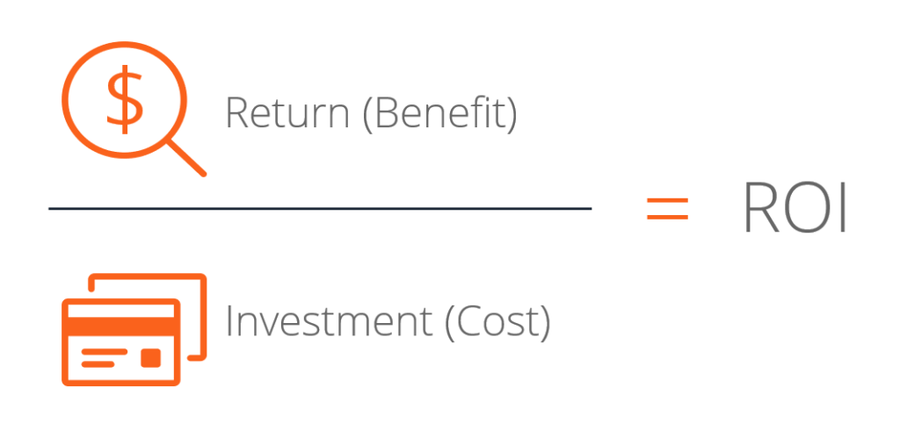
ROI is the ratio of the net profit of an investment to the cost of the investment, expressed as a percentage (Stobierski, 2020). See Fig 2 for an illustration of this.

Figure 2 - An explanation of ROI

An example of using ROI within an organisation could be measuring the effectiveness of a variety of new recruitment channels such as social media, recruitment portals, agencies, and job fair events. This would involve comparing the cost savings of recruitment through effective recruitment over the cost of implementing the processes.

The strength of ROI lies in its ability to provide qualitative results, which is vital for justifying HR initiatives within the organisation.
However, ROI may not capture other benefits such as improved employee morale or organisation reputation.
Balanced Scorecard
The Balanced Scorecard is a strategic planning system that is used to align business activities with the strategy of an organisation, which goes beyond financial measurements and includes those alternative benefits such as: employee perspectives, patient perspectives, and staff development (Kaplan and Norton, 2021).

The balanced score card is described as a set of measures that gives organisations a fast but comprehensive view of the business. It includes the results of financial measures and compliments them with non-financial measures and provides the opportunity to look at four perspectives: customer, internal, innovation and learning, and financial.

In the public sector where performance is linked to meeting targets, measuring performance can be more focused on general effectiveness, with focus on employee satisfaction and culture as well as retention and turnover. These metrics align with the public sector's goal of societal benefit rather than financial gain (Mulgan, 2010).
The Balanced Scorecard's strength is its holistic approach, which provides a better picture of performance, aligning with EBP's emphasis on using a range of evidence sources.
Awadallah and Allam (2015) have criticised the score card for its selection of objectives, stating that it leaves out interests of relevant stakeholders. They go on to criticise the lack of employee engagement in its definition of the objectives and measures and that it can be unfamiliar to employees.
It is clear that both ROI and the Balanced Scorecard have strengths and limitations in measuring organisational performance. A potential suggestion would be to integrate the two methods for a more comprehensive, strategic assessment. This could provide a more holistic understanding of performance.

AC. 3.2

Adding value refers to the additional benefits that HR practices bring to an organisation beyond their immediate function (Van Vulpen, 2023a). This can include enhancing employee satisfaction, improving organisational culture, and contributing to the achievement of strategic objectives (Personnel Today, 2012).

Adding value is crucial as it helps to align HR practices with the overall business strategy, ensuring that these contribute to the organisation's goals (Van Vulpen, 2023a). This can lead to improved organisational performance, increased competitiveness, and enhanced reputation (Personnel Today, 2012).

To measure the impact of people practice methods that align with both the long and short-term goals of an organisation, HR teams can use various methods:

HR Metrics & Analytics can be used, such as employee turnover rates, time to hire and employee satisfaction scores. These all give tangible data to help assess the effectiveness of practices like training, recruitment, and engagement activities.

ROI analysis is used for quantifying the financial value of people practices, for example calculating the ROI of a training programme involves assessing the cost against increase in productivity post-training. This helps to make informed decisions around future investments.

Surveys and staff feedback provide insights into how staff are perceiving HR practices, including their impact on overall satisfaction. This qualitative data is vital for understanding the impact of HR practices that influence cultures and behaviours.

Long term studies can be used to track the impact of HR practices over time, revealing trends and long-lasting effects that are not always immediately apparent.

HR practices ’definitely’ make a difference in business results, according to Yeung and Berman (1997). In conclusion, measuring the impact and value of people practices and creating value are fundamental to organisational success. They provide a comprehensive understanding of organisational performance and contribute to the achievement of strategic objectives.

References

Armstrong, M. and Taylor, S. (2014) Armstrong’s handbook of human resource management practice. 13th edition. London: Kogan Page.

Awadallah, E. and Allam, A. (2015) 'A Critique of the Balanced Scorecard as a Performance Measurement Tool,' International Journal of Business and Social Science, 6(7), p. 96. https://doi.org/10.30845/ijbss.

Barends, E. and Rousseau, D.M. (2018) Evidence-Based management: How to Use Evidence to Make Better Organizational Decisions. London. Kogan Page Publishers.

Brian (2022) What is HR benchmarking? - Human resources degrees. Available at: https://www.humanresourcesmba.net/faq/what-is-hr-benchmarking/ (Accessed: 10 October 2023).

Briner, R. (2023) Aligning HR with the business through the evidence-based HR process - HRD. Available at: https://www.hrdconnect.com/2023/10/03/aligning-hr-with-the-business-through-the-evidence-based-hr-process/ (Accessed: October 5, 2023).

Brooks, S. and Kenny, J., (No Date). Critical Analysis Toolkit. 1st ed. [pdf] University of Sheffield Management School.

Broomfield, B. (2023) HRBPs reimagined: A data-enabled model for business-driven HR - HRD. Available at: https://www.hrdconnect.com/2023/05/04/hrbps-reimagined-a-data-enabled-model-for-business-driven-hr/ (Accessed: October 5, 2023).

Buye, Ronald. (2021). Critical examination of the PESTEL Analysis Model. Available at: https://www.researchgate.net/publication/349506325_Critical_examination_of_the_PESTEL_Analysis_Model. (Accessed: 19 October 2023).

CIPD (2023a) Evidence Based Practice for Effective Decision Making. Available at: https://www.cipd.org/en/knowledge/factsheets/evidence-based-practice-factsheet/#what-is-evidencebased-practice (Accessed: October 7, 2023).

CIPD (2023b) PESTLE Analysis. Available at: https://www.cipd.org/uk/knowledge/factsheets/pestle-analysis-factsheet/ (Accessed: October 5, 2023).

CIPD Profession Map (2022c). Available at: https://www.cipd.org/uk/the-people-profession/the-profession-map/ (Accessed: October 5, 2023).

CIPD Code of Conduct and Ethics (2023d). Available at: https://www.cipd.org/uk/membership/professional-standards/code-of-conduct/ (Accessed: November 21, 2023).

CIPS (2023). ‘Benchmarking - What is Benchmarking?’ Available at: https://www.cips.org/intelligence-hub/quality-measurement/benchmarking. (Accessed: 19 October 2023).

Clark, S. (2015) Ethical decision-making: Eight perspectives on workplace dilemmas. Available at: https://www.cipd.org/globalassets/media/comms/the-people-profession/profession-map-pdfs/ethical-decision-making-2015-eight-perspectives-on-workplace-dilemmas_tcm29-9564.pdf (Accessed: November 21, 2023).

Forbes (2023) 'Why Ethical and Transparent HR Decision-Making Is Crucial to Team Success,' Forbes, 25 May. Available at: https://www.forbes.com/sites/forbeshumanresourcescouncil/2023/05/25/why-ethical-and-transparent-hr-decision-making-is-crucial-to-team-success/?sh=3a10adcb1583. (Accessed: 19 October 2023).

Darwall, S. (2013) 'Kant on respect, dignity, and the duty of respect,' in Oxford University Press eBooks, pp. 247–270. https://doi.org/10.1093/acprof:oso/9780199662609.003.0012.

De Bono, E. (1992) Serious creativity: using the power of lateral thinking to create new ideas. Available at: https://www.google.co.uk/books/edition/Serious_Creativity/vsz3BQAAQBAJ?hl=en&gbpv=1&dq=Serious+Creativity:+How+to+be+Creative+Under+Pressure+and+Turn+Ideas+Into+Action+Edward+de+Bono&printsec=frontcover. (Accessed: October 2023).

De Bono, E. (1985) Six Thinking Hats [E-Book]. 1st edn. Penguin House. Available at: http://dspace.vnbrims.org:13000/jspui/bitstream/123456789/4746/1/Six%20thinking%20hats.pdf. (Accessed: 19 October 2023).

Ethics Unwrapped (2023) Utilitarianism - ethics unwrapped. Available at: https://ethicsunwrapped.utexas.edu/glossary/utilitarianism. (Accessed: 21 November 2023).

HiBob (2023) What is benchmarking in HR? Available at: HiBob. https://www.hibob.com/hr-glossary/hr-benchmarking/ (Accessed: October 19, 2023).

Howlett, W. (2019) 'Critical thinking.' CIPD. https://soundcloud.com/cipd/podcast-154-critical-thinking?utm_source=clipboard&utm_campaign=wtshare&utm_medium=widget&utm_content=https%253A%252F%252Fsoundcloud.com%252Fcipd%252Fpodcast-154-critical-thinking.

Inspired Economist (2023) Benchmarking: an in-depth understanding of measuring performance and standards - inspired Economist. Available at: https://inspiredeconomist.com/articles/benchmarking/#:~:text=Benchmarking%20is%20a%20process%20in,efficiency%20and%20achieve%20superior%20performance (Accessed: October 19, 2023).

Kaplan, R.S. and Norton, D. (2021) The Balanced Scorecard—Measures that Drive Performance. Available at: https://hbr.org/1992/01/the-balanced-scorecard-measures-that-drive-performance-2. (Accessed: 19 October 2023).

Libretexts (2020) 12.8: Edward de Bono’s Six Hats of Thinking. https://socialsci.libretexts.org/Bookshelves/Communication/Argument_and_Debate/Arguing_Using_Critical_Thinking_%28Marteney%29/12%3A_The_Foundations_of_Critical_Thinking/12.08%3A_Edward_de_Bonos_Six_Hats_of_Thinking.

Mill, J.S. (n.d.) Utilitarianism [eBook]. London: Parker, Son, and Bourn. Available at: https://www-cambridge-org.ezproxy.uwtsd.ac.uk/core/books/utilitarianism/3A446B8AF3BD081490C8BCD32493A94E.

Mind Tools (2023) PEST Analysis. Available at: https://www.mindtools.com/aqa3q37/pest-analysis (Accessed: November 25, 2023).

Mulgan, G. (2010) Measuring Social Value. Available at: https://ssir.org/articles/entry/measuring_social_value (Accessed: November 21, 2023).

Oxcognita LLC - Oxford Review Enterprises Ltd (2023) Evidence-based practice: The definition and explanation of. Available at: https://oxford-review.com/oxford-review-encyclopaedia-terms/evidence-based-practice/ (Accessed: October 7, 2023).

Personnel Today (2012) How can HR prove it really adds value? Available at: https://www.personneltoday.com/hr/how-can-hr-prove-it-really-adds-value/ (Accessed: November 25, 2023).

Rousseau, D.M. (2020) 'The realist rationality of Evidence-Based Management,' Academy of Management Learning and Education, 19(3), pp. 415–424. Available at: https://doi.org/10.5465/amle.2020.0050.

Sackett, D.L. et al. (1996) 'Evidence based medicine: what it is and what it isn’t,' BMJ, 312(7023), pp. 71–72. https://doi.org/10.1136/bmj.312.7023.71.

SHRM (2021) 'Why ROI,' SHRM, 7 July. Available at: https://www.shrm.org/ResourcesAndTools/hr-topics/behavioral-competencies/business-acumen/Pages/Why-ROI.aspx#:~:text=Several%20features%20of%20the%20ROI,effectual%20measure%20for%20HR%20managers. (Accessed: 19 October 2023).

Sinnaiah, T., Adam, S. and Mahadi, B. (2023) 'A strategic management process: the role of decision-making style and organisational performance,' Journal of Work-applied Management, 15(1), pp. 37–50. https://doi.org/10.1108/jwam-10-2022-0074.

Stobierski, T. (2020) How to calculate ROI to justify a project | HBS Online. Available at: https://online.hbs.edu/blog/post/how-to-calculate-roi-for-a-project (Accessed: November 21, 2023).

Van Vulpen, E. (2023a) 7 HR Best Practices to Implement in 2023 – A Mini-Guide. Available at: https://www.aihr.com/blog/human-resource-best-practices/ (Accessed: November 25, 2023).

Van Vulpen, E. (2023b) HR benchmarking: All you need to know to get started. Available at: https://www.aihr.com/blog/hr-benchmarking/ (Accessed: November 25, 2023).

Waite, K. et al. (2021) People practice: A Complete Guide. CIPD - Kogan Page, p. 46.

Waters, S. (2019) 'Make Better Decisions with Evidence-Based HR,' SHRM, 16 August. https://www.shrm.org/hr-today/news/hr-magazine/1217/pages/make-better-decisions-with-evidence-based-hr.aspx.

Yeung, A. and Berman, B. (1997) 'Adding value through human resources: Reorienting human resource measurement to drive business performance,' Human Resource Management, 36(3), pp. 321–335. https://doi.org/10.1002/(sici)1099-050x(199723)36:3.

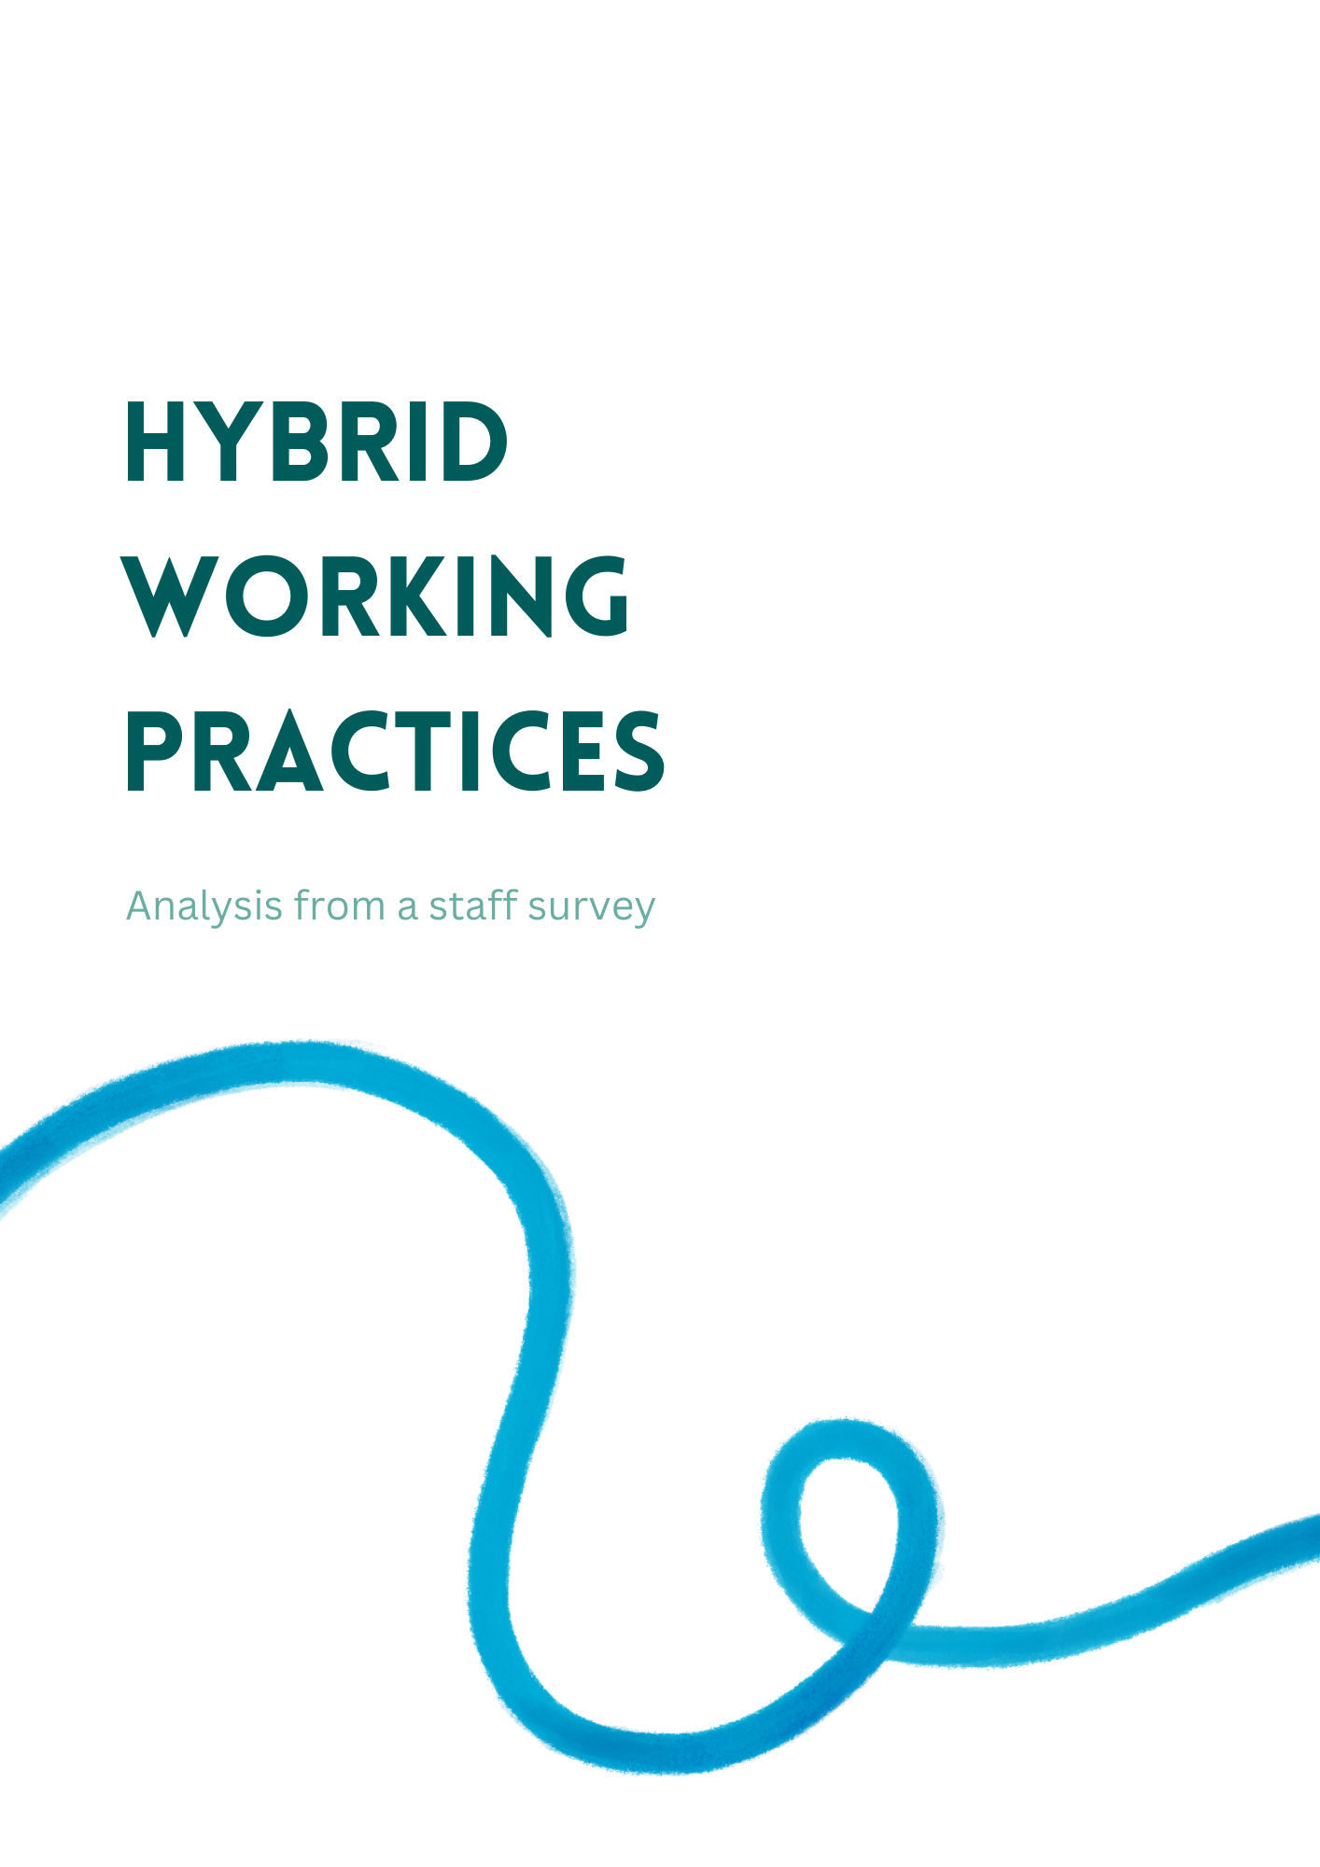

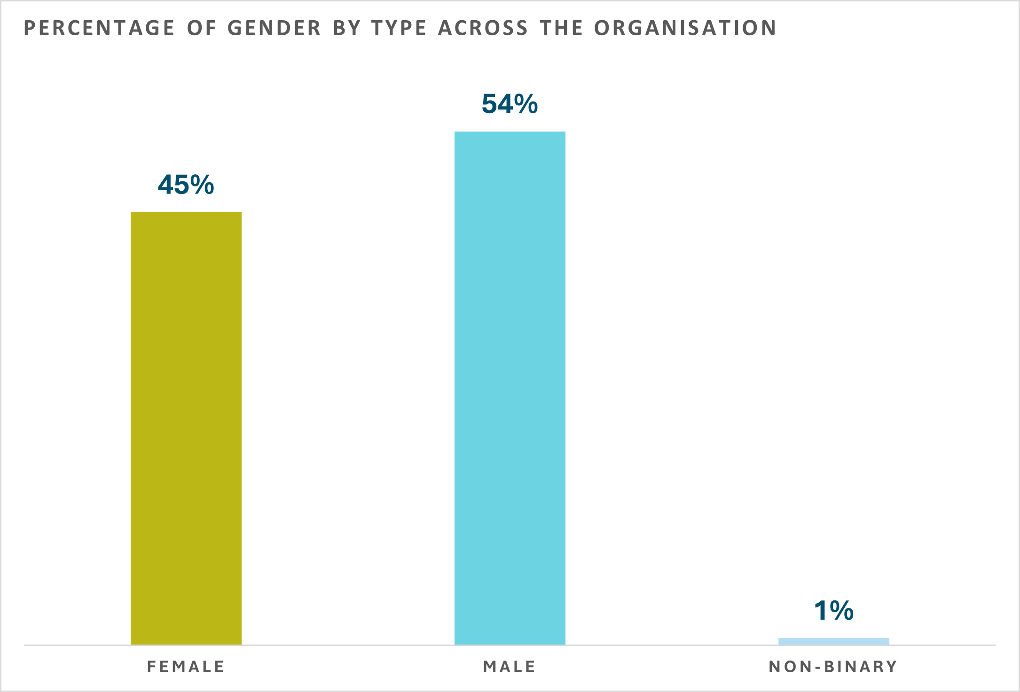

Males constitute a slight majority in the organisation, with females making up 45% and non-binary at 1%.

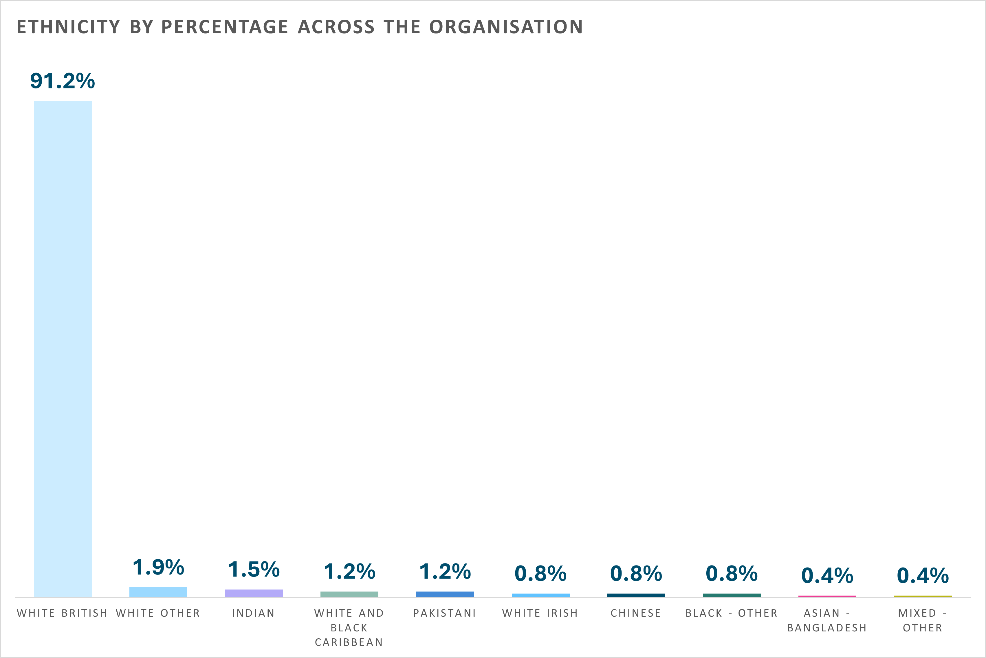
A significant majority of the organisation is White British, followed by smaller percentages of other ethnic groups.
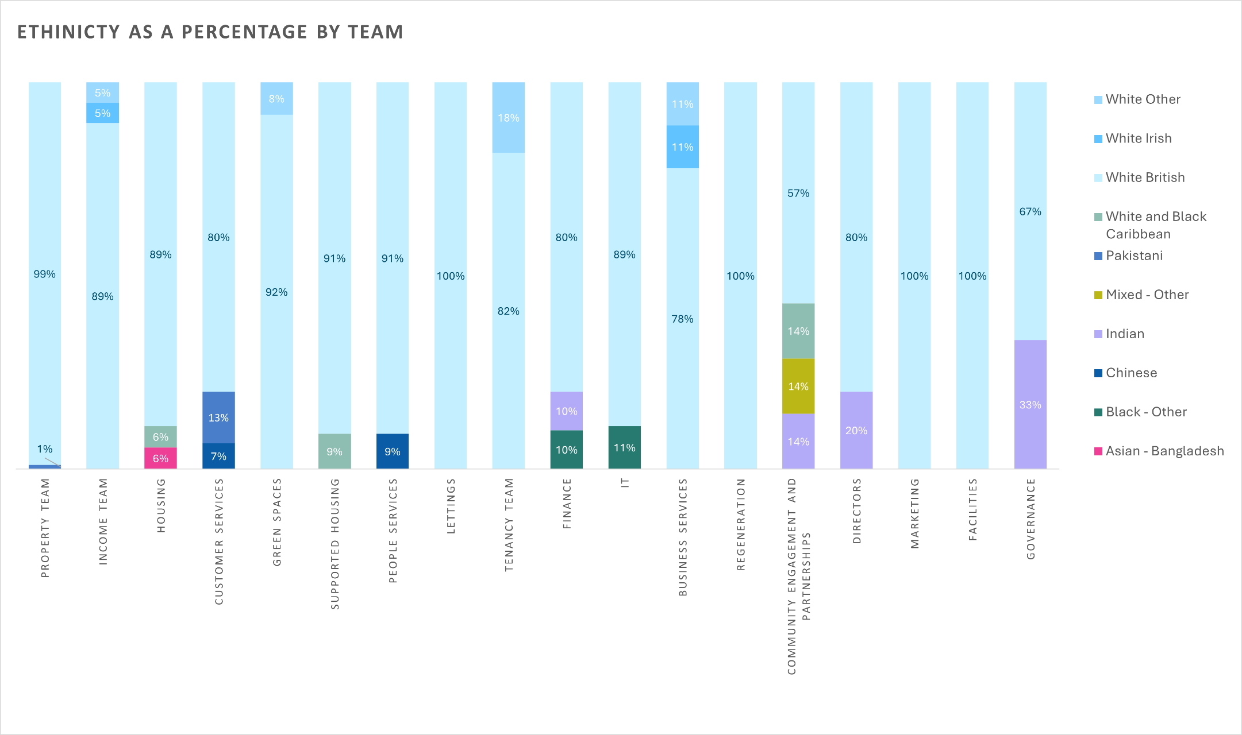
This chart shows ethnic diversity in the organization by teams. While White British is the majority, it also shows a diverse mix of other ethnic groups.
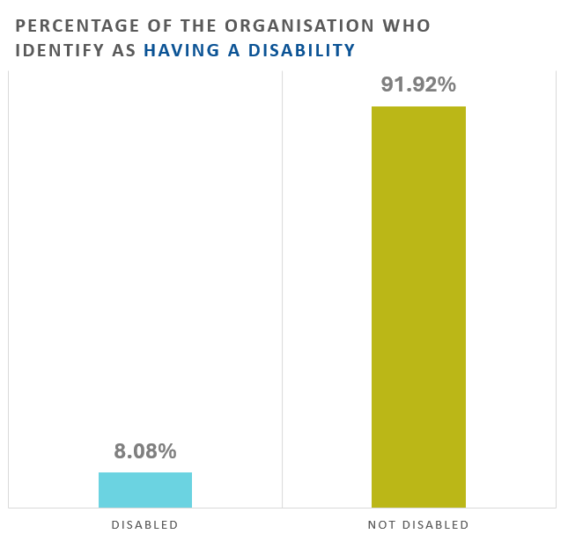

A small portion of the organisation identify as having a disability, whilst the vast majority do not.

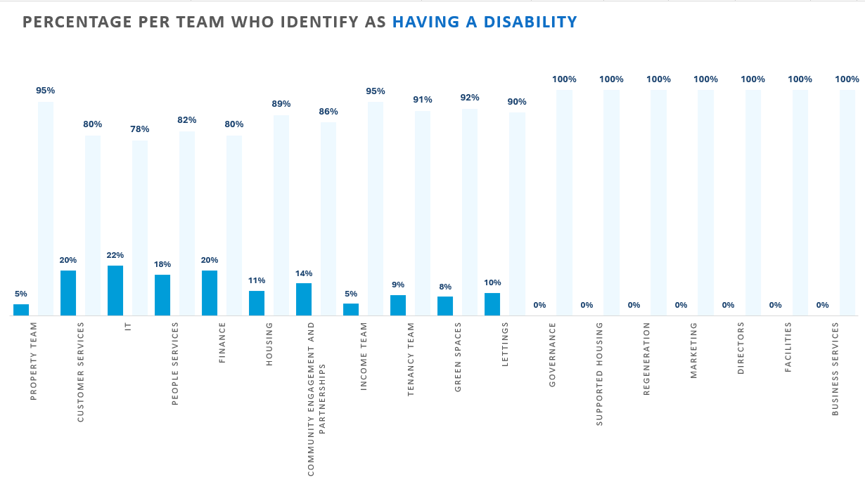
This chart shows the percentages of staff who identify as having a disability within each team. The highest proportion is in the IT team, whilst some teams report no disabled individuals at all.

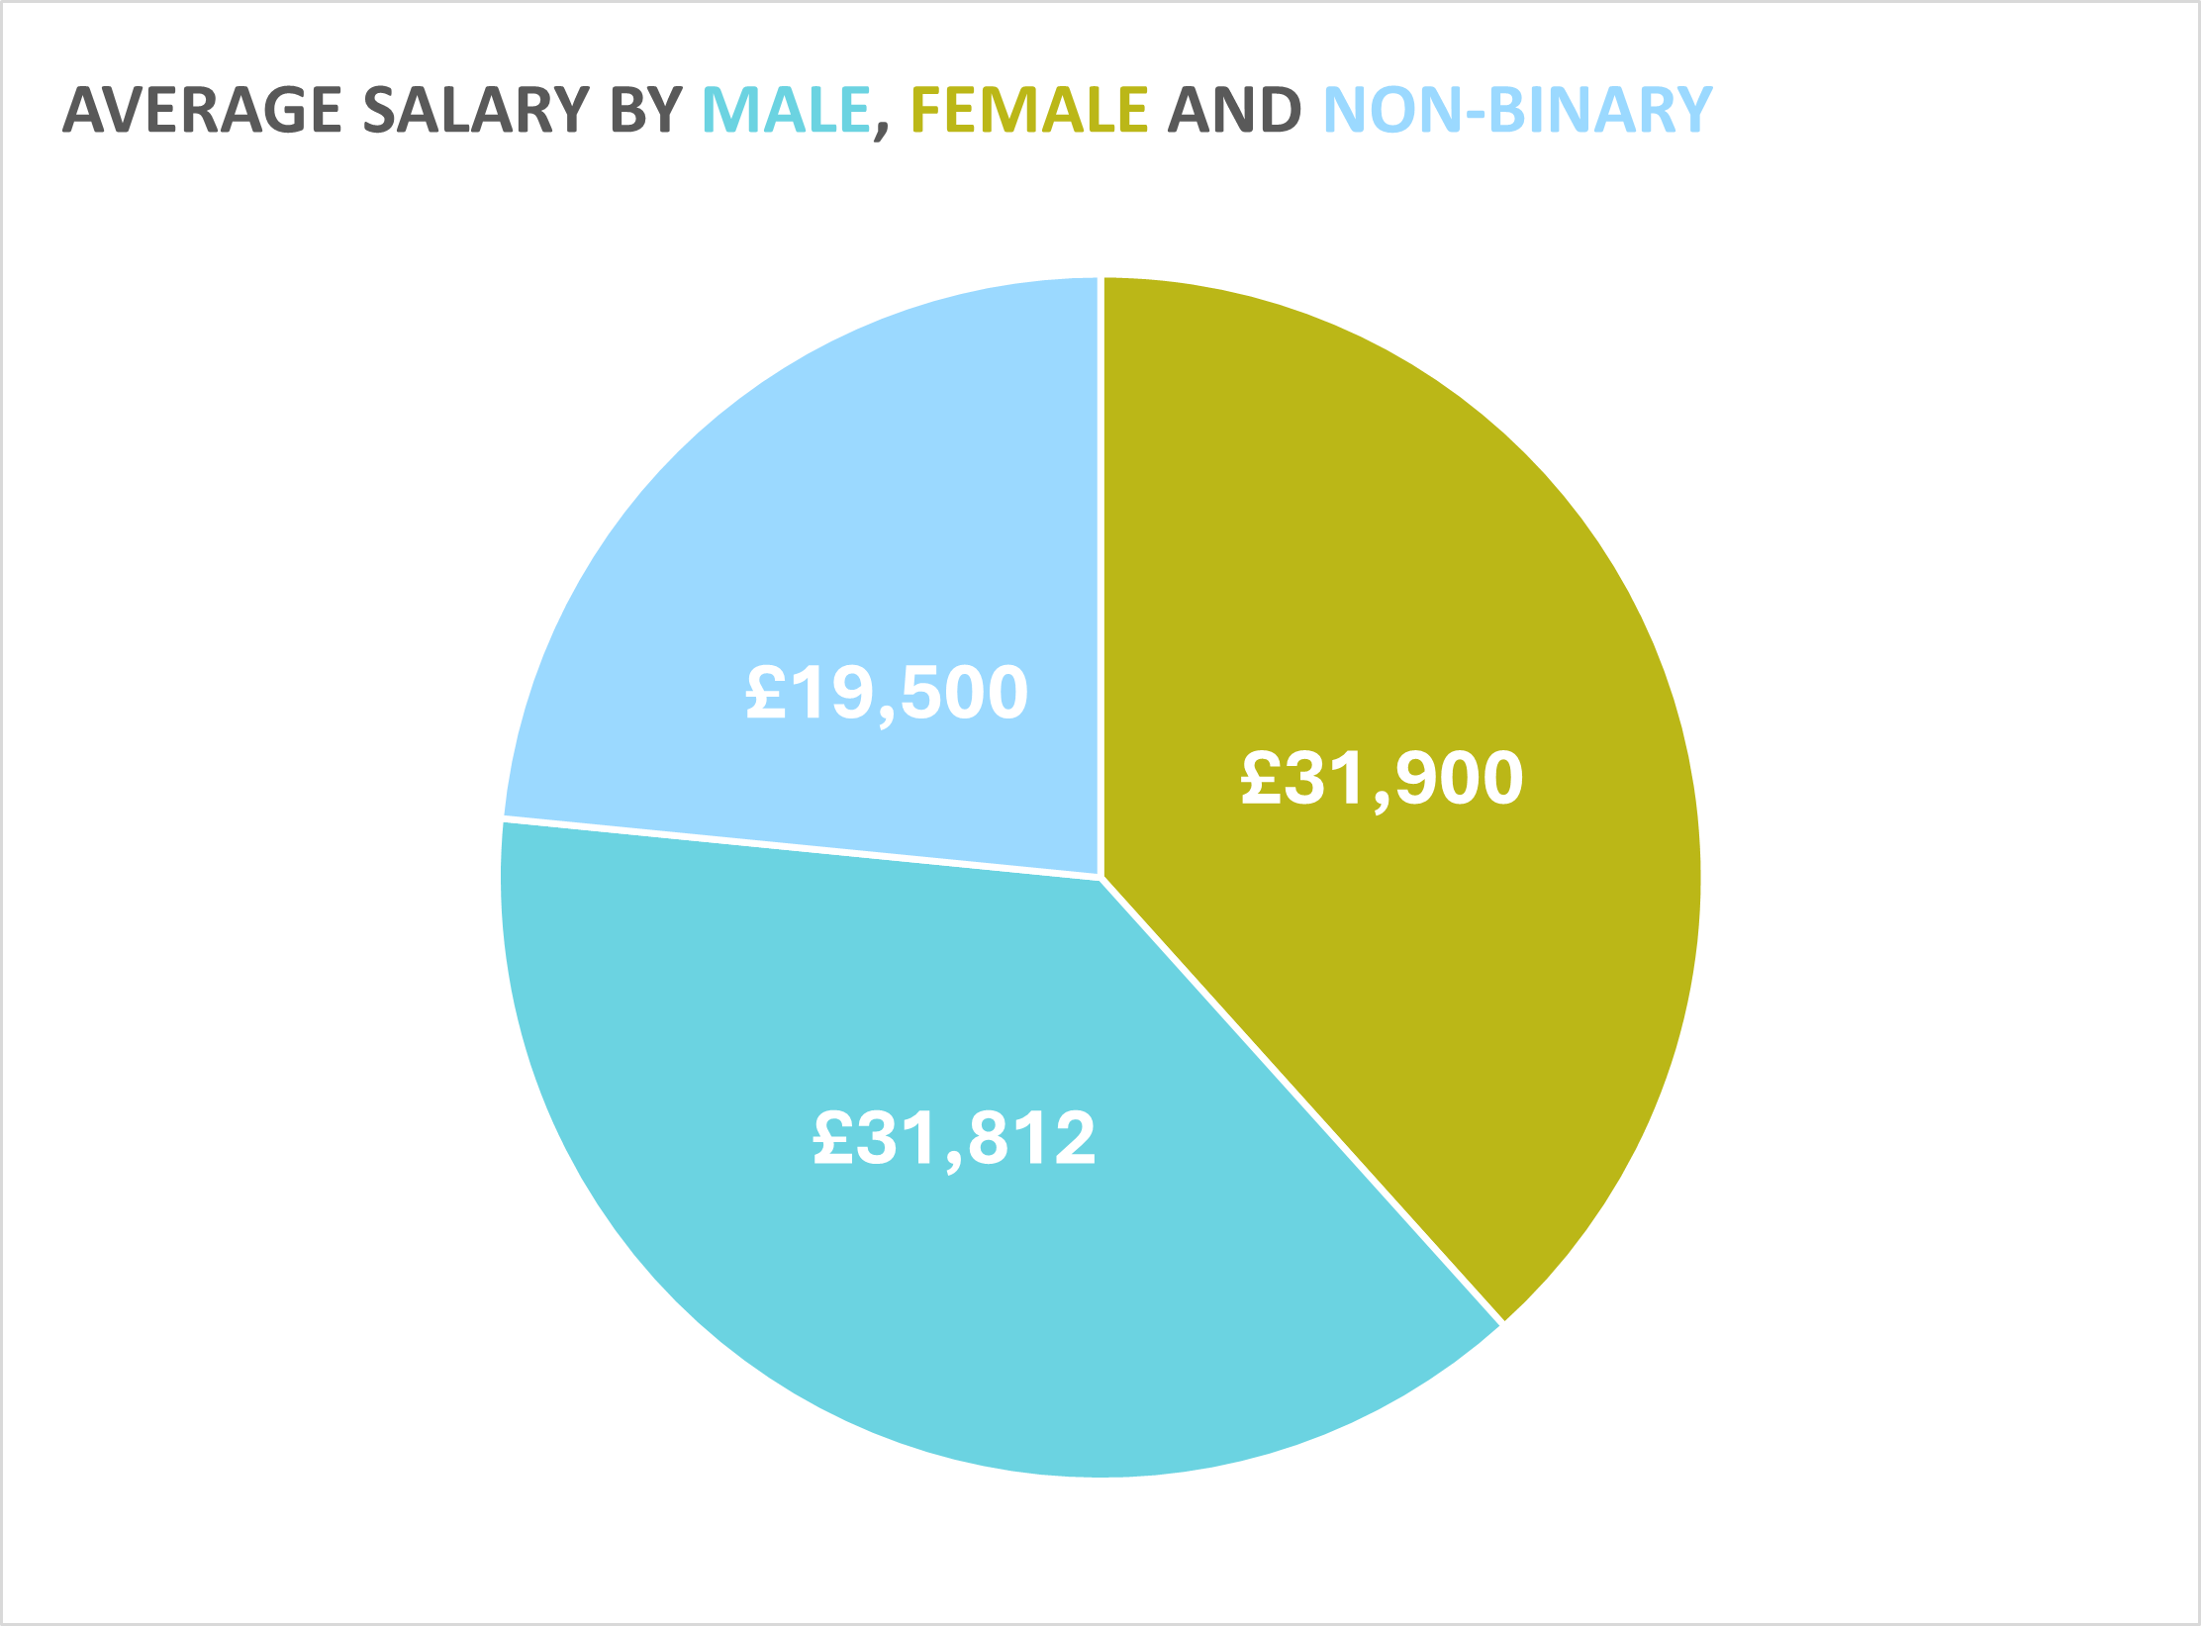

On average, females earn £88 more than males, and both genders earn substantially more than non-binary staff: males earn £12,312 and females £12,400 more than non-binary employees.

Recommendations

This section offers recommendations based on gender, pay, and diversity analysis. They aim to proactively enhance workplace inclusivity and equality, focusing on key improvements for ongoing EDI progress.

- Gender and Pay Audit

Addressing gender pay gaps, particularly for non-binary individuals, is essential for legal compliance and ethical business practices. The CIPD underscores the importance of fair pay for diversity and retention (CIPD, 2022).

Benefits

A fair pay structure enhances workplace equality, potentially boosting morale, productivity, and employer branding.

Risks

Failure to address pay disparities can lead to legal challenges, such as equal pay claims, and damage the organisation's reputation.

Financial Implications

The audit's initial costs lead to long-term benefits like lower legal dispute risks and better employee retention. SHRM's report links fair pay practices with employee satisfaction, impacting customer satisfaction and profitability (Miller, 2019).

- Inclusive Recruitment Policies

Developing inclusive policies can enhance diversity, particularly among ethnic minorities and individuals with disabilities, and aligns with the Equality Act 2010 (GOV.UK, 2015).

Benefits

A diverse workforce brings in varied perspectives, fostering innovation and better decision-making, as supported by McKinsey’s research on diversity in the workplace (McKinsey & Company, 2020).

Risks

Resistance to change can be a significant barrier. Additionally, there might be short-term increases in recruitment costs.

Financial Implications

Though initial costs may rise, the long-term benefits of a diverse workforce, such as increased innovation, better problem-solving, and enhanced company image, outweigh these costs. Research from BCG indicates that diverse companies report better innovation results and improved financial performance (Lorenzo et al., 2023).

Exclusion of Other Recommendations

The focus on Gender Pay Audit and Inclusive Recruitment Policies is due to the direct impact on compliance, diversity, and ethics. While diversity and inclusion training and disability inclusion are significant, they may be more effectively implemented after establishing fair pay and inclusive recruitment. Addressing these aspects first may help in creating a more receptive environment for future initiatives.

Based on the quantitative analysis of the employee survey data concerning hybrid working practices, there are clear themes and patterns regarding employee perspectives.
Work-Life Balance and Well-being
The majority of employees agree that hybrid working practices support their work-life balance and well-being.
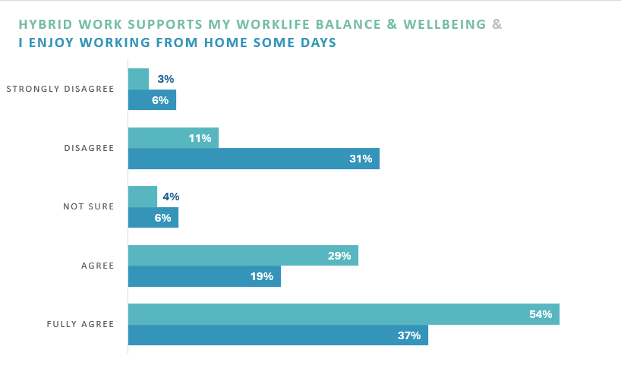

Challenges of Remote Work
A small group of employees struggle with remote work, while a larger percentage does not find it challenging. 34% are uncertain, suggesting it is too early to judge their adjustment to hybrid working.
Collaboration & Communication
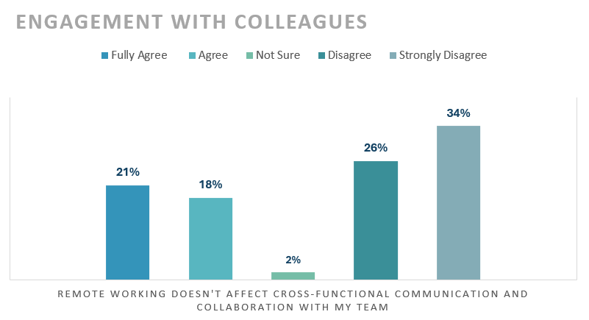
60% of respondents believe that remote working affects cross-functional communication and collaboration with their team.

Conflict
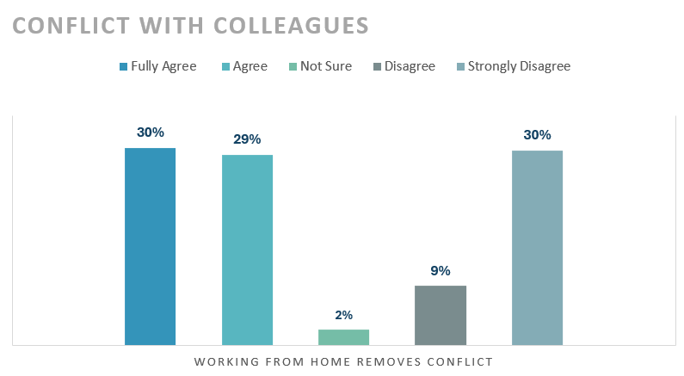
59% of respondents believe that working from home removes conflict.

83% of respondents do not miss engaging with their colleagues in the workplace.
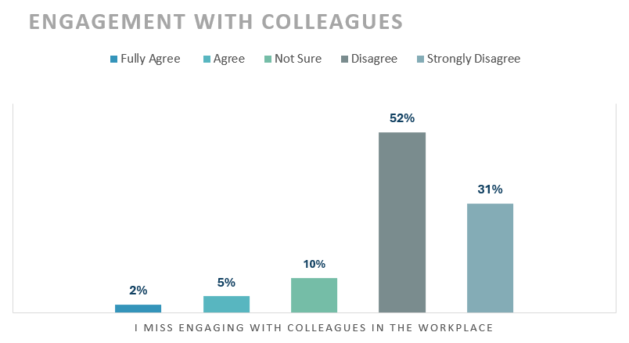

Productivity
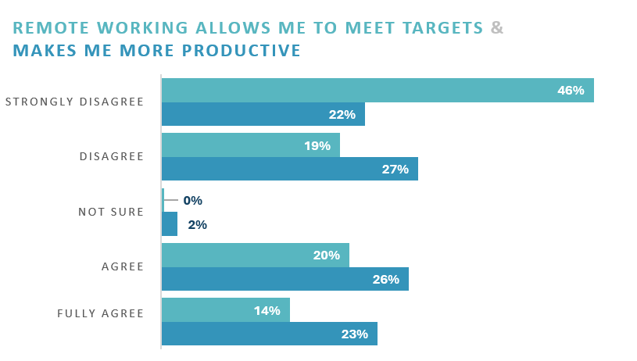
65% of employees believe remote work hinders meeting targets and 49% feel it reduces productivity, compared to 34% who find it helps meet targets and another 49% who find it increases productivity.

Stress
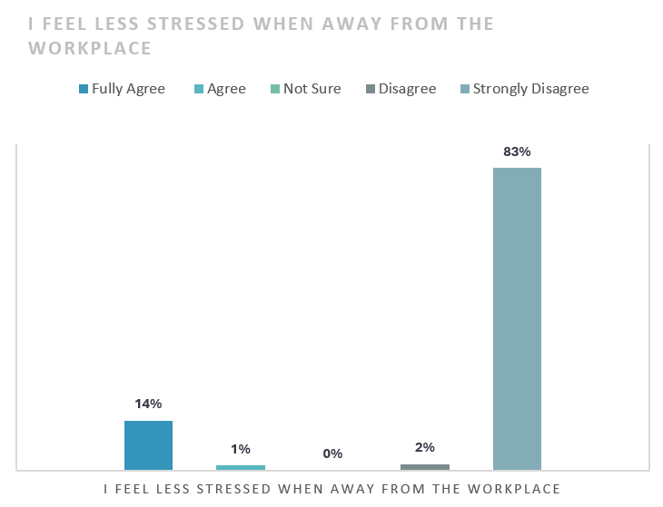
Data suggests a key theme: workplace stress. This suggests that many employees may experience more stress when working remotely.

Recognition and Company Culture
Most respondents feel unsupported working from home. 46% believe they receive equal recognition whether working remotely or in-office. Many agree they feel more connected to company culture with hybrid work.

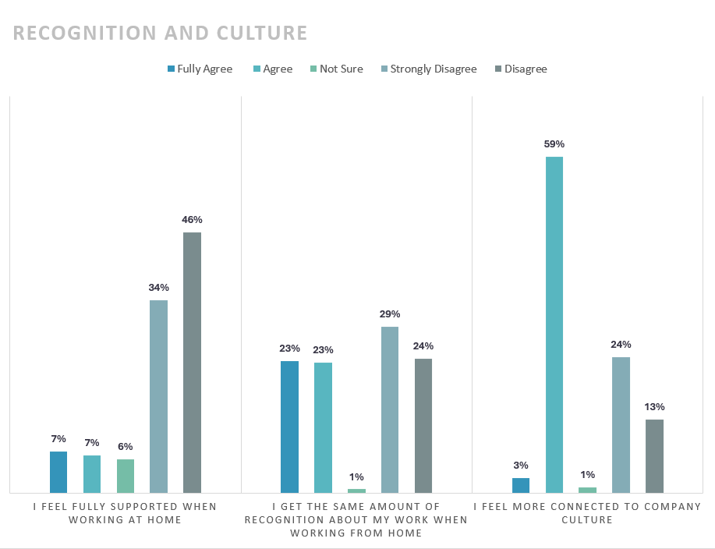

Recommendations
This section of the report outlines recommendations derived from scrutiny of employee responses. These targeted recommendations are aimed at enhancing work practices in response to evolving workplace dynamics.
- Work-Life Balance and Well-being
With the growing emphasis on flexible work arrangements, maintaining hybrid practices is vital for employee well-being and work-life balance. As per Holliday (2023), flexibility in work hours and location is a trend set to continue in 2024.
Benefits
This approach prevents burnout and reduces stress levels, fostering a supportive work environment. It is believed that flexible work arrangements contribute to employee satisfaction and well-being, as well as lower turnover (McNall, Masuda and Nicklin, 2009).
Risks
According to a review by Gifford, there is a potential impact on team cohesion and productivity if not managed effectively (Gifford, 2022).
Financial Implications
There are reduced costs associated with sickness and absence, offsetting any initial investments in flexible work infrastructure (Leddy, 2018).

- Remote Working Challenges
Training on digital tools and tailored approaches are crucial to address remote working challenges effectively. This is essential due to the increasing reliance on remote working practices.
Benefits
A study by McKinsey indicates that tailored training on digital tools offers significant benefits, employees can integrate learning into their day-to-day work and participate in remote activities that are relevant to their learning objectives. This leads to increased ability and connection within teams, leading to improved productivity (Dutta et al., 2021).
Risks
A study by Yang et al. (2021) found that there is a risk of over-reliance on digital communication, resulting in employees becoming siloed in how they communicate, engaging in fewer real-time conversations and could have implications for productivity and innovation.
Financial Implications
Costs for digital tools and training are an investment in long-term productivity and employee engagement. Downsides include investment for staff in a home office set up and high-speed internet and technology, which is a cost usually met by the employee (Kensington, 2023).
Exclusion of Other Recommendations
While all recommendations have merit, Work-Life Balance and Remote Working Challenges have been prioritised due to their direct impact on employee well-being. These areas offer a balance between immediate benefits in employee health and long-term benefits in productivity and engagement. Other recommendations, such as collaboration, communication & conflict, and recognition and company culture remain important and might follow as future phases of improvements.
Conclusion
Hybrid teams are the future (Insights, 2023); however, it remains an uncertain middle ground, a theme which is reflected in the survey results. The organisation is in the initial stages of this practice and must monitor and address blind spots to ensure success.

References

CIPD (2023) Disability and employment. https://www.cipd.org/uk/knowledge/factsheets/disability-discrimination-factsheet/ (Accessed: November 22, 2023).
Dutta, S. et al. (2021) Everyone is within learning distance: Building skills remotely. Available at: https://www.mckinsey.com/capabilities/operations/our-insights/everyone-is-within-learning-distance-building-skills-remotely (Accessed: December 2, 2023).
Gifford, J. (2022) Performance and productivity – the impact of team cohesion. https://www.cipd.org/en/knowledge/bitesize-research/performance-productivity/ (Accessed: December 2, 2023).
GOV.uk (2015) Equality Act 2010 guidance. Available at: https://www.gov.uk/guidance/equality-act-2010-guidance (Accessed: November 22, 2023).
Holliday (2023) The key trends to know about now so you’re ready for 2024 and beyond. Available at: https://www.hrgrapevine.com/content/article/2023-11-14-the-key-trends-to-know-about-now-so-youre-ready-for-2024-beyond (Accessed: November 22, 2023).
Insights (2023) Global Hybrid Working Report 2023, HR Grapevine. The Insights Group Ltd. Available at: https://www.hrgrapevine.com/resources/register/global-hybrid-working-report-2023/ (Accessed: November 22, 2023).
Kensington, L. (2023) The Financial Impacts of Remote Work. Available at: https://revyo.com/the-financial-impacts-of-remote-work/ (Accessed: December 2, 2023).
Leddy, C. (2018) The Finances Behind Flexible Working: The Upside of a Flexible Workplace. Available at: https://www.adp.com/spark/articles/2018/07/the-finances-behind-flexible-working-the-upside-of-a-flexible-workplace.aspx (Accessed: December 2, 2023).
Lorenzo, R. et al. (2023) How diverse leadership teams boost Innovation. Available at: https://www.bcg.com/publications/2018/how-diverse-leadership-teams-boost-innovation (Accessed: November 22, 2023).
McKinsey & Company (2020) Diversity wins: How inclusion matters, McKinsey & Company. McKinsey & Company. Available at: https://www.mckinsey.com/capabilities/people-and-organizational-performance/our-insights/diversity-wins-how-inclusion-matters (Accessed: November 22, 2023).
McNall, L., Masuda, A. and Nicklin, J. (2009) Flexible work arrangements, job satisfaction, and turnover intentions: The mediating role of work-to-family enrichment. https://psycnet.apa.org/record/2011-23277-004 (Accessed: December 2, 2023).
Miller, S. (2019) 'Pay fairness perception beats higher pay for improving employee engagement,' SHRM, 16 August. Available at: https://www.shrm.org/ResourcesAndTools/hr-topics/compensation/Pages/pay-fairness-beats-higher-pay-for-engagement.aspx#:~:text=,transparent%20pay%20process%20boosts%20employee (Accessed: November 22, 2023).

