IMPACT OF VIRTUAL LEARNING ENVIRONMENT (VLE) ON THE STUDENTS FROM UNIVERSITY OF WALES TRINITY SAINT DAVID, LONDON CAMPUS

Name: Vitalii Tugulschii
Student ID: 1906242
Module name: Digital Skills& Research Methods
Modul Number: BMSW4003
Lecturer Name: Mr. Balendran Kandasamy

Executive Summary
In today's modern world, the application of technology has a significant impact on the lives of all people. The concepts of online learning in the educational experience of students are to be illustrated in brief in the following research, which follows the impact of technology. The Virtual Learning Environment's main goal is to maintain stability while also developing a better educational concept. To do so, the concepts and motivations of students are represented in this study, as well as VLE evaluations. Students are more likely to cooperate with their lesson plan if a sustainable concept is developed and more resourceful formats are developed. Therefore, actuating the materialistic views and looking into the impact of VLE on the students is the main proposal that is portrayed in this research.

Table of Contents

Introduction 4
Aim and Objective 4
Literature review 5
Concepts of Virtual Learning Environment (VLE) 5
Theories related to VLE 5
Impact of Virtual Learning Environment (VLE) on the learning experience of students 5
Challenges faced by the students related to VLE 6
Strategies to overcome the challenges 6
Methodology 7
Primary research 7
Secondary research 7
Limitations 12
Ethical considerations 12
Conclusions 12
Appendices 14

Introduction
In this study, the discussion of the Virtual Learning Environment on the learning experience of the students are to be emphasised in brief and following that the reviews of different students along their experience are to be escalated. In the present world, technological transformation is the most important aspect, and following those changes in organisations, society, and even the educational sector is also observed. Virtual Learning Environment is one of the most essential and popular educational platforms that affect the lives of many children and students in the present day. During the ongoing pandemic situation, most schools and colleges were closed. Due to that reason, the actuation of virtual learning experiences has escalated a lot in the present day. In this report, the studies of different authors related to this topic and according to that collection of both primary and secondary data are to be generated to draw a sustainable conclusion.

Aim and Objective
The main aim of this research is to investigate the impact of the Virtual Learning Environment (VLE) on the learning experience of the students.
Following the aim, the objectives of this study are
- To analyse the concept of a virtual learning environment (VLE)
- To analyse the impact of VLE on student learning experience
- To identify the challenges related to VLE faced by learners
- To develop some strategies to overcome the challenges related to VLE faced by students

Literature review

Concepts of Virtual Learning Environment (VLE)
According to Hamid et al. (2018, p.1296), the virtual learning experience is developed in a worldwide manner after the actuation of Covid-19. Maintaining the normality in education and creating a structural balance in the environment, many schools and educational institutes have incorporated the use of VLE in their operational management. Following the use of VLE, a steady way of conveying the education to the children is practiced by the institute which helps them to restructure the educational loss that has been observed during the pandemic.
As suggested by Ng (2021), online learning creates the advantage of distance education and the application of computer-mediated technologies. In the present situation, the development of communication along with better participants is an important factor and based on that the concepts of VLE are generated. Not only for the children but the application of VLE is also subjected to both undergraduate and postgraduate students. In the technologically advanced world, creating advantages in the mode of education also helps to recognise the growth and development of communication in the present world.

Theories related to VLE
As suggested by WGU (2020), the Transformative learning theory is the most appropriate theory that discusses the pattern of VLE in the present day. Following the Transformative learning theory, the concept of education along with the use of technology is emphasised. Technological transformation along with the use of suitable methods helps to coagulate the curriculum of the students in recent days. Following better studies and enhancement in academics, the E-learning theory also helps to determine the growth of the students by observing the academic study conducted through the VLE platform.

Impact of Virtual Learning Environment (VLE) on the learning experience of students
Virtual Learning Experience (VLE) has a satisfactory impact on the learning experience of the students. There are different platforms for VLE such as Microsoft Teams, Zoom, and Moodle. And following that the presence of different tutors is also present who will give lecture materials to the students. Therefore, following the learning platforms and engagement of the students in a better way, the positive impact of VLE has helped the students to acquire knowledge during the lockdown phase. Following the formats of VLE, the students also have the comfort to study according to their timing as saving and recording of lectures are also available in the structural development of the Virtual Learning Environment.
While increasing the factors of VLE; students' performance improves. In today's world, students prefer the online platform because it offers more flexibility and better supervision. Following that, parents can keep track of educational reforms, and changes in the curriculum can be better observed according to academic years.
According to the studies of Darius, Gundabattini, and Solomon (2021, p.1326), online learning helps students to maintain a better educational background in the present situation. In the present days, students do not get any chances to maintain any kind of physical activities or take any kind of performances in sports networks. Due to the application of online learning, students manage to maintain a healthy lifestyle by engaging with sports and actively studying their curriculum by engaging with the virtual network.

Challenges faced by the students related to VLE
According to Barrot, Llenares, and del Rosario (2021), the factor of offline learning is a common process and suddenly changing the habitat of learning has caused different problems of adoption, understanding, and maintaining balance for many students. The mode of VLE was introduced in late 2012 but this system came to effect after the Covid-19 pandemic. Following the pandemic, most schools, colleges, and universities have adopted the mode of VLE. Therefore, a sudden change in habitat has caused adaptation problems for many students on a worldwide basis. Engaging with phones and electronic devices has also caused many students to suffer from problems in eyesight. Looking into all these factors the VLE has both positive and negative effects on the lifestyle of the students.

Strategies to overcome the challenges
A good online platform can help students keep up with their studies while also modifying their learning in a long-term way. Students can follow a conversational class by maintaining the structural platform and sequentially engaging the educator's teachings. As a result, to advise students on a better online platform, a stronger engagement of routine structure should be followed, which will further assist students in learning effectively using the online format.

Methodology

Primary research
A total of twenty-five people were chosen for this study, and the results of the survey were used to generate data for the following study. The feedback of London campus students is considered for primary data analysis because they are the most reliable resources that can provide appropriate feedback on VLE concepts. The use of surveys in the selection of data and the variation of primary research concepts aids in determining both the benefits and drawbacks of virtual learning concepts. As a result, primary research appears to be a viable option for gathering data for this study.

Secondary research
According to the study by Mpungose (2020), face-to-face studies are a wider network of learning and following this concept the application of VLE has been generated in recent days. The concepts of learning and how they affect the lives of children can be noted and used as an example for future growth, according to secondary research. The secondary research analysis also helps in the examination of previous authors' research and, as a result, a conclusion is drawn in the current study.
Secondary data is useful for highlighting the functionalities of modern technology and how their use has highlighted the pattern of outcomes for students in schools, colleges, and universities.

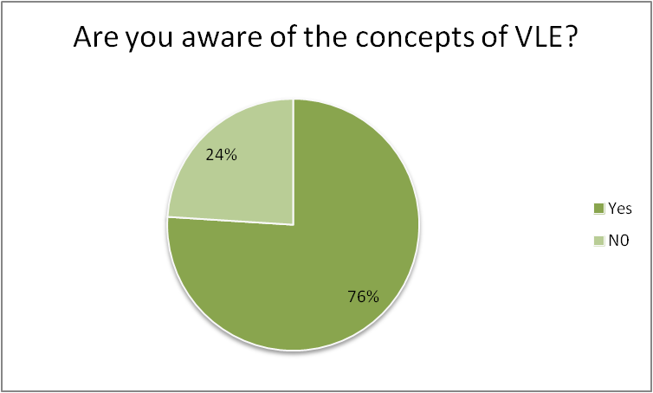
Most of the London campus students who were selected were familiar with VLE concepts. The virtual learning environment is an impressive platform that allows students to virtually learn their lesson plans using technology. As a result, most students today are familiar with the VLE format.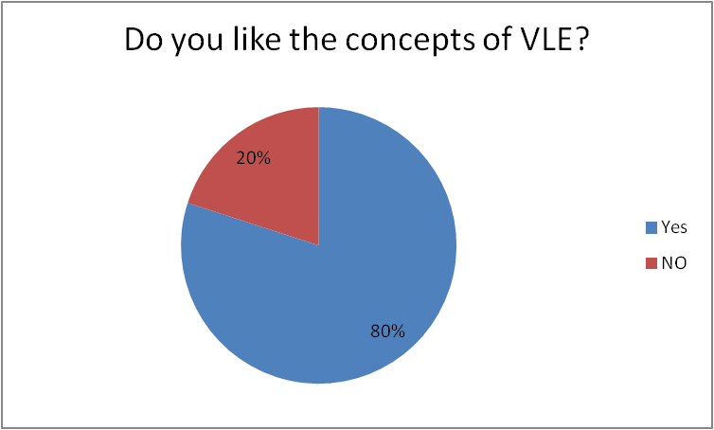
The majority of participants said they liked the idea of a virtual learning environment. When used as an online platform, Microsoft Teams supports and generates the facilities that are the main reason for the popularity of distance learning.
Eighty percent of the students chosen experienced a positive impact in their coursework while using the online platform. The use of a VLE is a simple task, and understanding the concepts helps to generate flexibility in timing and studies, which benefits students. 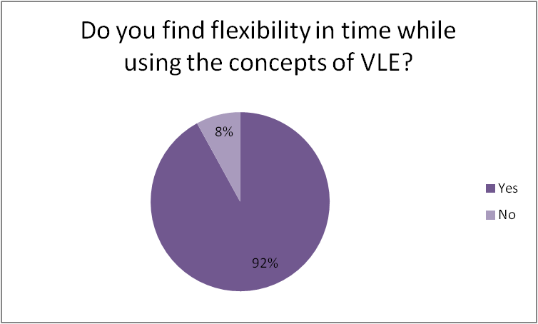
Maintaining the timing of the studies and setting the objective according to that is critical when conceptualizing the VLE. As a result, the majority of students report that they enjoy the scheduling flexibility that VLE provides and that it assists them in achieving better educational reforms.
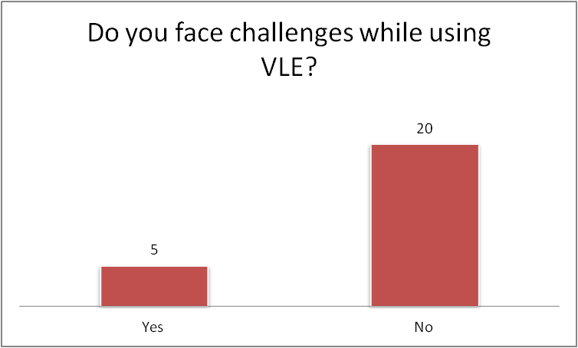
Almost all students were familiar with the concepts of VLE during the formulation of the collection of primary data and had no problems with their use. The system is designed in such a way that it is easy to use and helps students understand their studies, as well as on platforms such as Moodle where they can access study materials.

Following the use of platforms such as Microsoft Teams or Moodle, the participants responded that in the beginning, they have faced problems with adopting the virtual platforms while conducting their education. Maintaining a similarity between online and offline studies has created differences in timing for many students. In the implication of online studies, the students have also faced challenges to understand the VLE concepts at the beginning. However, as time passes most of the students must cope with the system and engage in their studies in a better way.
Following the secondary research, most students like the concepts of VLE as it is flexible. Maintaining flexibility in timing and considering a better educational format helps the students to grow a strong knowledge in academics. Following the concepts of academics, the strictly of the VLE is set according to the flexibility and timing of the students. Therefore, it can be said that utilising the concepts of virtual learning is a measurable format to study in the present day.

Limitations
During the conduction of the research, the most applied limitation was gathering the data from the students of the London campus. To get the survey report, no participants were ready to share their personal information. This is one of the most applied limitations of this research. Another limitation that was faced during the research was gathering the statistical secondary data. Most of the journals don't have the necessary statistical information about the students. Therefore, it took some time to gather data and poetry them in the following research.

Ethical considerations
During the conduction of the research, no ethical boundaries were breached. All the secondary data were collected from authentic sources and following that it was used in the research. During the conduction of the primary research, no personal questions were asked to the participants. Sharing of confidential data was prohibited while conducting the actuation of the research. Maintaining stability and actuating the ethical formats were vigorously followed while obtaining the data and formulating them in the research.

Conclusions
In the present day, the application of online learning is a common thing, and maintaining so, the actuation of this research is generated. Conceptualising the formats of Virtual Learning Experience, the application of both primary and secondary data is used in this research to generate a sustainable concept. As a result of the survey of 25 London campus students, we can conclude that most students were aware of the concept of VLE. They also find that using online platforms gives them more time flexibility and has a positive impact on their studies. However, some students encountered difficulties when using the Microsoft Teams platform. Because our university continues to use this platform, it would be a good idea if students could receive training to help them become more efficient when using VLE.

Reference list
Barrot, J.S., Llenares, I.I., and del Rosario, L.S. (2021) Students’ online learning challenges during the pandemic and how they cope with them: The case of the Philippines. Available at: https://link.springer.com/article/10.1007/s10639-021-10589-x#citeas (Accessed 27 April 2022).

Darius, P.S.H., Gundabattini, E. and Solomon, D.G. (2021). A Survey on the Effectiveness of Online Teaching-Learning Methods for University and College Students. Journal of The Institution of Engineers, Series B (102), pp. 1325-1334 Available at: https://link.springer.com/article/10.1007/s40031-021-00581-x (Accessed: 27 April 2022).

Hamid, Z. et al. (2018) ‘The Concept and Use of the Virtual Learning Environment in Teaching: A Literature Review’, International Journal of Academic Research in Business and Social Sciences, 8(6), p.1296. Available at: https://hrmars.com/papers_submitted/4517/The_Concept_and_Use_of_the_Virtual_Learning_Environment_in_Teaching_A_Literature_Review.pdf (Accessed: 27 April 2022).

Mpungose, C.B. (2020). Emergent transition from face-to-face to online learning in a South African University in the context of the Coronavirus pandemic. Available at: https://www.nature.com/articles/s41599-020-00603-x (Accessed: 28 April 2022).

Ng, C.F. (2021) The Physical Learning Environment of Online Distance Learners in Higher Education – A Conceptual Model. Available at: https://www.frontiersin.org/articles/10.3389/fpsyg.2021.635117/full (Accessed: 27 April 2022).

WGU (2020) What is the transformative learning theory? Available at: https://www.wgu.edu/blog/what-transformative-learning-theory2007.html#close (Accessed: 1 May 2022).

Appendices
Appendix 1: Questioner
1.
Are you aware of the concepts of VLE?
Yes | N0
2.
Do you like the concepts of VLE?
Yes | NO
3.
Have VLE generated a positive impact on your studies?
Yes | No
4.
Do you find flexibility in time while using the concepts of VLE?
Yes | No
5.
Do you face challenges while using VLE?
Yes | No
6.
What challenges do you face while using VLE?
Adaptation | Timing | Concepts

