
Program of study: CertHE Business Skills for the Workplace
Module Name: Enterprise & Entrepreneurship
Code: LCLM4006
Assignment Title: Business Plan
Lecturer’s Name: Chung Johnny
Name: Edwin Akaolisa
Student ID Number: 2508937

Table of Contents
Executive Summary 2
Overview of the Business 3
Unique Selling Point 4
Legal-format of Business 5
Management Team & Staff Structure 5
PESTEL- Analysis 7
Marketing plan 8
Online Marketing 8
Direct Marketing 8
Courier Platforms 8
Funding Source 9
Cashflow 9
Financial Assumptions 10
Monthly Revenue 10
Monthly Commission Income 11
Annual Commission Income 11
Estimated Profit 11
Growth Plan 11
Year 1 11
Year 2 11
Year 3 11
Reference List 12

Executive Summary
My business plan is a courier management company that acts as a middleman between customers who need goods delivered and drivers who carry out the deliveries. Move Ease will operate across the United Kingdom and will have a network of 15 drivers with vans the first year and will be growing every year. The business will find transport jobs through courier exchange platforms and direct customers, then allocate these jobs to drivers based on their location and availability.
Move Ease will earn money by taking a 15% commission from each completed job. Drivers will receive 85% of the job value. This business model allows the company to generate income without owning a large fleet of vehicles, reducing operating costs and making expansion easier.
The logistics sector is one of the most important industries in the UK because businesses and consumers rely on fast and reliable delivery services. The growth of online shopping has increased the demand for courier services. (Department for Transport, 2024).
The main aim of the business is to provide efficient transport solutions while building a strong reputation for reliability, customer service, and quick delivery times.
Marketing and funding source: Social media platforms such as Facebook, Instagram, and LinkedIn will be used to promote services and engage with customers, again read through my marketing plan (page 8) and have details of my marketing strategy.
I choose grant because, it demonstrates that my business idea has been assessed and considered worthwhile, which is good starting point because I don’t have to worry about repayment.

Overview of the Business
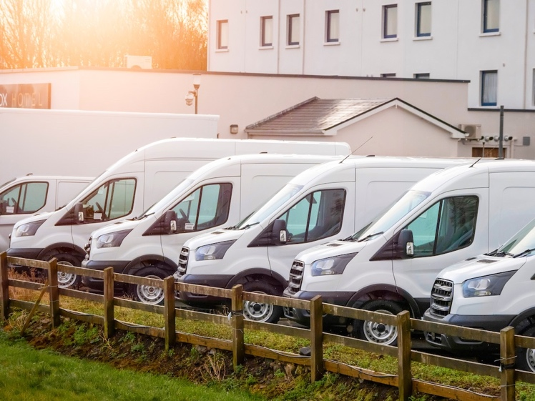

Move Ease limited registered company with uk company house will operate as a transport brokerage company. Rather than delivering goods itself, the company will organise deliveries by finding suitable drivers and assigning jobs to them through the sources
According to (logistics UK, 2026). The UK transport and logistics sector is one of the country’s largest and most important industries, with consistently strong demand because every business depends on moving goods or people and it contributes 175 billion pounds to the UK economy each year.
The demand is highly bigger than the service providers.
Many drivers are unable to access delivery work directly from courier service providers because of high registration, subscription or service fees required, but Move Ease bridged that gap by paying that subscription for fleets of drivers as the Move Ease company will register/pay and maintain accounts with multiple courier service platforms, enabling access to a wide range of delivery opportunities.
Move Ease company will allocate available jobs to its registered drivers based on availability, location and capacity. in return, drivers will pay the company a 15% commission on the value of each successfully completed job. this business model benefits both parties by reducing the financial burden on drivers while ensuring they have a consistent flow of work. it also enables the company to generate revenue by efficiently coordinating deliveries between courier service providers and drivers.
Target Market
The company will target:
- Retail businesses.
- E-commerce companies.
- Courier Exchange
- Manufacturers.
- Construction companies.
- Wholesalers.
- Freight forwarders
Move Ease will initially work with 15 drivers operating vans suitable for courier and delivery work. Drivers may be self-employed contractors, who work under agreements with Move Ease.

Unique Selling Point
Move Ease is from competitors because it will make initial payment of (3000 pound) to Courier Exchange for multiple account, bide and allocate jobs to drivers according to their location and convenient.

My business research with drivers shows that 85% of them cant afford the initial (2,000 pound) registration fee to Courier Exchange, or spending a lot of time bidding for jobs.

Move Ease feel the gap by paying, bidding, and allocating jobs to drivers and charge them 15% of any completed job
Move Ease will Increase the use of electric vans to achieve zero pollution, reduce carbon emissions, and help protect the environment for future generations.
Move Ease company (USP) is register/pay and maintain accounts with multiple courier service platforms, enabling access to a wide range of delivery opportunities
This business model is attractive because it reduces the need for expensive investments in vehicles and maintenance. Instead, move ease focuses on finding Contract/bidding, and managing operations. According to Christopher (2022), businesses that focus on coordination and supply chain management can achieve growth while maintaining lower operating costs.
To promote equal employment opportunities by recruiting qualified disable individual for positions such as customer service.

Legal-format of Business
Move Ease will be registered with UK Companies House as a private limited company (Ltd). This means the company is a separate legal entity from its owners. One advantage of a limited company is that the owner's personal assets are protected if the business experiences financial difficulties (Companies House, 2025).
Move Ease will work with drivers and customers, it must have appropriate insurance cover. This may include public liability insurance, employer's liability insurance (if staff are employed), and goods-in-transit insurance. These policies help protect the company against financial losses resulting from accidents, injuries, or damaged goods (Association of British Insurers, 2025).
Drivers must hold a valid UK/ EU full driving licence and ensure that their vehicles meet legal road safety requirements. Vehicles must be taxed, insured, and have a valid MOT certificate where required by law (Driver and Vehicle Licensing Agency, 2025).
Move Ease must also comply with data protection legislation. Customer information such as names, addresses, telephone numbers, and delivery details must be stored securely and used only for business purposes. The business must follow the requirements of the UK General Data Protection Regulation (UK GDPR) and the Data Protection Act 2018 (Information Commissioner's Office, 2025).
Move Ease must also meet its tax obligations. This includes registering with HM Revenue and Customs (HMRC), paying Corporation Tax on profits, and keeping accurate financial records. If the business reaches the VAT registration threshold, it must register for Value Added Tax (VAT) and submit VAT returns (HM Revenue and Customs, 2025).
By following these legal requirements, move ease can operate professionally, avoid penalties, and build trust with Government, customers, and business partners.

Management Team & Staff Structure

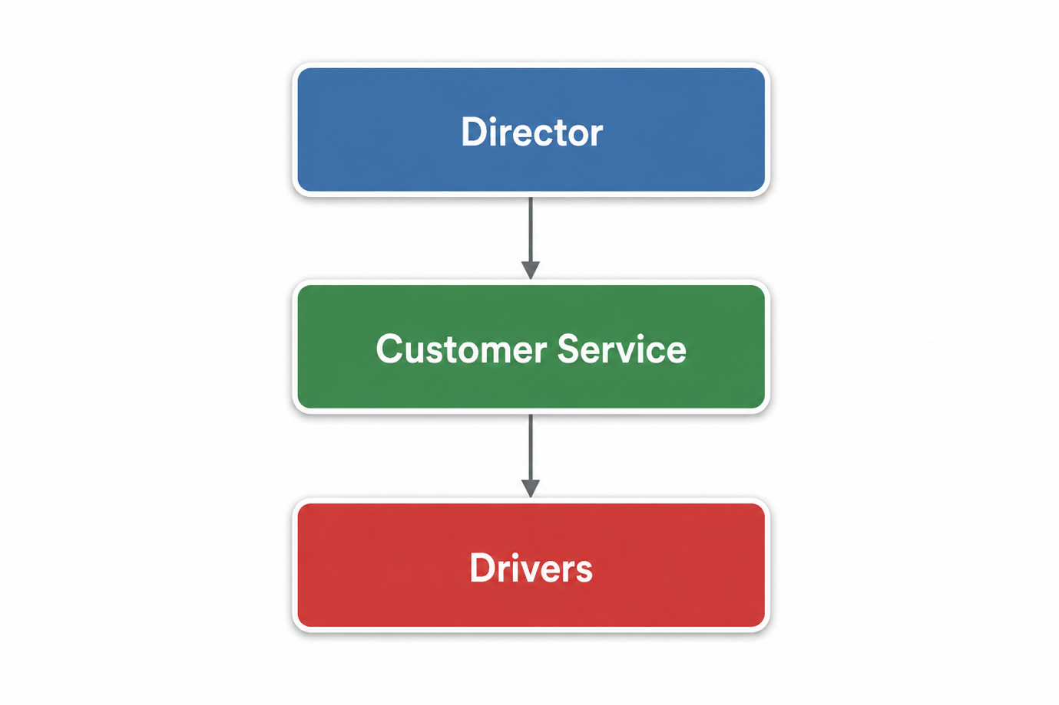
Figure 1: Management Structure (Source: designed by the author)

Director (myself)
- decision making
- Planning
- Sourcing Contracts
- Business development.
Customer Service
- Customer communication.
- Tracking drivers for safe delivery of jobs.
- Bidding jobs through courier exchange platforms.
- Allocating jobs to drivers according to their locations.
- Assigning jobs to drivers.
- Confirming successful completion.
- Create drivers group WhatsApp for job allocations, communications and other administrative purposes.
Drivers
- Collecting goods.
- Delivering goods safely.
- Maintaining professional customer service.
As the business grows, additional coordinators and administrative staff may be required.

PESTEL- Analysis

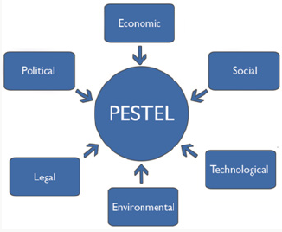

Figure 2: PESTEL analysis (Source: designed by the author)

Economic:
inflation: According to Consumer Prices Index (CPI), the UK is currently experiencing 2.8% of inflation for the 12 months until May 2026 (National Statistics, 2026). Rising inflation increases operation costs such as fuel, Vehicle maintenance, and
insurance cost, which can reduce profit margins. In terms of economic growth, during period of economic growth, businesses and consumers tend to send more parcels, which increases demand for courier services, and increase the profit margins.
Social:
In terms of population growth: A larger population increases demand for parcel deliveries. For the online shopping habits: More people shopping online increase the need for courier services.
Technological:
GPS and route optimisation: Reduce delivery times, fuel costs, and improves efficiency.
Mobile apps: Enable customers to book deliveries, track parcels and receive notifications.
Environmental:
Electric vehicles: Switching to electric delivery vans can reduce emissions and meet environmental target, but requires investment.
Climate change: Extreme weather (floods, storms, snow, and heatwaves) can delay deliveries and disrupt operations.
Legal:
Data protection law: Customers and delivery information must be handled securely and in accordance with privacy laws.

Road traffic and transport laws: Drivers must follow licensing, vehicle safety, speed limit, and transport regulations.
Political:
Political stability: Stable government provide a predictable business environment, while political instability can disrupt operations.

Taxation policies: increase in business taxes or fuel taxes can reduce profit, while tax incentives may support growth margins.

Marketing plan
The marketing strategy will focus on attracting both jobs and drivers.

Online Marketing
Move Ease will create a professional website explaining its services and contact information. Search engine optimisation (SEO) will be used to improve visibility on search engines.
Social media platforms such as Facebook, Instagram, and LinkedIn will be used to promote services and engage with customers.

Direct Marketing
Move Ease will contact local businesses directly through phone calls, emails, and networking events. Building relationships with local businesses can lead to long-term contracts.

Courier Platforms
Move Ease will use courier exchange platforms to access available jobs and increase business opportunities.
According to the Chartered Institute of Logistics and Transport (2024), strong customer relationships and professional service are key factors for success within the logistics industry.
The UK logistics industry is a major contributor to the economy. It supports the movement of goods between businesses and consumers. The growth of e-commerce has significantly increased demand for delivery services, particularly same-day and next-day deliveries (Office for National Statistics, 2024).
Courier exchange platforms play an important role in the industry. These platforms allow businesses to advertise transport jobs and enable courier companies to bid for work. This system helps reduce empty journeys by finding jobs for drivers from every location of their choice and improves efficiency (Courier Exchange, 2025).

Funding Source
Grant of 10,000 pound from (Better Business finance): Receiving a grant can demonstrate that my business idea has been assessed and considered worthwhile, which is good starting point because I don’t have to worry about repayment
Government loan: (10,000 pound) because the interest is low and some government loan programmes also provide mentoring, training or business advice.

These objectives will help the company grow steadily and become competitive within the UK logistics market.

Cashflow
The company earns revenue through a 15% commission on completed jobs from drivers.

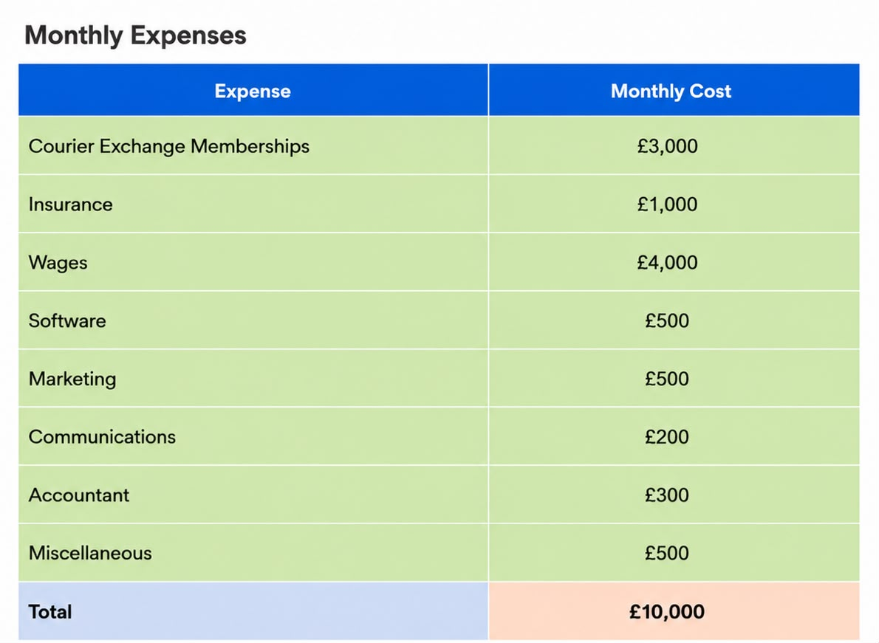

Job value | Driver receives | Company commission
£100 | £85 | £15
£250 | £212.50 | £37.50
£500 | £425 | £75

Financial Assumptions
- 15 drivers.
- 3 jobs per day.
- Average job value of £120.
- 22 working days per month.

Monthly Revenue
15 drivers × 3 jobs × £120 × 22 days
= £118,800 total monthly job value.

Monthly Commission Income
£118,800 × 15%
= £17,820.

Annual Commission Income
£17,820 × 12
= £213,840.

Estimated Profit
Monthly profit:
£17,820 − £10,000
= £7,820.

Growth Plan

Year 1
- Establish operations.
- Build customer base.
- Generate annual commission revenue above £200,000.

Year 2
- Increase driver numbers to 20.
- Secure long-term contracts.
- Improve operational systems.

Year 3
- Expand to 25 drivers.
- Increase market coverage.
- Develop partnerships with larger logistics providers.
The financial forecasts suggest that the company can achieve annual commission revenue of over £213,000 and annual profits exceeding £120,000. Through effective management, strong customer service, and strategic growth, The Company can establish itself as a successful and sustainable business within the UK transport sector.
These figures demonstrate that the business has the potential to generate significant profits while maintaining relatively low operating costs.

Reference List
Association of British Insurers (2025) Business Insurance Guide. Available at: Association of British Insurers(Accessed: 31 May 2026).
Christopher, M. (2022) Logistics and Supply Chain Management. 6th edn. Harlow: Pearson Education.
Companies House (2025) Running a Limited Company. Available at: Companies House (Accessed: 31 May 2026).
Courier Exchange (2025) Courier Exchange Platform Overview. Available at: https://courierexchange.co.uk (Accessed: 31 May 2026).
Driver and Vehicle Licensing Agency (2025) Vehicle and Driving Requirements. Available at: DVLA (Accessed: 31 May 2026).
Information Commissioner's Office (2025) Guide to UK GDPR. Available at: Information Commissioner's Office(Accessed: 31 May 2026).
HM Revenue and Customs (2025) Corporation Tax and VAT. Available at: HM Revenue & Customs (Accessed: 31 May 2026).
Logistics UK (2026) logistics is the stabilising force powering UK economy. available at: https://logistics.org.uk/media/press-releases/2026/june/logistics-uk-logistics-is-the-stabilising-force-po (accessed: 26 june 2026).
Office for National Statistics (2024) Internet Sales and E-commerce Statistics. Newport: ONS. Available at: https://www.ons.gov.uk (Accessed: 31 May 2026)
Statistics, N. (no date) Consumer price inflation, UK - Office for national statistics. Available at: https://www.ons.gov.uk/economy/inflationandpriceindices/bulletins/consumerpriceinflation/april2026 (Accessed: 30 June 2026).
Yuksel, l. (2012) `Developing a multi-criteria decision making model for PESTEL analysis; international journal of Business and management, 7(24), pp.52-66. doi:10.5539/ijbm.v7n24p52.

