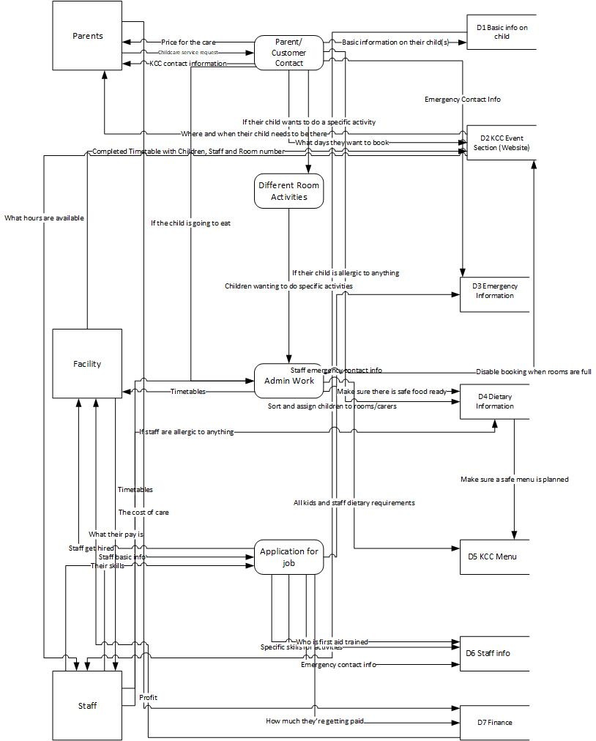
As you can see here this is my first DFD, with this one I have tried to include as much information. My second DFD which you can see here I have simplified a bit for one specific area of the data.

This DFD shows the first steps of a parent applying their child for caring and some of the important information that might go amiss if you are doing it by hand.

Here you can see my ERD, this shows all of the information that each individual needs to present to one another so they can all work well together.

