Experimental Strategies
Ellie Thomas
BA Photography in the Arts
Ryan L. Moule & Joe Coleman

Research Report
Word Count: 2469
The Parc Tawe pathway was the location that I selected for this project because, although being a route from the castle gardens to Parc Tawe shops, the walkway itself is quite intriguing. When taking a closer look at the space I realised that it had a cold and industrial feel to it especially with the walls being painted grey and the metal fixtures. I believe that the space itself has a lot of potential to be something other than just a walkway which influenced my decision to create an exhibition within this space. I captured photographs of every section of the pathway and conducted research on the location before determining what artwork I would put here.
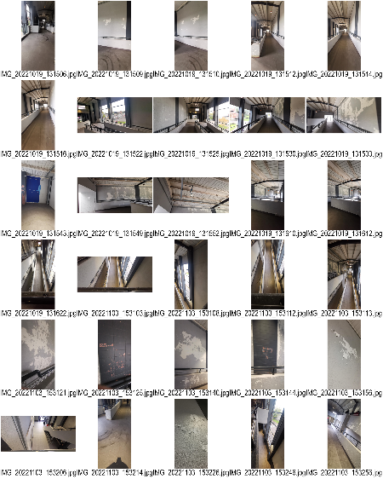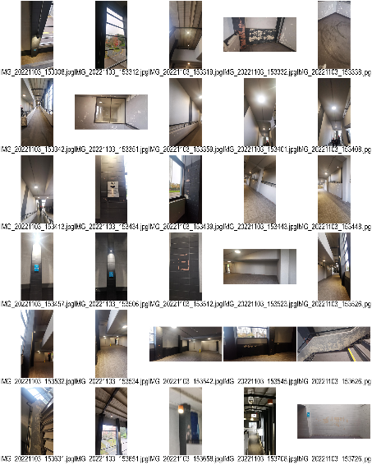
After conducting my research, I learned that in 1852, this location was the site of a dock that was first known as the "Town Float" but later changed its name to the "North Dock" and was built to divert part of the River Tawe into a channel known as the "New cut" and transform the original section of the river bed into a "floating dock" so that the ships would remain afloat at all times even on low tides. Prior to the 1920s, the Tawe valley's manufacturers exported 60% of the world's copper through the North dock. However, as the Prince of Wales Dock, the Kings Dock, and the Queens Dock were built, the shipping trade shifted to the east bank of the River Tawe. The North Dock was closed in 1930 because it was no longer required as a result of the construction of larger docks, decreased trade, and increasing ship sizes. The dock was demolished and turned into a wasteland that remained abandoned for many years. Because the location was not developed, it eventually developed into the "Hole in the Wall," a shortcut to the town. In the late 1980s after the site had been cleared the new Oasis Park shopping centre opened but later became known as Parc Tawe. Architects RGP were hired to create a wayfinding graphic to draw visitors through the complex whilst adding historical context in order to preserve some of the site's heritage.
In 2007, Richard wilson installed Turning the Place over in Liverpool’s city centre. The work consisted of a vast ten metre diameter ovoid section of the façade of an abandoned building in Liverpool. The section of façade had been cut which allowed it to rotate. The ovoid section was fitted onto a central spindle and aligned at a specific angle to the building. The spindle was placed onto motorised industrial rollers as this allowed it to rotate 360 degrees continuously. This artwork continued to operate up until the 8th january 2011. This piece of work that was created by Richard Wilson has inspired what I want to do in the Parc Tawe walkway as he has taken a building that was abandoned and by creating this work it gave the building a new life. By having an exhibition inside the Parc Tawe walkway it will give the space a new lease of life even though it is not abandoned like the building Wilson used no one really acknowledges the space as they are using it as a connecting point to get from one place to another but with artwork being displayed they will finally see what the space has to offer. This exactly why the group has decided that our photographs would be of the space rather than the history or something else.
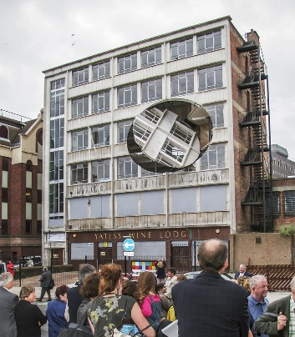
Roman Ondák’s work Measuring the universe has been presented at many locations over the year which include the Pinakothek der Moderne in Munich in 2007, MoMA in New York in 2009, the Stedelijk in Amsterdam in 2010–11, and at Parramatta Town Hall, Sydney, in 2014 as part of the Sydney Festival. As visitors enter the room, they are asked to stand against the wall so that their height can be noted and labelled with their name and the date of their visit. This work would not be possible without audience participation as it begins with an empty white gallery space. Measuring the Universe took place over the course of nearly three months and in that time frame there was thousands of measurements that formed a thick black band then encircled the gallery walls. Before opening the space Ondák was the first to be measured. Some of the measurements can be seen above or below the band’s boarders which highlights the presence of taller and shorter participants. Roman Ondák stated that “the idea is taken from a habit of parents to measure children” he went on to explain how he has carried out this tradition in his own home with his two sons. The marks of growth indicate time’s passage and how as we age, our experience and understanding of time, and the world itself, changes as the title Measuring the Universe would suggest. I have chosen to look at this piece of work as it has similar characteristics to what I want to create due to them both being marks created by the public. However, the marks that I will be focussing on are considered an act of vandalism whereas this was the intended outcome for the space. Unlike Ondák my work will be focusing on the existing marks in the Parc Tawe walkway and displaying them individually whereas this artist has encouraged the audience to participate and create the exhibition by adding their height, name and date to the walls. I had thought about having a space where people could add their own initials into the space as they walked through the exhibition but I realised that this could be a health and safety risk as it could cause crowding which is something that we did not want in this space as it is a public walkway.
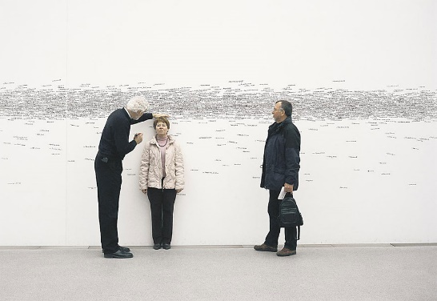
The space has a lot of marks that have been created by bikes, people carving or writing on the walls, and even paint that has chipped and fallen off, which I noticed after looking to see what this area had to offer. Before deciding to dedicate a piece of work to the initials that were scratched into the wall by the public, I considered how I would respond to the history of the space. For instance, I considered making a timeline of the area that would show the public exactly what this has been over the years or taking pictures of the docks as they are now and putting them on display in the area to show what it once looked like. After considering several various concepts, I came to the conclusion that my work would be based on the marks since it would highlight the physical features of the area that people utilise to move from one point to another. When deciding on what I would do with the initial markings I was sure on how I would display them but when talking with another member of the group Kino we decided we would combine our ideas together. Kino was going to use a lighting kit to just highlight sections of the space but after talking about our ideas we decided that we would make a mobile out my acetates and then use the light to project them onto the walls in the walkway. Before creating the acetates Kino and myself went to the space to test how we could use the Godox lighting kit by seeing if we could set it up in the space safely without it being an issue to the public and if the light would be bright enough for the space. Kino’s original concept was to create a column with the light rather than it just filling the space and to test this we used two books that we had on us to see how well we could create the column. However, when setting the exhibition up we decided against this idea as it gave us more space to display the photographs.
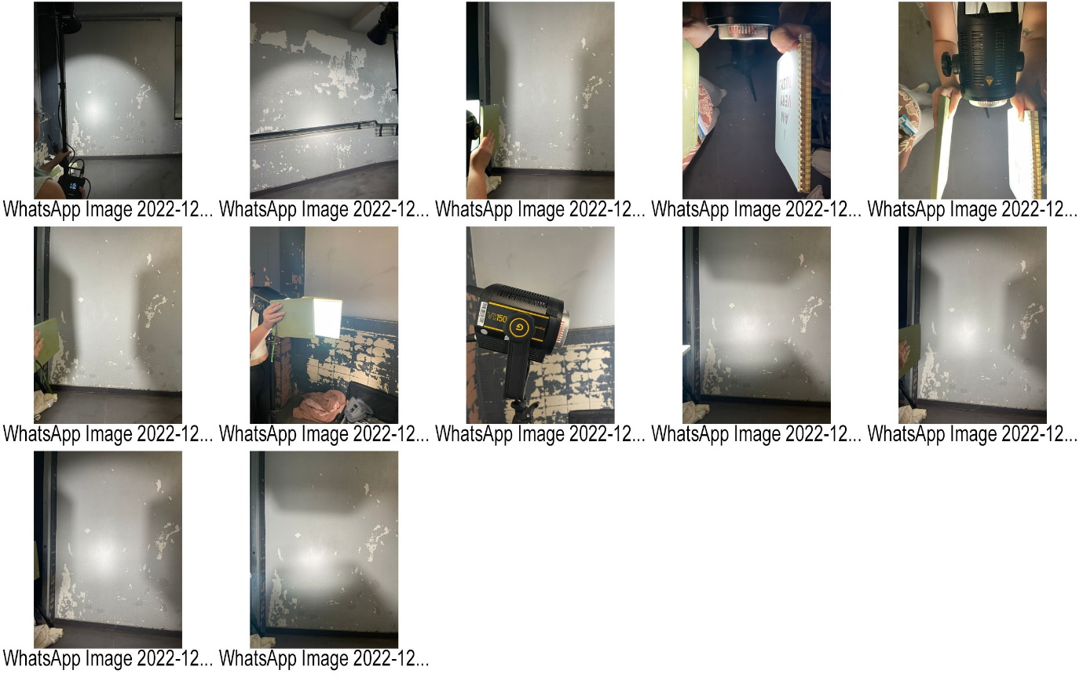
To create this work, I had to learn how to make acetates as this was something that I had not done previously so to resolve this I had to book a tutorial with the technician so that he could show me what I needed to do. Once I knew what to do, I printed out six images which I and Kino then tested them out with the lighting kit which can be seen in the video linked below.
https://youtube.com/shorts/YoMftgbL4Os
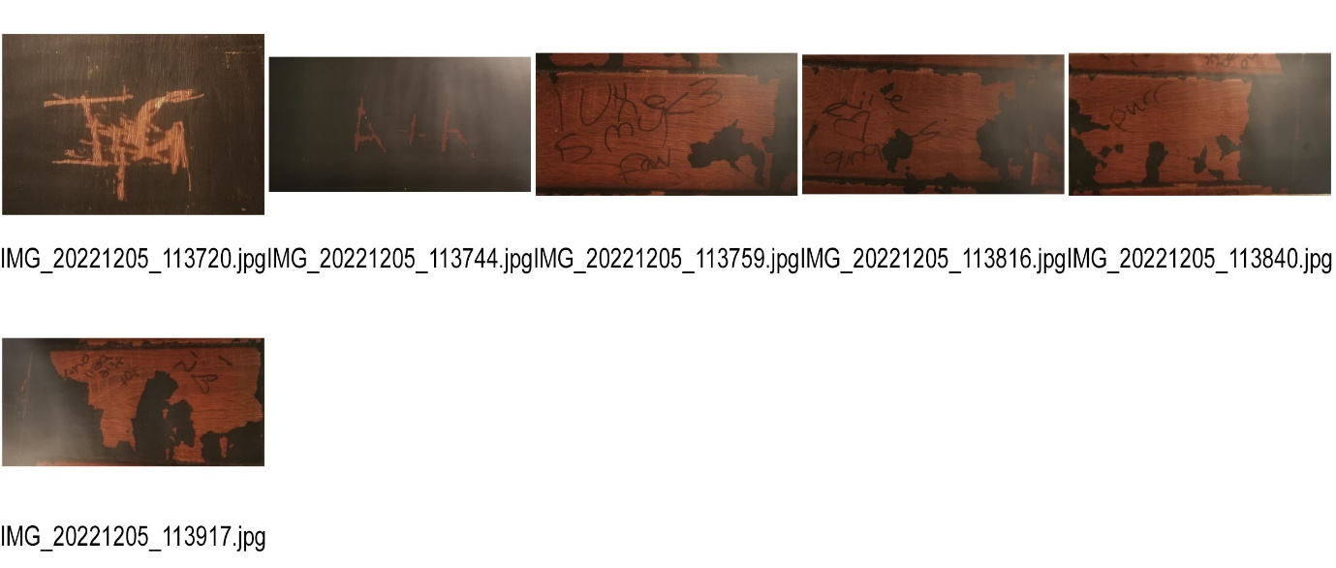
As you can see in the video the acetates did not work as I had planned so I realised that I would need to edit them and remove the background from them so that the only part of it visible was the initials as it would make it easier to project the image with the Godox lighting kit.
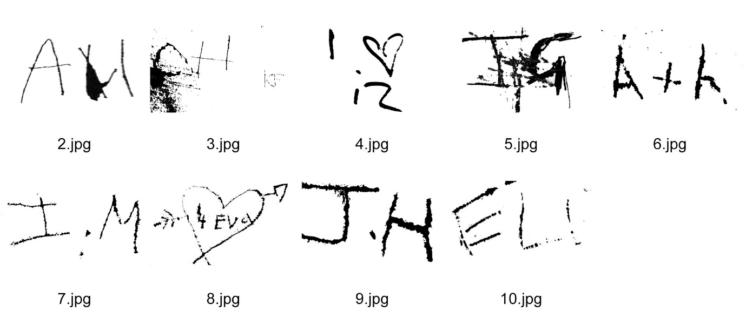
After changing the acetates, we tried it out with the light just to make sure that it would work how we planned, and we were very pleased with the results. The next step was to create the mobile of acetates but due to the limited time we had we were no longer able to produce this so we decided that we would hang each other acetates below each other by using clear fishing wire to attach them together.
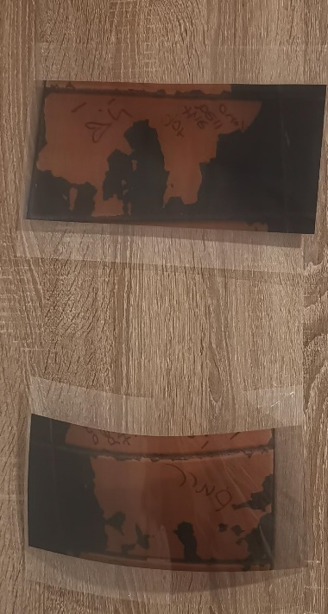
First attempts of attaching the images 1
Once I knew how to attach the images together the only thing left to do was install them in Parc Tawe. When attempting to install this in Parc Tawe I ended up having to change the location as I was originally going to hand it from the beams on the ceiling but realised that we could not reach it but there was another beam in the same area that was lower down which we managed to attach the images to. To make sure that they were secured safely and that they would not fall down we used zip ties with the fishing wire. Attaching the images to the beam took a lot longer than we initially thought as we had no tested out how to hang them in the space before our tester day which was the 30th november so this would be something that I would be more cautious of with future exhibitions so that it when the exhibition opened I would know exactly what I am doing instead of trying to figure it out on the day.
I employed a variety of research techniques throughout this module to make sure that my artwork will have the intended impact. In order to decide whether I wanted to respond to the site's history or the site itself, I began by conducting concept research on the space's past. Following my concept study, I went on a trip where I repeatedly visited the location to get to know it inside and out and to absorb the ambiance so that I could respond to it in my artwork. My fellow group members went with me to the site on a few occasions so that we could debate the location and work through our thoughts as a group. In doing so, we also used the research technique discussion. Due to the concept, I came up with for my piece, I had to use an artefact. I took the initials that were carved into the walls and used them to emphasise something that is already a physical feature of the space. Prior to starting any work, Richard Wilson and a number of artists drew my attention. Roman Ondák's work specifically motivated me to choose to emphasise the markings on the walls since I was unsure of which idea to pursue. The last research method, I employed was practical because I had to produce my work, but before, I had a tutorial with the technician to learn how to produce acetates.
Overall, the exhibition was successful as we managed to get every piece of work displayed and it did help to draw the public’s attention to the space, they were walking through which was the intention of having the exhibition here. If I was to recreate this exhibition one thing that I would do differently is how we advertised it as we did not have a social media page set up and in the space I would have included a piece of text to explain what we were trying to achieve with our exhibition as the public were not really sure what we were doing. One positive of not having the piece of text was that it encouraged the public to interact with us and ask us about what we were doing, and this might have had a different result if there was a piece of text telling them what we were doing instead. When discussing the succession of the exhibition of the group about what we would’ve done differently we decided that Rosie’s work would’ve benefited from being bigger as the size she printed in turned out smaller than we had thought it would’ve been, Chloe’s work was very successful except for two of her pieces that she had stuck to the wall with command strips. After about two hours her work fell off the wall and the command strips did not work well against the texture of the walls so for the next day of the exhibition, she attached them to the wall using zip ties, but this impacted how it looked as it no longer had the seamless affect it had the day before. Jacob’s work was displayed very well but one thing that I think should have been improved was the number of QR codes that he had printed out as there were only four, whereas I think there should have been a couple more displayed around the space rather than them just being near his work and the rest of the groups work. Kino and I discussed that we would have displayed our work different if we had more time to figure out the best way to attach it together and how to hang it from the beams. I believe that we successfully managed to get the public to engage with the space they were walking through instead of just ignoring it like normally. One problem we had was that occasionally there was a lack of communication from a group member, which made it take longer to complete certain aspects of the task as we tried not to step on each other's toes. For instance, it took us longer to reserve the space because Adam G, the owner of the space, needed to know what we intended to display there and how. However, due to a lack of communication, it took us longer than necessary to give Adam the information he required.


