
how to build A highly effective team
THE CASE STUDY OF Effective Team Working and Communication module BMSW4002


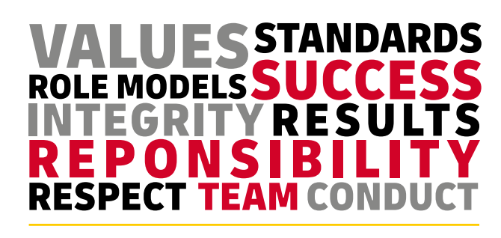

Written by Katarzyna Raza 2027554

December 10, 2021
University of Wales Trinity Saint David

Table of Contents
1.0 Executive Summary 2
2.0 Terms of Reference 3
3.0 Procedure 3
4.0 Introduction 4
5. 0 Findings 5
5.1.1 Belbin Theory : 6
5 .1.2 Tuckman theory 7
5.2 Importance of 2-way Communication. 8
5.3 Why is Effective communication essential 10
5.3 Why is Team working necessary? 10
5.4 Why is effective teamwork important for the continued success of the organization.? 11
6.0 Conclusion 11
• using Belbin Team Roles can help create : 11
7.0 Recommendations (If appropriate) 13
8.0 Bibliography/References 14
References 14
9.0 Appendices 15
10.0 Acknowledgements 16

1.0 Executive Summary

Andrea Jones, the owner of a medium-sized retail store in Swansea, has asked how to build a highly effective team for her organization.
This report contains modules and theories about two-way communication and teamwork, why they are essential for growing an organization, and how they should be implemented.
Belbin theory is presented in and explained in this report to show the importance of different team roles, how they should be implemented in the organization and how vital it is to understand people’s behavior, skills, and needs.
Tuckman’s theory highlights different stages during team forming.
Showing the importance of understanding people’s feelings and reactions during every stage allows the company to spot and resolve conflicts faster.
Knowing that conflicts will usually accrue in the storming phase of the team forming gives managers an advantage to “be ready” and have a plan when it happens.

This report explains SMART objectives to show the central issue in the company and how using Smart objectives tactics can helo in finding the company’s primary goal.
Three Communication modules highlight the importance of two-way communication in the workplace and how communication should be supposed to work in every workplace.Recommendations are provided at the end of the report, highlighting the importance of well-structured teams and communication between employees.

2.0 Terms of Reference
This report was requested by Melanie Squire, a teacher at the University of Cardiff Trinity St. Davies, as a case study for the Effective Team-working and Communication module BMSW4002 written by the student Katarzyna Raza, student number 2027554.
The report aims to investigate and contribute my idea as a business consultant for Andrea Jones Retail store development.
This report explains the importance of using theories in building a practical and high-performance team. What is two-way communication, and why is it important.

3.0 Procedure
The information for this report has been collected from several books, online articles, University learning tools, notes from the lectures.

4.0 Introduction
Andrea Jones is the owner of a medium-sized retail store in Swansea. After the pandemic, they have adopted a permanent online presence and serve customers via online service through deliveries. As her business grows, it needs to be more organized, structured, and trained effective teams.
The prominent People of the Company are Managers; they should encourage other employees, guide them, and make sure, that communication and quality of work are in place.
Nevertheless, there are 3 Managers, which are not communicating with each other, there is no clear vision of Company goals and objectives.
The company has 27 employees :
Six working in the stock room: their primary responsibilities are:
- Accepting deliveries,
- Filling the shelves,
- Processing online orders.
Some of them work night shifts without a manager on-site, and some of them work from home.
There is no record or schedule to clarify how many are on which shift.
There is no team, only a group of people working for this same employee who does not know each other well, creating a lack of trust.
They do not know what company objectives are; it is unclear if orders and deliveries are handled with care and on time as there is no supervision, no experts who can advise the less experienced workers.
Fourteen sales assistants, some are working from home.
The manager trains mostly part-timers and the new starters on duty.

One cleaner, two drivers -probably each driver is working 12hrs per shift.
Currently, The Company has no structure, working schedule, trained teams, or objectives.
There is only one security guard in place, which is open between 8 am-10 pm -in this case, either he is working more hours than he is supposed to do, or the company is not always secured were, in this case, is putting other workers in danger.
Teamworks theories can build a highly effective team, create better communications, avoid conflicts and meet Company Objectives.

5. 0 Findings
One of the most crucial things before building new teams is to set up company goals. To do this, Management should set up meetings, using Swot and pestle analysis to set goals and monitor them.
Every business needs a list of SMART objectives; it helps the teams understand what they need to do and why. (Doran,1981)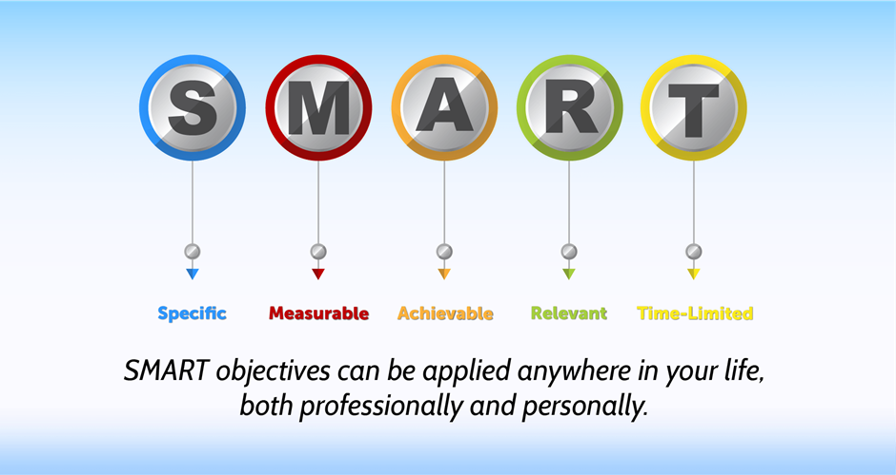
According to Becky Simon:
- “Effective teams are good at setting goals and then creating (and sticking to) a process, schedule, or framework to meet these goals by a deadline. They are good at coordinating their efforts and assigning responsibility so that everyone knows what they are doing and why it is essential to the task at hand. “
  - “Ineffective teams, on the other hand, do not set clear goals and do not outline a clear path to meet these goals. Since they do not know their goals, they typically struggle to assign roles and responsibilities. As a result, there is confusion about what people are supposed to be doing and why it is important. (Simon, 2017)”

5.1 How applying teamwork theories can improve teamwork and create an effective team?
Many theories can help to create an effective team.

5.1.1 Belbin Theory :
Dr. Meredith Belbin identified nine team roles: a group of different people with different skills, talents, and behaviors to create a highly performed team. These roles are in three categories: Action-Oriented, People-oriented, and thought-oriented. (Belbin,1981)
Managers will better balance the team by determining which roles team members are taking on. Understanding the different roles also gives greater insight into individual team members’ strengths and weaknesses, improving conflict resolution and team performance. (Anon., 2021)

5 .1.2 Tuckman theory
Tuckman’s theory is relevant to team-building challenges as the phases pertain to completing any task given to the team.
It explains the stages which every team will face.
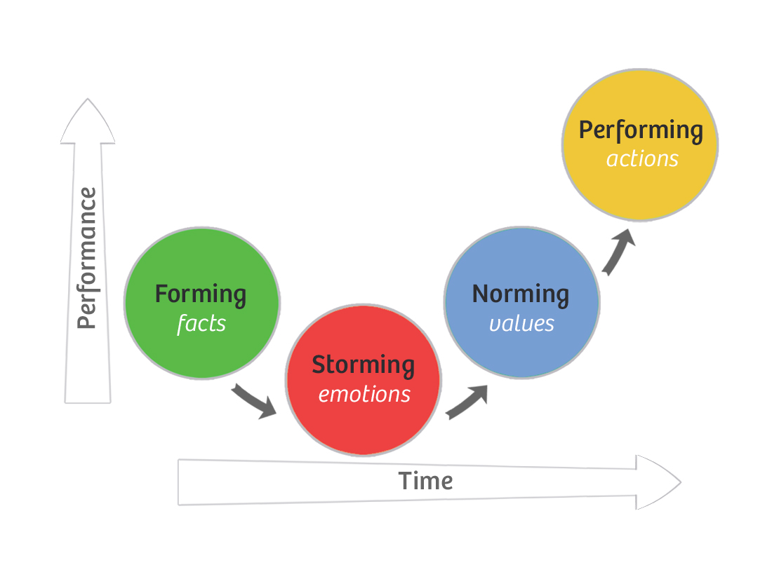Tuckman’s theory explains how humans interact in certain situations.
During the forming stage, everyone will try to know each other, find out the place and reason, why it is in this team, which role it will play.
In the storming phase, the person has his ideas, as every person has their personality can often clash, as they will have a different way of working,
The one person in the team will be slower by putting more attention to details,the other is faster and wants things done as soon as possible as is very confident that is doing everything in the right way.
Conflicts can happen where teams are not formed correctly (Belbin theory has not been considered), and there are more coordinators than team players, or the team will be based only on Monitors evaluators, which will have difficulties to make a decision.
In the norming stage, everyone knows each other, knows what the goal is, what are each other responsibilities, trust each other, and respects their own space. The team is formed, everyone knows who the leader is, and the leader makes sure that the rest of the team can count on him; he is probably the most experienced or the most likable person in the team.
Performing is the last stage in creating an effective team-after, after going through all the previous stages, everyone is working hard to achieve a common goal.

5.2 Importance of 2-way Communication.
Correct communication is that kind of communication where information flows in both ways. A sender sends the message to the receiver, and then the receiver sends a message back to the sender; this is called Two-way Communication.
There are two types of two-way communication
Verbal and Non-Verbal :
We will use the words in verbal communication by talking to someone or sending a message by letters, emails, or text.
Non-Verbal communication uses expressions; it is important what we see, not what we hear;
it is vital in every workplace, as it can be used during work interviews.
It allowed Us to understand more and figure out if the people around us are honest. It will help understand team dynamics and behaviors by watching.
- Shannon-Weaver model of communication
a simple basic model which explains the communication process; the model was created in 1949 for the phone industry.

In this model, communication occurs when a message has been sent and received.
However, have a limitation as it is only one way of communication. There is no feedback, no confirmation if the message was received or not.
There is a noise that can give a different outcome to the message, so the receiver will get a different message from the message that the sender has sent.
This model cannot be used in business, as it will create misunderstanding, leading to conflicts.

- Berlo’s model of communication

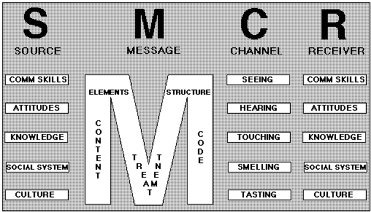
Berlo,s model of communication is based on Communication skills, attitude, knowledge, and culture,
The content of the message has to be clear, and the speaker will have knowledge and understanding of the topic, be correctly structured and understandable, the channel is using all human senses, and the receiver is on this same or similar level than the sender.
An example can be two doctors talking about the ongoing operation.
It will only work where sender and receiver are on this same level of knowledge, will not have a good result when used in the workplace, where there are mixed people whit different skills and experience.
- Schramm’s Model of Communication
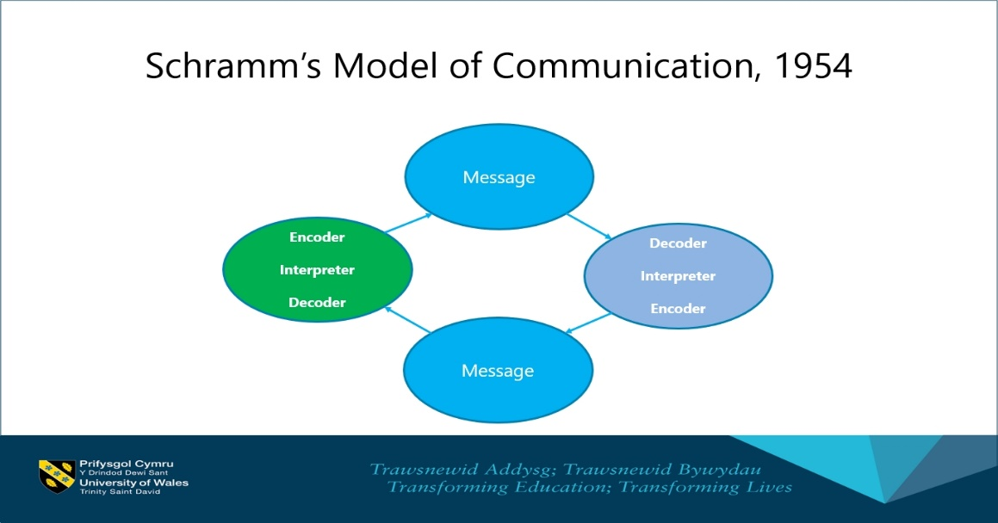

Schramm’s communication model is the two-way communication process, where the sender will send a message, and the receiver will reply. It is a simple explanation of two people’s conversation.

5.3 Why is Effective communication essential

According to Rebecca peters from CIPD, “Effective internal communication is vital in developing transparency in organizations. Clear and consistent internal messaging is needed significantly as organizations’ nature and workforces are constantly changing, driven by factors such as technology and diversity of employment contracts. (Peters, 2020)
Author Dev (2018) states that Effective Virtual Communication delivers the ability to communicate more efficiently and quickly.
Effective Virtual Communication has significant advantages like;
- Employees can share ideas and move forward faster.
- Forming relationships which are keeping them energized, inspired, and positive.
- They trust each other and can talk more openly and honestly in this way, and there will be no conflicts
- Increase productivity
- Enables the organization to find new talents
- Everyone knows what a clear mission, targets, and goals are.-there will be no misunderstanding.
- New employees will be able to give feedback, as questions -well-informed and trained employee will be more efficient.
- Problems will be highlighted and handled easier and faster.

5.3 Why is Team working necessary?

Middleton (2021) states that recognizing their strengths and addressing their weaknesses can make them better team players. Here the author motivates and delivers a tip to be a better team player in a team.
In addition, the author emphasizes the importance of team working with the following elements;
- Diverse ideas in a team bring up innovative solutions
- The workload is shared easily
- Recognition obtained from other team members increases our productivity
- Working in a team reduces stress.
- Working in a team improves our skillset personally.
- Make people feel that they belong.
- Bust confidence

5.4 Why is effective teamwork important for the continued success of the organization.?

What does this mean for Andrea Jones company?

- It means that well-structured and well-working teams will work more efficiently.
- There will be better communication between employees and Management.
- Working successfully as a team towards a joint goal helps everyone to work better together (Edu,2021)
- There will be fewer customer complaints, and better customer feedback will help a company grow.
- Smooth exchange of resources and responsibilities amongst team members allowed any project to work quickly and efficiently.

6.0 Conclusion

In conclusion, The long-term success of every business requires that the right talent.
The team is the company’s backbone, and one wrong person can make work difficult for everyone else in the team. Whether building an on-site team or a remote workforce, one thing remains the same -- the right talent matched with the same vision will significantly improve the chances of success. (Long, 2017)

using Belbin Team Roles can help create :
- Balanced teams based on behavioral contributions rather than job titles
- Self-aware individuals who can adapt their behaviors according to the situation and business need
- The right people do the right tasks, leading to better-performing teams
- Depersonalised team conversations, using a common language to discuss team contributions(Belbin,2021) (Anon., 2021)

- Tuckman’s theory helps understand all the stages of team forming, highlights the importance of communication, and shows which stage conflict will occur and how to handle it.

- Three Communications models explain types of communication and why it is crucial to understand human behavior.

This report highlights the company’s problem, advising on creating a good working team to improve communication, better relationship, and efficiency.

7.0 Recommendations (If appropriate)
Recommendations:

The communication schedule should be set:
There is no communication between Managers:
Daily Handover between Managers allows them to record what has been done and what needs to be done.
Managers and employees do not know each other:
Daily meetings between managers and on-duty teams -will highlight daily problems, share responsibilities between teams, set up daily targets.
There are no clear how many people are working on which shift, what they are doing, and how much:
Working schedules should be created-exact time who is working when and where allowed Managers to plan shifts easier, more productive, and efficient.

New starters should be working with the most experienced person on shift and training should be provided by the department’s expert, that new employee will be working.

References
Anon., 2021. Mindtools. [Online]
Available at: https://www.mindtools.com/pages/article/newLDR_83.htm#:~:text=%20Understanding%20Belbin%27s%20Team%20Roles%20Model%20%201,ideas%20and%20approaches.%20They%20thrive%20on...%20More%20
[Accessed 07 December 2021].
Anon., 2021. Why Use Belbin Team Roles?. [Online]
Available at: https://www.belbin.com/about/why-use-belbin
[Accessed 08 December 2021].
Edu, T. L., 2021. What is the Importance of Teamwork?. [Online]
Available at: https://leverageedu.com/blog/teamwork/
[Accessed 10 December 2021].
K.Smith, J. R. a. D., 1993. The Wisdom of Teams. Boston : McKINSEY& Company Inc..
Long, J., 2017. 5 Factors That Contribute to the Success of Your Business. [Online]
Available at: https://www.entrepreneur.com/article/305688
[Accessed 07 December 2021].
Mark Knapp, J. A. H. t. G. H., 2014. Nonverbal Communication in Human interactions. eight ed. Boston: Wadsworth Cengage .
Peters, R., 2020. CIPD. [Online]
Available at: https://www.cipd.co.uk/knowledge/fundamentals/relations/communication/factsheet
[Accessed 08 December 2021].
Simon, B., 2017. smartsheet. [Online]
Available at: https://www.smartsheet.com/team-working
[Accessed 08 December 2021].

References

9.0 Appendices

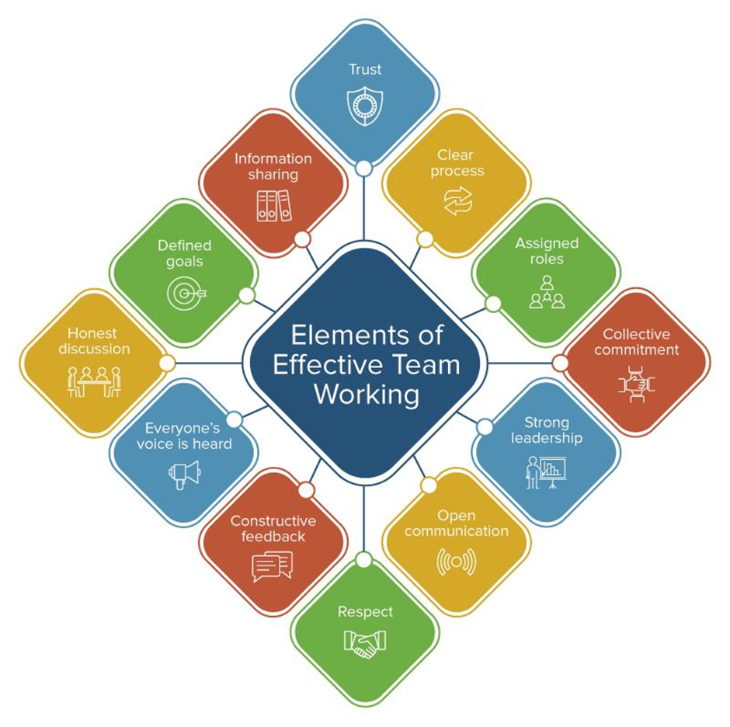

10.0 Acknowledgements
I want to thank :
My Tutor Melanie Squire, for the great and full of information lectures, for being patient and friendly, making everything look easier, believing in us, and giving confidence.
My Brilliant fellow students for being part of my journey, motivating each other, help and support.

