The Importance of Effectively Monitoring Guest Service Approaches

Student Name: Robert-Daniel Mihalcea
Student ID: 2240761
Module Code: BMIH4003
Word Count: 1490
Table of Contents
Introduction 3
Reputation Management 3
Market Trends 3
Challenges 3
Recommendation 4
Comparison of Global Hotel Players 4
Service Culture 5
Market Trends 5
Challenges 5
Recommendation 6
Comparison of Global Hotel Players 6
Brand Consistency 6
Hotel Standards 7
Conclusion 7
References 9

Introduction
Management of hotels and other types of lodging enterprises worldwide is what international hotel management means (Ford and Sturman, 2020). It includes guest services, lodging, food and beverage, advertising, finance, and HR. The hospitality industry is competitive; therefore, hotels must follow the newest trends to stay ahead (Liu and Yang, 2021). Keeping up with the industry is another approach to guarantee the firm provides the consumer experience they expect. This report will show the reputation management and service culture among the global players existing in the study. Moreover, it will also critically discuss and show examples of brand consistency and hotel standards.

Reputation Management
Reputation management has assumed critical importance in the cutthroat hospitality sector (Walker, 2020). Keeping a good reputation is crucial to bringing in and keeping repeat customers. This has both short- and long-term effects on a hotel's bottom line.

Market Trends

Online Reviews and Ratings
Research by Jenq (2019) on Internet hotel ratings and reviews shows that a one-point review score raises ADR(Alternative Dispute Resolution) by 9%. A 10% increase in favourable ratings may improve sales by 4.4%. Although good feedback is easy to respond to, negative criticism is as important. Building trust with new and returning visitors requires review responses.

Social Media Influence
Travellers' stories are amplified when shared on social networking sites like Instagram, Facebook, and X. A hotel's online reputation may take a serious hit from even one striking image or timely article (Wang and Anderson, 2023).

Transparency and Authenticity
Guests in the modern day appreciate openness (Padma and Ahn, 2020). They value real interactions and encounters. Hotels with clear descriptions of their amenities and a willingness to implement guest suggestions tend to have more success.

Challenges

Vulnerability to Negative Feedback
A hotel's reputation may be severely damaged by a small number of unfavourable online reviews (Lee et al., 2019). A single negative review posted online might have a significant impact on future reservations.

Managing Online Presence
The development of digital channels means that hotels must be vigilant in monitoring and contributing to discussions about their brand. This will take some effort and supplies.

Maintaining Consistency
Consistent quality of service across several properties or locations may be difficult to achieve in a global business. Disagreements might cause a fragmented representation of the brand or product (Aiyar et al., 2023).

Recommendation

Proactive Engagement
Communicating with visitors on review sites and social networks is essential. Positive and negative comments should be acknowledged, and the desire to resolve problems should be shown.

Implement Feedback Loops
Incorporate visitor comments into the procedures for fast problem-solving throughout their stay (Marcolin et al., 2021). In addition to fixing the problem, this effort exhibits dedication to the delight of the guests.

Invest in Staff Training
All employees must get enough training to ensure they can consistently provide excellent service. When workers are content and well-informed, they enhance the experiences they provide for guests.

Leverage Technology
Execute applications are designed to oversee and administer reputations. Among them are customer relationship management (CRM) platforms and sentiment analysis programmes.

Comparison of Global Hotel Players

Focus on guest feedback.
Marriott and Hilton prioritise visitor feedback. These hotel brands often gather visitor input to enhance operations and amenities (Hilton, 2022).

Use of social media
Others like IHG and Hyatt utilise online platforms well (Chaturvedi and Mahanta, 2022). These hotel chains connect with visitors, promote their businesses, and oversee their reputations on online platforms.

Partnerships with OTAs
The hotel operators Accor and Wyndham collaborate extensively with OTAs to maintain accurate listings and positive brand reputations (Solomon, 2019).

Service Culture
Service culture refers to the norms of conduct governing how staff treat customers and one another (Heppell, 2015). It is crucial to the hotel sector since it affects visitor pleasure and loyalty.

Market Trends

The rise of digital technology
Hotel guests are increasingly reserving and checking in online. Hotels must provide smooth and fast digital experiences to fit their service attitude with this evolution.

The growing demand for personalisation
Inngoers depend on establishments to cater to their specific requirements and whims (Ko, 2023). Hotels should encourage their staff to provide guests with individualised service.

The increasing focus on sustainability
Hotel guests are growing more eco-conscious and want sustainable lodgings. Hotels should reduce energy and trash to promote sustainability.

Challenges

High turnover
High turnover in the hotel sector makes it hard to create a service culture. Hotels must offer development and training to assist staff in delivering exceptional customer service (Harkison, 2022).

Language barriers
Tourist hotels generally have multilingual personnel. This makes communicating and implementing a service culture across cultures difficult. Hotel multilingual workers require cultural sensitivity and communication lessons.

Budget constraints
Hotels have minimal margins, making it hard to invest in service culture. However, hotels must invest in service culture to boost customer pleasure, loyalty, and revenue.

Recommendation

Invest in employee training and development
Training and developing staff is crucial since they represent the hotel's public face. Hotels should provide classes in interpersonal skills, cultural sensitivity, and verbal and written communication.

Empower employees
Employees should be given the autonomy they need to provide a unique and satisfying service to each customer (Peng et al., 2022). The hotel staff should be encouraged to take initiative and think creatively.

Create a culture of feedback
The employees of the hotel have to establish an environment where they may freely provide and receive suggestions. This will aid in identifying and resolving weak spots in the service culture.

Comparison of Global Hotel Players

Emphasis on luxury
Luxury and personalised service are hallmarks of Four Seasons and Ritz-Carlton. High staff-to-guest ratios and extensive personnel training characterise these hotel brands.

Emphasis on value
Value and reliability are hallmarks of the Holiday Inn and Hampton Inn brands. These hotel businesses strive to provide a uniform experience for their patrons across all of their hotels, employing fewer people to do so (Hill, 2023).

Emphasis on sustainability
The eco-friendly practices of Soneva and Six Senses are well-known. These hotel groups have adopted several eco-friendly policies, such as switching to renewable energy sources and cutting down on trash.

Brand Consistency
Maintaining a recognisable hotel brand requires unwavering adherence to established branding practices. Brand consistency refers to the maintenance of cohesion between a company's digital and brick-and-mortar identities (Jeong et al., 2022).
Marriott International is an excellent illustration of how to maintain a consistent brand. Through its reward programme, Marriott Bonvoy, and the use of brand hallmarks like spotless, contemporary decor and personalised service, Marriott can maintain uniformity throughout its more than 31 distinct hotel brands (Marriott International, 2023). This regularity helps create trust and familiarity among visitors.
Smaller, independent hotels may find it more difficult to maintain brand consistency. Their low resources and fragmented ownership might make brand consistency difficult to achieve and sustain. The difficulty of providing the same individualised service at several boutique hotel locations is one example.
Hotels may act by implementing brand standards, training programmes, and technological solutions (Dogru et al., 2023). In addition, they may use several online mediums to spread the same marketing message uniformly. To improve brand consistency, guest loyalty, and revenue development, hotels may take cues from market leaders like Marriott and employ individualised methods.

Hotel Standards
The quality and degree of service that hotel visitors should expect throughout their stay are defined by a set of standards. They play a crucial role in maintaining uniformity and maximising customer happiness.
The Ritz-Carlton is typical of a hotel group consistently delivering exceptional service and luxurious accommodations. Their world-famous service and meticulous attention to detail are guaranteed at every one of their locations. Their quality commitment has given them a solid reputation and a dedicated following (TBH, 2023).
Yet, there are obstacles that smaller, independent hotels must overcome. Meeting industry standards may be challenging for businesses with limited resources and diverse ownership arrangements. These inns may not be able to match the conveniences and services of bigger corporations.
Hotels may take a staged approach to address these issues by focusing first on improving fundamentals like housekeeping, employee training, and client interaction. It is possible to shorten procedures and keep quality high by using technological solutions for business and guest evaluation systems (Morrison, 2022). By measuring against established competitors like The Ritz-Carlton, hotels may contribute towards establishing and maintaining high-quality standards, eventually boosting customer satisfaction and driving commercial success.

Conclusion
In conclusion, there is a wide range of important considerations that go into international hotel management, from brand management to service culture. Keeping up with market trends like online reviews, social media impact, and transparency is essential in the highly competitive hotel business. Challenges, including sensitivity to negative criticism and keeping consistency among characteristics, must be overcome. Proactive participation, feedback loops, staff training, and the use of technology are just a few of the recommendations that give real-world answers. Hotels may gain a competitive advantage by modelling their operations after those of industry giants such as Marriott, Hilton, Four Seasons, and The Ritz-Carlton.

References
Aiyar, Mr.S., Chen, Mr.J., Ebeke, C.H., Garcia-Saltos, Mr.R., Gudmundsson, T., Rodriguez, S.L., Ruta, M., Schulze, T., Soderberg, G. and Trevino, J.P. (2023). Geo-Economic Fragmentation and the Future of Multilateralism. International Monetary Fund.
Chaturvedi, A. and Mahanta, V. (2022). Hyatt has seen a remarkable recovery in India, says the CEO. The Economic Times. 17 Dec.
Cimpanu, C. (2019). Marriott reveals data breach affecting 500 million hotel guests. [online] ZDNet. Available at: https://www.zdnet.com/article/marriott-announces-data-breach-affecting-500-million-hotel-guests/.
Dogru, T., Line, N., Mody, M., Hanks, L., Abbott, J., Fulya Acikgoz, A. George Assaf, Bakir, S., Adiyukh Berbekova, Anil Bilgihan, Dalton, A., Ezgi Erkmen, Mahala Geronasso, Gomez, D., Graves, S., Iskender, A., Ivanov, S., Murat Kizildag, Lee, M. and Lee, W. (2023). Generative Artificial Intelligence in the Hospitality and Tourism Industry: Developing a Framework for Future Research. Journal of Hospitality & Tourism Research, 9(4). doi:https://doi.org/10.1177/10963480231188663.
Ford, R.C. and Sturman, M.C. (2020). Managing hospitality organisations: achieving excellence in the guest experience. Thousand Oaks, California: Sage Publications, Inc.
Harkison, T. (2022). Luxury Tourism and Hospitality Employees: Their Role in Service Delivery. The Emerald Handbook of Luxury Management for Hospitality and Tourism, 7(4), pp.199–219. doi:https://doi.org/10.1108/978-1-83982-900-020211010.
Heppell, M. (2015). 5 Star Service : How To Deliver Exceptional Customer Service. Boston: Pearson.
Hill, LJ (2023). Holiday Inn introduces new design hallmarks to the Middle East. [online] THP News. Available at: https://tophotel.news/holiday-inn-introduces-new-design-hallmarks-to-the-middle-east/ [Accessed 1 Nov. 2023].
Hilton (2022). Hotels by Hilton - Book the Best Rates Across All Brands. [online] Hilton. Available at: https://www.hilton.com/en/.
Jenq, S.-N. (2019). Exploring the Impact of a Hotel's Rating and Number of Reviews through Online Transactions. OALib, 06(05), pp.1–15. doi:https://doi.org/10.4236/oalib.1105401.
Jeong, M., Shin, H.H., Lee, M. and Lee, J. (2022). Assessing brand performance consistency from consumer-generated media: the US hotel industry. International Journal of Contemporary Hospitality Management, 8(5). doi:https://doi.org/10.1108/ijchm-12-2021-1516.
Ko, C.-H. (2023). Exploring the Relationship between Hotels' Performance and Their Owners' Attitude. OAlib, 10(05), pp.1–14. doi:https://doi.org/10.4236/oalib.1110166.
Lee, M., Lee, S. (Ally) and Koh, Y. (2019). Multisensory experience for enhancing hotel guest experience. International Journal of Contemporary Hospitality Management, 31(11), pp.4313–4337. doi:https://doi.org/10.1108/ijchm-03-2018-0263.
Liu, C. and Yang, J. (2021). How hotels adjust technology-based strategy to respond to COVID-19 and gain competitive productivity (CP): strategic management process and dynamic capabilities. International Journal of Contemporary Hospitality Management, ahead-of-print(ahead-of-print). doi:https://doi.org/10.1108/ijchm-10-2020-1143.
Marcolin, C.B., Becker, J.L., Wild, F., Behr, A. and Schiavi, G. (2021). Listening to the voice of the guest: A framework to improve decision-making processes with text data. International Journal of Hospitality Management, 94(22), p.102853. doi:https://doi.org/10.1016/j.ijhm.2020.102853.
Marriott International (2023). About Marriott International | Corporate Information. [online] Marriott.com. Available at: https://www.marriott.com/marriott/aboutmarriott.mi.
Morrison, A.M. (2022). Hospitality and travel marketing. 5th ed. Clifton Park, N.Y.: Delmar ; [London.
Padma, P. and Ahn, J. (2020). Guest satisfaction & dissatisfaction in luxury hotels: An application of big data. International Journal of Hospitality Management, 84, p.102318. doi:https://doi.org/10.1016/j.ijhm.2019.102318.
Peng, J., Yang, X. and Huan, T.-C. (2022). The effects of empowering leadership on employee adaptiveness in luxury hotel services: Evidence from a mixed-methods research. International Journal of Hospitality Management, 101, p.103113. doi:https://doi.org/10.1016/j.ijhm.2021.103113.
Solomon, M. (2019). HEART OF HOSPITALITY: great hotel and restaurant leaders share their secrets. SL: Select Books Inc.
TBH (2023). Marketing Strategies and Marketing Mix of Ritz-Carlton. [online] The Brand Hopper. Available at: https://thebrandhopper.com/2023/09/16/marketing-strategies-and-marketing-mix-of-ritz-carlton/.
Walker, J.R. (2020). Introduction to hospitality management. Boston: Pearson.
Wang, F.X. and Anderson, C. (2023). How Firm Strategies Affect Consumer Biases in Online Reviews. Service Science. doi:https://doi.org/10.1287/serv.2023.0316.

Appendix
Appendix 1
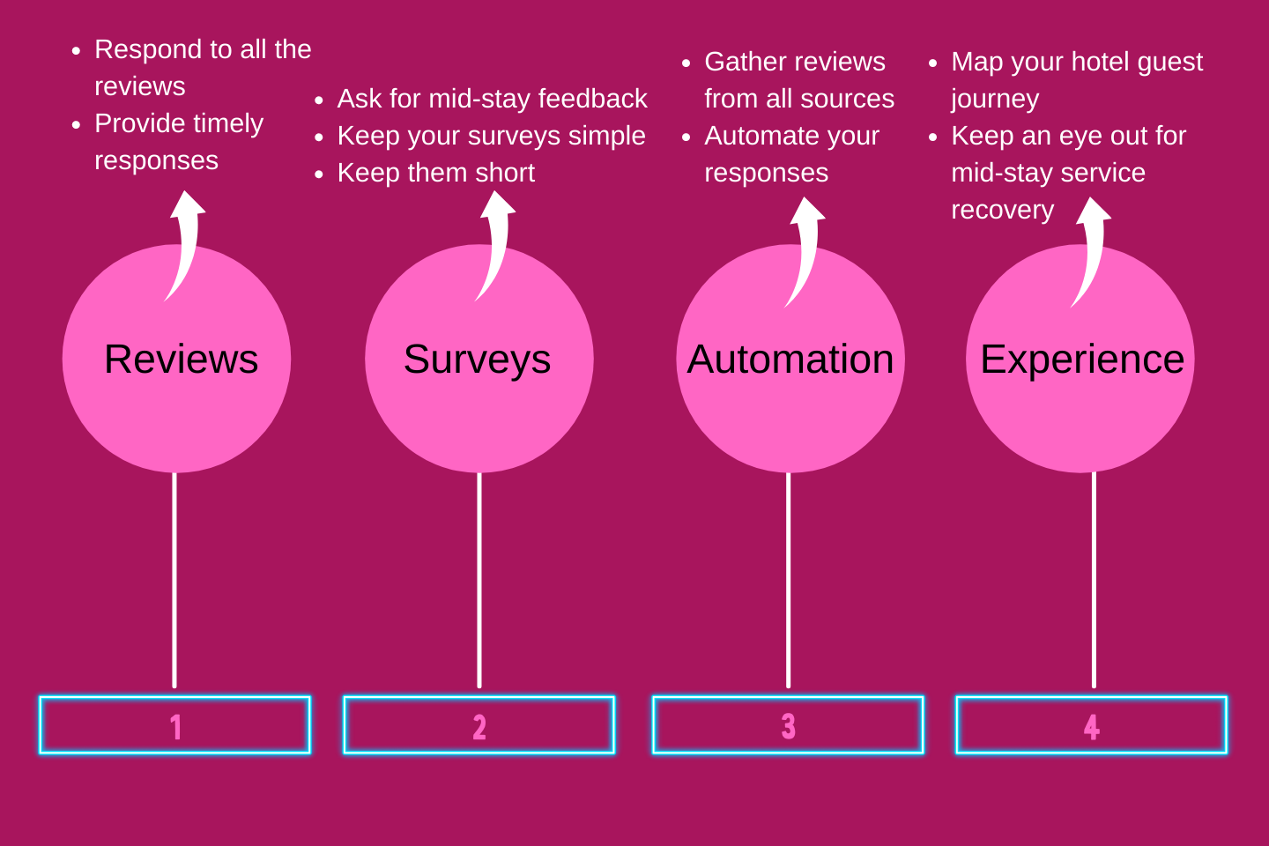
Figure 1: Reputation management in hotels (Tantawy and Losekoot, 2020)
Appendix 2
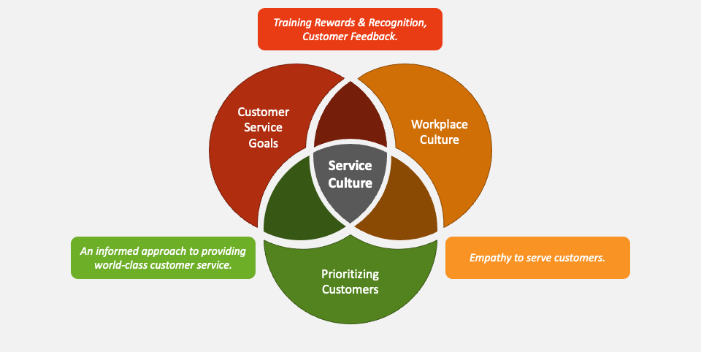
Figure 2: Service culture in the hospitality industry (Peng et al., 2022)

Appendix 3
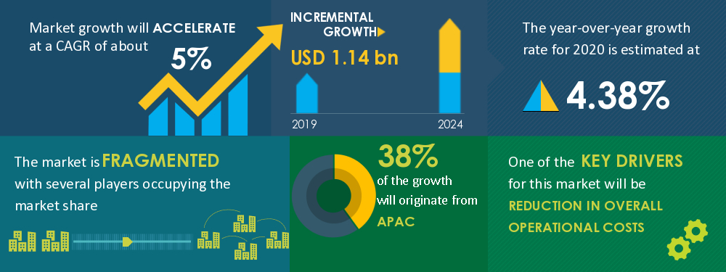
Figure 3: Growth of the hospitality industry (Liu and Yang, 2021).
Appendix 4
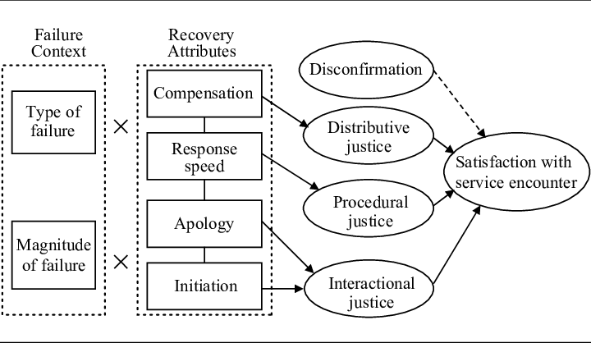
Figure 4: Recovery model from a service failure (Jeong et al., 2022)

