Drive Cycle Generation and Analysis for Potential Implementation of a Series Hybrid System
Jeffrey Elliss
^{UWTSD Swansea}

1. INTRODUCTION

It has been requested that the typical duty cycle of the renegade DX10C offroad buggy be investigated. The company wants to move towards a lower fuel consumption and greener product. This duty cycle analysis will inform decisions about a potential series hybrid system to recover energy and use it to reduce the fuel consumption of the buggy. To investigate the potential benefits of such a system it is important to understand where energy may be recovered and the effects of any such system may have on drivability, efficiency, and customer opinion both in terms of enjoyment and perception of how “green” the company is.

1.1 Initial Assumptions

In order to construct a representative driver cycle a number of assumptions are made about both the drivers actions and the conditions of the vehicle and track. These include but are not limited too:

- When cornering the driver only requests sufficient torque to maintain a constant velocity.

-When traversing a gradient, the driver maintains
close to maximum throttle when climbing.

-When no steering input is required, the driver is requesting maximum torque.

General Assumptions
-The vehicle does not break traction during the cycle
-All surfaces are dry
-When decelerating the vehicle can utilise the full amount of available grip. I.E. at all points the vehicles braking system can produce a force greater than the maximum tractive force that can be generated by the tyres. This was considered to be sufficient detail for the drive cycle itself as the vehicle does not currently have any regenerative systems acting during the braking phase but will have to be modified to incorporate these systems.

-The vehicle mass is assumed to have two occupants of approximately 70kg including safety equipment.

-The vehicle is assumed to have three distinct gears rather than the CVT system that is employed.

1.3 Masses

The mass of the vehicle not including occupants is given. It is assumed that during operation two occupants in full safety gear will be in the vehicle. The author is assumed to be of average mass. Including helmet, neck restraint and races suit totaling to 70kg. This mass was added to the vehicles dry mass as well as assuming a full fuel tank at the start of the cycle.

1.4 Resistive forces and energy losses

During operation all vehicles lose energy in the following ways:
-Aerodynamic drag forces opposing vehicle motion

-Rolling resistance losses due to surface imperfections and hysteresis in tyres.

-Inefficiencies in the transfer of energy from the drive source to the wheels

-Energy used to accelerate the vehicle up to the desired velocity

Other losses that are not included in the calculations include but are not limited to:

-Force required to change the direction of the vehicle by deforming the tyre.
-Energy lost due to the motion of suspension dissipating energy through the dampers.

1.4.1 – Aerodynamic Forces

The aerodynamic drag losses are relatively low due to the low velocities at which the vehicle operates although a vehicle of this type is likely to have a high coefficient of drag. In this case assumed to be 0.55 as the vehicle has exposed wheels and little bodywork. The frontal area of the vehicle was approximated at 1.5m^2 by examining a picture of the vehicle and scaling from the known size of the wheels.

1.4.2 – Rolling Resistance

Rolling resistance can be considered as the retardation force generated by a vehicle moving over flat ground after aerodynamic forces are removed. It is typically dependant on tyre geometry, inflation pressure and the surface the vehicle is on. This model assumes that it does not change with vehicle speed however in reality the coefficient of rolling resistance will increase with velocity due to the increased rate of energy loss required to deform the tyre. (Wong,2001,p8) The vehicle operates at relatively low velocities in this drive cycle and as such this effect is assumed to be negligible.
The rolling resistance of ATV tyres on a gravel track can be taken to be approximately 0.09 as measured by Petterson and Gould in 2020.

$Rolling Resistance=Coefficent rolling resistance*Vertical load$
Equation 1-Rolling Resistance Calculation

1.4.3 – Gradient Resistance

$$Rg=9.81*mass*sin\left(change in height\right)$$
Equation 2-Gradient resistance calculation
The drive cycle includes several 3m height climbs. Due to the effect of gravity the upward motion of the vehicle is resisted transferring some of the kinetic energy and output of the ICE to gravitational potential energy. When applying a hybrid system this energy may be recoverable. However, it may not be possible to apply a system at this time due to the weight transfer from the rear to the front axle when descending the slope.

1.4.4 -Acceleration Forces

$$F(acceleration)=\frac{Acceleration}{mass}$$
Equation 3-Acceleration resistance calculation

1.6 Total Resistances
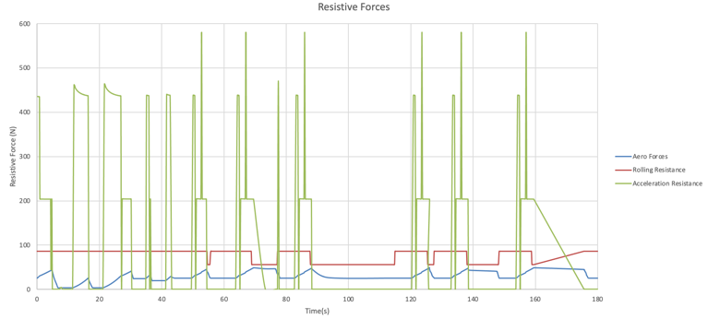
Figure 1-Aerodynamic, rolling and acceleration resistances overlayed
Figure 1 shows the acceleration resistance peaks sharply part way up the gradient this is due to a bump on the gradient in the data collected on the simulator which suddenly caused the vehicle to hop and land suddenly. This does not exceed the power or grip limits calculated and as such has been included in the drive cycle as it is likely that such a situation may occur in a real drive cycle.
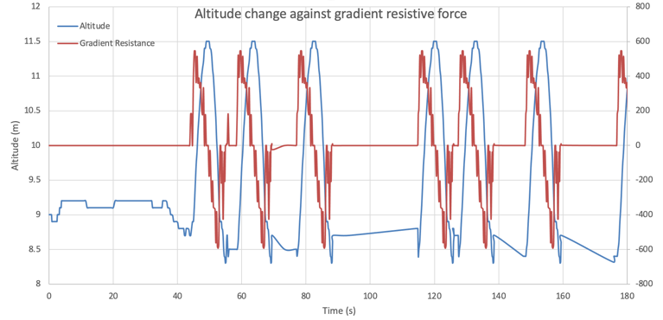
Figure 2-Gradient and resistive force
Figure 2 shows the change in altitude over the course of the lap overlayed with the resistive forces created by the gradient. Between the start of the cycle and the 40 second mark there are some minor undulations approximately 0.02m in height. It is assumed that the vehicle suspension will absorb these undulations and they do not affect the drive forces required, hence they resistance force does not change for these sections.
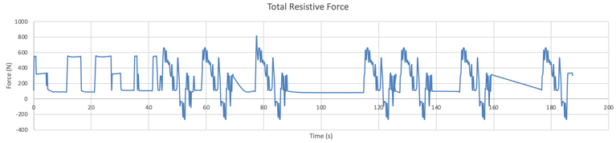
Figure 3-Total resistive force
The total resistive forces shown in figure 3 that even including the drag factors when rolling down the gradient there is energy to be harvested although this may or may not be practical depending on the hybrid system.

2. Creating the drive cycle

The basis for the drive cycle is data collected in a simulation package by driving at a moderate speed around Daytona Rallycross circuit. This generated a significant incline as well as corner radius data that could be scaled to be suitable for the type of drive cycle required. The data also provides a gradient which is climbed on a loose surface such as these vehicles may be required to climb. Once the distance and altitude data were collected the maximum performance of the vehicle was calculated on different surfaces. This provided a basic starting point for braking distances, cornering speeds and maximum drive forces. These values were used to make reasonable assumptions about braking distances and cornering velocities considering the quality of driver likely to be in control of the vehicle.
When considering the course design several significant risk factors were identified, first the risk of rolling is significantly increased if traversing a gradient and turning simultaneously. The vehicles centre of gravity is quoted as “Very low” however considering the weight transfer effects of cornering and climbing a significant grade simultaneously it was decided that cornering and climbing should be kept separate.

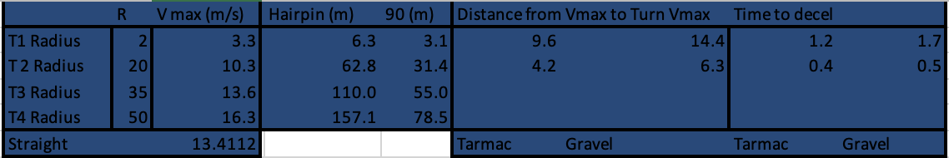
Table 1-Maximum Cornering speeds (m/s)
Approximate maximum cornering speeds were calculated using the vehicle mass, surface mu and selected corner radii.
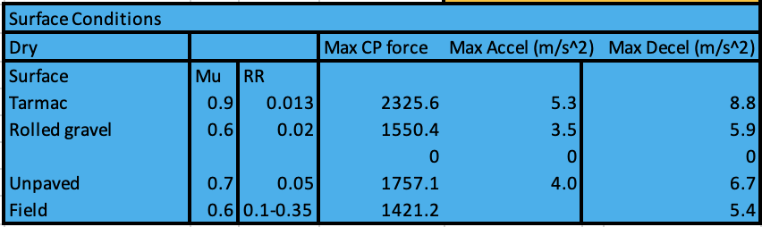
Table 2-Surface Mu and maximum accelerations under ideal conditions
Table 2 shows maximum tractive effort, calculated by the maximum force that the tyre can produce and the vertical load applied by the vehicle. These were used to check the drive cycle did not exceed realistic limits.
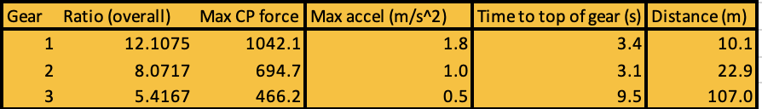
Table 3-Gear Ratios and accelerations
Table 3 shows the calculated gear ratios in place of the CVT transmission. These are overall values between the engine and the wheel using the top speed of the vehicle and assuming
Figure 1 shows the velocity changes over the course of the duty cycle. Begins and ends at the same velocity as this will be the most common situation during teach session of multiple laps that the vehicle will complete. When applying an energy recovery system it may be important to ensure that the vehicle can always begin from a starting point at 0 velocity.
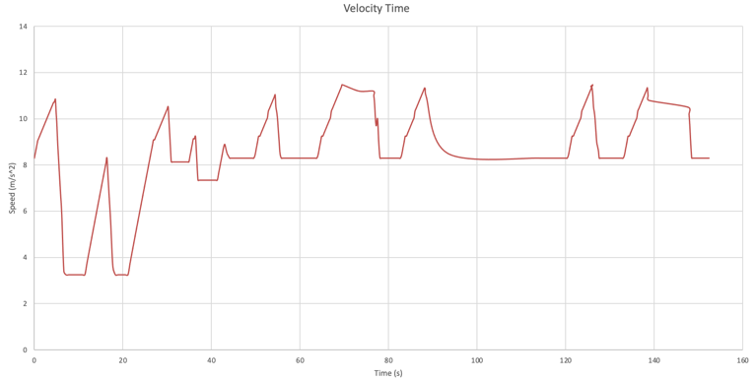
Figure 4-Velocity time graph representing the created duty cycle
The velocity graph is constrained to a maximum velocity, the quoted top speed of the vehicle at 13.41m/s. This speed could be adjusted by changing the final drive gear ratio of the vehicle.
Figure 4 clearly shows significant periods of deceleration during which energy is lost in the friction breaks, if this energy can be recovered and recycled to drive the vehicle. As well as this in the process of accelerating sharply the engine is forced to run in sub optimal condition, rich mixtures at some times lean at others. Meaning that it does not run in an ideal region of the BSFC chart for significant periods of time using more fuel than would otherwise be necessary to generate the required amount of energy.
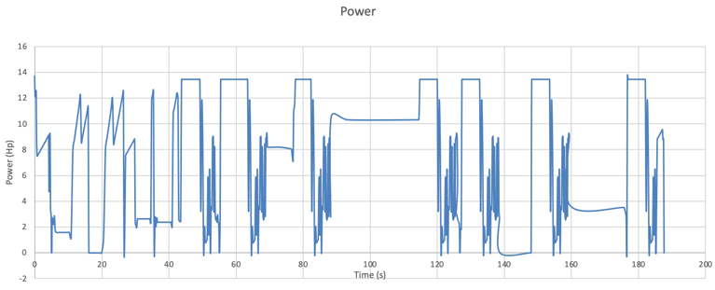
Figure 5-Instantaneous power
Figure 5 shows the instantaneous power required at each point in the drive cycle. This was used to ensure that the drive cycle was not unrealistic and could be completed by the vehicle.
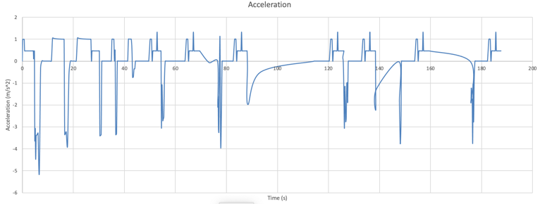
Figure 6-Acceleration
Figure 6 shows the accelerations calculated throughout the drive cycle, it is noted that the decelerations are significantly faster than the accelerations. This is in part due to the vehicle only being rear wheel drive and in part due to the fact that under acceleration the vehicle is always assumed to drive force limited and cannot break traction without building momentum in the drivetrain and suddenly releasing it. When applying any hybrid systems it may be important to consider shock loads to the tyre in any transition period between ICE and alternate drive systems.
4.Brake specific fuel consumption (BSFC)

BSFC measures the amount of energy that an internal combustion engine extracts from a unit of fuel. It can be measured at a range of torque and engine speed values and used to calculate how much fuel a vehicle will use for a given amount of work done. (Ehsani,2019,p57) For the purpose of this model a BSFC chart for a hybrid scooter was scaled to the torque and rpm and power limits of the 300cc naturally aspirated engine used in the vehicle.
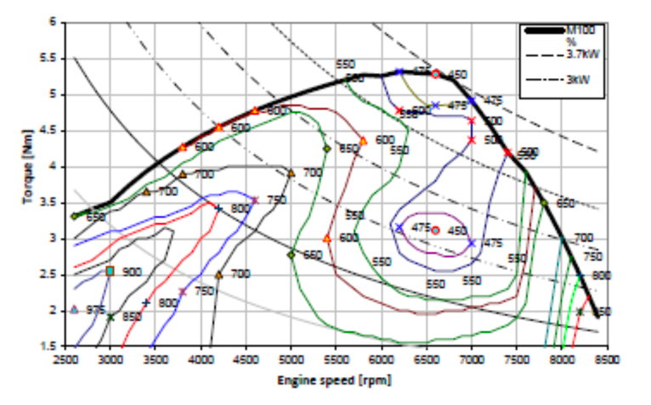
Figure 7-Original BSFC chart
In order to use the BSFC data shown in Figure 7 the torque and rpm axes were scaled after the graph was digitized and values were manually read to create a lookup table which could then be used to calculate the amount of fuel used per time step.
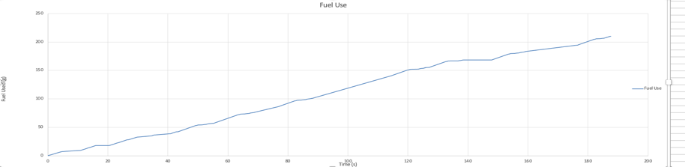
Figure 8-Fuel used against time
The total fuel usage per lap for this example drive cycle is 210g. This equates to 0.278l with a current price of approximately 145p currently (November 2021) and a total duration of 187.8s the current cost per minute of customer driving time is 12.88p.

3. CONCLUSIONS

A representative drive cycle has been created however it is reliant on a significant number of assumptions which have been considered to be reasonable. This drive cycle has been used to calculate a cost per time figure which may be used as one tool to evaluate the implementation of a hybrid system on the businesses profitability.
It has been identified that there are two main sources of recoverable energy in this drive cycle, kinetic energy which is currently simply dissipated as heat in the friction brakes and gravitational potential energy (gpe) gained when climbing the gradients. There are complexities involved in recovering the gpe as well as in recovering the kinetic energy. Further to this it has also been identified that due to the changing load and speed conditions on the ICE excess fuel is used to generate the energy required to complete the drive cycle. If a hybrid system could reduce the range over which the ICE is required to operate a greater efficiency could be achieved further reducing cost and tailpipe emissions.
Simulated data was used to help ensure that the drive cycle was realistic. However, the use of this data also complicated the process of generating the drive cycle

REFERENCES

ANTONELLI, M., MARTORANO, L., CALEO, A., CARMIGNANI, L., CAPOZZELLA, P. and MARCACCI, M., 2006. Optimization of an Internal Combustion Engine for an Hybrid Scooter. SAE Transactions, 115, pp. 1132-1140.
EHSANI, M., GAO, Y., LONGO, S. and EBRAHIMI, K.M., 2019. Modern electric, hybrid electric, and fuel cell vehicles. Boca Raton: CRC Press, an imprint of Taylor & Francis Group.
PETTERSON, T.C. and GOOCH, S.D., 2020. ROLLING RESISTANCE OF ATV TYRES IN AGRICULTURE. Proceedings of the Design Society: DESIGN Conference, 1, pp. 2561-2570.
WONG, J.Y.(., 2001. Theory of ground vehicles. 3 edn. New York ;: Wiley.

Appendix – Raw digitized BSFC Data

