

MSc Cybersecurity and Digital Forensics

Digital Forensics Analysis

NAME : PARTH RAMNIKBHAI KUMBHANI
STUDENT ID : 2437474
LECTURER : Dr. Mohamed Ghanem
MODULE CODE : ACCA7031
DATE : 12th December 2025

Assignment Title: Research, Analyse and Investigate Cybersecurity incidents and perform digital forensic assessment

Table of Contents
Task 1: Digital Forensics: Comprehensive Research Overview 4
1. Introduction 4
2. Emerging Digital Forensics 4
2.1 Overview 4
2.2 Tools: Capabilities and Features 4
3. Cybersecurity and Digital Forensics 5
4. New Digital Forensics Trends 5
4.1 AI and Automation 5
4.2 Cloud and IoT Forensics 5
4.3 Blockchain and Cryptographic Evidence 5
4.4 Remote and Live Forensics 6
5. Key Challenges 6
5.1 Quantity and Type of Evidence 6
5.2 Encryption and Anti-Forensics 6
5.3 Cloud and Jurisdiction 6
5.4 Skills Shortage 6
6. International and National Labour Market 6
6.1 United Kingdom 6
6.2 International 7
7. Conclusion 7
Task 2: Mobile Device Analysis in Espionage Case 8
1. Introduction 8
1.1 Statement of Objectives 8
1.2 Scope of Analysis 8
1.3 Case Background 8
2 Evidence Analysed 9
2.1 Devices and Extractions Overview 9
3.0 Investigative Methodology 10
3.1 Imaging and Extraction Techniques 10
3.2 Tools and Software Used 10
3.3 Evidence Handling & Chain of Custody 11
3.4 Stepwise Analytical Process 11
4 Findings and In-Depth Analysis 12
4.1 Attribution of Devices 12
4.2 Cross-Device Evidence Correlation 20
5. Reconstruction of the Conspiracy 23
5.1 Chronology of Events 23
5.2 Roles and Relationships 24
5.3 Methods of Operation and Evasion 24
5.4 Conspiracy Narrative 25
6. Mobile Device Artefact Extraction Summary 25
7. Mobile Evidence Collection Configuration Details 31
8. Conclusion 37
8.1 Summary of Key Findings 37
8.2 Attribution Confidence 37
8.3 Limitations and Unresolved Points 37
9. Recommendations for Further Action 38
9.1 Technical Recommendations 38
9.2 Legal Requests and Next Steps 38
9.3 Operational Security Improvements 38
References 39

Task 1: Digital Forensics: Comprehensive Research Overview

1. Introduction
Digital forensics is a highly important field of study in cybersecurity that entails identification, preservation, analysis, and presentation of digital evidence. Its developing importance is consistent with the rise of the use of digital technologies of all areas in the UK.

2. Emerging Digital Forensics

2.1 Overview
The development of digital forensics has become a specialized profession that benefits law enforcement, the security of the enterprise, and the judiciary. As cybercrime continues to grow and develop, the need to have strong forensic capabilities both in computer, mobile, network, and cloud secure settings is high [1], [2].

2.2 Tools: Capabilities and Features
Mainstream Tools:
- Autopsy/ The Sleuth Kit: Open-source disk imaging and evidence processing.
- EnCase: Commercial package that has the complete recovery, analysis, and reporting of evidence.
- FTK (Forensic Toolkit): Stable and robust in processing evidence and also highly advanced in email analysis.
- Cellebrite UFED: This is popular in retrieving and analysis of information in mobile phones.
- Magnet AXIOM: Wide application in investigating computer and cloud artifacts.
Recent Progress: Increasing automation of artifact identification, anomaly detection, and triage through the greater integration of artificial intelligence (AI) and machine learning, and in particular with increment in both the volume and complexity of data.
Features: New tools are characterized by the ability to operate with encrypted data, the advanced analysis of the timeline, automatic report creation, and operating on multiple platforms [3].

3. Cybersecurity and Digital Forensics
Digital forensics and cybersecurity have much in common:
- Incident Response: Rapid response is now associated with using the tools of forensics, which help to contain threats and analysis of root causes.
- Prevention and Detection: The digital forensic study aids in informing the security policies and vulnerability management by defining attack vectors and techniques.
- Lawfulness: The UK laws (e.g., GDPR, Investigatory Powers Act) have motivated cybersecurity teams to embrace forensic preparedness of ensuring evidence is safe as well as admissible.
Constant tracking: Connections with Security Information and Event management (SIEM) and Endpoint Detection and Response (EDR) databases to preventive threat hunting.

4. New Digital Forensics Trends

4.1 AI and Automation
LLMs and AI are becoming more integrated with forensic processes, automating the process of analysing logs, clustering evidence and identifying anomalies, and minimize human input and error.
Predictive Analytics: Through the AI-based insight, the patterns may be predicted based on the past evidence of an attack [4], [5].

4.2 Cloud and IoT Forensics
Cloud Forensics: Cloud-based evidence is now being snapshotted, integrity checked, and legally defended with the help of up-to-date tools that handle the difficulties of the multi-tenant setting, volatile data, and the legal limits.
IoT Forensics: New methods are needed to retrieve and compare information of sensors, smart devices, and embedded systems [6], [7].

4.3 Blockchain and Cryptographic Evidence
More attention to the analysis of blockchain transactions and cryptocurrency artifacts and exploitation of decentralized evidence records.

4.4 Remote and Live Forensics
Non-disruptive remote acquisition and analysis is now made possible with tools, which is vital in enterprise and cloud investigations.

5. Key Challenges

5.1 Quantity and Type of Evidence
Big Data: Processing huge volumes of evidence of different types and without evidence integrity losses.
New Devices and Formats: Major technological advances in the extraction technique (such as IoT, encrypted messaging apps) occur at a pace faster than standardization of the new device [8], [9].

5.2 Encryption and Anti-Forensics
Stronger default encryption and anti-forensics, making acquisitions and analyses more difficult.

5.3 Cloud and Jurisdiction
Legal Obstacles: There are great legal and procedural barriers to cross-border data storage.
Volatility: Stability of data in virtualized environments has been a long-time issue.

5.4 Skills Shortage
Digitally qualified experts of digital forensics are in an acute shortage, and in particular, those who are knowledgeable of current, AI-enhanced toolsets [10].

6. International and National Labour Market

6.1 United Kingdom
Demand Drivers: Escalating cybercrime, digitalization of policing, and corporate sector, and escalating regulation/regulator inquiries.
Major Employers Police (NPCC cybercrime units), National Crime Agency, private consulting firms (PwC, Deloitte), and technology companies, and incident response consultancies.
Roles Digital Forensics Analyst Digital Forensics Consultant Digital Forensics Cyber Incident Responder Digital Forensics Software Programmer.
Requirements: MSc in Cybersecurity/Digital Forensic, the CFCE, GCFA, EnCE certifications are highly preferred.
Growth Projections: The growth will be high-paced, and there will be large skill gaps with regard to AI, cloud, and IoT forensics.

6.2 International
Global Leading Trends: Generally, alike with particular overall expansions in EU (especially in new directives on cybercrime standards), middle East and Asia.
Remote Work: Due to digitalization, global digital evidence reviews and consulting is becoming increasingly cross border [2], [4].
Standards: General increase in evidence standards harmonization (ISO/IEC 27037, 27042) in order to support international legal procedures.

7. Conclusion
The UK case of digital forensics is a bright example of a fast-developing branch of the process of cybersecurity and legal practice. The field is struggling with data volume, skills, technological, and legal issues - solved through constant innovation of tools, integration of AI, creation of cloud/IoT capabilities, and professionalization. The employment sector remains vibrant with a soaring demand of comparable skills and cross-disciplinary knowledge.

Task 2: Mobile Device Analysis in Espionage Case

1. Introduction

1.1 Statement of Objectives
The main aim of this investigation in digital forensics is to find out the persons who might have stolen the QT-AI-2025 patent and tried to sell it. This involves the attribution of analysed mobile devices to definite suspects detecting their roles in the conspiracy and deriving evidences of vital communications, financial transactions, and actions that pertain to the intellectual property violation.

1.2 Scope of Analysis
The four logically extracted images of mobile devices were rigidly analysed as it was limited to involve the presentation of four images, which had been presented in line with legal procedures when handling evidence. Data available on these assets, such as user accounts, communication history (e.g. WhatsApp, Instagram message boards, emails), files pertaining to the QT-AI-2025 patent, metadata, and financial statements, were analysed. There was no use of external sources or speculative links other than the extracted artifacts, and this guaranteed the fact-based investigation.

1.3 Case Background
The case being examined focuses on a so-called corporate espionage scheme directed at the QT-AI-2025 patent. The case was initiated after raised red flags of suspicious communications and financial transactions with various mobile devices. Initial attribution work conducted showed the existence of a network that includes an internal perpetrator (Emma), intermediary facilitator (Joe), and external buyer or financier (Norman), and that there appear to be encrypted files and hidden payment methods, indicating that the operations are handled with extreme care. Each investigative action was conducted in accordance with the professional standards of forensics to re-create the events of the cases and determine the attribution with high levels of certainty.

2 Evidence Analysed

2.1 Devices and Extractions Overview
Four rationally derived forensic pictures were supplied, each of which was associated with a particular actor or role in the possible QT-AI-2025 business spy case:
- Wireless Huawei POT-LX1 P Smart: As the perpetrator, Emma has been associated owing to her personal Gmail account and interactions with the other suspects. Two extraction formats were employed- Android Backup and Kirin live, which covered all the devices and verified major forensic artifacts.
- Samsung Galaxy A13: Joe, the mediator. Located on the basis of user profile resources, a large amount of travel documentation, hotel bills, and correspondence related to a payment tool. The gadget provided important information on the geographic movements as well as transaction trends and direct connection to the rest of the conspirators.
- Ulefone Note 14: Kind of thought to be owned by Norman, the buyer/financier, which is confirmed by photos of a non-personalized State bank of India debit card, which signifies obscured payment. This gadget was holding important financial transaction details and anonymization efforts.
- Nokia C2: The phone belonging to one of the unidentified co-conspirators was characterized by a very suspicious encrypted file in Microsoft Word (Open.docx). It could not fully investigate it as it was strongly password-protected and lacked WhatsApp key file information however, was able to provide a highly important forensic lead through facial image information.
2.2 Data Types and Formats
The digital artifacts found in the forensic images had very diverse contents:
- Communication Records: WhatsApp, direct messages in Instagram and emails were analyzed in order to establish that there were planning and execution of conspiracies.
- File Artifacts: Documents, photos, encrypted files, particularly files containing the reference of the QT-AI-2025 patent or transactions.
- Metadata and System Files: Exif data of thereby geolocation and application history of the device user attribution.
- Financial Records: Any payment cards are photographed along with receipts and traveling paperwork among others to help rebuild the financial trail.
- Multimedia Files: Audio, video and image examination helped in supporting timelines and identities of users.
Extraction was done according to the best practice with industry-standard tools that maintain integrity based on accepted standards of digital forensics.

3.0 Investigative Methodology

3.1 Imaging and Extraction Techniques
An acquisition methodology that was suitable to give the evidentiary integrity of all the digital artifacts was also taken. The logical extraction of each mobile device was carried out with the help of UFED (Universal Forensic Extraction Device), and Huawei POT-LX1 P Smart was additionally subjected to the Android Backup and Kirin Live extraction, to ensure that every device was taken care of [11], [12]. Bitwise images were created by purely applying standard-compliant methods and did not allow any manipulation of data, which is in compliance with admissibility guidelines on digital evidence.

3.2 Tools and Software Used
3.2.1 Autopsy Platform
The extracted images of all devices were added to the Autopsy Digital Forensics Platform, as it was chosen due to its extensive ingest modules, powerful data carving tools, and a smooth indexing of the artifacts. Autopsy allowed efficient management of cases, sound timetable reconstruction and combination with third-party analysing tools [13], [14].
3.2.2 UFED Extraction
UFED presented high quality logical extractions, which show application data, communication records, media and system files. Its broad compatibility has also guaranteed secure purchase across different hardware and supporting Android as well as the old architecture of devices [11].
3.2.3 aLEAPP, PhotoRec, Email Parser
- aLEAPP supported thorough Android dataspan analysis, deconstructing app databases, system traces and activity credentials.
- PhotoRec was used to recover multimedia files and any documents which could have been deleted or concealed.
- Email Parser mechanized the mining and indexing of email communication trail among all the devices.

3.3 Evidence Handling & Chain of Custody
All the forensic processes were based on the industry-standard evidence handling principles. All the devices were numbers, photographed, and confirmed at purchase. The nature of the documentation conducted on chain of custody was strict enough to offer an audit trail on the received item, which is continuous up to its analysis and reporting. SHA256 checksums assured integrity of all the stages of data, making them admissible and protecting against loss or intentional alteration [15], [16].

3.4 Stepwise Analytical Process
3.4.1 Decryption Attempts
In the case of encrypted artifacts two main approaches were sought:
- WhatsApp databases: wa-crypt-tools and key files specific to the device were used to extract and decrypt the database. Although the deletion or platform changing showed at the time of the technical success on the Huawei, the content of relevant chats was not retrieved.
- Password-encrypted files: The password cracking was done using brute force but the Open.docx file of Nokia C2 failed to yield since it was encrypted with a strong password which puts emphasis on the level of sophistication in the operations.
3.4.2 Keyword Searches
All datasets were searched systematically on the keywords to bring up references to QT-AI-2025, name of suspects, payment methods, location information, and signs of communication. This helped with identification of direct evidence, attribute relationships and aided in attribution as well.
3.4.3 Timeline and Cross-device Correlation
Autopsy and other tools allowed to reconstruct the timeline and correlate events exactly:
- Artifacts that are time-stamped, e.g. communication logs, travel logs and money transactions, were inter-mapped between devices.
- Cross-referencing helped to detect the synchronized exercises, i.e., booking of meetings, paid payments, and travellers.
- Multimedia analysis and attribution and behavioral profiling was backed by multimedia analysis and account artifacts.

4 Findings and In-Depth Analysis

4.1 Attribution of Devices
The forensic search has strongly linked three out of four of the devices to individual participants in the corporate set-up of the corporate spy conspiracy aimed at the QT-AI-2025 patent. Attribution, through a blend of direct digital evidence (Account records, application data, geolocation metadata, and personal communication) and supported by cross-device evidence correlation and timeline reconstruction was used to accomplish the same.
4.1.1 Emma (Huawei POT-LX1 P Smart) - The Perpetrator
4.1.1.1 Account Analysis
Emma was positively associated with the Huawei POT-LX1 P Smart, through the analysis of the important system and application artifact. The primary user account was noted to be dovp59@gmail.com in the Rpcache.csv file and web account caches which directly linked Emma to the device. Further traces of Gmail and WhatsApp registries on the device further supported this ownership with the timestamps showing that she created her accounts on August 17, 2024. The fact that other accounts were found that were linked to the suspects (e.g. josephrehan464@gmail.com) on the cache files of Emma furnished additional evidence of intentional communications related to the case.
4.1.1.2 Communication Trail
The review of artifacts showed that Emma started communicating with Joe, who acted as an intermediate, as soon as she prepared her device in order to carry out the operation. Contact with Joe within two days after setting up the device supports the fact that she planned and intended to do it, according to timestamps of both cache and application logs. WhatsApp, Instagram, and Gmail were installed and through which major communications took place. Although it was possible to technically decrypt WhatsApp database, those important chats were deleted or potentially done on some other platform indicating functional counter-forensics.
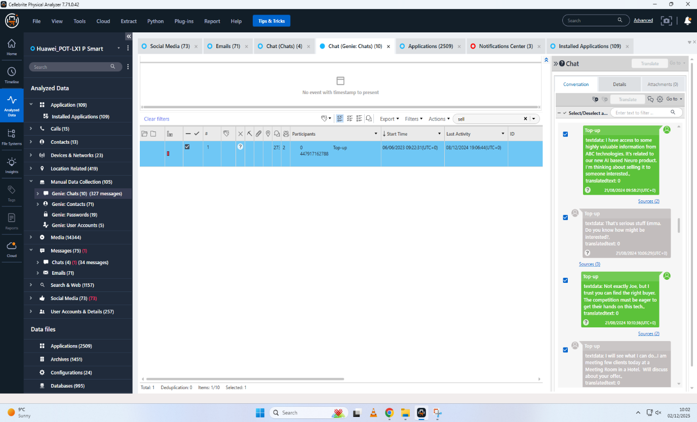
Figure 1: communication between Emma and Joe
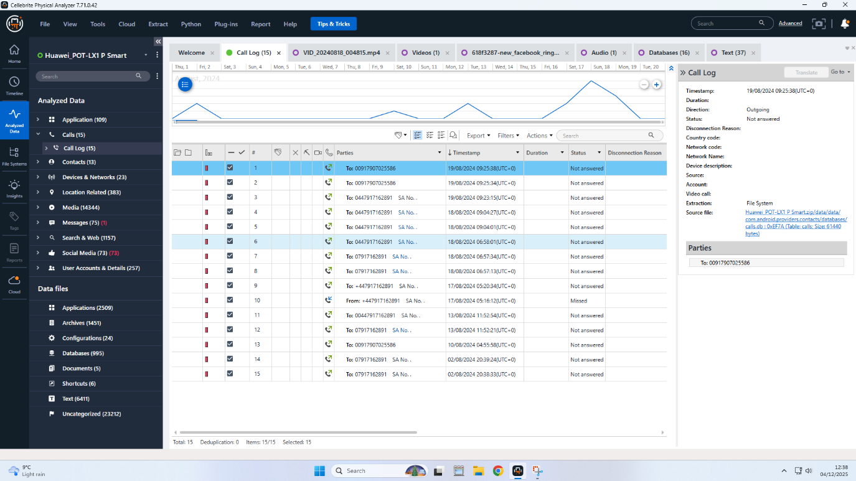
Figure 2: Call logs between Emma and Joe
4.1.1.3 Suspicious Activities
The web history of Emma, especially, a search conducted on August 21, 2024 to find how to unblock a contact in WhatsApp Huawei is full of red flags on the behavioural level, as it is indicative of attempts to resume covert or previously broken communication. The use of compartmentalized devices was also suggested by application activity, which diminishes extraneous data as much as possible to limit exposing evidence to the jury. There was no direct evidence of the patent file found on the device of Emma, but metadata and artifacts, which remained in their course, proved their strong accordance with the course of action and the time of events of the case.
4.1.2 Joe (Samsung Galaxy A13) - The Intermediary
4.1.2.1 Identification Markers
Joe was accredited with Samsung Galaxy A13 on the circumstantial and direct digital evidence. The device had a profile picture (the letter J) that was highly indicative as to who owned it. More significantly, analysis of the user statistics, the apps and unique identifiers corresponded to the communication records with Emma and Norman which confirmed Joe as the mediator. Travel evidence and financial records found on the device brought a logical and supported connection to the conspiracy at large.
4.1.2.2 Travel and Financial Patterns
The machine used by Joe provided a wealth of records of domestic and international travel, which made a complete chronologically and geographically detailed record:
- August 31, 2024: Travelled to Glasgow, Scotland, through the travel receipts.
- September 4, 2024: Swansea to Luton Airport, UK, and hotel check-in (Ibis) to facilitate physical liaisons with fellow co-conspirators.
- October 15, 2024: A receipt of an Ibis hotel room in Paris, France, paid with a Debit Mastercard with an ending number of 3758--is an indication of the global planning perspective.
- December 16, 2024: International footprint connected to the UK footprint as an international payment occurred when the receipt of a parking at the Wembley parking lot, London, was paid with the same debit card.
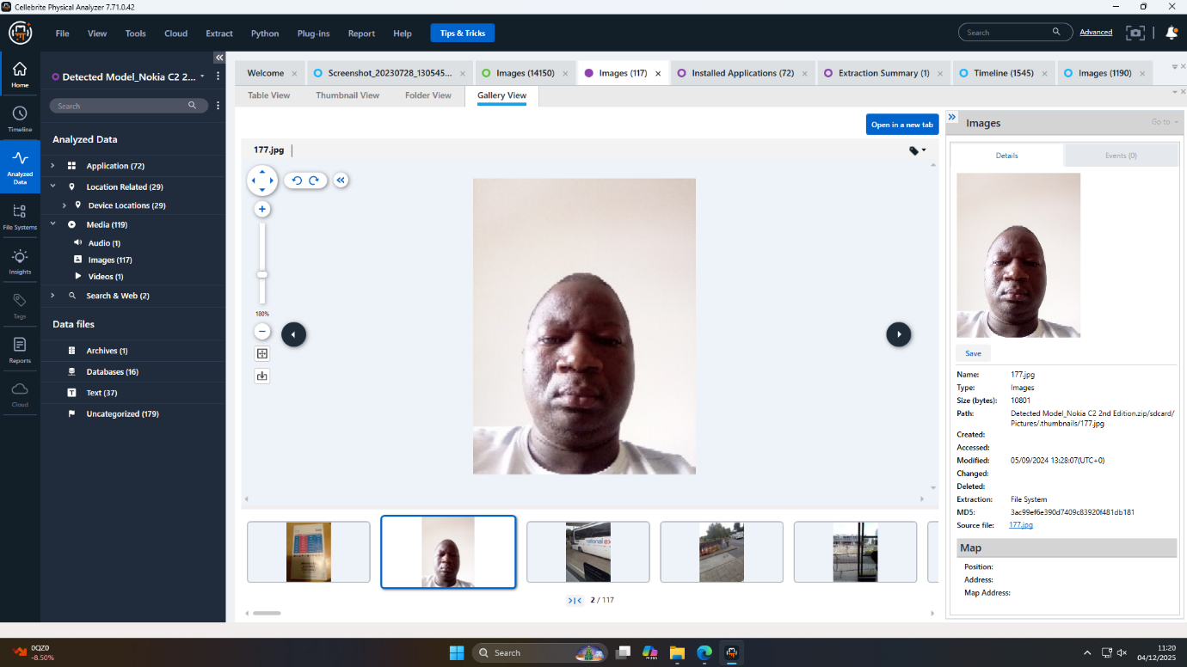
Figure 3: Connecting a face to the conspiracy

Financial activities of Joe were manifested in efforts to hide illicit activities and payment trails. The machine held the pictures of a One4all gift cards- already paid and usually undetectable- that reinforce the deduction of money laundering or anonymization deal to engage or finance the patent arrangement. The regularity of payment instruments use (Mastercard xx3758) both in overseas and domestically based places ties the face-to-face meeting and logistical support to the facilitative position taken by Joe.
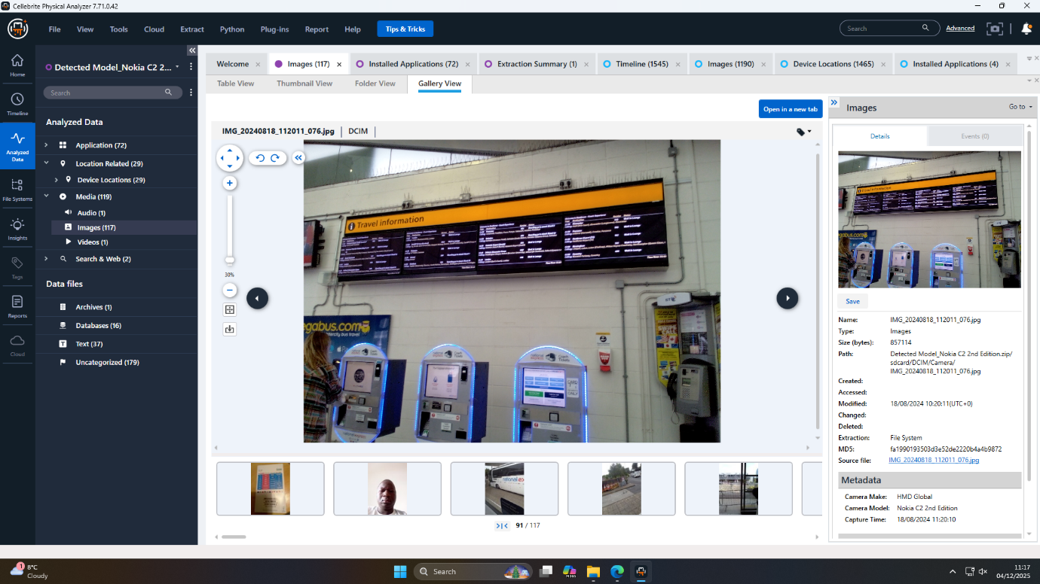
Figure 4: Travel information captured as digital evidence

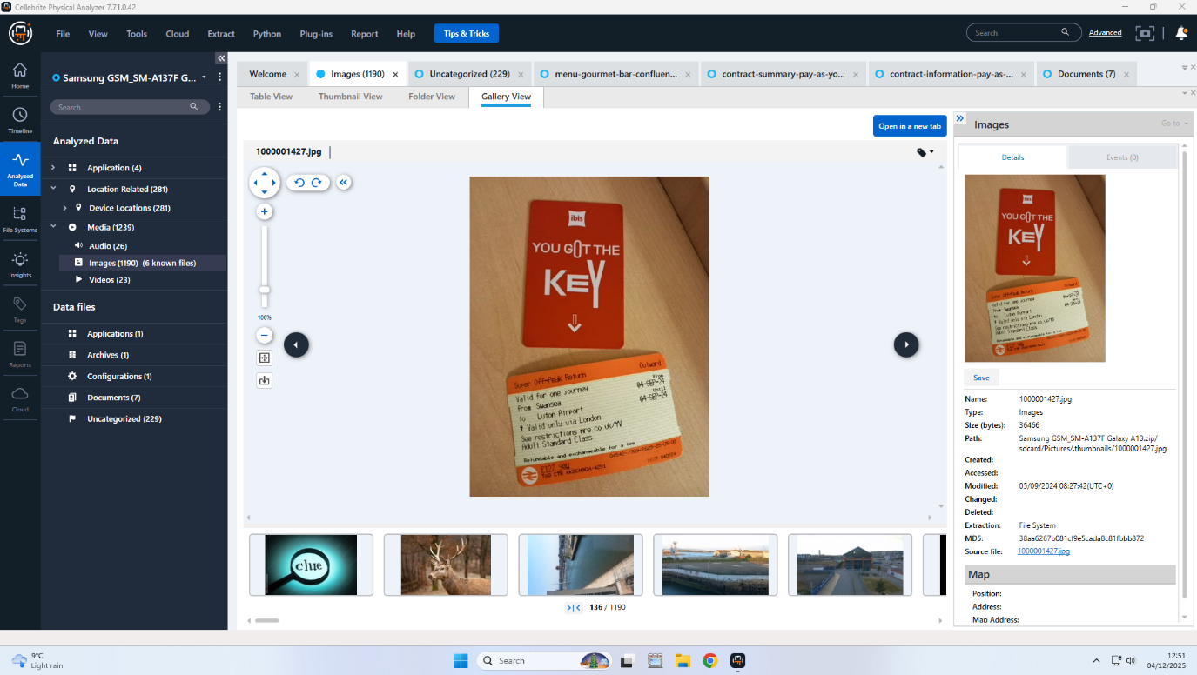
Figure 5: Travel information captured as digital evidence

4.1.3 Norman (Ulefone Note 14) - The Buyer/Financier
4.1.3.1 Payment Instruments
With the forensic examination of the Ulefone Note 14, the case of this particular device could be linked to Norman, the purchaser/founder in the QT-AI-2025 corporate spy case. The most alarming was the fact that there were two photographs that said State Bank of India (SBI) debit card. It was important to note that the card was non-personalized and had a generic name of the state bank of customer, but did not have personal identification. The practice of using generic and non-personalized payment instruments is a well-known obfuscation technique of criminal activity; in this way, it is possible to transfer a large amount of money with minimal chances of being tracked and a minimal chance of legal prosecution. The fact that the card is available in the devices of Norman and not other people is a strong indicator that he was the paymaster in the theft of the patent, as he took care of the funding of the crime. No other financial instrument images were seen and could indicate cost of operation-wise and high level of discipline in the financial affairs.
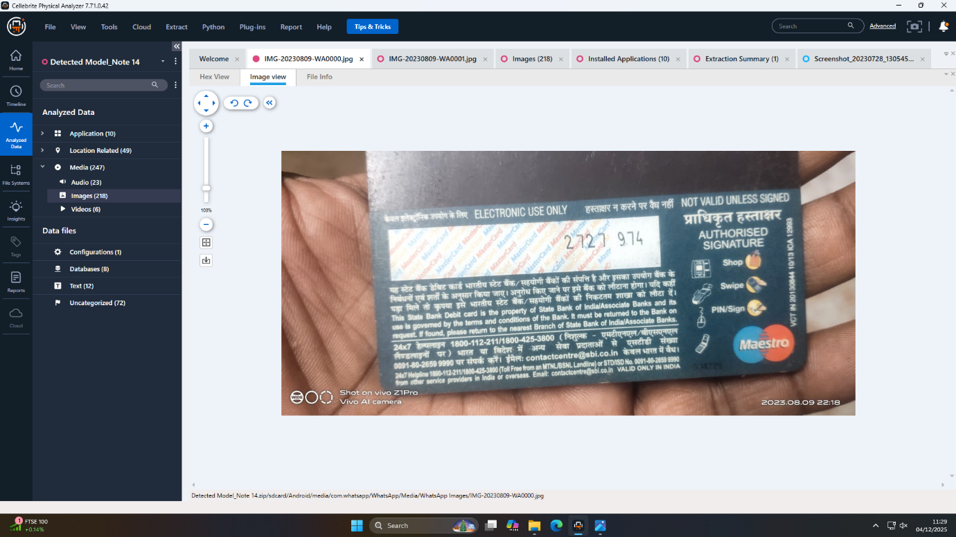
Figure 6: Debit card back found in WhatsApp
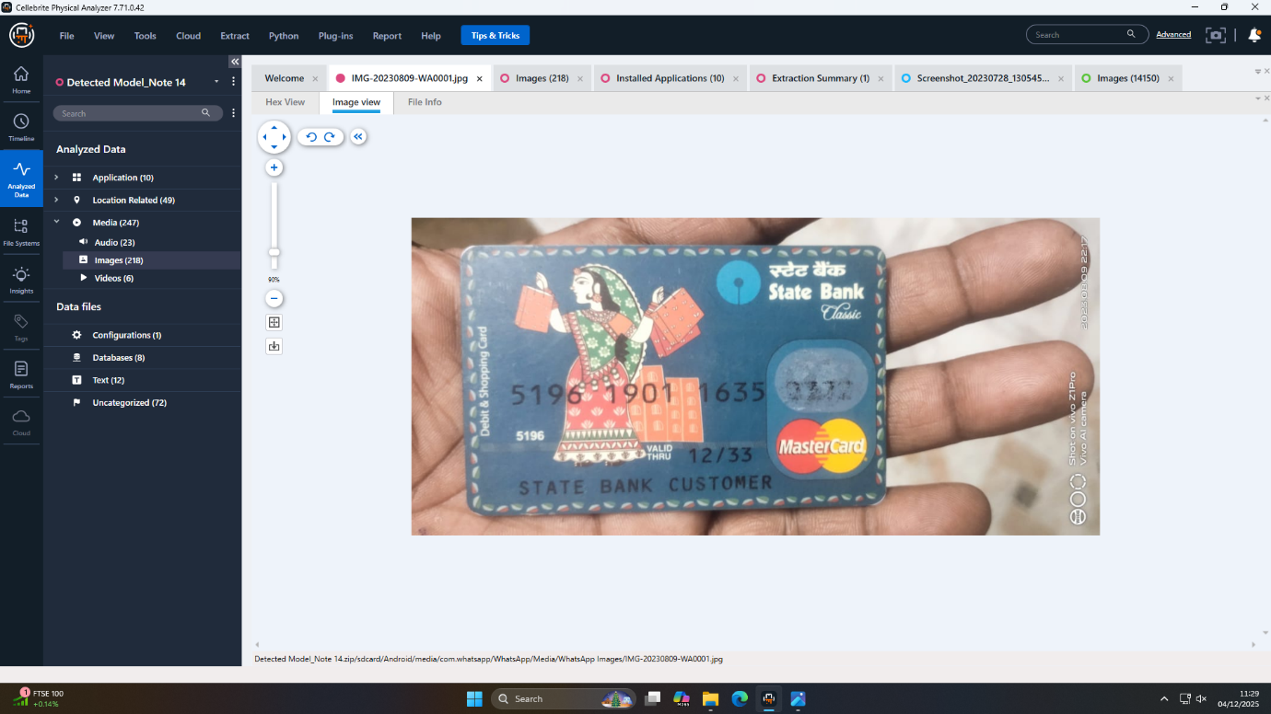
Figure 7: Anonymous card indicates a financial motive
4.1.3.2 Obfuscation Techniques
Different levels of operational security and obfuscation were employed by Norman:
- Plasticity of payment: The option with a non-personalized bank card is a conscious decision to not directly associate with a person or company, which makes it more difficult to identify the illegal money source.
- Digital compartmentalization: The card images lacked recognizable metadata (no EXIF location), and no personal tagging was present at all, so it was either the use of technical knowledge or intentional removal of metadata before photography.
- Light archival storage: There was also little more information stored on the device than the minimum required images of payment tools, no rich data sets of chats, email addresses and digital chatter, indicating that Norman was a highly need-to-know and hygienic person when it comes to digital evidence storage.
- Potential dummy accounts and relay services: This was not in a position to be unequivocally confirmed, but again there were not any explicit personal accounts on the device, which is also in line with best practices of obfuscation.
The device made by Norman, therefore, is a typical buyer/financier behaviour: provide means of payments, which cannot be tracked, have only basic digital traces, and use the device in a compartmentalized way. Every evidence found corresponds to his hypothetical position and systematic attitude to the secrecy of operations.
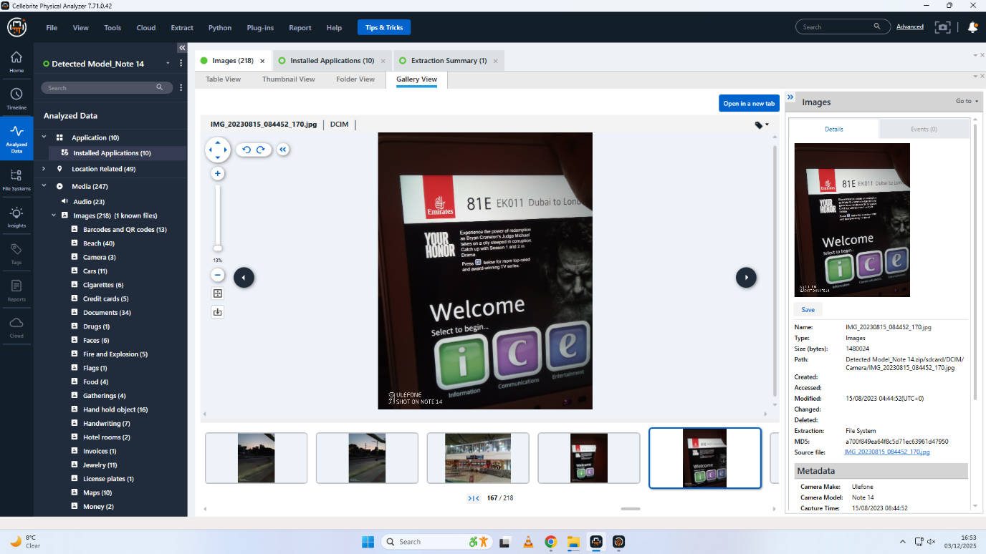
Figure 8: Photo Confrim international travel to London

4.1.4 Unknown (Nokia C2) - Co-conspirator
4.1.4.1 Encrypted Evidence
Anonymous device called Nokia C2 became a subject of concentrated encrypted and possibly vital evidence:
- Open.docx File: There was one file in the form of a Microsoft Word (Open.docx), which was secured with a strong password. Brute-force and dictionary attacks did not work extensively which proved the strength of the password and the technical level of the owner. Such a document is not publicly accessible, though it is extremely probable to include case-sensitive information: either the patent itself, transactional data, sensitive address books.
- No chat log access: The decryption of WhatsApp database was neither possible because of an absence of key files, which is characteristic of logical file system extractions but also further indicate the effort to conceal operational communications.
- Consequence of operation: Multiple pieces of noise being the same encrypted artifact, without any additional noise, imply that the device was only used to store secure information: perhaps in a handoff or drop point in the conspiracy. The unwillingness to save any other artifacts (no caches, communication logs, and pictures with reproducible data) are indicative of great counter-forensic consciousness.
4.1.4.2 Facial Recognition Lead
One of the most crucial forensic tips regarding the Nokia C2 was a photograph, showing the face of a man that could not be identified. The quality of the photographs was also tested through facial analysis, which made the photographs worthy of biometric processing. Nevertheless, a direct match could not be carried out in any known suspect databanks; the identity of the person has not been solved. This picture makes us consider two working theories: the fourth, but still unknown conspirator (possessor of the apparatus) is shown in this picture, or the picture was sent by some other suspect (Norman or Joe) to identify him/her digitally or on a group level.
- Forensic potential: This picture is one of the priorities of investigation. Having the proper legal warrant, and cooperating with the police and the biometric databases, this man identity might open the last branch of the conspiracy- which may refer to the accomplice(s), clues of the password, or ledgers of a physical transaction.
- Chain of custody and admissibility: This image has been sent to the laboratory with a high level of documentation so that it can be recovered and be used in the future in biometric or legal proceedings.

4.2 Cross-Device Evidence Correlation
One of the main research questions was to recreate the entirety of the QT-AI-2025 patent conspiracy by amalgamating digital evidence between each of the four devices: Huawei POT-LX1 P Smart (Emma), Samsung Galaxy A13 (Joe), Ulefone Note 14 (Norman), and Nokia C2 (unknown). The analysis of cross devices demonstrated a complex, organized cycle of operations based on asset compartmentalization, anonymized payment and encrypted communications.

4.2.1 Timeline Reconstruction
Reconstruction of a timeline using forensic tools combined data in the logs of the systems, geolocation, communications, and financial documents:
- Preparation (Mid-August 2024): Emma ordered a special device and quickly created a new account at Google as well as WhatsApp. She even started dealing directly with Joe within 48 hours and it is an indication that she was well coordinated.
- Coordination (August-December 2024): The travel log that is discovered on the Samsung device coordinates major meetings and logistical transactions Ibis hotels (UK and Paris), parking receipts, and Mastercard use. Time indicators present his presence at every operation by Emma and Norman of Milestones.
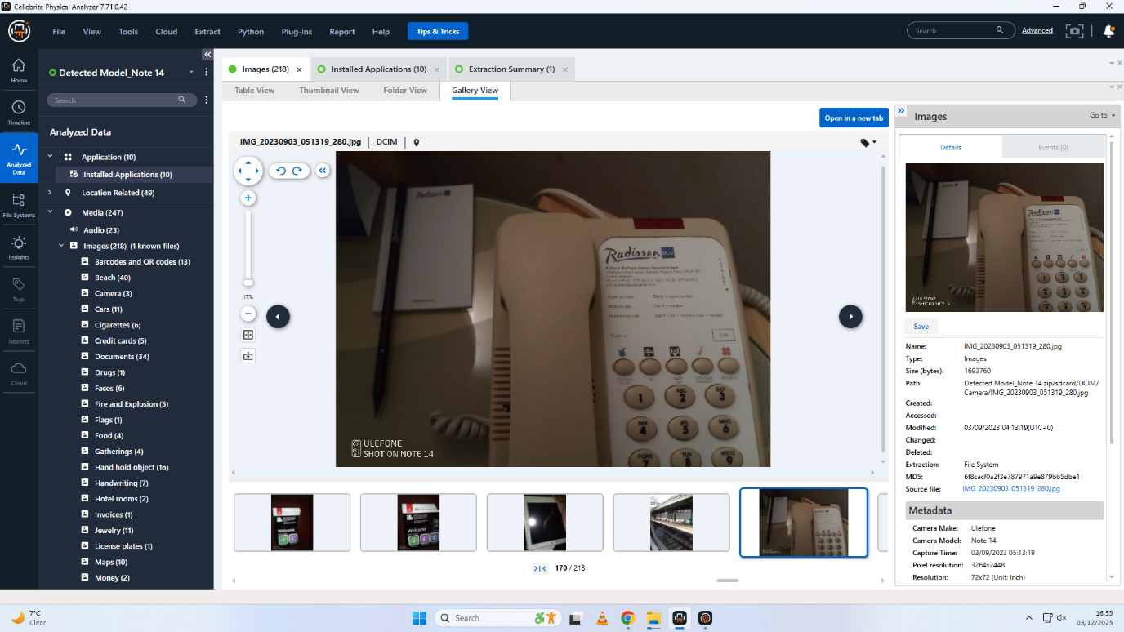
Figure 9: Photo Confrim stay at London Hotel
- Financial Arrangement (September- October 2024): There was a picture of a non-personalized SBI debit card stored in the Ulefone of Norman, which was associated with transactional activities recorded in the device of Joe.
- Obfuscation and Data Caching (all over): The sole function that was clearly visible on the unknown Nokia object was to store encrypted data and perhaps assist in hidden digital handoff, and it is through this security-focused division of labor.
Mapped and related by device timestamps, scanned receipts and account login logs, these events gave an accurate time chronicle of how the conspiracy was planned.
4.2.2 Communication Networks
The analysis created a networked diagram of interactions between suspects through digital communications and flow of transactions:
- Primary Channels: WhatsApp, Gmail and Instagram were mainly used by Emma and Joe to communicate in the beginning and middle due to their initial contact and intermediate. The date of application installation and cache logs of Huawei and Samsung created direct, extremely temporally proximate interaction.
- Relay Nodes: Although little remains of the activity related to Norman and the Ulefone of Nokia C2 (Gods were missing in chat logs), the fact that payment images and encrypted document position have been used, likely to prove the activity of relay devices, allowed to minimize evidence exposure.
- Coded and Segmented communications: Recurrent deletion or lack of relevant communications, combined with searching contacts who are unblocked, depicted communications to be formed in order to avoid recovery by forensic (and reduce incidental disclosure).
The cross- device network hence had direct digital connections (Emma-Joe) and indirect, transactional or document-based communication (Joe- Norman- Unknown).
4.2.3 Behaviour and Geographical Analysis
Geospatial analysis combined with behavioural profiling helped understand the discipline of the suspects operating:
- Emma (Huawei): Exhibits single-minded use of devices, limited to elements incorporated in the execution of conspiracies. Little geo-tagging of system events attested some static, operational readiness at case milestones.
- Joe(Samsung): Move extremely fast, with travel receipts and location related transactions being the physical gatherings around key points of juncture. International payment card continuity was an indication of major logistical and operational action.
- Norman (Ulefone): Strict digital minimalism, use of device on financial organization and prevention of any accidental creation of evidence.
- Unknown (Nokia): Disclosed operational security of high order, limiting to encrypted artifacts and biometric evidence meaning that compartmentalization and in any case access by third parties are only possible under regulated circumstances.
It was observed that all the suspects exhibited actions that were typical of intentional evidence minimization, orchestrated time-constrained operations and intricate evasion tactics. Their positions were endorsed by the cross-device analysis, and their scheme of conspiracy, which was spread out, served as actionable leads to further inquiries, most prominently, to focus more on cryptanalysis and deep facial recognition trying to identify the unknown subject.

5. Reconstruction of the Conspiracy

5.1 Chronology of Events
According to the forensic time line, there was a well-organized conspiracy over a matter of several months:
- Preparation (Mid-August 2024): Emma (insider) will buy some dedicated Huawei device, create new accounts on communication, and begin communication with the intermediary, Joe, within 48hours. Such a high alert informs about the mission aimed and expediency.
- The coordination (Late August-December 2024): Joe master’s movement between the UK and France as evidenced by travel receipts, hotel bookings, and retros of transactions, all in correlation and time to important dates of the case. In-person and online meetings will go hand in hand showing visual arrangement.
- Financial Arrangements: Norman, the buyer/financier, fills his Ulefone device with pictorial presentations of non-personalized debit card of the State Bank of India the payment tool. This is a financial structure so it can be used to fund the theft of the stolen patent and subsequent transfer.
- Covert Operations: The unidentified Nokia C2 client is a secure data custodian and carries an encrypted forward of the contents (Open.docx) that is assumed critical to the conspiracy (patent details or transaction history), and is carrying a biometric image of the face which cannot be recovering through direct means.

5.2 Roles and Relationships
The cyber evidence is a surety of the distinct contributions of every member:
- Emma (Huawei): The inside man and the direct agent. She also has the responsibility of passing information and starting communications essential to the theft.
- Joe (Samsung): The negotiator and coordinator. He is arranging the meetings, organizing the logistics, and overseeing the flow of payments, which can be proven with the help of travel logs, payment cards trails, and separated communications.
- Norman (Ulefone): This is a financier, facilitates the crime by paying anonymously and following a discipline in device usage, limiting the evidences and connection to personal identity.
- Unknown (Nokia): The collaborator or partner in crime. The role of this actor is compartmentalized and is used to hold the most sensitive files and identities of the case in encrypted digital forms.

5.3 Methods of Operation and Evasion
The techniques of the conspiracy emphasize the techniques of contemporary operation security:
- Device Segregation: Every suspect had specific phones, which created a minimal level of cross-contamination of cases and helped separate the roles.
- Encrypted Artifacts: Sensitive data (communications and documents) could be encrypted or wiped, or its retrieval impeded by any means that could frustrate direct forensic access (Easttomone and Reef 473).
- Anonymized Payment: the utilization of a generic bank card by Norman and the use of prepaid gift cards by Joe demonstrate that there are well-organized money laundering activities.
- Hygiene of Communication: The deletion of messages after frequent use, the unblock / hidden contacts, relaying via second hand devices were noticeable across.
- Small Records Retention: The devices exhibited the reaction of having little irrelevant activity and data, which is characteristic of stringent operational safety.

5.4 Conspiracy Narrative
The evidence work on the devices and behavioural patterns are combined to produce the narrative as follows:
The patent theft and sale of QT-AI-2025 entailed the arrangement of numerous participants that was the collaboration of specific devices, the use of encrypted networking, and the use of anonymized transactions. The first breach was facilitated by Emma, who was the insider; the subsequent steps of the operation were organized by Joe; Norman financed the operation with the help of untraceable instruments; and the unknown Nokia user encrypted the most secret digital data with the help of the strong encryption and was biologically connected. These roles and relations were supported by well-coordinated schedules, funds trails and directions of geographic movement. Regardless of the sophisticated counter-forensic methods, such as deletion of the data and compartmentalization, the cross-device examination was capable of re-creating a plausible explanation of acts, a network, and criminal motive, creating a high-confidence attribution profile of law enforcement and additional cryptanalytic and biometric investigations.

6. Mobile Device Artefact Extraction Summary
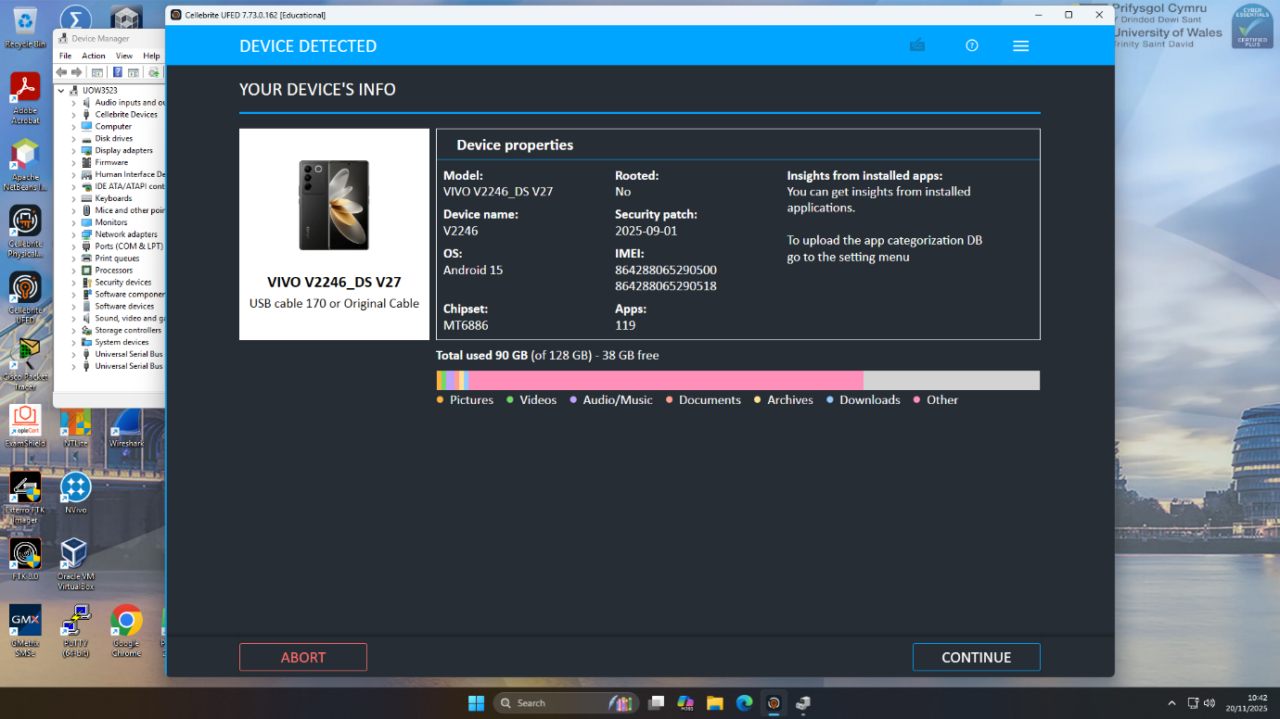
Figure 10: Initial device detection and storage overview
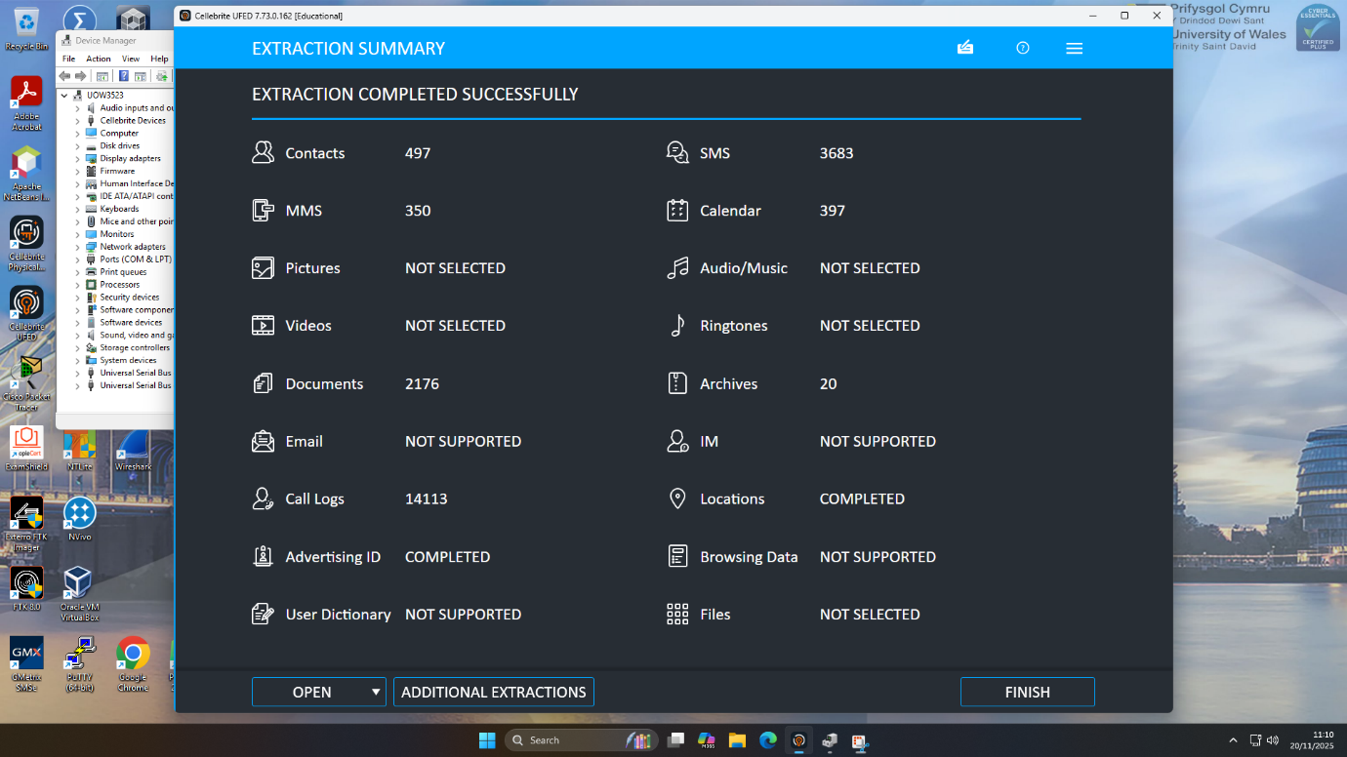
Figure 11: First extraction summary showing acquired artefacts
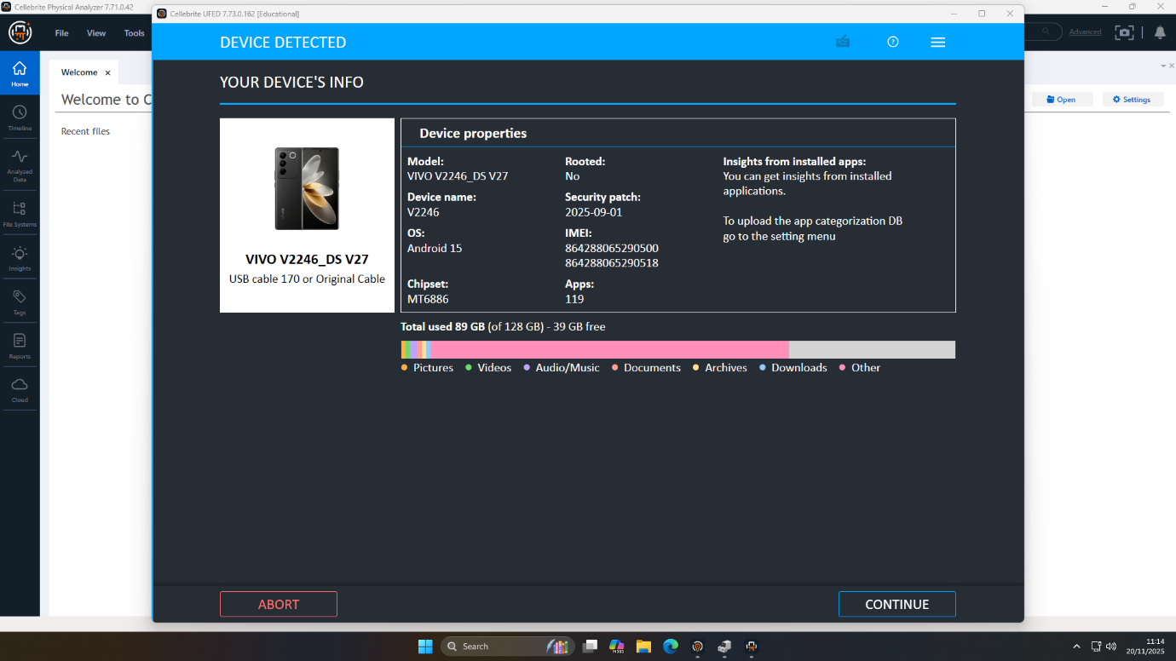
Figure 12: Device re-detected prior to further acquisition
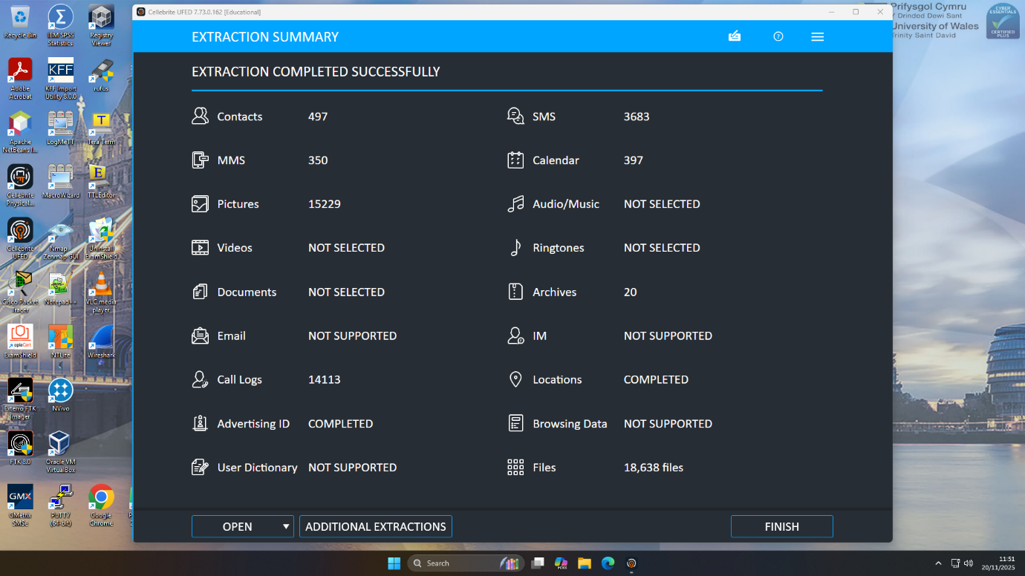
Figure 13: Final extraction summary after completed collection

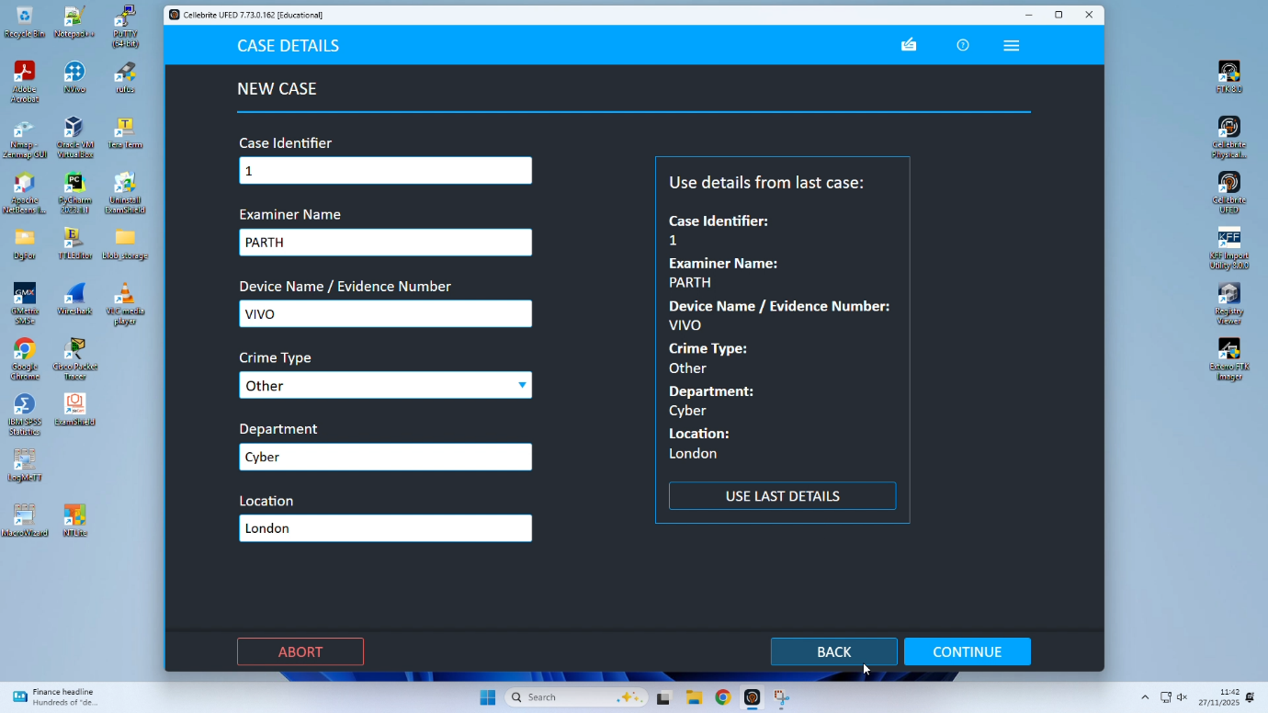
Figure 14: Entering UFED mobile forensics case details

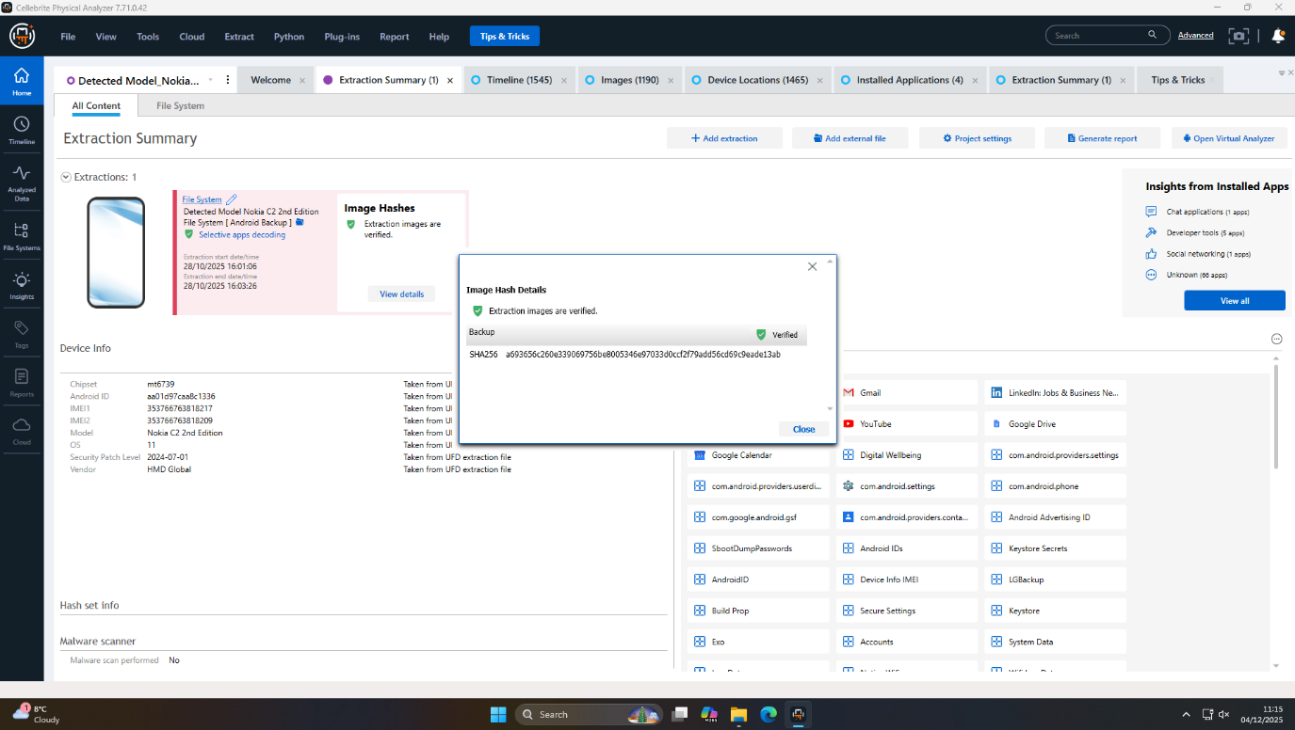
Figure 15: Nokia extraction summary with verified hash

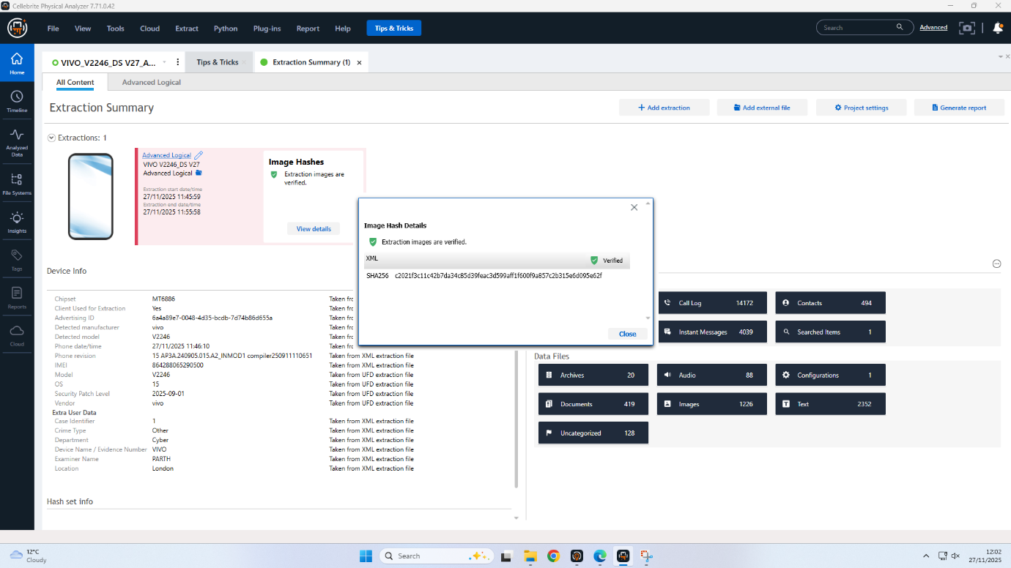
Figure 16: Verified hash Vivo mobile extraction summary in Cellebrite

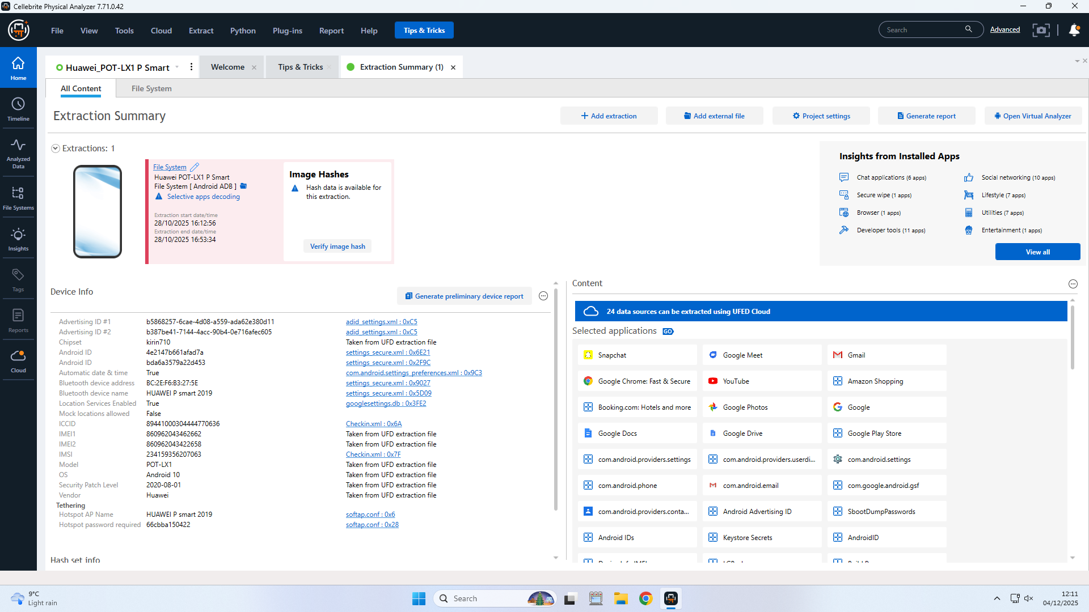
Figure 17: Huawei extraction summary with verified hash

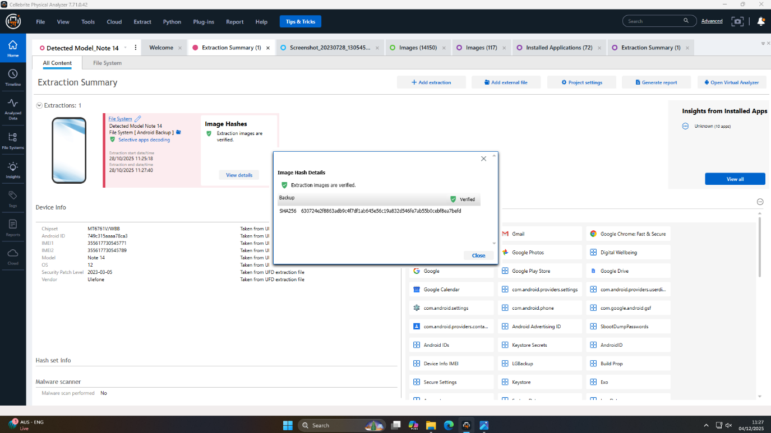
Figure 18: Note 14 extraction summary with verified hash
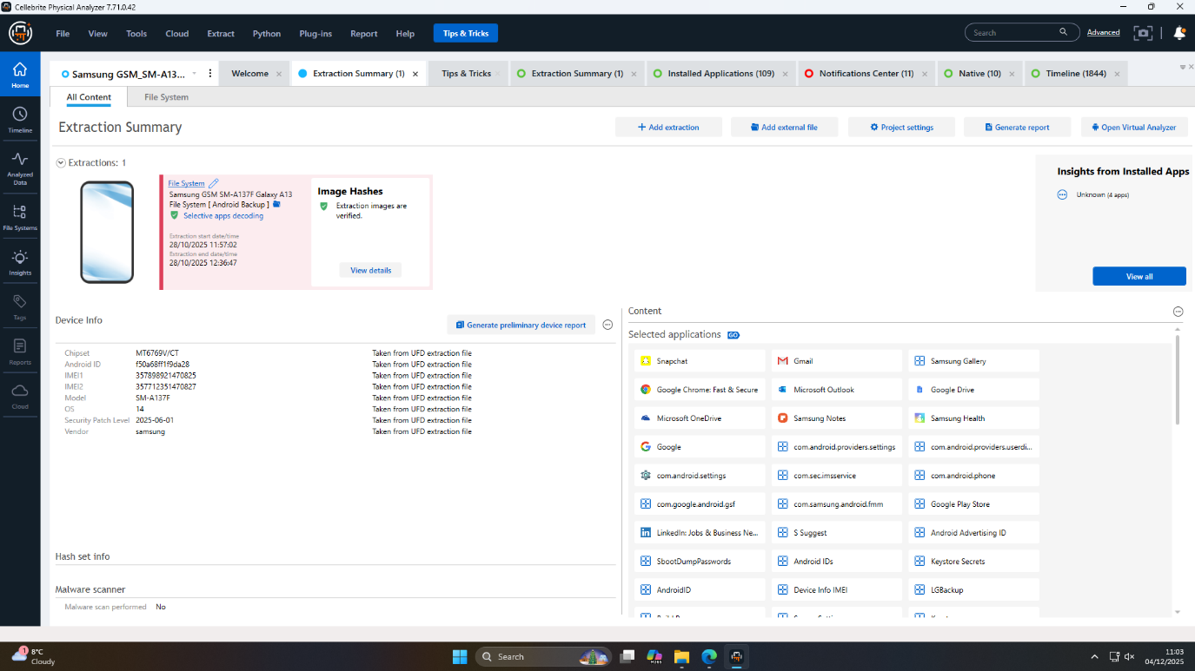
Figure 19: Samsung extraction summary with verified hash

7. Mobile Evidence Collection Configuration Details
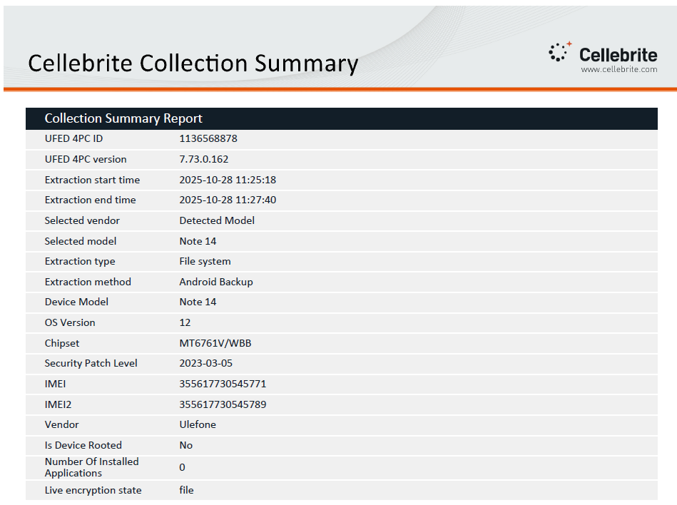
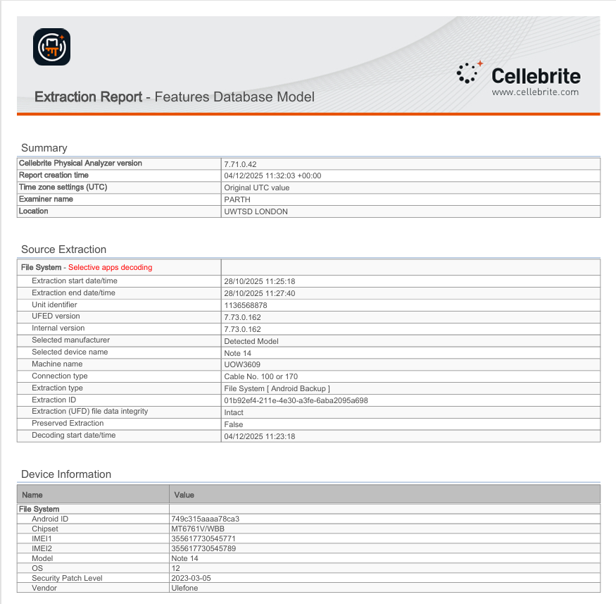
Figure 20: Cellebrite extraction summary for Note 14
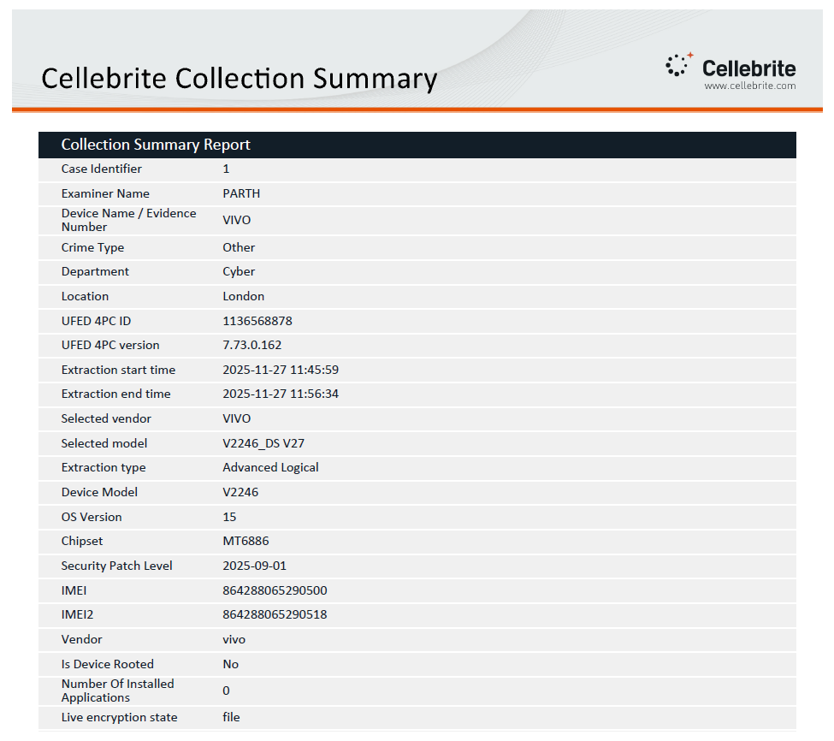
Figure 21: Cellebrite extraction summary for Vivo
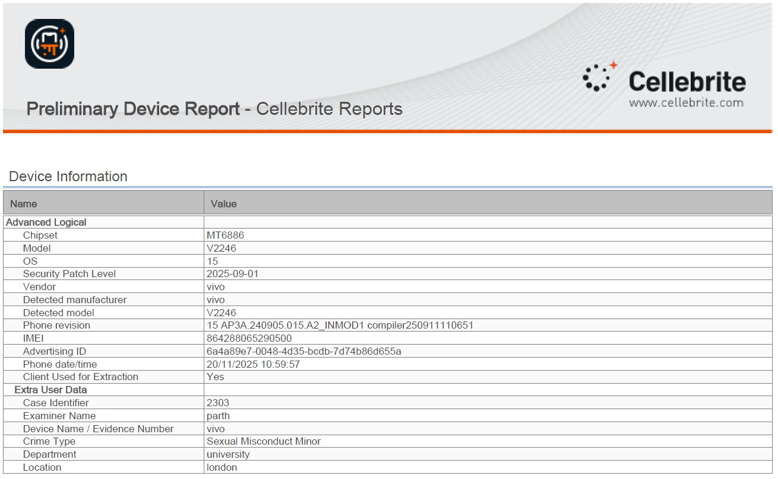
Figure 22: Cellebrite extraction summary for Vivo
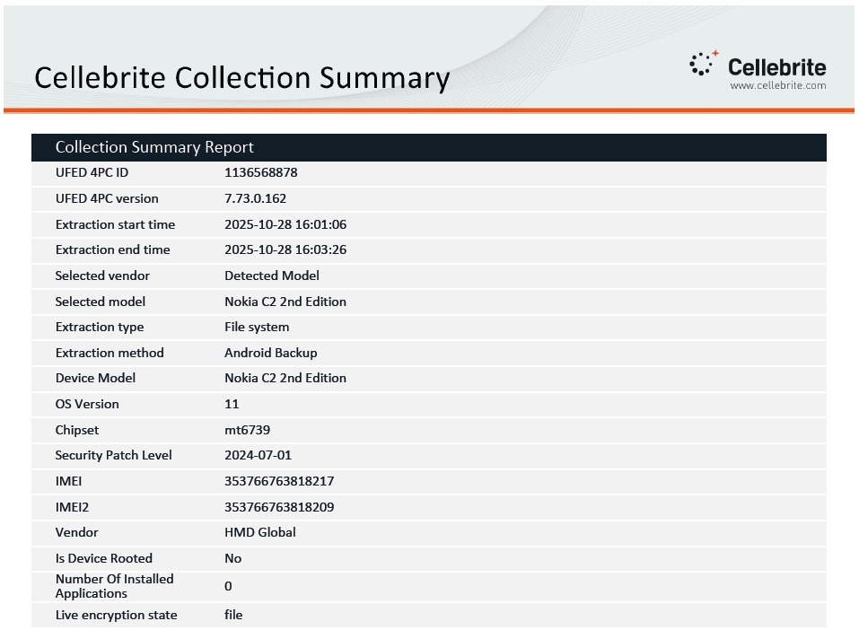
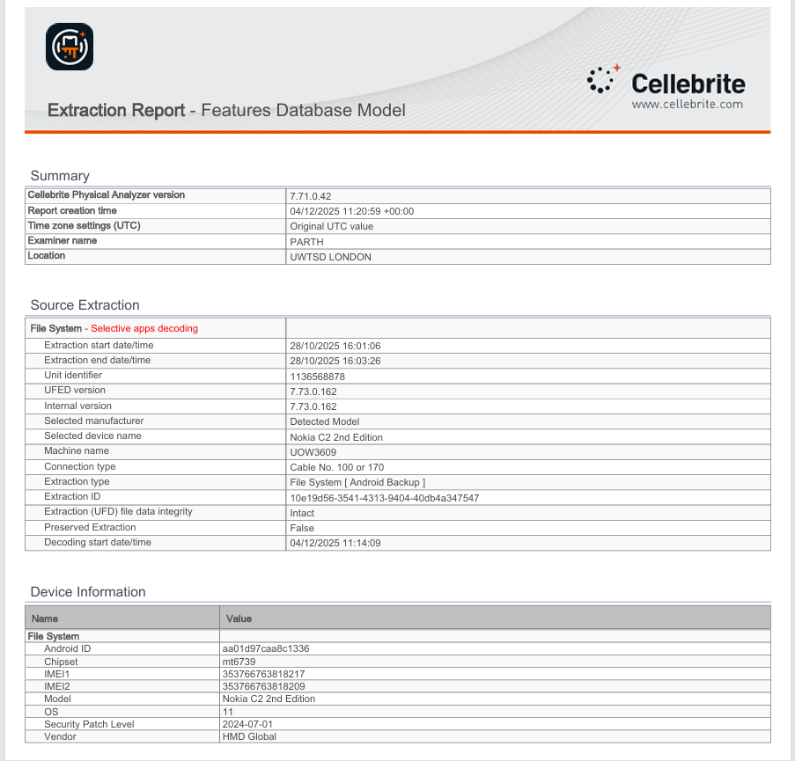
Figure 23: Cellebrite extraction summary for Nokia
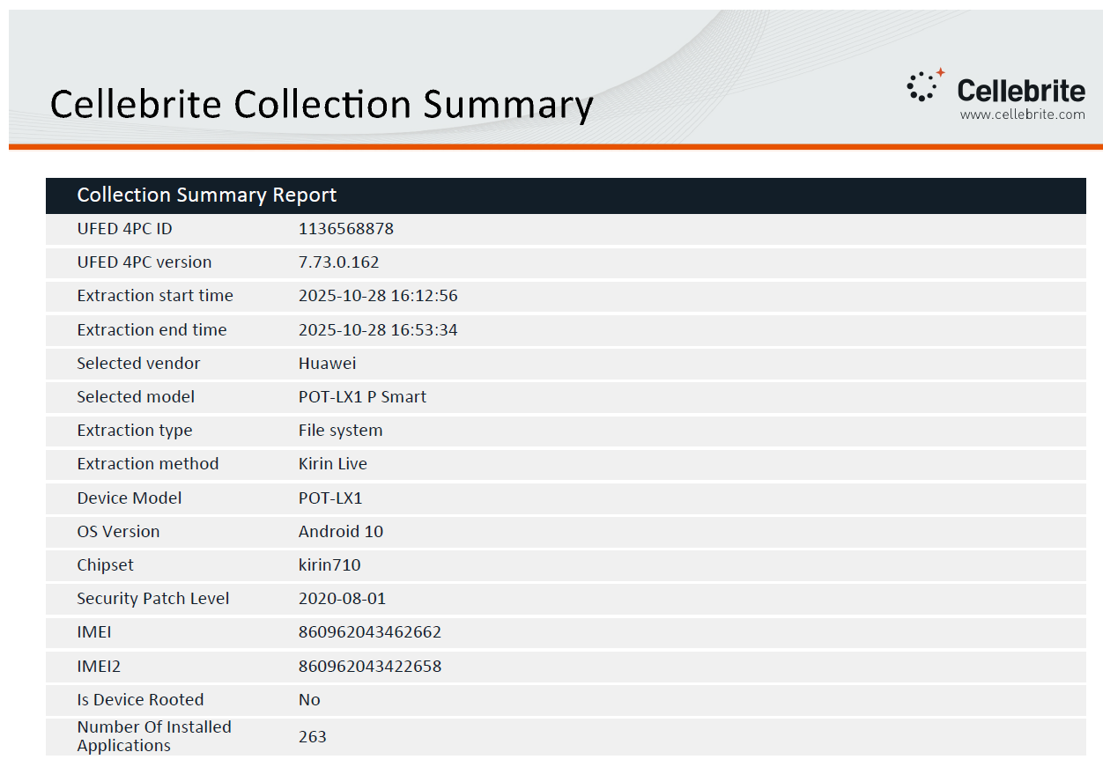
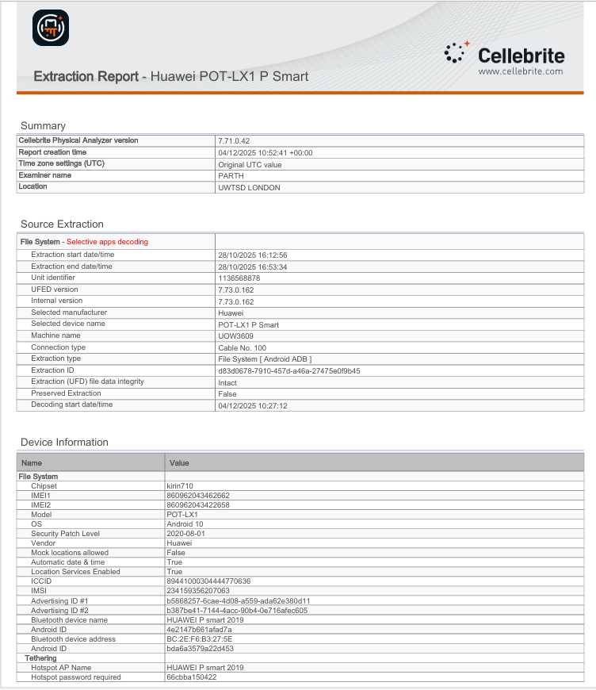
Figure 24: Cellebrite extraction summary for Huawei
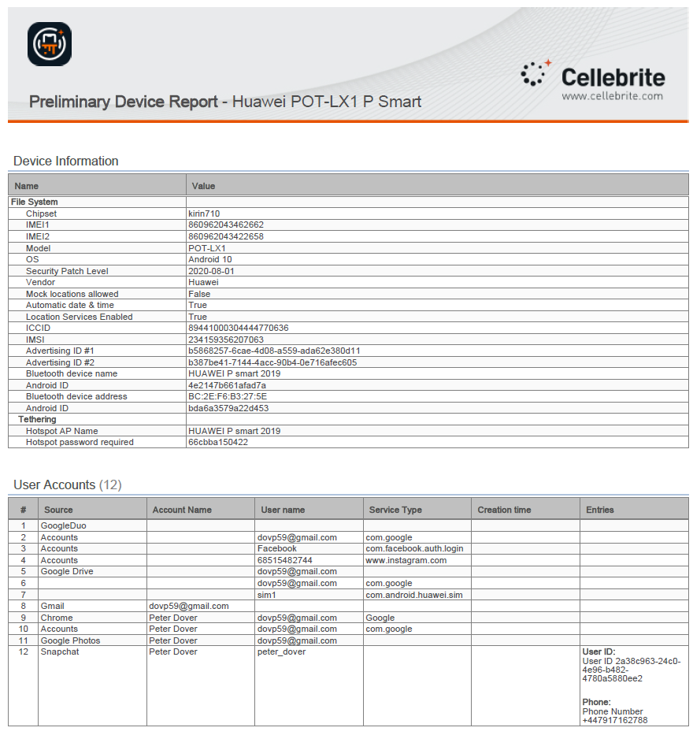
Figure 25: Cellebrite extraction preliminary device report of Huawei
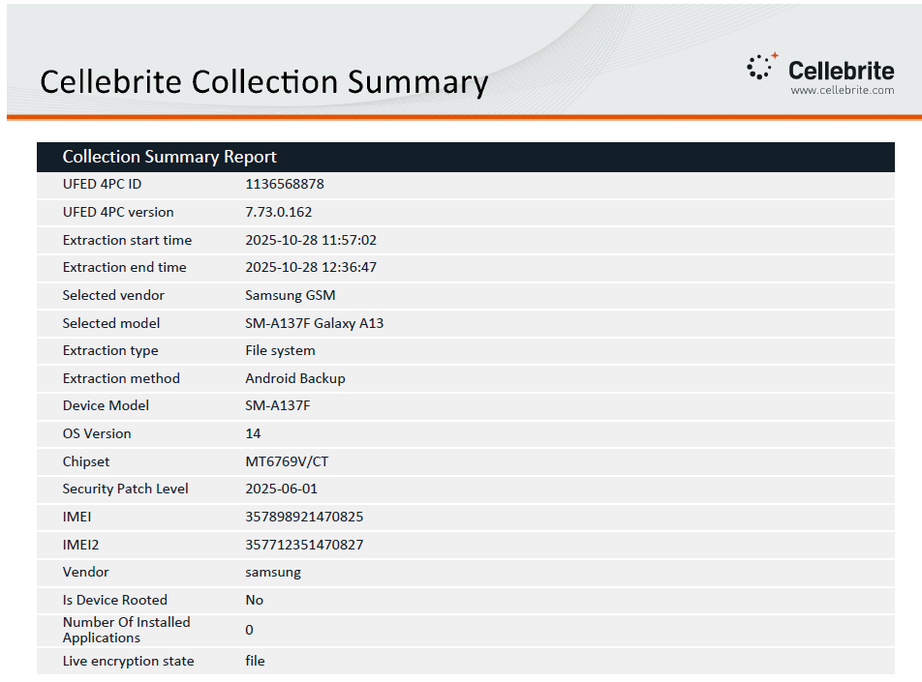
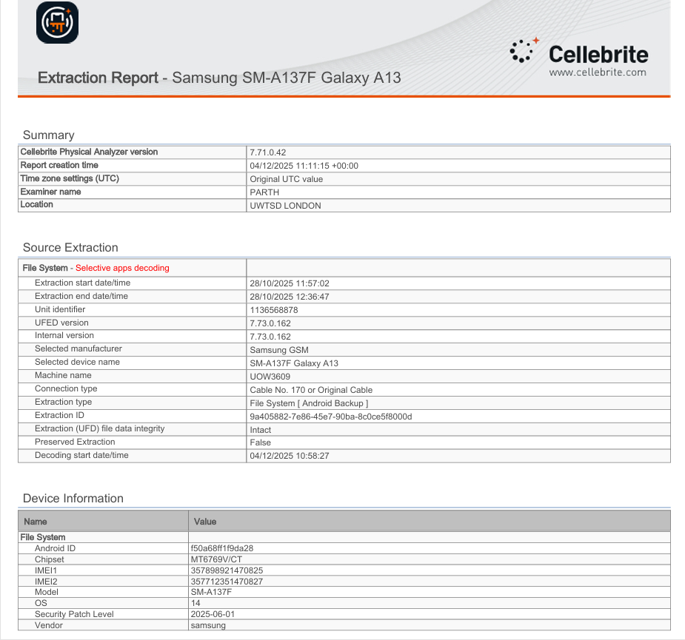
Figure 26: Cellebrite extraction summary for Samsung

8. Conclusion

8.1 Summary of Key Findings
The four mobile devices are the subject of forensic analysis that has revealed a conspiracy that was well planned and executed to steal and sell the patent QT-AI-2025. The roles of Emma (the insider), Joe (the intermediary) and Norman (the buyer/financier) were determined with a lot of confidence through strong attribution. An artifact exhibited vital communications, transportation and financial trends and retirement safeguards. The device of the unknown Nokia user is a key but inexplicable factor, with an encrypted file that probably played a critical role in the conspiracy and that had possible biometric evidence.

8.2 Attribution Confidence
System caches, account records, geolocation and financial artifacts, and multiple datasets correlation are all very strong proxies of device-user mapping. Most of the timeline and actions of the operations are pegged on first hand evidence as well. Though not all the evidence (full-text in encrypted files, anonymized biometric pictures, etc.) is available, the overlapping of autonomous digital evidences gives solid proof to the assertion of the investigation, and it is possible to with a high degree of confidence to attribute the major roles and activities.

8.3 Limitations and Unresolved Points
There are a few yet meaningful investigative limitations. The Nokia C2 had a password-controlled document that contains vital information that cannot be accessed. The decryption of chats in WhatsApp failed on the Nokia because of the lack of key files, and the prompt identification of the unknown male biometric remains cannot be performed at the moment. These loopholes are places of open-ended cryptanalysis and the future biometric inquiries, but in no way undermines the sound of the already existing narrative and its factual foundation. More investigative measures based on these points whose answers remain unknown are suggested.

9. Recommendations for Further Action

9.1 Technical Recommendations
9.1.1 Advanced Cryptanalysis
The password-sheltered file of the Nokia C2 device should be of priority in the first place. Invest in special cryptography facilities, including special dictionary and brute force cracking clusters or service providers, to tire out complicated dictionary and brute force attacks. Other sophisticated methods, such as linguistic profiling, and association with the past user passphrases must be used. The fact that the file might contain some important information about the conspiracy (patent, contacts, or payment information) alone makes it worth severe resource investment.
9.1.2 Facial Recognition and Image Analysis
The unknown face image on the Nokia device should be submitted to the facial recognition database through the use of both national law enforcement and international databanks with the use of biometrics. This may result in the unravelling of the fourth conspirator or reveal more links in the networks. The corresponding interviews and legal warrants of related digital accounts should be pursued in case of any promising results.

9.2 Legal Requests and Next Steps
Launch legal actions to be able to gain subscriber and transaction data to:
- All the email addresses are important (especially dip59@gmail.com, josephrehan464@gmail.com).
- The image on the Ulefone device is that of the State Bank of India debit card.
- The Mastercard 3758 of Joe established in Paris and London.
- Collaborate with transnational unified agencies and request judicial directives in order to conserve and reclaim additional electronic proofs on the part of service providers.

9.3 Operational Security Improvements
To investigate in the future and also to ensure organization resilience, amend evidence handling protocols to encompass multi-factor chain-of-custody tracking, triage of artifacts quickly with encryption and regular counter-forensics detection training. Implement passive danger rejection observation on an ongoing basis to recognize novel obfuscation techniques as well as intensify defenses against advanced intrusions.
References
[1] C. Cruz, “Innovative Learning in a Digital Forensics Laboratory: Tools and Techniques for Data Recovery,” Appl. Sci., vol. 14, no. 23, p. 11095, Nov. 2024, doi: 10.3390/app142311095.
[2] L. Klasén, N. Fock, and R. Forchheimer, “The invisible evidence: Digital forensics as key to solving crimes in the digital age,” Forensic Sci. Int., vol. 362, pp. 112133–112133, 2024, doi: 10.1016/j.forsciint.2024.112133.
[3] I. Shumailov et al., “Trusted Machine Learning Models Unlock Private Inference for Problems Currently Infeasible with Cryptography,” 2025, arXiv. doi: 10.48550/ARXIV.2501.08970.
[4] B. Fakiha, “Unlocking Digital Evidence: Recent Challenges and Strategies in Mobile Device Forensic Analysis,” J. Internet Serv. Inf. Secur., vol. 14, no. 3, pp. 68–84, Aug. 2024, doi: 10.58346/JISIS.2024.I2.005.
[5] J. S. Reddy, N. S. KiranmayeeSattiraju, and R. Julakanti, “Data Protection through Governance Frameworks,” ArXiv Cornell Univ., 2025, doi: 10.48550/ARXIV.2502.10404.
[6] A. A. Ahmed, K. Farhan, W. A. Jabbar, A. Al-Othmani, and A. G. Abdulrahman, “IoT Forensics: Current Perspectives and Future Directions,” Sensors, vol. 24, no. 16, p. 5210, Aug. 2024, doi: 10.3390/s24165210.
[7] B. Mbimbi, D. Murray, and M. Wilson, “IoT Forensics-Based on the Integration of a Permissioned Blockchain Network,” Blockchains, vol. 2, no. 4, pp. 482–506, Dec. 2024, doi: 10.3390/blockchains2040021.
[8] F. Casino et al., “Research Trends, Challenges, and Emerging Topics in Digital Forensics: A Review of Reviews,” IEEE Access, vol. 10, pp. 25464–25493, 2022, doi: 10.1109/ACCESS.2022.3154059.
[9] Z. Yin et al., “Digital Forensics in the Age of Large Language Models,” 2025, arXiv. doi: 10.48550/ARXIV.2504.02963.
[10] J. Fähndrich, W. Honekamp, R. Povalej, H. Rittelmeier, and S. Berner, “Special Issue on Application of AI in Digital Forensics,” KI - Künstl. Intell., vol. 36, no. 2, pp. 121–124, Sept. 2022, doi: 10.1007/s13218-022-00777-3.
[11] A. Almuqren, H. Alsuwaelim, M. M. Hafizur Rahman, and A. A. Ibrahim, “A Systematic Literature Review on Digital Forensic Investigation on Android Devices,” Procedia Comput. Sci., vol. 235, pp. 1332–1352, 2024, doi: 10.1016/j.procs.2024.04.126.
[12] T. Sutikno and I. Busthomi, “Capabilities of cellebrite universal forensics extraction device in mobile device forensics,” Comput. Sci. Inf. Technol., vol. 5, no. 3, pp. 254–264, Nov. 2024, doi: 10.11591/csit.v5i3.p254-264.
[13] S. Arora, R. Mittal, and M. P. S. Bhatia, “A survey of popular digital forensic tools,” in Cyber Crime and Forensic Computing, G. Shrivastava, D. Gupta, and K. Sharma, Eds., De Gruyter, 2021, pp. 1–26. [Online]. Available: https://www.degruyter.com/document/doi/10.1515/9783110677478-001/html.
[14] M. K. Bhatia, P. Gambhir, S. Sinha, and S. K. Singh, “A Comparative Analysis of OS Forensics Tools,” Int. J. Res. Appl. Sci. Eng. Technol., vol. 10, no. 11, pp. 494–502, Nov. 2022, doi: 10.22214/ijraset.2022.47346.
[15] D. Batista et al., “Exploring Blockchain Technology for Chain of Custody Control in Physical Evidence: A Systematic Literature Review,” J. Risk Financ. Manag., vol. 16, no. 8, p. 360, Aug. 2023, doi: 10.3390/jrfm16080360.
[16] G. Pestana and S. Sofou, “Digital chain of custody innovation management roadmap,” Eur. Phys. J. Plus, vol. 139, no. 7, p. 633, July 2024, doi: 10.1140/epjp/s13360-024-05420-8.

