
E PORTFOLIO
Software and app for business
My student id 2229734
Taiba Rashid

A Little bit about me
My name is Taiba Rashid I am currently a student at the university of Wales UWTSD doing digital skills Level 4. I am hoping to carry on after level 4 to achieve a degree in this field. I have a lot of support from family and friends who motivate me to build my self-confidence and help me realise that I can achieve my goals and study as a 39 year old single parent. I am working towards achieving my best at this university. In the next coming years I am dedicating my time and efforts to my studies and gaining the qualifications I am passionate about. The reason I chose Digital skills is because they are so many different fields I can get a Job in with this qualification Especially if I have a degree in it and level 4 is just a start towards my Dream job
In my portfolio I will include my work from my course digital skills module [software and app for business]. Thia module includes 5 tasks and will have written texts pictures and references from the sources I used to collect information.
Task 1 a b
An Ecommerce software solution is the system or tool that allows you to start or enhance your online business. This software allows you to list and sell your products and accept payments.
An E commerce website builder is the most convenient and popular way to buy and sell products/physical goods online. There are so many different websites online that are available for businesses to use to sell their products/goods.
Through an e commerce website business can benefit in several ways
: process orders
: make and process payments.
: manage shipping and logistics.
: provide customer services
: recognition for your business through the websites like advertisement
Shopify is one of the most used e commerce website to buy and sell products for businesses
As a business choosing the right platform to sell your products is essential
Shopify features -easy to set up-easy to manage-exceptional security-access to a variety of shopify payment methods like paypal stripe etc -a variety of useful integration for dropshipping-supports for best SEO practices-automated store emails-hosting with unlimited bandwidth
Founders of shopify: Tobias lutke-Daniel Weinand-Scott Lake 
Other websites you can use for your business are
Wix e commerce- wix has lots of pros its features help your business to design well it has profession designs and which ever one you choose to use give your site the results are great-It has the fastest loading pages-easily accessible to customers-it offers all necessary core functions like inventory management-orders-marketing-payments-fulfilment-dropshipping
Founders of Wix: Avishai Abrahami-Nadav Abrahami-Giora Kaplan

Weebly- one of the best features that weebly provides for businesses that it allows you to sell for free-customised and suggested emails-Dynamic tax and shipping calculators-bulk inventory-mobile optimization-coupon codes-Drag and drop-ssl encryption
Founders of Weebly: David Rusenko-Chris Fanini-Dan Veltri 

[1] [2] [3]
IEEE citations

References IEEE citation

[1] | a. abrahami, wix, 05 10 2006. [Online]. Available: www.wix.com. [Accessed 22 02 2023].
[2] | T. lutke, shopify, 6 2006. [Online]. Available: www.shopify.com. [Accessed 02 2023].
[3] | d. rasenko, weebly.com, 02 2006. [Online]. Available: www.weebly.com. [Accessed 22 02 2023].

Some pictures of each website using features they carry businesses can use

Shopify
Shopify automation
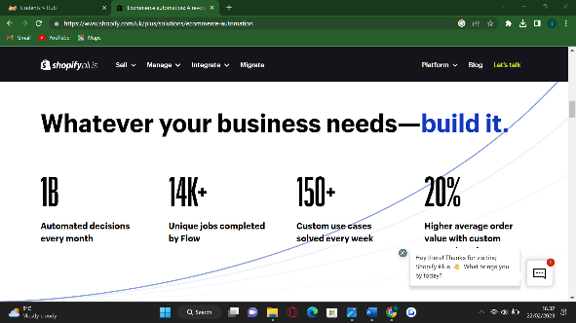

Weebly
Weebly drag and drop for creating blogs

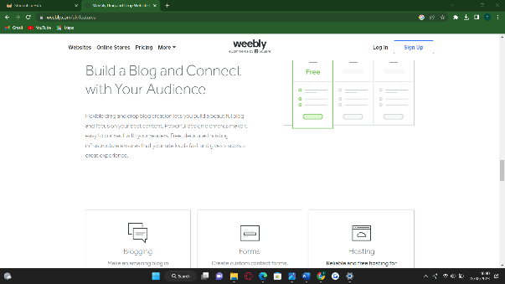
Wix
Wix features
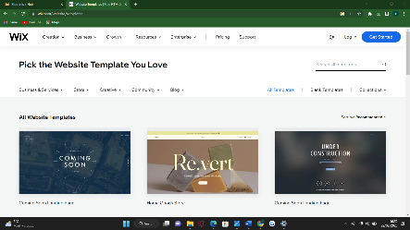
Pick your own template.

[4] [5] [6] IEEE citations References

References

[4] | "shopify features," shopify, 2006. [Online]. Available: https://www.google.com/search?q=shopify+features&rlz=1C1YTUH_en-GBGB1039GB1039&oq=shopify+features&aqs=chrome.0.69i59l2j35i39j0i512l2j0i22i30j69i60l2.7326j0j4&sourceid=chrome&ie=UTF-8. [Accessed 22 02 2023].
[5] | "wix features," wix, 2006. [Online]. Available: https://www.wix.com/website/templates. [Accessed 22 02 23].
[6] | "weebly features," weebly, 2006. [Online]. Available: https://www.google.com/search?q=weebly+features&rlz=1C1YTUH_en-GBGB1039GB1039&sxsrf=AJOqlzV-dCRZatQ1uQl1dw1Vb0K4kuOQEA%3A1677086366838&ei=nk72Y73oMpGMhbIP6sOhmAo&oq=weebly&gs_lcp=Cgxnd3Mtd2l6LXNlcnAQARgAMgQIIxAnMgQIIxAnMgoILhCDARCxAxBDMgQIABBDMgQIABBDMgQI. [Accessed 22 02 2023].

Task 2
Mind-map of contemporary software Applications that are used to support day-to-day business/Organisation operations.
Most common used software applications are word processing programs. Accounts software. Billing software. Payroll software. Database software. Asset management software. Desktop publishing programs.
The more Advanced software applications that are used in business now are:

QuickBooks
Quick book features helps maintain your book of accounts online it also allows your employees to access your business financial data anywhere anytime from multiple devices.
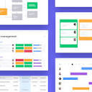
Project management software
Project management features include Task management, resource management, team collaboration, time tracking, reporting, file management is one of the top features offered by Project management software.
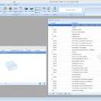
Accounting software
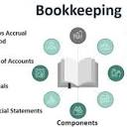
Account software features are: Security. Cloud-readiness. User-friendliness. Integrations. Bookkeeping capabilities. CRM capabilities. Financial reporting and projections.

Bookkeeping
Bookkeeping software and Accounting software are very similar. This software manages and records the day-to-day financial transactions of an organization, including fixed asset management, expense management, revenue management, accounts receivable, accounts payable, subledger accounting, and reporting and analytics.


Zoho Corporation
Zoho has features such as Sales Force Automation. Canvas Design Studio( NEW).Process Management. Journey Orchestration. Omnichannel. Analytics. Sales Enablement.


Communication software
Communication software features include direct and group messaging collaboration & Productivity. Email. Instant Messaging. Web & Video Conferencing. Mobile device management.
Reference from www.google.com
Google pages
Google search bar
Mind map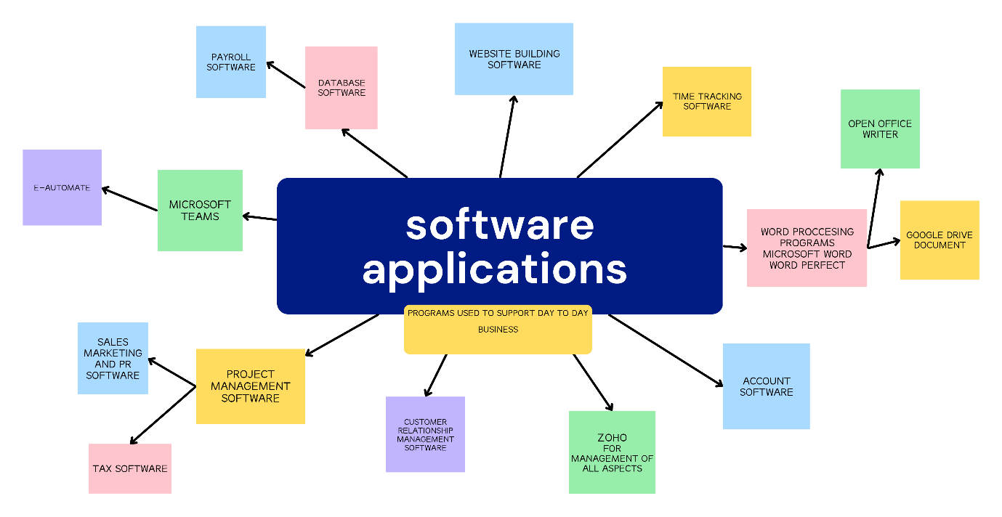

References
IEEE Citations
[7] "minute dock," software applications, 2009 -2020. [Online]. Available: https://minutedock.com/academy/5-types-of-software-every-business-needs. [Accessed 25 02 2023].
[8] "proof hub," software application, 10 2013. [Online]. Available: https://www.proofhub.com/articles/best-business-management-software. [Accessed 25 02 2023].
https://www.canva.com/graphs/mind-maps/
google sites google.com

Task 3. Office Applications for creating storing, analysing & presenting information/data. (Approx. 250 words).
Task A.Analyse several contemporary Office applications (e.g., for Word-processing, Spreadsheets, Databases, Presentations), and document a summary of their key features using written text with some images and relevant citations (approx. 2/3sources).

Task b Test some business-related features of a freely available Office Application of your choice and document several screenshots with brief accompanying description to provide evidence of practical use.
Task a
Microsoft Teams.
Microsoft Teams is an advanced solution to improve communication for work, projects, study etc it is an easier way to communicate as a group via video call and audio call
Features of teams :
:Teams connect
:online meetings
:chat function
:document storage in sharepoint
:screen sharing
:audio conferencing
:full telephony
:meeting scheduling
:activity feed
:video recording

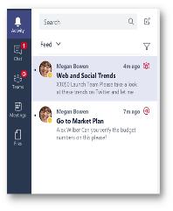
Chat function
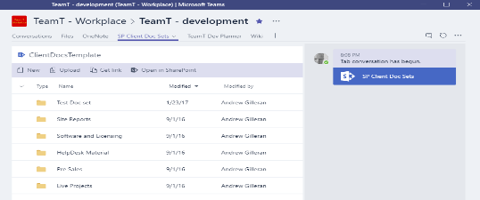SharePoint

Reference
[9] IEEE citation
[9] | d. kent, "dispatch," best team features, 2023. [Online]. Available: https://dispatch.m.io/best-microsoft-teams-features/. [Accessed 23 02 2023].

Excel.
Excel is a spreadsheet program developed by Microsoft. It is commonly used to organise data in columns and rows. It also allows you to do mathematical functions produce graphs and charts.
Some features of Excel:

:pie chart
:mixed or combination type charts
:data validation
:conditional formatting
:choose function
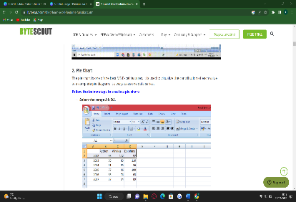
Pie chart

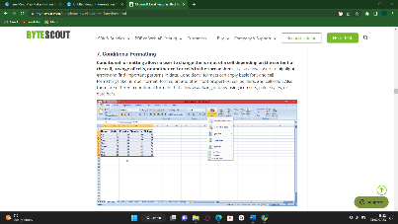 conditional formatting

References
B. T. o. Writers, "bytescout.com," bytescout academy, 2006. [Online]. Available: https://bytescout.com/blog/learn-excel-features-functions.html. [Accessed 02 2023].
Google.com
Youtube.com

PowerPoint.

Microsoft PowerPoint is a powerful slide show presentation program. It is a standard component of the company’s Microsoft Office suite software, and it comes together with Word, Excel, and other office productivity tools. PowerPoint is Microsoft's presentation software that enables users to create engaging presentations that consist of individual pages, or slides, which may contain text, graphics, sound, movies, hyperlinks, and other objects. PowerPoint enables users to add animation and effects to slideshow elements. Presentations can be printed, displayed, notated, and navigated by the presenter.
Some features of PowerPoint:

:Audio features.
:Bi-directional text features.
:Collaboration features.
:Design and layout features.
:Keyboard features.
:Object insertion features.
:Picture features.
:Print features.
:Animations

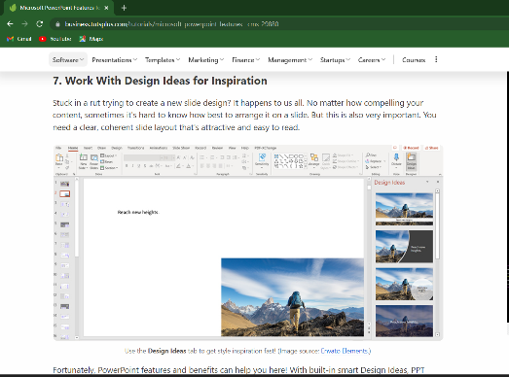 Design and layout features

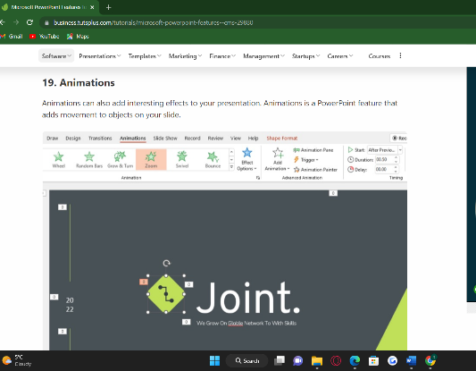 Animation

References

A.Childress, "Avento tuts +," learning skills, 2007. [Online]. Available: https://business.tutsplus.com/tutorials/microsoft-powerpoint-features--cms-29880. [Accessed 25 02 2023].
"Byjus.com," think and learn private limited, 2011. [Online]. Available: https://byjus.com/govt-exams/microsoft-powerpoint/. [Accessed 25 02 2023].

Outlook.

Microsoft Outlook is the preferred email client used to send and receive emails by accessing Microsoft Exchange Server email. Outlook also provides access contact, email calendar and task management features. Outlook may be used as a standalone application or with various other software’s.

Features of outlook:
Email service
Popular email client for many businesses
Calendaring
Task management
Contact managing
Note taking
Preview pane options
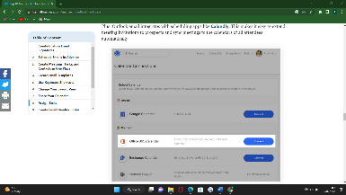 calendaring

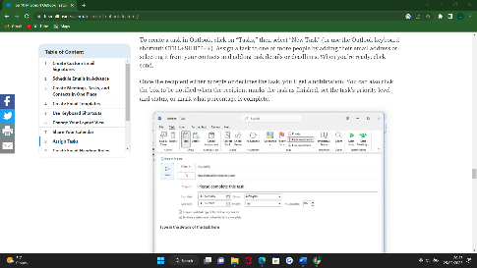 Task management

References
E. Kraus, "fit samll bussiness," 2013. [Online]. Available: https://fitsmallbusiness.com/microsoft-outlook-features/. [Accessed 25 02 2023].

Google sites
Google answers

OneNote.

OneNote is a digital note-taking app that provides a single place for keeping all of your notes, research, plans, and information — everything you need to remember and manage at work, or a school , university or at home

In OneNote, notebooks never run out of paper. Notes are easy to organize, print, and share, and you can search and find important information quickly, even if you forget where you've originally captured it. Best of all, your notebooks are stored online so you can easily get to them on any of your mobile devices.

Organize data in Notebook. Organize data in Notebook is one of the best features of OneNote

Web clipper. OneNote web clipper allows you to take information from a web page to OneNote
Templates.
Text Search.
Translation.
Recording.
Protect Sections with Password.
Tags.
Translate Notes.

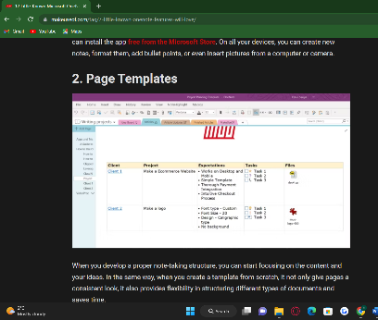 Template

References

r. saigal, "MUO," 2007. [Online]. Available: https://www.makeuseof.com/tag/7-little-known-onenote-features-will-love/. [Accessed 26 02 2023].
Google.com

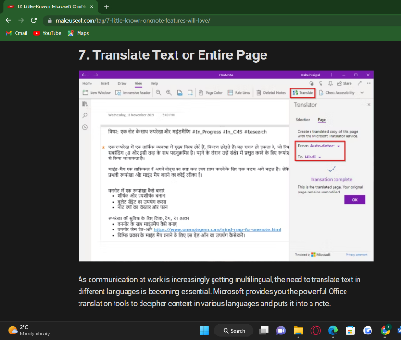 Translate

OneDrive.
One drive is the Microsoft cloud service that connects you to all your files. It lets you store and protect your files share them with others and get to them from anywhere on all your devices. When you use OneDrive with an account provided by your company or school it's sometimes called "OneDrive for work or school." It used to be known as "OneDrive for Business," so you may still see it called that in places.
Features of one drive:
:Unlimited file access, anytime.
:Renders files available from anywhere for collaboration.
:Organisational platform for files.
:Free-up device storage.
:Sharable content across teams, large or small.
:Customisable sync experience (for admin)
:Securely store files and information.
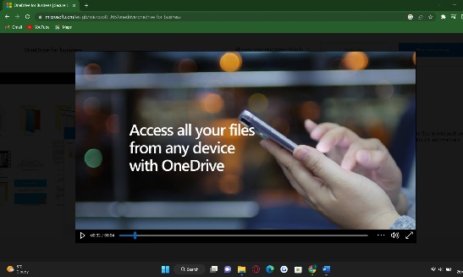 Unlimited file access, anytime.
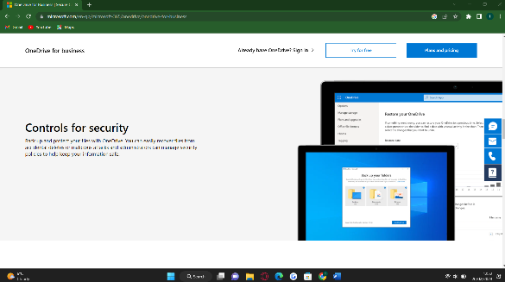 security

References
"micrososft one drive," updated 2023. [Online]. Available: https://www.microsoft.com/en-gb/microsoft-365/onedrive/onedrive-for-business. [Accessed 26 02 2023].
Google.com Video references
Task b. Test some business-related features of a freely available Office Application of your choice and document several screenshots with brief accompanying description to provide evidence of practical use.
Quip is a collaborative productivity software suite for mobile and the Web. It allows groups of people, businesses or for study purposes to create and edit documents and spreadsheets as a group, typically for business purposes
Quip is available for your Mac, iPad and iPhone.

Quip features:
: Documents and spreadsheets with embedded CRM data
: Two-way data sync with CRM
: Comment, share, and edit in real-time.
: Create and edit files together.
: Choose between a variety of file types, including word processing documents, spreadsheets, and slideshow presentations.
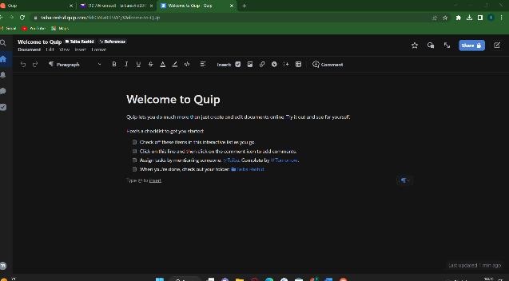 quip app welcome page
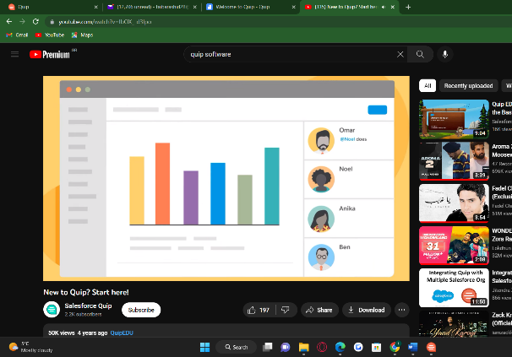 new to quip YouTube Tutorial

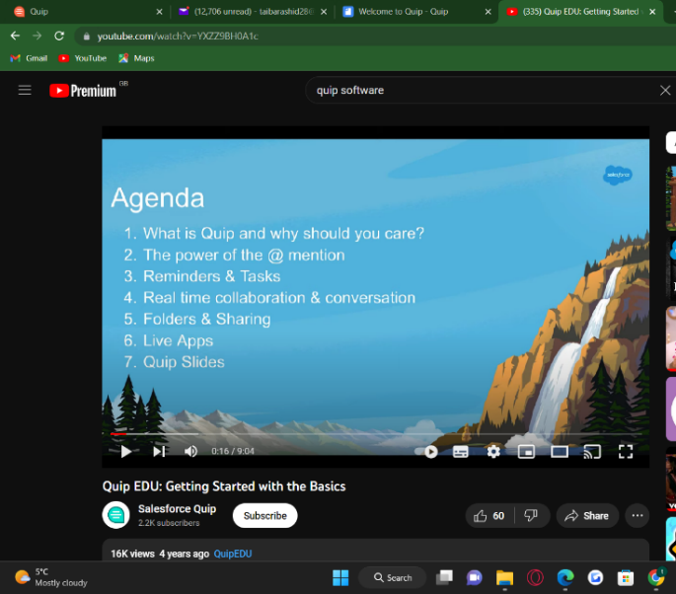 Getting started with the basics.
YouTube tutorial
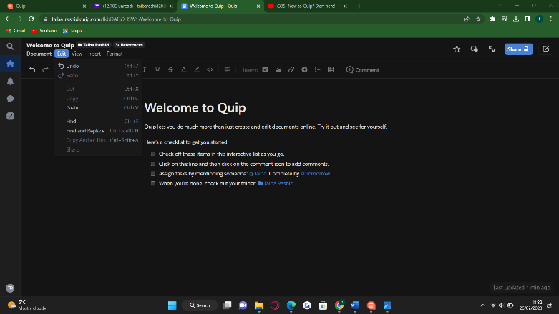 Quip Edit features.

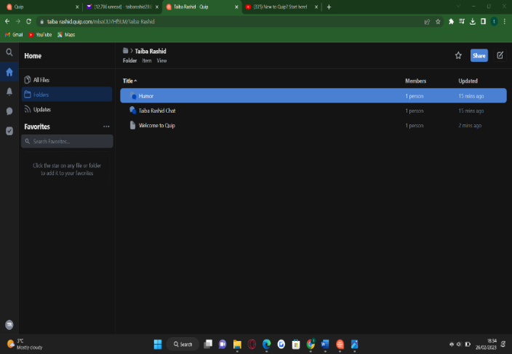 access to folders you create and updates.

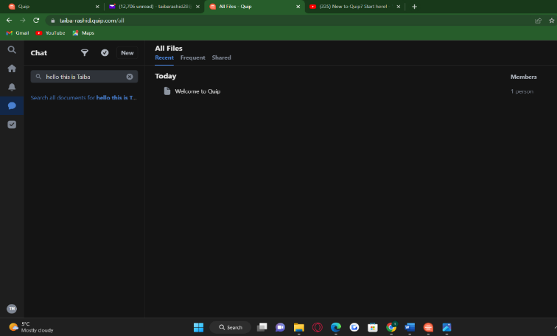
Chat bar for communication, comments and sharing ideas.

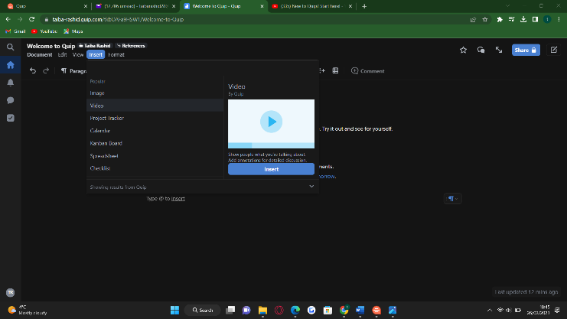
Showing others what you are discussing adding visual details videos images or spreadsheets

References
k. G. bret taylor, "salesforce," quip LLC, 2012. [Online]. Available: salesforce.com. [Accessed 26 02 2023].
https://www.softwaretestinghelp.com/best-free-office-software/ https://www.salesforce.com/products/quip/overview/
https://quip.com/
https://quip.com/download
https://www.youtube.com/watch?v=fbOX_-d3Ipo
youtube.com
Wikipedia
Google search google.com

Task 4. Poster of Digital Dashboard and Data Analytics software. (Approx. 200-250 words).
Complete either a(i) or a(ii) below:
a. ii. Test some features of a freely available Digital Dashboard/Data Analytics software application of your choice and document several screenshots with brief accompanying description to provide evidence of practical use.
What is a digital dashboard/data analytics software.
A digital dashboard is an analysis tool that allows business users to monitor and analyse their most important data sources in real time. With interactive data visualizations digital dashboards allow for an improved decision making process and continuous growth. Digital dashboards evaluate weekly monthly or yearly progress depending on how often you analyse it. Modern, interactive dashboards make it easy to combine data from multiple sources and deeply explore and analyse the data directly within the dashboard itself. Dashboards are a powerful way to communicate data and other
information, especially with a user-centered, goal-centric design that follows dashboard design best practices and proper data visualization.
Some dashboard software’s available to use are:
Idashboards 
Tableau 
Yellowfin 
Zoho Analytics 
CXO software
Clic data
Qlik sense
Looker 
Microsoft power BI 

Features of digital dashboard are:
Dashboard chart filter/click-to-filter.
Drill-throughs.
Drill down.
Cross tab filters.
Time interval widget.
Chart zoom.
Custom chart tooltips.
Advanced data options.

Key features of Dashboards
They communicate information quickly.
They display information clearly and efficiently.
They show trends and changes in data over time.
They are easily customizable.
The most important widgets and data components are effectively presented in a limited space.

The Digital Dashboard software I have chosen to test out its features is Tableau

Features of Tableau
Informative Dashboards. ...
Supports numerous data sources. ...
Connectivity with Live and In-Memory Data. ...
Trend lines and predictive analysis
Provides Great Security. ...
Easy Collaboration & Sharing. ...
Provides a Mobile Version. ...
Advanced Visualization Capabilities. ...
Availability of Maps.

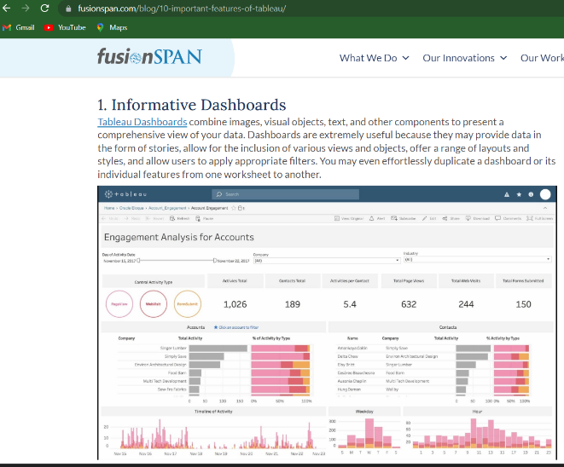

Informative Dashboard
Tableau Dashboards combine images, visual objects, text, and other components to present a comprehensive view of your data. Dashboards are extremely useful because they may provide data in the form of stories, allow for the inclusion of various views and objects, offer a range of layouts and styles, and allow users to apply appropriate filters. You may even effortlessly duplicate a dashboard or its individual features from one worksheet to another.

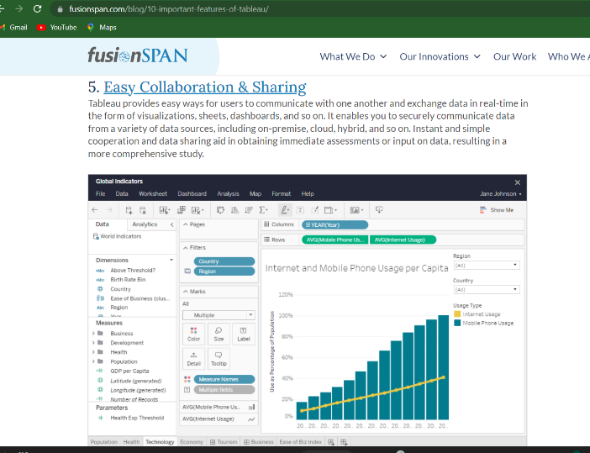

Easy Collaboration and sharing

Tableau provides easy ways for users to communicate with one another and exchange data in real-time in the form of visualizations, sheets, dashboards, and so on. It enables you to securely communicate data from a variety of data sources, including on-premise, cloud, hybrid, and so on. Instant and simple cooperation and data sharing aid in obtaining immediate assessments or input on data, resulting in a more comprehensive study.

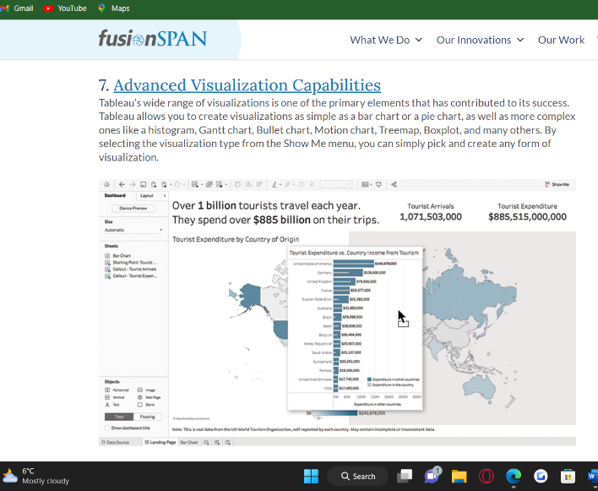

Advanced visualization capabilities
Tableau’s wide range of visualizations is one of the primary elements that has contributed to its success. Tableau allows you to create visualizations as simple as a bar chart or a pie chart, as well as more complex ones like a histogram, Gantt chart, Bullet chart, Motion chart, Treemap, Boxplot, and many others. By selecting the visualization type from the Show Me menu, you can simply pick and create any form of visualization.

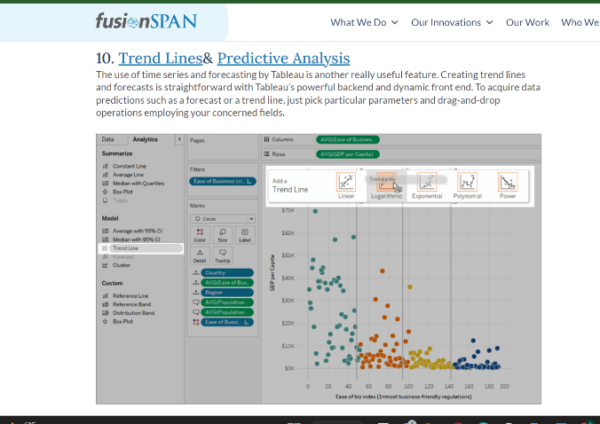

Trend lines and Predictive Analysis
The use of time series and forecasting by Tableau is another really useful feature. Creating trend lines and forecasts is straightforward with Tableau’s powerful backend and dynamic front end. To acquire data predictions such as a forecast or a trend line, just pick particular parameters and drag-and-drop operations employing your concerned fields.
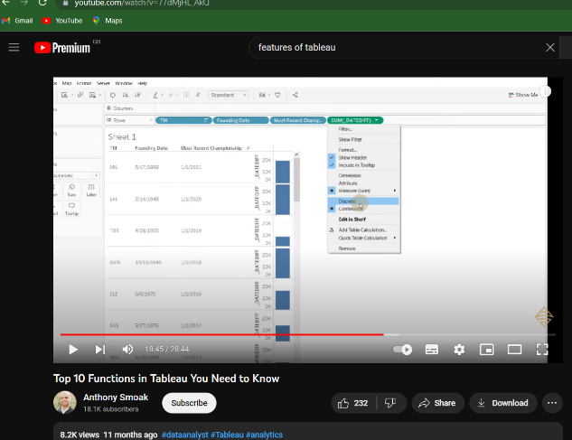

Data sources
You may connect to and fetch data from a variety of data sources using Tableau. Tableau supports a wide range of data sources, including local files, spreadsheets, relational and non-relational databases, data warehouses, big data, and on-cloud data. Any of Tableau’s data sources may be readily connected and combined with data from other sources to generate a combinatorial perspective of data in the form of visuals. Tableau also supports a variety of data connections, including Presto, MemSQL, Google Analytics, Google Sheets, Cloudera, Hadoop, Amazon Athena, Salesforce, SQL Server, Dropbox, and a number of others.

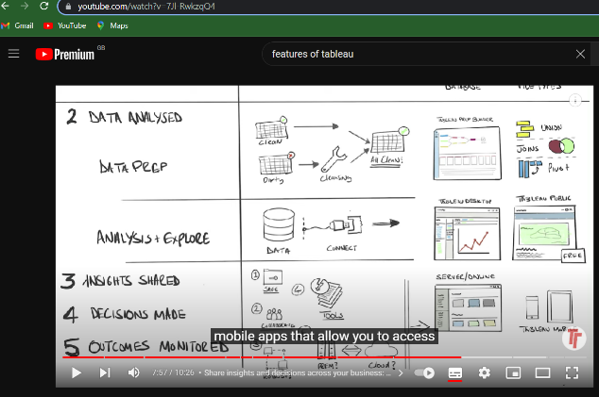

Provides a mobile version.

Tableau recognizes the importance of mobile phones in today’s society and offers a mobile version of the app. Dashboards and reports may be created in a mobile-friendly format. Tableau allows you to adjust mobile layouts for your dashboard based on your mobile device. Customization allows you to add new phone layouts, interactive offline previews, and more. As a result, the mobile view provides Tableau users with a great deal of flexibility and convenience while working with their data on the move.
References
Ortner, M., 1999. capterra uk. [Online] Available at: capterra.co.uk[Accessed 12 03 23].
Anon., 2012. Datapine. [Online] Available at: www.datapine.com[Accessed 12 03 23].
Eweek.com
Youtube.com
Google.com
Toptal.com
Fusionspan.com

Task 5. Communication, Collaboration & Project Management applications. (Approx. 250 words).
a. Analyse several contemporary Communication/Collaboration/Project Management applications and document a summary of their key features using written text with some images and relevant citations (approx. 2/3 sources).
b. Test some features of a freely available Communication/Collaboration/Project Management application and document several screenshots with brief accompanying description to provide evidence of practical use.
Include your answer to this task on a page in your e-portfolio.
Task 5 a
Communication software/Application: A communication software is used to provide access to systems and also to exchange files and messages in forms of text audio/video between different computers and various devices. There are all these different ways to communicate and the most common way is through Email, chats and video conferences.
Collaboration software/Application: Collaborative software or groupware is application software designed to help people working on a common task to attain their goals. One of the earliest definitions of groupware is "intentional group processes plus software to support them. This is the type program that shares data between computers for processing. In particular, several programs have been written to harness the vast number of computers connected to the Internet.
Project Management software/Application: Project management application software is designed to plan and document project tasks and activities, build schedules and timelines, solve project issues, manage risks and threats, assign budgets and control costs, establish collaboration and cooperation between project participants, assure and control quality.

Some Communication collaboration project management software applications are:
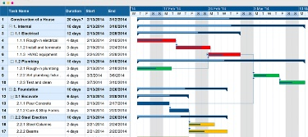

Gantt Charts

Go To Meeting 
Microsoft Teams
RingCentral
 Zoom

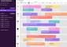
Task management
Slack 
Zoho Meeting - Online Meetings

Dialpad

Webex Meetings

Workplace

Aircall
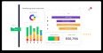 monday.com - Work Management

Troop Messenger 
WhatsApp

Skype
Mobile application


Microsoft teams
Key features of Microsoft Teams:
Teams and channels
Conversations within channels and teams
A chat function
Document storage in SharePoint
unique meeting ID and passcode
Online video calling and screen sharing
Online meetings
Audio conferencing
Collaboration

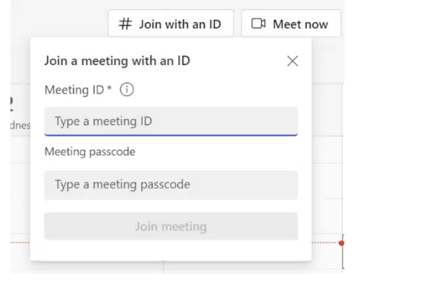

unique meeting ID and passcode


Chat function

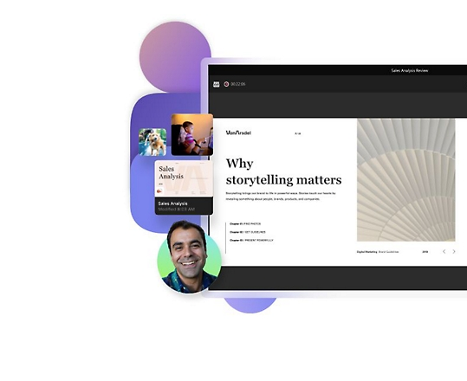

Collaborate
Skype
key features of skype
Instant messaging and chat history.
Calls between Skype and landline / mobile phone numbers.
Skype Premium.
Voicemail.
Video calling and screen sharing.
SMS text messaging.
Wireless hotspot network access.
Application features
Skype prime

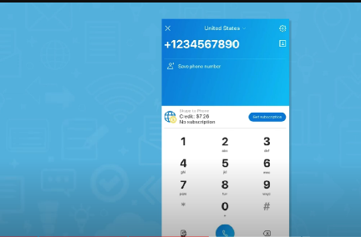

Calls between Skype and landline / mobile phone numbers


Instant Messaging as a group or private

Microsoft dynamic 365 for project management
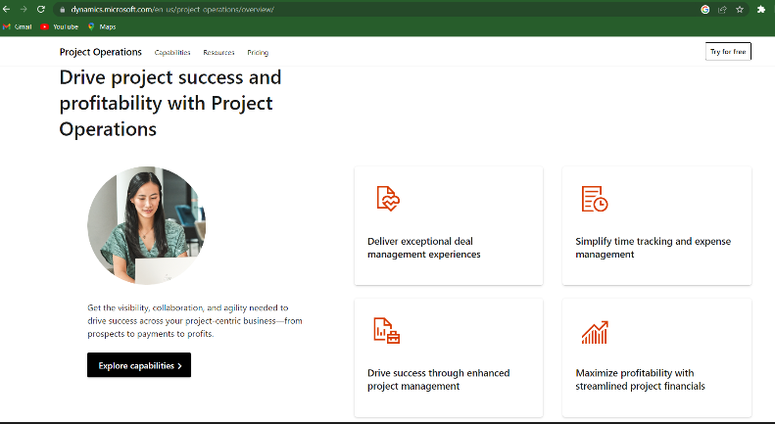
Gantt Charts
Key features of Gantt Charts
Task names
Task duration
Dependencies
TASK HIERARCHIES
Resource names of roles

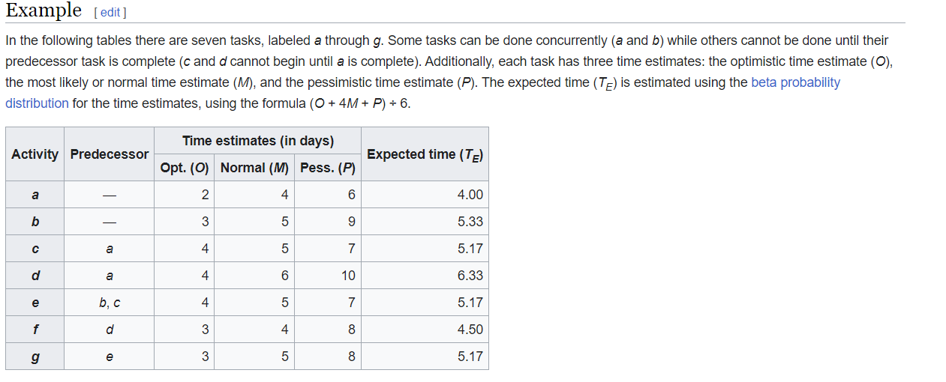
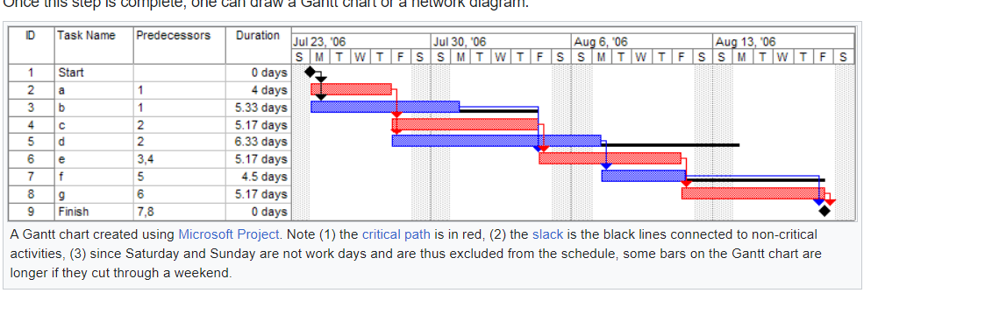
References
h. gant, "wikipedia," 1910-1915. [Online]. Available: https://en.wikipedia.org/wiki/Gantt_chart. [Accessed 17 03 2023].
"project management," 2021. [Online]. Available: https://project-management.com/top-10-project-management-software.com. [Accessed 17 03 2023].
microsoft teams, 2017. [Online]. Available: https://www.microsoft.com/en-gb/microsoft-teams/group-chat-software.com. [Accessed 2023].

5 b. Test some features of a freely available Communication/Collaboration/Project Management application and document several screenshots with brief accompanying description to provide evidence of practical use.
zoom


Zoom offers a variety of features to enhance your video conferencing experience while using Zoom Meetings. These support articles tell you how to use meeting features as the host or participant and how to create, schedule, and live stream meetings. Zoom is also a great tool for collaboration and project management using zoom Whiteboard.
Zoom makes collaboration easier between teams and external participants with enterprise chat and instant video meetings. Zoom Team Chat allows you to communicate in real-time across your entire organization. With 1:1 chat and group chats

Key features of zoom
- Virtual Meetings. Connect virtually from anywhere with Zoom Meetings.
- Team Chat. Collaborate together with Zoom Chat.
- VoIP Phone System. Call the world with Zoom Phone.
- Online Whiteboard. Create and brainstorm with Zoom Whiteboard.
- Conversational Intelligence.
- Email and Calendar.

New features as of 2023
- Immersive view.
- Blurred background.
- PowerPoint as a virtual background.
- Live transcription.
- Clip and share highlights.
- Suppress background noise.
- Zoom App search.
- Improved Zoom Chat.
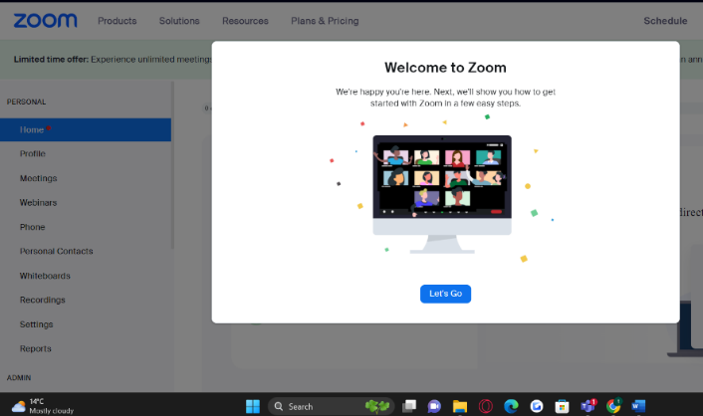
Zoom welcome page
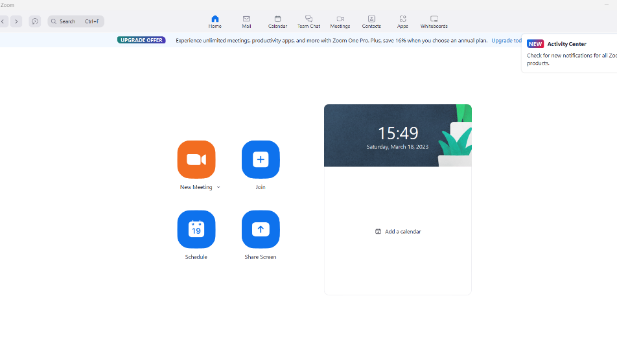

Zoom Home page

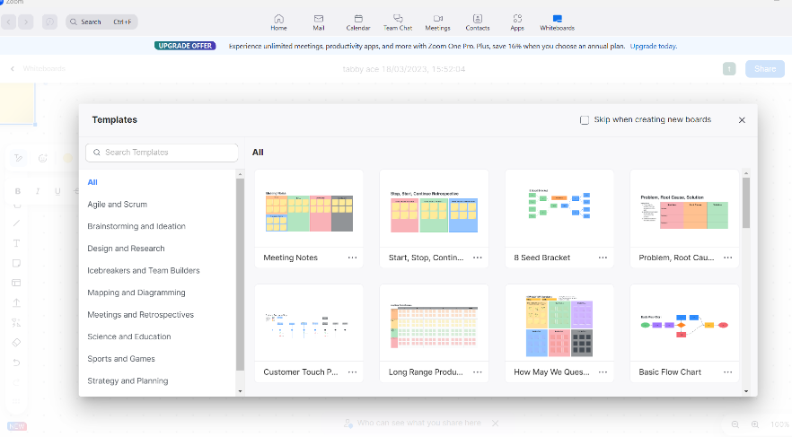

Zoom White Board
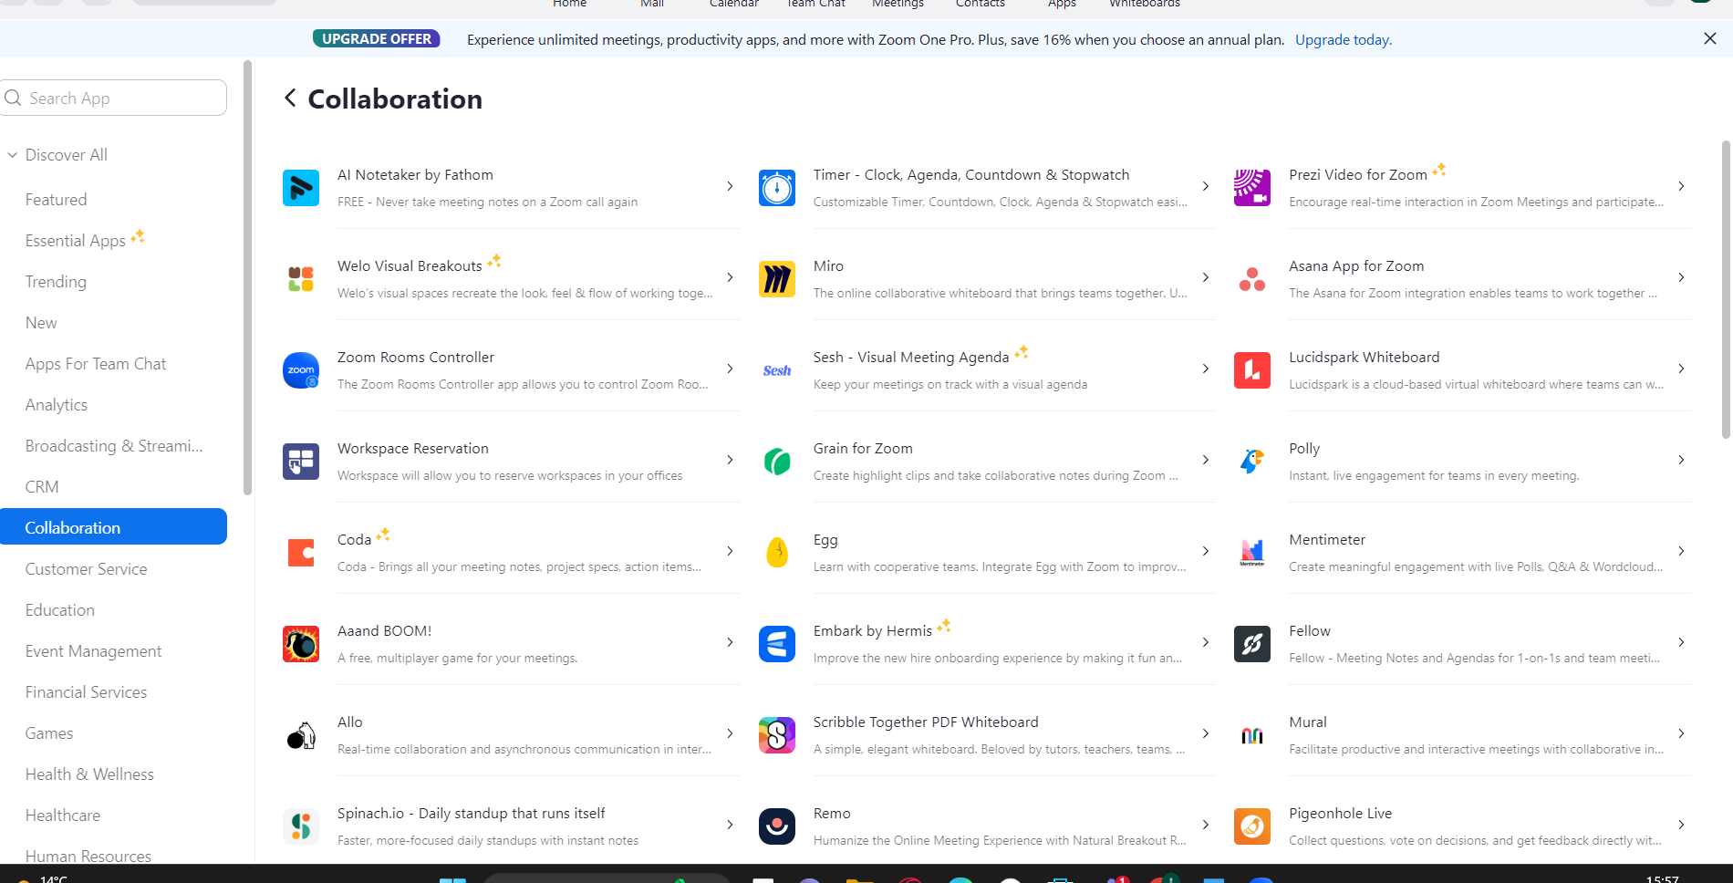
Zoom Collaborating

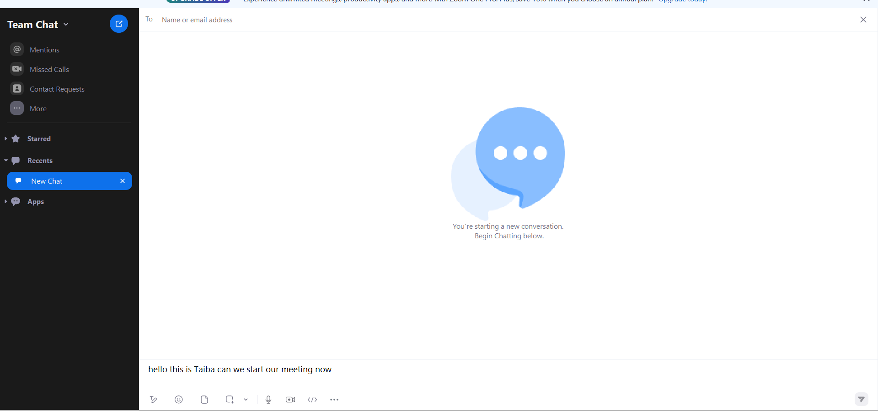
Zoom Communicating

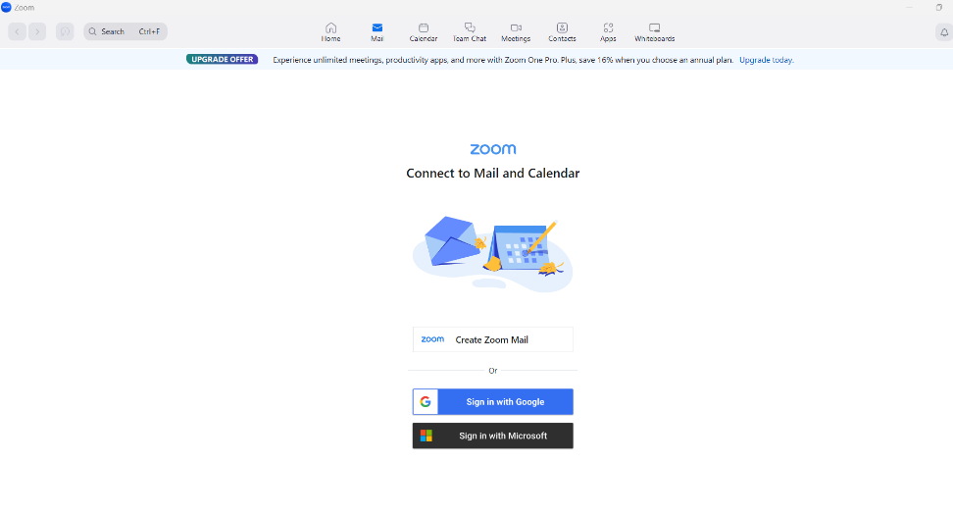
Zoom Email and calendar feature

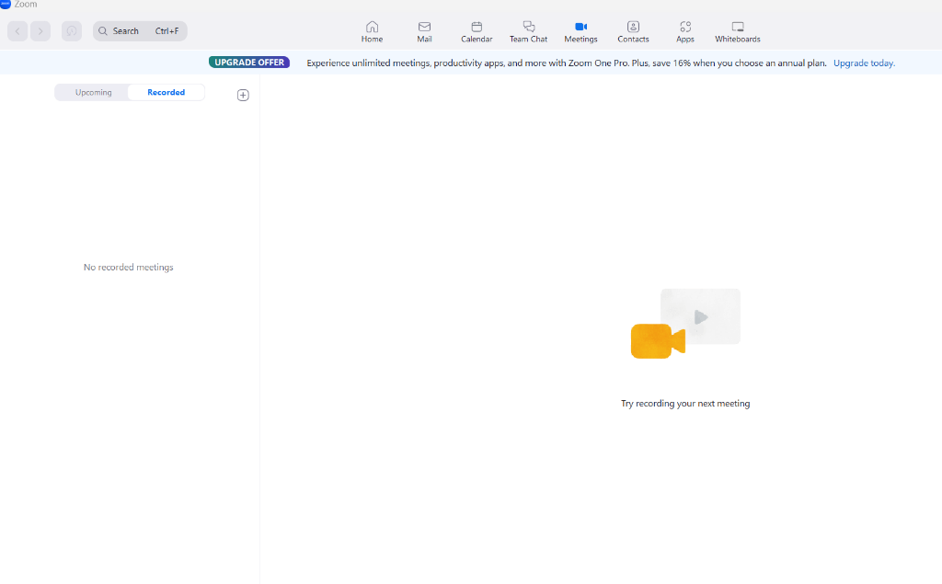
Zoom meetings feature

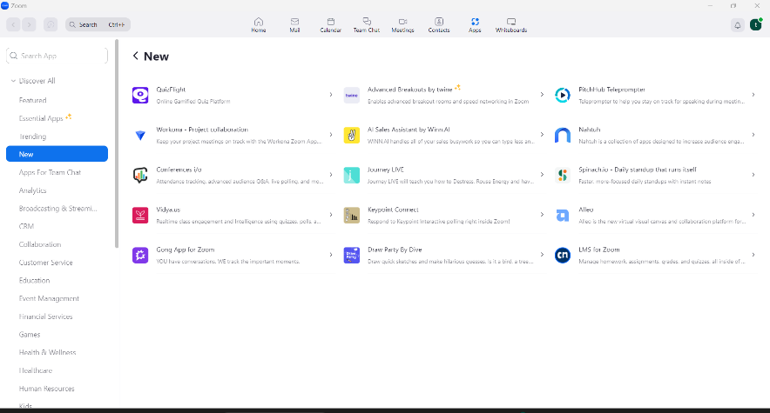 Zoom new features.

References
f. E. yaun, "zoom.us," zoom video communication, 2011. [Online]. Available: https://support.zoom.us/hc/en-us/sections/4415034398477-Zoom-Meeting-Features. [Accessed 18 03 2023].
Windows & Mac : http://zoom.us/download (download the Zoom Client for Meetings)
iOS (iPhone): https://itunes.apple.com/us/app/id546505307 or Find “ZOOM Cloud.
Android: https://play.google.com/store/apps/details? id=us.zoom.videomeeting
support.zoom.us," 2011. [Online]. Available: https://support.zoom.us/hc/en-us/articles/4415294177549-Downloading-the-Zoom-desktop-client-and-mobile-app. [Accessed 2023].

