  Component One:  What are the key skills required when working in the housekeeping team? 750 words (+/- 10%)  Contribution to Overall Module Assessment: 25% | Student No: | 2131347
 | Module Title: | Operating Hotel Facilities
 | Module Code: | BMIH4006
 | Lecturer: | Laurence Blake
The National Career Service identifies that the housekeeper career is composed of hotel housekeeper, housekeeping manager and head housekeeper, with an average salary starting from £14,500 to £25,000, a normal schedule of 40 hours per week, usually working during special day such as weekends or bank holidays. This role can be achieved by taking a college course, taking an apprenticeship or working for the role. The main requirements for the job include 2 or GCSEs at grades 9 to 3 (A* to D), 4 or 5 GCSEs at grades 9 to 4 (A* to C) (National Career Service, 2023).
Housekeeping skills are essential for any person that is interested in working as a professional housekeeper, the most common skills including time management in order to be able to finish the number of assigned rooms and duties in the time frame that the hotel and customer expects, attention to detail to ensure that all things are left in order and organised in the way that is expected, communication with clients or other employees in order to fulfil the expectations of the employer or the customer, interpersonal skills due to the direct work with customers, flexibility to work on a changing schedule with shifts that may include evenings or holidays, customer service through ensuring that the client is satisfied, and also a number of hard skills such as cleaning, sweeping, mopping and other cleaning related skills, infection control and polishing (Indeed, 2022). Choosing a career in housekeeping requires a lot of flexibility and organisation, but also self-discipline in order to some of the unpleasant and tedious tasks, trustworthiness when passing by some of the customer’s valuables, listening skills when asked to prioritise different tasks, physical aptitudes such as strength and flexibility, and even equipment know how to use the different types of tools that each hotel has, especially in the more exclusive hotels (Axelrod and Tieperman, 2022). According to the Healthy Journal, the most important skills of a housekeeper in the eye of the employer include being detail oriented, excellent communication skills, highly responsible and reliable, staff motivation and room design, but also team working skills. Resources for employers (2023) identifies the job description for the housekeeper which include responsibilities such as performing a number of cleaning activities, inspecting and caring for all the rooms according to the standards of the hotel, using and protecting the correct equipment, notifying the superiors of broken items or other disturbances, dealing with complaints, ensuring the cleaning stocks and consumables are replaced, and apply all the health and safety measures. The main requirements of the job include having experience in the industry, proven performance, friendly and open, having good time management skills, having customer service skills, working fast but offering quality, having a high-school degree (Workable, 2023). From my personal experience of working at Premier Inn at the reception, most of the skills that we learn at reception are also useful for housekeeping and are transferable skills. Also, in the morning we help housekeeping empty the rooms so they can easily come after and clean, while the customer have a self-checkout by leaving their keys in the boxes from the reception.
In order to progress in the career as a housekeeping manager, there are some other skills that need to be added in the portfolio such as knowing the housekeeping procedures, learning how to budget, leadership, facility maintenance, inventory management, problem solving, safety and security, decision making, scheduling, performance management, training, development, organisation and team building (Climb the Ladder, 2022). In order to continue developing skills and becoming better at the job it is important to refine the organisational skills through practice, to participate in different training programmes which can be offered by the employer or by other professional organisations, to know how to use different types of equipment and tools, and more (Indeed, 2022). The best practices for optimising the housekeeping operations in a hotel include streamlining the process by aligning the housekeeping tasks with other departments, reducing the times for the standard operating procedures, standardising the quality for the cleanliness, focusing on inventory management, investing in technology such as housekeeping software, but also different gadgets and tools, ensuring that the employees are trained and feel appreciated by giving them rewards, keeping the discarding process in check, and always using the correct vendors for the business (Ezee Absolute, 2022).

Word Count | 724

References:
Axelrod, S. and Tieperman, J. (2022) 15 basic skills you need to be a good housekeeper, available at: https://www.wikihow.com/What-Basic-Skills-Do-You-Need-to-Be-a-Good-Housekeeper (Accessed at: 18 Feb 2023)
Climb the ladder (2022) 16 housekeeping manager skills for your career and resume, available at: https://climbtheladder.com/housekeeping-manager-skills/ (Accessed at: 18 Feb 2023)
Ezee Absolute (2022) 9 best practices to optimise hotel housekeeping operations, available at: https://www.ezeeabsolute.com/blog/optimise-hotel-housekeeping-operations/ (Accessed at: 18 Feb 2023)
Indeed (2022) Guide to housekeeping skills (with tips and examples), available at: https://www.indeed.com/career-advice/career-development/housekeeping-skills (Accessed at: 18 Feb 2023)
National Career Service (2023) Housekeeper, available at: https://nationalcareers.service.gov.uk/job-profiles/housekeeper (Accessed at: 18 Feb 2023)
The Healthy Journal (2023) What is the most important skill of a housekeeper should have? Available at: https://www.thehealthyjournal.com/faq/what-is-the-most-important-skill-of-a-housekeeper-should-have (Accessed at: 18 Feb 2023)
Workable (2023) Housekeeper job description, available at: https://resources.workable.com/housekeeper-job-description (Accessed at: 18 Feb 2023)
Component Two:
Contribution to Overall Module Assessment: 25%
In this scenario – You have just been promoted to team leader for a floor within the hotel. A guest complains that on their arrival, their room had not been properly cleaned. Create an action plan and answer the following questions.

Problem | Why did it happen? | What are you going to do? | How will you prevent this from happening in the future? | What measures would you introduce to improve team effectiveness?
The room was not properly cleaned when the guest arrived | We are understaffed and the housekeeping is trying to do their jobs as good as possible, but we have the hotel at full capacity. | In order to successfully handle the customer, it is important to make sure it is not taken personally, to listen and determine the validity of the complaint, to consider the source, to ask for details on how to improve service, to offer solutions, to share feedback and to let the negative feelings go.  The response to the customer was that we are sorry that this happen to you, but please can you share with us how the service could have been better? Also, we can give you a free meal at the hotel’s restaurant and while you enjoy your meal your room will be thoroughly cleaned by one of our employees. | In order to ensure that this will not happen in the future, we will hire some extra agency housekeepers and we will re-check the cleaning schedules for the rooms to have more time to be attended. Also, room checks will be done in order to ensure that the standards of the hotel are being kept and meetings with the employees will be held to remind them the standards of their work. | In order to improve team effectiveness it is important to establish a healthy work culture, invest in the employees by training them, to use different tools and technology in order satisfy the guests, to ensure the staff is highly skilled, to create daily plans and checklists, to have a clear working schedule, to delegate staff to do tasks, to recognise the merits of the employees, to use feedback from customers and employees, to motivate the employees and to cooperate with all the other employees.

References:
HHS (2020) How to build a housekeeping team that improves guest satisfaction, available at: https://www.hhs1.com/blog/how-to-build-a-housekeeping-team-that-improves-guest-satisfaction (Accessed at: 21 Feb 2023)
LinkedIn (2017) 10 rules of housekeeping leadership, available at: https://www.linkedin.com/pulse/10-rules-housekeeping-leadership-mohsin-haider (Accessed at: 21 Feb 2023)
La Guardia (2023) Unit 5: Understanding and resolving guest problems, available at: https://www.laguardia.edu/uploadedfiles/ce/content/english_language_learning/center_for_immigrant_education_and_training/gp-hotel_t.e.a.c.h/unit5.pdf (Accessed at: 21 Feb 2023)
Symmons (2019) 5 common hotel guest complaints and how to address them, available at: https://www.symmons.com/hotel-guest-complaints/ (Accessed at: 21 Feb 2023)
The Janitorial Store (2023) How to handle criticism from your cleaning customers, available at: https://www.thejanitorialstore.com/public/how-to-handle-criticism-cleaning-customers-584.cfm (Accessed at: 21 Feb 2023)

Component Three:
Contribution to Overall Module Assessment: 50%
Your task is to create and prepare a presentation following the detailed scenario provided below.

As the floor housekeeping manager and given the recent guest complaints you need to put together a basic training presentation for your colleagues within the housekeeping team to get the best out of them, ensure that brand standard is being achieved and that Health and Safety procedures are also being followed.

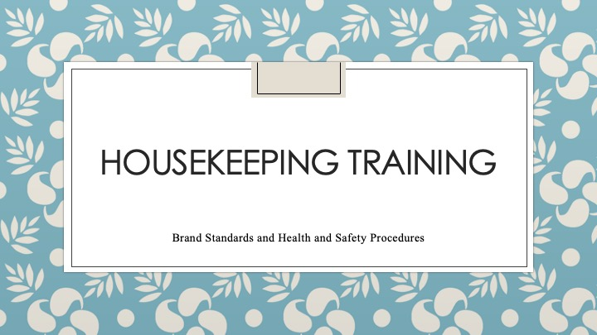

Training Notes: Introduction: Welcome the Housekeeping Team! As a housekeeper, you are an essential part of our organisation, and we rely on you to uphold our brand standard and ensure that our guests have a comfortable and safe stay. In this training, we will cover the following areas: Brand Standards and Health and Safety Procedures.

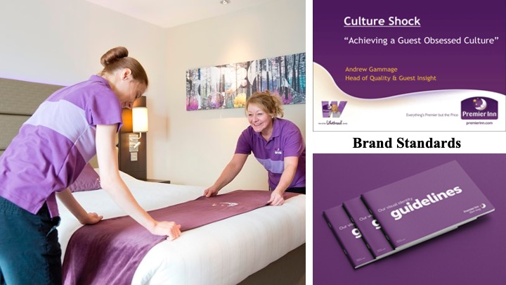

Training Notes: Brand Standards: As a housekeeper, you are responsible for maintaining the cleanliness and overall appearance of the rooms and common areas. Brand standards refer to the specific expectations set by the hotel for the quality of its services and the experience it provides to its guests. To ensure that we meet our brand standard, please follow the guidelines mentioned in the following slides

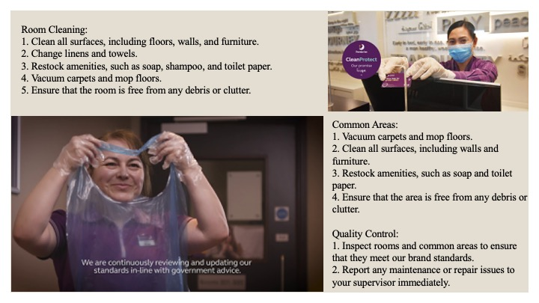
Training Notes: Room Cleaning:
1. Clean all surfaces, including floors, walls, and furniture.
2. Change linens and towels.
3. Restock amenities, such as soap, shampoo, and toilet paper.
4. Vacuum carpets and mop floors.
5. Ensure that the room is free from any debris or clutter.
Common Areas:
1. Vacuum carpets and mop floors.
2. Clean all surfaces, including walls and furniture.
3. Restock amenities, such as soap and toilet paper.
4. Ensure that the area is free from any debris or clutter.
Quality Control:
1. Inspect rooms and common areas to ensure that they meet our brand standards.
2. Report any maintenance or repair issues to your supervisor immediately.
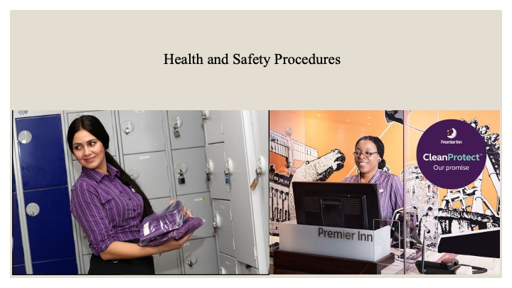

Training Notes: Health and Safety Procedures:
We take the health and safety of our guests and staff seriously. As a housekeeper, you play a vital role in maintaining a safe environment. Health and safety procedures are put in place to ensure that guests and employees are safe from harm. Please follow the guidelines mentioned in the following slides
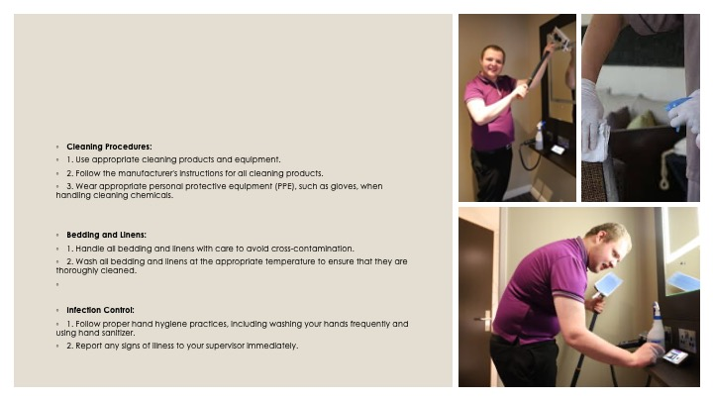

Training Notes: Cleaning Procedures:
1. Use appropriate cleaning products and equipment.
2. Follow the manufacturer's instructions for all cleaning products.
3. Wear appropriate personal protective equipment (PPE), such as gloves, when handling cleaning chemicals.
Bedding and Linens:
1. Handle all bedding and linens with care to avoid cross-contamination.
2. Wash all bedding and linens at the appropriate temperature to ensure that they are thoroughly cleaned.

Infection Control:
1. Follow proper hand hygiene practices, including washing your hands frequently and using hand sanitiser.
2. Report any signs of illness to your supervisor immediately.

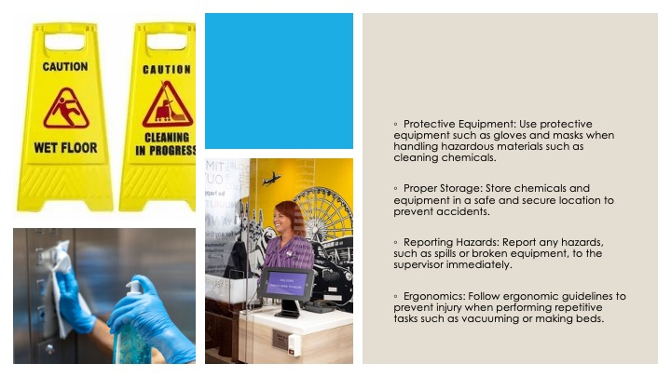

Training Notes:
Protective Equipment: Use protective equipment such as gloves and masks when handling hazardous materials such as cleaning chemicals.
Proper Storage: Store chemicals and equipment in a safe and secure location to prevent accidents.
Reporting Hazards: Report any hazards such as spills or broken equipment to the supervisor immediately.
Ergonomics: Follow ergonomic guidelines to prevent injury when performing repetitive tasks such as vacuuming or making beds.

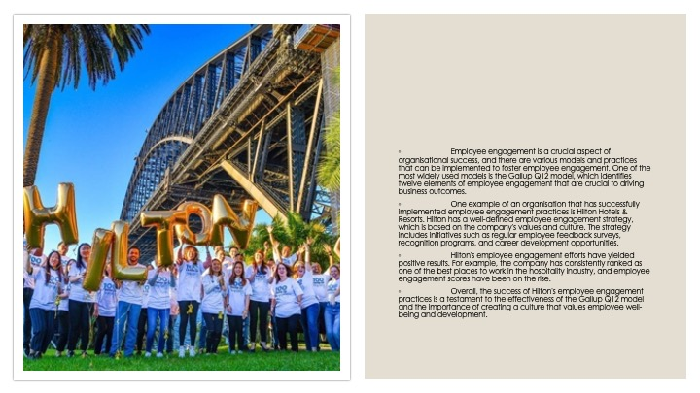

Training Notes: Employee engagement is a crucial aspect of organisational success, and there are various models and practices that can be implemented to foster employee engagement. One of the most widely used models is the Gallup Q12 model, which identifies twelve elements of employee engagement that are crucial to driving business outcomes.
One example of an organisation that has successfully implemented employee engagement practices is Hilton Hotels & Resorts. Hilton has a well-defined employee engagement strategy, which is based on the company's values and culture. The strategy includes initiatives such as regular employee feedback surveys, recognition programs, and career development opportunities.
Hilton's employee engagement efforts have yielded positive results. For example, the company has consistently ranked as one of the best places to work in the hospitality industry, and employee engagement scores have been on the rise.
Overall, the success of Hilton's employee engagement practices is a testament to the effectiveness of the Gallup Q12 model and the importance of creating a culture that values employee well-being and development.

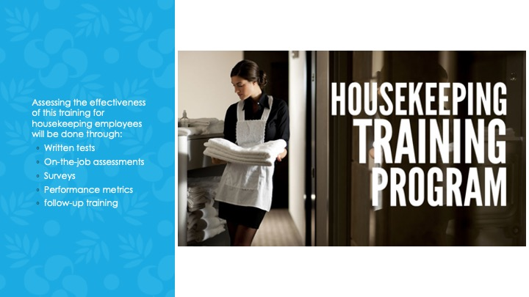

Training Notes: To assess the effectiveness of the training for housekeeping employees, the following methods could be employed:

Written tests: Conducting written tests to evaluate employees' understanding of the training material and their ability to apply it in practical situations.
On-the-job assessments: Observing employees performing their duties and providing feedback on their adherence to brand standards and Health and Safety procedures.
Surveys: Conducting employee satisfaction surveys to evaluate whether the training has improved employee morale and engagement, which can have a direct impact on the quality of work.
Performance metrics: Measuring the housekeeping team's performance metrics such as guest satisfaction, room cleanliness, and efficiency, to see if there is an improvement after the training.
Follow-up training: Conducting follow-up training sessions or refresher courses to reinforce the learning and ensure that employees are consistently implementing the best practices.

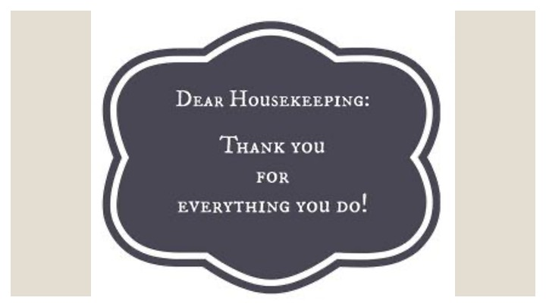

Training Notes: Conclusion: Thank you for taking the time to complete this training. Remember, as a housekeeper, you play a crucial role in ensuring that our guests have a comfortable and safe stay. By following our brand standards and health and safety procedures, you can help us achieve our goal of providing a memorable experience for our guests.

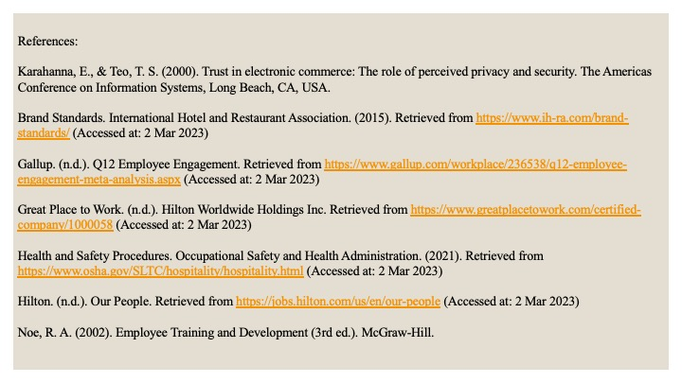

Training Notes: References.

References

Karahanna, E., & Teo, T. S. (2000). Trust in electronic commerce: The role of perceived privacy and security. The Americas Conference on Information Systems, Long Beach, CA, USA.

Brand Standards. International Hotel and Restaurant Association. (2015). Retrieved from https://www.ih-ra.com/brand-standards/ (Accessed at: 2 Mar 2023)

Gallup. (n.d.). Q12 Employee Engagement. Retrieved from https://www.gallup.com/workplace/236538/q12-employee-engagement-meta-analysis.aspx (Accessed at: 2 Mar 2023)

Great Place to Work. (n.d.). Hilton Worldwide Holdings Inc. Retrieved from https://www.greatplacetowork.com/certified-company/1000058 (Accessed at: 2 Mar 2023)

Health and Safety Procedures. Occupational Safety and Health Administration. (2021). Retrieved from https://www.osha.gov/SLTC/hospitality/hospitality.html (Accessed at: 2 Mar 2023)

Hilton. (n.d.). Our People. Retrieved from https://jobs.hilton.com/us/en/our-people (Accessed at: 2 Mar 2023)

Noe, R. A. (2002). Employee Training and Development (3rd ed.). McGraw-Hill.

