[Word Count: 2253]

Assignment Entitled:
Business Report – Comparison of Two Hospitality Organisations
Student ID:
2128265

Name:
Rukhsana Kousar

Lecturer:
Tristan Hawk[ins

[Assignment Entitled]
Comparison of Two Hospitality Organisations

[Namely]
Mandarin Oriental Hotel Group
Premier Inn

Executive Summary

The purpose of this report serves to highlight in-depth critical analysis to research involving the comparative study evaluation to namely. ‘Mandarin Oriental Hotel Group - MOHG’ and ‘Premier Inn’ of the two leading International hotel chains and, multinational, forerunner brand names in hospitality. The former’s successful acclamation to Fortune 500 Global Company remains a reputable subsidiary of namely ‘Jardine Matheson Holdings Limited’, which has a primary listing on the London Sock Exchange, in addition to secondary listings on the Singapore Stock Exchange and Bermuda Stock Exchange. Whilst for the majority of its business interests and the current collateral worth to MOHG as their primary company asset was among the top 200 publicly traded companies valued by the market cap since 2021 with total revenue worth @ US$109 billion - for which, MOHG’s present market worth is valued @ more than £1.66 billion, figures as such represented by steady growth to yearly increases in the current market share that MOHG’s evaluation report to these figures are proudly propagated. By contrast, the Premier Inn’s representation to facts and figures for the current financial year, whilst presently available from April 2023 of the annual release to results published by namely ‘Whitbread’ of its parent company, therefor; whilst brand ‘Premier Inn UK’ was the key driver behind its company’s strongest financial performance over recent years this despite Covid-19 of the pandemic and lockdown that figures show rapid increase of its current market share at 12% such comprising of the UK market as its total revenue worth rose @ 14% from the previous financial year in 2022 and 9% worth of the current global market position since Premier Inn’s recent expansion programme into Germany of its every major town and city, in addition to a cosmopolitical alliance with the city of Dubai of United Arab Emirates, since.

Table of Contents

Executive Summary

Table of Contents

(A) Introduction……………………………………………………………………….5
(B) Total Revenue……………………………………………………………………..6
(C) Causes For Rising/Falling Revenue………………………………………………7
(D) Market Position…………………………………………………………………...8
(E) Customer Segmentation………………………………………………………….10
(F) Potential For Growth……………………………………………………………..11
(G) Financial Commitment To CSR………………………………………………….13
(H) Bowman's Strategic Clock for Recovery………………………………………...14
(I) Recommendations………………………………………………………….……..16
(J) Conclusion………………………………………………………………………..17
(K) References……………………………………………………………………….18

(A) INTRODUCTION

Mandarin Oriental
The Mandarin Oriental Hotel Group is a prestigious hotel chain that holds and manages a number of five-star hotels throughout the globe (Buttle et al. 2016). The company has expanded from its Asian roots to grow into a globally recognized brand. It now manages 37 hotels and 9 residential developments in over 25 nations and territories. The Group brings its eastern origins to each hotel through distinctive architecture, design, and culture (Yacinta, 2022). There are currently many hotels and residences being built under the Mandarin Oriental Hotel brand, and this company remains linked to the renowned Jardine Matheson Group

Premier Inn
Premier Inn has expanded so rapidly that it is now the largest hotel chain across the United Kingdom and Ireland (Ghandour, Bilal and Mudassar, 2015). There are more than 500 reasonably priced hotels in the network. The company is owned by Whitbread Plc., the biggest hotel chain in the United Kingdom. Approximately 40,000 people are part of Whitbread Plc.'s global workforce. Ten million customers in the United Kingdom are regularly maintained (Berry, 2022). Strategic plans to build 60,000 rooms could increase the number of available hotel rooms across the United Kingdom. The chain of hotels has been profitable because of sound corporate practices and creative ideas.
(B) TOTAL REVENUE

Mandarin Oriental
According to the most up-to-date financial statements, Mandarin Oriental's annual income stands at £0.45 million right now (Yenny et al. 2023). The company made £0.45 billion in sales in 2022, up from £0.31 billion in revenues the year before (Bas and Sivaprasad, 2022). In business, "revenue" means all money generated by selling goods or providing services (Yacinta, 2022). However, prices are not taken out like earnings are.

Premier Inn
Due to its business traveller focus, Premier Inn's parent firm, Whitbread, has experienced annual earnings an increase above the levels prior to COVID. Pretax profits for the fiscal period ending 2 March 2023 increased by 544% to £375 million from £58 million (George, 2021). The company's profits increased by 34% to £280 million prior to the epidemic's arrival. Sales increased by 54% to £2.6 billion in the previous year. COVID's earnings increased by 27% from £2 billion during 2019-2020 (Filimonau, Derqui and Matute, 2020). Premier Inn reports greater revenue after demonstrating strength in the mid-range and budget hotel markets of the United Kingdom (Tan and Despotis, 2021). Sales at Premier Inn UK increased 50% to £2.5 billion the previous year. By 2022, the average price of a hotel room in the UK will have increased by £19 (Terence, 2022).

(C) CAUSES OF RISING/FALLING REVENUE

- Forecasting future demand
Customer demand is extremely unpredictable. Changes in the national economy, extreme weather, and other factors all lead to the periodic nature of the occurrences under consideration (Chen, Lee and Ho, 2018). The process of demand forecasting involves the examination of past demand information in addition to current and future factors that may affect demand in numerous kinds of consumers (Buttle et al. 2016). With sufficient information, strategies for pricing, advertising, and distribution can be developed to account for shifts in anticipated demand.

- Management of inventory
The actual goods or services themselves are what "inventory" relates to in the larger picture of managing revenue (Rahimi and Gunlu, 2016). One such comparison is the expected lifespan of something that goes bad quickly, like food. This means that if an apartment isn't booked out for that night, it will never remain accessible for another person to book. Any vacant spaces within a hotel will reduce its bottom line. Managing money effectively also requires adopting an appropriate distribution strategy (Raddon and Sung, 2012). Demand projections for different consumer groups and channels are used to create a distribution plan that blends capacity and income.

(D) MARKET POSITION [Share of Current Market Value]

Mandarin Oriental
Mandarin Oriental had a market value of greater than £1.99 billion by October 2023 (Yenny et al. 2023). There is evidence suggesting that Mandarin Oriental ranks 3881st among the globe's most valuable companies, as per market capitalization ratings. An organization's market capitalization, which can also be written as "market cap," is equal to the number of shares that are still outstanding. It's usual practice to utilize this metric when seeking to estimate a company's value (Bas and Sivaprasad, 2022).

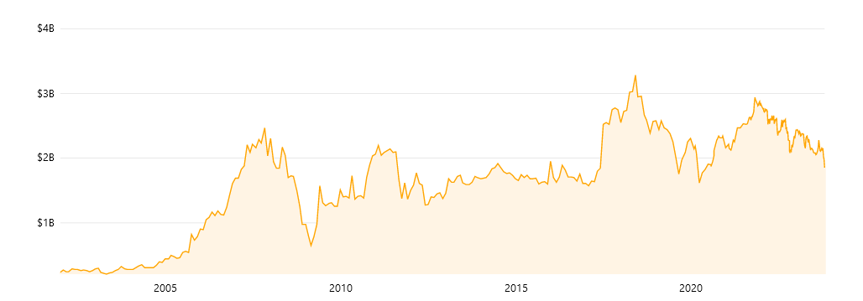
Figure 1: Mandarin Oriental’s Market Cap history (Yenny et al. 2023).

Premier Inn
Premier Inn, which is owned by Whitbread, is the market leader in the low- and mid-range hotel segment in the United Kingdom. The UK hotel market has recovered more quickly than projected, which allows Whitbread's flagship UK Brand to achieve double-digit revenue raises. Prioritizing corporate clients is their policy (Jones and Comfort, 2021). The benefits of expanding the organization's customer base outside of one segment are varied. In comparison to the current 82,700 rooms within the matured UK and Ireland marketplace, Whitbread predicts that this number might rise to 125,000 (George, 2021). Despite the epidemic, the UK market expanded throughout all of the six quarters leading up to September 2022 (Berry, 2022). Premier Inn will have to make more effort to expand across the UK when economic challenges increase. Overall, this year has started off well. Pipeline implementation might allow Whitbread to increase its market position and keep it at the top of the quality and value rankings (Chen, Lee and Ho, 2018).
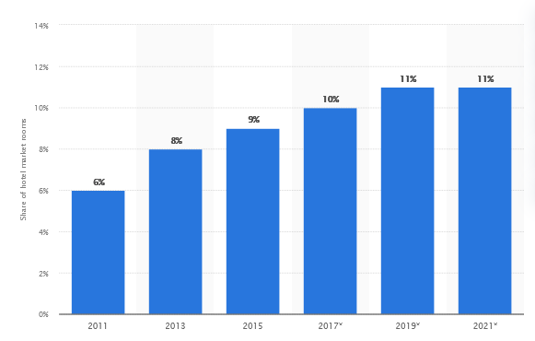
Figure 2: Share of Premier Inn (Published by Statista Research Department & 1, 2016)

(E) CUSTOMER SEGMENTATION

Mandarin Oriental
Luxury hotels like the Mandarin Oriental utilize segmenting demographics as their primary approach for targeting their customers (Jones and Comfort, 2021). Market segments with the greatest potential to produce large revenue can be readily recognized through the use of demographic division (Zhong et al. 2021). Customer job, revenue, age, and family situation are all major factors that influence the hotel's financial performance (Yacinta, 2022). In addition to successful professionals and business executives, the hotel offers to their spouses or significant others who have no young kids or who are grown and on their own. The 25 to 30-year-old category and the 40 to 55-year-old category are therefore of particular relevance to Mandarin Oriental (Chew, 2018).

Premier Inn
Comparisons in geography, wealth, and consumption habits are common among consumers of similar services. The typical travel patterns and climatic conditions of the customers could be targeted. Among the factors considered in the demographic breakdown are age, sex, and ethnicity (Raddon and Sung, 2012). The wealthy may be addressed by this commercial. Markets in conventional and price categories come next. A larger number of tourists could be reached using that approach. Individuals' online and offline behaviours are used to classify them into one of several categories (XIA, 2022). Most of the company's customers are middle-aged and older men on business trips. Additionally, the company's major consumer demographic for tourist-related items is females between the ages of 25 and 44 (Terence, 2022). Premier Inn Hotels UK concentrates mainly on the 25-54 age range for their family and group bookings.

(F) POTENTIAL FOR GROWTH

Mandarin Oriental
There will soon be a hotel in Hangzhou run by the prestigious Mandarin Oriental Hotel Group. In 2025, the establishment will officially launch its offerings (Yenny et al. 2023). The growth and development of the city have occurred in recent years. The developer behind Westlake 66, Hang Lung Properties, is in discussions to merge with the Mandarin Oriental, Hangzhou. The new building is expected to become an iconic building in the area. West Lake is one of China's most visited tourist attractions. Economic districts Binjiang and Qianjiang are easily accessible from the land.
More than 7% annual growth in the Chinese hotel industry is forecasted until 2027. In recent years, China's hotel industry has expanded rapidly. China's rapid economic growth, increasing population, and numerous natural assets have attracted hotels from all over the world (XIA, 2022). The hotel industry in China is performing well due to the current COVID-19 easing and growing domestic and corporate travel (Filimonau, Derqui and Matute, 2020). With or without these advantages, the market's continued growth indicates well for further growth. Communicating with Chinese customers is difficult for foreign companies. For businesses seeking to grow internationally, an absence of language skills can be an essential obstacle (Chew, 2018). Cultural barriers are among the most prevalent obstacles that businesses face when trying to break into the Chinese market.

Premier Inn
The largest UK hotel chain, Premier Inn, is exploring potential acquisition and merger opportunities in the larger German marketplace in an effort to expand its budget brand there (Ushakov et al. 2020). The United Kingdom is almost 40% smaller than Germany. Compared to the UK before the pandemic, growth in revenues per space available has exceeded it (Sinha and Ekka, 2021). As REITs are declining, hotel business owners such as Premier Inn can develop by acquiring, leasing, converting, and building new properties (Lugosi and Jameson, 2017).
To attract German customers, the bargain brand offers more dairy products for European breakfast. This company has begun accepting more popular payment ways and adds an additional duvet to bedrooms. Executives see significant potential in the challenges faced by a number of separate German hotel chains. Overall, the percentage of lodging facilities in Germany that are privately owned and operated has decreased by 5% in 2019 (Berry, 2022). After the pandemic, the German hotel industry may be progressively but surely improving.

Premier Inn's management is trying to reduce their disadvantages as inflation and employment difficulties continue. Premier Inn is the leading budget hotel brand in the United Kingdom. The possible decline in competition resulting from the collapse of several smaller hotels speaks well for Premier Inn. Premier Inn has more than 900 hotels throughout the UK and Germany, which gives it greater purchasing power than smaller chains and makes it better able to adapt to price increases (Jones and Comfort, 2021). Premier Inn offers lower prices than its rivals as most consumers book directly through the hotel rather than through internet booking agents, who may impose charges.

(G) FINANCIAL COMMITMENT TO CSR

Mandarin Oriental
The entirety of Mandarin Oriental's hotels works collaboratively with their neighbourhoods to organize a wide range of both free and fee-based CSR activities (Ushakov et al. 2020). The Mandarin Oriental Hyde Park in the city of London offers travellers the opportunity to offer while working in the kitchen to prepare food for those in need (Yacinta, 2022). Every one of London's numerous Oxfam Shops appreciates and encourages volunteers to assist with handling phones and introducing customers (Zhong et al. 2021).

Premier Inn
The Premier Inn management group places a premium on making decisions that are beneficial for both individuals and the environment. Premier Inn's goal for Earth Day is to drastically cut down on the hotel's carbon footprint (George, 2021). The business's target is to reduce the level of emissions by half by 2025 and by 88% by 2050. Whitbread's influence on the environment is less now because it consumes less energy. Besides, Priorities involve minimizing pollution, fostering strong neighbourhoods, and guaranteeing fair wages for work of equal value (Ghandour, Bilal and Mudassar, 2015). Premier Inn suffered from political and financial uncertainty in April. The company is working to increase its market position despite the failings of the independent hospitality sector throughout the UK (Rahimi and Gunlu, 2016). Premier Inn suffered more than its competitors due to its regional concentration and local customers. Travellers from other countries helped London's business in the subsequent quarter.

(H) BOWMAN’S STRATEGIC CLOCK FOR RECOVERY

Porter's Generic (Re) Mandarin
Mandarin Oriental uses a concentration strategy that's in line with Porter's generic approach. Lower-cost focus means providing a market-specific cheaply (Chew, 2018). The most effective value-focus strategy concentrates on how customers are received rather than on factors like dimensions, flavour, or appearance (Sinha and Ekka, 2021). Mandarin Oriental constantly reviews its approach to marketing and changes its product design and packaging to meet consumers' psychological needs and enhance value (Yenny et al. 2023).

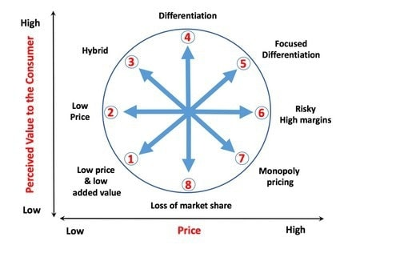
Figure 3: Bowman’s strategic recovery clock (Breier et al. 2021)

Bowman Strategic Management (re) Premier Inn
The clock indicates Premier Inn employs a variety of approaches. The business plan focuses on being cost-effective and differentiating the company's products (Berry, 2022). By using this strategy, businesses hope to improve their product's appeal to consumers and its overall worth in the marketplace. But the product's affordable cost makes it hard to pass up (Tan and Despotis, 2021). Sometimes they will use discrimination targeting. This approach has a number of advantages but comes at an enormous cost. High prices reflect the high quality of the goods and services offered (Lugosi and Jameson, 2017). High-investment businesses benefit from this strategy.

(I) RECOMMENDATIONS

Mandarin Oriental
Initially, the organization should avoid price discounts as they may damage its reputation with environmentally concerned customers. Furthermore, the company should think about behavioural segmentation to identify clients who make the payments themselves and those whose loved ones or close relatives pay.

Premier Inn
The company's history of acquisitions and mergers has the potential to be an important factor here as well. To achieve these goals, a merger with the Mandarin Oriental Hotel Company could be beneficial in the future for both companies. Equities and separate sections help the organization meet market governance standards and assist its intended market.

(J) CONCLUSION

The hotel industry contributes greatly to global GDP. Before the virus spreads further, a safe restarting approach is essential to rebuilding the global marketplace and making people feel at ease again. A comprehensive crisis management strategy can assist the hotel business in its ultimate recovery. The hotel industry worldwide has benefited from globalization, but it has additionally presented new challenges.
(K) REFERENCES

Bas, T. and Sivaprasad, S., 2022. An Exploratory Insight into the Impact of COVID-19 on the Travel and Tourism Sector: UK Evidence. Bas, T. & Sivaprasad, S. (2022). An exploratory insight into the impact of COVID-19 on the travel and tourism sector: UK evidence. In S. Karabulut (Ed.), Economic and Financial Analysis of Global and National Developments, pp.355-369.
Berry, C.T.P., 2022. Equity research-Whitbread PLC (Doctoral dissertation, Instituto Superior de Economia e Gestão).
Breier, M., Kallmuenzer, A., Clauss, T., Gast, J., Kraus, S. and Tiberius, V., 2021. The Role of Business Model Innovation in the hospitality industry during the COVID-19 crisis. International Journal of Hospitality Management, 92, p.102723.
Buttle, F., Bowie, D., Brookes, M. and Mariussen, A., 2016. Hospitality Marketing. Taylor & Francis.
Chen, M., Lee, D. and Ho, C.I., 2018, October. Business intelligence from Facebook fan pages: A case study of luxury hotels. In Global Conference on Business, Hospitality, and Tourism Research (GLOSEARCH 2018) (p. 61).
Chew, W.S., 2018. Corporate Governance and Risk Performance in Mandarin Oriental International Limited. Available at SSRN 3182136.
Filimonau, V., Derqui, B. and Matute, J., 2020. The COVID-19 pandemic and organisational commitment of senior hotel managers. International Journal of Hospitality Management, 91, p.102659.
George, R., 2021. Tourism and Hospitality Marketing Principles. In Marketing Tourism and Hospitality: Concepts and Cases (pp. 3-31). Cham: Springer International Publishing.
Ghandour, R., Bilal, J. and Mudassar, H., 2015. Relationship between Service Quality, Customer Retention and the Role of Social Media-Case study Premier Inn Hotel (UK). Journal of Organizational Studies and Innovation, 2(4), pp.1-12.
Jones, P. and Comfort, D., 2021. Modern slavery statements and leading UK hotel companies. Athens Journal of Tourism, 8(3), pp.147-162.
Lugosi, P. and Jameson, S., 2017. Challenges in hospitality management education: Perspectives from the United Kingdom. Journal of Hospitality and Tourism Management, 31, pp.163-172.Published by Statista Research Department and 1, J. (2016) Whitbread: Premier Inn Hotel Room Share 2011-2021 statistic, Statista. Available at: https://www.statista.com/statistics/755691/premier-inn-share-of-hotel-market-rooms-united-kingdom-uk/ (Accessed: 22 October 2023).
Raddon, A. and Sung, J., 2012. Lifelong Learning in the Context of Organizational Competitiveness: A Case Study from the Mandarin Oriental Hotel Group. Lifelong Learning in Action: A Life's Work, 1, p.361.
Rahimi, R. and Gunlu, E., 2016. Implementing customer relationship management (CRM) in the hotel industry from an organizational culture perspective: the case of a chain hotel in the UK. International Journal of Contemporary Hospitality Management, 28(1), pp.89-112.
Sinha, A.K. and Ekka, P., 2021. Hospitality Industry of India- its present status and future prospects. The Researchers' International Research Journal, 7(1), pp.85-95.
Tan, Y. and Despotis, D., 2021. Investigation of efficiency in the UK hotel industry: a network data envelopment analysis approach. International Journal of Contemporary Hospitality Management, 33(3), pp.1080-1104.
Terence, B., 2022. UK Economic Strategy Presents Opportunity for Businesses, Including Hotels, To ' Level Up'.
Ushakov, R.N., Kryukova, E.M., Khetagurova, V.S., Mukhomorova, I.V. and Zelenov, V.V., 2020. Efficiency of hotel management. Training of specialists in the hotel industry field. Journal of Environmental Management & Tourism, 11(2 (42)), pp.388-395.
XIA, S., 2022. Leadership Styles And Their Impact On Employee Engagement In The UK Hospitality Industry Organisations (Doctoral dissertation, SIAM UNIVERSITY).
Yacinta, L., 2022. Industrial Training Report Hot Chinese Kitchen at Li Feng, Mandarin Oriental Jakarta.
Yenny, M., Ningsih, R.A.P.S.P., Suzana, Y., Nurwenda, D. and Sugiarto, S., 2023. The Effect of Motivation on Work Productivity of Kitchen Employees at Mandarin Oriental Hotel Jakarta. International Journal of Travel, Hospitality and Events, 2(2), pp.151-161.
Zhong, L., Sun, S., Law, R. and Li, X., 2021. Tourism crisis management: Evidence from COVID-19. Current Issues in Tourism, 24(19), pp.2671-2682.

