
Title: Marketing Management - Assessment 1.

Course Name: Master of Business Administration
Course Code: LCMB7001
Student: Errol Malcolm
Student Number: 1709503
Lecturer: Tushara Balendran

Diagram above from: ups logo - Bing images
Contents:
Introduction: 3
Background: 4
Mission Statement: 5
Communication: 6
Diagram below sourced from Gamers Decrypted: 6
Integrated Marketing and Communications: 6
New promotional strategies that UPS can use to raise awareness of the brand: 7
On-line promotional strategies: 7
Off- line promotional strategies: 7
Branding and brand equity: 7
Keller’s Brand Equity model: 8
Measuring managing and perfecting consumer brand equity: 12
The Consumer Journey and Touchpoints: 12
Diagram above from: modern customer journey - Bing 13
The UPS Consumer Journey and Touchpoints: 13
Conclusion: 15
Appendix 1. 16
Appendix 2. 17
Appendix 3. 18
References: 19

Introduction:
The purpose of this report is to critically appraise how United Parcel Services (UPS), the American parcel delivery company, can create innovative marketing strategies for raising awareness of the brand as well as, managing and evaluating the customer journey across a variety of communication channels, to ensure current and future stakeholders’ expectations are fulfilled.

Background:
The United Parcel Service (UPS) was founded in 1907 by, James E. Casey, and Claud Ryan. The business started as an American Messenger Company, which began in Seattle. The pair borrowed $100 and set up the business in a cellar belonging to Ryan’s uncle. Then in 1912 they joined forces with a rival company, and also purchased a refashioned delivery vehicle, known as a Model-T Ford which they used for the business. In 1916 they decided to employ Charles Soderstrom, he thought of the idea of painting all the vehicles brown which he realised hid the dirt the vehicles all accumulated. However, now they are a company that cover 220 countries across the globe with their services in parcel delivery (Lewis, 2017).

Mission Statement:
“Grow our global business by serving the logistics needs of customers, offering excellence and value in all that we do. Maintain a financially strong company with broad employee ownership-that provides a long-term competitive return to our shareowners. Inspire our people and business partners to do their best, offering opportunities for personal development and success. Lead by example as a responsible, caring, and sustainable company making a difference in the communities we serve.” UPS, (2019).

​

Communication:
The definition of communication is a doubled action procedure that involves the sender and the receiver of communication. Transmission model of communications according to Shannon. Shannon’s main aim was more centralized on the engineering side of the analysis, Weaver’s was more aimed at the philosophical side of the analysis which effects the human side of communications. Shannon and Weaver’s Communication model has seven vital components. Transmission model of communications (Lyon, 2017; Hooley, 2019; Chandler and Munday, 2020).

Diagram below sourced from Gamers Decrypted:

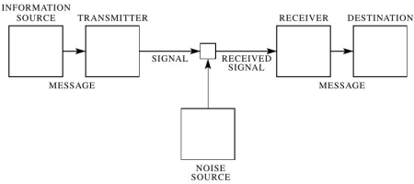

Positives: the model provides how information is transferred and messages are received.
Negatives: the model does not cover non-verbal communications, feedback, interactive responses, and face to face dynamics.

Integrated Marketing and Communications:
What is the definition of Integrated marketing and communications (IMC)?
The definition of IMC, also referred to as promotional mix, or marketing promotional mix. it is an integrated blend of various types of marketing communications, e.g., adverts, direct mail, newspapers, public relations, personal sales, the internet, and more, which are all directed at the consumer. In addition, these are some of the combinations that are applied by companies to attract and convince consumers. (Kotler, 2017). Integrated marketing communications (IMC) for the UPS organisation it is considered as a stakeholder-centred-coordinated procedure of cross-functionality, that plans and jointly aligns the organisations data and statistics, which ensures the way forward for on-going communications, and messages by various forms of media platforms, on-line, or offline which creates a base for a long-lasting financial relations that has value for the organisation and their consumers (Pocu, et al. 2017).

New promotional strategies that UPS can use to raise awareness of the brand:
To raise awareness of the brand, UPS could form partnerships with universities around the globe, In particular with MBA students, that are interested in forming businesses that require global logistics, which would offer these MBA students a chance to build a global business, for instance, shipping tea from Asia to the UK, or buying and distributing electrical goods from China, or shipping blue mountain coffee from-Jamaica, to all parts of the globe. Or UPS could get into Formular E (electric) motor racing, with the organisation promoting innovations and systems, and the connections with taking care of the planet, a lot of technology is required to build formular E cars, because of UPS’s links to technology and innovation, this could be albeit extremely expensive, but nevertheless a seamless side business for the organisation, which will raise even more global appeal. I also believe that these suggestions will raise new awareness for the brand and place them even further ahead of their competitors.

On-line promotional strategies:
Digital marketing equals brand engagement, so to engage the brand, UPS have their own website, however for new marketing promotions this could include promoting their new links to universities around the globe by promoting their partnerships with global MBA students. They could also link this promotion on Facebook, Twitter, and LinkedIn, This would also inform individuals, and prospective students that visit the site, of this new promotional strategy. Furthermore, as mentioned above, UPS could start a formular E team, with the brand logo featured all over their new formular E car, the driver, possibly Lewis Hamilton wearing the brown UPS drivers attire with the logo on it, as well as on the drivers helmet which would be featured on their website, that would feature a yearly plan of where all the races would take place around the globe, and information on how to buy tickets.

Off- line promotional strategies:
UPS could advertise the new partnerships with universities and MBA students in educational magazines, on TV adverts, University Open days, University paper-back prospectuses, Bill- boards, Clothing such as sweat-shirts, T-shirts, baseball caps, etc, not too dissimilar to what most global universities do now, by selling branded clothing with university logo’s printed on them. Furthermore, off-line promotions for the UPS racing team, would be the logo featured all over the formular E cars, the team mechanics would be dressed head to toe in the UPS attire, as well as all the garages around the globe, where the races take place would be decked out in the UPS colours and logo, as well as the exterior mobile offices, which is not too, dissimilar to what Mercedes-EQ Formular team, Jaguar- Formular E team, and Envision Virgin racing team, and others do today, tickets, passes, to all circuits would also have the UPS logo on them.

Branding and brand equity:
According to Troiville, et al. (2019) in conjunction with the promotion of goods and services organisations today are pouring millions of pounds into their brands, in the hope of seeking global appeal (Steenkamp, 2014). The thinking behind this is to attain a valuable experience, in conjunction with building firm relations, amongst their consumers. Furthermore, this is all to create increased brand equity, that is the “added value” including the effectivity of the brand name. (Farquhar, 1989; Stahl et al., 2012). This procedure is worth the effort, for organisations that build brands, for example the retail sector. The retail sector are, a sector that should adopt this approach, in building brand equity which will go a long way to improve the organisations name. Measuring retail brand equity (RBE) is viewed as a challenge for scholars, the reason being, “the rise of the retailer as not just a retail outlet but also a brand provides perhaps one of the most critical trends in the retailing field” (Grewal and Levy, 2009). Retailer brand equity is a valuable and intangible asset that affects consumer behaviour and consumer performance (Grewal et al. 2009; Keller, and Lehman, 2006). A fine example of the significance of retail brand equity is a conclusion of the Global Powers of Retailing annual report (Deloitte, 2012). “retailers will have to find ways to distinguish themselves from competitors in order to succeed (Troiville, et al. 2019). UPS has built brand equity, by being leaders and gaining trust from consumers, with their brand which represents quality, with a degree of excellence and service innovativeness. Their vehicles, and the standard of politeness of their driver workforce are high contributing factors of the organisations brand equity (UPS investor, 2021).

Keller’s Brand Equity model:
According to Oppong and Phiri, (2018) creating loyalty in a competing market is strategically significant, this is because it sustains market share, which increases revenue for the organisation. Furthermore, to Increase a brands awareness, jointly with brand association, and brand equity, generates immense loyalty which assists an organisation the option to build on predicted sales growth, and an increased profit share of the market (Acker, 1991). Furthermore, brand loyalty has a connection to consumer attachment to a particular brand, or service (Acker, 1991). Oliver, (1999) his explanation of loyalty is that it is a dedication to frequently purchase a preferable product item, or service, in-spite of your competition’s marketing schemes, or impacts. Brand loyalty has classifications which relates to loyalty and a settled way of thinking (Chaudhuri and Holbrook, 2001; Yousef, et al,. 2017).
Behavioural loyalty specifies consumers continual support to a brand at the same time as, attitude loyalty displays how fondly consumers are dedicated to the particular brand. Furthermore, it has been recognised that the loyal consumer ensures positive indicators on an organisations share price, as well as the all-inclusive profits of a brand (Chaudhuri and Holbrook, 2001; Acker, 1996). Acker (1991) uncovered that brand loyalty lowers marketing expenditure in keeping consumers to gaining newer ones, the effects of this are, a financial up-lift for the organisation with the added protection of unpleasant battles with the competition. Additional bonuses are these loyal consumers will recommend your product or services to others (Acker, 1992). Furthermore, what is very noticeable here is how brand awareness is seen as a brand asset, which helps to achieve and further improve brand value (Acker, 1996; Keller, 2013) Acker (1996) his explanation is that brand awareness holds prominence inside consumer mindsets.
Keller, (1996) his explanation is that brand identification, recall, the ability to easily remember a brand or service (Hoeffler, and Keller, 2002). On the other-hand, Acker, (1996) defines brand awareness as brand remembrance, brand recall and top minded awareness. Keller (2013) highlighted, that one of the benefits of establishing a better brand awareness is that it positively affects consumers which will include other brand variations that can be pondered at a later stage for purchase. Besides, a strong awareness to a brand can influence consumer purchasing choices, for instance of brands that are thought about. Additionally, consumers who are aware of a particular brand are able to give the brand a feeling of familiarisation, substance, and commitment (Acker, (1992) Previous analysis has uncovered that, brand awareness favourably affects brand equity as well as loyalty (Assif, Abbas, Kashif, Hussain and Hussain. 2015; Pike and Bianchi, 2016).

Keller’s brand equity model or otherwise known as the Customer-Based Brand Equity (CBBE) model which forms the shape of a pyramid. The understanding surrounding Keller’s thoughts on this model is as he suggests, by having a strong brand, organisations are required to build the correct brand image which is carried-out by developing a suitable brand encounter, or experience. These experiences coupled with your brand must ensure consumers or prospective consumers are left feeling positive, and with up-lifting emotional thoughts about the organisation. Furthermore, once you shown that you can demonstrate a value brand it is at that moment that brand equity is achieved, and consumer opinions will reach others.

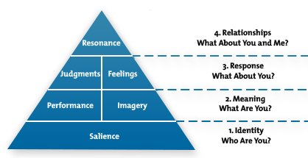
Keller’s diagram sourced from: Parifly. com

Keller’s pyramid has four sector levels, which moves from the bottom level to the top.
- Identity
- Meaning
- Response
- Relationship

For the purpose of creating a substantial brand it is vitally important to structure consumer relations from the ground upwards as mentioned earlier.
Identity, salience, who are we?
The term simply means how do individuals know your organisation, and most specifically your brand, which is seen as a significant first step, to build brand equity, if consumers or others have no idea who you are, it will be extremely challenging for them to have any-sort of judgement, or recognition of your brand. Therefore, a clear picture of your brand identity is required at this first stage of the pyramid. To have any success with this first stage extensive analysis is required to seek out who are your target market, when all the information has been acquired, you then focus on who needs your service. UPS apply this by understanding their consumers, and prospective ones and knowing what they need in the logistical field, reliable, first class, and on-time deliveries (Retail marketing, 2019 ;UPS Annual report, 2019).

Meaning, performance, what are you?
This second stage of the pyramid is separated into two sections, which focusses on the brands main features, this encompasses, functionality, reliability, style/design, price, durability, customer service, and customer satisfaction. Inevitably, if your organisation holds up to what they say, they are going to carry-out, this will produce positive effects for the organisation, and assist consumers further up the pyramid ladder. Furthermore, reliability is more than just a saying, if you state you are a reliable organisation, that is required to be lived up to. This is exactly why UPS can say they are one of the most trusted global shipping and logistics companies worldwide (Retail marketing, 2019; UPS Annual report, 2019).
Meaning, Imagery, what are you?
The second stage of the pyramid, but the opposite sector which focusses on the way your brand deals with your consumer social and psychological requirements. Brand imagery is to do with what thought processes individuals go through when your brand is displayed, it is about how uplifted they would be to have a connection with that particular brand, and its reputability. This does seem more effective once the organisation present their brand values, those of which that relate to your consumers. For instance, does the organisation care about the environment? does the organisation care about communities? UPS cares about the environment, and have to adhere to many laws, and started various programs on minimising waste within their organisational communities. Additionally, in the communities, where they operate UPS, “have helped communities to recover from disasters which creates more sustainable practices that strengthen our business in a changing world” (David Abney, ex UPS Chairman, 2019; Retail marketing, 2019).
Judgement, response, what about you?
The third stage of the consumer brand equity pyramid which also has two sections that relate to judgement and feelings. These are connected to the way individuals feel about the brand whether that is either in a positive or a negative way. Judgement, is related to the thoughts of individuals, for instance if they see your brand as dependable, or useful, or it may be seen as a service that has no relevance, or brand that is too costly with no affectivity, However, these judgements all fall into four separate categories:
- Quality – real/perceived quality
- Credibility – brand reputation
- Consideration – the brand relevancy
- Superiority – the brands standing amongst competitors.
In addition, if an individual has no knowledge of your brand, this can have an effect on anything negative the individual hears about the brand through the spoken word. To alleviate these judgements from occurring organisations are required to respond to consumer’s dissatisfactions or grievances they may have. Acquiring the relevant computer software will be helpful in these moments. It can also give vital feedback to the organisation to re-look at the brand to see if it is still delivering on brand promise. UPS has built brand equity by being a leading and trusted organisation with a brand which signifies reliability and service innovation (Retail marketing, 2019; Annual report, 2019).
Feelings, response, what about you?
The third stage and second sector of the pyramid focusses on the feelings of individuals, and more importantly how they feel about the brand. Observing Keller’s understanding, he suggest there are six uplifting feelings organisations need to adopt here, which are:
- Warmth
- Fun
- Excitement
- Security
- Social approval
- Self-respect
It is not feasible to focus on all of these listed, however, organisations will need to adopt one of the following to make consumers receive the feeling of these effects when they come across the brand. Connecting your brand to feelings of positivity along-side judgements, this is seen as significant for building consumer-based brand equity, and it is what brings long-lasting trust between consumers and the organisations they continuously use. Furthermore, eradicating all feelings that are negative coupled with judgements is not easy, so a positive start is the key to success here. UPS, their main focus is to build long-lasting relations with their consumers by dealing with 1.6 million consumers, who ship there goods daily with the organisation, and delivering 9.9 million packages on a daily basis too, which has come about through long-lasting relations (Retail marketing, 2019; Annual report, 2019).
Resonance, relationships what about you and me?
Now we reach the pinnacle the top of the pyramid, the objective of consumer brand equity – resonance. The stage where consumers are way past the aware stage and are buying your goods or services and who know the brand, and have introduced others to the organisation, and are supporters of the brand. This is seen as one of the most challenging levels to get to, furthermore, according to Keller who sees resonance, as having four categories, which are:
- Behavioural loyalty – how continuous consumers opt to buy your brand.
- Attitudinal attachment – the love that connects individuals feelings towards the brand.
- Sense of community – the bond that created for others who utilise the brand.
- Active engagement – the way individuals are engaged with the brand, whom may have not even acquired anything from their (e.g., social media platforms, marketing circumstances, and online chats.)
To reach the level of resonance is not an easy task, however, once you have, there are many benefits, that maybe applied to retain this ongoing consumer support such as:
- Exclusive offers, for those that signed up through e-mails for instance.
- Loyalty cards
- Points-rewards schemes
- Free/limited time experience
- Shareholder possibilities
- Community chat rooms
- Charity events
These are a few suggestions for keeping your consumers coming back for more. In addition, as mentioned earlier, to reach this stage is quite challenging, but once you get there, the brand equity model brings an importance as well as a strong force to the brand and the entire organisation (Retail marketing, 2019; Annual report, 2019).

Measuring managing and perfecting consumer brand equity:
Now that we have grasped that much more knowledge of Keller’s brand equity model, we are now able to take-into consideration a few significant steps that will need to be applied to climb the steps of the pyramid, for the foreseeable future. Carrying-out well organised research and following up on new fads and outdated consumer behaviours, as well as feedback from consumers, which will govern if the brand has a worthwhile effect on individual consumers. When analysing consumer effectiveness towards brand equity, the other elements to take- into account are:
- Financial metrics
- Brand buzz metrics
- Consumer metrics
The above information will assist even further adding that much more information on how the brand is being regarded and how well it has an effect on the organisation. Keeping a focus on these areas of the Keller’s brand equity model can give a boost to consumer loyalty and assists with travelling along the bottom rung of the triangle. Besides that, organisations should constantly seek to bring out branded items on a regular basis, this is seen as an attribute that is vital for strengthening consumer brand equity in the not-too distant future and seeking out ways to achieve this should be top of the list for marketing companies (Retail marketing, 2019; Annual report, 2019).

Positives: are that Keller’s’ brand awareness is highly significant alongside unique association, and this definitely assists in supporting loyalty from consumers. Furthermore, heightened brand awareness and firm connections are also positive contributing factors that have an impact to the value of a brand, that also heightens loyalty (Oppong and Phiri, 2018).
Negatives: are that if Keller’s model is applied to only one product his analysis may not hold true to all consumer items. Additionally, more analysis should be carried-out for larger product items to increase the theory results to a variation of product items (Oppong and Phiri, 2018).

The Consumer Journey and Touchpoints:
According to Roggeveen et al. (2019) the consumer experience covers a wide area, of the consumer journey (Lemon and Verhoef, 2016) this is due to the actual journey it-self, whether the experience is received in a department store, or by a multitude of a selection of touch points, which impacts the consumers all-embracing cognizance of the retail consumer decisions. However, retailers pour vast amounts of finances to create the right ambience, that they want to communicate and attract consumers throughout the stages of their shopping journey. In addition, it is also significant to widen the idea, to understand that the consumers encounter begins as part of an extensive lengthy journey, a part of which takes place inside department stores, however, there are other stands of the journey that take place away from the department store too. Department-store touchpoints create the ambient segments, such as design, in conjunction with social components (Baker et al. 2002), nevertheless, these same similarities or components can be seen on a website for instance, or an app, shipping or packaged goods, as well as other retailing-operated touchpoints (Roggeveen et al. 2019).
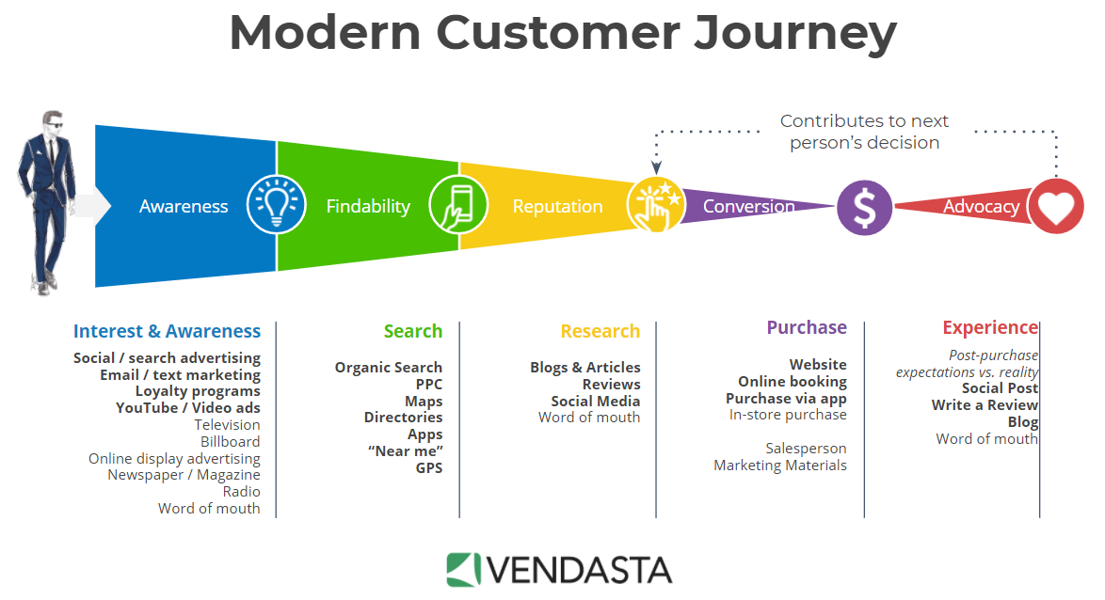

Diagram above from: modern customer journey - Bing

The UPS Consumer Journey and Touchpoints:
Pre-purchase, the UPS customer journey, starts with awareness of the service, from word of mouth to the various e-commerce platforms, websites, multi cart management, omni channel carts, multi-site listing pricings, etc. Then there is the demand generation, which are services from affiliated influencers, or e-mails/sms, loyalty referrals, and reviews etc, from the various providers rakuten, listrak, zinerelo. Then comes the period of consideration, this is just before the period of purchase. Then there are the various types of payments services, accounting integration, int’l landed cost cal, and their providers who are v technologies, and zonos.
Purchase, warehouse fulfilment, these services will involve services such as order management, inventory management, ship/rate/track api, fulfilment, from their various providers, solid commerce zenkraft, connect ship, NRG ship, ozlink, fishbowl, Trackpad, and UPS e-fulfilment. The next stage is retention, these services are linked to shipping rules, s2ap, global shipping, apple compatible sw, and packaging, and their providers, Shipper HQ, Connect ship, Hub box, konos, NRGship, SealedAir, UPS simple rate boxes. Hardware Items for shipping could include, Laptops, pc’s, Scanners, Scales, Printers, from providers such as, Dell, HP, Compaq, Pc connection, Stratix Honeywell, Metlor-Toledo, Zebra. Advocay, services are online returns management, and the providers are Ready Returns. (UPS customer technology program, 2020). Furthermore, according to UPS improving the customer experience, (2021), who highlight that improving the touchpoints enhances the consumer journey. UPS applications along with their technology allows you to pay attention to particular features which affords the consumer a smooth e-commerce perceptibility, whilst shipping and easier returns, together with procedures that are less turbulent for billings and costings administrations. UPS is renowned for their professionalism and services, which brings about consumer expectations (UPS improving the customer experience, 2021; Larke, et al., 2018).
Post Purchase, according to UPS staff writer, (2018) because of strong competition around on-line purchasing retailers constantly try to address new alternatives to make a presence, Once the consumer has selected the “buy” button and has purchased an item, if this procedure is carried out with success, it will increase the UPS organisations standing way above their competitors. Furthermore, the final part of this process consumers are able to increase the brand, this also will lead to consumer loyalty, which will keep them returning. This likelihood has a 60-70 percent comparison to 5-20 percent chance of acquiring a sale from a new consumer, so this post-purchase stage of the experience is not to be treated lightly by organisations and requires considerable care. In addition, there are innovative processes the E- retailers can adopt when utilising post-purchase strategies, which are:
Communicate with consumers, which places the UPS organisation in direct contact.
Offer delivery options, when your involvement is logistics consumers require two procedures free shipping options at speed. This could be put in place for certain consumers as a reward for being loyal.
Make package tracking easy, package and tracking, alongside being able to have visibility are most important for E-retailers, UPS carry-out this procedure by having the technology that allows their consumers to serve themselves in this process, which is linked to API’s on their consumers websites that also gives out a selection of delivery times and dates.
Keep a tone of omnichannel communications, which is carried out by UPS, by way of being able to be in consistent touch through the use of (mobile, in-store, live chat, desktop, e-mails, etc) this will also add to the post-purchase stage.
Use packaging for brand awareness, there are significance to brand packaging, which retailers can utilise here, certainly if this is carried out within, and outside of all packages, this leaves a good impression on your consumers.
Making the return procedure as easy as possible, the complicated procedure of logistical returned items, and most significantly what happens to the items afterwards is an important stage in the post-purchase process, Dejianne says. “As e-commerce purchases continue to grow there’s a greater need to understand reverse logistics and put in place a clear policy and an easy process for returns”.
Be environmentally friendly, being able to live environmentally friendly, and sustainable, consumers thoughts of the minimization of waste materials, to increase UPS brand equity. UPS have put in place though companies such as Packsize and Sealed Air which furnishes retailers with customize packaging and interiors for their packaging. Post-sale consumers is the very last moment you can make on your consumers purchasing experience (UPS staff writer, 2018).

Positives: are that the benefits of e-commerce shopping is that it is open 24 hours a day and seven days a week, which is a huge plus for those individuals who may not have the luxury of time, to visit a store in-person during regular day time shopping hours. Furthermore, because consumers are purchasing off a website, there is no need for employees. Consumers can purchase from your website, from all parts of the globe (Sachin, 2019).
Negatives: are that e-commerce consumers are unable to physically touch, or try on items of clothing, however, this has now changed, with augmented reality consumers are able to try on clothing to see how they look. Furthermore, with e-commerce you may have to wait a day for deliveries, where- as, in physical stores purchases can be bought and taken home straight after being purchased (Sachin, 2019).

Conclusion:
This report has delivered a critical appraisal of vital marketing activities and the contribution of the marketing department of the UPS organisation. However, I would like to recommend a few strengths, to weaknesses I have identified in UPS’s customer journey map. The customer journey map has a way of assisting design teams to draw and plan out the design proposal and principles. With these maps design teams are able to produce customer experience statistical measuring devices, that will assist them to gauge and support their service and advancement through the entire customer journey. Additionally, the statistical measuring devices should be developed in accordance with customer requirements, and assumptions of the way him or her may behave to the varied influence design teams create for him or her, is a continual reminder that customers are at the heart of the development procedure. In addition, with the utilisation of the clustering analytical procedure, this will enable design teams to capture emotional behaviour characteristics, alongside cognitive diagnostic patterns among the users in question, in accordance with the priority statistics. As a matter of fact, when face-to-face with customers journey, the cluster offers the chance to evade the amalgam journeys in a single typology (Alverez, et al., 2020).

Diagram below sourced from: ups-map.jpg (1650×1200) (stageriggingwarehouse.com)

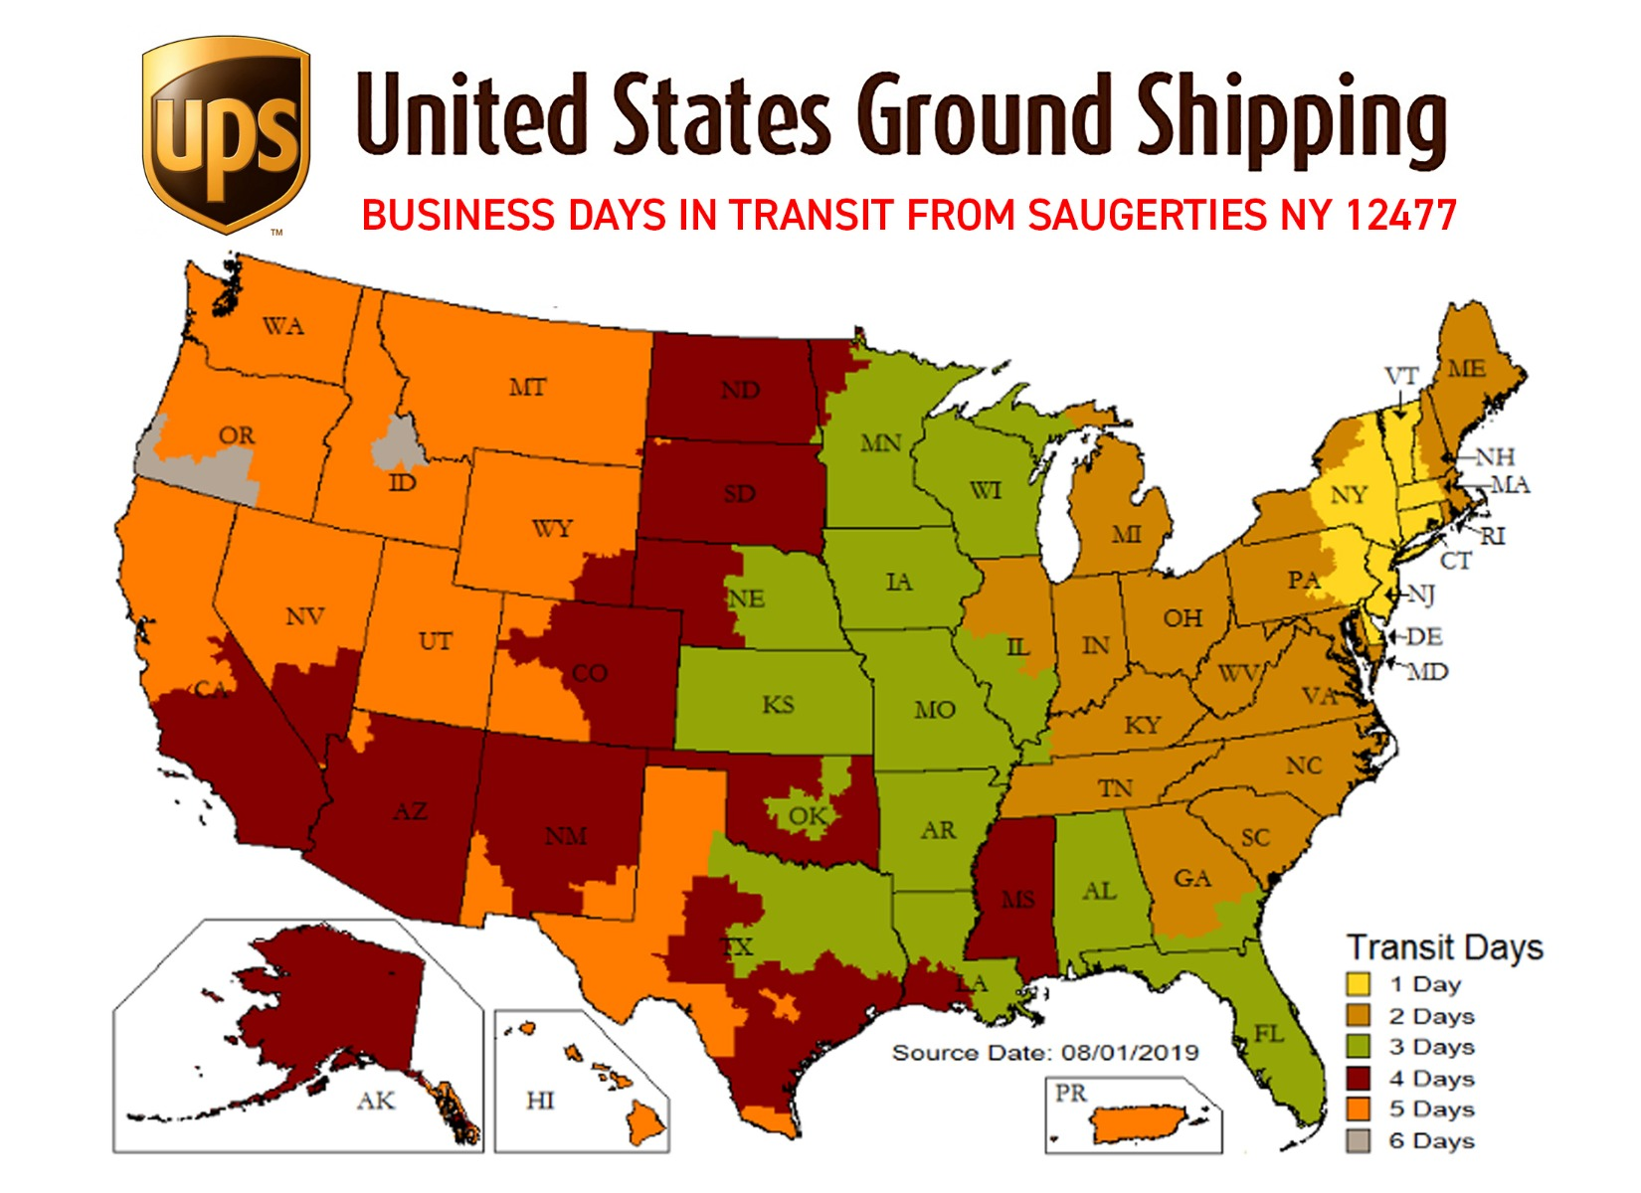

Appendix 1.
Customer journey map below sourced from: Customer_Journey_Infographic.pdf (ups.com)
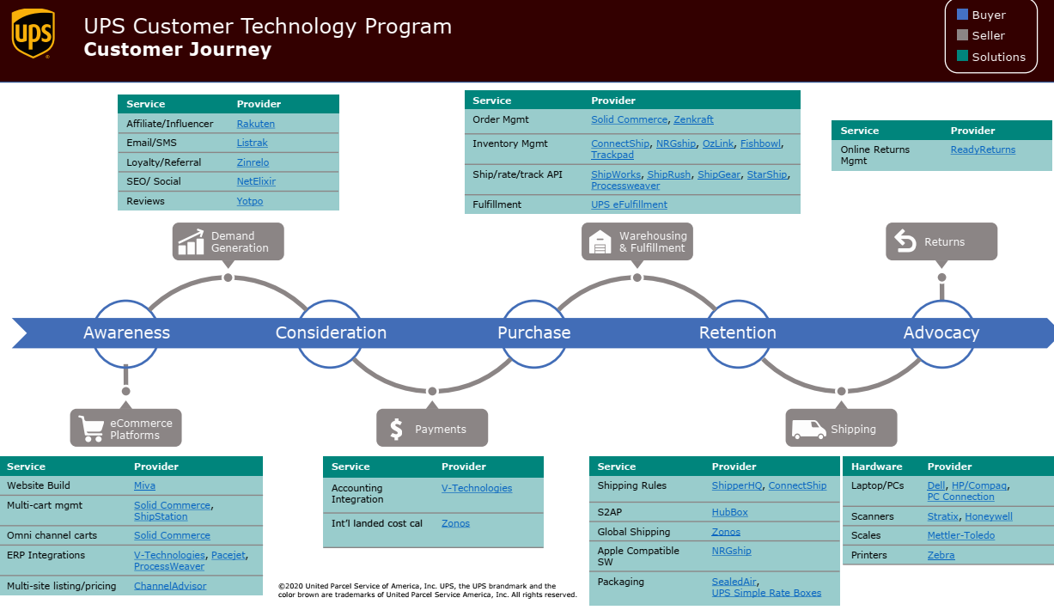

The image below of UPS vehicle that runs by electric with zero emissions.
Diagram sourced from UPS to Add Zero-Emissions Delivery Trucks | Transport Topics (ttnews.com)
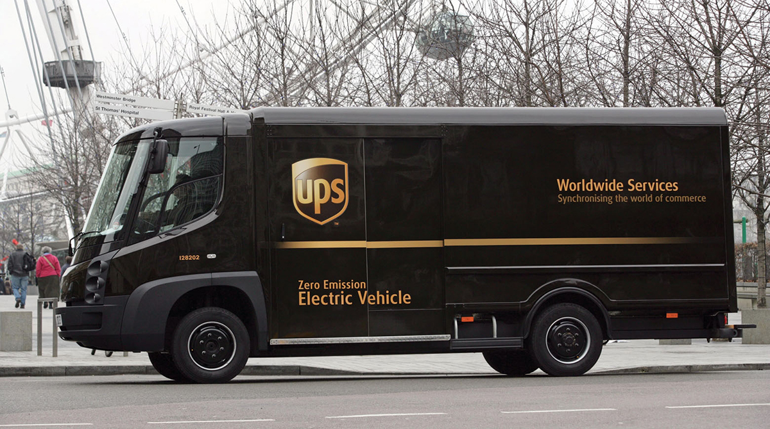

Appendix 2.
UPS world map of operating regions.
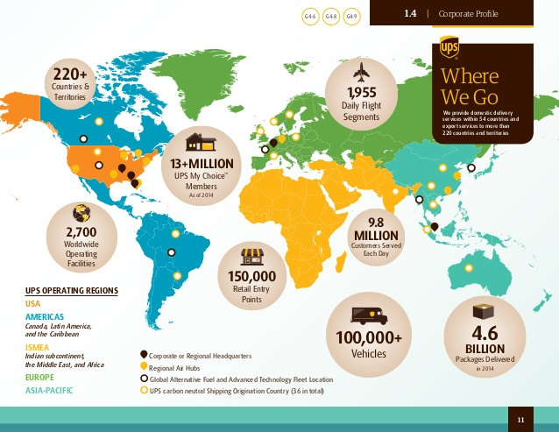

Diagram below sourced from: UPS sorts millions of packages a day. Here's what that looks like (courier-journal.com)
UPS world-port in Louisville where millions of packages are sorted.


Appendix 3.
The diagram below shows you how to track your delivery once you have received your e-mail. Diagram sourced from: UPS-Infographics-Geoawesomeness.jpg (880×729)
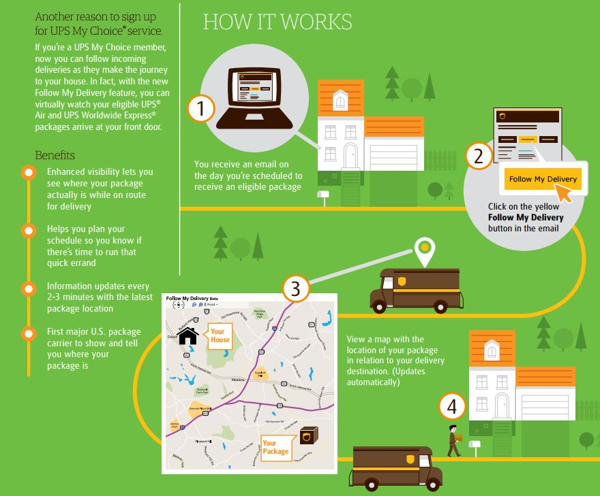
Diagram below sourced from: UPS Announces New Uniforms for Drivers | Transport Topics (ttnews.com) Two colleagues wearing the UPS summer uniform.



References:
Alvarez, J. et al., (2020) An Enriched Customer Journey Map: How to Construct and Visualize a Global Portrait of Both Lived and Perceived Users’ Experiences? Designs, 4(3), p.29.
Akram, S. Hasan, A, J. & Hussam A, M., (2019) Employing marketing information systems for the success of small and medium enterprises: A field study of some Tourism and Travel companies in Baghdad. African Journal of Hospitality, Tourism and Leisure, 8(4), pp.African Journal of Hospitality, Tourism and Leisure, 2019–08-01, Vol.8 (4).
Armstrong and Kotler., (2015) In Akram, et al., (2019).
Baker, J. Parasuraman, A. Grewal, D. and Voss, G.B., (2002) The influence of multiple store environment cues on perceived merchandise value and patronage intentions. Journal of marketing, 66(2), pp.120-141. In Roggeveen et al. (2020)
Chandler, D. Munday, R., (2020) Shannon and Weaver’s model. A Dictionary of Media and Communication, pp. A Dictionary of Media and Communication, 2020–02-20.
Deloitte, J., (2006) Global powers of retailing. In Troiville, (2019).
Farquhar, P.H., (1989) Managing brand equity. Marketing research, 1(3). In Troiville, (2019).
Gamers Decrypted., (2016) Available at :https:// gamersdecrypted.com/team-ranked-swtor-part-3-team-ranked-communication/Team Ranked in SWTOR: Part 3 - Team Ranked Communication - Gamers Decrypted (Accessed: 30. 04. 2021).
Grewal, D. Levy, M. and Kumar, V., (2009) Customer experience management in retailing: An organizing framework. Journal of retailing, 85 (1), pp.1-14. In Troiville, (2019).
Hollensen., (2010) In Akram, et al., (2019)
Hooley, G., (2019) Marketing Strategy and Competitive Positioning. United Kingdom Pearson Ltd.
Keller's Brand Equity Model - Strategy Tools From MindTools.com Available at :https://www.midtools.com/pages/article/keller-brand-equity-model.htm (Accessed: 30. 04. 2021).
Keller, K, L. and Lehmann, D.R., (2006) Brands and branding: Research findings and future priorities. Marketing science, 25 (6), pp.740-759. In Troiville, (2019).
Koter, P, T., (2017) Principles of Marketing 17th Edition United Kingdom: Pearson Ltd.
Kotler and Keller., (2009) In Akram, et al., (2019)
Larke, R. Kilgour, M. & O’C, Huw., (2018) Build touchpoints and they will come: transitioning to omnichannel retailing. International journal of physical distribution & logistics management, 48(4), pp.465–483.
Laundon and Laundon., (2016) In Akram, et al., (2019)
Lewis, R., (2017) "United Parcel Service". Encyclopedia Britannica. https://www.britannica.com/topic/United-Parcel-Service. (Accessed 1. 05. 2021).

Lemon, K, N. and Verhoef, P.C., (2016) Understanding customer experience throughout the customer journey. Journal of marketing, 80(6), pp.69-96. In Roggeveen et al., (2020)
Leydesdorff, L, Petersen, A & Ivanova, I., (2017) Self-organization of meaning and the reflexive communication of information. Social Science Information, 56(1), pp.4–27.
Lyon, A., (2017) Transmission Model of Communication: Alex Lyon [video]. Available at: Transmission Model of Communication. Alex Lyon - YouTube (Accessed: 26. 02. 2021).
Media Radar., (No Date) United Parcel Services Advertiser Profile Available at :UPS United Parcel Service | Advertising Profile | See Their Ad Spend! | MediaRadar (Accessed: 01. 05. 2021).
Nooshabadi., (2012) In Wu, P, T., & Lee, C, J., (2016)
Oppong, P. & Phiri, M., (2018) Impact of brand awareness and association on loyalty : the role of equity in plant medicine market in Kumasi, Ghana. African journal of business and economic research, 13(2), pp.163–181.
Pansari, A., et al., (2017) Customer engagement: the construct, antecedents, and consequences. Journal of the Academy of Marketing Science, 45(3), pp.294–311.
Peck and Childers., (2003) In Wu, P, T. & Lee, C, J., (2016)
Porcu, L, Del-Barrio G, Salvador & Kitchen, P, J., (2017) Measuring integrated marketing communication by taking a broad organisational approach. European journal of marketing, 51(3), pp.692–718.

Proctor., (2005) In Akram, et al., (2019)
Retail Marketing, (2019) Customer brand equity understanding Keller’s model. Available at: Customer brand equity and understanding Keller’s brand equity model (papirfly.com) (Accessed: 01.05.2021).
Roggeveen, A, L. Grewal, D. & S, Elisa B., (2020) The DAST Framework for Retail Atmospherics: The Impact of In- and Out-of-Store Retail Journey Touchpoints on the Customer Experience. Journal of retailing, 96(1), pp.128–137.
Rook and Hoch, (1985) In Wu, P, T., & Lee, C, J., (2016)
Sachin, A., (2019) Advantages and Disadvantages of E- Commerce Available at: Advantages and Disadvantages of E-commerce | Arenasoftwares (Accessed: 01. 05. 2021).
Steenkamp, J.B., (2014) How global brands create firm value: the 4V model. International Marketing Review. In Troiville., (2019).
Sudhir, K. and Talukdar, D., (2004) Does store brand patronage improve store patronage?. Review of Industrial organization, 24(2), pp.143-160. In Troiville, (2019).
Swant, M. Forbes (2019) The World’s most Valuable Brands. Available at: The 2020 World's Most Valuable Brands (forbes.com) (Accessed: 01. 05. 2021).
Troiville, J. Hair, J, F. & Cliquet,. G., (2019) Definition, conceptualization, and measurement of consumer-based retailer brand equity. Journal of retailing and consumer services, 50, pp.73–84.
UPS., (2019) Annual Report Available at: https://www.annualreports.com/HostedData/AnnualReports/PDF/NYSE_UPS_2019.pdf NYSE_UPS_2019.pdf (annualreports.com)
UPS Investor., (2021) Corporate Profile. Available at:Investors.ups.com/ups-profile/corporate-profile Corporate Profile | UPS (Accessed: 30.04.2021).
UPS Staff Writer., (2016) UPS Pulse of the Online Shopper White Paper. Available at: UPS Pulse of the Online Shopper | UPS - United States (Accessed: 01. 05. 2021).
UPS., (2019) United Parcel Services Mission and Vision Statement Analysis. Available at: https://mission-statement.com/ups/#:~:text=July%203,%202019%200%20Comments%20UPS%E2%80%99s%20mission%20statem (Accessed: 01. 05. 2021).
UPS., (2019) United Parcel Services Mission and Vision Statement Analysis. Available at: https://mission-statement.com/ups/#:~:text=July%203,%202019%200%20Comments%20UPS%E2%80%99s%20mission%20statem (Accessed: 01. 05. 2021
Wu, P, T. & Lee, C, J., (2016) Impulse buying behaviour in cosmetics marketing activities. Total quality management & business excellence, 27(9-10), pp.1091–1111
Yousaf, A. Amin, I. & Gupta, A., (2017) Conceptualising tourist-based brand-equity pyramid: an application of Keller brand pyramid model to destinations. Tourism and hospitality management, 23(1), pp.119–137.

Diagram below sourced from: Amazon.com : BROWN PIPING UPS LOGO BASEBALL CAP : Clothing


