Managing Enterprise in 21st Century
Student name: Jahangir Ali
Student ID 1705535
Lecturer name: Dr Husam Helmi

Contents
Introduction 3
Describing the awareness of the learning journey in business plan development 3
Reflection on business plan development 3
Reflective Cycle 5
Development of the personal skill set for self-employment 6
Conclusion 8
Reference 9

Table of Figures
Figure 1 - Gibb's model of reflective Cycle 5

Introduction
The reflection report mainly includes understanding of the module learning journey regarding the business plan interaction. However, this module also includes discussion on the development of personal skills which can help to establish me in self-employment situation. The discussion starts with reflection on the business plan elements which can be important for business plan related discussion. Additionally, the Gibbs model of reflective cycle has also been discussed in order to prioritise the business plan interaction during the class. After that, different skills has been discussed in terms of self-employability. Skills such as organising skills, communication skills, problem-solving skills, decision-making skills etc. are found important for self-employment.

Describing the awareness of the learning journey in business plan development

Reflection on business plan development
Most of the originations use the business plan to analyse their activities and actions for the future regarding the market situation. Carbol (2011) found that a business plan also reflects the organisations’ motives in terms of its mission and vision in overall activities. In this course, we have learned how a business plan is being developed in order to incorporate the organisation's goals and objectives. There are some key elements in business plan that we have learned and these elements also reflect on the overall objectivity of the plan. In the following section, different key elements of business plan have been discussed. We learned that these key elements can help any business person to get a look at the business prospect and articulated presentation can also find different issues within the problem.
Executive summary: An Executive summary includes that major findings in an analysis identifying key issues of the whole report. I learned that management of the organisations can use the key findings in the report which can essentially help to decide actions. I also learned that in the reports or assessment, Executive summary is being placed at the first points or section attracting the readers about the value of the report (Wentzensen and Wacholder, 2013).
Situation analysis: A situation analysis mainly describes the nature of the problem, purpose of the report, situation of the marketplace etc. issues. Additionally, the situation analysis also describes the marketplace and market environment describing key issues. I found that conducting a situation analysis is fruitful for development of strategies as it recognises the external and internal business environment.
Nature of products and services: I also learned during the course that describing the nature of products and services can also help the management to understand key issues of the product related strategy. For instance, understanding the nature of the product can help me to assess the product related information and develop a better strategy and tactics.
Financial analysis: Financial analysis is another important aspect of the business plan as it can help me to understand the flow of financial resources of the organisation and it will also help me to get a look into the financial statements. However, in the business plan, a pro-forma financial analysis is being developed to manage the cash flow in a prospective way.
Segmentation, targeting, positioning: It is relatively important in terms of marketing activities. I learned in the class interaction that develops these STP can help the organisation to formulate strategies for the market (Armstrong et al., 2015). For instance, segmentation can help me to understand the nature of the market and the nature of the customer in terms of their age, geographic or lifestyle choices. Targeting can help me to assess the target market or target customer for the intended product or service. Positioning can help me to assess how a product will perform differently in the market with the competitors’ products.
Market structure: According to Wheadon and Duval (2014), the understanding market structure is also important in development of business plan as I have found that market structure related issues such as number of competitors, the market size, number of suppliers etc. can help me to formulate an effective business plan. The market structure is important in the business plan as it can also help me to develop strategies regarding the possible market changes in the future.
Marketing plan: I also learned that marketing plan development is another important part of the whole business plan as it includes various issues such as marketing strategy, marketing tactics, different communication strategies etc. marketing plan can help me to represent the nature of the product in marketplace in terms of product, price, place, promotion, people, etc. important issues.
Implementation plan: I learned that many managers do not consider the implementation as an important part of the business plan but it might be the most important part. I found that the implementation plan includes various key elements such as responsibility distribution among the business personnel, time scheduling, and monitoring activities of the whole business plan.

Reflective Cycle
According to Husebo et al (2015), as learning arose from our own experience in the different field, developing a habit of constant learning can also help to increase our learning in the long run. The Gibbs model of reflective learning suggests that we have to incline to learn things continuously from different sources and our surrounding so that our inner self could come as a developed person. There are 6 steps of the model which also work as a cycle of learning and developed. These are described in terms of the course learning as follows-
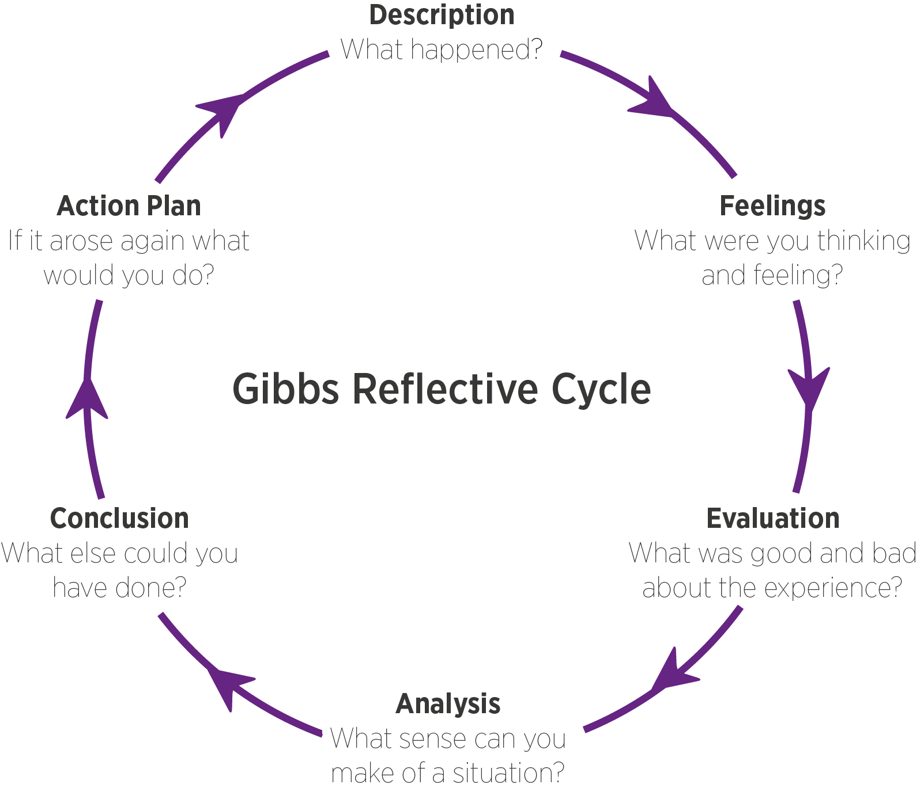
Figure 1 - Gibb's model of reflective Cycle
Source: internet

- Description: The description should include the situation of the learning, the roles played by me and other members, what is the key elements that happened. Answering such questions can help me to find an understanding of the situation to learn. As I passed a session class lecture, I found that business plan is important for analysing the problem or implementing a strategy for a new market environment.
- Feelings: In this stage, I have to concentrate on the thoughts and feelings that I experienced during the class session on business development. I feel it important that manager need to develop a business plan to assess the situation and get look into the possible scenario of the problem.
- Evaluation: By asking questions such as what are the positive and negative aspects of the situation, why these are bad or why these aren’t that bad etc. can help to find out which was correct decision (Parker, 2006). For instance, I learned that evaluation my decisions and felling can help me to realise the importance of the business plan development.
- Analysis: It is also important for me to assess the information and overall finding to reach a solution for the problems or issues. It is important to develop a sense of the situation which can help me to assess the situation and increase my learning ability.
- Conclusion: The conclusion is the justification of the findings in the previous stages. When I reach a conclusion, it means that I reached my final decision about something and I need to carry on my skills and knowledge and devote myself to that.
- Action plan: Action plan is the last stage but it can also lead to reflection and understanding of something new. Action plan mainly includes what are the different activities that I might do in different situation so that my actions are being justified. It is also related to the future actions of different situations in the future (Parker, 2006).

Development of the personal skill set for self-employment
Self-employment is very honest approach for a person to establish himself in the society and minimising the demand for a career approach in a particular job position. I might use the different skills and knowledge if I consider developing a career there. As self-employment skills are different from other related career paths, it can help me establish differently among themselves. The following section consists of different skills for self-employment:
Organising skills: According to Andrews and Higson (2008), the key skill for a position in self-employment situation is the organising skills which will help me to organise the resources for self-employability. As there are different resources in the environment and it requires an organiser to make them functional for a production, such skills can help me to allocate resources for production. Additionally, the different resources for production will also help me to make a business model for self-employability.
Communication skills: It is another critical skill which requires in every situation. Communication skills an help me to develop a better relationship with the people surrounding me (Dwyer, 2005). As I will be working independently, I will have to make a connection with people from similar sector or organisations from similar sector. Building communication skills can help me to assess such relationship context and develop a better prospect. Communication skills can also help to understand what others are saying and it can also help me to express myself and my opinions among tethers.
Problem-solving skills: Dwyer (2005) found that problem-solving skills are also important in work as different problems might arise from the work and employment. It could be complaint from customers, it could be environmental issues, and it can also come from neighbours as I’m self-employed and work in home. In order to develop problem-solving skills, I also need to increase my knowledge and find out solutions for possible problems that I might face from my work. Developing problems solving skills can also help me to build self-confidence and desire to perform even complex tasks.
Team-working: The purpose of the team working in my self-employment situation is that different opportunities might come positively for me and it might require working with others. Developing such skills can help me understand the nature of teamwork how to handle different situation in team work. Team work can also help to learn from other team members and apply them in my work so that I could increase my productivity.
Quick-decision making: Mumford found that (2007) found that decision-making skills are important in the development of key strategies in different work. Quick decision-making skills can help me to decide in critical situations which are important for my self-employability. Additionally, quick decision making can also help me to overcome the challenges that appear suddenly. Sometimes taking quick decision might be wrong and can bring unexpectedly negative impact.
Negotiation skills: Thomas (2008) emphasised that having and developing negotiation skills can help me to develop my own strategies and present them to others in conflicts and bargains. As I will be self-employed, I might have to learn a lot of things to survive on my own. Having strong negotiation skills can help me address the situation and develop a better position among the competitors. The skilful negotiation skill can help me to develop peaceful or win-win solutions for the different parties and this can also help me to improve my reputation.

Conclusion
In conclusion, there are lots of skills are important for a person to survive in as self-employment situation. As there are lots of skills are important for the self-employability situation, developing such skills can help a person to keep him self-employed for a significant time in the competitive market. This module has given various knowledge and insights about the self and work-related knowledge. Applying them in any situation might help me to establish a better self and position as a skilful person.

Reference
Andrews, J. and Higson, H., 2008. Graduate employability,‘soft skills’ versus ‘hard’business knowledge: A European study. Higher education in Europe, 33(4), pp.411-422.
Armstrong, G., Kotler, P., Harker, M. and Brennan, R., 2015. Marketing: an introduction. Pearson Education.
Carbol, B., 2011. Business Plan Development.
Dwyer, J., 2005. Communication in business: strategies and skills. Pearson Education.
Husebo, S.E., O'Regan, S. and Nestel, D., 2015. Reflective practice and its role in simulation. Clinical Simulation in Nursing, 11(8), pp.368-375.
Mumford, T.V., Campion, M.A. and Morgeson, F.P., 2007. The leadership skills strataplex: Leadership skill requirements across organizational levels. The Leadership Quarterly, 18(2), pp.154-166.
Parker, V., 2006. Business impact of executive coaching: demonstrating monetary value. Industrial and Commercial Training, 38(3), pp.122-127.
Thomas, D., 2008. Cultural Intelligence: People Skills for Global Business: Easyread Super Large 20pt Edition. ReadHowYouWant. com.
Wentzensen, N. and Wacholder, S., 2013. From differences in means between cases and controls to risk stratification: a business plan for biomarker development. Cancer discovery, 3(2), pp.148-157.
Wheadon, J.D. and Duval , N., 2014. Business plan development activities as a pedagogical tool in entrepreneurship education. The Journal of Engineering Entrepreneurship, 5(1), pp.31-48.

