

MARKETING FUNDAMENTALS
Name: Dragan Nacevski
ID: 1817167

Executive summary
This report sheds light on the marketing fundamentals of the retail company Adidas. The stages of marketing and its roles are further explained with the kelp of SWOT and PESRLE analysis. The marketing mix and the 4ps of marketing mix are explained with the help of diagrams. The importance of communication for a company like Adidas is further classified with examples.
Table of Contents

Introduction 2
Task 1 (A) 2
1. Process and stages of marketing 2
2. Role of Marketing 7
3. Stakeholder Engagement 10
Task 1 (B) 11
Include a definition of communication 11
You could include a diagram and brief explanation of a communication model 12
Schramm’s Model of Communication 12
Provide a definition of Integrated Marketing Communication 12
Different types of promotion chosen by ADIDAS 13
Conclusion 14
References 15

Introduction
Marketing is one of the most important activities that a company needs to perform properly in terms of selling products and services. This is because effective marketing does not only create brand awareness, but it can also increase sales. This study highlights the major marketing fundamentals of the organisation Adidas.

Task 1 (A)

1. Process and stages of marketing
Definition of marketing
The action that is being taken by organisations for the purpose of promotion and selling respective products, can be defined as marketing
Mission Statement
The Adidas group strives to become a global leader within the industry that it is operating in with brands that have been built to change the perspective of sporting lifestyle.
Objectives
- To be the global leader in the sporting goods industry
- To maximise the group’s operational and financial performance
- To establish ecommerce as a third sales channel
- To achieve qualitative and sustainable growth
Situational Analysis
SWOT Analysis
Strengths  - Leading sports goods manufacturer  - Portfolio Diversification  - Proper financial position  - Good Network of distribution | Weaknesses  - High Price Range  - Manufactured outsourcing  - Limited kinds of products
Threats  - High level of competition  - Supplier Dominance  - Government Regulations | Opportunities  - Lifestyle changes  - Development of new markets  - Product line can be expanded
Table 1: SWOT
(Source: Created by author)
Analysis
Adidas has been successful in establishing itself as a successful brand. It has been observed that the organisation has been operating since the year 1949 (adidas.co.uk, 2019). Hence, it has a legacy and heritage attached with it. Moreover, the company has different product portfolios with a range of footwear and accessories. As commented by França et al. (2017), organisations which offer a wide range of products have higher chances of increased sales rate. Similarly, it operates in different countries and hence it has been successful in developing a strong financial position. However, the main area of weakness is that if offer products with high range of prices. Hence, it might not be an affordable brand for all individuals. Similarly, the organisation has the tendency of suffering from supplier dominance as majority of its production are being outsourced. It has been identified that 35% of its products are developed in China and 93% production are in Asia, hence it can suffer from import regulations (yougov.co.uk, 2018). Therefore, it is important to expand the product line and offer products at comparatively lower prices.

PESTEL Analysis
Political | - Trade Policies  - Political Unrest  - Import Tariffs and restrictions  - Shipping and distribution restriction
Economical | - Unemployment rate (3.9%)  - Wages rate (£ 7.83 per hour)  - Taxation rates (20%)  - Inflation rates (2.48%)  - Interest rates (0.75%)
Social | - Culture  - Religion  - Life Style  - Preferences
Technological | - Innovative technologies  - Management and Accounting system
Environmental | - Restricted Material in production  - Reduce carbon emission  - Attain green company targets
Legal | - Health and Safety At Work 1974  - Environmental Protection Act 1990  - Consumer Protection Act 1987

Table 2: PESTEL
(Source: Created by author)
Analysis
The major political factors that can affect the organisation Adidas include changing policies as well as political unrest in different countries. As per the opinion of Rosenbaum et al. (2019), companies which are operating in the international market, can get affected due to the difference in government stability of the respective countries. Moreover, the Trump Administration can impose import tariffs and restrictions, which certainly are impactful political factors. The productivity level of an organisation depends on the employees’ strengths and the taxation and inflation rates to a great extent. It has been observed that unemployment rate, wage rate and taxation rate of UK are 3.8%, £ 7.83 per hour and 20% respectively (gov.uk, 2019). Hence, if the organisation does not increase the level of productivity, then the estimated annual revenue cannot be increased as well. The social factors that are affecting Adidas include culture, religion and lifestyle preferences. This is because, people are becoming more health conscious and hence they are willing to get proper fitness accessories. Therefore, while making any decision all communities and beliefs need to be addressed properly. Business organisations need to ensure that workers are safe within the workplace. It has been observed that the UK government has developed Health and Safety At Work 1974 to ensure this (worksmart.org.uk, 2018). Hence, this is an impactful legal factor in the case of Adidas.

Porter’s Five Forces Model
Factors | Analysis | Impact
Threat of New Entrants | The threat of new entrants of the organisation Adidas is low to moderate. This is because, a brand can enter on a local scale with a low budget, but to match the brand size of Adidas requires high investment. Moreover, it is going to take a huge amount of time build brand equity. Hence, these are moderating the level of threat arising from new entrants. | Moderate
Bargaining power of suppliers | Despite the fact that suppliers are playing an important role in the business operations of Adidas, bargaining power is low as there are a large number of suppliers in the supply chain. | Low
Bargaining power of buyers | Due to the product quality and marketing strategy of Adidas, the bargaining power of the buyers is also low to moderate. The organisation has always focused on product quality, design and performance, which make the customers loyal. | Moderate
Threats of substitutes | The number of competitors for Adidas is not very large as there are a limited number of brands, equal to its size. Moreover, the organisation has a strong customer base, which is loyal to Adidas and might not look for substitutes. | Moderate
Level of competitive rivalry | The level of competitive rivalry within sporting goods manufacturing industry is quite high. It has been observed that the main competitors of the organisation include Nike, Puma, and others. Despite high level of saturation, the level of competition is steadily increasing. | High

Table 3: Porter’s Five Forces
(Source: Created by author)
The marketing mix elements could be defined and related to the chosen company. (4ps:
Product, price, place, promotion)
Price | - ADIDAS uses the skimming as well as the competitive pricing methods keeping in mind with its competitors like Nike and Puma.  - Due to the high quality of the products, the pricing of the ADIDAS is expensive.
Product | - ADIDAS is a leading global brand supplying wide variety of products but mostly focuses on the sportswear.  - ADIDAS also sells and designs products like sunglasses, caps, deodorants and lotions.
Place | - ADIDAS has made it very easy for customers to purchase goods around the world through distribution channels like retail stores, online sites and franchises (Gummerus, et al. 2017)  - ADIDAS is available at around 55 countries.
Promotion | - ADIDAS has promoted its products with mediums like social media and television advertisements.  - ADIDAS makes brand endorsement deals with popular celebrities like David Beckham and Muhammad Ali to reach more customer base.
Table 4: Marketing Mix 4P’s
(Source: Influenced by Kwin et al. 2018)

2. Role of Marketing
Adidas works on the dynamic market where the fundamental goal is to keep up fruitful marketing correspondence techniques, actualize high assistance quality and create procedures to improve these administrations. The pur¬pose of Adidas marketing correspondence is to get and keep a client (Resnick, et al. 2016). The quality of Adidas is that it utilizes compelling correspondence procedures and correspondence mix for the brand making a special picture of its products. Accepting into account open doors of Adidas it is clear that the organization arrives at a broadly scattered objective market which will assist it with presenting the message in a customized manner, offer the chance of advising purchasers in insights regarding the total range advertised (Resnick, et al. 2016). Solid brand picture of Adidas encourages the organization to set up dependability, certainty, and capability for clients (Engelen et al. 2018). This system will be upheld by the purchasing procedure and the valuing, and as the most significant this situating methodology causes the clients to include product inside their psyches. Marketing correspondence permits Adidas to make a perplexing heap of pictures about its products in the client's brain (Engelen et al. 2018). Adidas speaks to a guarantee about a top notch sports divine beings; it is a kind of value affirmation.

Definition of Societal marketing
ADIDAS has implemented societal marketing strategies, with which it aims at making better marketing decisions by giving preference to the customer’s needs and demands. Societal marketing focuses on maintaining social responsibilities and maintain valuable service to improve the relationship with the customers by being way ahead of its competitors like Nike and Puma.
Process of implementing the concept
The process of implementing the societal marketing strategy by ADIDAS are-
- Keeping the customer’s needs and demands at its first priority
- Implementing improvement in the products if required by giving importance to the customer’s feedback
- Be aware of the social responsibilities with a vision and creating a trust factor
Definition and advantages of branding
Branding is rendered as setting a unique identity in the market with the help of brand names and logos. ADIDAS has created a unique brand name globally by branding itself as a sportswear company.
The advantages of branding are-
- It helps ADIDAS stand out from rest of the competition
- Proper branding helps in attracting the customers
Process of implementing the strategy
Branding is implemented by ADIDAS by looking at its market range, products sold and customer satisfaction. Since, ADIDAS has gained huge profit in the recent years with its sportswear and shoes; it has branded itself as a sportswear company and is successfully sustaining its brand names and values.

Ansoff Matrix Strategies
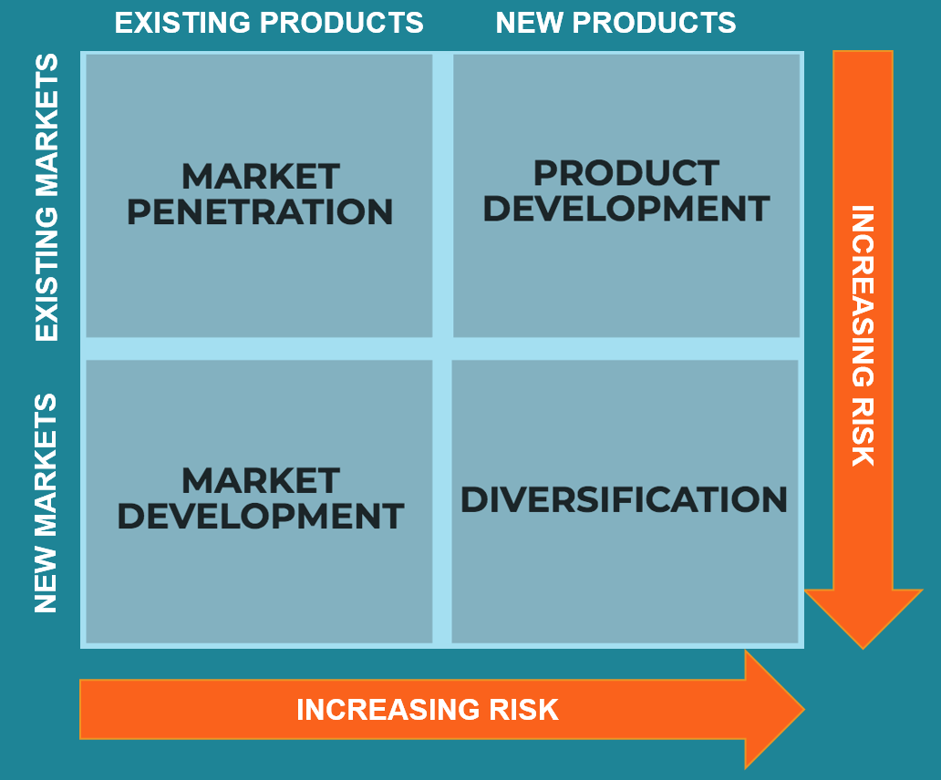
Figure 1: Ansoff Matrix
(Source: Influenced by Sukma et al. 2019)
Market penetration
ADIDAS aims at entering the existing market with the uses of its existing products. In order words ADIDAS aims at increasing its market share by implementing the marketing strategies like promotional and distribution activities.
Product development
Product developments refer to developing a new product and presenting it in an existing market (Resnick, et al. 2016). ADIDAS has been developing its products like its sport shoes and bringing wide range of victory by improving the quality.
Market development
ADIDAS has been entering different new markets globally with its existing products attempting to gain more customers. ADIDAS has globally reached up to more than 50 countries with better distribution and marketing strategies.
Diversification
ADIDAS had been initiating innovation as its products and developing new products and entering new markets. Although this strategy has a risk factor involved, ADIDAS has been actively experimenting.

3. Stakeholder Engagement
Definition of Stakeholder
Stakeholders can be defined as individuals or social groups that have an interest in the business.
Definition of internal and external stakeholders
Internal stakeholders can be defined as entities taking part within the business activities, which includes employees, managers, board of directors. External stakeholders does not take part in the business, but can get affected due to the performance level, which includes consumers or suppliers.
The internal stakeholders of the organisation Adidas, includes, employees and board of directors. The external stakeholders, of the organization, include Consumers and Suppliers.
Process of communicating with stakeholders
The organisation Adidas tends to communicate with the employees via training sessions and while communicating with the board of directors, board meetings are being organised. On the other hand, in terms of while communicating with the external stakeholders like consumers; Adidas looks to collect consumer feedback during promotional activities, so that the needs and desires of the respective customers can be figured out. Lastly, while communicating with the suppliers, Adidas maintains the process of direct email settlement.
Impact of Stakeholders on Marketing
The internal stakeholders of the organisation Adidas like the employees and the board of directors are the individuals who are actually playing important roles in the marketing activities (Engelen et al. 2018). Hence, their respective performance levels are going to decide whether effective marketing can be performed or not.

Task 1 (B)

Include a definition of communication
Communication in an organization is defined as the means of receiving and sending messages in an organizational environment. The communication can be with different stakeholders like customers, governments, suppliers and within the employees. As in the case of ADIDAS, it communicates with its employees by organising training and development programs and through meetings and organisations interactive sessions (Wang, et al. 2017). ADIDAS also actively participates in communicating with its customers through mediums like social media and promotional activities like advertisements. ADIDAS receives feedback and implements it as per the demands of the customers. With the suppliers, ADIDAS maintain a professional communication method through emails and fax. Therefore I have analysed that communication is extremely necessary for a company like ADIDAS to sustain and develop its marketing strategies.

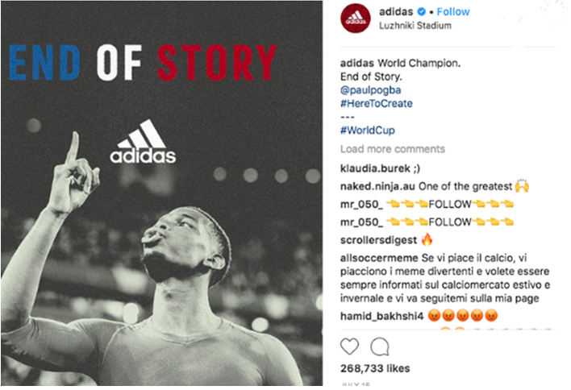
Figure 2: Blog of Addidas on social media

You could include a diagram and brief explanation of a communication model

Schramm’s Model of Communication
Schramm's model of communication was first proposed by Wilber Schramm in 1954. According to the communication model, communication is a two way transformation of messages between the sender and the receiver. Hence, Schramm's talks about coding and decoding the messages through the means of converting and interpreting (da and Las, 2017). In the case of ADIDAS, with the help of this communication model, it communicates with its customers and converts the feedback by implementing the feedback given by the customers in the producers. If there are any changes to be made or the customers are not satisfied with the products, telecommunication model helps in lessening the gap and creating a proper relationship.

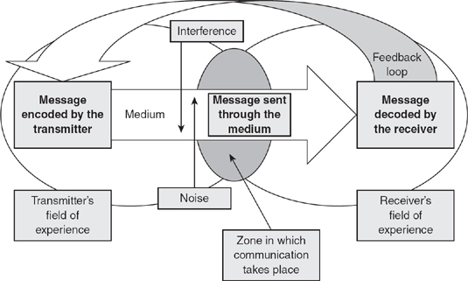
Figure 3: Schramm’s Model of Communication
(Source: inspired2learn.co.uk, 2019)

Provide a definition of Integrated Marketing Communication
The integrated marketing communication, in simple words refers to linking all the forms of communication and messages together. In other words, it is the process of integration of all the promotional tools and working them together. It is the amalgamation of traditional communication tools like advertising and bringing it together with the new forms like social media and digital communication (Wang, et al. 2017). Similarly, ADIDAS implements this form of communication to create a more interactive session with different stakeholders. The prominent example I have noticed is experiential marketing followed by ADIDAS by making it more fun and creative in terms of communication.

Different types of promotion chosen by ADIDAS
Television commercial
The television commercial is one of the, cost effective types of promotional activity implemented by ADIDAS. ADIDAS has a huge number of television commercial ads all around the world with collaboration with networks like BBC and CNN. I have analysed that TV commercial helps ADIDAS in reaching a huge customer base all around the world.
Social media
Another important promotional strategy implemented by ADIDAS is through social media promotion. With the rise in social media platforms like Facebook and Instagram, as referred at the blog post, I have analysed that's the social media popularity created a huge awareness among the customers.

Conclusion
The study concludes that marketing is an impact activity for any business company. Moreover, it can be concluded that organisations need to implement marketing strategies so that the sales rate can be increased and the stakeholders can be satisfied as well, by analysing the business environment properly, so that areas of strength can be identified.

References
adidas.co.uk (2019), Cyber Week Up to 65% Off Available at: https://www.adidas.co.uk/ [Accessed on: 21 November, 2019]
da Silva, E.C. and Las Casas, A.L., (2017). Sports marketing plan: an alternative framework for sports club. International Journal of Marketing Studies, 9(4), pp.15-28.
Engelen, P.J., Heugens, P., van Essen, M., Turturea, R. and Bailey, N., (2018). The impact of stakeholders’ temporal orientaton on short-and long-term IPO outcomes: A meta-analysis. Long Range Planning.
França, C.L., Broman, G., Robèrt, K.H., Basile, G. and Trygg, L., (2017). An approach to business model innovation and design for strategic sustainable development. Journal of Cleaner Production, 140, pp.155-166.
gov.uk (2019), Data about Rates Available at: https://www.gov.uk/income-tax-rates [Accessed on: 22 November, 2019]
Gummerus, J., von Koskull, C. and Kowalkowski, C., (2017). Guest editorial: relationship marketing–past, present and future. Journal of Services Marketing, 31(1), pp.1-5.
inspired2learn.co.uk (2019). Communication Models. Available at: https://www.inspired2learn.co.uk/article/51/AZofCoachingandMentoring/ [Accessed on 14.11.2019]
Kwon, W., Lee, H.W. and Kim, Y., (2018). Global marketing of Formula One: Local variations and geocentric marketing mix. International Journal of Applied Sports Sciences, 30(2).
Resnick, S.M., Cheng, R., Simpson, M. and Lourenço, F., (2016). Marketing in SMEs: a “4Ps” self-branding model. International Journal of Entrepreneurial Behavior & Research, 22(1), pp.155-174.
Rosenbaum, S.M., Madsen, T.K. and Johanning, H., (2019). Managing the challenges of piggybacking into international markets. International Marketing Review, 36(1), pp.56-73.
Sukma, D., Lubis, P.H. and Utami, S., 2019. Analysis of Marketing Strategy of Minyeuk Pret Using STP, Ansoff Matrix, and Marketing Mix.
Wang, Z. and Kim, H.G., (2017). Can social media marketing improve customer relationship capabilities and firm performance? Dynamic capability perspective. Journal of Interactive Marketing, 39, pp.15-26.
worksmart.org.uk (2018), Health and Safety Available at: https://worksmart.org.uk/health-advice/health-and-safety/employer-duties/what-health-and-safety-work-act [Accessed on: 20 November, 2019]
yougov.co.uk (2018), Adidas Available at: https://yougov.co.uk/topics/consumer/explore/brand/Adidas [Accessed on: 20 November, 2019]

