Managing projects in the Organisation
Lecturer: Rebecca Francis-Davies
Student: Nicoleta Bichir

Blog number 1
Deadline: 03rd May 2024
What is a project?
When an individual or organization conducts a project, involves distinctive collection of coordinated activities with specific objectives, within a predetermined timeframe, budget, and performance criteria. The activities have distinct beginning and ending points. A project is a limited undertaking to generate a distinct product, service, or outcome
(Malsam, 2023).

Project management: involves the application of knowledge, processes, and tools to complete work efficiently, utilizing methods, skills, techniques, and the team's experience to achieve project goals. This definition encompasses the entire life cycle of project management, which includes initiation, planning, execution, monitoring, control, and delivery of organizational objectives (Malsam, 2023).
How To Successfully Manage a Project?
Watch this video!
https://www.youtube.com/watch?v=vNUrLlv2cLw

Every successful project goes through the same five phases:
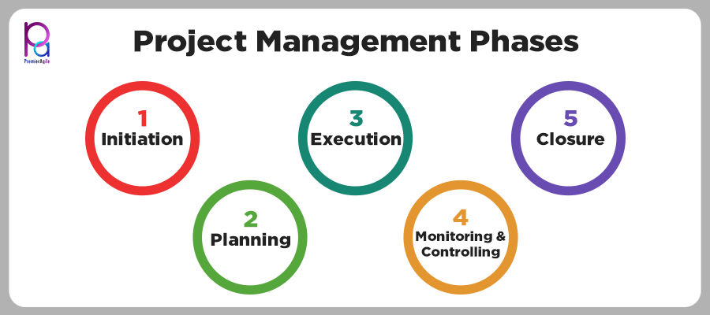
1.Initiating phase
- Define the project scope and objectives.
- Identify key stakeholders.
- Teams and stakeholders may engage in brainstorming sessions to generate ideas.
- Identify communication channels and tools.
- Establish project team roles and responsibilities.
- Planning Phase
- Develop a comprehensive strategy for project execution, oversight, and management.
- Begin by establishing clear project objectives.
- Outline project objectives using popular methodologies like S.M.A.R.T. and CLEAR.
- M.A.R.T. stands for Specific, Measurable, Achievable, Realistic, and Timely, ensuring clear and achievable goals.
3. Execution Phase
- The project execution phase involves the implementation, monitoring, and control of planned activities to achieve the project objectives.
- The main goal of this phase is to successfully deliver the project within scope, on time, and within budget.
4.Monitoring and Controlling:
- Monitoring and controlling ensure work aligns with the project plan.
- The project manager identifies deviations and takes corrective action as needed.
- Adjustments are made to realign work with project objectives.
5. Closing:
- The final project management process group is closed.
- Deliverables are completed and handed over to the end customer.
- The team conducts a lessons-learned meeting to review the project and consider improvements (ATLASSIAN, 2024)

References
ATLASSIAN, 2024. Definition of project life cycle: Exploring the 5 phases. [Online]
Available at: https://www.atlassian.com/work-management/project-management/project-life-cycle#:~:text=The%20project%20life%20cycle%20includes,on%20time%20and%20within%20budget.
[Accessed 01 May 2024].
Malsam, W., 2023. Project Manager. [Online]
Available at: www.projectmanager.com
[Accessed 02 May 2024].

Blog number 2:

What is a quad chart?
Strategic planners adopt a quad chart as a visual aid to categorize information into four quadrants, providing a concise perspective. The quadrants serve to emphasize particular facets, enabling stakeholders to promptly evaluate the state of a project or organization.
(Frost, 2012).
What are the benefits of a quad chart?

- Enables clear visualization: Quad Charts simplify complex data by dividing it into four categories for easy understanding.
- Efficient Communication: Their organized format enables stakeholders to quickly grasp essential information, facilitating swift decision-making.
- Strategic Analysis: They identify critical factors and highlight key aspects for strategic planning, project management, and risk assessment.
- Real-time Updates: Dynamic versions offer real-time insights, enabling businesses to adapt and make prompt decisions.
- Effective Presentations: With their visual appeal and structured layout, Quad Charts make presentations impactful, ensuring audience engagement.
- Collaboration: Creating Quad Charts promotes teamwork, encouraging discussions and comprehensive analysis through collective insights

What are some common mistakes to avoid when creating Quad Charts?
Lack of focus: Incorporate charts, graphs, and icons where necessary to enhance visual appeal and comprehension. Disregarding Updates: Consistently revise Quad Charts to incorporate up-to-date information, guaranteeing precision and pertinence (Stamey & Honeycutt, 2005).

Disregarding Updates: Consistently revise Quad Charts to incorporate up-to-date information, guaranteeing precision and pertinence (Stamey & Honeycutt, 2005).

An example of a quad chart:

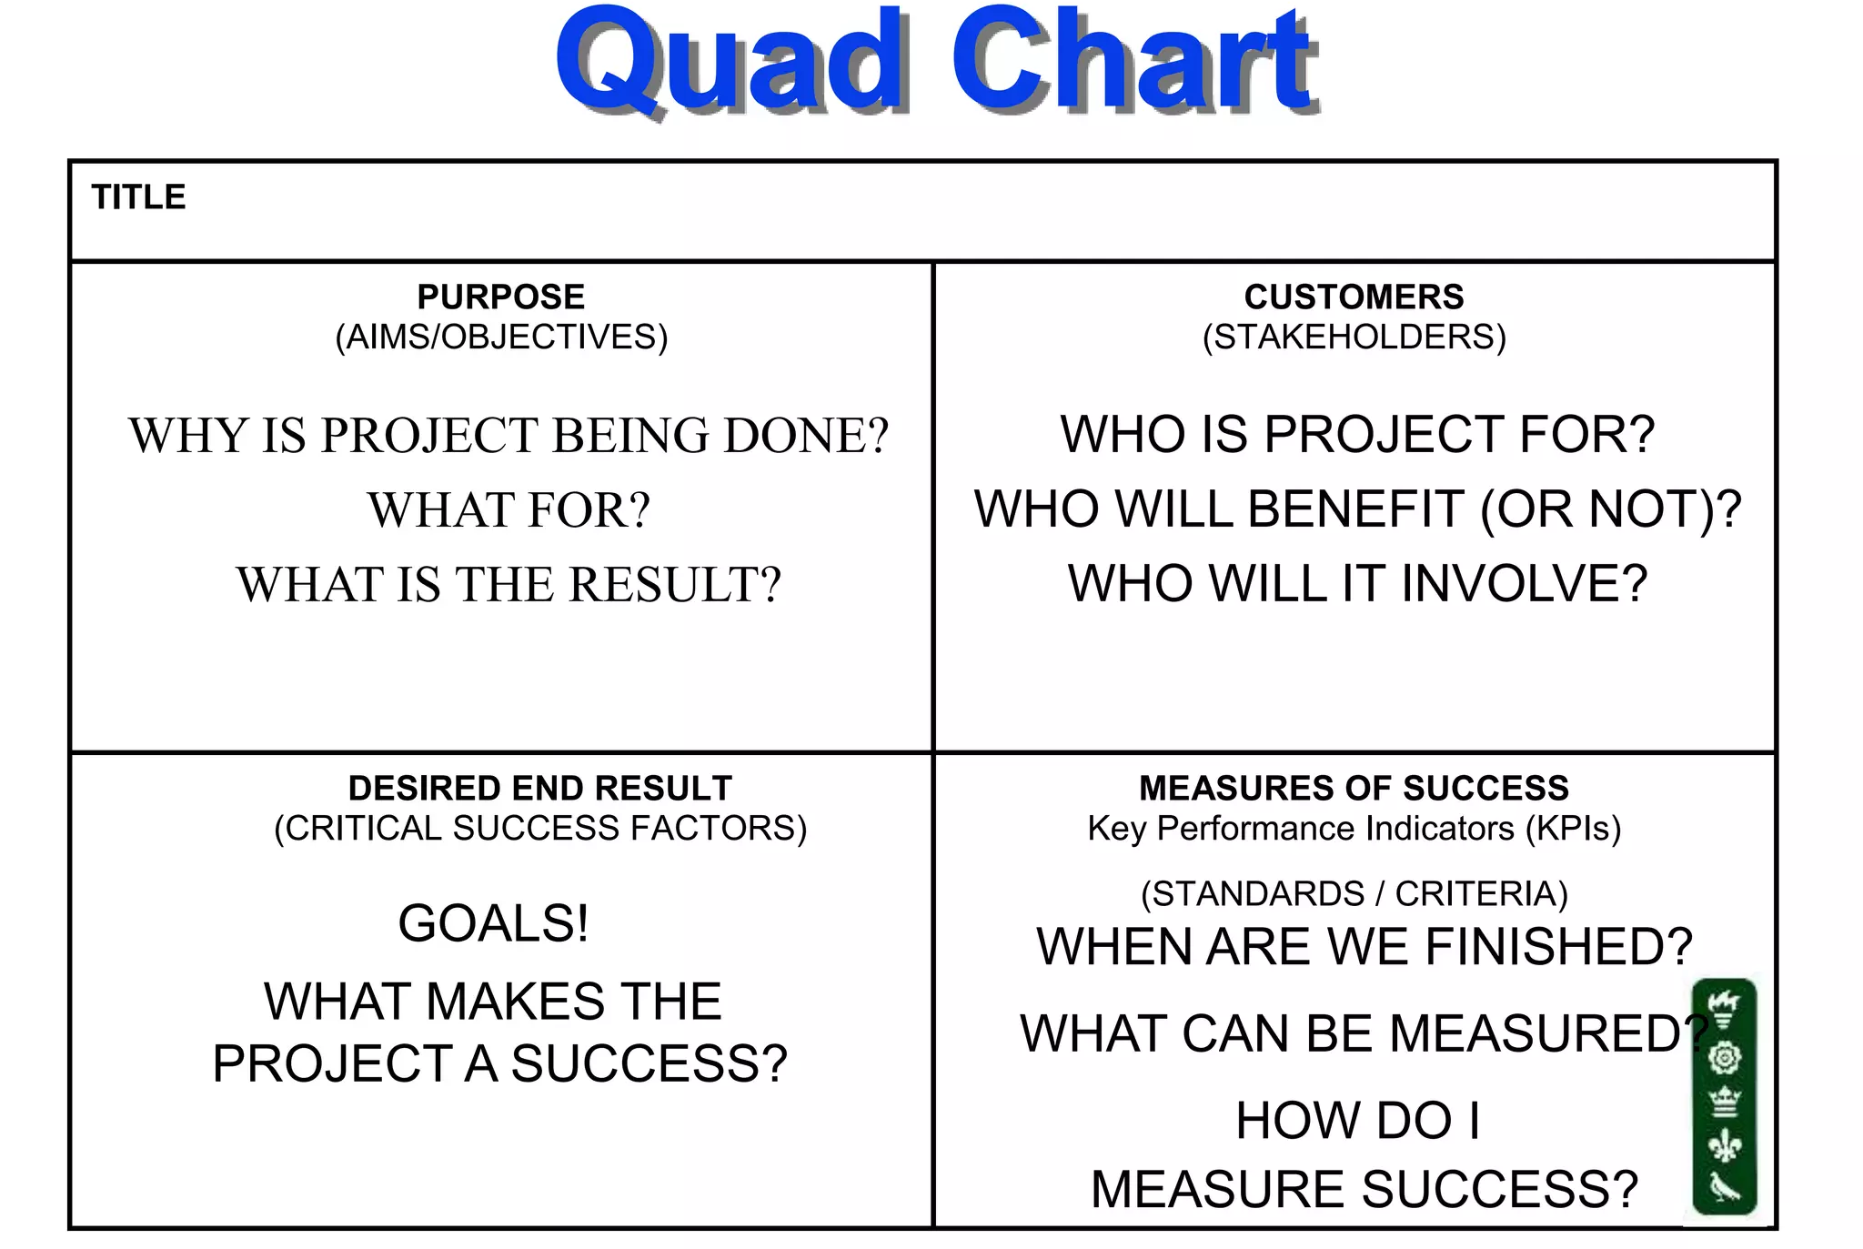

Reference list:
Frost, E., 2012. So What’s a Quad Chart, Exactly? Exercises in Genre. GRASSROOTS WRITING RESEARCH JOURNAL, p.113.
Kerzner, H., 2018. Project management best practices: Achieving global excellence. John Wiley & Sons.
Stamey, J. and Honeycutt, T., 2005. Quad charts in software project management. Journal of Computing Sciences in Colleges, 21(2), pp.322-327.

Blog number 3
Stakeholder vs Shareholder:
How they are different?

A stakeholder is a individual, group, or organization that has an interest in or concern for an organization or project (Lee & Brown, 2019)

In general, there are two types of stakeholders:

Internal stakeholders are those who are directly affected by the company's success or failure and frequently possess a financial interest in the organization.

A few examples of internal stakeholders are:

- Shareholders or investors with a stake in the company benefit when it announces profits.
- Employees can get bonuses or increased compensation if the company achieves success.

External stakeholders have an indirect interest in the company's success.
- Customers gain when a company reinvests profits to produce a superior product or streamlines its operations to produce a cheaper product.
- Contractors and suppliers can get rewards when a company expands existing operations and hires more external people (Tamplin, 2024).
What is a shareholder?
A shareholder is an individual or organization that possesses shares or stock in a publicly and privately operated company. Shareholders, also known as company members, have a monetary interest in the organization or project's profitability (Sinha, 2023).

What is the biggest difference between a stakeholder and a shareholder?
While stakeholders have a wider range of interests in the company's operations and outcomes, shareholders are more focused on the financial returns from their shares. All shareholders are stakeholders in the company, but not all stakeholders are shareholders (Landau, 2019).

Reference list:
How, S.M., Lee, C.G. and Brown, D.M., 2019. Shareholder theory versus stakeholder theory in explaining financial soundness. International Advances in Economic Research, 25(1), pp.133-135.
True Tamplin, 2024. Stakeholder in Business, available at Stakeholder | Definition, How They Work, Types, vs Shareholders (financestrategists.com)
Peter Landau, 2019. Project Management, Blog on Stakeholder vs Shareholder: How They are Different & Why it Matters. Available at: www.projectmanager.com


Blog number 4:

What is Project risk management?
According to PMI, project risk is defined as the probability of certain events having a negative impact on project objectives, the level of vulnerability to unfavorable events, and the likely outcomes of these events.

Consequently, three risk factors define the project risk.
- The risk event or identification refers to what could potentially harm the project.
- The risk probability refers to the likelihood of an event occurring.
- The amount at stake -what could potentially be lost (Schieg, 2006).
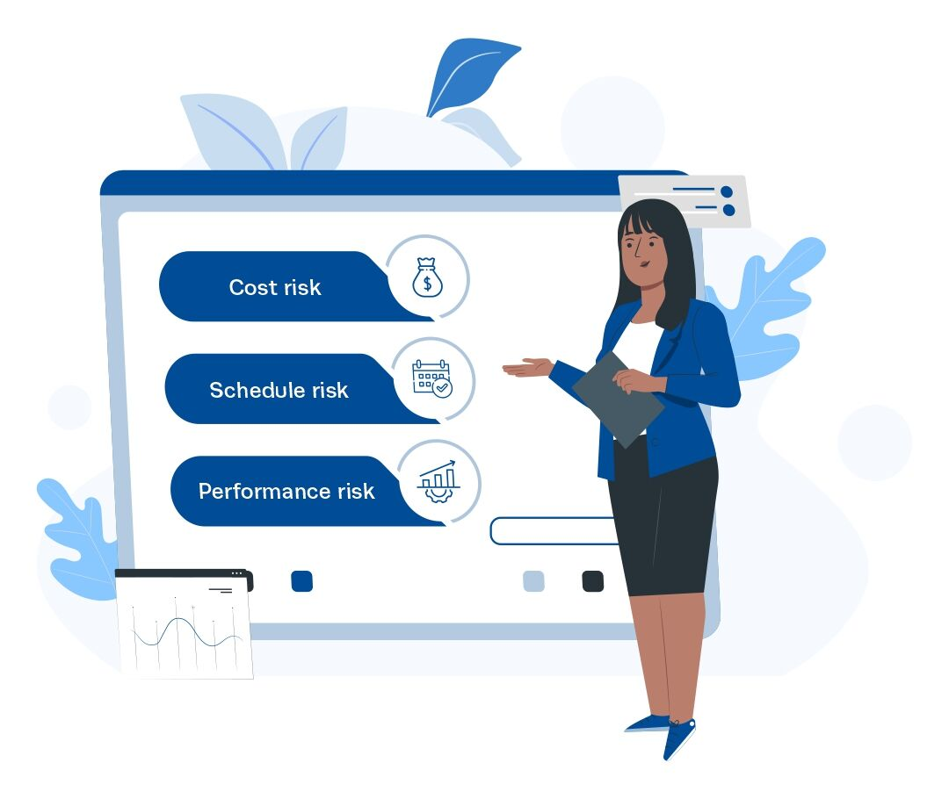
Common Types of Project Risks?
Cost risk refers to the uncalculated growth in project costs. Moreover, it is the risk that the project will cost more than its allocated budget.
Schedule Risk is the chance that activities will need to be extended for a longer period than expected. Typically, this risk is also due to poor planning.
Performance risk refers to the negative impact of a project failing to deliver results that meet its specified objectives (Walker, 2005).

Why is Project Risk Management Important?
- It contributes in preventing significant disasters.
- It improves your income by reducing your expenses.
- Ensures effective completion of the project.
- Provides you with a distinct advantage over your competitors.
- It strengthens the perception of being accountable and responsible.
- It facilitates the exploration of novel opportunities (Walker, 2005).

Reference list:

Schieg, M. (2006) ‘Risk management in construction project management’, Journal of Business Economics and Management, 7(2), pp. 77–83. Doi: 10.1080/16111699.2006.9636126.

Cooper, D. F., Grey, S., Raymond, G., & Walker, P. (2005). Project risk management guidelines. Wiley.

Blog Number 5:


Our project, titled "Spread Joy, Donate Toys," involves collecting preloved plastic toys from individuals and households and passing them on to various charities for rehoming.
Managing a project focused on collecting toys for fundraising and self-awareness involves various abilities and skills.
Through this project, I connected my organizational and communication skills to the "Spread Joy, Donate Toys" project, which helped ensure its success and efficiency.

- Resource Management: We identified and allocated resources, such as volunteers, collection points, and storage facilities. For our project, we utilized the university's facilities to collect all the toys in Haywood House.
- Improved Communication Skills: I led the communication efforts by designing promotional materials and sending regular updates to stakeholders. Additionally, I coordinated with volunteers, providing clear instructions and support. Effective communication raised public awareness, increased participation, and kept all team members aligned with our goals, resulting in a higher volume of toy donations and a more engaged volunteer base.
- Effective Stakeholder Management: I maintained regular communication with charities to understand their needs and tailored our collection efforts accordingly. Managing stakeholder relationships effectively ensured that the collected toys met the needs of the recipient charities, enhancing the impact of our donations and building strong community support (Sunindijo, 2015).

Self-Development Plan
Enhance key skills to improve performance in future projects, with a focus on problem-solving and motivational skills.

- To study and apply different problem-solving frameworks (SWOT analysis)
- Improve analytical and strategic thinking (Bower, 1982)
- Learn about motivational theories and techniques (e.g., Maslow's Hierarchy of Needs, Herzberg's Two-Factor Theory).
- Implement motivational techniques in current projects, such as recognizing achievements and providing constructive feedback (Riley, 2005).

References list:
Sunindijo, R.Y., 2015. Project manager skills for improving project performance. International Journal of Business Performance Management, 16(1), pp.67-83.
Bower, J.L., 1982. Solving the problems of business planning. The Journal of Business Strategy, 2(3), p.32.
Riley, S., 2005. Herzberg's two-factor theory of motivation applied to the motivational techniques within financial institutions.

