
BSc. Health and Social Care. Level 6 Term 1

Assignment 2

Topic:
General Anxiety Disorder, Schizophrenia, and Autism

Student name:​ Elizabeth Owusu
Student ID: ​1917244
Module name: Mental Disorder and Psychopathology
Module code: BMHP6006
Lecturer name: Bianca Sanfilippo ​
Date: 14/04/2022

Contents………………………………………………………………………2
Content Page……...………………………………………………………………………….….2- 3
Introduction……………………………………………………………………………………………4
General anxiety disorder 1………………………………………………………………………4- 5
  - Levels of depressive episodes…………………………………………………………………5
  - People suffering from a general anxiety disorder in the United Kingdom …………………5
  - Statistic…………………………………………………………………………………………….5
Causes of General Anxiety disorder (Aetiology) 2…………….…………………………………6
1.1Implications………………………………………………………………………………….…….6
Signs and Symptoms.……………………………………………………………………………6- 7
Risk factors……………….…………………….…………………………………………………….7
When Anxiety can be diagnosed……………………………………………………………………7
Current treatment of GAD…………….…………………………………………………………….8
Measurement and Rehabilitation……………………………………………………………….8
Recommendation for improvement of general anxiety disorder………………8- 9
Complementary Therapies…………………………………………………….……………9
Care for general anxiety disorder………………………………………………………9- 10
Schizophrenia………………………………………………………….……………………………10
Definition of Schizophrenia……….……………………………………………………………….10
Types of Schizophrenia……………………………………………………………………………11
Causes of Schizophrenia (Aetiology) ………….………………………………………………11
Signs and Symptoms………………………………………………………….11
Critical classification of Schizophrenia……………………………………………………………11
Statistic………………………………………………………………………………………………12
F20- F29, Diagnosis,,,,,,,,,,,,,,,,,,,,,,,,,,,,,,,,,,,,,,,,,,,,,,,,,,,,,,,,,,,,,,,,,,,,,,,,,,,,,,,,,,,,,,,,.,,,,,,,,,,,,,,,,,,,,,,12
Previous treatment…………………………………………………………………………….12
Current treatment…………………………………………………………………………12-13
Measurements of rehabilitation for Schizophrenia……….………………………………….13
Guidance of Care…………………………………………………………………………………13
Recommendation for improvement……………………………………………………………….13
Autism……………………………………………………………………………...……………14- 15
Classification of Autism……………………………………………………………………..16
Causes (Aetiology) of Autism……………………………………………………………………16
Signs and Symptoms of Autism….………………………………………………………………16
Critical classification……………………………………………………………………………….16
Signs and Symptoms of Autism……………………………………………………………………16
Critical classification of Autism……………………………………………………………...……16
Diagnosis…………………………………………………………………………………………….17
Autistic team…………………………………………………………………………………………17
Current treatment of Autism……………………………………………………………………….17
Interventions…………………………………………………………………………………………18
Measurement of rehabilitation for Autism……………………………………………………......19
Recommendation of improvement for Autism…………...………………………………………19
Guidance and Principles of care……………………………………………………………….19
National Autism Society…………………………………………………………………………19
Conclusion…………………………………………………………………...……………………20
References……………………………………………………………………………………….21
Appendices……………………………………………………………………………………A- D

Introduction
In this report, a critical examination of the classification, diagnosis, treatment, and measurement of rehabilitation of three mental disorders from the ICD-10 (WHO, 2010) will be provided, such as.
General Anxiety Disorder
Schizophrenia
Autism
The paper will also examine the causes and symptoms of the above disorders, as well as the statistic and prevalence and the provision of care, treatments, and support available, and recommendations for improvements.

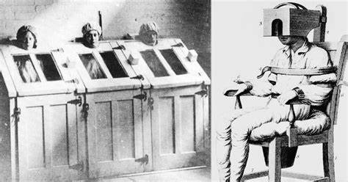
During the American civil war era, they linked Generalised Anxiety Disorder to over-enthusiasm. In the early 1930s, everybody suffering from mental disease was sterilized.
Ancient Greece believed anxiety to be caused by uterine problems. The Early Renaissance thought that anxiety is influenced by witchcraft, whilst the Victorian era will send those suffering from anxiety to asylums. Medicine began to modernize in the late 1930s. There are many available therapies available now that can help. (Taylor, 2020) (PHE, 2021).

General Anxiety Disorder
General Anxiety Disorder is characterized as a continual sensation of worry, intense panic, and terror that can have a serious negative impact on a person’s daily life, affecting physical and mental health and wellbeing. (NHS, 2021). Generalized Anxiety Disorder is classified within ICD-10 (WHO, 2010), ‘F40-F48’,

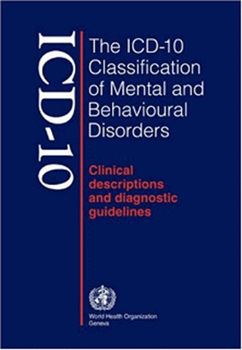
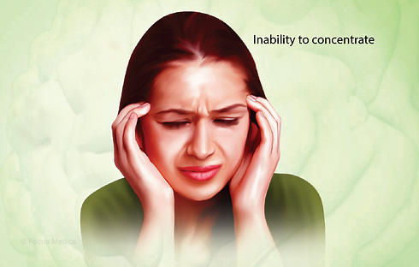
Neurotic, stress-related, and somatoform disorders. (GAD) is under sections F41 of F40-F48.

General Anxiety Disorder (GAD) is a long-term disorder that makes you apprehensive about a variety of circumstances and difficulties rather than a single occurrence. Persons with GAD are anxious most of the time and cannot recall the last time they felt relaxed. As soon as one anxious thought is resolved, another about a different issue appears.
It is a condition characterized by excessive tension, concern, and apprehension about everyday situations. (Chutima, 2018).
1.1 Levels of depressive episodes
Moderate depressive Episodes
Mild depressive episodes
Severe, without psychotic symptoms
Episodes of depression are marked by some of the above symptoms, most notably a loss of self-esteem and a sense of worthlessness or guilt. Suicidal ideas and actions.
When four or more of the symptoms listed above are present, the patient is likely to find it difficult to carry on with normal activities.

Usually, two or three of the symptoms listed above are present. These are usually distressing for the patient, but he or she will be able to continue with most tasks.

Severe depressive episodes with psychotic episodes
Hallucinations, delusions, psychomotor slowness, or stupor severe enough to make normal social interactions difficult. Maybe life-threatening.

1.2 People suffering from general anxiety and disorder in the United Kingdom
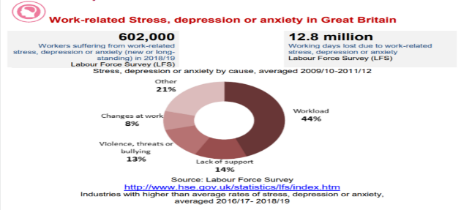
Six out of every hundred people suffer from a generalized anxiety disorder. The United Kingdom has the world’s 62nd highest rate of anxiety disorders.
1.3 Statistics
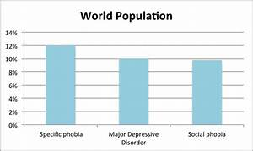
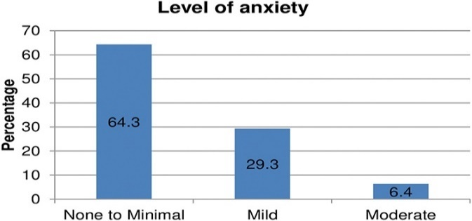
In England, almost 1 in 6 adults (17%) satisfied the criteria for CDN in 2014. This was a (2.9 %) rise since 1931. Anxiety disorder affected 8.2 million people in 2013. According to the 2010 Global Burden of Disease Study, depression and anxiety are the most common mental illness worldwide. Within a week, 5.9% of adults in the United Kingdom reported having General Anxiety Disorder. Phobia accounts for 2.4%, OCD for 1.3%, and panic disorder for 0.6% of the population (Morriss, 2019).

Severe symptoms affect 42 % of women with GAD (NHS, 2016, 2020). 3 5.9% of adults in the UK reported experiencing Generalised Anxiety Disorder (NHS, 2021). ln 2018, when people in the UK were asked how anxious they felt yesterday, the average score was 2.85 out of 10 (where 10 is 'completely anxious’).

2 Causes (Etiology)
Anxiety is the anticipation of a future threat, categorized as anxiety in DSM-5. It is not to be confused with fear, which is an emotional reaction to a real or perceived impending threat. It’s a sensation of stress, or panic as well as disquiet, such as concern, that can influence daily life physically and psychologically.
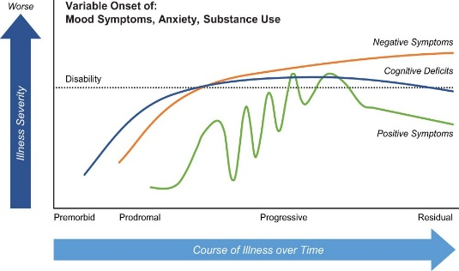
Anxiety can be caused by genetics, life experience, medicines, or situations. Although the actual origin is unknown, probable triggering factors include genetic predisposition and aberrant brain circuit functioning. Benzodiazepines and alcohol dependence, as well as traumatic and stressful circumstances, are all linked to drug usage.
2.1 Implications

When symptoms of generalized anxiety disorder are not treated, they might progress to depression, insomnia, or substance dependence over time. Avoid substance abuse (drugs, alcohol, tobacco).

Signs and Symptoms
Mentally

Uncontrollable worry and nervousness

Getting easily startled

Heightened alertness

Trouble sleeping

Indecisiveness

Inability to concentrate

Feeling dread

Irritability

Impending doom

Disassociation

Racing thought

Appetite changes

DCM 5

Physical
Sweating
Hot flushes and blushing
Hair loss, Dry mouth, and shaking
Extreme tiredness/ Lack of energy, headache, dizziness and fainting. Stomach aches, Nausea and sickness.
Consistent anxiousness, shaking, muscular tenseness, dizziness, and epigastric discomfort are among the most common symptoms and presumptions. fears

Risk factors
Social Factors: -

Environmental. (Leonard, 2019).

Non-environmental.

Biological Factors: -

Neuro-chemical imbalance,
Hormones levels, and Genetics

Psychological Factors

Traumatic Experiences
Domestic Abuse, Bullying, child abuse, and Chronic Pain.
Despite a high level of psychological stress, GAD showed no signs of cognitive impairment (Leonard, 2019).

When anxiety can be diagnosed
A medical professional can help you with GAD. There is no need for a lab test or imaging. Diagnosis can last for several years or the rest of one’s life. GAD is frequent in persons aged 35 to 50, and more so in women than men, and people with a family history of the disorder may be more susceptible to certain forms.
Having symptoms for six months can be more likely for a person to be diagnosed with anxiety that is difficult to control is another sign that you may be suffering from the disorder.
According to the NHS, the GP may perform a physical examination or blood test to rule out what could be causing the symptoms, such as anemia (iron or vitamin B12 and folate deficiency) or hyperthyroidism (overactive thyroid gland). Patients can also complete questionnaires.


The picture above: Different diagnosis

Current treatment of GAD
Psychological therapies such as cognitive behavior therapy, which is available on the NHS. Antidepressants and selective serotonin reuptake inhibitors are examples of psychological therapy. Treatment options are determined by the severity of the anxiety (NHS, 2021). (Below are examples).
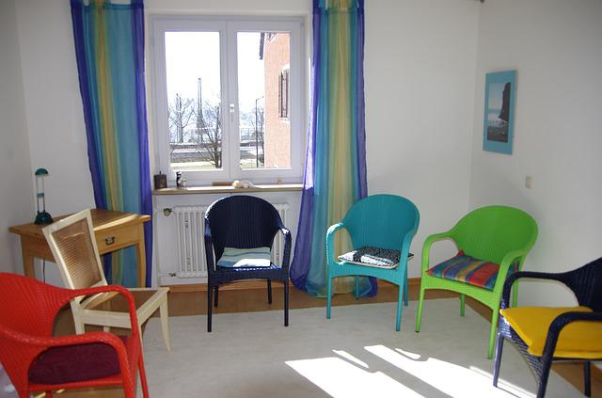
 Group therapy
NHS Hospital
Measurement and Rehabilitation of General Anxiety Disorder
It is necessary to understand the rehabilitation measures to assess the efficiency of the treatments. If a treatment is not working, it needs to be changed.
‘Anxiety Disorder Questionnaire (GAD-7)’. (See appendix A). This questionnaire is a tool to measure the level of anxiety over two weeks, according to NHS.

Recommendation for improvement of General Anxiety Disorder
Education and awareness should be implemented into society, and support should be given to carers and patients, making treatment easy access for the different therapies. People should be encouraged to try psychological counseling before taking medication. On the NHS, you can access psychological treatments (NHS, 2021).
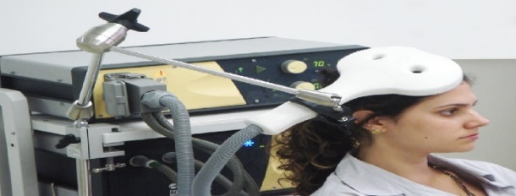

Complementary therapies
Complementary Biomedical therapy
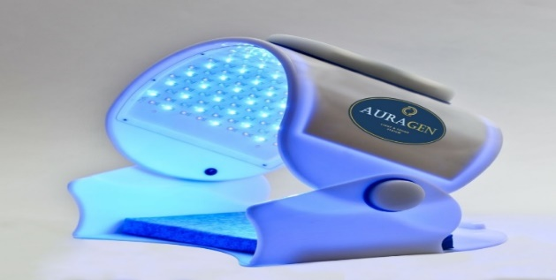
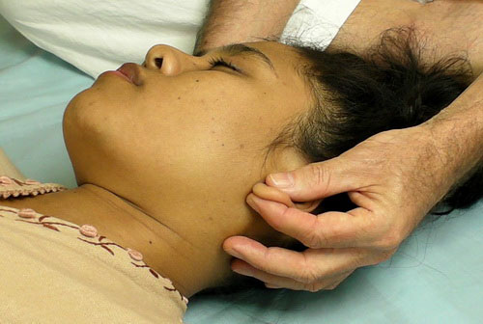
This Photo by Unknown Author is licensed under CC BY
Holistic therapy
Care for people with general anxiety disorder
The World Health Organization defines the quality of life as an individual’s sense of their place in life about their goals, aspirations, standards, and concerns in the context of the culture and value system in which they live.

People working with people who have a generalized anxiety disorder must develop a relationship with them. Collaborate with the person to investigate treatment choices. Work within the Person-Centered- Approach to ensure inclusion. You must guarantee dialogue in an environment that respects Confidentiality, Privacy, and Dignity. Ensure activities like walking, or yoga are allowed.




Person-Centered-Care is ongoing listening and learning, concentrating on what matters to the person now and in the future, and acting on that information in collaboration with their family.

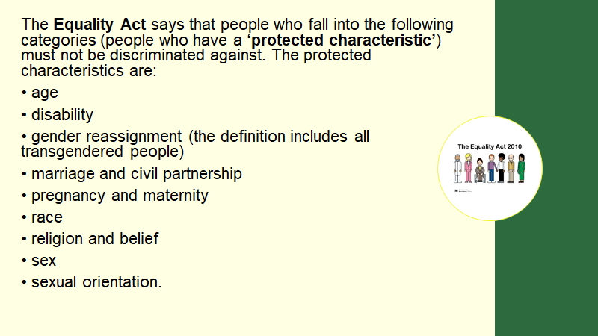
Nice guidelines, Person-Centered Care and Equality Act 2010
Th In 1998, United Kingdom signed the UK Human Rights Act, which was modified after the European Convention on Human Rights and included additional rights such as those listed. The right to quiet family life and the right not to be tormented. The right to practice own faith, receive an education and be free of discrimination.
Schizophrenia
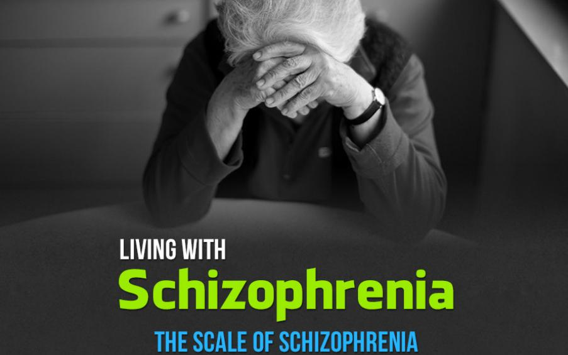
Schizophrenia is a mental illness that affects one’s thoughts, feelings, and actions. It might be short-term or long-term. People with Schizophrenia may hallucinate, have delusions or twisted thinking, or feeling of paranoia. Hearing voices is a typical symptom in patients suffering from Schizophrenia. (NYU, 2021).
These voices usually tell them what to do or warn them about impending danger, and this might cause them to modify their behavior (Owen, 2017)

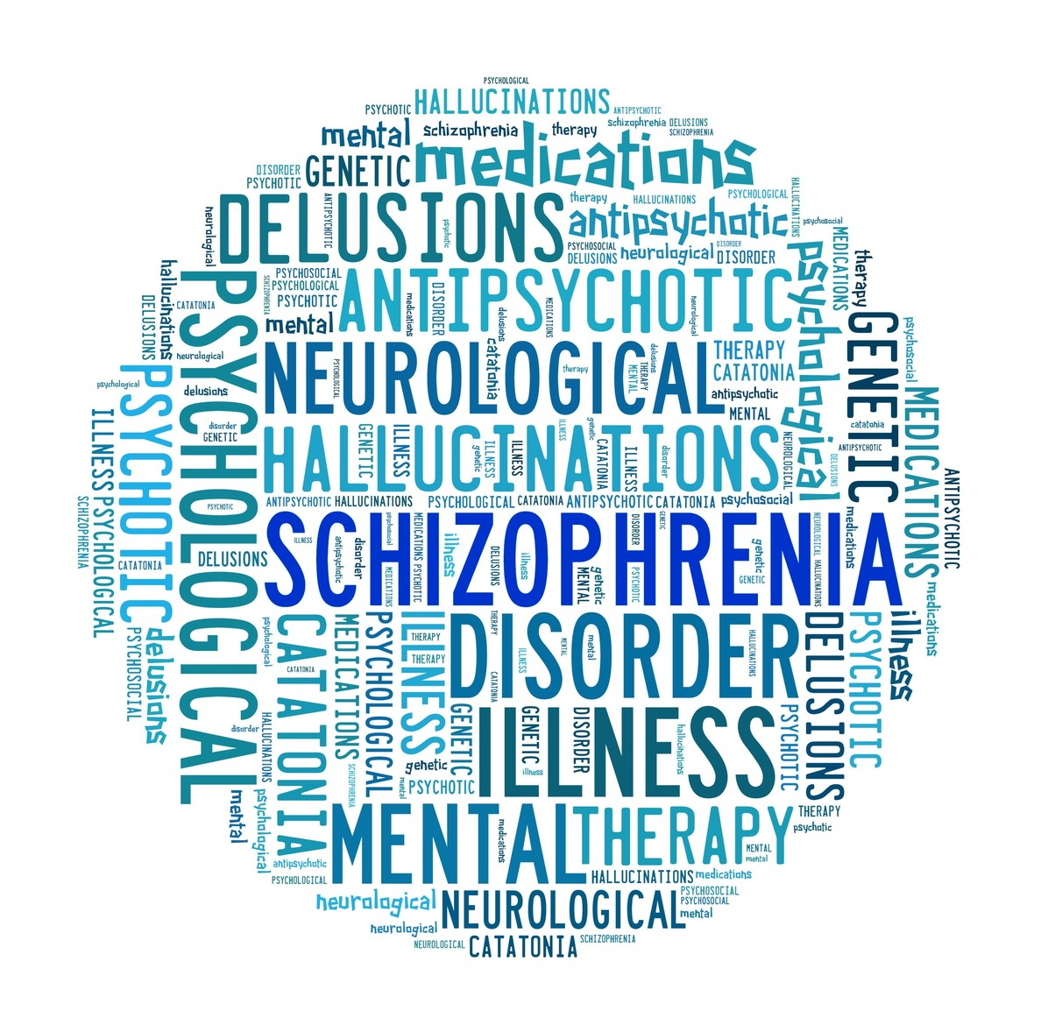
Definition
According to the World Health Organization, schizophrenia affects one out of every 100 people and is a chronic severe mental condition that affects 20 million people globally. Males (12 million) are more likely to have it than females (9 million). Schizophrenia causes significant handicaps and can hurt educational and occupational success.

Different episodes
Post-schizophrenic depression

Paranoid

Hebephrenic

Hebephrenic

Schizophrenia

Residual

Undifferentiated Schizophrenia

Schizophrenia/ Unspecified

Causes (Etiology)
The causes of schizophrenia are unknown, but experts believe that a mix of genetic and environmental variables, such as virus exposure while in the womb or delivery problems, such as a newborn not receiving enough oxygen, may play a role.
Imbalances in neurotransmitters, or chemical messengers in the brain, may play a role in schizophrenia. Neurotransmitters are chemical messengers that carry messages between nerve cells and the rest of the body, including muscles and organs. They influence mood, arousal, anger, learning, and memory.

Risk factors

Signs and Symptoms
Schizophrenia patients may have poor interpersonal skills, as well as a deterioration in cognitive functioning, which includes difficulties with attention, memory, mental processing speed, and problem-solving, men and women are equally affected by this illness.
Men in their teens or early twenties and women between twenty to thirty years, a rapid shift in their personality and demeanor (NYU, 2021). A psychotic episode is a sudden change in personality and behavior that causes a person to lose touch with reality.
Critical classification of Schizophrenia
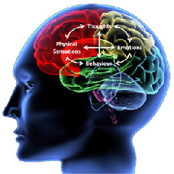
The schizophrenia of F20 is classified in the Statistical Classification of Diseases and Related Health Problems,10th Revision (ICD-10) Version for 2010, chapter 5, Mental and Behavior Disorder, on section F20-29.
Disturbances in thought and perception, as well as inappropriate or dampened effects, characterize and characterize this condition. Certain cognitive deficits may develop over time, but the clarity of thought and intellectual capacity is usually preserved.
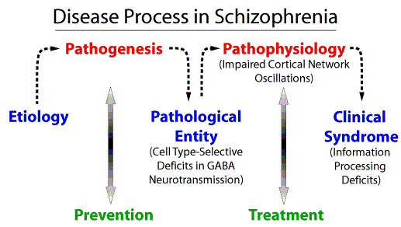
Statistics
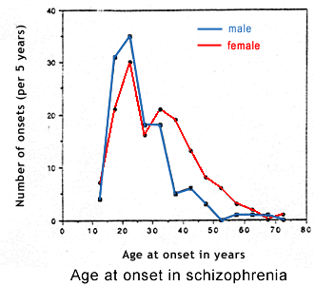

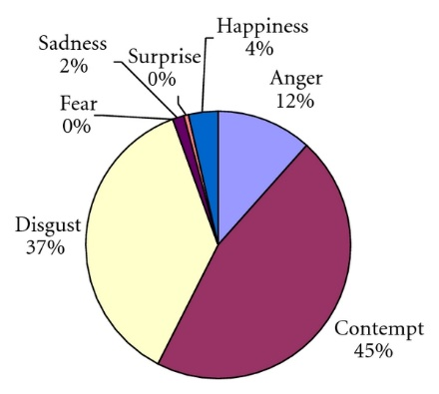
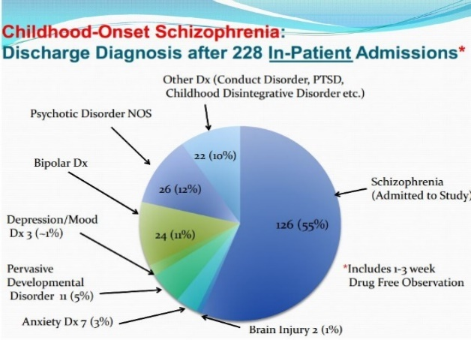
Facial sign
F20-F29, Diagnosis
According to the NHS, a person must have had at least two of the following symptoms, such as delusions, disorganized speech, catatonic behavior, and diminished capacity to function, with some level of abnormalities present for at least six months (NYU, 2021).
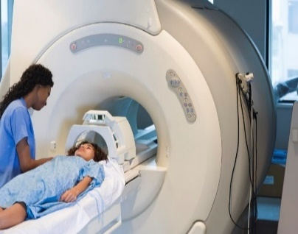
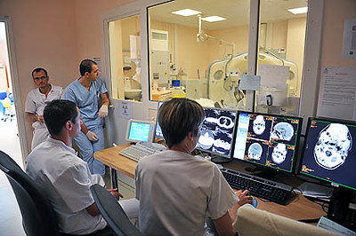
Additional tests, such as an MRI scan of the brain’s structure, may be ordered by a doctor in a try to discover or detect any abnormalities that may be causing schizophrenia symptoms. To rule out illness with comparable symptoms, such as alcohol and drug usage, a doctor might do a standard blood test.
This Photo by Unknown Author is licensed under CC BY-NC-ND
Schizophrenia symptoms can fluctuate over time and vary from person to person. Similar symptoms, such as substance abuse disorder, must usually be ruled out before a diagnosis can be made.
MRI Scan
Imaging
Schizophrenia should not be diagnosed unless the signs of schizophrenia appear before the affective disturbance.
Previous treatment for schizophrenia
Individuals suffering from Schizophrenia were to be incurable in the 1930s. Patients were hospitalized and subjected to harsh and unethical treatment techniques, which have since been identified. Most of the therapeutic goals were to provide food, clothing, and shelter to the patients. The practice of Moral therapy was proposed in 1923.

Current treatment for Schizophrenia
Psychiatrists, nurse practitioners, social workers, and other therapeutic specialists can assist with psychosocial therapy to address the behavior, psychological, and social difficulties associated with schizophrenia. Psychological treatment can assist a person in coping with the day-to-day obstacles of living with an illness, such as trouble communicating and keeping a job. (NYU, 2021). Approaches to Psychotherapy
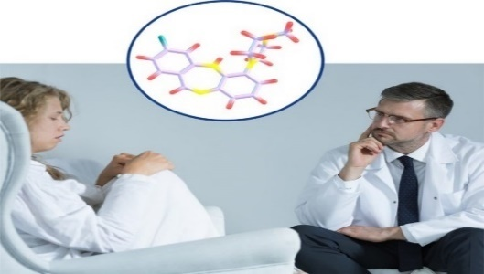
Treatment duration differs from person to person. People with less severe symptoms may just need to see a therapist regularly, whereas those with more severe symptoms, such as psychotic episodes that produce an abrupt change in personality and behavior and endanger a person’s health or safety, may need guidance, and a therapist on long time support and treatment.
Predicting treatment

Measurement of Rehabilitation for Schizophrenia
We can only measure the quality of care and therapies provided in the case of schizophrenia to successfully control and manage the condition and avoid problems such as self-harm and suicide, substance abuse, neglect and self-neglect, lack of dignity, and human violations.
With the same indications that are used to assess long-term mental illness, we may assess the quality of life.
The Quality Indicator for Rehabilitative care (QuIRC-SA). The instrument provides exact indicators that show that high-quality care and successful disease management are being provided. (See Appendices B).
Guidance of Care. Adult
Children and young people
Assist children, as well as their parents, in maintaining their safety and developing positive relationships. Communication and information should be excellent. Culture, ethnicity, and social inclusion should all be taken into consideration.
Improve care services for people with schizophrenia. Understand ethnicity and race culture. Provide a comprehensive service. Information and decision-making should be shared. Adult psychosis and schizophrenia are managed, as well as a caregiver the assistance needed.


People with schizophrenia are more likely to be stigmatized, discriminated against, and have their human rights violated. (WHO, 2022).

Recommendation for improvement
According to NICE, the ability to recognize and avoid psychosis, as well as assist with early intervention for first-time psychosis, treatment, and referrals to rehabilitation and care is important. Checks regularly to recognize symptoms and provide support to caregivers are also crucial (NICE, 2018).
Supported assisted living, supported housing, and supported employment are all important care alternatives for people with schizophrenia.

Autism

ICD 2010 is the code for autism, Developmental disorders of the mind, and health ad disorders are classified internationally.
I
F84 Pervasive developmental disorder
ICD-10

Rett’s syndrome
Atypical Autism
Childhood autism
Other childhood integrated disorder

The disorder is associated with mental retardation and stereotyped movements.
Other pervasive developmental disorder
Pervasive developmental disorder
(Hodges, 2020)

Common features:
Features consist of amazing social tension, tough to maintain problems, frustration, lashing, anxiousness regularly, and straight to the point without emotions are some of the characteristics. (NHS, 2021) (NHS, 2019).

Autism spectrum disorder is a developmental issue caused by brain abnormalities, a genetic disease, and other unknown reasons. Scientists believe that autism has numerous origins that interact to alter how people develop in the most frequent ways. (Wisniowiecika, 2019).

Classification

Childhood Autism is classified in the International Statistical Classification of Diseases and Related Health Problems 10th Revision (ICD-10) Version for 2010,
as the existence of a pervasive developmental con- normal or impaired development before the age of three years, as well as the typical type of abnormal functioning in all three categories of psychopathology. (WHO, 2010)

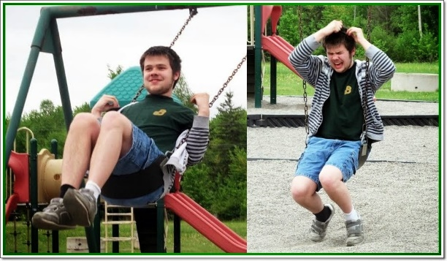


Challenges
Sensory Integration Disorder

AUTISM
SPECTRUM
DISORDER

ODD
ADHD
Depression
Anxiety
Specific learning difficulty
Gifted

Auditory Processing
Tourette’s

ADD
OCD
Developmental coordination disorder

The brain’s hyperserotonemia is thought to be an endophenotype of autism spectrum disease, lowering serotonin levels in the brain (Goin-Kochel, 2021).

Routine and rigidity in daily functioning

Changes in terms of social interaction

Communication impairment
Challenges

Sensory stimulus

Limited theory of
mind

ry of mind
mited theory of mind

Limited eye contact

Hypersensitivity and hyposensitivity

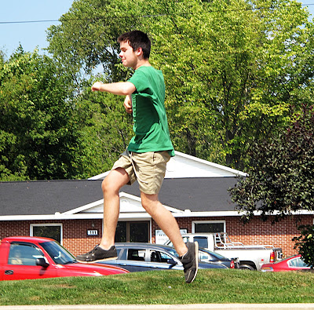
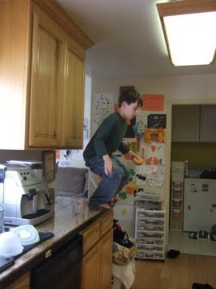

Causes (Etiology) of Autism
Genetics and Environmental factors like diet and vaccines may be among the factors of Autism (Picciotto, 2018) (Millau, 2018). Loss of function of the postsynaptic cell adhesion- protein- neuroligin 4 was consistently identified as the monogenetic cause of autism, according to a study published in the journal Experimental Medicine. (Zhang, 2018).

Signs and Symptoms of Autism Adult
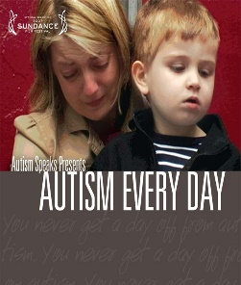

Adults with Autism have trouble comprehending and interpreting social and emotional cues (Zhang, 2018).

Children with Autism often do not make eye contact, have limited responsiveness to sensory stimuli, and do not respond to their names.
They have repetitive behaviors or actions. The absence of speech may be the first sign (Millau, 2018)..
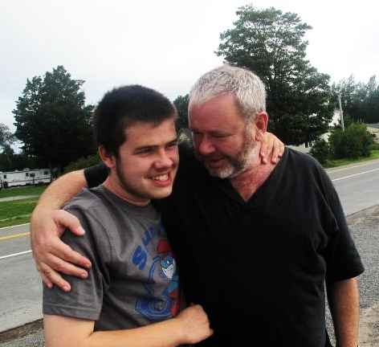

Critical Classification of Autism
Autism Spectrum Disorder, F84, according to the World Health Organization, is a set of conditions. It can be identified as early as infancy, but it can also be diagnosed much later in life. According to the Centres for Disease Control and Prevention, autism encompasses a wide spectrum of conditions marked by difficulties with social skills, and challenging behaviors. speech, and non-verbal communication (NAS, 2020) (NHS, 2021).
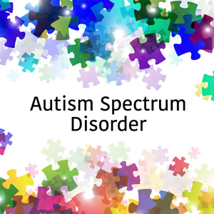

Diagnosis of autism
Professionals, such as doctors, therapists, or Special Education Needs (SENCO) workers at your child’s school, can diagnose your child. Confirm their thoughts on submitting the child for an autism evaluation. (NHS, 2019).

Your appointment with additional professionals may be determined by what happens during an autism assessment. When it comes to children’s evaluations, the assessment team may inquire about your child’s development, such as when they first started talking. They will pay attention to how your child interacts and plays (ADI-R) (Goin-Kochel, 2021).
Diagnostic tools such as the DISCO (Diagnostic Interview for Social and Communication Disorders), the ADI-R (Autism Diagnostic Interview-Revised), the ADOS (Autism Diagnostic Observation Schedule), and the 3 Di (Development, Dimensional, and Diagnostic interview) are used to gather information to determine whether someone is on the Autism Spectrum.
The ADOS technique is distinct from others in that it is not based on developmental data hence just considers present behavior and skills. The diagnosis is based on these criteria, although the clinical judgment of the individual physician is vital. (NAS, 2020).

Autistic Team
Doctors, Occupational Therapies, Psychologist, Educational Psychologist, Clinical Psychologist, Pediatrician
Specifications have been added to the DSM-5 to assist clinicians in describing linked or conventional conditions, such as intellectual impairment, linguistic impairment, hereditary problems, behavior disorder, and catatonia (NAS, 2020).

Current treatment of Autism
Innovative Therapy, therapeutic approach, the use of psychometric assessment instruments, cognitive behavior therapy, social skills training, emotional regulation, impulse control, practical advice, and coaching may is used as treatment options (NAS, 2020) (Taylor, 2020).

Interventions
Interventions can help with symptom management and distress

Early interventions

Behavioral Interventions

Autism symptoms can be detected in the first month of life, according to a new study.
Music therapy looks to be a useful strategy for early autism intervention (Su, 2018).


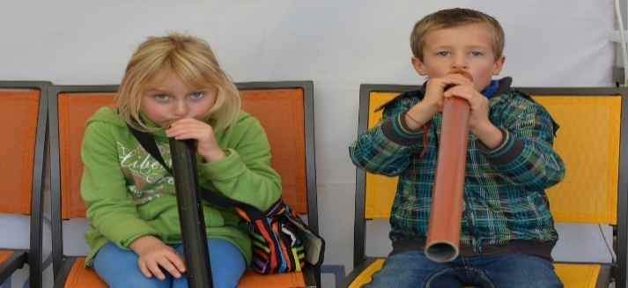
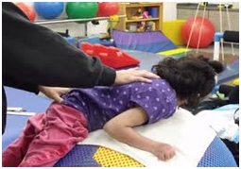
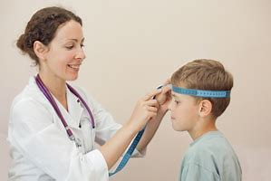
According to a twin study, autism is associated with high head size, and the brain of a person with autism may grow expanded throughout their lives.
Fragile X (A new autism treatment

M
Occupational Therapies

Music therapy
IAPT treatment services
People in England can use NHS psychological therapy (IAPT) services; a GP can refer you, or you can self-refer, IAPT (Improving Access to Psychological Therapies) services provide cognitive behavior therapy (CBT), counseling, alternative therapies, guided self-help, and mental issues such as anxiety and depression. (NHS, 2021).

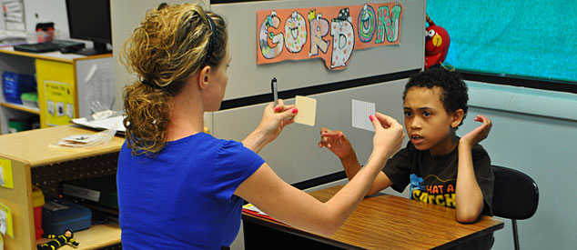

Measurement of Rehabilitation for Autism
CARS (Childhood Autism Rating Scale) and observation, often known as ADOS (Autism Diagnostic Observation Schedule) are used in the measurement of Rehabilitation. See Appendix C

Recommendation for improvement for Autism
Complementary therapy such as yoga in Autism has shown to be useful in improving the behavior of autistic children. Early social communication is the most effective treatment for Autism (Green, 2018).

Guidelines and Principles of Care: NICE guidelines (NICE, 2018).
Ensure that all children or young adults diagnosed with autism can access health care services
Ensure that professionals complete advanced training in autism spectrum disorder

Review and Re-assessment

Create opportunities for enjoyable activities
Provide key workers to support the child and family

Assessment and care should be based on a multi-disciplinary approach

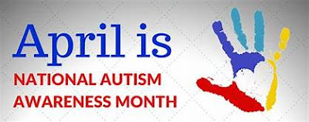
National Autism Society


The National Autism Society promotes Early Intervention for Autism (Green, 2018).

Conclusion
It is critical to demonstrate a grasp of the value of a Person-Centered Approach, as defined by the human Right Act, and nondiscriminatory practices as defined by the Equality Act 2010. Racism is not permitted as one human right cannot be exercised if another is denied, thus, you cannot express racist beliefs and claim that it is acceptable just because you are expressing an opinion.
The King’s Fund has several services to assist anyone working in the health field in sharing knowledge, learning, and ideas. (Smith, 2008). Public Health England pledges to make England the best place to live in the world. (PHE, 2021).

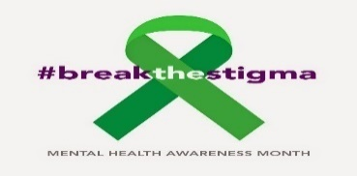
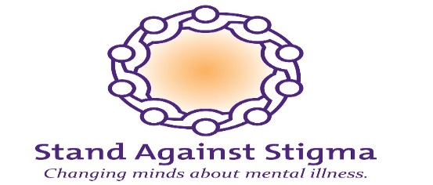
This Photo by Unknown Author is licensed under CC BY-ND


References.

Chutima et al, (2018) Common Environmental Factors May Underpin the Comorbidity Between Generalized Anxiety Disorder and Mood Disorders Via Activated Nitro-oxidative Pathways. PubMed, 18(19), pp. 1621-1640.
Goin-Kochel. (2021). Beliefs about the causes of autism and vaccine hesitancy. Journal of Clinical Pediatrics, 2(1), pp. 35-36.
Green et al. (2018). Paediatric Autism Communication Therapy-Generalised (PACT-G) against treatment as usual for reducing symptom severity in young children with autism spectrum disorder: study protocol for a randomized controlled trial. 21 September.514(19).
Hampton et al. (2021). Generalized Effects of Naturalistic Social Communication Intervention for Minimally Verbal Children with Autism. J Autism Dev Disord, 2 May, 51(1), pp. 75-87.
Hodges et al (2020) Autism spectrum disorder: definition, epidemiology, causes, and clinical evaluation. Translational Pediatrics, February, 9(1), pp. s55-s65.
Kaira, L, and Amitai A.,( 2019). Cognitive functions in young adults with generalized anxiety disorder. National library of medicine, 56(11), pp. 1-7.
Millau, M.. Rivard, M., and &. Mello, C., (2018). Immigrant Families’ Perception of the Causes, First Manifestations, and Treatment of Autism Spectrum Disorder. Journal of Child and Family Studies volume, 3 July, 27(1), pp. 3468-3481.
MIND (2019) Depression (Online). Available at: https://www.mind.org.uk/information-support/types-of-mental-health-problems/depression/about-depression/
(Accessed: 12 April 2022).
Morriss, R., (2019).'Clinical effectiveness and cost minimization model of Alpha-Stim. Journal of Affective Disorders., 253(1), pp. 426-437.
NAS, (2020). Specifiers for autism spectrum disorder. [Online]
Available at: https://www.autism.org.uk
[Accessed 25 April 2022].NHS – National Healthcare Service (2021) Depression (Online). Available at: https://www.nhs.uk/mental-health/conditions/depression/
(Accessed: 12 April 2022).
NHS,( 2019) How to get diagnosed. [Online]
Available at: https://www.nhs.uk/conditions/autism/getting-diagnosed/how-to-get-diagnosed
[Accessed 10 April 2020].
NHS, (2019) What is Autism? [Online]
Available at: https://www.nhs.uk/conditions/autism/what-is-autism/
[Accessed 12 April 2022].
NHS,(2021). NHS psychological therapies service. [Online]
Available at: https://www.nhs.uk/service-search/mental-health/find-a-psychological-therapies-service/
[Accessed 16 April 2022].
NHS, (2021). Overview - Generalised anxiety disorder in adults. [Online]
Available at: https://www.nhs.uk/mental-health/conditions/generalised-anxiety-disorder/overview/?msclkid=838b3c0ca9f211ecadff8211
[Accessed 20 March 2022].
NHS,(2021). we are autistic. [Online]
Available at: https://www.nhs.uk/conditions/autism/what-is-autism/
[Accessed 11 April 2022].
NHS, (2022) Treatment - Generalised anxiety disorder in adults. [Online]
Available at: https://www.nhs.uk
[Accessed 17 April 2022]. NICE – National Institute for Health and Care Excellence (2021) autism spectrum disorder in under 19s: support and management. (Online). Available at: https://www.nice.org.uk/guidance/cg170/chapter/recommendations (date accessed: 19 April 2022).
NICE – National Institute for Health and Care Excellence (2021) autism spectrum disorder in under 19s: support and management. (Online). Available at: https://www.nice.org.uk/guidance/cg170/chapter/recommendations (date accessed: 19 April 2022).
NICE, (2020). Clinical guidelines. [Online]
Available at: https://www.nice.org.uk/guideline/c8185
[Accessed 16 March 2022
NICE – National Institute for Health and Care Excellence (2019) Generalised anxiety disorder and panic disorder in adults: management. (Online). Available at: https://www.nice.org.uk/guidance/cg113/chapter/1-Guidance#principles-of-care-for-people-with-generalised-anxiety-disorder-gad (date accessed: 19 April 2022).
NICE – National Institute for Health and Care Excellence (2019) Generalised anxiety disorder and panic disorder in adults: management. (Online). Available at: https://www.nice.org.uk/guidance/cg113/chapter/1-Guidance#principles-of-care-for-people-with-generalised-anxiety-disorder-gad (date accessed:19 April 2022).
.NICE, (2018). NICE guideline [NG116]. [Online]
Available at: https://www.nice.org.uk/guidance/ng116/chapter/Recommendations
[Accessed 30 March 2022].
NICE – National Institute for Health and Care Excellence (2016) Psychosis and schizophrenia in children and young people: recognition and management. (Online). Available at: https://www.nice.org.uk/guidance/cg155/chapter/recommendations (date accessed: 19 April 2022).
Hodges, H., Fealko, C., and Soares, N.(2020). Autism spectrum disorder: definition, epidemiology, causes, and clinical evaluation. Translational Paediatrics, 9(1), S55–S65. https://doi.org/10.21037/tp.2019.09.09. Accessed; 24/4/2022.

NYU, (2021). Education and Research. [Online]
Available at: https://nyulangone.org/conditions/schizophrenia/diagnosis
[Accessed 20 March 2022].
Owen,( 2017). Schizophrenia. Lancet, 2 July, 388(10039), pp. 86-97.
PHE, (2021). Annual GDP for England, Wales, and the English regions. [Online]
Available at: https://www.ons.gov.uk/filters/73a6fa70-69d4-470b-b04e-bfa70903c556/dimensions
[Accessed 16 April 2022].
PHE, (2021). PHE. [Online]
Available at: https://www.gov.uk/government/publications/healthy-ageing-consensus-statement
[Accessed 16 April 2022].
Picciottoet al.(2018). Understanding environmental contributions to autism: Causal concepts and the state of the science. Autism Research, March, 11(4), pp. 554-586.
Smith, L.,(2008).The Kings Fund. [Online]
Available at: https://uk.linkedin.com/in/simon-lawton-smith-7ab43333
[Accessed 15 April 2022].
Southward et al. (2020). A Day in the Life of Borderline Personality Disorder: A Preliminary Analysis of Within-Day Emotion Generation and Regulation. Journal of psychopathology and behavioral assessment, 42(4), pp. 702-713.
Su, S. Maw, A. and Cheyori, H.,(2018). Effectiveness of cognitive, developmental, and behavioral interventions for Autism Spectrum Disorder in preschool-aged children: A systematic review and meta-analysis. Heliyon, September, 4(9), p. eo0763.
Tanaka et al. (2018) Brain hyperserotonaemia causes autism-relevant social deficits in mice. Molecular Autism 9, 60 (2018). https://doi.org/10.1186/s13229-018-0243-3. Accessed; 24/4/2022(http://creativecommons.org/licenses/by/4.0/),
Taylor, S. and Brumbly, A., (2020). Healthy Minds in the Twentieth Century, Cham: Springer Nature. (https://www.springernature.com/gp/products/books{ Palgrave Mcmillan}.
WHO,(2010). International Statistical Classification of Diseases and Related Health Problems 10th Revision (ICD-10) Version for 2010. [Online]
Available at:: https://icd.who.int/browse10/2010/en#/V
[Accessed 12 April 2022].
WHO, (2022). [Online]
Available at: https://www.who.int
[Accessed 16 April 2022].
Zhang, B., (2018). Autism-associated neuroligin-4 mutation selectively. Journal of Experimental Medicine, 3 May, 215(6), pp. 15543-1553.

Appendix A
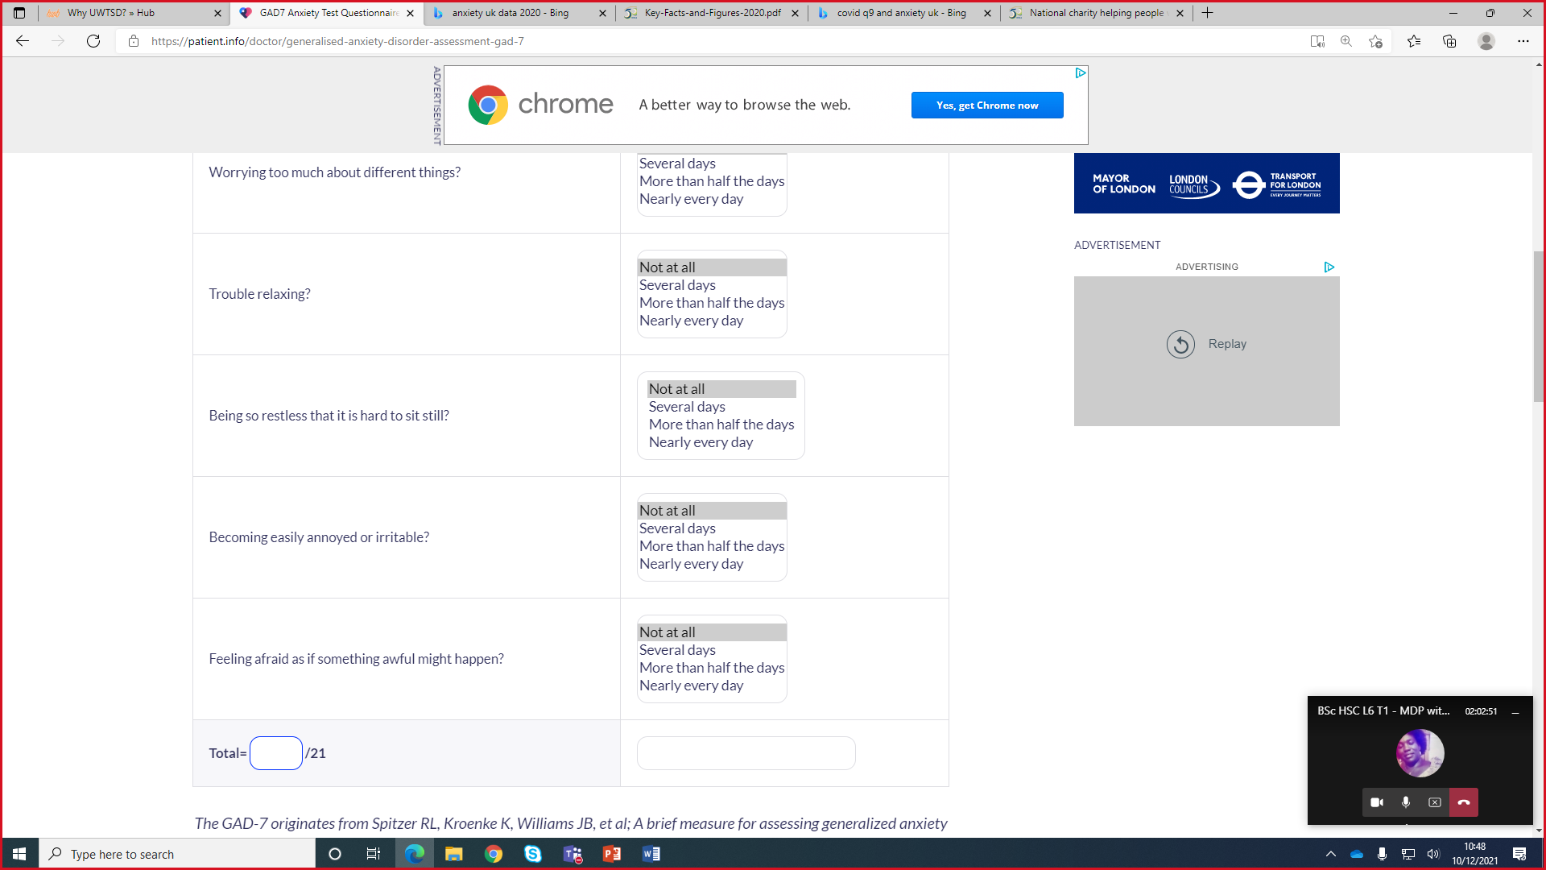
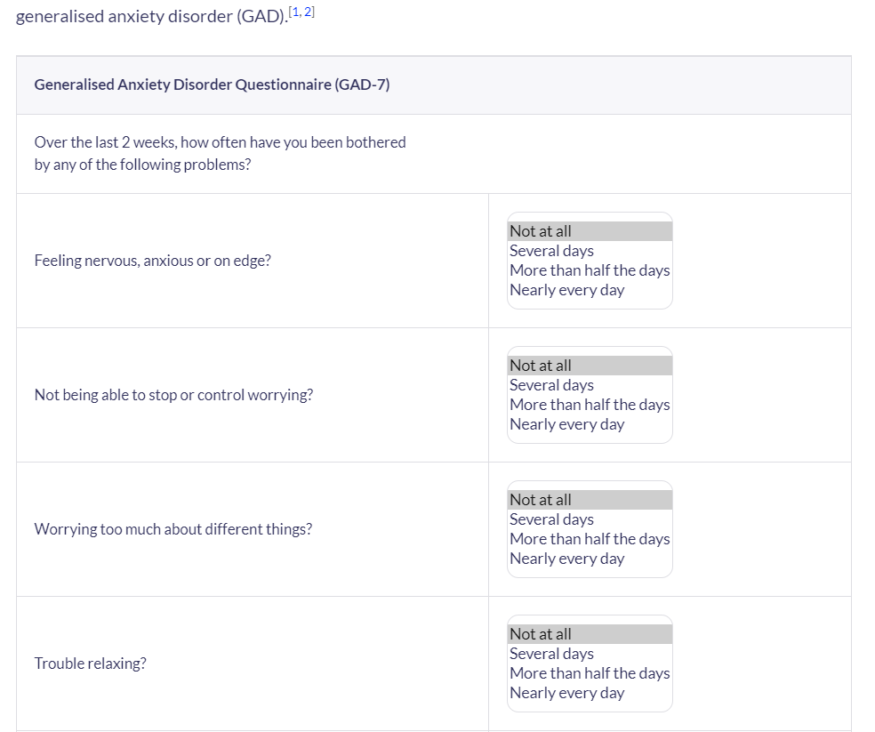

Appendix B
Indicators for rehabilitative care:
Quality Indicator for Rehabilitative Care (QuIRC-SA)’
The indicators to be considered are the these:
Living Environment’
Therapeutic Environment’
Treatments and Interventions,
Self-Management and Autonomy,
Social Interface,
Human Rights
Recovery Based Practice

Appendix C

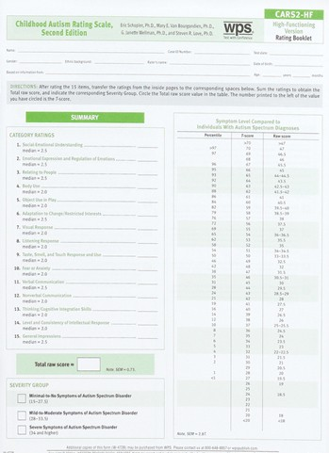

Appendix D
For children.



