Ach Ich Fühl’s from Die Zauberflöte

Throughout this essay, I will be analysing Wolfgang Amadeus Mozart's final opera, The Magic Flute (Die Zauberflöte 1791), specifically looking at Pamina's aria Ach Ich Fühl's. In the last year of Mozart's life, he returned to German Opera. He wrote a tremendous demonstration of artistic genius for the common folk of Austria written in singspiel, a form that contains spoken text and sung. This opera is specifically enticing as it has secret masonic ideologies. It includes several genres of music; from comedic folk-like lines in Papageno's arias to deep hymn-like arias for Sarastro to reflect his character as a spiritual leader, [operanorth.co.uk accessed on 12/01/2021] to grand coloratura feats in the Queen of the night arias as well as beautiful lyrical arias for Tamino and Pamina. This incredible diversity resulted from Mozart writing specifically for the singers he had at the time. Emanuel Schikaneder (Papageno) and Johann Joseph Nouseul (Monostatos) were both comedic actors, not trained singers. While Josepha Hofer (Queen of the Night) is Mozart's sister-in-law and an incredible coloratura soprano, this role is famous for its difficulty. [courses.lumenlearning.com accessed on 12/01/2021]

Wolfgang Amadeus Mozart, born in 1756 in Salzburg, Austria, was an exceptional composer of the classical period. In his short 35 years of life, he composed over 600 pieces of music starting from the age of 5 under the guidance of his music teacher and father, Leopold Mozart. Over the next 30 years, he had several esteemed prominent positions, including the court musician under the ruler of Salzburg and the chamber composer under the Emperor of Vienne. Being an independent composer and musician also fascinated Mozart leading to him independently writing music for the common folk; however, he could not stay in this role forever as it was not financially stable. Although during this time, he accomplished abundance and high regard. Famous composer Haydn wrote to his father exclaiming, 'I tell you before God, and as an honest man, your son is the greatest composer known to me by person and repute, he has taste and what is more the greatest skill in composition'.
[themarginalian.org accessed on 12/01/2021] He also spent seven years following the ideals of the Masonic order leading to him becoming a 'Master Mason' in the last few years of his life. His last contribution to the brotherhood in 1791 was his brilliant Magic flute opera which has been described as an Enlightenment allegory, veiled in Masonic ritual [sfopera.com accessed on 11/01/2021]. This is evidential when you look at the continuous use of 3's. The overture commences with three striking chords in the key of Eb major containing three flats; we are first introduced to Tamino struggling to kill a serpent, being rescued by the three ladies who severs the serpent into three pieces. Later we are introduced to 3 slaves, three spirits and even three priests to the three temples that have inscribed 'Nature', 'Reason' and 'Wisdom', yet another masonic ideogram. Many researchers believe the principal characters of the production are formed from principal figures in and around the Masonic order. The Queen of the night represents Empress Maria Theresa whilst Sarastro represents 'prominent Viennese Freemason Ignaz von Born' [operanorth.co.uk accessed on 12/01/2021] opposites of freemasonry hence the Queen having an extreme F6 and Sarastro having an intense F2. Furthermore, it is believed that Tamino potentially showcases the brotherhood path to freemasonry; through the rituals, he undertakes throughout the opera. While Pamina represents the Austrian people being indoctrinated by the overbearing Empress to banish the masonic order from their psyches; hence Pamina is asked by her mother, the Queen, to kill Sarastro. Alternatively, Pamina has also been debated about potentially representing the brotherhoods ideology of the perfect woman, as her sole purpose in the opera is to marry Tamino. When this no longer seems liable, she becomes distraught and suicidal. Due to the phycological warfare and masonic bias that this opera provides, the order was eventually abolished under the rule of Francis II throughout Austria.

This piece of music is fascinating, as, throughout the entire piece, it remains in the melancholy key of G minor and rarely ventures from this. It also has a dominant homophonic texture with recurrent extended chords that leaves the singer predominantly exposed, allowing the listener to empathize with the despair that Pamina feels fully. This immediately is showcased within the first few bars of the piece as the orchestra starts andante, a speed of less than 100bp instantly establishing the piece as distressing. The singer begins on an exasperated sigh on the subdominant note D5 of the G minor scale; it then descends to the tonic G4 then leaps up to the tonic an octave above G5 before returning to its origin note D5. This octave leap coupled with the repeated descending pattern expertly demonstrates the agonizing confusion that Pamina is experiencing at this very moment. The choice of words "Ach Ich Fühl's, es ist verschwunden/ Ah I feel it it's vanished, alongside the 'Ach' being on the upbeat of the bar further displays Pamina's sudden heartbreak. However, this is drastically contrasted to the beautiful resonate high G5 on Ewig/forever and Bb on Liebe/Love as the phrase 'Ewig hinder Liebe Glück/ Forever gone, the happiness of love' is repeated twice the first instance is that of sorrow and loss whilst the repeat feels like more of a plead, a prayer, a wish that the words that she is saying aren't true.

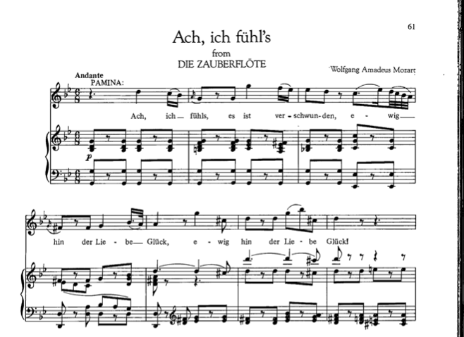
Figure 1 ‘Ach Ich Fühl’s’, Die Zauberflöte, bars 1-7

The song briefly ventures into the relative major that is Bb major; however, this is not done smoothly, which is peculiar as relative significant modulations are usually quite simplistic, yet Mozart chooses to do this abruptly and even eludes towards a possible D minor key by using an A major chord as well as the presence of consecutive dominants. This violently shakes Pamina from the dismal text in the previous bar to reminisce about what they were 'Nimmer kommt ihr, wonne stunden/ Never will you, blissful hours' and what they could have been before being dragged back to the harsh reality that it is truly over.

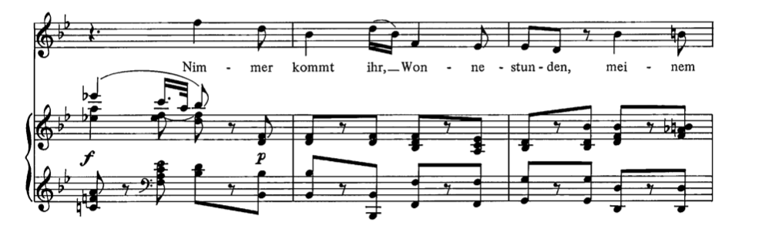
Figure 2 ‘Ach Ich Fühl’s’, Die Zauberflöte, bars 8-10

Interestingly, Mozart puts a stringent rhythmic section right next to a few bars of rhythmic freedom. It is believed that this is done to properly reflect the shift from spiralling in heartbreak demonstrated by a quick succession of ascending demi semi quavers reaching an astonishing Bb on the repeated word heart as though with each note, her heart breaks more, leading to exhaustion at the end of the phrase causing the following phrase to have rhythmic freedom as she no longer has any emotional energy left so has resorted to asking Tamino calmly if he understands what he is doing to her and how her tears are flowing solely for him, returning to the original motif of an exasperated sigh 'Ach' compared to 'Sieh'.
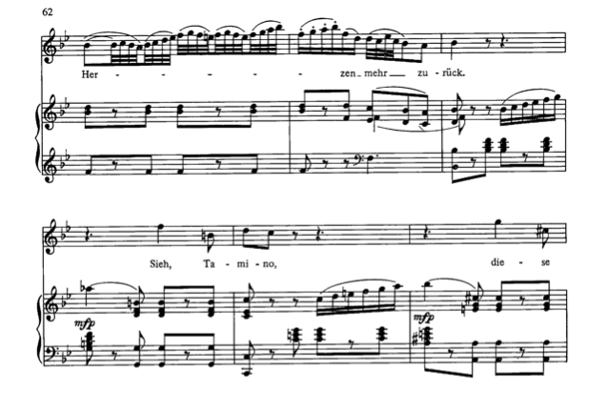
Figure 3 ‘Ach Ich Fühl’s’, Die Zauberflöte, bars 14-19

'Der Lieber sehnen/ Feels the longing of love' is repeated twice over the dominant prolongation as if she's spiralling repeating phrases as she doesn't quite understand it, this is juxtaposed by the quaver rest quaver rhythmic ostinato in the accompaniment, as though the music is attempting and potentially failing to push her back to some mental stability and normality. The resignation and sadness are reinforced by the finality created by two consecutive cadences, the music realizing that her mental health is in an inescapable decline.

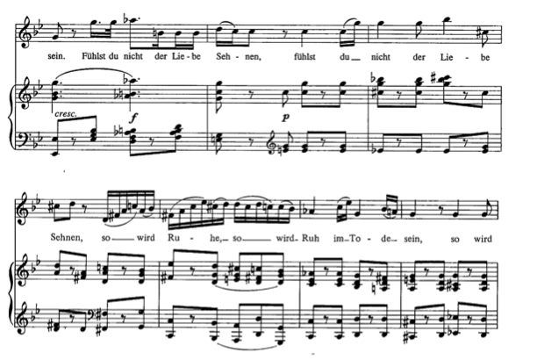
Figure 4 ‘Ach Ich Fühl’s’, Die Zauberflöte, bars 30-36

Mozart's choice of terraced dynamics is quite peculiar as this is a fundamental element of music of the past, specifically the baroque period. However, this was composed in the classical period when gradual music changes were widespread among composers. This is expertly used to show how Pamina's emotions are sporadic as her pain is sudden and poignant, the news she is receiving is so incomprehensible to her that diligent logical thinking is impossible hence the sudden changes in dynamics.

Word painting is an incredible tool used in this aria as herzen/heart, liebe/love, Fühlst/feel, ruhe/peace is used on the highest notes of the aria representing the hope that deep inside Tamino still feels for Pamina meanwhile death being of the deepest darkest notes.

The last page of this aria is a fascinating section. The fermata on the text 'im tode sein/ to be in death' is particularly enticing, especially when coupled with the fact that the phrase starts on the mediant Bb4 quickly ascends to the submediant Eb5 descending to the augmented leading note F# before landing on the tonic G4, this demonstrates the absolute emotional rollercoaster that Pamina must endure in order to gain clarity this is further, signified by the power of 3 masonic motif previously mentioned returning, as the phrase 'im tode sein/ to be in death' is repeated three times a continual mental cycle like a rollercoaster. When playing close attention to the final sung note in conjunction with the accompaniment part, we must question if this mental torment really concludes here, or if Pamina will always be in a state of distress as the piece appears to end on a V-I chordal progression, but the 5th is missing in the I chord and replaced with a 7th providing an unsatisfactory, incomplete perfect cadence on the final sung note of the aria.

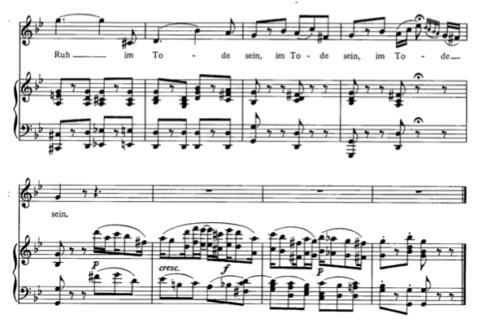
Figure 5 ‘Ach Ich Fühl’s’, Die Zauberflöte, bars 37-44

- https://www.operanorth.co.uk/news/the-magic-flute-in-a-nutshell/
- https://courses.lumenlearning.com/musicapp_historical/chapter/mozarts-the-magic-flute/
- https://www.themarginalian.org/2016/10/07/mozart-haydn-friendship/
- https://sfopera.com/contentassets/4328b14fa0504e58b2dceab451fe1205/magicflutemajorthemesnew.pdf
- https://www.mozartsroses.com/magic-flute-overview-essay.html
- https://scarab.bates.edu/cgi/viewcontent.cgi?article=1264&context=honorstheses
- https://opera-inside.com/ach-ich-fuhls-an-aria-from-the-opera-die-zauberflote/
- https://www.schmopera.com/aria-guides-ach-ich-fuhls/
- https://achichfuehls.wordpress.com/2012/10/21/aria-linguistics-ach-ich-fuhls/
- https://en.wikipedia.org/wiki/Wolfgang_Amadeus_Mozart
- Wolfgang Amadeus (1791) Ach Ich Fühl’s available at: https://kupdf.net/download/ach-ich-fuhl-39-s_58c6e69cdc0d60c678339028_pdf
Accessed on 11/01/2021

