

Strategic Management (LCMB7003)

Strategic Analysis of (GOOGLE INC)



Student name: NAVEEN AVULANNAGARI REDDEPPAREDDY
Student Number: 2213721

Lecturer: Dr GLADIUS KULOTHUNGAN
Word count: 5500
Submission Date: 01/08/2023
Table of Contents
Introduction 2
GOOGLE INC Background 3
GOOGLE Mission and Objectives 3
Macro-Environment Analysis 4
PESTEL Analysis 4
Micro-Environment Analysis 6
Industry Life Cycle 6
Porter’s Industry Five Forces Analysis 7
Internal Analysis 9
GOOGLE Strategic Resources and Capabilities 9
Value Chain Analysis 10
Primary Activities 11
Secondary Activities 11
VRIO Analysis of Distinctive Resources and Capabilities 11
SWOT Analysis 12
Strategies to Sustain Competitive Advantage 14
Growth Strategies 14
Green Strategy and CSR 16
Conclusion 17
Recommendation 17
References 18
Appendix
Appendix 1:
Appendix 2:

Introduction
In these report will expain the ideas, theories, and frameworks covered in the strategic management module to a GOOGLE INC. to conduct a thorough strategic analysis. The examination should concentrate on how the organisation tackled its main problems and how they gained a competitive advantage by Google Inc. Their managerial strategy decisions. will know they comprehend strategic.The ability to apply management principles to actual business situations. and also the Google Inc what are the Missions and objectives, and analysis of the company which strategic they apply like internal analysis, external analysis, which they are PESTAL, SWOT, Macro analysis of the company. Will examine the Google perfomance of VRIO Analysis of Distinctive Resources and Capabilities.
The Google Inc. companyhow they strategie to sustain in the competative advantage and clear explanation about the company internal and external performances, of global value chain, clear understanding of primary activities and secondary activities, how they strategies of Green Strategy and CSR of the company and also expain the growth in the market with competative world.

Google Inc., Background History

Source: Google official website
Google was founded by Two Stanford University doctoral candidates named Larry Page and Sergey Brin established Google. In order to investigate the connections between websites, they created a search engine dubbed "Backrub" in January 1996 as a study project. The business registered the domain name "Google.com," a pun on the phrase "googol," which stands for the number 1 followed by 100 zeros, in September 1997. Their goal of organising the enormous amount of information available on the internet is reflected in the name.
Funding and Incorporation of the Google Inc. was formally incorporated as a privately-held company on September 4, 1998. Family, friends, and investors provided the founders with their early finance, which also included a sizeable investment from Andy Bechtolsheim, a co-founder of Sun Microsystems. Google Search In the year 1998, Google introduced its web search engine, giving consumers a quick and easy way to look up information on the internet. It immediately became well-liked for its clear and uncluttered user interface September 2021 update On September 4, 1998, Google Inc., currently a division of Alphabet Inc., was established. The business would have been about 23 years old at that time.
Rapid Development In the late 1990s and early 2000s, Google expanded quickly, eventually ranking among the most well-liked search engines on the planet. The company's success was largely attributed to its user-friendly design and emphasis on providing relevant search results (Google annual report, 2021).

Google Inc Mission and Objectives

Mission:
"Google's mission is to organize the world's information and make it universally accessible and useful."
This mission statement accurately captures Google's primary goal, which is to compile and organise the massive amount of online information such that it is useful to users everywhere.
Objective
"To provide access to the world's information in one click” Google's primary goals are to provide innovative technology products and services that improve the user experience while also driving business growth and profitability. These goals are reflected in their numerous products and projects, which include search, advertising, cloud computing, hardware, and other areas. To push the boundaries of current technology in order to provide a reliable, quick, and user-friendly solution for information accessibility.
- To push the ad system, communities, and content.
- To ensure that tools are available everywhere.
- To have the best artificial intelligence research facility in the world and a global search engine
Google's corporate vision statement is comprised of three components: the world's information, accessibility, and one click. The company fulfils the "world's information" element of the vision statement by indexing webpages and maintaining databases of the resulting data. Google practises the "accessibility" component by making its products available to everyone across the world. The "one click" portion of the company concept refers to simple information availability. (Allison, 2017).

Macro-Environment Analysis
The Macro environmental analysis, or PESTEL analysis, is a strategic management tool used to evaluate the outside forces and influences that have an impact on a firm or organisation at a more general societal level. It aids businesses in comprehending the societal, technological, environmental, political, economic, and legal influences that may have an impact on their operations, plans, and results (Kotler, et al., 2016).
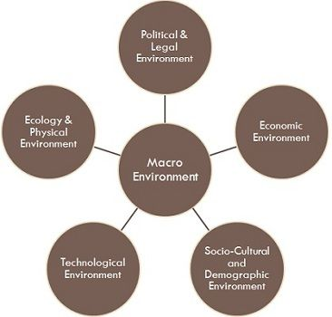

Source: (Kotler, et al., 2016)

PESTEL Analysis
A PESTEL analysis is a framework for evaluating macroenvironmental elements that can affect a company's operations and performance. Here's how Google Inc's PESTEL study looks.
Political Factors:
Government laws: Google operates in several countries and is subject to varied privacy, data protection, and content filtering regulations.
Antitrust and competition laws: Because of its strong market position, Google has received antitrust scrutiny in various countries.
Intellectual property regulations: Intellectual property rules apply to the company's innovations and technologies, limiting its capacity to protect its assets (Edrawsoft. , 2021).

Economic Factors:
Economic conditions: Economic variations can have an impact on advertising budgets, which are a substantial source of revenue for Google via its advertising platforms such as Google Ads.
Exchange rates: Google's global activities leave it vulnerable to currency changes, which harm its revenue in various areas. Economic conditions: can have an influence on consumer spending on items and services that produce advertising revenue for Google. Consumer spending can have an influence on consumer spending on items and services that produce advertising revenue for Google (Edrawsoft. , 2021).
Social and Cultural Factors:
Adoption of digital technologies: Growing digitalization and internet penetration benefit Google's core operations such as search and advertising.
Concerns about data privacy: As people become more aware of data privacy issues, there is more scrutiny and demand for greater data protection measures.
Diversity and inclusion: Societal expectations of diversity and inclusion may have an impact on Google's workforce composition and business practises.
Technological Factors:
Google relies on continual innovation to maintain its competitive edge, particularly in areas such as search algorithms, artificial intelligence, and cloud computing. Rapid technological change Because technical improvements are so rapid, Google must adapt swiftly and invest in developing technologies (Farooq, U, 2021).
Environmental Factors:
Due to growing environmental concerns, Google has prioritised sustainability projects such as renewable energy investments and carbon neutrality.
Google's data centres and activities require a substantial amount of energy, which may have an influence on its environmental footprint (Panmure , 2021).
Legal Factors:
Data protection laws: Google is required to follow a variety of data protection legislation, such as the GDPR in the European Union, which influence its data handling practises. Litigation over intellectual property rights: Google has been involved in legal conflicts over intellectual property rights, particularly with regard to its software and Android platform. Liability and content moderation: Google is facing legal concerns as a result of user-generated content on its platforms, which may result in liability issues (Edrawsoft. , 2021).
Micro-Environment Analysis
A strategic management tool called microenvironment analysis is used to evaluate the internal and immediate external elements that have a direct impact on a company's operations, performance, and decision-making. The microenvironment, in contrast to the macroenvironment, which focuses on more general societal and economic influences, investigates particular aspects that are closer to the company and within its direct control or impact (Kotler & Armstrong, 2010).

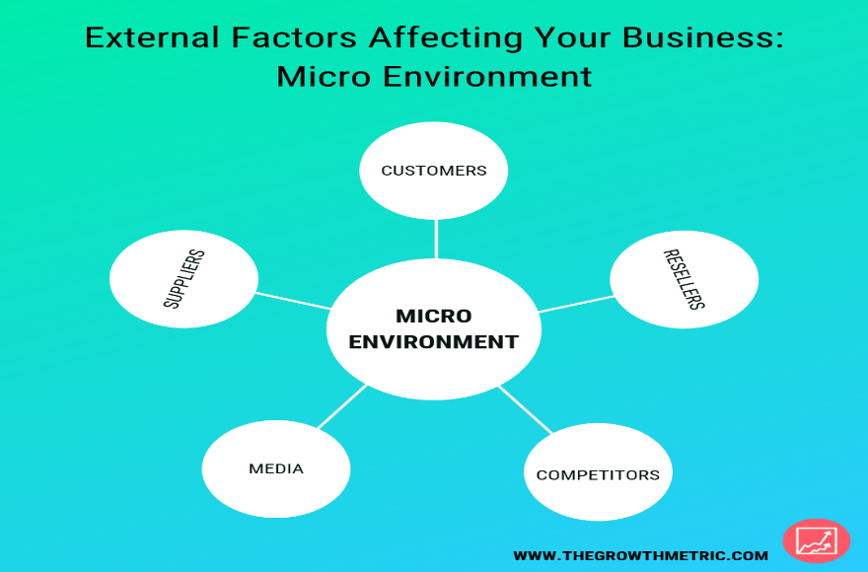

Industry Life Cycle
The The industry life cycle is a model that describes the stages of growth and maturity of an industry, typically represented by the following stages
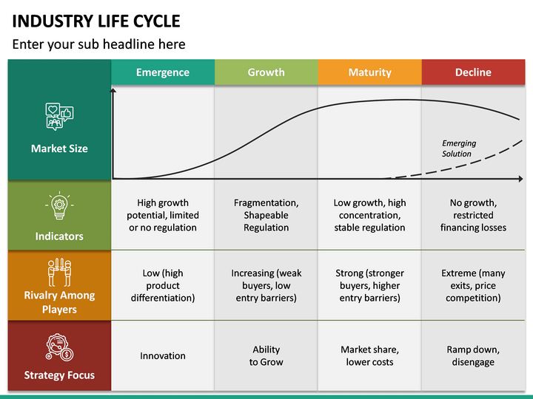
Source: Google official website
Introduction stage: When a new technology or product is first offered to the market, an industry is in its infancy. In this period, businesses like 1998-founded Google led the way in internet search and digital advertising, establishing the foundations of the online search and technology industries.
Growing Stage: As consumer demand rises and businesses compete for market share, the industry expands quickly during this era. As the internet became more broadly accessible and its search engine gained prominence in the early 2000s, Google saw considerable growth.
Maturity Stage: When growth rates level out and the market achieves saturation, the industry has matured. The internet search and technology sector, in which Google is a prominent player, had matured by the early 2010s, with well-established rivals and a sizable user base (Daniels, et al., 2018).
Decline Phase: The industry's growth slows down during the decline phase as a result of market saturation, heightened rivalry, or the emergence of innovative technology. The online search and technology sector had not yet started a marked transition (Daniels, et al., 2018).

Porter’s Industry Five Forces Analysis
The Porter's Five dynamics model, created by Michael E. Porter, is a popular tool in strategic management for examining the dynamics of competition in a market or sector. The model looks at five major elements that affect competitiveness and a company's capacity to make money in order to evaluate an industry's attractiveness and profitability

The Porter's Five dynamics model,
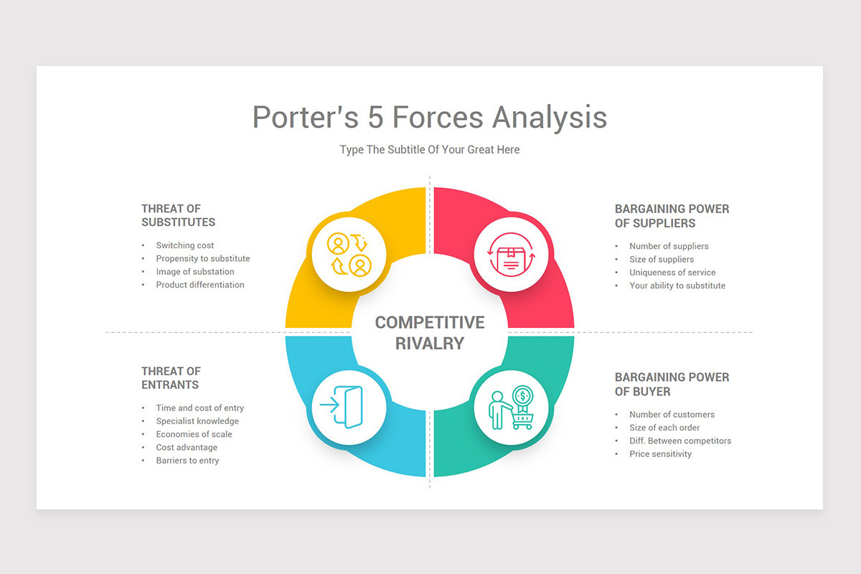
Threat of New Entrants: [MODERATE FORCE]
High Entry Barriers: Because of network effects and brand loyalty, Google's dominance in search and online advertising causes high entry barriers.
Economies of Scale: Because of Google's huge infrastructure and massive user base, it is able to generate economies of scale that newcomers may find difficult to match.
Developing complex search algorithms and technologies necessitates tremendous knowledge and resources (Schumann, , et al., 2014).
Bargaining Power of Suppliers: [WEAK FORCE]
Low Supplier Power: Although Google's suppliers largely include content creators, software developers, and data providers, the company benefits from a large pool of vendors from whom to choose.
Possibilities for Customization: Because of the availability of other suppliers and the nature of online services, Google can easily swap suppliers (Goldfarb, 2014).
Bargaining Power of Buyers: [WEAK FORCE]
Low Buyer Power: Google has a massive user base, giving it a strong negotiating position with advertising, content creators, and other stakeholders.
Switching Costs: Because of habit and familiarity, users frequently rely heavily on Google's services, making it difficult for them to transfer to competing platforms (Murthi, et al., 2017).
Threat of Substitute: [MODERATE FORCE]
Low Substitute Threat: Google's full ecosystem of services, including search, email, maps, and cloud computing, is difficult to imitate.
Powerful Brand Loyalty: Google's brand awareness and reputation act as a powerful deterrent to replacements (M.E, 2014).
Competitive Rivalary: [STRONG FORCE]
High Rivalry: Google competes with a variety of companies in numerous industries, including Microsoft (Bing), Amazon (advertising and cloud services), and Apple (Siri and mapping).
The fast-paced nature of the technology sector needs ongoing innovation and development in order to maintain and expand market share.
Advertising rivalry: Because advertising is Google's principal source of revenue, there is fierce rivalry for ad dollars (Jacques , et al., 2015):.

Internal Analysis
The Google's internal analysis would probably concentrate on analysing the company's diverse product portfolio, workforce quality, corporate culture, financial performance, and market presence, as well as ensuring compliance with data privacy and legal requirements. The investigation would also look at Google's reputation and brand value, as well as potential strategic alliances.

GOOGLE INC Strategic Resources and Capabilities
The strategic capabilities and resources that Google Inc. (now Alphabet Inc.) holds have helped it to achieve a dominant position in the technology sector. Google has a number of strategic assets and competencies, some of which are:
Physical Resources
Plant and Equipment: As of February 2015, Google had purchased approximately 178 businesses. This provided them with a considerable number of material resources to support their purpose. Their primary physical assets are 85 offices spread over more than 40 nations. Their corporate culture is fostered at their main office, the Googleplex, which is located in California. In addition to offering mobile, wearable, productivity, and cloud-based goods, Google entered the robotics market in 2014 after purchasing the artificial intelligence startup Deep Mind (Berney & Hesterly , 2012).
Raw Materials: To run their systems and research centres, they need a sizable amount of energy. Additionally, they depend on consumers to help marketers pay for their commercials. Server building materials and storage capacity are examples of additional raw materials.
Finally, Google overtook Apple as the most valuable brand in the world.Google was replaced here by Apple in 2011. In 2014, Google took it back with a brand value of $158 billion. Compared to Apple's 20% reduction from 2013, this was a 40% increase.They are well-known among suppliers, clients, and users.
Intagible Resource
Customer loyalty: Not just because of the impact, but also since the majority of services are provided without charge to consumers, Google services and distinctive services foster a feeling of loyalty in customers. It is a socially responsible behaviour that most customers appreciate and is challenging to replicate.
Capabilities
Integrated Resources: Thanks to the Company's general diversification strategy, it is able to offer a wide range of services to a diverse group of customers without losing its ability to differentiate itself from the competition.Businesses frequently work to keep their name from being synonymous with what they do.FedEx, for example, makes a point of not using the word FedEx as a verb. Google doesn't mind, though. As a result of customers being able to use the services of a rival company while referring to it by your name, having your name as the verb of what you do carries the risk of losing your distinctive brand. Because Google makes money from advertisements and has their name in the dictionary, they have a lot of services to leverage the risk of switching to Bing or asking.
Skills and knowledge of employees: They employ those with the greatest expertise in computer science and related fields.
Search: They are capable of searching since that is the most obvious part of what they do.
Software engineering: They excel at both maintaining scalable hardware infrastructure in the engineering processes and content indexing.
Quality of services: Each product is specially created to include many high-quality characteristics.Google Earth and Gmail are two instances (Berney & Hesterly , 2012).

Value Chain Analysis

The value chain is the series of interconnected operations that a firm undertakes to create, manufacture, market, distribute, and support a product.

Google, in contrast to the usual paradigm, employs a distinct value chain. We will make some assumptions to demonstrate how raw materials become completed commodities for sale as they gain value during transportation. It has a complex value chain because the majority of its products are not physical (Daniels, et al., 2018).
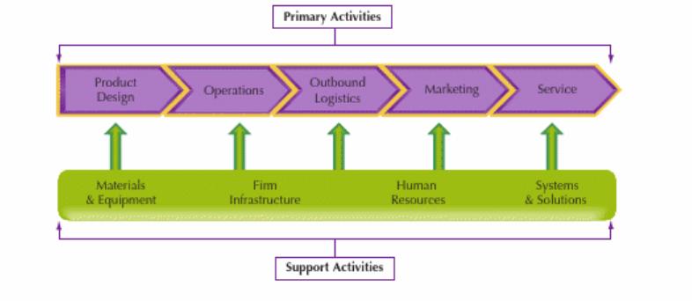

Primary Activities
The development, production, and distribution of a company's goods or services to clients are considered its primary activities. The value chain typically includes these five main activities:
Inbound Logistics: Receiving, storing, and distributing raw materials and other inputs utilised in the production process are all part of inbound logistics. Effective incoming logistics aid in inventory control and cost reduction.
Operations: This phase involves turning raw materials into completed goods or services. It includes producing, putting together, or offering the service.
Outbound Logistics: After the goods are complete, outbound logistics handles their storage, distribution, and delivery to clients or end-users.
Marketing and Sales: The goal of this activity is to market and sell goods and services to consumers. It involves sales channels,and customer relationship management and advertising.
Service: This category includes customer support and after-sales service. To increase client satisfaction, it comprises services like warranty, maintenance, repairs, and customer assistance (Daniels, et al., 2018).

Secondary Activities
Supportive activities serve a crucial role in ensuring that primary activities run well even when they are not directly involved in the creation or distribution of products. The value chain consists of the following four auxiliary activities (Daniels, et al., 2018)
Procurement: the process of finding and buying the supplies, equipment, and services needed for the main tasks. Effective procurement can lower costs and raise input quality.
Human resource management: HRM is the process of finding, selecting, onboarding, and managing personnel. Primary activities are more successful when the worker is skilled and motivated.
Technology development: focus of this activity, which aims to advance both primary and supporting activities through research, development, and innovation.
Infrastructure: which includes organisational structure, information technology, accounting, and other administrative procedures, is referred to as the company's overall support systems (Daniels, et al., 2018).

VRIO Analysis of Distinctive Resources and Capabilities

The VRIO analysis is a framework for assessing a company's assets and skills using the four factors of Value, Rarity, Imitability, and Organisation. The VRIO framework can be used to evaluate Google's unique resources and capabilities in the following manner (Berney & Hesterly , 2012).
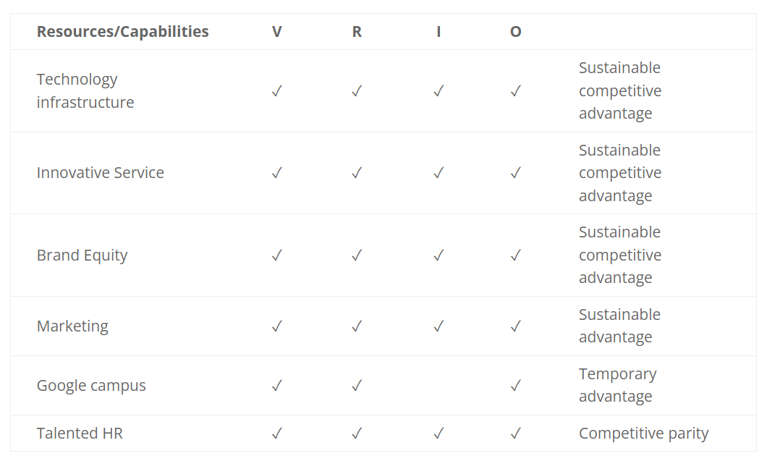
Source: Google Inc official website
Value: Both Google and its users benefit from Google's wide range of resources and abilities. A few of its key assets are its search engine technology, enormous user base and data, solid brand reputation, and broad range of goods and services (such as YouTube, Android, and Google Cloud). These assets play a crucial role in Google's capacity to compete favourably and to make money through advertising and other services.
Rarity: Many of Google's assets and skills are uncommon and difficult for rivals to access. For instance, Google has a distinct advantage over competitors due to its cutting-edge search algorithms, artificial intelligence, machine learning, and data analytics capabilities.
Imitability: Google's resources and abilities are challenging to duplicate. Its technology and search algorithms have been improved over many years of research and development, making it difficult for rivals to imitate. Furthermore, it is challenging to replicate Google's enormous data and user base, providing the corporation with unique insights and potential for development.
Organisation: In order to generate value and keep a competitive advantage, Google has efficiently organised its resources and skills. The company's innovative culture, investment in research and development, and skilled employees are essential to efficiently utilising its resources (Berney & Hesterly , 2012).

SWOT Analysis
The Google Inc. SWOT analysis examines both internal and external strategic elements that have an impact on the technology industry. Google's company strengths, weaknesses, opportunities, and threats are evaluated in this SWOT analysis (the SWOT factors). Market changes that are relevant to the rapid advancement of technology and trends in consumer tastes and expectations are taken into account when evaluating the business.
Strength
Google is the most extensively used search engine in the world, with a large market share, resulting in great brand awareness and user loyalty. Google has a diverse product portfolio that includes search, advertising, cloud computing, hardware (Pixel devices), and operating systems (Android).
Innovative Culture: The company's emphasis on innovation, combined with Alphabet's "moonshot" projects, spurs the creation of game-changing technology.
Expertise in Data and Analytics: Google's access to massive volumes of user data improves its capacity to provide personalised services and targeted advertising. Google works on a global scale, with offices, data centres, and users in a variety of nations, giving it a considerable international footprint.
Despite aggressive competitors on the global market, Google is able to operate profitably and grow. When taking into account computing technologies, innovation, the internet environment, and market circumstances, the following internal aspects are among the qualities that underpin Google's success: (Benzaghta, et al., 2021).
Weakness
Dependence on Advertising Revenue is because advertising accounts for a significant percentage of Google's revenue, the company is subject to changes in the advertising sector and consumer behaviour.
Concerns about privacy: Google is under criticism for data privacy and user data processing, which can undermine user trust and lead to regulatory challenges.
Market Share Loss in Some Industries: Google has encountered competition in various areas, such as social media (Google+ shutdown) and online video (YouTube rivalry).
Product Complexity: Managing and integrating a diverse range of products and services can be challenging (Cooper, et al., 2023).
Opporunities
Cloud Computing Expansion: As organisations continue to transition towards cloud-based solutions, Google's cloud services (Google Cloud Platform) have room for expansion.
AI and Machine Learning: Google can develop advanced applications in sectors such as healthcare, driverless vehicles, and language translation by leveraging its AI skills.
Smart Home and Internet of Things (IoT): Google's investments in smart home devices (Google Nest) and the Internet of Things (IoT) industry provide prospects for growth.
Expanding in Emerging Markets: Expanding into markets with increasing internet penetration, such as India and Southeast Asia, gives opportunities for growth. (Cooper, et al., 2023).
Treats
Google confronts rivalry in a variety of product areas, including search (Bing, Yahoo), advertising (Facebook), and cloud computing (Amazon Web Services, Microsoft Azure).
Regulatory Issues: Google's dominance has drawn regulatory attention over antitrust, privacy, and data protection issues, potentially leading to legal challenges. Regulations Concerning Privacy is Stricter privacy requirements (e.g., GDPR) have an impact on data collection practises and may impede Google's capacity to efficiently target adverts.
Consumer Behaviour Modification: Changes in consumer preferences, such as greater usage of voice search and mobile apps, have the potential to destabilise Google's traditional search and advertising structures. (Palomares, et al., 2021).

Strategies to Sustain Competitive Advantage
The business is backed by Facebook's general competitive strategy (Porter's model) and its customers' accessibility and operational efficacy. Related aggressive endeavours assist Facebook boost its market share and income by increasing the social networking site's accessibility throughout additional regions of the world. The results of these intense tactics and generic strategies have an impact on the competitive environment and external variables that affect the company's business performance in relation to the global industry (see Porter's Five Forces Analysis of Facebook Inc.).
Innovation has allowed the company to stay in the race against other digital giants like Apple, Facebook, Samsung, IBM, Amazon.com, Microsoft, Intel, Twitter, and Snap Inc. (Snapchat). Google ensures that its personnel are prepared to handle business demands related to external factors like competition through its corporate culture. The technology sector aggressively fosters its corporate culture traits both formally, through personnel training, and informally, through customised leadership and managerial support. The organisational culture of Google is always being improved in an effort to maintain creativity and innovation (Jacques , et al., 2015).

Growth Strategies
Growth strategies, without a doubt, relate to a company's plans and efforts to expand its business operations, increase market share, and reach higher levels of revenue and profitability. These tactics might include everything from entering new markets to launching new products or services. Here are some frequent development tactics, as well as references to further research (Kotler , et al., 2017).

Ansoff Matrix:
The Ansoff Matrix is a strategic tool that aids businesses in deciding on growth strategies by taking into account current and potential new markets, as well as current and potential new products. The Ansoff Matrix could be used by Google to find chances for growth.
Market Penetration: By further growing its user base and ad revenue, Google can concentrate on gaining market share in already-established markets. To keep current consumers and draw in new ones, this can entail improving its search engine, advertising platforms, and cloud services (Kotler, et al., 2016).
Market Development: Google can broaden its service offerings to areas with lower internet penetration or approach emerging economies with rising rates of digital adoption in order to penetrate new markets. This tactic can include modifying items to suit regional demands and preferences (Hussain, et al., 2013).
Product Development: To address evolving customer needs and cutting-edge technologies, Google can innovate and create new goods and services. This might involve developments in cutting-edge technology like artificial intelligence, cloud computing, smart gadgets, and others.
Business diversification: Google may think about expanding into brand-new areas or sectors. It might look at possibilities in the fields of healthcare, smart home technologies, or driverless vehicles, for instance.
International Strategies: Google's global presence and success depend on its international strategies. The business can use a variety of strategies to grow abroad:
Global Standardisation: By providing uniform goods and services everywhere, Google may pursue a global standardisation plan. This strategy makes use of the company's robust worldwide brand and scale economies.
Localization: Google can use a localization approach to account for various cultural and market preferences. To better appeal to local consumers, this entails customising goods and services to certain locales or nations.
Transnational Strategy: A transnational strategy incorporates both localization and global standardisation. Google can incorporate localised features to cater to regional needs while yet maintaining a consistent worldwide brand image (Merchant, 2014).
Entry Mode Strategies: When entering new markets, Google can employ a variety of entry mode methods, including:
Direct Investment (Wholly Owned Subsidiaries): Google may decide to create wholly owned subsidiaries in nations with sizable market potential or strategic importance in order to have total control over operations and resources (Glazer, 1999).
Licencing and Joint partnerships: Google may enter into licencing arrangements or joint partnerships with regional businesses in particular markets.
Acquisitions: Google's market entry and growth can be sped up by buying regional firms that provide comparable technology or have established user bases.
Exporting and Online Sales: Google can begin its market penetration by exporting goods and services to new markets or by providing online sales to clients in various geographical areas.
Google may successfully and sustainably achieve its growth objectives by using these strategic evaluations to help it choose the best entry mode and expand its market (Miller, 1992).

Green Strategy and CSR
The Google has made considerable investments in renewable energy and sustainability. In order to run its global operations, the corporation wants to use only renewable energy. To lessen its carbon footprint and fight climate change, Google has made investments in renewable energy projects such as solar and wind farms.

Energy efficiency and long-term viability of data centres:
Google is constantly attempting to make its data centres, which are necessary to run its huge web services, more energy efficient. To reduce energy use, the company uses hardware that is energy-efficient and cutting-edge cooling technology (Adomako & Tran, 2022).
Carbon Neutrality: By offsetting its carbon emissions through investments in various renewable energy and carbon offset programmes, Google has become carbon neutral for its global operations.
Circular Economy and Waste Reduction: Google aspires to embrace a circular economy approach by enhancing product lifecycles, cutting waste, and encouraging recycling and material reuse.
Environmental activities: The business backs a range of environmental activities, including programmes for water stewardship, biodiversity projects, and conservation efforts.
CSR and Social Initiatives: Google regularly participates in CSR programmes that emphasise economic empowerment, digital literacy, diversity, and inclusion. Globally, the firm supports social entrepreneurs and nonprofit organisations through funding, resources, and technological assistance (Adomako & Tran, 2022).

Conclusion
The conclusioon of the report is a strategic study of Google Inc. reveals a winning strategy that emphasises technology, client centricity, and international growth. Their fundamental competencies are driven by their missions of information organisation and accessibility for all. Google capitalises on its strengths, corrects its shortcomings, and spots potential threats using PESTEL and SWOT analysis. Through VRIO analysis, sustainable competitive advantages are highlighted. Their operations are supported by a strong global value chain with primary and secondary activity. The company's CSR initiatives and Green Strategy serve as examples of its environmental and social responsibilities. In general, product development, market penetration, and strategic alliances drive Google's growth, placing it as a leader in the tech sector.

Recommendation
- Invest in R&D to promote continual innovation and the creation of new products.
- Prioritise user needs and improve the customer experience by being customer-centric.
- Explore new business endeavours that go outside your main goods and services to diversify.
- Global Expansion: Explore new markets and customise offerings for various geographies.
- Strengthen commitment to environmentally beneficial behaviours and renewable energy sources.
- Prioritise data privacy and improve security procedures when it comes to data security.
- Strategic Partnerships: Work together to broaden the ecosystem and speed up innovation.
- To attract and keep top talent, promote an inclusive workplace culture.
- Impact on society: Promote CSR programmes and neighbourhood involvement.
- Compliance with regulations: Prepare for and adjust to changing regulatory conditions.

References
Edrawsoft. 2021. 'A Report on Google SWOT Analysis', PESTLE Analysis, [online]. Available at: https://www.edrawmax.com/article/google-swot-analysis.html (Accessed 16 June 2021).
Farooq, U., 2021. 'PESTLE Analysis of Google LLC | Marketing Tutor', Marketing Tutor, [online]. Available at: https://www.marketingtutor.net/pestle-analysis-of-google/ (Accessed 16 June 2021).
Panmure Institute. 2021. 'Google PESTEL/PESTLE Analysis & Recommendations - Panmure Institute', PESTLE Analysis ,[online]. Available at: http://panmore.com/google-pestel-pestle-analysis-recommendations/ (Accessed 16 June 2021).
Bruce, N. I., Murthi, B. P. S., & Rao, R. C. (2017). A dynamic model for digital advertising: The effects of creative format, message content, and targeting on engagement. Journal of Marketing Research, 54(2), 202-218.
Dobbs, M. E. (2014). Guidelines for applying Porter’s five forces framework: A set of industry analysis templates. Competitiveness Review, 24(1), 32-45.
Goldfarb, A. (2014). What is different about online advertising? Review of Industrial Organization, 44(2), 115-129.
Schumann, J. H., von Wangenheim, F., & Groene, N. (2014). Targeted online advertising: Using reciprocity appeals to increase acceptance among users of free web services. Journal of Marketing, 78(1), 59-75.
Google LLC – About Google.
Jacques, J. T., Perry, M., & Kristensson, P. O. (2015). Differentiation of online text-based advertising and the effect on users’ click behavior. Computers in Human Behavior, 50, 535-543.
Lee, H., Kim, M. S., & Park, Y. (2012). An analytic network process approach to operationalization of five forces model. Applied Mathematical Modelling, 36(4), 1783-1795.
Adomako, S., & Tran, M. D. (2022). Stakeholder management, CSR commitment, corporate social performance: The moderating role of uncertainty in CSR
Regulation. Corporate Social Responsibility and Environmental Management, 29(5), 1414-1423.
Kotler, P., & Armstrong, G. (2010). Principles of Marketing. Pearson Prentice Hall. This widely used marketing textbook provides a comprehensive explanation of the microenvironment and its components in the context of marketing
Glazer, R. (1999). Competitive Advantage Through Information-Intensive Strategies. Handbook of Services Marketing and Management, 409.
Hussain, S., Khattak, J., Rizwan, A., & Latif, M. A. (2013). ANSOFF matrix, environment, and growth-an interactive triangle. Management and Administrative Sciences Review, 2(2), 196-206.
Merchant, H. (2014). Configurations of governance structure, generic strategy, and firm size. Global Strategy Journal, 4(4), 292-309.
Miller, D. (1992). The generic strategy trap. Journal of Business Strategy, 13(1), 37-41.
Allison, J. (2017). A vision statement taxonomy: Linking strategic management, strategic communication, and organizational culture. Global Journal of Management and Marketing, 1(2), 1-18.
Barney, J.B., Hesterly, W.S.: Strategic Management and Competitive Advantage, 4th edn. Pearson Education (2012)
Benzaghta, M. A., Elwalda, A., Mousa, M. M., Erkan, I., & Rahman, M. (2021). SWOT analysis applications: An integrative literature review. Journal of Global Business Insights, 6(1), 55-73.

Cooper, D. A., Yalcin, T., Nistor, C., Macrini, M., & Pehlivan, E. (2023). Privacy considerations for online advertising: A stakeholder’s perspective to programmatic advertising. Journal of Consumer Marketing, 40(2), 235-247.
Palomares, I., Martínez-Cámara, E., Montes, R., García-Moral, P., Chiachio, M., Chiachio, J., … & Herrera, F. (2021). A panoramic view and SWOT analysis of artificial intelligence for achieving the sustainable development goals by 2030: Progress and prospects. Applied Intelligence, 51, 6497-6527.
Kotler, P., Keller, K. L., Brady, M., Goodman, M., & Hansen, T. (2016). Marketing Management. Pearson Education Limited.

