Student Name: Rukshana Begum

Student number: 2120527

Module title: Sustainable Hospitality & Tourism Management

Module code: BMIH5006

Lecturer name: Kathryn Roberts

Executive summary
The report has discussed the concept of sustainability hotel practices and greenwashing, taking Langham Hotel into consideration. It showed the hotel industry to be one of the biggest contributors to the UK's GDP, and that common greenwashing practices such as unclear certification, self-reporting, and so on are issues that are hindering customer trust. However, the report has also included resource conservation, technology adoption and so on as sustainably hotel practices and trends. On top of that, the report showed Langham Hotel has LEED, Green-Key and Green Globe certifications; however, they are aware of greenwashing as some of their practices, such as towel policy and recycling bin, are not created with environmental sustainability in mind but are often mistaken as so. It is stated in the report that the hotel self-evaluates and uses EarthCheck, ISO 14001, and others required to do so, but third-party certification and zero-waste initiatives can also be taken as alternatives. The report has also included that the hotel uses a lot of energy-efficient technologies. Yet, there are certain areas of improvement, such as ensuing emphasis on the circular economy, using their party certification, and so on, which are given as recontamination in the report.

Table of Contents
Introduction 1
Industry Overview 2
Common greenwashing practices in industry 2
Sustainable Hotel Practice Trends 3
Case study: Langham Hotel 3
Green Certifications 3
Potential Greenwashing 4
Self-Evaluation Practice 5
Self-evaluation alternatives 5
Energy-efficient technologies 6
Conclusion and Recommendations 7
Reference List 8

Introduction
The hotel or accommodation industry of the UK is one of the major industries that contributes toward economic development. In 2022, this industry alone generated over £16.40 billion (Brotherton, 2023). Even so, it is one of the most waste-generating industries. However, over the years, consumers have become more aware of the fact that irresponsible services are majorly impacting the environment. That is why they are more willing to purchase from companies that are more environmentally friendly. So, companies require some certification to measure and publish their eco-friendliness with others. Greenwashing is one of such certifications. It is a self-evaluating marketing technique that allows us to increase our level of eco-friendliness to present to the customers. However, due to the fact that it is a self-evaluation tactic, companies can make data up and present fault status to the customer, which can drastically reduce their trust in the company (Batabyal, 2018). Greenwashing can be beneficial for hotel industries as consumers are becoming more and more aware and want to take services from responsible businesses. That is why many businesses, including the Langham Hotel, have already embraced such practices (The Langham, 2022). So, this report will briefly discuss the hotel industry and the green practices that Langham Hotel uses for its business improvement and how those are affecting the hotel's business.

Company Overview
Langham is one of the most prestigious and oldest hotels in the UK.
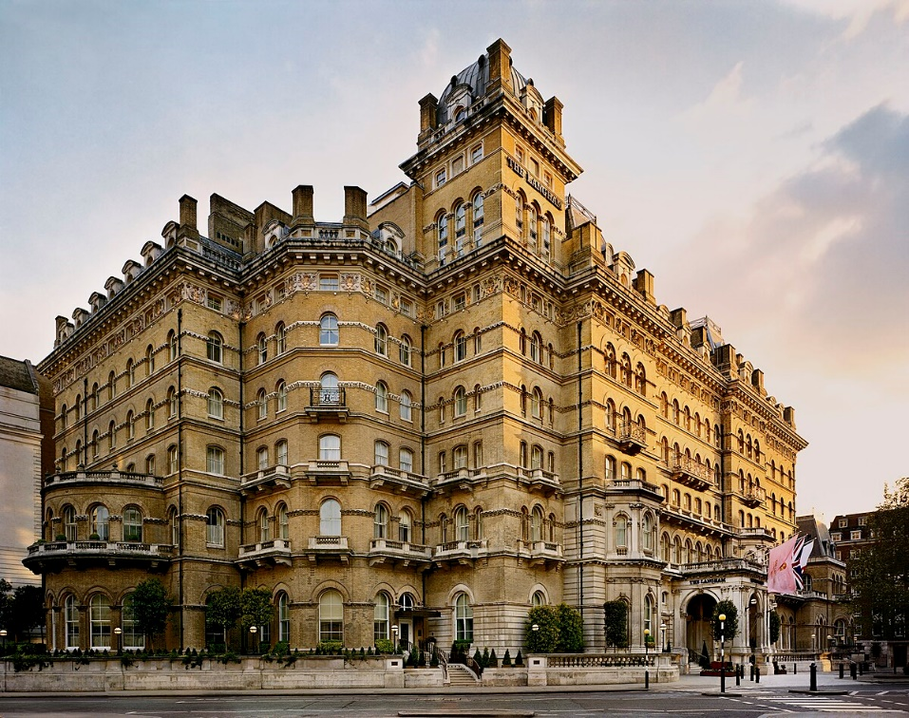
Figure 1: Langham Hotel.
Source: (The Langham, 2022).
The hotel was founded in 1865, and it was the largest and the most modern hotel of that time. At present day, it features 380 rooms where people can rest. Around 1,787 employees work for the company across different properties on four different continents.

Industry Overview

Common greenwashing practices in the industry
Greenwashing in most industries is used to create misleading information, such as showing something as eco-friendly when it clearly is not (Costa and Costa, 2022). In spite of that, in the UK hotel industry, some greenwashing practices are commonly used, which are discussed below.
Unclear certification: Businesses sometimes create certifications to promote their brand; those certifications lack authenticity, and the data presented are suspicious or may be irrelevant. The Goring has been changed this past year for presenting unclear certifications of their eco-friendliness (Bowen and Aragon-Correa, 2019).
Self-reported data: Another practice that is done in greenwashing is the self-reporting of data. The greenwashing is done via self-evaluation, which makes it easy and also one of the biggest weaknesses of this concept. The reason is that no company wants to show itself as less eco-friendly that is why they change the data according to their preferences. However, doing so means betraying the customers and stakeholders. Merchant Hotel used this practice of greenwashing, for which they have faced serious consequences in the past (Liao, Ye and Wu, 2021).

Sustainable hotel practice trends
The hotel industry generates a lot of waste, which is one of the leading reasons for environmental pollution. Consumers are now more aware of their actions or purchasing decisions, which is why the importance of sustainability in hotel practice has increased. Some new trends have emerged in the hotel industry which are discussed below.
Rescues conservation: The hotel businesses are operated by utilising various resources such as furniture, equipment and various products. However, those were before used and thrown away, but now they are repaired, reused and recycled, which reduces cost and improves sustainability, making it a new trend in the 21st century (Management Association, 2018).
Technological adoption: Technological advances can be seen in every industry, including the hotel industry, which has made business operations easier and more efficient. On top of that, different technologies such as solar panels and high-capacity batteries are making energy management more efficient and promoting sustainability in business. The Balmoral has been seen using solar power and high-capacity storage units to minimise the reliability of their electricity supply (The Balmoral, 2022).

Case study: Langham Hotel

Green Certifications
To present their level of eco-friendliness companies pursue third-party bodies that offer certification facilities to those companies (Jensen and Skytte, 2020). These certifications work as a statement that a company is eco-friendly. There are a variety of green certificates the hotel Langham also has a few of them.
LEED: Certifications are given up on using a specific method that evaluates various aspects of a company; however, the LEED certification, which is also known as Leadership in Energy and Environmental Design, is a green certification program which tests and states the practices used to construct a property (Cooper, 2021). The Langham Hotel was created with eco-friendliness in mind and taking the most sustainable initiatives, which is why, upon assessment, the company was assigned the LEED certification by the body called Greenguard.
Green Key: Other than waste generation, another polluting factor for the UK's hotel industry is its carbon emission level and footprint. That is why both the companies and the consumers have become aware of the negative impacts of such businesses and have taken the initiative of boycotting such businesses. To ensure the quality of their service and eco-friendly initiatives, Langham also got the Geen Key certificate from Energy Star (The Langham, 2022). These certifications assess the carbon footprint and emission level of the business and provide certification on it. The data and certifications can be accessed by the consumers, stakeholders or any interested parties.
Green Globe: Another factor that a hotel business has to be aware of besides their environmental, social and economic sustainably is the sustainability of their supply chain. That is why Langham took the initiative to get Green Globe certification from a third-party body called EcoLogo which assesses their supply chain thoroughly and creates certification which is transparent to higher-ups as well as the employees (Korstanje, George and Nedelea, 2020). It helps the business to improve its brand image and name as the certification is one of the most rigorous of them.

Potential Greenwashing
Langham has various policies that are green, and some that are not specifically made to promote green but are often mistaken for green policies. Even so, those policies hold great value for the development, sustainability and improvement of the businesses. Some of those policies are discussed below.
Towel policy: Langham has a policy where they encourage their guests to reuse their towels in order to reduce wastage. However, it has very little positive impact on the environment yet allows businesses to save costs (Haski-Leventhal, 2018).
Recycling bin: The hotel provides a recycling bin in every single room to motivate its guests to recycle. However, without proper instruction, education, or recyclable waste management, having a recycling bin can be ineffective.
Even so, many companies use those practices are green initiatives or greenwashing their business. Doing so is easier if self-evaluation or reporting of eco-friendliness is done as they can write off different things as sustainability practices without proper justification. That is why the validity of self-reported data is considered to be low. That is why Wickham, Donnelly and French (2021), stated that self-reported data can be easily tampered with if not created under the supervision of a third party.

Self-Evaluation Practice
Self-evolution refers to evaluating a business via internal parties. Langham empathises with self-evolution practices a lot which means the business evaluates themselves in order to gain results and take improvement initiatives (Sloan, Legrand and Chen, 2017). This allows them to accurately judge their state of business, save costs, and get the job done more efficiently. Some of Langham's self-evaluation practices are discussed below.
EarthCheck: This particular self-assessment tactic allows Langham Hotel to monitor, measure and reduce its environmental impact by covering areas including waste, water, energy management as well as community engagement (Legrand, Chen and Laeis, 2022). However, it is done on a large scale which is also its limitation as smaller aspects which are affecting the environment can be easily missed while using this method.
ISO 14001: In order to check Langham's environmental management system, they use ISO 14001 (The Langham, 2022). This is a pre-set standard can businesses can follow and compare in order to gain insight into their business status. Using this self-evolution method, Langham is able to publish accurate and authentic resources; however, it costs the company much more than usual practices. So, the use of this practice can be limited for businesses which lack the necessary resources and investments.
Green Hotel Association Standards: This is another program where sustainability standards are set and can be compared against the business's own performance in order to get insights about how green a company is (Kasliwal and Agarwal, 2022). Langham uses this self-evaluation method which allows it to gain the trust and loyalty of the customers and improve the value of its brand. On the contrary, sometimes the standard can be too high for businesses that are new to the industry, and it can lead to the degradation of their brand value due to unimpressive results via assessment.

Self-evaluation alternatives
Being portrayed as a green business or a business which is concerned about the environment automatically gives it a competitive edge over others. That is why nearly all businesses want to get in their eco assessments. Most of the time, the audits and evaluations are done by the company itself; they often tamper with the results and publish false statements. However, it can be solved by ensuring independent auditing and verification of the hotel's sustainability. Independent auditing or verification is done by another party which is not a part of the organisation. They will do the assessments correctly and show the most authentic results which will reduce the risk of consumers doubting the company (Bowen and Aragon-Correa, 2019). However, using an independent auditing and verification system can increase the overall cost and time for assessment initiatives. Using third-party or independent individuals for assessment purposes is undoubtedly useful; however, its effectiveness can be further improved, and better results can be found if those certifications are merged with stricter standards. Standers are the limits or goals set by a company which they are willing to achieve via business operation. There are two things that can be emerged to get better results and achieve greater sustainability (Jauhari, 2021). Emerging the two will make the assessment process easier and cost less due to improved efficiency. On top of that, the businesses will get greater results in the certifications due to their strict standards and regulations. Other than setting high standards, there are other approaches that can be used to ensure genuine green initiatives, some of which are discussed below.
Third-party certifications: Rather than self-evolution of eco-friendliness, businesses can hire third parties or other bodies to get certification about eco-friendliness. Those businesses are more competent to do so and can effectively get the job done with greater accuracy (Hatanaka, Bain and Busch, 2021). The risk of presenting wrong data or false reports can also be eliminated by taking this initiative.
Zero-waste initiative: Businesses can also take the zero-waste initiative where they can try to ensure the most possible utilisation of the available resources, reuse items and recycle them which allows repurposing of the used items and lowers the rate of wastage. Having a lower waste rate can also improve a business's profit level by reducing operational costs (Inkson and Minnaert, 2018).

Energy-efficient technologies
In recent years technologies have improved by a great margin and made their way into the hotel industry as well (Chau, 2020). So, hotels can utilise those technologies which are more energy efficient and effective; using such technologies can improve the operational efficiency and cost of operation and improve the effectiveness of the business.

Conclusion and recommendations
Langham is one of the oldest and most prestigious hotels in the UK. They have green certifications such as LEED and Green Key, which are provided by third-party bodies. On top of that, they use self-evolution tactics such as EarthCheck and ISO 14001, which allow them to present data that is accurate and transparent. The business has been operating successfully for many years; however, they can take some improvement initiatives that will make them greener and more desirable to consumers. Those initiatives are given below as recommendations.
- Langham Hotel should ensure the implementation of the circular economy principle in their operational initiatives to gain a competitive advantage and it will also make the industry greener (Zink and Geyer, 2020).
- They should educate the employees and other people about green business operations to ensure the distinction between normal and green policies which will allow them to get the brand value that they deserve.
- The business should use third-party certification bodies to assess different aspects of their company and offer clear as well as transparent data to all interested parties.
- Langham as well as the hotel industry should adopt new energy-efficiency technologies and optimise their supply chain to improve efficiency and reduce the cost of operation (Edgell. 2020).

Reference List
Batabyal, (2018). Managing Sustainable Tourism Resources. IGI Global.
Bowen, F. and Aragon-Correa, J.A. (2019). Greenwashing in Corporate Environmentalism Research and Practice. Organization & Environment, 27(2), pp.107–112. doi:https://doi.org/10.1177/1086026614537078.
Brotherton, B. (2023). An Introduction to the UK Hospitality Industry a Comparative Approach. London: Routledge.
Chau, K.T. (2020). Emerging Energy-Efficient Technologies for Hybrid Electricity Use. Proceedings of the IEEE, 95(4), pp.821–835. doi:https://doi.org/10.1126/science.1212741.
Cooper, C. (2021). Essentials of tourism. Third edition. London: SAGE.
Costa and Costa, C. (2022). Sustainability and competitiveness in the hospitality industry (Costa & C. Costa, Eds.). Business Science Reference.
Edgell. (2020). Managing sustainable tourism: A legacy for the future (Third edition). Routledge.
Haski-Leventhal, D. (2018). Strategic corporate social responsibility: Tools & theories for responsible management. London: SAGE.
Hatanaka, M., Bain, C. and Busch, L. (2021). Third-party Certification in the Global Environment. Food Policy, 30(3), pp.354–369. doi:https://doi.org/10.1080/1523908x.2014.947922.
Inkson, C. and Minnaert, L. (2018). Tourism management: An introduction. 2nd ed. London: SAGE.
Jauhari, V. (2021). ‘Managing Sustainability in the Hospitality and Tourism Industry: Paradigms and Directions for the Future’ 9th ed.Oakville: Apple Academic Press. Inc
Jensen, S.G. and Skytte, K. (2020). Interactions between the Power and Green Certificate Markets. Energy Policy, 30(5), pp.425–435. doi:https://doi.org/10.1016/s0301-4215(01)00111-2.
Kasliwal, N. and Agarwal, S. (2022). A Study on Consumers’ Attitude and Choice of Preferences for Green Attributes of the Hotel Industry. Prabandhan: Indian Journal of Management, 8(1), p.21. doi:https://doi.org/10.1037/0022-3514.82.3.434.
Korstanje, George, B. and Nedelea, A. (2020). Strategies for promoting sustainable hospitality and tourism services. IGI Global.
Legrand, W., Chen, J.S. and Laeis, G.C.M. (2022). Sustainability in the Hospitality Industry Principles of Sustainable Operations. Milton: Taylor & Francis Group.
Liao, P., Ye, F. and Wu, X. (2021). A Comparison of the Merchant and Agency Models in the Hotel Industry. International Transactions in Operational Research, 26(3), pp.1052–1073. doi:https://doi.org/10.1111/itor.12365.
Management Association, (2018). Sustainable Tourism. IGI Global.
Sloan, P., Legrand, W. and Chen, J.S. (2017). Sustainability in the hospitality industry: principles of sustainable operations. 3rd ed. London: Butterworth-Heinemann.
The Balmoral (2022). The History of the Balmoral Hotel in Edinburgh - Rocco Forte. [online] www.roccofortehotels.com. Available at: https://www.roccofortehotels.com/hotels-and-resorts/the-balmoral-hotel/story/.
The Langham (2022). Our Story | Luxury Hotel in West End | the Langham. [online] www.langhamhotels.com. Available at: https://www.langhamhotels.com/en/our-story/.
Wickham, Donnelly, T. and French, L. (2021). Strategic Sustainability Management in the Event Sector. Event Management, 25(3), 279–296.
Zink, T. and Geyer, R. (2020). Circular Economy Rebound. Journal of Industrial Ecology, 21(3), pp.593–602. doi:https://doi.org/10.1111/jiec.12545.

