

BSc (Hons) Applied Computing

An Investigation into the use of Mobile Software for teaching individuals with Dyslexia

Research Project

By

Ethan Paul Morgan

Supervisor: Jeanette Adams

Second Marker: John Williams

Department of Applied Computing

University of Wales, Trinity Saint David
March 26th, 2020

Keywords

Dyslexia, Mobile, Applications, Software, Learning

Abstract
This research project is concerned with the study of Dyslexia and Technological approach to support those with it. It provides a consistent literature review on the different elements of Dyslexia, the modern tools available and their descriptions. As well as teaching approaches that will be spoken about. Furthermore, analysis of the human brain as different components are affected by Dyslexia, providing neurological evidence. The evidence brought forth provides a basis for inclusion into a deliverable, a software package that will provide a set of guidelines, routines and functionality based upon my literature review, as well as a design and implementation of the deliverable, as well as analysis of methodologies, and the application of them within the project, which will have to fulfil a criteria. Amongst these criteria are the aims and objectives, these are applied in order to provide a foundation towards an evaluation, reflection and recommendations at the end of this paper. Amongst all this, prepared academic resources will be referenced properly, following the Vancouver Reference System Conventions in order to provide a basis of understanding, towards the evidence supplied.

Table of Contents
Abstract 4
1. Chapter 1 - Introduction 4
2. Chapter 2 - Research & Literature Review 4
2.1. What is Dyslexia? 4
2.2. Neurological Evidence 5
2.3. Methods of Teaching 7
2.3.1. Orton-Gillingham Approach 7
2.3.2. Assistive Technology 9
2.3.3. Phonograms 9
2.4. Current Systems 11
2.4.1. Audio Books 11
2.4.2. Incremental Writing 12
2.4.3. Mobile Applications 12
2.4.4. Text to Speech 13
2.5. Conclusion 13
3. Chapter 3 - Research & Development Methodologies 14
3.1. Research Methodologies 14
3.1.1. Philosophy – Positivism 14
3.1.2. Approach – Deductive 14
3.1.3. Strategy – Case Study 15
3.1.4. Time Horizon – Cross sectional 15
3.1.5. Data Collection – Quantitative & Qualitative 15
4. Development Methodologies 16
4.1. Aims and Objectives 16
4.1.1. Aim 16
4.1.2. Objectives 16
5. Resources 17
5.1. Hardware 17
5.2. Software 17
6. Project Plan 17
7. Chapter 4 - Design & Implementation 17
7.1. Design 18
7.2. Implementation 18
8. Chapter 5 - Evaluation 18
9. Chapter 6 - Conclusion & Recommendations 18
10. Chapter 7 - Reflection 18
11. Chapter 8 - References 18
12. Chapter 9 - Bibliography 20

Chapter 1 - Introduction
In this proposal, it will introduce some topics in relation to the title. Topics such as What is Dyslexia, the methods to teach those who have it, the current ecosystem of tools and the final conclusion. This conclusion will draw from the current research gathered so far, and will be applied with reasoning by scientific merit, evidence and logical reasoning. Furthermore, later titles such as What is Dyslexia, providing a brief synopsis as a guide towards later chapters. This includes Methods of Teaching, which provides several key areas whereby those with dyslexia are taught and supported. The Current systems available and the advantages and disadvantages. The aims and objectives to provide a brief but detailed description of what the aims and objectives are and what they offer, overall Aim is to provide a Mobile Application that formalizes an approach to the Orton-Gillingham Approach mentioned in a later chapter. As well as the objectives that will be applied and operated on and satisfy those objects through academic research and constant application. The research methods that will be applied to this project, and the reasons behind their inclusion, finally the project resources and project plan.

Chapter 2 - Research & Literature Review

What is Dyslexia?

Dyslexia is a learning difficult that effects 1 in 10 people globally, putting more than 700 million in risk to an illiterate world. Even with this statistical result, dyslexia is clearly losing the theoretical battle due to the current teaching methods and approaches that help support individual learning [1]. Teaching Methods such as Assistive Technology and Phonology are useful, but all rely heavily on analogue methods, whilst these analogue methods aren’t considered un-reliant. It is believed that modernisation and constant evolution is key to providing a solution to different generations [1].

Dyslexic individuals cannot maintain specific characteristics such as Spelling, Reading and Writing [2]. Those with Dyslexia are not considered low intelligence, nor does it imply negative education potential [3]. It is neither specific to certain races or genders or social backgrounds and it is shown to be more prevalent in males rather than females, with the statistical evidence showing that it is the ratio of 3:1 and 5:1 but this is still largely disputed. Furthermore, 4% or even up to 6% of the population is affected by the disorder [3]. Dyslexia is noticeable due to inconsistent spelling when writing emails or letters to family and work, as well as letter arrangement being chaotic. British education employs SENCO classes, known as Special Education Needs Coordinator to different schools to provide extra educational needs to those that fit under the requirements [3].

Dyslexia can be broadened into two categories. Mild and Acute. Mild dyslexia is largely unnoticeable due to its minor effect on individuals; those with mild dyslexia are often not supported to the degree as an individual with acute dyslexia [4]. This is due to the relevance nature that those with mild, are capable of supporting themselves through their education and are also capable to support themselves during life [4]. Acute Dyslexia is the more severe case of Dyslexia, as stated by Daffran who is mentioned in later parts of this proposal “Mild is like a small cute, whilst acute is a large gaping wound that hinders someone for the rest of their life”. As dark as this quote is, it provides a good abstract to the differences. Mild often includes the intense and often anxiety-ridden struggle with language [5]. Understanding spoken language as well as written and will require considerable support during their younger years in education in order to understand their own personal self, and to indulge in the self-help that they can apply in different areas of life, especially in the world of work [5].

Neurological Evidence
Temporo-Parietal Cortex in the left frontal cortex of the left hemisphere of the brain and is initially used by most children to learn spoken language through auditioning (hearing) and learn to relate spoken or heard words to meaning [6]. Children who are learning to read by summary, which is done by associated visuals such as cross-modal translation from sight to sound [6]. This process does depend on phonological individual sounds that do make up words. In this explosion of network connectivity, other components of the brain are activated also. The Temporo-parietal region of the brain is involved in this process using cross-modal integration. [7] In this neurological process, a Neuroimaging analysis is key to elect structural correlation between different individuals. In Figure 2. the left Arcuate Fascicules is activated through the connection of the Longitudinal Fascicules [7]. Whereby this activation is a network of connectivity processes, releasing chemical compounds in the brain that involves a carefully constructed set of tasks in order to involve the Superior longitudinal fascicules in this process [5].

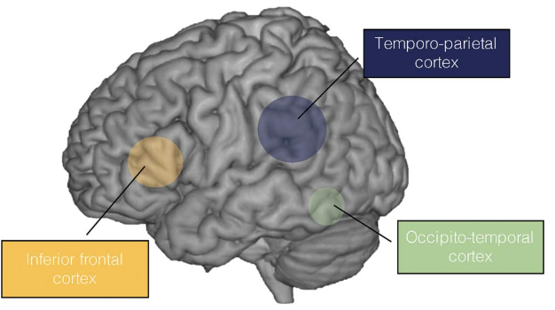
Figure 1. [5]

The Cerebellum is functionally and anatomically connected to the temporo-parietal and frontal regions, which is important for complex phonological processing and verbal working memory and motor processing. The hippocampus plays an important role in this campaign of verbal and phonological processing as memory as inevitably important role in this process. Individuals who suffer from such a neurological disorder is shown to have a decreased activation level in the hippocampus which decreases the remembrance of language and phonological representation; even though this is an affect in the short-term memory, long term memory is also affected. [7]

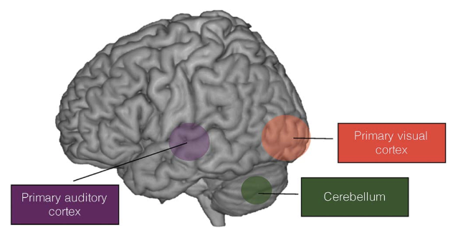

Figure 2. [5]

The superior longitudinal fasciculus provides better phonological awareness due to its association with the connectivity tract. This tract is important in the mapping of visual word information with meaning [6]. This also meanings that it is associated with better reading skills and the visual processing of the words in conjunction with the mapping of words [6]. Alongside this evidence, other data proposes that the supramarginal gyrus and the posterior superior supports phonological coding and graphemes phonomime translation. An inflammation is an often occurrence in the parietal lobule of the brain, this is largely due to anxiety of the individual who are struggling to decode and encode strings of letters where signals are lessen to their usual strength, further developing anxiety-like symptoms [6].

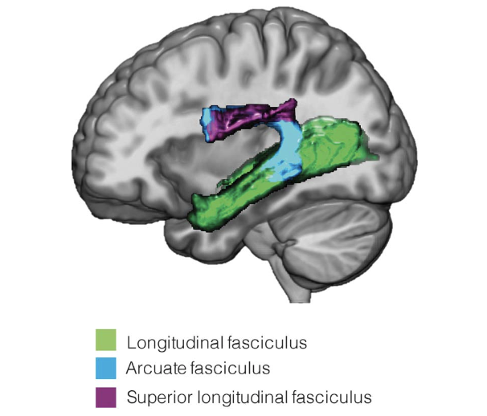

Figure 3. [6]

Methods of Teaching

Orton-Gillingham Approach

The Orton-Gillingham Approach was devised by Anna Gillingham and Samuel T. Orton as an approach to teach those suffering with language-processing deficiencies such as Dyslexia, something that was a mutual interest to both Orton and Gillingham. The approach demonstrates different methods to teach those with the previously disclosed deficiencies [7]. These approaches involved applying phonology, syllabification and morphology as well as others. Other parts of the approach involved the encoding and decoding of language, and how their different elements makes a construct. As stated by Kristin L. Sayeski in her paper, the Orton-Gillingham approach can be expressed as methodologies, that follow multisensory, cognitive, flexible and explicit [7] During the late 1930s, Orton and Gillingham had split on their research and devised similar but separate approaches, since this event, the two approaches has since conjoined into one singular approach creating the modern Orton-Gillingham approach that we see today.

The Figure that we see below, provides an exemplary model on what the approach offers. Even though different pars are labelled numerically, they do not need to be followed specifically in that order. The Approach must follow the displayed fundamentals. These fundamentals such as Multisensory by making use of the brains visual and auditory centres in order to too achieve a greater understand and to develop muscle memory [7]. The approach is also sequential and incremental, meaning that each next step is built from the last, where it is built from the last concept. Feedback is another important part of the approach, whereby supplied evidence of improvement is given to the individual to build confidence, and to guarantee that the individual has learnt correctly. Individualized is another important aspect, whereby each requirement that are unique to an individual should be met specifically for that individual. Lastly, Phonograms provide a unique way to build a relationship between letters and letter combination as well as sound and explicit whereby nothing is left implicit, everything must be taught exactly what they need, where no assumptions can be made [7].
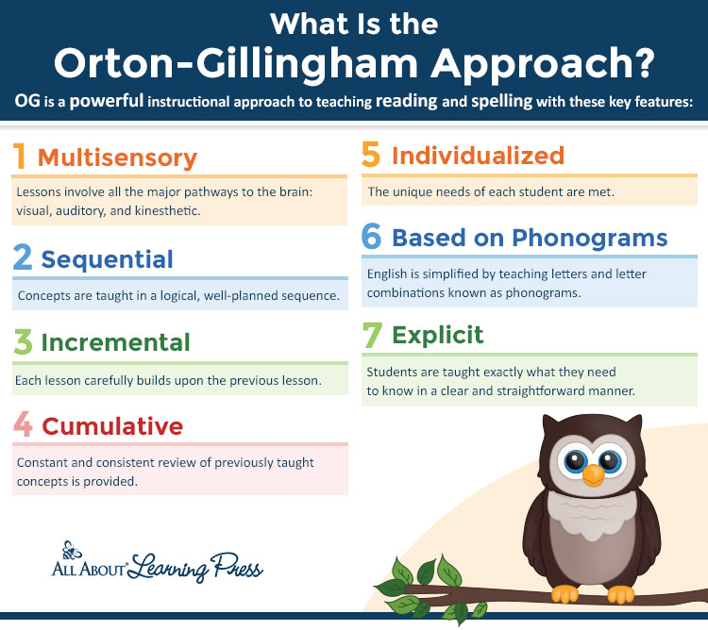

Figure 2.

Assistive Technology
Assistive technology has been used for many years, especially whereby budgetary requirements are high, and certain education institutes or organizations are capable for funding such technology. In the modern era, this technology has become less costly, and more frequent and can be free such as with Operating Systems like Windows 10 and MacOS [8].

As stated by the Welsh Governments Learning Division, Text-To-Speech assistive technologies can assist with the following. Reading Web pages, Reducing Eyestrain, assisting second-language learning, Checking word spelling and pronunciation. As stated by Lorna McKnight that many sources advocate for the use of text-to-speech and other audio solutions can provide a simplified and budgetary approach to teaching those with learning disabilities. Even audio-tooling for phonology has brought a greater method to supporting those with learning complications [8].

Phonograms
Phonograms are the core of any language, it consists of a grapheme (written character) and a phoneme (speech), whilst this is not a technological method, it is can still be applied to modern technology, and provide a good basis for different uses and is evident in the previously mentioned methods. Phonograms can be used to teach language through relationships by connecting sound and physical motion. As shown in figure 1 below, the right-frontal hemisphere controls the right hand, which is the most dominant hand for writing and the left is the language dominant hemisphere of the brain [9]. Note that in this figure, labels are mis-represented, as illiterates in this figure are people with dyslexia, and literates are those who are not dyslexic.

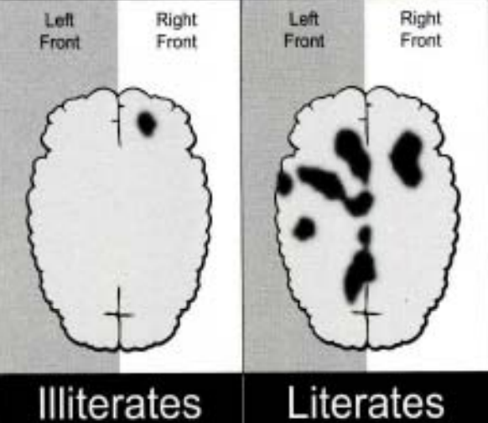

Figure 3.

In this figure, it shows a loss of relationship between physical motion and phonetics whereby even though both sides of the brain are inter-twined by sending and receiving messages, illiterates struggle to make the relationship between physical motion and phonetic functions [9].

Current Systems

There are many different solutions towards supporting those who are dyslexic, some of these approaches involve motor skills to emotional or physical stimulation. Such as using audio as a teaching method, especially in the modern world where majority of our learning tools are audio or visual. In our modern world audio books are a unique but modern way to teach those with dyslexia.

Audio Books

Hearing different words being pronounced, letters being said and whole paragraphs being spoken; this is especially effective amongst children, who take effort in mimicking speech and actions of others, this approach is considered the multi-sensory method [9]. Another solution is through Mobile Applications, as mobile phones are extremely common in society, it is not un-reasonable to believe that many students or youngsters have a mobile phone or tablet device.


Figure 5. WordLevel Audio books

Many of the younger generations are capable of understanding technology quicker than older generations. With this information, different teaching methods can be applied. Mobile applications that follow the multi-sensory method can be used effectively in nurturing a child or an adult in their education [9]. As there are many different tools available to support the education of those who have Dyslexia. A paper by Jorge Madeira, states that 17% of the population suffer with some degree of Dyslexia, whether it is minor or major, it is prevalent.

Incremental Writing

The traditional guidelines of teaching students with dyslexia involve writing shorter sentences, less use of upper-cased letters and prefer lower-case letters where possible, whilst avoiding underlined text, and bold letters as much as possible [10]. Largely this is usable and accurate, but it is also a partially outdated method of teaching, with technology becoming more prevalent, it is only natural that we should migrate to the latest forms to better teach the newer generations or improve the previous.

Mobile Applications

As stated in this paper, mobile apps are incredibly useful as an effective solution, especially to technologically literate children. The levels of interactivity and the ability to correct certain tasks as if they never happened, while allowing multi-sensory activities to commence. These can include, audio, physical and emotional stimulation that can provide a more unique and tailored experience towards supporting those with dyslexia [10].

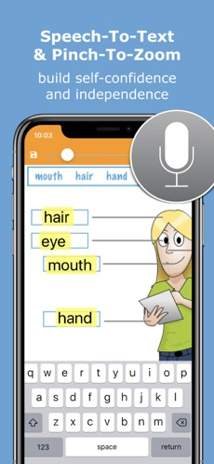

Figure 6. SnapType Pro Mobile Application

Text to Speech
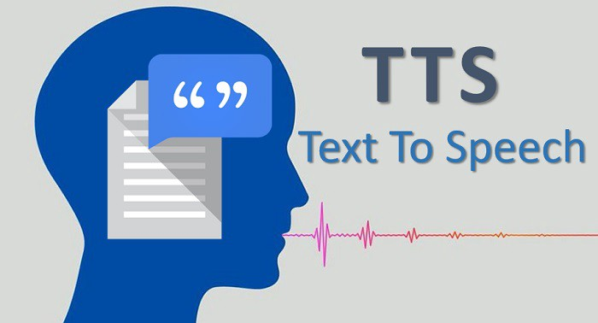
Other methods stated by E.A Draffran’s paper, supporting those who have dyslexia, is through text-to-speech systems that involve providing words from a dictionary or reading different user interface elements to the user, whilst this is incredibly useful it is avoiding the problem rather than providing a total solution, and as such should not be considered a total modern solution. This is largely due to the simplicity whereby users are heavily restricted to only text-to-speech systems, whereby users may refuse to attend to write or type their sentences and would prefer to use a system that does their pronunciation for them [11].

As stated by E.A Daffran, nearly 70% of students with dyslexia purchased an OCR or Optical Character Recognition with their scanners and printers. Even though this is largely useful, it is still avoiding the problem, whereby students could use a handheld OCR, or have to use an OCR implementation in their scanner in order to understand pages in a book is merely avoiding the issue [11].

Figure 7. Unknown Creator

Conclusion
In conclusion, the current methods towards teaching those with dyslexia are sufficient and usable but could always improve in multiple ways. Systems such as Text-To-Speech or Assistive-Technology have proven to be effective in teaching, and with their uses capable of being expanded to different areas, their uses could be more appropriately used or even mixed-together. Which comes to ending point and a possible solution. Even with Orton-Gillingham’s approach deeming to be the most effective and approachable methodology to teaching and supporting those with dyslexia.

In essence, this methodology can be applied to technology, and by mixing Assistive Technology alongside Phonetics, and a possible all-in-one solution could provide a more effective method to teaching; with Orton-Gillingham’s approach being the core and centre of the development. Therefore, a mobile application is the greatest solution. With this, users can simply use their own devices, saving different educational institutes a hefty amount of money, allowing them to support part of their budget elsewhere, as well as provide home learning for students who suffer with anxiety in a crowded classroom atmosphere. By providing this solution, students and even teachers can draw greater conclusions on how their students are working, and how they’re work is progressing. As well as being simple to use and understand, whereby older generations can easily learn and adapt to this method.

Chapter 3 - Research & Development Methodologies

Research Methodologies
The research onion was developed by Saunders et al in 2007. It describes a layered methodology for applying different research applications to different areas. Whereby detailed explanations must be given in order to gain an academic rational that is considered correct and provides credibility. Each layer has a different approach [16]. The philosophy layer provides a set of believes in which the author must obey, where this can be positivism as previously mentioned or epistemology [16]. The Approach layer provides two distinct approaches. These are deductive and inductive. Where Deductive begins with a theoretical standpoint to produces some form of output that provides further information. Compared to Inductive whereby information is given, and a theory is the output [16]. Strategy is more often the simplest, as it deals with the qualitative and quantitative data collection methods, whereby qualitative is a data collection method concerned with the quality of the data, and where quantitative is concerned with the quantity. [17]. Choices layer is mostly in accordance to the method mixing, whether research is conductive with a single method, or multiple method mixed [17]. Time Horizons is the time frame the project will last for, this can be cross-sectional, meaning the time period of the project is short but concise, or is it longitude where it can be done across many months or years [17].

Philosophy – Positivism
Whilst the project is based upon the phenomenology philosophy, some minor elements of positivism will leak into the project. Whereby the app will progress through cause and effect which is a part of the positivism philosophy. In conjunction to this, phenomenology is based upon a more subjective viewpoint than an objective viewpoint, whereby the development will not be approached through personal tastes, dislikes and likes; but will be approached through scientific reasoning, good practice and effective application design, even though this can harbour disadvantages, such as users not liking the design, layout or overall approach of the app, changes can be made to suit a greater crowd quite easily. As the development is iterative and feature driven, elements can be removed and added succinctly.[12].

Approach – Deductive
For the project, a deductive approach will be utilized in order to develop a confirmation rather than a theory. As the project already begins with a theoretical standpoint and a conformation to support the factual evidence and hypothesis. Compared to Inductive, the project does not end with a theory nor does it begin with an observation; therefore, the project will follow a deductive approach [13]. Especially as a deliverable is being created, it cannot be used upon theory, as there are no proven grounds that it operates as desired. There is fault in this which can maintain disadvantages, such as the lack of a theoretical standpoint because this could bring viable testable theories that are overlooked and un-recognized for their content and character. The approach to vaulting over this disadvantage is by developing possible theories into a factual entity, whereby it is no longer a theory through adaptability and exchange.

Strategy – Case Study

Case studies are a highly legitimate research methodology, that fits both qualitative and quantitative data [14]. In the sense that case studies deal heavily with the human psyche and the complexities that come with the scenarios that are within the case study itself. Case studies are also extremely in-depth, whereby missed insights and further information is not presented visibly. The disadvantages of this is that it’s immensely time consuming and lacking in great statistical information due to it taking such a long time. Even though this can delay the desired speed of productivity within the project, it can be re-directed simply by the change in the case study parameters in order to maintain a level of productivity.

Time Horizon – Cross sectional
As the project will be conducted a short period of time where testing can be conducted during development. As I do not need data or results that is across a long period of time, as the development of this project is iterative and will require constant refinement until the project completion or a stable level of satisfaction in the results. This does conflict with the Strategy, as case studies are time-consuming and depending on the parameters may take a certain time to fulfil each goal. This is a major disadvantage but can be diminished by altering the parameters of the case study and making pre-planned changes to certain areas in the project so that more time-consuming elements can receive more breathing-room.

Data Collection – Quantitative & Qualitative
As the project relies heavily on scientific reasoning, a more qualitative approach will be necessary in order to achieve this set ideal, as well as providing evidence of good practice and effective application design. But, in order to understand if the application has an effective design, a quantitative approach would also be required, this is largely due to the use of a case study, whereby data collected will be brought in from a specific user(s), as well as objective and subjective standpoints that prove the application to be functional, effective and reliable in the task and duty it was set to do [16]. A mixture of both Data Collection methodologies are somewhat of a hand-full and can stall the project greatly if not done correctly, these stalls such as effective application design can largely be subjective and a constantly changing variable, therefore it could possibly slow or completely stall the project till what is wanted is achieved. The Feature driven development methodology will help avoid this fault greatly. Feature drive development will allow the project to progress through features of the deliverable without slowing the project down as features can be added, removed and testing efficiently.

Evaluation Criteria
The evaluation criteria is an extremely important part of the project. For each feature, change and test it should fulfil a criteria in order to be labelled as done, complete or satisfactory. The applications functionality is important, whereby features and additions should be usable, performant and efficient in its goal. Questions such as is the overall goal still relevant is extremely important. As the overall goal should not change at all and should stay as relevant as possible. Another criteria, is the fulfilment of the output, does what results are inputted into the mobile application outputted correctly, such as the completion of levels, changes in user settings. Sustainability is another criteria that is impactful on the nature of the deliverable, as devices are updated frequently, changes to those devices might impact the application, therefore it is vital that the application is sustainable and can adapt to constant changes in operating systems, hardware architecture and so on.

Evaluation Criteria Summary
- Overall Goal Still Relevant?
- Input provides the Correct Output?
- Is the App Sustainable?
- Is it Adaptable to Future Software & Hardware?
- Does the App provide what its developed to do?

Methods of Testing

Project Inclusion

The methods of testing is applied by following majorly to the industry used tools.
Unit Testing will be used in order to sufficiently test the application. This includes but is not
limited to the testing of each component within the application. Meaning the views,
data input, touch response from the users touch screen device and so on.
Using GitHub means I Can perform GitHub actions, where I can automatically run these
tests every time I commit changes to the master branch of repository. This method is called
Test Driven Development where each change mostly a major change, will undergo a set of
routine tests in order to guarantee correctness of code and the best possible outcome so that
the application operates as planned.

Unit Testing
Unit Testing is the individual testing of small sections of code. These are typically automated by Continuous Integration providers. Such as GitHub or GitLab whereby Code can be tested as soon as changes are made to the central repository [21]. Even though Unit Testing is based upon small sections of code, it can also be applied to entire classes in an Object-Oriented Language or entire Modules. Unit Testing mostly compromises of contracts. These contracts must be satisfied, or the software build will fail and not continue with linking and building into an executable format or run a web server.
These contracts often contain assertions. Assertions are implicit conversations made between testing elements, such as test data, and the module, function or interface that you are testing. The benefit to Unit Testing is that it can be done early on in development and doesn’t rely on complete code nor does it rely on compiling whole programs as some programming languages and their testing facilities provide evaluation of tests rather than full program compilations [21].

System Testing
System testing commonly called Software Testing, is a testing methodology built upon running a system with the intention of finding faults. It is a more of an investigative approach to testing. System testing involves the testing of the completed product and its interface to other components [22]. Such as software which communicates with peripherals such as a keyboard and a mouse and testing their functionality within that System. System Testing compromises of a multitude of different testing such as a collection of software testing routines. Even though System Testing and Software Testing are used in conjunction with one another, they are somewhat different in that System Testing involves testing a collection of modules, to which are the software and each module tests itself through System Testing [22].

Usability Testing
Usability Testing is a common testing method used in mostly GUI driven applications or applications where human interaction is required for its functionality. Usability Testing consists of a set of objectives, and a user can use the software freely or with a certain level of restriction depending entirely on what is the desired outcome of the test. This testing will be observed and analysed on a set of different guidelines, such as how long it took a user to complete a task, what is the ergonomic quality of the software, number of times a user approached a task without or with errors. Within this form of testing, recommendations and a review is written by the user to improve the software [23].

Acceptance Testing
Acceptance Testing is a methodology whereby software is tested purely on the satisfaction of a set of requirements and whether it complies with software standards, or complex with business standards. This also involves an assessment for delivery on whether the software can be delivered by following the assessment requirements. These requirements can involve the performance and effectiveness of the software, more often than not Usability Testing can be involved in this process as Usability Testing has a lot in common with the practices of Acceptance Testing, therefore these two methodologies are often used together [24].

Development Methodologies
The development methodology chosen is Feature Driven Development (FDD) []. It is a set of practices whereby the development of software is incrementally and iteratively produced based upon features added to the software. These features are client-based functionality, but as there is largely no client, the development strategy is largely based on what is believed as required to maintain the correct functionality and to sufficiently map progress. This a benefit, an advantage to the development of the application but there is a distinguished disadvantage to this also [25].

Whereby in the development unnecessary additions may be made that isn’t required or needed and may waste valuable time that could be utilized on other parts of the application, such as where there may be a deficiency. Alongside this as previously stated, Test Driven Development will pair extremely well alongside FDD, this is due to their parallel nature where each feature can be tested through Unit Testing providing a level of correctness in the code and the applications usability [25].

The figure below shows the methods applied in Feature Driven Development. Whereby an overall model is made alongside a Feature List and a Plan which turns into a Design by Feature. Even though the development followed this, Plans were not made, were a more trial and error phase was implemented rather than the Plan phase. So that the application could be developed within a short period of time without sacrificing valuable time. It should also be noted that Feature Driven isn’t completely dependent on a single stream of phases, it can also be adapted to be a repeated step, such as the Feature List and Design by Feature was conducted back and forth so that trial and error could occur.

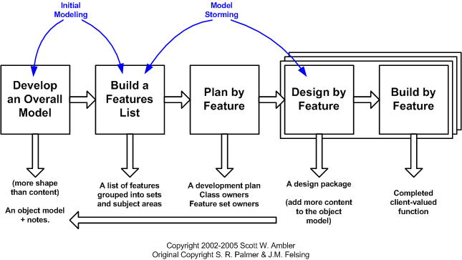
Figure 11. Scott W. Ambler

Resources
The application has many resources, largely cheap and affordable but sufficient enough in order to maintain a good level of progress, accuracy in the code and application, and further progress towards the overall goal. Resources such as a Digital Ocean droplet to run a backend if a backend is required at the final state unless data can be stored locally. This droplet will allow a virtual machine in order to conduct data analysis and storage, as well as a location for testing, where Unit Test data and operations can be sent to rather than relying on GitHub Actions. GitHub is another resource, this is where the source code will be kept, and where versions of the software can be managed and documented in order to succinctly document every last piece of the software. This is also where I can create different branches also called versions of the original code to run unit tests and perform other actions on specific parts without compromising the master branch with broken changes that are being tested and altered. Which in turn will maintain a level of best practice within project.

Hardware
Hardware is largely a MacBook Pro 15 inch, with a i7 at 3.5Ghz, 500GB SSD, GTX 760M 4GB video Ram, Raspberry Pi 3 with a 64-Bit Arm CPU 16GB SD card and a 1TB external drive for data keeping. This Raspberry Pi 3 is also running a custom altered version of Debian as a local server for testing when the Digital Ocean Droplet Server is no longer required. As this is major project, a small set of hardware is largely required, and due to the use of iPhone and Android simulators that can run on the MacBook Pro, a physical mobile device is largely not required for this project.

Software
In regard to software, there are quite a few. PostgreSQL database is used if required for backend functionality as alongside Scala using the Typelevel Stack, which includes a set of libraries called, Doobie for Database control, Circe for JSON parsing, Http4s as the https server, Cats for category theory and purely functional programming built on mathematical abstraction, and Cats-Effect in order to have the IO Monad and Resource Monad for greater concurrency style and to provide asynchronous and synchronous code. For the frontend, being the application, the Flutter framework will be used, which is a cross-platform framework for mobile and desktop development, whereby the app could be an Android, iOS, MacOS or Windows Desktop Application, all from the same code base. Making cross-platform easier and simpler from one programming language called Dart. Even though this is a major advantage, having a single codebase for multiple devices, as well as having a set of Scala libraries for functional programming to maintain side-effects and to guarantee correctness of code whereby unit testing may not be required, this is also a danger, as Flutter is still somewhat in its infancy, even though its proven useful in its industry use such as Google Maps and the Google App Store. The use of Functional Programming Oriented libraries means that even though a level of abstraction is gained, it can make code somewhat harder to understand if another user does operate on the same code or level of abstraction such as Category Theory application in Functional Programming, these applications include Monads, Monoids, Functors, Applicatives, Kleislei and so on, as well as having to manage an ecosystem of libraries where updates are frequent and somewhat constant. Another thing to note, SBT or the Scala Build Tool will be used as the build and packaging system for the application, SBT means dependencies and software structure can be fitted correctly, as well as enabling compiler flags to add more warnings so that code can be functionally correct.

Lastly, Docker will be used. Docker is a container system that allows users to contain their applications inside of small instances of an OS. In this case the written Docker containers will be running a Linux container, where It will run the code and which Docker will allow users to run and build the app or work on the app without the need to install many of the dependencies, where in some cases some libraries are platform specific, but with docker that issue is no longer. Should be noted that the use of Scala, SBT, Docker is largely dependent on whether a backend, database and server is used, as data could be easily managed on the user’s device that is also shared amongst their respected cloud platform, such as Google cloud or iCloud.

Chapter 4 - Design & Implementation

Design
Requirements were set front the beginning, they are simple requirements as an app of this magnitude does not require anything sophisticated. The requirements are as follows

- Follow a Simple Design
- Be Colourful, Exciting, Modern
- Colourfulness should not breed un-readability
- Buttons should stand out and remain where necessary
- Pages should be self-explanatory or make use of a simple title
- Taptic Feedback on button press is optional, but if possible, it should be added
- Taptic Feedback should include a response, Colour Changes, Sound, Vibration
- Dark and Light Colours must not clash too heavily
- Levels must be self-explanatory and simplistic

The idea behind these requirements is simple, as the app is more focused on providing an implementation of the Orton-Gillingham approach, it allows some legroom for a simple design. And with the target audience being mostly children or young adults, it should be modern, exciting and colourful in order to grab the attention of a younger audience who can easily be distracted. This should also be taken into account where colourfulness could be a disadvantage as colourfulness can distract the user heavily, and as it is targeted as someone who is dyslexic, they may find it difficult to read or understand certain letters or words, this can also be mentioned with the fact that buttons are required to stand out, be easy to read, font must be at a readable and stable size for all mobile devices. Following the Simple design requirement, Pages should be self-explanatory based upon their contents or the icon that address which page it is, therefore allowing more room for greater content that is useful for the user, rather than a description of each page.

Taptic feedback for all of the mentioned elements is important, as many people may press a button with no feedback from the device can somewhat confuse the user into believing that they didn’t press it right, or that their device isn’t working correctly, therefore some form of feedback such as Colour Changes, Sound or vibration is necessary in order to maintain a consistent design. Dark and Light colours cannot clash too heavily, as previously mentioned readability is important, and those with dyslexia attempting to read certain words or letters are required to be able to read those words and letters consistently and easily, as no user should have to re-read words more than twice. Levels must be self-explanatory; this is somewhat un-avoidable as all levels provide somewhat of a basic and simple system that are all largely similar so that there is a level of consistency, therefore levels will maintain that level of consistency due to their small nature and simple execution.

The Design went through a few stages. As an industry or professional practice system was not used, I relied heavily on trial and error by testing designs, rather than mocking them through wireframes, photoshop and illustrator. This choice was largely due to the fact that, if a design was made or several, it would take a considerate amount of time to implement the design into the application, and whether that design worked or not, due to the structure of Flutter, it would’ve meant major alterations or a complete restart would need to occur, which would take a considerable amount of time. Even though this would harm the design phase, I managed to work around it. I followed the previously mentioned trial and error in order to test quickly different layouts and designs without trying to get a specific layout or design. Below are two images of the two major designs. Between these images were a mountainous amount of changes. Such as Font Size, Colour and Buttons, Typography, simplicity, whether a menu bar at the top or bottom was necessary or just to rely on buttons

Wireframes

The First Design Test
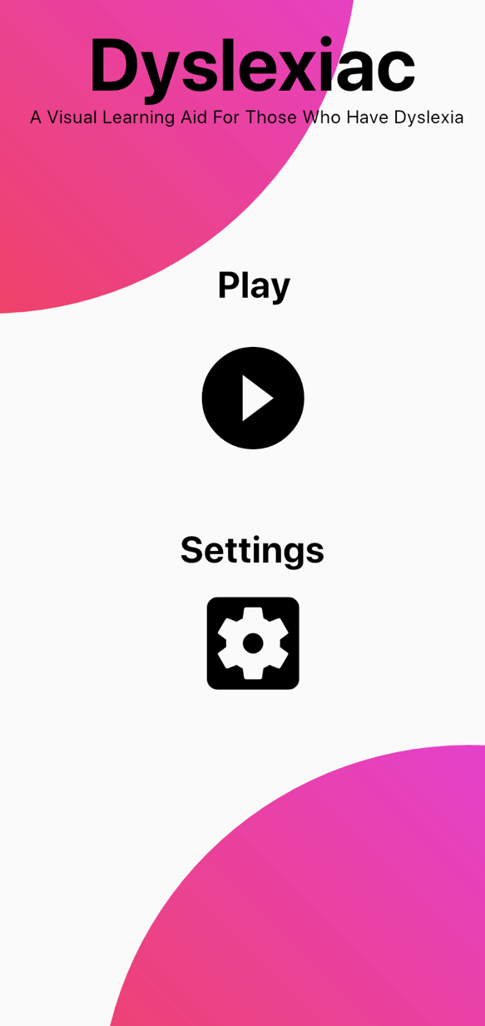
This design, even though it is visually pleasing, colourful, abstract and minimalistic. It looks very barren, plain and boring. Granted its goal is simplicity but it fails heavily in making it look alive. The colour balance - black and pink will make it more difficult for users whom are dyslexic to read it, especially the sub-title font-size. Even those who aren’t dyslexic may struggle to read the letters correctly. The icons are boring, plain and flat. Even though they follow a well-used Material Design, they still lack any balance amongst the rest of the design. Sadly, this design lacked anything unique, each page was the same as before in order to reach the goal of consistency and so that the human eye does not need to retrain itself on the colours, imagery or objects that are seen, so that the user can focus to a consistent level. Buttons did not highlight, or offer any taptic feedback, such as changing colour, vibrating or make a sound.



Figure 8.

Figure 9. Unknown Author

As shown in Figure 9, it is quite a flat and boring set of colours that does may provide readability issues, as it is largely a “girly” colour scheme. It is not the goal of the app to create an mobile application for a specific gender, as it should be neutral.

The Second and Final Design Test

The final design, which was the second, it should also be mentioned that in-between this design and the first, a large portion of trial and error occurred to gain something that fitted the mobile applications ideals. The pink doesn’t blend with any of the colours, it should also be mentioned that the wave image that covers have of the app, is an animation to make the app seem livelier without maintaining a boring and basic minimalistic design. Each page uses the same animation background to maintain consistency, so that the human eye does not need to retrain itself to focus on new imagery, where each page relies on similarities to keep a level of focus. Something that the previous design failed at.

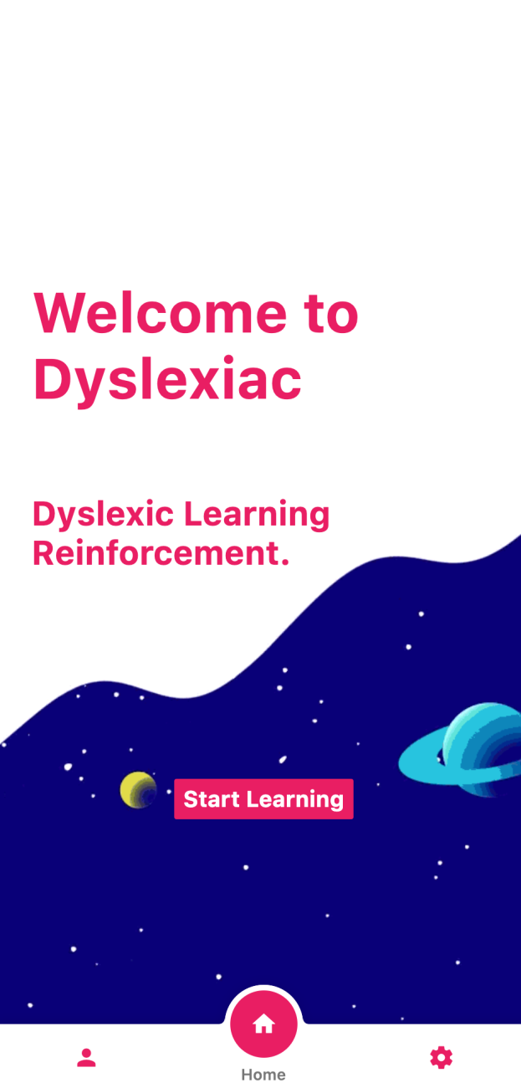
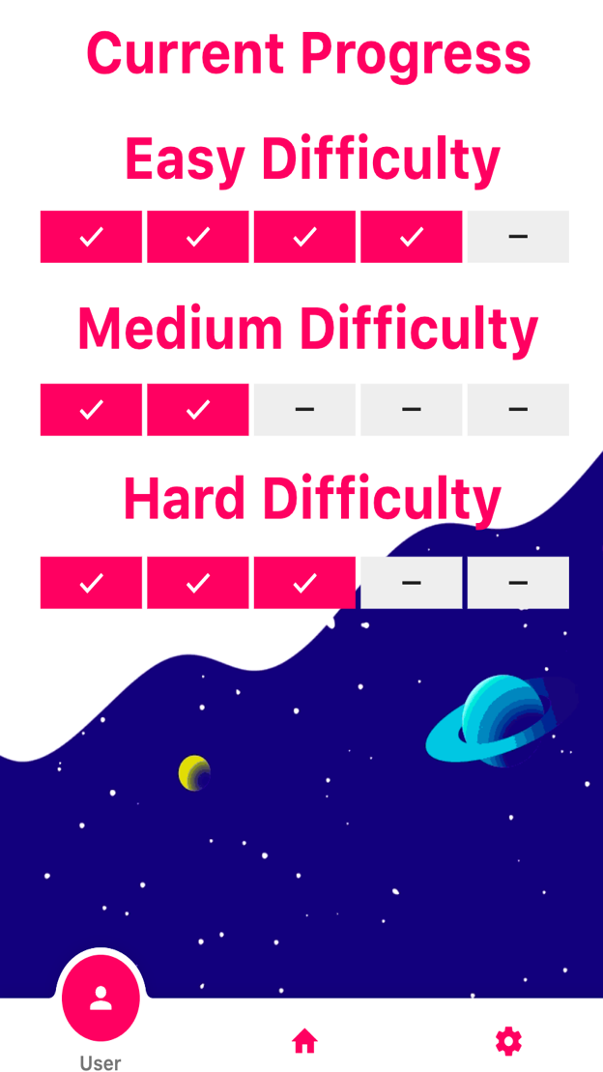
Figure 10.
Figure 11


The colour pallet for the second design follows more an vibrant and exciting colour pallet, this is largely due to the calming nature of blue, as such as that Blue is often found in mental wards and hospitals as its considered a calming colour, while white and pink are considered neutral colours that do not impose any emotion. These colours are not gender specific, whereby socially pink and purples are considered “girly” colours, therefore a choice of a blend provides a level of neutrality.

Figure 12. Author Unknown

Implementation
The implementation was somewhat simple to implement. Due to the previous method of trial and error by developing the visual components of the mobile application meant that there was a framework ready to use for the implementation. This cut down production time considerably, as a large portion of the User Interface, and User Experience was complete. The tools used to carry this out was with Flutter, luckily with Flutter it allows Hot Code Reloading; meaning changes can be made and it will show on the mobile application instantly, no need to recompile the whole mobile application or reset connections for the backend. Large parts of the UI, especially being the bottom navigation, was from a package; sadly, due to that package being out of date and no longer supported in the current Flutter version, it meant it had to be re-implement. This compromised of developing this library using different techniques and style, coming mostly from a Functional Programming background, which was used to implement large portions of the library using functional techniques that allowed the code to be up to %3 shorter due to the level of abstraction that was possible. The Text Editor used was Visual Studio Code, a lightweight cross-platform modern text-editor running on Electron; the community has developed many packages for it that makes development, simpler and easier, due to the reporting of type errors in my code before changes were made to the app itself, as well as displaying the actual colour of hexadecimal representations of that colour. It comes with a debugging facility where breakpoints could be set, as well as a UI for step in and out of code, as well as conducting on the fly unit tests. This UI also showed an extremely detailed tree of different classes and their hierocracy and the same with types. Lastly, VSCODE had routines to run the app depending on the outputted platform, as well buttons to either hot reload manually or on save, run and stop the debugger, restart the application, or restart processes, offering a considerable amount of control of the emulator and the mobile apps State.

Many issues came around during the implementation. Due to the age of Flutter and it being a young project that is production ready; it’s speed and performance was limiting, luckily Flutter can compile for multiple platforms, such as iOS, Android, macOS, Linux and Windows, the last 3 being desktop applications. A major issue for the application was the speech recognition. Luckily there is a package library for this facility that works across all devices. The main issue with this was that it was somewhat outdated for the current version of iOS, which made a goal for me to implement latest iOS support.

Below is an example of code. First, first we create an instance of the SpeechToText class, then we check whether we can initialize the instance, do a quick if statement check, if true then listen for the users voice else just tell the user that it does not work report the issue then stop the class.

import 'package:speech_to_text/speech_to_text.dart' as stt;

stt.SpeechToText speech = stt.SpeechToText();
bool available = await speech.initialize( onStatus: statusListener, onError: errorListener );
if ( available ) {
speech.listen( onResult: resultListener );
}
else {
print("Please check system settings, or enable STT");
}
// some time later...
speech.stop()

For the project, no pattern was used due to the fact that the mobile application is not built industrial scale use. State is managed internally by the Flutter Runtime; even though I could have used the Bloc pattern which is a pattern to manage the State of a mobile application by the use of a class hierarchy. For testing, there was no need for major unit tests, the mobile application can be tested simply by using it in the emulator. That being said, some tests were run with expected results, these unit tests were simple widget tests to guarantee that switches, buttons and so on sent their State to the Flutter Runtime. As I was following a Feature Driven methodology, it involved a set of routines; these routines includes a Feature List, this list contained features that were required or option as shown below.

Required | Description | Optional | Description
Page Navigation | Allows the user to navigate pages | Player Profile | Players profile, showing level, experience points and profile image
Speech Recognition | For the user to say the words in the game and report correct or false | Backend Support | Database support, login using Google or FaceBook
Progress Reports | Display progress for the user | Settings Menu | Alter app settings such as colours and data tracking
Tablet/iPad Support | Support the app for tablet users. | Mailing List | Email users about their scores, reports or email parents to report their progress, and email updates for the app current and future
Allow Screenshots | Allow users to screenshot their progress to be up uploaded to other sites. | Notifications | Notify users on their progress, to finish a level or to congratulate them on passing a level
Show Terms and Conditions | Display terms and conditions on the first launch of the mobile application

In this list, it’s clear what is required and what is optional. As a mobile application is large prospect, not every feature is labelled on the list. Some of these include Desktop support, as it’s a smaller market where portable devices may be a greater one, but Desktop Support is viable with Flutter.

Following this Feature list, its noticeable that some of the requirements such as navigation and progress reports are shown in the design screenshots, this is due to the fact that Feature Driven is also design by feature and build by feature. Meaning that the elements in the Feature list is used to design the app and some of not all of the required features must be in the mobile application.

As mentioned, Chapter 3 Section 3.2.2, Docker and Scala with SBT was going to be used, this has become an issue, Docker support for Scala is largely dependent on the creation of these containers by the community. The community has created containers for Scala SBT, but they lack updates, and do not allow the exposure of ports and concurrent running of docker containers, meaning that the backend cannot communicate with anything outside the container which made things problematic. Even though the project could just run and write code without a container, the overall goal was for cross-platform, and doing so without a container means that users must have the same dependencies and tools on their system in order to run and build the backed.

Chapter 5 - Evaluation
The project went smoothly, even though there were many hiccups and walls in the way, a large portion was complete. The data received from the research as well as the app itself, provided unique and specific data on the behaviour of those with dyslexia, it should also be noted that there was not enough time for testing, other than a subject who suffers from Dyspraxia and Dyslexia found the application useful, but concluded that at her age of 22, that it appears to be something better for a younger audience such as 5 to 14 year olds. Due to its simple nature. The objectives were mostly all met, other than research into the current mobile application ecosystem and interviewing a collection of candidates to test the mobile application. Even though these are minor objectives, the latter is extremely important, and something that the project could benefit from. Objectives such as researching development practises was met, as they were evaluated and analysed Feature Driven Development, as well as the analysis of different testing methods in the Design and Development phases.

The evaluation criteria that was put in place fulfilled a large portion of the goal of correctness. The overall goal remained the same throughout the project, where there was no differences and changes that would affect that. Furthermore, the adaptability to newer devices, operating systems and system methods is also fulfilled as Flutter is in its infancy, it has a lot more modern software and hardware to accommodate, and when the app no longer works on newer devices, the simple case of recompiling for that new targeted platform will make adaptability extremely easy. The other case for Adaptability was that in some apparent times, when running the app on an iOS emulator the UI would look correct the buttons would fit in the correct spaces adjacent to others, and colours would blend correctly with others or in some cases just be the correct colours. When testing for Android, this was a huge issue as rendering on the two devices were different and would cause minor issues but luckily this was a simple fix of changing the rendering engine in the Flutter Config files.

There are some things that were difficult to do, and some were proven suspiciously easy. For example, the designs, it was difficult to accommodate such a large audience, especially when the platform is not established already, but like Twitter, Facebook and Reddit where users are used to the UI and the mobile applications were built on already created foundations. This was apparent to me as an issue, I believe one of the biggest issues was the lack of designs and analysis of other mobile platforms that accommodate the same audience or a similar audience the use of trial and error proved incredibly useful for a short length project such as this. Where some may spend Weeks or Months at a time developing designs, conversing with specialists and talking to artists. Alongside this report the app had to be designed and implemented as a one-man project. Due to this, the choice trial and error proved useful, where designs could be implemented on the spot and toyed with until a certain desired point could be met, as stated in my Design in Chapter 4, I had certain goals for the design and to fulfil that criteria for the design whereby that was an objective and an aim in and of itself. The two designs that were shown followed those principle objectives and aims, and were useful in acquiring a specific look, feel and experience that the user may gain.

One of the objectives was the analyse data, read truthful academic resources and provide detailed analysis of my findings, this is believed that this was achieved greatly. My analysis of Dyslexia showed many data-oriented statistical information as evidence towards Dyslexia and a detailed explanation of Dyslexia itself, alongside this even more detail was gained by providing neurological evidence, by showing different parts of the human brain and the activity that dyslexia plains in those areas, that section plays an important part in the evidence as to show a more medical and biological side rather than just statistics to which is how that objective was met.

Further information gathered from my literature review was the Orton-Gillingham Approach, which is a set of methods to teach those with dyslexia, though re-iteration and constant application. This is something that feel that was met, as the apps levels are iterative and constant where users play levels that they have previously played but with minor differences, even though the whole Approach was not implemented a large portion of it is, such as connecting words with sound and letters with sound, so that when users speak the letter or word it tells them whether It was correct or not, which was the minimum requirement to fulfil the Orton-Gillingham Approach. Further research conducted involved looking into the current and modern applications used by those with Dyslexia. Text to Speech is the most common, as nearly all devices, mobile applications and websites support Text to Speech, including operating systems such as MacOS and Windows, whereby users can hear whole paragraphs or web pages if needed, or even select small portions to hear individual sentences. Another modern application used are mobile applications, whereby users can take photos or scan text with their mobile phone, and it will either translate, or play a form of text to speech to the user or display the text in the app using a more appropriate font. The literature review is a section that could be done differently. More improved academic research on Neurological Evidence would have provided a clear and concise evidence-based argument towards the comparison of Neurology and the Orton-Gillingham approach. Something that was lacking and would provide a greater detail towards the conclusion and final approach towards the deliverable.

The analysis of Testing, such as Usability Testing, System Testing and Acceptance Testing provided a unique view on Testing theory in a practical point of view, such as testing the mobile application in a real environment, testing if the mobile application fulfils the aims and objectives, and whether the performance is suitable. Alongside this analysis it provided a unique view on the Industry used techniques, finding that Unit Testing is an extremely popular methodology when testing different software, especially large-scale software whereby Unit Testing libraries can provide a greater step towards proving the quality and effectiveness of software. The analysis of different development models provided a unique perspective. Which I chose Feature Driven, the choice in this model proved useful, it is an iterative approach therefore provided a cycle that was adaptable, even though feature driven has a set of guidelines, they can be broken, therefore the model was bent, twisted and turned to better fit the project goal. Such as that the features were built on a trial and error methodology so that the speed of development could be greater. This worked well, as such that testing different colours, animations, UI components and so on allowed a concise and fluid development. This did provide a basis for further exploration as more time was given towards different areas, these areas such as creating new libraries to support the design.

Chapter 6 - Recommendations
The overall project was difficult and immense. Research was conducting iteratively, whereby during the design and development of the deliverable questions were asked and researched in parallel. Such as the neurological evidence, when the design was being created, the idea of the psychological changes with design brought to attention to analyse and research the neurological side of Dyslexia. This was a great investment of time as information could be greatly improved and a more medical approach could be applied in my Literature Review. The analysis of the current ecosystem of tools, software, physical and virtual solutions proved useful in the research, allowing a greater aspect for the mobile application overall, especially with Text to Speech whereby it could utilized this convention for the app so that users could say words and letters instead of just typing them, which vocalisation is a greater asset towards applying the Orton-Gillingham Approach. The research on the Onion was immensely useful, understanding each section, applying advantages and disadvantages to each one, understanding the short comings in the area and applying fixes, as well as developing a conscious image of what is ahead in this project. In Chapter 3, an Evaluation Criteria was written, this was followed to the letter, and posed a great improvement to the overall workings of the mobile application, as well as being applied to the rest of the research.

The mobile application was lacking in some areas, these areas such as customizability, especially if the user is meant to use the device for long periods of time, it would be better if there was a different style, animation, colour, or even a profile whereby the user could save information and details on their progress to share with family members or friends or even teachers. Levels created were quite simple and somewhat simplistic and could have done with a greater additional difficulty, even though they did progress into more challenging levels, the medium or hard difficulty didn’t appear to provide any challenge, which is a shortcoming of the mobile application. Logging in would have improved the app heavily, users tracking their progress, as well as providing statistical evidence and analysis of the user’s progress throughout their experience. Even though all these additions would make the app better, there are ways in which the app could have been developed differently. Performance improvements could have been achieved through the use of their platform depended languages and frameworks. Such as Apple’s is Swift with their SwiftUI which can be massively more performant than using Flutter. Android makes use of Java and Kotlin which the latter being the currently first-class supported language, meaning that Kotlin has gained Googles approval and is the main and largest support language for that platform. For Desktop C++ with QT or Electric using Web technologies such as JavaScript, HTML, CSS with a framework such as React or Angular or even Vue would have provided a somewhat performant version as well as being able to provide a web client if a web version is required. These are all improvements and somewhat of a benefit to the used method of development, even though Flutter provided the ability to use one framework, one language with all platforms with a fairly performant application, issues such as networking, graphics rendering, optimizations were difficult to improve with Flutter, therefore the use of Java, Kotlin or Swift or the slightly outdated but still used Objective-C for the iOS platform, would have employed a unique and effective set of tools to improve the application in its speed and to provide networking capabilities such as the logging in, better database creation and entry, as well as more learning resources, greater documentation from the authors and more support from other developers in different chat-rooms, forums and websites.

Chapter 7 - Reflection
Throughout the project is was quite a challenge, a lot of research had to be conducted through academic resources, providing academic intellectual reasoning and applying to the research under each heading. Analysing different areas of the research in application of the deliverable, as well as providing evidence through references to support my arguments and ideas, unless I have shown an empirical point of view. Analysis of Research methodologies so I could better guide my work towards a goal, the Research Onion was used to provide a clear stance on each layer of research, which further allowed critically analysis of different sections of the report. Further analysis of the Aims and Objectives so that I could understand what my goal was, which such a large project, its key to remember what I was doing, why, the goals that are required and what I’m trying to achieve with these aims and objectives. As this is a deliverable, I was required to provide some testing, these testing methodologies provided a unique perspective on testing my system through Unit Testing, System Testing and so on. Provided with these methodologies, the design came in place, The choice of Feature Driven allowed a specific allocate of time, as well as a method of developing an application through iterative and feature driven means, with this I did decide to somewhat alter the methodology by applying Trial-And-Error to the iterative process, which allowed a more faster-paced and pin-point development.

The implementation was the next phase, During the designing phase, no wireframes were used, only a colour pallet for colour goals and a trail-and-error. I made use of Flutter and hot-code reloading abilities so that I could make changes and see them instantly. I chose two colour ranges for two designs and did trial-and-error within the Feature Driven cycle, testing features through this trial and error provided some more time to work on the report itself or on other designs or create the library for the navigation bar and so on. After the implementation a strict evaluation was ongoing, evaluating the whole project, including the implementation and written work so I could understand what I had done correctly and incorrectly, my weaknesses and my strengths, as well as a detail look into the sections that were most important in the projects.

This report was somewhat stressful, the parallel nature was something that I was lacking as a skill, I felt that I managed my time inefficiently, trusted resources for large parts of explanation rather than conducting more, I also felt that even though my academic writing had improved, the elongating of words meant that I did not get to the point as fast as I should have, meaning I lost a lot of time and wasted a lot of the time over-explaining certain parts. My time could have been better managed through applications and perseverance to not lot my mind wander or get distracted. During the report I felt more confidence, my academic writing improved and the addition of more medical-oriented information in the literature review allowed me to express my academic side, even though I do feel as if I did not provide enough information in those sections, which was a let-down. My multi-tasking was lacking in efficiency, I failed in some areas to maintain a parallel nature in conducting research. alongside designing and developing the implementation.

Even though these short comings were prevalent, I believe my ability to learn a new technology, as well as implementing that knowledge into a mobile application provided a good new set of skills. As well as an intellectual curiosity into the medical portion of the research, learning about topics whereby they are alien to me. Fulfilling the objectives were key to some form of success, as well as reaching most if not all of the aims. Providing me with a key set of self-guidance as well as supporting improvements throughout the project. Even during the project support with Flutter and finding resources was not required and was done completely on my own accord, as well as providing my own library, something that gave me adequate experience in creating a library to support my project as well as furthering my own skills towards an industry level, as the library provides a set of routines built upon being reliant and re-usable, which is one of the requirements in industry grade software.

Overall what I learnt was that the project was a major challenge, intellectually stimulating and a personal goal. The skills I had were somewhat not enough, time-management could have improved greatly to manager time greater especially towards more research, more features for the mobile application, as well as more freedom towards other goals within the project such as the design which could have been improved. That is also a skill that was lacking, whereby a greater design skill would have proven to me to make a more attractive app and a more attractive design overall, especially as 2 designs as I believe now could be 3 or 4 more to provide a greater range of choice in the implementation. I believe I should have gone for a more supported and knowledgeable tool for the implementation, so that support and guidance could be gained easily and without fear of failure or premature functionality. My progress throughout the project was smooth and the end goal was achieved. But greater research, development and knowledge could have improved the academic and intellectual portion, as well as greater structure and more concise writing throughout the project itself. The project reached its goal, research was conducted correctly and through academic means, but lacked greater management of time and the lack of a multi-tasking skillset proved to be a disruption in the processes of the report. If I could repeat this process again, managing my time through an application such as Trello or Toms Planner, even a mobile application so that I could specifically allocate tasks for the project amongst my job, hobbies and other classes I attend. Understanding that using the newest technology is not often the best choice, as older technologies are more battle-tested. And conduct greater academic research within the realms of intellectual ideas and philosophy to provide a standpoint for further exploration and a more concise, academic, philosophical and technical writing.

Chapter 8 - References
[1]. Cramer S. Dyslexia International: Better Training, Better Teaching. Dyslexia-International.Org. 2019 [Cited 22 October 2019]. Available From: Https://Www.Dyslexia-International.Org/Wp-Content/Uploads/2016/04/Di-Duke-Report-Final-4-29-14.Pdf

[2] S Hughes. The Orton Gillingham Language Approach: Research Review. Nessy, British Dyslexia Association 2014 [Cited 23 October 2019]. Available From:
Http://Www.Nessy.Com/Us/Files/2014/06/Orton-Gillingham_Report-Final-Version.Pdf

[3] Ebere Sunday Chisom. Understanding Autism. University of Nigeria. April 2016 [Cited 23 October 2019]. 10.13140/Rg.2.1.3292.4566. Available From: Https://Www.Researchgate.Net/Publication/301284556_Understanding_Dyslexia

[4] Jill Hammond And Fabian Hercules. Understanding Dyslexia: An Introduction for Dyslexic Students in Higher Education. The Glasgow School of Arts. July 2013 [Cited 23 October 2019]. Available From: Https://Www.Ed.Ac.Uk/Files/Imports/Filemanager/Understanding%20dyslexia%20inc%20addendum%20feb%202015.Pdf

[5] Anila D'Mello. Cognitive Neuroscience of Dyslexia. Massachusetts Institute of Technology. 2016 [Cited December 3rd 2019]. Available from: https://www.researchgate.net/publication/328824514_Cognitive_Neuroscience_of_Dyslexia
[6] Tanaka, H., Black, J. M., Hulme, C., Stanley, L. M., Kesler, S. R., Whitfield-Gabrieli, 2011. The brain basis of the phonological deficit in dyslexia is independent of IQ. Psychological Science, 22(11), https://academic.oup.com/cercor/article/24/4/989/325113

[7] Sayeski, Kristin & Earle, Gentry & Davis, Rosalie & Calamari, Josie. Orton Gillingham: Who, What, And How. Teaching Exceptional. Children. December 2018 [Cited 28 October 2019]. Available From: Https://Www.Researchgate.Net/Publication/329761545_Orton_Gillingham_Who_What_And_How

[8] Tessie E. Rose. Orton-Gillingham Methodology for Students with Reading Disabilities 30 Years of Case Law. University of Nevada Las Vegas. March 2007 [Cited 23 October 2019]. Available From: Https://Files.Eric.Ed.Gov/Fulltext/Ej785952.Pdf

[9] Unknown Author. The Dyslexia Toolkit an Essential Resource Provided by The National Centre for Learning Disabilities. National Centre for Learning Disabilities. No Date [Cited 29 October 2019]. Available From: Https://Www.Readingrockets.Org/Sites/Default/Files/Dyslexiatoolkit.Pdf

[10] Welsh Government. Assistive Technology Guidance for Teaching Practitioners to Support Learners with Specific Learning Difficulties. Welsh Government Support for Learnings Division. December 2018 [Cited 5 November 2019]. Available From: Https://Gov.Wales/Sites/Default/Files/Publications/2018-03/Assistive-Technology-Guidance-For-Teaching-Practitioners-To-Support-Learners-With-Specific-Learning-Difficulties.Pdf

[11] Larna Mcknight, Current Perspectives on Assistive Learning Technology. University of Oxford. December 2012 [Cited 5 November 2019]. Available From: Https://Www.Emerald.Com/Insight/Content/Doi/10.1108/17549451211235000/Full/Html

[12] Dr Duncan Milne Neuropsychologist. Teaching the Brain to Read. Dyslexia International. March 2005 [Cited 5 November 2019]. Available From: Https://Www.Dyslexia-International.Org/Content/Articles/Teaching%20the%20brain_En.Pdf

[13] Madeira, Jorge & Silva, Catarina & Marcelino, Luis & Ferreira, Paula. Assistive Mobile Applications for Dyslexia. Procedia Computer Science. June 2016 [Cited 5 November 2019]. Available From: Https://Www.Researchgate.Net/Publication/283170658_Assistive_Mobile_Applications_For_Dyslexia

[14] E. A. Draffan, D. G. Evans & P. Blenkhorn. Use of Assistive Technology by Students with Dyslexia in Post-Secondary Education. School of Informatics, University of Manchester, Manchester, Uk. March 2007 [Cited 24 October 2019]. Available From: Https://Www.Researchgate.Net/Publication/24179425_Use_Of_Assistive_Technology_By_Students_With_Dyslexia_In_Post-Secondary_Education

[15] Dylan Riley. The Paradox of Positivism. University of Berkley. Spring 2007 [Cited 6 November 2019]. Available from: https://sociology.berkeley.edu/sites/default/files/faculty/Riley/positivism.pdf

[16] Hussain Saleem. Inductive and Deductive Research Approach.University of Kalachi. March 2008 [Cited 6 November 2019]. Available from: https://www.researchgate.net/publication/330350434_Inductive_and_Deductive_Research_Approach

[17] Crowe, Sarah And Cresswell, Kathrin And Robertson, Ann And Huby, Guro And Avery, Anthony And Sheikh, Aziz. The Case Study Approach. Bmc Medical Research Methodology. S.L. : Bmc Medical Research, 2011 [Cited 8 November 2019]. P. 0-100. ISBN 1471-2288.

[18] Hassan H. Elkatawneh. Comparing Quantitative and Qualitative Approaches. University of Walden. January 2016 [Cited 8 November 2019]. Available from: https://www.researchgate.net/publication/315029674_Comparing_Qualitative_and_Quantitative_Approaches

[19] Mark Saunders. The Layers of Research Design. The Association of Neuro Linguistic Programming. December 2013 [Cited 8 November 2019]. Available from: https://anlp.org/files/research-onion-layers_42_357.pdf

[20] Arunaditya Sahay. Peeling Saunders Research Onion. Birla Institute of Management Technology. July 2016 [Cited 8 November 2019]. Available from:
https://www.researchgate.net/publication/309488459_Peeling_Saunder's_Research_Onion

[21] Osvaldo Jimenez. Unit Testing. Stanford University. Fall 2008 [Cited 12 December 2019]. Available from: https://web.stanford.edu/class/archive/cs/cs108/cs108.1092/handouts/06UnitTesting.pdf

[22] Adtha Lawanna. The Theory of Software Testing. The Intelligent Transport Journal. June 2012 [Cited 1 January 2020]. Available from: https://www.researchgate.net/publication/236031163_The_Theory_of_Software_Testing

[23] J. M. Christian Bastien. Usability Testing. A Review of some methodological and technical aspects of the method. International Journal of Medical Informatics. May 2009 [Cited 5 January 2020]. Available from:
https://www.researchgate.net/publication/236031163_The_Theory_of_Software_Testing

[24] Wei Shi. On Acceptance Testing. Carleton University. January 2013 [Cited 5 January 2020]. Available from: https://www.researchgate.net/publication/236031163_The_Theory_of_Software_Testing

[25] Sadhna Goyal. Agile Techniques for Project Management and Software Engineering. University of Munich. 2 June 2008 [Cited 20 January 2020]. Available from: http://csis.pace.edu/~marchese/CS616/Agile/FDD/fdd.pdf

Chapter 9 - Bibliography

