
Coursework 2: Configure and Manage the Virtualised Enterprise Network
Module Name: Network Operating Systems and Services
Module Code: ACCA5023
Course: BSc Applied Computing
Student ID: 2426532
Student Name: Sonya Vakarelova
Lecturer Name: Md Abrar Jahin Almazi Bipon
Submission Date: 17.03.2026
Sonya Vakarelova

Table of Contents
Introduction 4
1. Routing 5
1.1 Routing in Birmingham Network 5
1.2 Routing in London Network 9
2. Domain Server (Birmingham) 13
2.1 Creating new forest (sonya.acca) 13
2.2 Creating A Host for Servers 15
2.3 Creating a Reverse Lookup Zone and PTR Records 16
3. Encrypted Connection between Birmingham and London 21
3.1 Site-to-Site VPN Configuration 21
4. Users 23
4.1 Creating User Accounts 23
5. Domain Membership 24
5.1 Joining Clients to the Domain 24
6. DHCP Server 26
6.1 DHCP Scope Configuration 27
6.2 Configure L-CD as DHCP Relay Server 28
6.3 DHCP Testing and Verification 28
7. Test and Troubleshoot 29
7.1 Network Connectivity Testing 29
8. Disk Drive Configuration 29
9. IIS Server 31
9.1 Creating webs.sonya.acca website 31
10. Remote Desktop Services 34
Conclusion 36
References 36

Figure 1: Installing the Remote Access role in Server Manager 5
Figure 2: Selecting the Routing role service during Remote Access installation 6
Figure 3: Installation progress of the Remote Access and Routing services 7
Figure 4: Firewall rules allowing Routing and Remote Access traffic 8
Figure 5: Completion of Routing and Remote Access configuration with LAN routing enabled 8
Figure 6: Enabling IP forwarding in the sysctl configuration file on the Debian Server 9
Figure 7: Applying IP forwarding configuration using the sysctl command 10
Figure 8: Adding a static route on the Debian server to reach the Birmingham network 10
Figure 9: Adding a persistent route using the route -p add command. 11
Figure 10: Successful ping test confirming network connectivity. 12
Figure 11: Ping results confirming communication between the two networks. 12
Figure 12: Selecting Active Directory Domain Services during role installation in Server Manager. 13
Figure 13: Creating a new forest and entering the domain name sonya.acca 14
Figure 14: Forward Lookup Zone for the domain sonya.acca in DNS Manager 14
Figure 15: Host (A) records configured in the sonya.acca DNS Forward Lookup Zone 15
Figure 16: Zone type selection during reverse lookup zone creation 16
Figure 17: Selecting IPv4 Reverse Lookup Zone in the DNS New Zone Wizard 17
Figure 18: Specifying the network ID for the reverse lookup zone 17
Figure 19: Reverse lookup zone created in DNS Manager 18
Figure 20: Creating a PTR record for a server in the reverse lookup zone 19
Figure 21: PTR records displayed in the reverse lookup zone 19
Figure 22: PTR records mapping server IP addresses to hostnames 20
Figure 23: DNS lookup test using the nslookup command for b-dc.sonya.acca. 20
Figure 24: Installing StrongSwan IPsec VPN software on the Debian server. 21
Figure 25: Configuring the site-to-site VPN tunnel parameters in the /etc/ipsec.conf file. 22
Figure 26: Configuring the VPN pre-shared key in the /etc/ipsec.secrets file. 23
Figure 27: User accounts created in Active Directory Users and Computers. 24
Figure 28: Logging into the sonya.acca domain using a domain user account. 25
Figure 29: Successful login to the client machine using a sonya.acca domain user account. 25
Figure 30: Installation of the DHCP Server role on the B-DC server. 26
Figure 31: Authorising the DHCP server in Active Directory using the DHCP Post-Install Configuration Wizard. 26
Figure 32: Creating a DHCP scope and specifying the scope name in the New Scope Wizard. 27
Figure 33: Configured DHCP scopes displayed in DHCP Manager. 28
Figure 34: DHCP client receiving IP address and successful network connectivity test. 29
Figure 35: Adding a new virtual hard disk to the London Server in VirtualBox. 30
Figure 36: Initialising the new disk in Disk Management. 30
Figure 37: Creating a new simple volume on the disk. 31
Figure 38: Creating the website HTML file with a welcome message. 32
Figure 39: Creating the webs.sonya.acca website in IIS Manager. 32
Figure 40: Configuring HTTPS binding with SSL certificate. 33
Figure 41: Configuring firewall rules to allow web traffic. 33
Figure 42: Accessing the IIS website from a web browser. 34
Figure 43: Accessing Remote Desktop Services via web interface. 35
Figure 44: Configuring firewall rules to allow Remote Desktop connections. 35

Introduction

The virtual network used in this coursework was originally deployed in Coursework 1 using Oracle VM VirtualBox [10], consisting of servers and client machines across the Birmingham and London networks. Each network operates on its own subnet and is connected through a WAN link.
This coursework builds on the initial setup by configuring key network services to enable full communication between the two locations [1]. Services such as routing, DHCP, DNS, Active Directory, and VPN were implemented to ensure efficient and secure network operation. Additionally, user accounts, file storage, web services, and remote access were configured to support organisational needs. The final system was tested to confirm that all components are functioning correctly and that connectivity between both networks is fully operational.

Routing
Routing allows communication between different networks by forwarding packets from one subnet to another. In this virtual network environment, routing enables devices in the Birmingham network to communicate with devices in the London network. Without routing, the two networks would remain isolated, and systems would only be able to communicate within their own subnet.

1.1 Routing in Birmingham Network
To allow communication between the Birmingham and London networks, the Windows Server located in the Birmingham network was configured with the Routing and Remote Access Service (RRAS). This service allows the server to act as a router and forward network traffic between different subnets.
The first step was to install the Remote Access role through Server Manager.
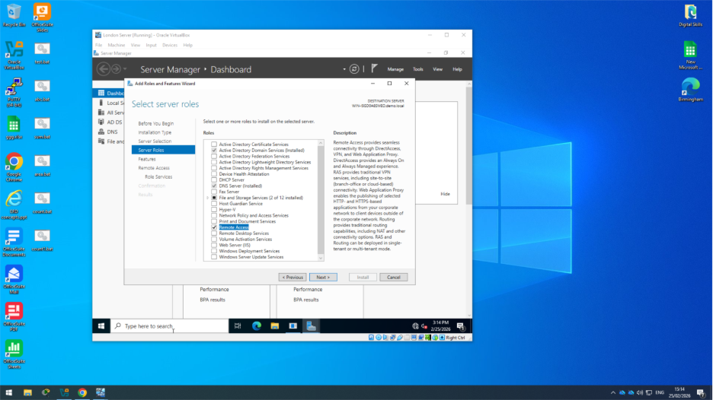
Figure 1: Installing the Remote Access role in Server Manager

During the installation process, the Routing role service was selected to enable routing functionality on the server.
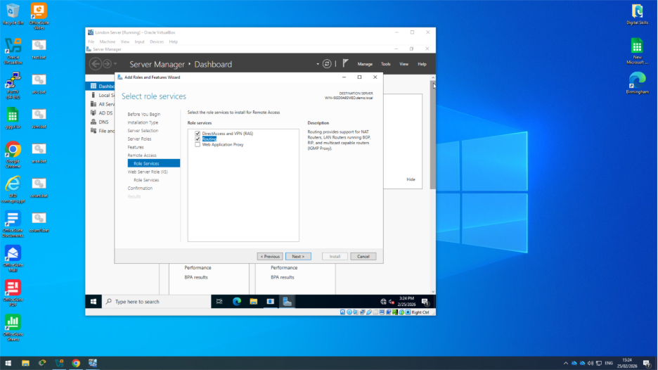
Figure 2: Selecting the Routing role service during Remote Access installation

After selecting the required role services, the installation process was completed through Server Manager. The system then began installing the Remote Access role and the associated routing components.
The installation progress window confirms that the DirectAccess, VPN (RAS), and Routing services were successfully installed on the Windows Server.
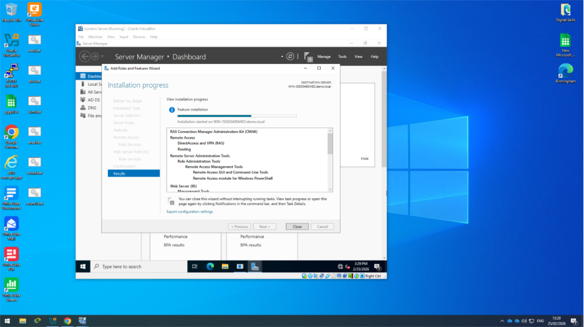
Figure 3: Installation progress of the Remote Access and Routing services

Once the installation was completed, the Routing and Remote Access management console became available. This console is used to configure and manage routing services on the server.
After installing the routing services, the Windows Defender Firewall with Advanced Security settings were reviewed to ensure that routing traffic was allowed. The required inbound rules for Routing and Remote Access were enabled so the server could forward network traffic between the Birmingham and London networks.
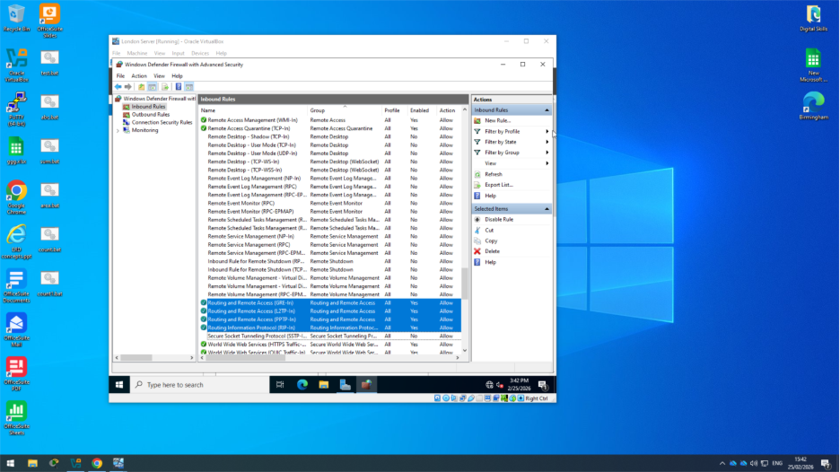
Figure 4 : Firewall rules allowing Routing and Remote Access traffic

Once the Remote Access role was installed, the Routing and Remote Access Setup Wizard was used to configure the service. The LAN routing option was selected to allow the Windows Server to forward traffic between the Birmingham and London networks, as shown in Figure 5.
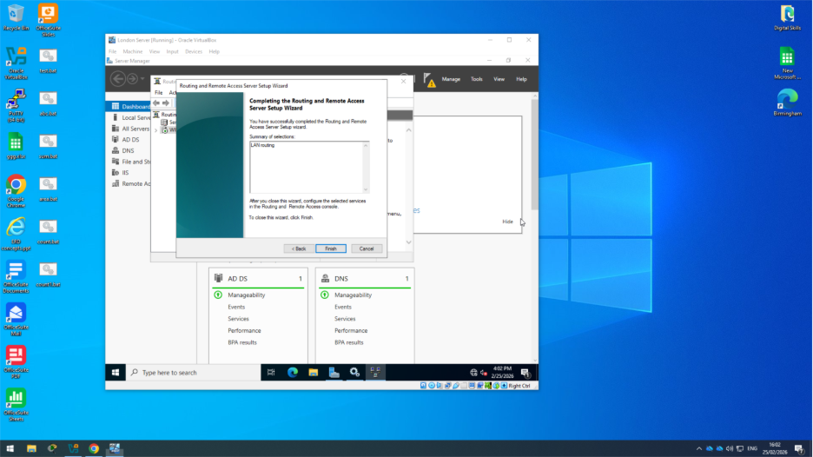
Figure 5 : Completion of Routing and Remote Access configuration with LAN routing enabled

Routing in London Network

Routing in the London network was configured on the Debian server by enabling IP forwarding. This allows the system to forward network packets between different interfaces and act as a router between the London network and the WAN connection.
To enable this feature, the sysctl configuration file was edited and the parameter net. ipv4.ip_forward=1 was added. This configuration ensures that the Debian server can forward packets between the connected networks.

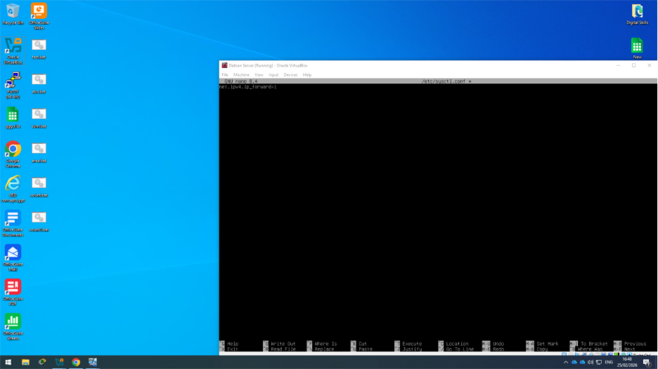
Figure 6 : Enabling IP forwarding in the sysctl configuration file on the Debian Server

Once the configuration file was modified, the new settings were applied using the command: sudo sysctl-p
This command reloads the sysctl configuration and activates IP forwarding, allowing the Debian server to forward network packets between the London network and the WAN connection.
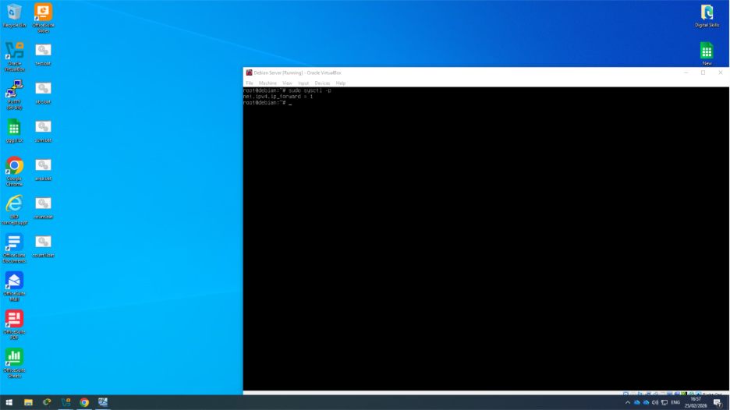
Figure 7: Applying IP forwarding configuration using the sysctl command

A static route was added on the Debian server to allow communication with the Birmingham network. The command used specifies that traffic destined for the 172.16.1.0/24 network should be forwarded through the gateway 10.0.0.1, which connects the London network to the Birmingham network.
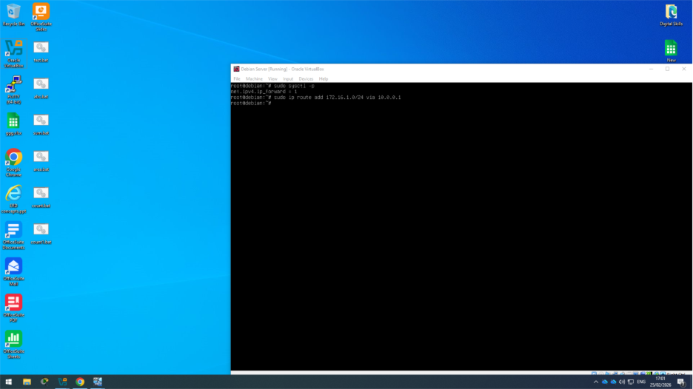
Figure 8 :Adding a static route on the Debian server to reach the Birmingham network

A persistent routing entry was added to allow the server to reach the 172.16.2.0/24 network through the gateway 10.0.0.2.
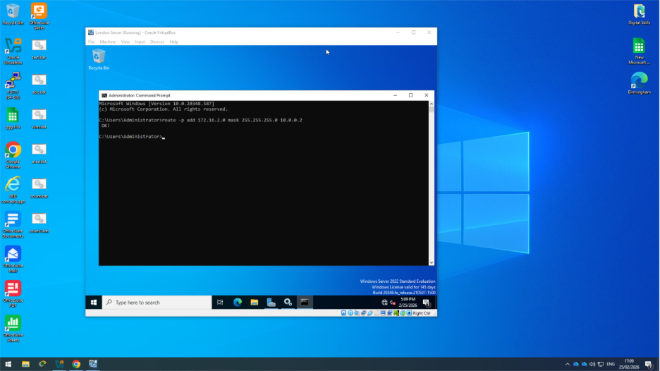
Figure 9: Adding a persistent route using the route -p add command.

A connectivity test was performed using the ping command to verify that the routing configuration was working correctly. The successful replies confirm that communication between the connected networks is functioning as expected.
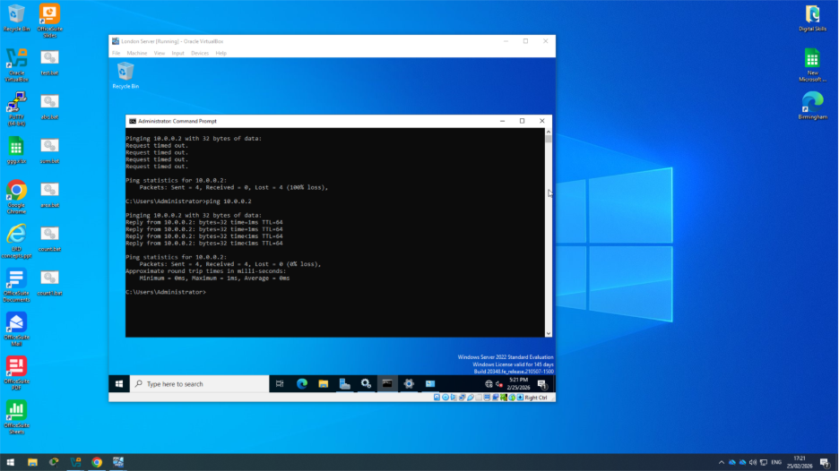
Figure 10: Successful ping test confirming network connectivity.

Network connectivity was verified using the ping command. The replies confirm that the server can successfully reach the gateway and communicate with the remote network.
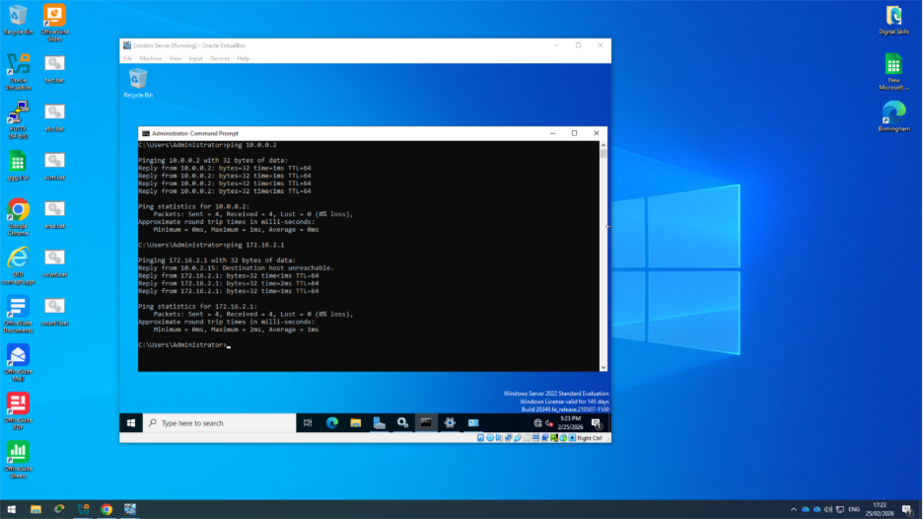
Figure 11: Ping results confirming communication between the two networks.

Domain Server (Birmingham)

The Active Directory Domain Services (AD DS) role was installed on the Windows Server using Server Manager. This role provides centralised management of users, computers, and network resources within the domain environment.
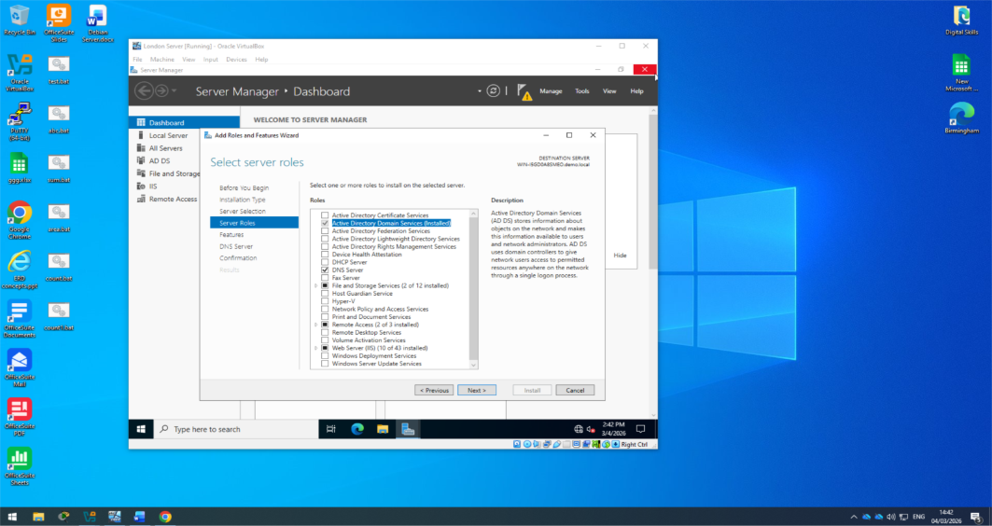
Figure 12: Selecting Active Directory Domain Services during role installation in Server Manager.

2.1 Creating new forest (sonya.acca)
To configure the domain infrastructure, the server was promoted to a Domain Controller using the Active Directory Domain Services Configuration Wizard. During this process, the option Add a new forest was selected, and the domain name sonya.acca was specified as the root domain.
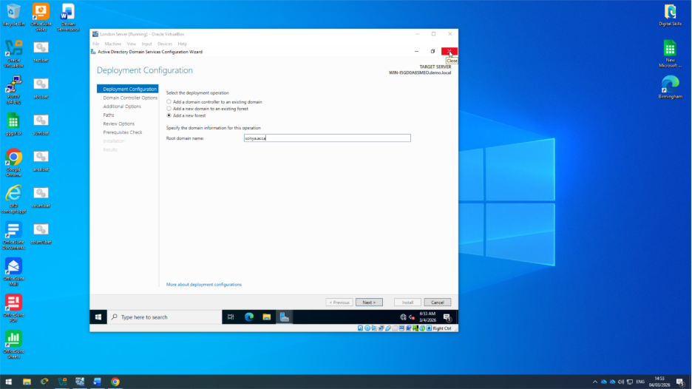
Figure 13: Creating a new forest and entering the domain name sonya.acca

After promoting the server to a Domain Controller, the DNS service was automatically configured. The Forward Lookup Zone for the domain sonya.acca was created, allowing the server to resolve hostnames within the domain.
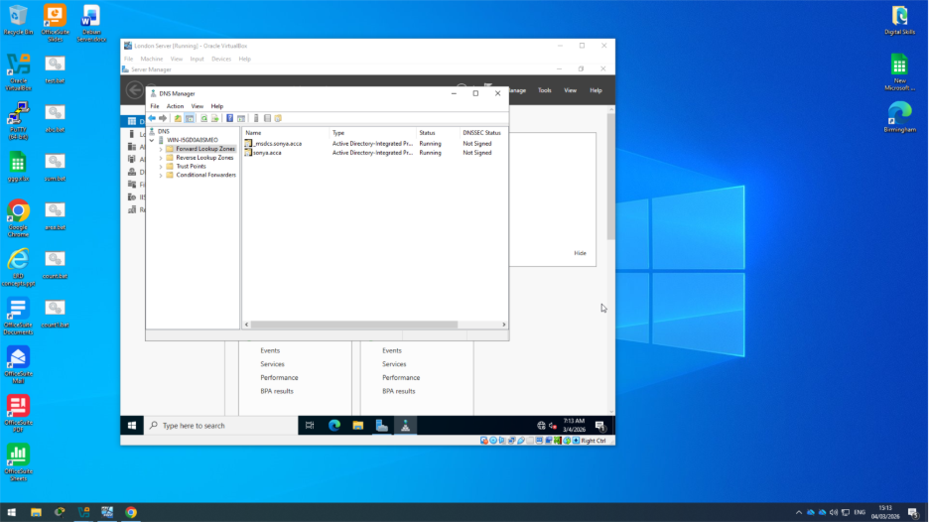
Figure 14: Forward Lookup Zone for the domain sonya.acca in DNS Manager

Creating A Host for Servers

Several Host (A) records were created in the sonya.acca Forward Lookup Zone to allow systems within the network to be resolved by hostname instead of IP address [3], [7]. These records map the server and client names to their corresponding IP addresses within the network.
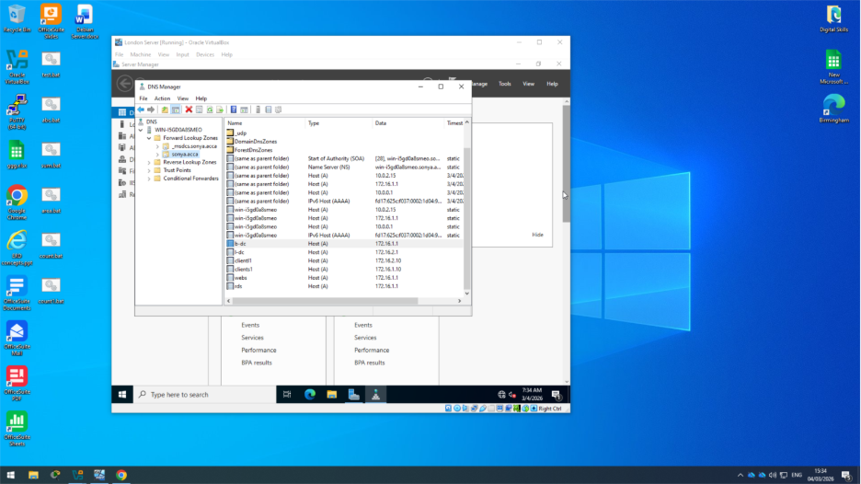
Figure 15: Host (A) records configured in the sonya.acca DNS Forward Lookup Zone

A Reverse Lookup Zone was created using the New Zone Wizard in DNS Manager. This zone allows IP addresses to be resolved back to hostnames, improving network management and troubleshooting.
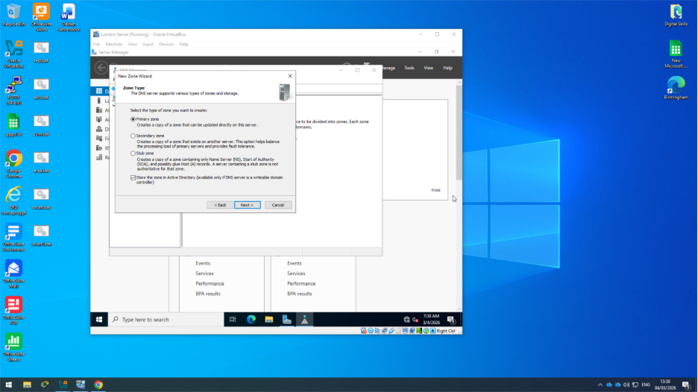
Figure 16: Zone type selection during reverse lookup zone creation

Creating a Reverse Lookup Zone and PTR Records

A Reverse Lookup Zone was created in DNS Manager to allow IP addresses to be resolved back to hostnames. This enhances network management and enables administrators to verify server identities. After creating the reverse lookup zone, PTR (Pointer) records were configured for all servers in the Birmingham and London networks.

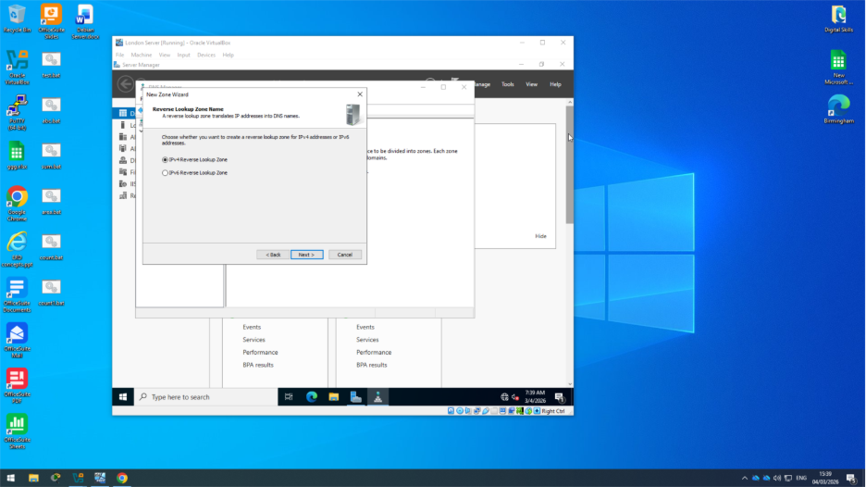
Figure 17: Selecting IPv4 Reverse Lookup Zone in the DNS New Zone Wizard

During the reverse lookup zone configuration, the Network ID was entered to define the subnet associated with the zone. The network 172.16.1 was specified to match the Birmingham subnet.
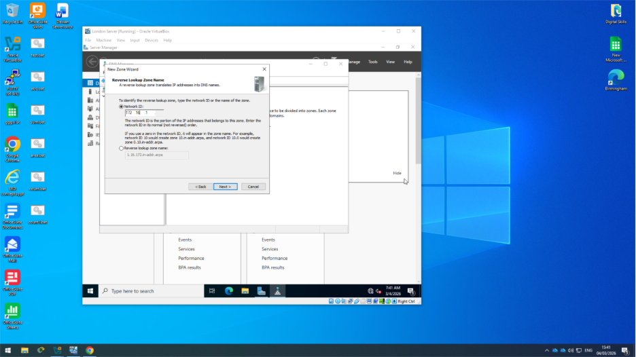
Figure 18: Specifying the network ID for the reverse lookup zone

After completing the configuration in the New Zone Wizard, the Reverse Lookup Zone was successfully created in DNS Manager. This zone allows the DNS server to resolve IP addresses back to hostnames within the network.
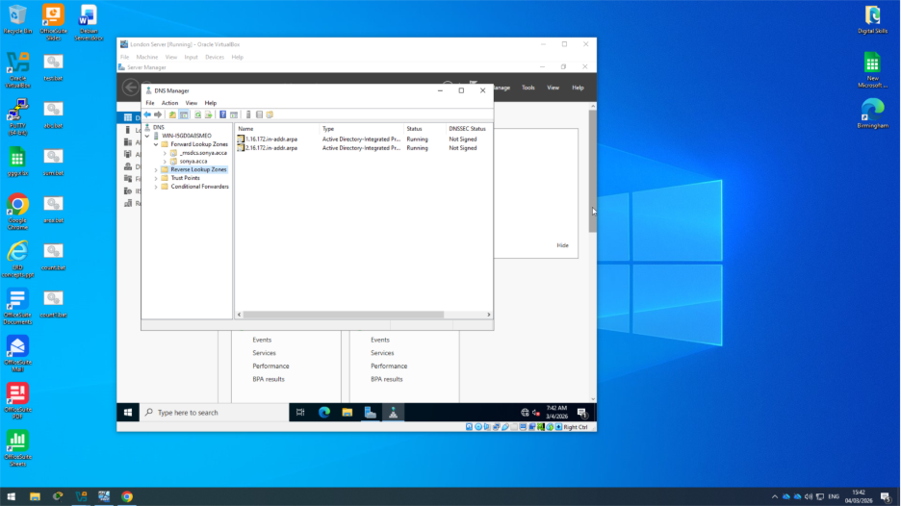
Figure19: Reverse lookup zone created in DNS Manager

PTR (Pointer) records were created in the reverse lookup zone to map each IP address to its corresponding hostname. This allows DNS to perform reverse name resolution.

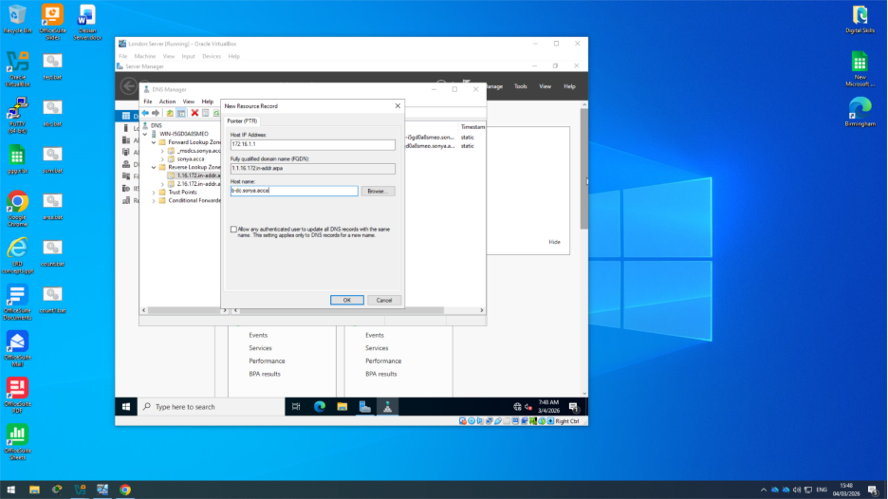
Figure 20: Creating a PTR record for a server in the reverse lookup zone

PTR records were configured in the reverse lookup zone to map the IP addresses of the servers to their corresponding hostnames. This allows DNS to perform reverse name resolution within the sonya.acca domain.

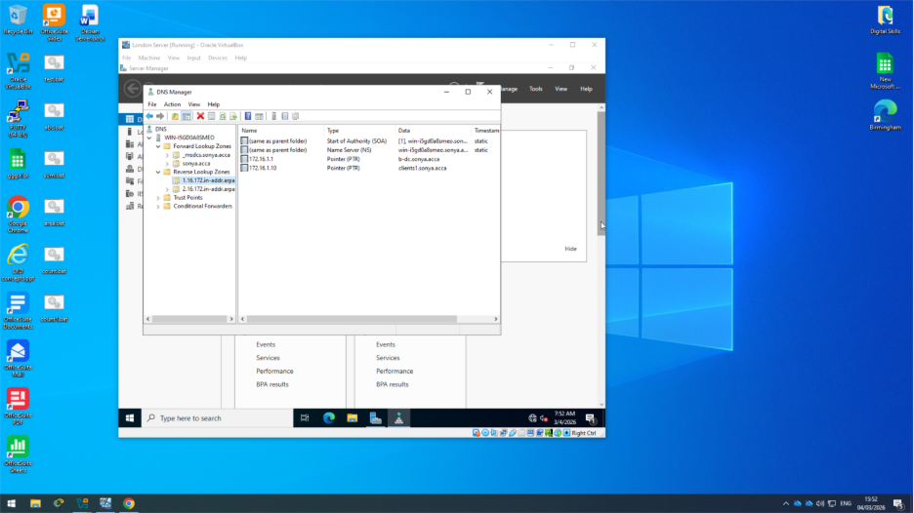
Figure 21: PTR records displayed in the reverse lookup zone

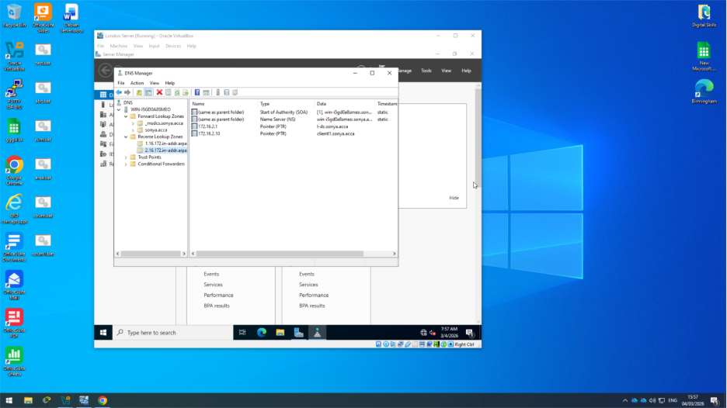
Figure 22: PTR records mapping server IP addresses to hostnames

To verify that DNS was configured correctly, the nslookup command was used to test hostname resolution within the domain.
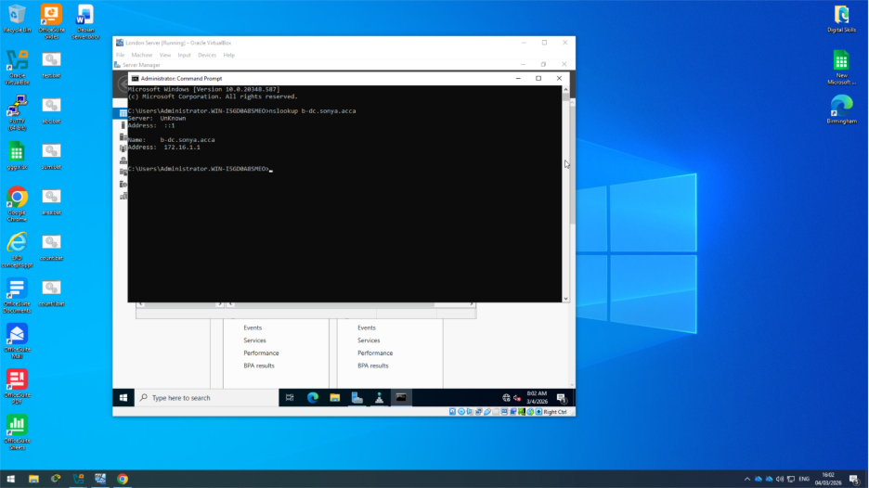
Figure 23: DNS lookup test using the nslookup command for b-dc.sonya.acca.

3. Encrypted Connection between Birmingham and London

3.1 Site-to-Site VPN Configuration
To provide secure communication between the Birmingham and London networks, a site-to-site VPN connection was configured. This encrypted connection protects the data transmitted between the two locations using IPsec with Internet Key Exchange (IKE) [2].

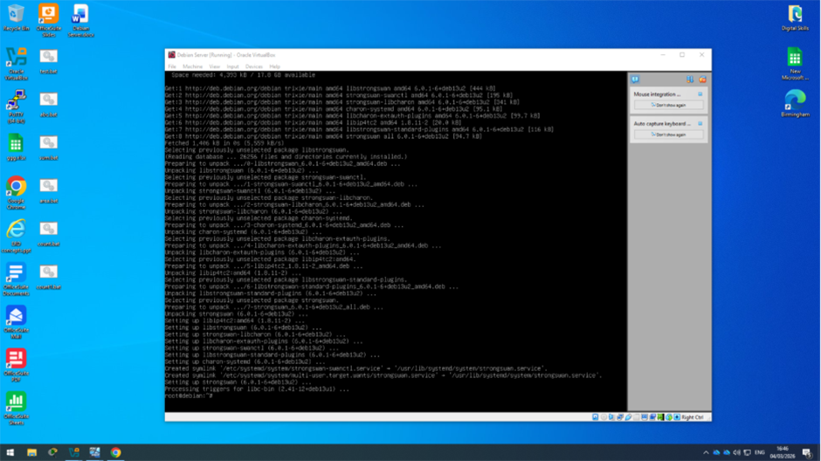
Figure 24: Installing StrongSwan IPsec VPN software on the Debian server.

To configure the VPN on the London server, the StrongSwan IPsec VPN software was installed on the Debian server. StrongSwan allows the system to create secure, encrypted tunnels between networks.

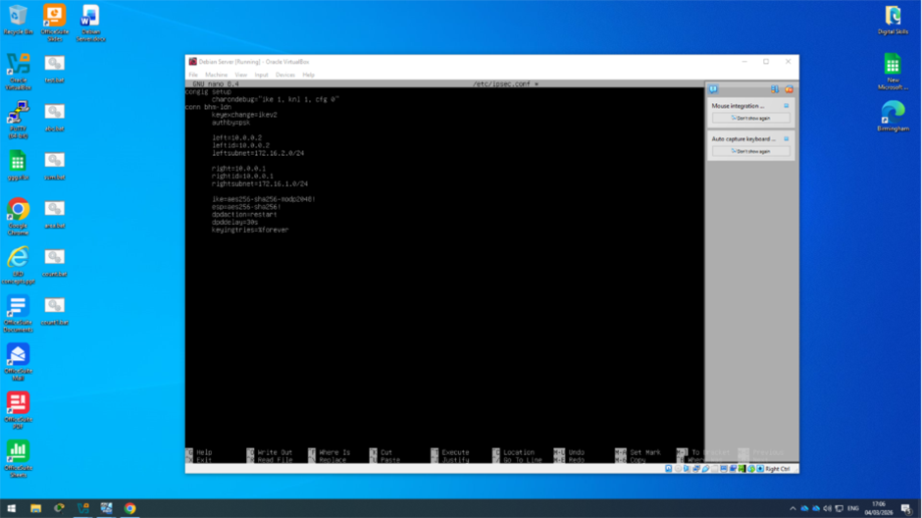
Figure 25: Configuring the site-to-site VPN tunnel parameters in the /etc/ipsec.conf file.

The IPsec configuration file (/etc/ipsec.conf) was edited on the Debian server to define the parameters for the site-to-site VPN tunnel between the Birmingham and London networks. The configuration specifies the local and remote IP addresses, subnets, and encryption settings used to establish the secure connection.

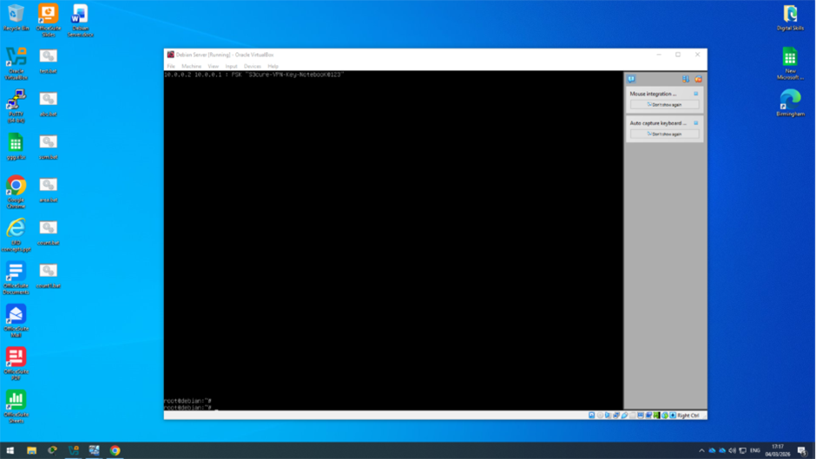
Figure 26: Configuring the VPN pre-shared key in the /etc/ipsec.secrets file.

The VPN authentication key was configured in the /etc/ipsec. secrets file. A pre-shared key (PSK) was defined to authenticate the site-to-site VPN connection between the Birmingham and London networks.
After completing the configuration, the IPsec service was started to establish the secure tunnel between the Birmingham and London networks. The VPN connection uses IPsec encryption with Internet Key Exchange (IKE) to provide a secure and persistent communication channel between the two sites.

4. Users

4.1 Creating User Accounts
User accounts were created in the sonya.acca domain to allow users to authenticate and access network resources within the organisation. Active Directory provides centralised management of user identities, which simplifies administration and improves security across the network [5].

The accounts were created following the required SAM Account Name naming convention, where the first letter of the user’s first name is combined with a dot and the full last name. For example, a user named John Smith would have the username j.smith.

Once the accounts were created, they were verified in Active Directory Users and Computers to confirm that the users were successfully added to the domain.
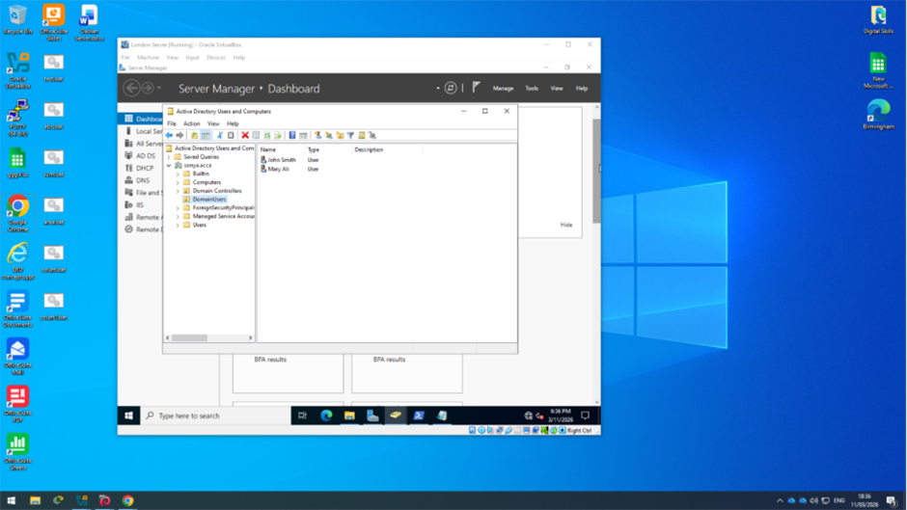
Figure 27: User accounts created in Active Directory Users and Computers.

5. Domain Membership

5.1 Joining Clients to the Domain
The client machines were joined to the sonya.acca domain to enable centralised authentication and management through Active Directory. Joining the computers to the domain allows domain users to log in and access network resources securely.
After joining the domain, the login process was tested using a domain user account to verify that authentication through Active Directory was functioning correctly.

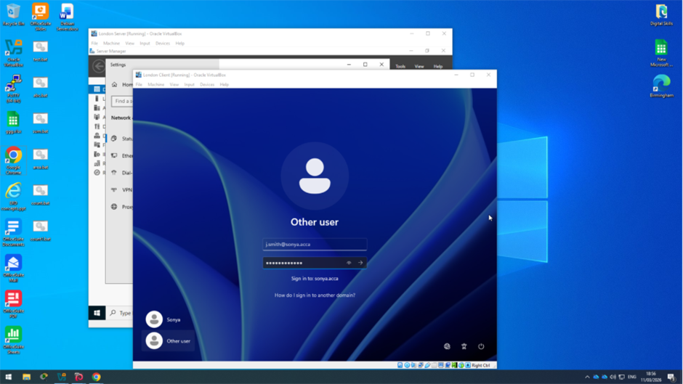
Figure 28: Logging into the sonya.acca domain using a domain user account.

After entering the domain credentials, the user successfully logged into the client machine that had been joined to the sonya.acca domain. This confirms that the computer was correctly connected to Active Directory and that domain authentication was functioning properly.

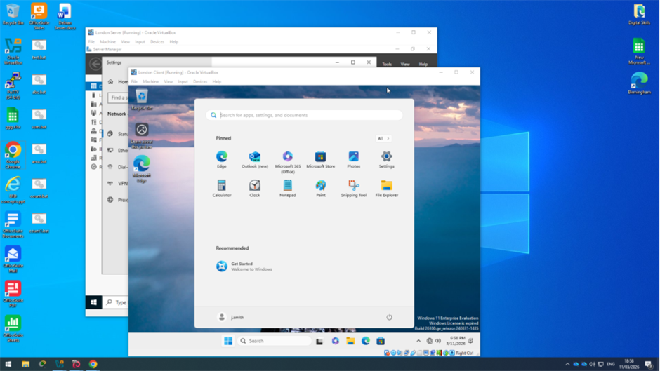
Figure 29: Successful login to the client machine using a sonya.acca domain user account.

6. DHCP Server
To automatically assign IP addresses to client machines in the network, the DHCP Server role was installed on the B-DC server in the Birmingham network. DHCP allows devices to receive IP addresses and other network configuration settings automatically.
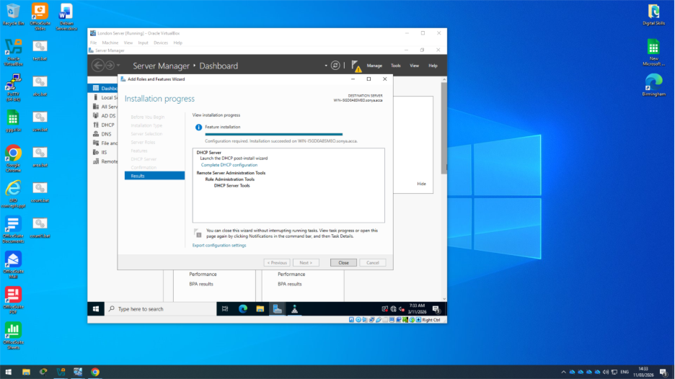
Figure 30: Installation of the DHCP Server role on the B-DC server.

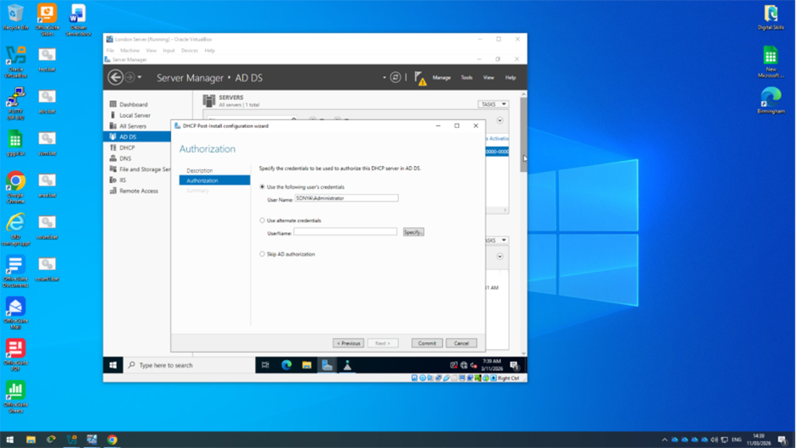
Figure 31: Authorising the DHCP server in Active Directory using the DHCP Post-Install Configuration Wizard.
After installing the DHCP Server role, the DHCP Post-Install Configuration Wizard was used to authorise the DHCP server in Active Directory. Authorising the server ensures that it is allowed to assign IP addresses to client devices within the domain network.

6.1 DHCP Scope Configuration
A DHCP scope was created on the B-DC server to define the range of IP addresses that can be assigned to client devices. The scope was named Birmingham Scope to clearly identify the network it serves.
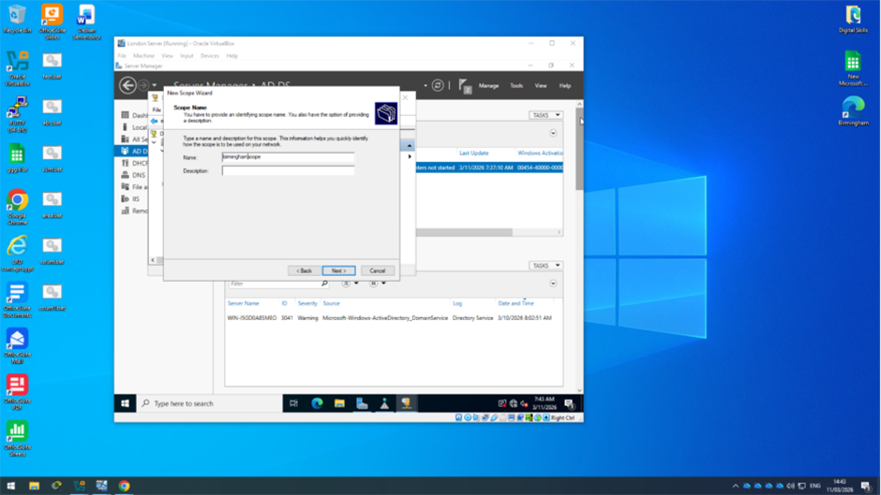
Figure 32: Creating a DHCP scope and specifying the scope name in the New Scope Wizard.

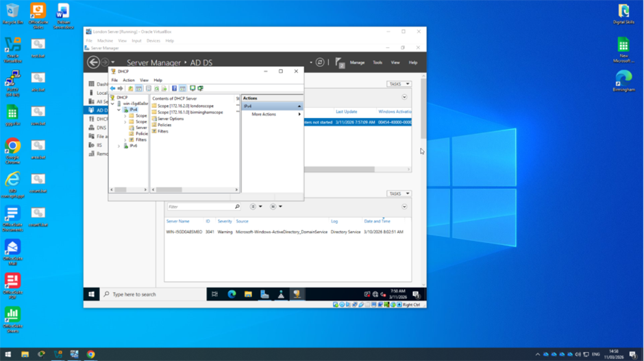
Figure 33: Configured DHCP scopes displayed in DHCP Manager.
The DHCP scopes for both networks were successfully created and are displayed in the DHCP Manager. This confirms that the server is configured to allocate IP addresses to clients in each network.

6.2 Configure L-CD as DHCP Relay Server
The L-CD device was configured as a DHCP relay agent to forward DHCP requests from the London network to the Birmingham DHCP server [4]. This allows client devices on a different subnet to receive IP configuration automatically.

6.3 DHCP Testing and Verification
The DHCP configuration was tested on a client device. The client successfully received an IP address, and a ping test to the gateway confirmed proper network connectivity.

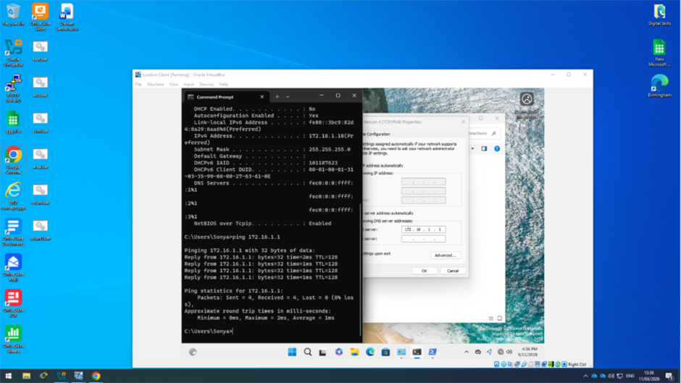
Figure 34: DHCP client receiving IP address and successful network connectivity test.

7. Test and Troubleshoot

7.1 Network Connectivity Testing
The network connectivity between the Birmingham and London networks was tested to ensure that all systems were functioning correctly [1]. The ping command was used to verify communication between servers and client devices across both networks.
The successful results confirmed that routing, DHCP, DNS, and VPN configurations were working correctly and that the network was fully operational.

8. Disk Drive Configuration
A new virtual hard disk was added to the London Server using VirtualBox to provide additional storage. The disk was then initialised and configured using Disk Management. A new simple volume was created, formatted, and made ready for use.
This storage can be used for file storage and sharing across the network, allowing authorised users to access shared resources efficiently.

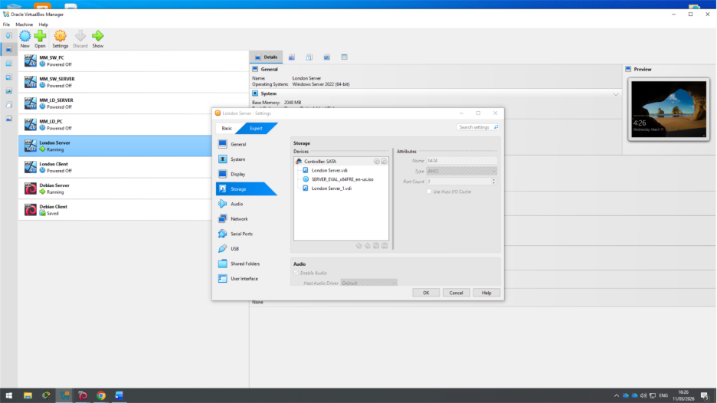
Figure 35: Adding a new virtual hard disk to the London Server in VirtualBox.

A new virtual hard disk was added to the virtual machine to increase available storage.

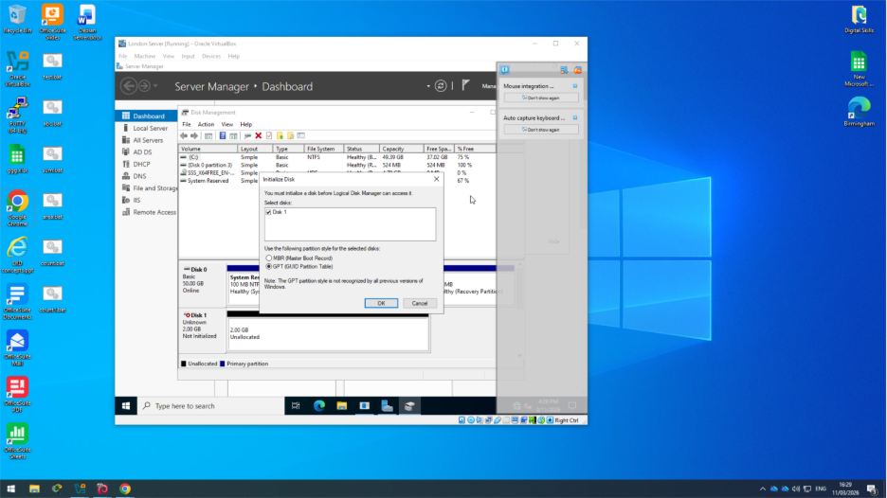
Figure 36: Initialising the new disk in Disk Management.

The new disk was initialised using the GPT partition style to prepare it for configuration.

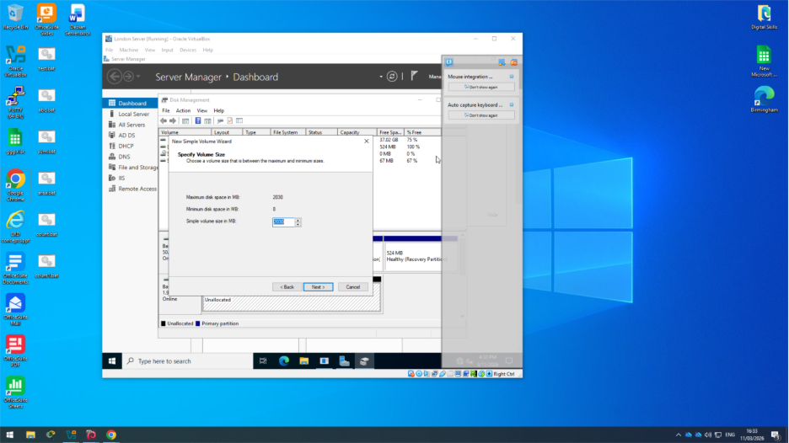
Figure 37: Creating a new simple volume on the disk.

A simple volume was created and configured, making the disk ready for use and data storage.
The disk was successfully configured and is now available for storage and potential file sharing within the network.

9. IIS Server
The IIS server was configured to create and host the webs.sonya.acca website, with secure access using HTTPS and authentication for domain users [8].

9.1 Creating webs.sonya.acca website

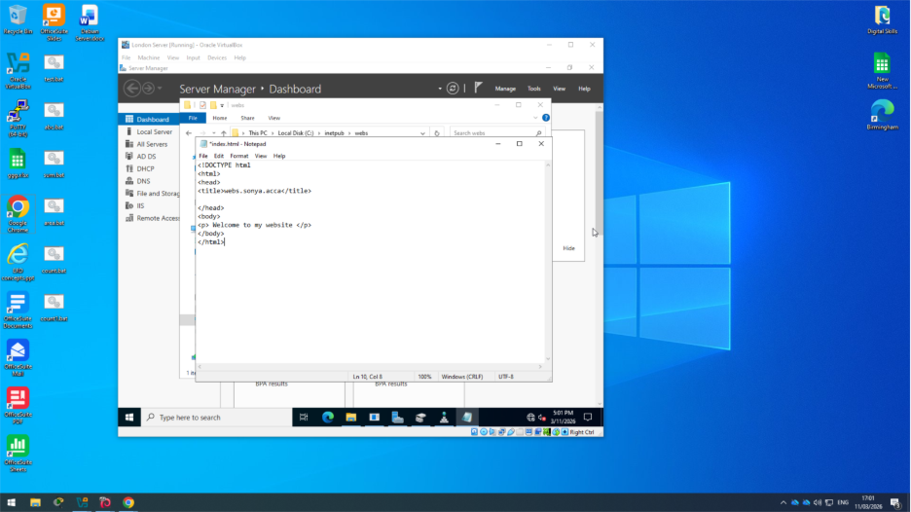
Figure 38: Creating the website HTML file with a welcome message.
An HTML file was created containing the welcome message that will be displayed to users accessing the website.

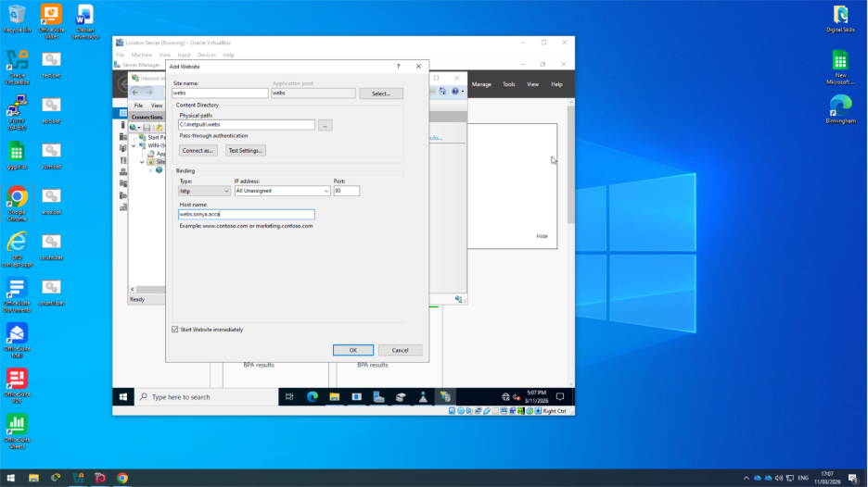
Figure 39: Creating the webs.sonya.acca website in IIS Manager.
A new website named webs.sonya.acca was created and linked to the folder containing the HTML file.
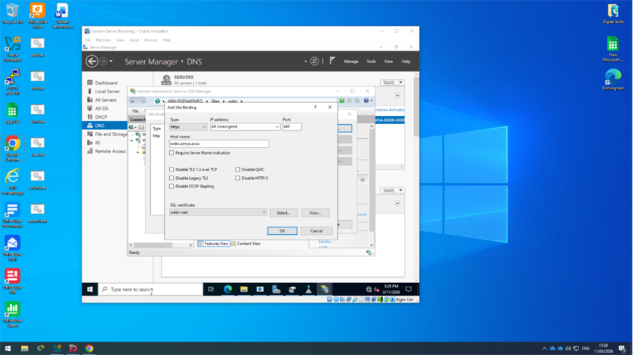
Figure 40: Configuring HTTPS binding with SSL certificate.
HTTPS was enabled by adding a secure binding and selecting an SSL certificate for encrypted communication.

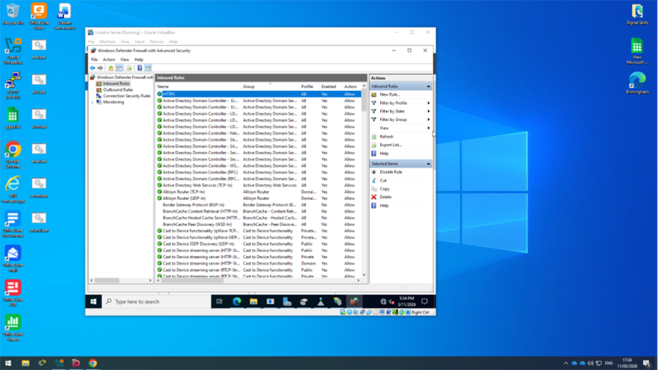
Figure 41: Configuring firewall rules to allow web traffic.
Firewall rules were configured to allow HTTP and HTTPS traffic so the website can be accessed from clients.

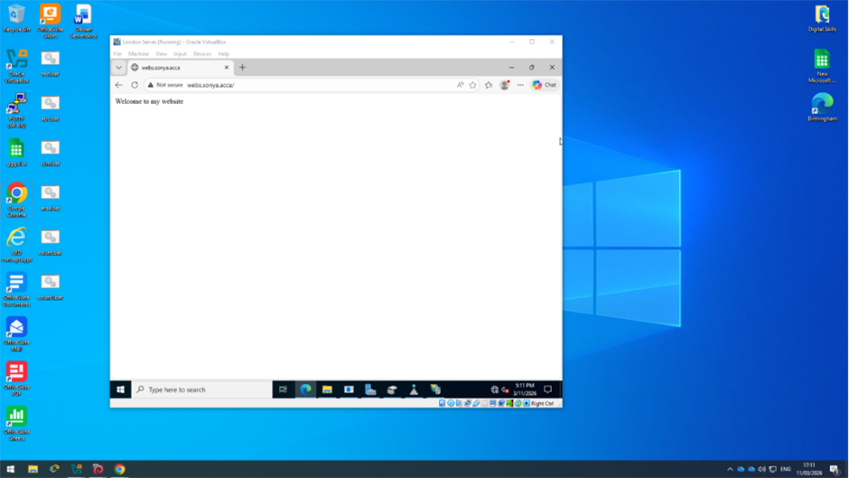
Figure 42: Accessing the IIS website from a web browser.
The website was successfully accessed from a client device, displaying the configured welcome message.
Windows Authentication was enabled to ensure that only authorised domain users can access the website securely.

10. Remote Desktop Services
Remote Desktop Services were configured to allow remote access to the server from client devices within the network [9].
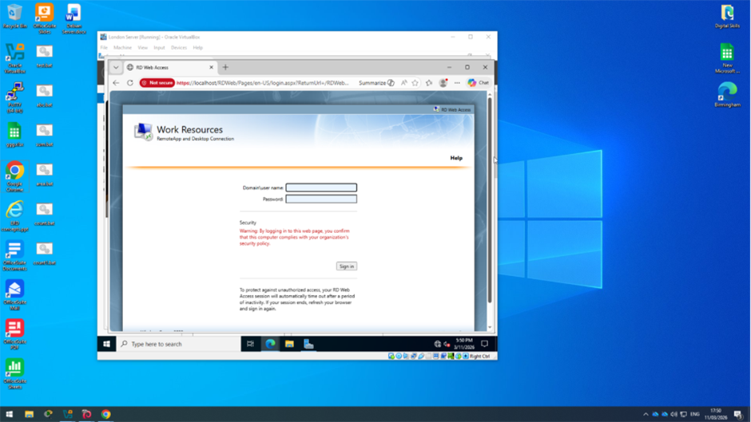
Figure 43: Accessing Remote Desktop Services via web interface.
The Remote Desktop web interface was successfully accessed, allowing users to log in remotely.

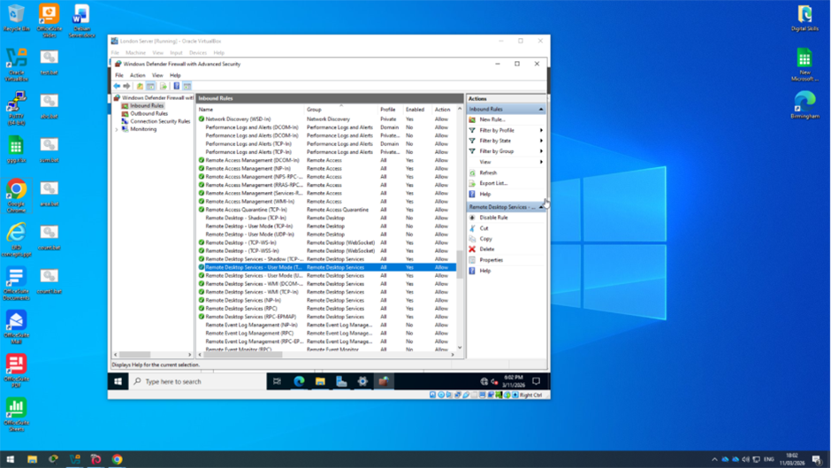
Figure 44: Configuring firewall rules to allow Remote Desktop connections.
Firewall rules were enabled to allow Remote Desktop Services traffic, ensuring remote access is permitted.
This configuration allows authorised users to securely access the server remotely.

Conclusion
The network was successfully configured to connect the Birmingham and London sites. Key services such as routing, DHCP, DNS, and VPN were implemented and tested. The system is fully operational, allowing secure communication and user access across the network.

References
[1] J. F. Kurose and K. W. Ross, Computer Networking: A Top-Down Approach, 8th ed. Pearson, 2021.
[2] W. Stallings, Network Security Essentials: Applications and Standards, 7th ed. Pearson, 2020.
[3] A. S. Tanenbaum and D. J. Wetherall, Computer Networks, 6th ed. Pearson, 2021.
[4] G. Odom, CCNA 200-301 Official Cert Guide, Volume 2, Cisco Press, 2019.
[5] Microsoft, “Active Directory Domain Services Overview,” 2023. [Online]. Available: https://learn.microsoft.com
[6] Microsoft, “DHCP Overview,” 2023. [Online]. Available: https://learn.microsoft.com
[7] Microsoft, “DNS Overview,” 2023. [Online]. Available: https://learn.microsoft.com
[8] Microsoft, “Internet Information Services (IIS) Overview,” 2023. [Online]. Available: https://learn.microsoft.com
[9] Microsoft, “Remote Desktop Services Overview,” 2023. [Online]. Available: https://learn.microsoft.com
[10] Oracle, “VirtualBox User Manual,” 2023. [Online]. Available: https://www.virtualbox.org/manual

