

Optimizing Digital Marketing with Artificial Intelligence: Consumer Perceptions and Personalized Strategies for Amazon

Dissertation Proposal
LCMB7020
Name : Sandeep Dammalapati
Student Id : 2214841
Module Name : Dissertation
Lecturer name : Dr Hoang Dang Nguyen

Table of Contents
Acknowledgement 3
Chapter 1: Introduction 4
1.1 Background 5
1.2 Rationale of study 6
1.3 Aim 6
1.4 Objectives of the Study 6
1.5 Hypothesis 6
Chapter 2: Literature Review 7
2.1 AI improves the effectiveness of personalized marketing strategies 7
2.2 Consumers find personalised marketing strategies driven by AI to be more relevant and practical 11
2.3 Tailored marketing communications increase customer happiness and engagement. 17
2.4 Data security affects consumers' faith in AI-powered marketing. 21
2.5 Literature gap 25
Chapter 3: Research Methodology 25
3.1 Introduction 25
3.2 Research Philosophy 26
3.3 Research Approach 27
3.4 Research Strategy 27
3.5 Type of Investigation 28
3.6 Choices 28
3.7 Time Horizons 29
3.8 Data Collection and analysis 29
Chapter 4: Analysis of data 31
Chapter 5: Conclusion and Recommendations 50
References 52
Appendix 56

Acknowledgement

I would like to express my deepest gratitude to everyone who supported and guided me throughout the process of completing this dissertation.
First, I extend my sincere thanks to my supervisor, Dr Hoang Dang Nguyen, for their invaluable guidance, feedback, and encouragement. Their expertise and insights have been instrumental in shaping this work.
I am also grateful to my family and friends for their unwavering support, patience, and understanding during this journey.
Finally, I wish to thank the participants of this study, whose contributions made this research possible. Thank you all for your help and encouragement.

Chapter 1: Introduction
Artificial Intelligence (AI) has become a vital instrument in the fast-paced digital world for optimizing the efficacy and efficiency of marketing initiatives, especially when it comes to personalization and customization. AI is changing the way brands interact with their customers by enabling businesses to provide highly personalised and targeted marketing experiences. AI can handle enormous volumes of data in real-time. Through an increase in relevance, convenience, and engagement, this move towards AI-driven personalization is radically altering conventional marketing strategies.
By applying data-driven insights to better how companies target their clients, artificial intelligence (AI) increases the effectiveness of customized marketing tactics (Davenport & Ronanki, 2018). Artificial Intelligence (AI) enables businesses to maximize their marketing efforts by using methods like machine learning and predictive analytics to make sure the correct messages are sent to the right customers at the right time. As a result, marketing resources are used more effectively, conversion rates rise, and return on investment (ROI) grows. Research indicates that incorporating artificial intelligence (AI) into marketing tactics can lead to notable improvements in efficiency, waste reduction, and client acquisition for businesses (Jarek & Mazurek, 2019).
Additionally, as AI tools analyze customer behavior and preferences in real-time, consumers find personalised marketing strategies driven by AI to be more relevant and convenient. Customers enjoy a seamless, understandable, and catered-to buying experience thanks to these personalised experiences (Loureiro et al., 2021). Businesses may improve consumer happiness and the overall brand experience by customizing offerings, content, and suggestions to individual tastes. Studies indicate that customers value marketing initiatives that align with their requirements and inclinations, leading to increased brand loyalty (Huang & Rust, 2021).
AI-powered personalised marketing messages directly affect customer pleasure and engagement in addition to relevancy. Personalised marketing increases customer interaction with the material, leading to increased engagement rates (Zhang et al., 2020). Research has demonstrated that customized marketing efforts enhance customer satisfaction by offering value by catering to the individual interests and requirements of the consumer. Long-term business success depends on the positive results of such interaction, which frequently result in greater brand loyalty, repeat business, and good word-of-mouth referrals (Loureiro et al., 2021).
However, despite the obvious advantages of AI-driven personalization, worries about trust and data security are still common. Customers are growing more aware of how their data is used, so companies need to make sure they have strong data protection policies in place to keep their customers' trust. Studies reveal that customer confidence in AI-driven advertising is significantly impacted by the organization's capacity to protect individualized information (Loureiro et al., 2021). To establish and preserve this trust, openness in data handling procedures and unambiguous communication on data use are essential (Huang & Rust, 2021). Customers are more inclined to interact with AI-powered marketing and provide personal information when they have confidence that their data is secure.
The last important factor influencing confidence in AI-powered marketing is perceived benefits. Customers are more inclined to accept AI-driven tactics if they can clearly identify benefits like ease, personalised experiences, and time savings (Kaplan & Haenlein, 2020). Comprehending these advantages and their impact on trust is crucial for e-commerce sites such as Amazon, where customer experience is heavily customized. The better the trust relationship between the firm and the consumer, the more aligned the AI-generated recommendations are with consumer wants (Huang & Rust, 2021).

1.1 Background
Artificial intelligence (AI) has had a profound impact on several commercial disciplines, with digital marketing being one of the most affected. Businesses may now personalize marketing efforts at a never-before-seen scale because of AI's capacity to analyze massive volumes of data, spot trends, and forecast customer behavior (Kaplan & Haenlein, 2019). AI's machine learning, natural language processing, and predictive analytics capabilities are what are driving this shift. Taken together, they allow for more accurate targeting, effective customer segmentation, and improved engagement tactics. One of the first companies to use AI for digital marketing is Amazon, which is a prime example of how new technologies may revolutionize industries. Using AI, Amazon improves user experiences by delivering information in a more customized manner, making personalized suggestions, and focusing advertising. Using collaborative filtering and machine learning algorithms, Amazon's recommendation engine, which contributes significantly to its sales, makes product recommendations based on the unique behaviors and interests of each user (Smith & Linden, 2017). In addition to raising revenue and fostering client loyalty, personalization raises customer satisfaction.

1.2 Rationale of study
In the digital age, personalised marketing strategies are now essential for drawing in customers and promoting conversions because of the constant shift in their expectations. Though marketing can benefit greatly from artificial intelligence (AI), little is known about customer attitudes towards and desires for AI personalization. Since client acceptance and confidence in AI technologies directly affect the effectiveness of customized marketing initiatives, this information gap is critical (Acquisti, Brandimarte, & Loewenstein, 2016). Digital marketing campaigns can benefit from the informative information that can be obtained by comparing these impressions to Amazon's marketing strategies.

1.3 Aim
The aim of the study is to investigate consumer attitudes and preferences about Amazon's AI-powered personalised marketing methods.

1.4 Objectives of the Study
- To investigate how AI might help with Amazon's tailored marketing.
- To evaluate how customers view tailored marketing powered by AI.
- Assessing the influence of customized marketing messages on the attitudes and actions of customers.
- To determine the variables affecting customer acceptability and trust in AI-driven personalization.

1.5 Hypothesis
- AI improves the effectiveness of personalized marketing strategies.
To investigate how AI may improve the effectiveness of targeted marketing.
- Consumers find personalised marketing strategies driven by AI to be more relevant and practical.
To understand consumer attitudes towards the benefits of AI-driven personalization.
- Tailored marketing communications increase customer happiness and engagement.
To investigate how individualized messaging affects customer satisfaction and engagement directly.
- Data security affects consumers' faith in AI-powered marketing.
To determine the main factors that influence consumer trust in marketing driven by AI on a significant e-commerce platform.
- The perceived benefits of AI-powered marketing influence consumers' trust in it.
To determine the main factors that influence consumer trust in marketing driven by AI on a significant e-commerce platform.

Chapter 2: Literature Review
As digital technology advances, so do digital marketing strategies. In the field of digital marketing, artificial intelligence (AI) has become more prevalent recently. Businesses can better understand their customers with the use of artificial intelligence (AI), which could improve communication and allow for the customization of products and services to meet customer needs. Artificial intelligence (AI) can help save costs, increase consumer satisfaction, and reduce errors in digital marketing activities by providing data-driven insights and optimization. Huang and Rust have highlighted the benefits of artificial intelligence in digital marketing (2021). Prominent marketing writers Philip Kotler and Kevin Lane Keller acknowledge the paradigm shift in marketing strategy brought forth by artificial intelligence in their seminal work "Marketing Management" (15th edition, 2015). They argue that the shift from rule-based applications to adaptive algorithms has fundamentally changed the process of decision-making, allowing marketers to make data-driven decisions and respond swiftly to shifting market conditions. This study looked at how artificial intelligence (AI) is revolutionizing marketing personalization. By leveraging AI to analyze vast amounts of customer data and tailor marketing messages to individual preferences, brands may improve consumer engagement, the quality of the relationship between a brand and its customers, and how well a business communicates with them, all of which contribute to sales success. Theories of consumer engagement offer a useful framework for understanding the effects of AI-driven personalization (Alamsyah & Syahrir, 2024).

2.1 AI improves the effectiveness of personalized marketing strategies
2.1.1 Definitions of Artificial Intelligence (AI):
Sheikh et al. (2023) define artificial intelligence (AI) as the theory and development of computer systems that can do activities that would normally require human intelligence, such as language interpretation, complex decision-making, and speech and picture recognition.

According to Ertel (2016), the study of creating computer systems that can perform tasks like speech recognition, visual perception, language translation, and decision-making that typically require human intelligence is known as artificial intelligence (AI).

According to Glikson and Woolley (2020), artificial intelligence (AI) is a cutting-edge technology that seeks to mimic human intelligence and interact with its surroundings. The term artificial intelligence (AI) is a compound word that comes from the combination of the words artificial, which implies made by humans, and intelligence, which refers to thought.
2.1.2 Definition of Efficiency:
Efficiency refers to the ability to achieve a desired result with the least number of resources, time, and effort. In a business context, efficiency is often related to maximizing output while minimizing inputs, such as cost, labor, or time. It is a key metric in determining the effectiveness of processes, systems, or strategies in achieving goals without unnecessary waste.

Efficiency is crucial in the fields of marketing and e-commerce for streamlining processes and enhancing client interactions. Agnihotri et al. (2020) state that a company's ability to effectively use its resources such as time, money, and technology to provide customers with relevant, focused information is a key indicator of marketing efficiency. Automation and data analytics further boost efficiency in AI-driven marketing, allowing companies to personalize messaging and cut down on campaign duration and expense. Additionally, Kim and Lee (2021) stress that AI solutions can increase operational efficiency by automating repetitive operations, freeing up time for businesses to concentrate more on customer interaction and strategic decision-making.

2.1.3 AI in Marketing:
Artificial intelligence (AI) technologies like machine learning, natural language processing, and predictive analytics have revolutionized marketing operations by enabling automated data analysis, segmentation, and personalised content distribution (Berghausen & Backhaus, 2019). Artificial intelligence (AI) algorithms have the capability to sort vast amounts of client data. Once sorted, the data may be utilized to detect patterns, predict preferences, and offer tailored recommendations instantly. Marketing uses artificial intelligence (AI) for a variety of purposes, such as trend forecasting, comparing various marketing platforms, and personalizing advertising messaging (Kulkov, 2021). Artificial intelligence (AI), according to Davenport et al. (2019), automates commercial processes, generates customer and market insights utilizing algorithm-based programs, and offers insights based on historical data. There are several uses for artificial intelligence (AI) in the marketing process.

2.1.4 AI and Efficiency:
Artificial Intelligence (AI) has been a game-changer in increasing productivity in a few areas, most notably marketing. Businesses may increase operational performance and effectiveness by using AI to automate complicated processes, improve decision-making, and provide personalised experiences at a scale. In the field of marketing, AI-driven solutions enable companies to instantly evaluate enormous volumes of data, facilitating more precise consumer segmentation and targeting. AI, for instance, may analyze consumer data from various sources, including social media, CRM systems, and past purchases, to spot trends and forecast future behavior. With this skill, marketers may more precisely customize their campaigns, improving their chances of success and cutting down on resource waste (Chaffey & Ellis-Chadwick, 2019).

AI is also necessary for automating monotonous tasks so that human resources can be allocated to more strategic projects. For instance, AI-powered chatbots may react to queries from customers whenever they come up, providing prompt support and increasing customer satisfaction levels all while reducing the need for a significant number of human staff (Kietzmann, Paschen, & Treen, 2018). Furthermore, by anticipating demand, maximizing inventory levels, and cutting expenses associated with logistics, AI-driven algorithms can improve supply chain management and boost overall corporate efficiency (Davenport & Ronanki, 2018).

2.1.5 Efficiency of Marketing Strategies:
Customized marketing strategies have become increasingly vital for businesses aiming to maximize their marketing effectiveness and customer engagement. Unlike traditional marketing, which often adopts a one-size-fits-all approach, customized marketing focuses on delivering tailored messages to individual customers or specific customer segments based on their preferences, behaviors, and needs. This targeted approach enhances marketing efficiency, leading to improved customer satisfaction, higher conversion rates, and better resource allocation.

The accuracy of message delivery to the target audience is one of the fundamental components of tailored marketing tactics. Businesses can segment their audience and provide tailored content that appeals to groups by utilizing customer data. This accuracy makes sure that marketing dollars aren't squandered on indifferent audiences, which boosts campaign effectiveness. Relevance of marketing communications has a big impact on customer engagement, and personalised content has a greater click-through and conversion rate (Wedel and Kannan, 2016). This is because messages that specifically target the requirements and interests of the client are likely to receive a favorable response.

Automation and artificial intelligence (AI) are two more cutting-edge technologies that help attain efficiency in customized marketing. To forecast behavior, determine customer preferences, and automate the distribution of personalised information, artificial intelligence (AI) is essential for the analysis of big datasets (Rust & Huang, 2014). AI-driven technologies, for instance, may segment consumers according to their demographic data, past browsing habits, and purchase patterns, allowing marketers to send the appropriate message at the appropriate moment. Businesses can maximize their resources and cut expenses thanks to this automation, which also improves the pace and accuracy of marketing efforts and lessens the need for personal intervention. According to Chaffey and Smith (2017), using AI in marketing tactics can result in significant cost savings because it shortens the time and effort needed to run campaigns and boosts their efficiency.

AI helps with data collection and market analysis in the early stages. It is used for segmentation, targeting, and positioning in the next step. Ultimately, standardization, personalization, and relationship development are facilitated by AI (Huang & Rust, 2020). AI is more efficient than humans at certain marketing jobs when properly trained and overseen. AI-driven customer service chatbots, for example, could supplement or replace human personnel, resulting in increased efficiency, lower expenses, and a better return on investment (Sheehan et al., 2020). AI is also very good at quickly analyzing tactical data and using machine learning to decision-making in the context of campaigns and customers. Marketing teams can concentrate on creating strategic objectives that can guide AI-powered marketing campaigns thanks to this efficiency (Haleem et al., 2022).

To expand marketing operations in the digital sphere, marketing makes use of platforms like social networks, media, and search engines in addition to data, information, and communication technologies like artificial intelligence (AI). Enhancing customer relationships through knowledge, influence, empowerment, and participation is the main objective (Krishen et al., 2021). Digital marketing uses artificial intelligence (AI) to become increasingly complex and targeted as technology advances (Davenport et al., 2019). Advertisement optimization, lead generation, customer assistance, and content creation are all possible with AI technology (Sarath Kumar Boddu et al., 2022). AI chatbots, for instance, can efficiently respond to questions and deliver pertinent information in customer care, improving the customer experience (Nicolescu & Tudorache, 2022). Another use is in recommendation systems for online retailers. Here, artificial intelligence algorithms evaluate and synthesize data to generate customized suggestions for users, improving the overall buying experience (Bawack et al., 2022).

Artificial Intelligence (AI) is a key component that increases the effectiveness of marketing campaigns through task automation, enhanced decision-making, and personalised experiences. Artificial intelligence (AI)-powered solutions, such chatbots, machine learning, and predictive analytics, have completely changed the marketing landscape by enabling companies to handle massive datasets, improve targeting, and personalize content distribution. This has improved resource efficiency and raised consumer happiness. AI greatly increases marketing productivity by automating monotonous operations, analyzing consumer behavior, and providing real-time insights. Businesses should anticipate increased operational productivity and more successful, customized marketing tactics as they continue to implement AI.

2.2 Consumers find personalised marketing strategies driven by AI to be more relevant and practical

2.2.1 Definition of Convenient:
Convenient refers to something that is easy to use, suitable, or well-suited for a particular purpose, often providing comfort or efficiency without requiring much effort or inconvenience. Convenience, in general, implies minimal difficulty, saving time, or effort in achieving a desired outcome.
For example, the ease of use and accessibility of goods and services is frequently linked to convenience in marketing and consumer behavior. Convenience in the digital age includes things like easy-to-use interfaces, quick transactions, and tailored services that save customers time and effort.
According to Brown and Venkatesh (2005), convenience plays a critical role in consumer decision-making, influencing factors like product choice and customer satisfaction. The increasing reliance on technology, such as AI and automation, enhances convenience for consumers by simplifying processes like product recommendations and personalized shopping experiences.

2.2.2 Definition of Relevant:
Relevant refers to something that is closely connected or appropriate to the matter at hand. In a business or marketing context, relevance signifies how well a product, service, or piece of information meets the specific needs, preferences, or interests of a target audience.
Relevance is a major factor in determining consumer behavior since people are more inclined to react favorably to information they perceive as relevant or useful to their circumstances. Relevance in marketing, according to Kotler and Keller (2016), improves client happiness and loyalty by skillfully catering to their unique requirements and preferences. Personalised marketing tactics driven by AI, such as those employed by Amazon, are designed to enhance relevance by customizing adverts and recommendations to the individual habits and preferences of each customer.

2.2.3 Digital marketing:
Digital marketing is the term used to describe a wide range of techniques for promoting and supporting products and services with digital channels like the internet, mobile devices, social media, email, search engines, and other digital platforms. It communicates with a target market, increases brand awareness, increases website traffic, and ultimately accomplishes business objectives by using a variety of online techniques and tactics (Chaffey and Smith, 2019).

Almost all marketing operations that take place online are referred to as "digital marketing," including the digital channels that companies utilize for promotion and communication with both existing and new clients. Digital marketing is the creative and distinctive promotion and advertising of goods and services via a variety of distribution channels. It's a time- and money-efficient method for marketers to connect with customers (Todor, 2016).

According to the Digital Marketing Institute, Digital Marketing is “the utilization of advanced innovations to make a coordinated, designated and quantifiable correspondence which assists with securing and holding clients while building further associations with them” (Smith, 2007).

2.2.4 Artificial Intelligence in Digital Marketing
This indicates clearly that managers can forge profitable long-term connections with their clients by maintaining a well-coordinated link through digital marketing (Bouchra, 2021). To achieve their marketing objectives, businesses who are looking for efficient marketing techniques frequently implement cutting edge technology. Advanced computing technologies facilitate the analysis of customer requests and preferences by adopting contemporary trends. Intelligent digital marketing solutions that improve client experiences through big data are becoming more and more accessible, which is encouraging for new enterprises (Davenport, 2020). The process of gathering and analyzing target audience data is made easier for digital marketers by artificial intelligence. AI is also used in digital marketing to collect, analyze, and interpret customer-related data to automate decision-making processes. AI technologies give sophisticated platforms that offer speed and dependability in digital marketing by collecting customer data based on observations and socioeconomic patterns. For long-term use, cutting-edge technology is frequently distilled into more manageable, long-lasting programs (Gentsch, 2018). By using a large quantity of unstructured data in marketing campaigns to find potential consumers and improve comprehension of the links between customer and management, artificial intelligence (AI) revolutionizes customer interactions. Therefore, to fully utilize AI tools, marketing teams must become adept with them (Bouchra, 2021).
In Business, digital marketing requires a lot of data to be collected, and online platforms like social media and different websites are essential for this. Digital marketing uses Artificial Intelligence (AI) solutions to efficiently transform this data into usable insights (Campbell, 2020). AI is a modern strategy that aids businesses in comprehending their target market and gaining knowledge about sophisticated consumer behavior. AI-powered digital marketing makes it easier to communicate directly with clients by answering their questions, sending messages, and giving them the information they need. Small AI tools are therefore used to reduce the amount of human intervention in communication jobs. Digital marketing uses artificial intelligence (AI) in a few ways, such as data gathering, analysis, and interpretation; robotic decision-making; content production; language processing; and media purchasing choices. AI improves the efficacy of digital marketing campaigns for companies of all sizes by reducing human error and risk (Hall, 2019). Many AI solutions in digital marketing are dependent on communication-derived customer data. As a result, successful digital marketing strategies, higher response rates, and more efficient strategy execution are made possible by the combination of AI and big data analytics (Davenport, 2020).
Amazon prime is an example of how sophisticated AI-driven digital marketing techniques create lucrative, long-lasting connections with consumers by upholding a well-organized online presence (Bouchra, 2021). The business uses artificial intelligence (AI) to turn massive volumes of data into useful insights by analyzing client demands and preferences using state-of-the-art technologies. This method improves operational efficiency by automating decision-making processes and streamlining data gathering and analysis (Davenport, 2020).
In general, Amazon's usage of AI in digital marketing serves as an example of the advantages of fusing cutting-edge technology with big data analytics to improve the execution of strategic plans, boost response rates, and propel successful marketing campaigns (Davenport, 2020). Through process automation, enhanced consumer interactions, and deeper insights, the company's strategy exemplifies how artificial intelligence may revolutionize digital marketing operations.
2.2.5 AI personalized Marketing Methods:
Artificial intelligence (AI) personalised marketing methods relate to the application of AI to customize marketing plans based on the unique demands, tastes, and behaviors of each individual customer. Artificial Intelligence (AI) leverages a plethora of data, such as browsing history, past transactions, demographic data, and real-time interactions, to generate highly targeted marketing content, offers, and suggestions.
Personalised marketing driven by AI improves consumer engagement by elevating the relevance and significance of interactions. Recommendation engines, such as those employed by Netflix or Amazon, for instance, examine user behavior to make recommendations for goods or entertainment that are likely to appeal to their interests. Davenport et al. (2020) claim that AI-driven personalization in marketing helps businesses increase customer happiness by providing customized experiences that more successfully satisfy customers than generic methods.
Liu et al. (2021) highlight that AI methods such as machine learning, natural language processing, and predictive analytics allow businesses to predict customer needs, segment audiences more accurately, and deliver personalized communication at scale. These techniques optimize marketing efficiency by ensuring that messages resonate with customers, thereby increasing conversion rates and customer loyalty.
2.2.6 Use of Artificial Intelligence in Digital Marketing
Customer insights and targeting: Artificial intelligence (AI) systems can analyze customer data to discern behaviors, preferences, and buying trends. This makes it possible for businesses to design more individualized consumer experiences and more successful targeting plans.
Chatbots: Employees can concentrate on more challenging tasks while AI-powered chatbots handle routine client enquiries. Chatbots increase customer happiness and engagement rates by tailoring responses based on user behavior and data.
Predictive analytics: Businesses can leverage customer data to make better decisions by utilizing AI-powered predictive analytics. Predictive analytics enables more accurate sales forecasting, the identification of effective marketing strategies, and customization of the customer experience to meet the needs of each unique client.
Content creation: Complete articles, social media messages, and product descriptions are being generated by artificial intelligence. AI-powered content creation instruments can save businesses.
2.2.7 Attitude
According to Spears and Singh (2004), attitude is a basic component of human individuality and is a synthesis of a person's assessments. While Cooper et al. (2010) stress that attitudes influence our perceptions and direct behavior, Bohner (2002) contends that attitudes are fundamental to human identity. Social experiences and mental images influence attitudes, which in turn influence behavioral consequences (Cooper et al., 2010). They include emotional, cognitive, and behavioral reactions to certain things (Bohner & Wanke, 2002). The relationship between attitude and behavior can be strengthened by the consistency of the information impacting an attitude, underscoring the significance of initial knowledge in determining behavioral results (Glasman & Albarracín, 2006). In the end, attitude is defined by Cooper et al. (2010) as an internal, individualized idea that is specific to each person.
According to Boer and Fischer (2013), values are important in social psychology because they can predict attitudes and behaviors as well as affect cognitive functions and life orientations. Social attitudes and behaviors are influenced by values, which serve as the core drivers of actions and judgements. These moral and social relationships within certain cultural contexts are the source of these values. Roos and Hahn (2017) assert that while values are shaped by individual norms and beliefs about accountability and consequences, they are generally stable and evolve gradually over time. Consumer attitudes are defined by Hansen (2008) as a mediating factor between consumer behavior and values, implying that values have less of an immediate impact on behavior. The process from formation to action is illustrated by this hierarchical relationship, which places values at the base, attitudes in the center, and behavior at the top.
Consumer Attitudes:
Customer attitudes towards a certain product can be classified as favorable, unfavorable, or neutral depending on their individual experiences and opinions about its usefulness. In contrast to other options, these sentiments show the preferences of the customer or their identification with the product (Amoroso & Lim, 2017). Rajagopal (2022) asserts that customers are divided into several categories based on common experiences with goods, inventions, ideals, and social advancements. Therefore, a consumer group's overall attitude can affect their purchasing choices and mold their perception of how well society satisfies their wants (Rajagopal, 2022).
Technology has a big impact on how consumers behave and interact with businesses, which creates dynamics that are harder to evaluate and more complicated. Information technology and communication-related consumer behavior patterns are impacted by underlying attitudes and beliefs as well as elements like adoption, dissemination, and application (Shareef et al., 2016). Like websites, consumer opinions are primarily influenced by the content when it comes to email marketing.
2.2.8 AI and Personalized Marketing Strategies
A brand's ability to stand out from the competition is becoming more and more difficult in the current digital marketing landscape. Generic messaging is thrown at consumers incessantly, which frequently leads to banner blindness and decreased brand memory. Personalized marketing, however, is how artificial intelligence (AI) offers a revolutionary solution. Utilizing AI's analytical powers, marketers may tailor content and messaging to match the unique interests, past purchases, and online behaviors of each individual customer (Chen et al., 2024). By shifting to more individualized marketing, companies can strengthen their relationships with customers, increasing engagement and brand loyalty and, eventually, gaining a competitive edge. Purchase history, demographics, and previous interactions, in addition to client Relationship Management (CRM) data, provide important insights into client preferences. Further indicators of customer interests include surfing habits, content viewed, and time spent on pages (Craig et al., 2024).
Engagement:
The degree of interaction, involvement, and emotional connection that a person has with a specific entity be it a brand, product, service, or even content is referred to as engagement. Engagement in marketing and customer relations usually refers to how eagerly and actively customers participate in different interactions with a business. This could involve actions like clicking on advertisements, leaving reviews, writing reviews, sharing content on social media, making repeat purchases, and signing up for loyalty programs.
Businesses have been able to improve their relationships with customers, increase engagement, foster brand loyalty, and obtain a competitive advantage by implementing personalised marketing. CRM data, which comprises demographics, past interactions, and purchase history, can be used to infer customer preferences. Furthermore, a user's interests can be inferred from reading material, surfing patterns, and the amount of time spent on pages (Craig et al., 2024). Conventional marketing often segments its target audience according to categorical variables such as age or geography. However, by evaluating a wider range of data points, such as past purchases, internet activity, and social media connections, AI makes it possible to create more complex groups. AI enables firms to more effectively customize marketing messages with these intricate client groupings. For instance, a targeted email campaign from an online retailer can motivate customers who have abandoned their carts to finish their purchases. By ensuring that marketing materials are engaging and pertinent, this degree of personalization significantly raises the possibility that a customer will convert. Real-time personalization made possible by AI allows marketing messages to be dynamically modified depending on a customer's current interactions and behavior, surpassing static segmentation. Consider a consumer perusing a travel website and investigating several locations. Artificial intelligence can analyze this real-time activity and present personalized pop-up adverts with exclusive deals on flights or hotels for the exact destinations the customer is researching right away.
AI-powered personalised marketing improves customer experiences by increasing the convenience and relevancy of interactions. It does this by using real-time modifications based on user choices, habits, and historical behavior, predictive analytics, and bespoke content. Artificial intelligence (AI) products that simplify consumer interactions and increase engagement and loyalty include chatbots, recommendation engines, and predictive models. AI-powered digital marketing techniques enhance client targeting, content creation, and decision-making by analyzing enormous volumes of data. AI-driven marketing may increase consumer satisfaction and business performance by improving relevance and convenience. Companies like Amazon are a prime example of this, using AI to create personalised experiences.

2.3 Tailored marketing communications increase customer happiness and engagement.

2.3.1 Defining Customer Satisfaction:
The psychological condition that arises when the perceived performance of a product or service meets or goes beyond the expectations of the customer is known as customer satisfaction. It is defined as the discrepancy between expectations and perceived performance by Kotler and Keller (2016). The customer is satisfied if the performance meets or exceeds their expectations; they are not satisfied if it falls short. The subjective aspect of satisfaction which is determined by the opinions of specific customers rather than by objective standards of quality is highlighted by this definition.
2.3.2 AI Enhances Forecasting
Artificial intelligence enables companies such as Amazon to enhance their supply chain forecasts, resulting in superior product performance. Demand forecasting is improved by leveraging AI's capacity to analyze and adjust to a variety of data sources (Bryan et al., 2021). Saving money, becoming more efficient, and using less time and resources are the main reasons why supply chain management (SCM) is implementing AI (Hangl et al., 2022). Artificial Intelligence (AI) could recognize patterns and trends, which enables firms to precisely predict demand and store only what is required, reducing waste. It also helps businesses predict sales patterns, allowing for greater purchases for products that are expected to gain popularity.

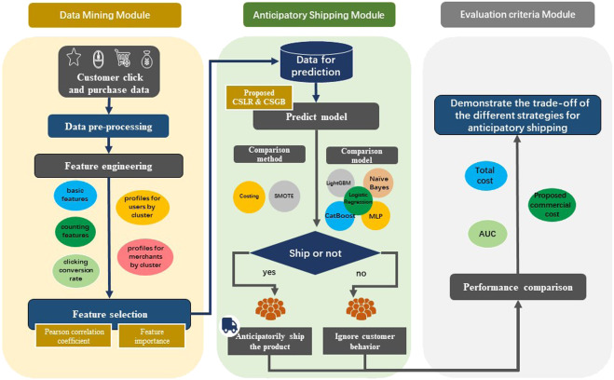
Flowchart of algorithm for functional of Anticipatory Shipping.
Source: (Pratiksha, 2023)

This section demonstrates Amazon's purposeful effort to forecast market trends and improve its customer-focused methodology. Amazon raises consumer satisfaction by using predictive analytics to foresee new trends. The corporation can efficiently change its operations to match growing consumer demands thanks to its strategic vision. Amazon places a high priority on trend forecasting because it is committed to staying flexible and responsive to its customers' ever-changing demands and making sure that customer satisfaction is at the center of its business strategy. Consumer behavior and corporate practices are changing because of process automation and digitization, gadget advancements like smartphones and tablets, and the proliferation of communication channels. To minimize aspects that have less of an impact on supply chain resilience, companies must carefully create a flexible company plan. To attain better performance outcomes, a resilient supply chain needs to be both proactive and reactive, able to foresee internal and external interruptions and uncertainties (Wicaksono et al., 2022). Restocking efficiency and prediction accuracy are two areas where leading supply chain companies, like
Artificial Intelligence (AI) is being used by Amazon to transform supply chain forecasting, which improves product performance and operational efficiency dramatically. Amazon can analyze a variety of data sources, including historical sales data and current market trends, by incorporating AI, which makes it possible to estimate demand more precisely (Bryan et al., 2021). This advanced strategy optimizes stock levels by forecasting sales patterns for new items and reduces waste by making sure that stock levels are closely in line with real demand (Hangl et al., 2022). For instance, Amazon can modify inventory and logistics by using AI-driven analytics to identify products that are likely to experience a spike in demand.
2.3.3 Consumer Engagement with AI-Powered Personalization
Consumer attention is highly competitive in the world of digital marketing. Brand recall declines and banner blindness occurs when generic messaging is frequently lost in the deluge of information (Etukudoh et al., 2024). Brands can develop marketing plans that are specific to consumer tastes, past purchases, and online activity by utilizing AI's potent data. According to Jiang and Wang (2024), this strategy helps brands forge closer bonds with customers, which in turn boosts engagement and loyalty while giving them a significant competitive edge.
According to Hassan et al. (2024), personalization is particularly good at analyzing large amounts of client data. Generic and ineffective campaigns are often the result of traditional marketing, which frequently relies on small datasets. Yet, artificial intelligence (AI) algorithms could access a vast array of data sources, such as CRM records, past interactions, demographics, and purchase histories, to extract insightful information about the preferences of their clients. It is possible to infer customer preferences from website usage patterns, browsing behaviors, material viewed, and time spent on pages. Social media likes, shares, and comments also reveal customer attitude and brand loyalty. AI algorithms can find hidden patterns and distinguish between distinct client segments by examining this data. AI may, for example, recognize a subset of consumers who recently downloaded a fitness app and buy running shoes on a regular basis (Hassija et al., 2024).
Brands can use this information to customize their marketing messages by giving clients training advice that fits their fitness objectives or offering specific discounts on running clothes. With AI, client segments with comparable characteristics are identified, improving targeting and segmentation. AI employs a wider range of data points including purchase history, online behavior, and social media interactions to build more sophisticated groups than traditional marketing, which often divides consumers by demographics like age or geography (Matcov, 2024). These targeted audience segments allow brands to effectively communicate with each unique group of consumers with tailored communications. For instance, an online retailer can give incentives to consumers who have abandoned their shopping carts to entice them to finish their purchases through targeted emails. Like this, social media advertisements can be tailored to appeal to audiences, showcasing goods and services that meet their requirements and interests. This level of personalization increases the relevance and engagement of marketing messaging, which increases the likelihood that a customer will convert. Real-time personalization made possible by AI overcomes static segmentation. AI can, for example, analyze a user's behavior when they browse a travel website and explore various places, and then dynamically change the content that appears to them (Lai, 2024).
AI-powered real-time behavior analysis makes it possible to show customized pop-up advertisements with special deals on travel and lodging for regions. Additionally, by providing personalised product recommendations or responding to enquiries based on a user's browsing history, AI-powered chatbots on websites can improve customer service. The user experience is significantly enhanced by this real-time personalization. Instead of being bombarded with generic messaging, consumers now receive marketing that is relevant to their present needs and interests, which deepens their relationship with the brand (Mayo et al., 2024). Although there is a lot of promise for AI-powered personalization, openness and proper data policies must come first. Consumers must trust that the ways in which their data is used to customize their experiences are legitimate. Additionally, to prevent deceiving customers, brands must be transparent about AI's role in personalization (McGurk & Reichenbach, 2024). This customized experience is where marketing is headed as artificial intelligence keeps changing the marketing scene. By leveraging AI's capabilities for data analysis, segmentation, and real-time personalization, brands can create marketing campaigns that are highly targeted and resonate with specific consumers. This strategy boosts engagement, fortifies brand loyalty, and propels company success. The possibilities for tailored marketing are only going to grow as AI technology develops (McLaughlin, 2024). Creating genuine connections with customers is the future of marketing, and artificial intelligence provides the means to make this vision a reality but to make sure that this future is advantageous for both customers and marketers, ethical concerns and appropriate data practices are essential. Generic messaging overtakes the digital marketing scene frequently, which can cause alienation among consumers. Personalization enabled by AI offers a revolutionary approach. Artificial intelligence (AI) uncovers hidden patterns and distinguishes between different client segments by evaluating vast amounts of customer data, such as CRM records, purchase histories, online activity, and social media interactions.
2.3.4 Satisfaction
Satisfaction is the result of a need, want, or appetite being met and the pleasure or happiness that results from them being satisfied. The degree to which a consumer's expectations of a good, service, or encounter are met or beyond is referred to as satisfaction. It is a crucial sign of how well a business or brand fulfils the promises made to clients. Customer loyalty, repeat business, and general business success are all heavily influenced by satisfaction.
In marketing and business management, customer satisfaction is a key notion that denotes how well a product or service meets or surpasses the expectations of the consumer. It is a vital indicator of an organization’s success and a major force behind client retention, recurring revenue, and positive word-of-mouth. Maintaining a competitive advantage in today's market requires an understanding of and commitment to improving customer satisfaction.
Theoretical Foundations of Customer Satisfaction:
A few theories have been put out to explain how consumers arrive at their satisfaction assessments. Oliver's (1980) Expectation-Disconfirmation Theory is one of the most generally recognized ideas. This hypothesis states that customers' impressions of the actual performance compare favorably with their expectations, leading to satisfaction. Satisfaction results from positive disconfirmation when performance meets or exceeds expectations; discontent results from negative disconfirmation when performance falls short. The Equity Theory is another significant idea that holds that consumers evaluate a transaction's fairness to determine how satisfied they are. When customers believe they have received value equal to what they have contributed whether in terms of cash, time, or effort they are likely to feel satisfied (Adams, 1965). This approach emphasizes how important fairness and perceived value are in determining contentment.
The utilization of AI-powered personalization by Amazon has greatly improved customer satisfaction and engagement. Amazon has streamlined its processes and customized its interactions to match the demands of each unique consumer by utilizing AI for precise demand forecasts, customized marketing, and customer service enhancements. This method increases supply chain efficiency, decreases waste, and fosters customer loyalty all at the same time. Amazon continues to lead the way in developing personalised, real-time experiences that increase consumer pleasure as AI technology develops, setting up the business for long-term success in the cutthroat online market.

2.4 Data security affects consumers' faith in AI-powered marketing.
2.4.1 Definition of Trust
According to McKnight et al. (2020), trust in digital platforms is essential for promoting customer engagement, loyalty, and long-term business success especially now where privacy and data security are major concerns.
2.4.2 Definition of Data Security
According to Stallings (2018), data security encompasses various techniques such as encryption, access control, data masking, and secure backups, all of which aim to prevent breaches, ensure data integrity, and comply with legal and regulatory frameworks like the General Data Protection Regulation (GDPR). Vacca (2020) further adds that, in the context of cloud computing and remote services, data security strategies must account for evolving threats such as malware, phishing attacks, and insider threats.
2.4.3 Trust and Data Security
Trust in business can be a legal structure in which an individual or group looks after assets on behalf of another individual or company. Land, buildings, investments, and money can all be included in trusts. The settler is the individual who places assets into the trust; the trustee is the person who oversees the trust's administration; and the beneficiary is the person who gains advantages from the trust. In the context of consumer behavior, trust is often defined as the expectation that a business will deliver on its promises, safeguard customer data, and act in the best interests of the consumer. According to Gefen (2020), trust is essential for reducing uncertainty in online transactions, particularly in e-commerce, where direct human interaction is absent.
Data security is the process of securing digital information to prevent loss, illegal access, and corruption. It includes all facets of technology, such as user devices, storage devices, hardware, software, administrative controls, and organizational policies and procedures. Protecting data from ransomware and other threats that can encrypt, destroy, change, or distort it is another aspect of data security.
In the current digital era, where sharing and online transactions are commonplace, trust and data security have become important issues for businesses as well as consumers. In this context, "trust" refers to customers’ faith in firms’ ability to handle their personal information in a secure, dependable, and morally responsible manner. Contrarily, data security includes all the tactics and safeguards used to keep private information safe from hackers, illegal access, and other threats. Ensuring regulatory compliance, upholding business reputation, and preserving customer relationships all depend on the interplay between trust and data security.
According to Gefen (2020), Businesses need to take a proactive and thorough strategy to safeguard client information if they want to increase trust through data security. This calls for the development of an organization-wide security awareness culture in addition to the implementation of strong technical safeguards. Important elements of this plan include providing personnel with regular training on data protection procedures, establishing clear guidelines for managing data, and acting quickly in the event of a security problem.
Additionally, companies should place a high priority on openness and communication with their clients. Obtaining explicit consent for data use, giving customers control over their data, and clearly outlining data protection procedures can all greatly increase trust. In the event of a data breach, prompt and open communication is crucial to minimizing harm to clients' reputations and confidence.
The confidence that Amazon has earned from consumers, especially about data security, is essential to its success in the e-commerce sector. Amazon places a high priority on securing user data by utilizing cutting-edge security techniques like encryption, multi-factor authentication, and ongoing monitoring because it is a platform that handles enormous volumes of financial and personal data. Complying with international data protection laws, such the CCPA and GDPR, is essential for protecting the rights of consumers. At Amazon, open communication is another way to establish trust. Customers have control over their personal information because the corporation makes its data usage policies very apparent. In the case of a data breach, Amazon's prompt and open reaction helps minimize harm and preserve consumer trust. Strong data security and client-focused communication are combined by Amazon to safeguard consumer information and build trust, both of which are critical to the company's ability to maintain its market dominance. This trust maintains Amazon's standing as a dependable and safe e-commerce platform, fosters customer loyalty, and promotes repeat business.
2.4.4 Definition of Benefits:
Benefits refer to the positive outcomes or advantages that individuals or organizations derive from a product, service, or activity. In a consumer context, benefits are the desirable results that customers seek when purchasing a product or engaging with a service, such as convenience, timesaving, improved quality, or cost savings. These benefits can be functional (e.g., performance, ease of use) or emotional (e.g., satisfaction, status).
Benefits in digital marketing and e-commerce are frequently associated with how well a good or service satisfies customer wants and enriches their lives. Leroi-Werelds (2022) states that customers assess a product's value by looking at how well it meets their unique demands and adds value beyond its essential features.
According to Hsu et al. (2021), consumers' trust and engagement with AI-driven platforms are significantly influenced by perceived benefits including convenience and personalization. Establishing a long-term relationship and fostering loyalty requires that rewards match client expectations.
Furthermore, Gao et al. (2020) have observed that the advantages of digital platforms increasingly entail AI-powered personalised experiences that improve consumer happiness and expedite decision-making.
2.4.5 Perceived Benefits
The advantages or favorable results that customers anticipate obtaining from a good service, or activity are known as perceived benefits. These advantages may be material (like cost savings or functioning) or immaterial (like convenience or satisfaction). Customers typically weigh the projected advantages against the related costs or risks, therefore how they perceive these benefits affects their decision-making.
Perceived benefits are essential for encouraging customer involvement and trust in the context of digital marketing and AI-powered services. For example, because they save time and are convenient, personalised services like purchase recommendations based on past behavior are seen favorably. Chen and Li (2022) draw attention to the fact that by tailoring the buying experience to each customer's unique demands, personalised AI-driven e-commerce services can dramatically increase perceived advantages. Furthermore, Park et al. (2021) highlights the strong correlation between customer trust and perceived benefits, particularly in the context of digital platforms and artificial intelligence (AI), where security and personalization are critical aspects.
2.4.6 Trust and Benefits
Trust is a fundamental component in consumer relationships, particularly in the digital age where personal data is frequently shared with companies. When consumers trust a company, they are more likely to engage in transactions, share personal information, and remain loyal. This trust is built on the belief that the company will act in the consumer's best interest, protect their data, and deliver on promises made. The benefits that consumers perceive from a trusted relationship with a company significantly influence their behavior and loyalty.
According to McKnight et al. (2020), Relationships with customers depend heavily on trust, especially in the digital age when sharing personal information is commonplace. Customers are more inclined to transact and divulge personal information when they have faith in a business, which can boost customer loyalty. This confidence is based on the conviction that the business would uphold its end of the bargain, safeguard customer information, and honor its word. Trust is largely fostered by perceived benefits, such as better customer experiences and personalised services. For instance, by offering observable advantages, Amazon's recommendation system which customizes product recommendations based on previous purchases increases customer pleasure and trust. Transparency in data handling procedures is also essential since it builds trust when businesses are honest about how they utilize and safeguard data.
Consumer engagement with AI-powered marketing is heavily influenced by perceived benefits and trust. Because customers expect businesses like Amazon to protect their personal information, data security is essential to building trust. Amazon increases customer satisfaction by providing tailored experiences and openly disclosing data protection policies. Convenience and relevancy are two perceived benefits that reinforce this trust and encourage customer loyalty and enduring connections. As AI technology develops, upholding a balance between providing meaningful, personalised experiences and strong data security will continue to be crucial for retaining customer trust and promoting corporate success.

2.5 Literature gap
Research examining the direct relationship between personalised marketing messages and client involvement and happiness is noticeably lacking. While data security issues are often brought up in relation to artificial intelligence, not enough research has been done to determine how these issues particularly affect customer trust in AI-driven marketing. Furthermore, there is a dearth of study on how consumers' trust levels are impacted by their perceptions of the advantages of AI applications.
This study aims to close these gaps by investigating a few important topics, including the efficiency of AI in providing personalised marketing, consumer views of AI-powered personalization, the connection between engagement and satisfaction with tailored marketing messages, and the variables affecting confidence in AI marketing tactics. By addressing these shortcomings, the research will improve our comprehension of how artificial intelligence affects customer attitudes, marketing efficacy, and trust. This will yield important takeaways for companies looking to maximize their use of AI in marketing.

Chapter 3: Research Methodology

3.1 Introduction
A organized framework that guides the research process by taking into account the theoretical and philosophical underpinnings of the study and how these affect the choice of research methodologies is known as research methodology, according to Saunders, Lewis, and Thornhill (2019).

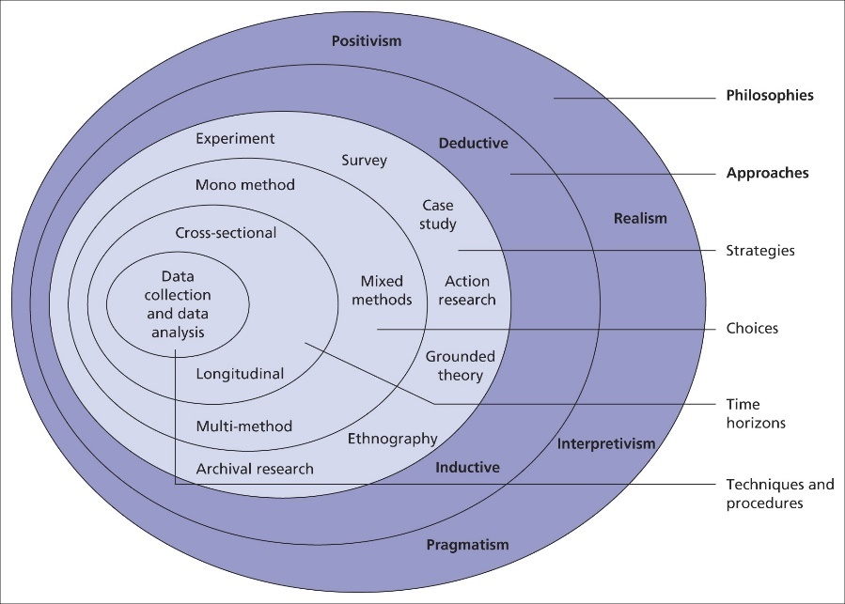
(Fig: The Research “Onion” by Saunders, Lewis, and Thornhill, 2019)
The conceptual framework known as the "research onion" is frequently used to illustrate the stages and levels of the research process. This paradigm, which provides an organized method to assist researchers in planning and carrying out their studies, is extensively used in both academic and professional settings. The layers of the research onion are stacked one on top of the other, working inward from the outermost layer. Every layer in the model represents a different step in the research process (Saunders, Thornhill, and Lewis, 2015).

3.2 Research Philosophy
A set of presumptions and viewpoints regarding the creation of knowledge and its relationship to study is research philosophy, according to Saunders, Lewis, and Thornhill (2019). According to Bryman (2016), positivism is an epistemological position that promotes the use of scientific means to investigate social reality and beyond. To enable control and prediction of the occurrences under study, positivist research aims to establish causative or explanatory linkages (Park, Konge, and Artino, 2020).
This study will be directed by a positivist methodology in accordance with the research questions that are provided in this paper. The researcher will gather scientific evidence by embracing positivism to create explanations based on a common worldview. This data will be analyzed to see if the study's goals are validated or invalidated.

3.3 Research Approach
Research methodology, which is defined by differences in foundational reasoning and investigative methodologies, is the systematic and structured strategy that researchers employ to carry out their studies. According to Saunders, Lewis, and Thornhill (2019), there are three main methods for developing theories: abduction, induction, and deduction.
Saunders, Thornhill, and Lewis (2015) state that the deductive technique involves the construction of theories through the application of a research strategy meant to substantiate a theoretical claim. This approach is frequently presented at the outset of a study proposal and is widely utilized in quantitative research. Rather than creating a new theory, the researcher aims to test or validate an existing one (Creswell, 2013). The processes in this process include formulating a hypothesis, obtaining data to support it, and determining whether the findings support or contradict the theory (Creswell, 2009).
The Deductive Approach is a way of thinking that starts with a broad theory or collection of hypotheses and proceeds from there to the specific. It usually involves extensive empirical investigation to test the theories. By beginning with well-established theories on artificial intelligence (AI) and marketing, specifically in relation to personalised marketing techniques, this study uses a deductive method. These theories offer a basic knowledge of how artificial intelligence (AI) might improve marketing initiatives by increasing the efficacy and relevance of customer interactions. This strategy is especially pertinent in the case of Amazon because the corporation heavily relies on AI to inform its marketing plans. Based on a user's browsing and purchase history, Amazon's recommendation systems make product recommendations. These systems are theoretically based on models that forecast customer behavior and preferences. Using a deductive methodology, this study develops hypotheses based on accepted theories, such as the usefulness of AI in raising consumer satisfaction, trust, and engagement, and examines them in the setting of Amazon's e-commerce platform. The deductive approach is useful in this situation because it makes it possible to apply well-established theoretical frameworks to the particulars of Amazon's business practices. For example, beliefs about data security and consumer trust may be directly applied to Amazon's use of AI to analyze customer data and customize purchasing experiences. The study can assess if the predicted results, such greater customer loyalty or higher conversion rates, match the observed facts by putting these hypotheses to the test within Amazon's ecosystem.

3.4 Research Strategy
In general, the deductive research approach and the survey strategy work together (Saunders, Lewis, and Thornhill, 2019). This method, which is frequently applied in the fields of business and management studies, primarily responds to enquiries concerning "who," "what," "how much," "where," and "how many." As such, it may be applied to both exploratory and descriptive investigations (Saunders, Thornhill, and Lewis, 2015).
A survey, according to Fowler (2013), is a systematic technique to collect data from a population to describe, understand, or provide the context for the attitudes, behaviors, or beliefs of a broader community. A survey questionnaire approach was employed in this study to gather thorough, reliable, and understandable data from Amazon users (followers and/or customers) in order to analyze the study's problem statement.

3.5 Type of Investigation
This study uses primary research methodologies for data collection and analysis to achieve its research goals. These techniques improved the consistency and dependability of the analysis by providing the researcher with a comprehensive understanding of the study subject from a variety of sources.

- Primary Research
Saunders, Lewis, and Thornhill (2019) define primary research as the systematic process of acquiring fresh and original data appropriate for a specific research project. Mostly referred to as field research, primary research uses methods such as surveys, observations, interviews, and experiments to explore certain research objectives or subjects (Saunders, Thornhill, and Lewis, 2015). The research "onion" assists investigators in selecting methodologies that align with their objectives and research questions by offering a systematic framework for primary research. This systematic approach ensures a coherent research methodology and enhances the study's quality, validity, and dependability by addressing elements such as research philosophy, approach, strategy, choices, time horizon, and methodologies.
For this investigation, a survey questionnaire was employed to gather primary data. It's common knowledge that survey questionnaires are an effective and well-liked tool for gathering primary data from many respondents (Bryman, 2016). By using this method, the researcher can collect standardized data on attitudes, beliefs, behaviors, or demographic traits linked to the research question (Fowler, 2013). In this instance in particular, the survey questionnaire has yielded insightful information about how to collect relevant and significant data from participants who are aware of Amazon's focused marketing campaigns (Yin, 2018).

3.6 Choices
The careful selection of methods and tools that researchers employ to conduct a study and provide answers to research questions is referred to as methodology choices, and it is done so to guarantee coherence in the research design. A multitude of factors, including the goals, questions, and objectives of the study, the surroundings, the available resources, and the expertise of the researcher, influence the methodological decision (Saunders, Lewis, and Thornhill, 2019). Three methodological alternatives are available to researchers: mixed, qualitative, or quantitative approaches. The choice of approach depends on the research philosophy, theory development process, and study design.
Merriam and Tisdell (2016) define qualitative research as a broad phrase that encompasses interpretive techniques aimed at elucidating, analyzing, and comprehending the significance of naturally occurring events in the social realm. Understanding is more important than frequency.
A research challenge in quantitative research is identified by attempting to explain a phenomenon or by searching for patterns (Creswell, 2013). The researcher next quantitatively assesses and analyses the data using a range of graphical and statistical tools, looking into the relationships between variables and assessing objective concepts (Saunders, Lewis, and Thornhill, 2019).
According to Creswell (2013), a mixed methodologies research strategy blends quantitative and qualitative research methods to produce a more thorough grasp of a study subject. The author of this study adopts an epistemological stance, employs positivism as the guiding philosophy, and employs a deductive technique that gives priority to empirical, quantitative research and primary data collection to arrive at findings that may be widely implemented. This study will solely consider quantitative data because it is using a mono-method quantitative research strategy.

3.7 Time Horizons
The research employed a cross-sectional time perspective, with data collection occurring at certain points over the ten-week study period, due to its short duration. A cross-sectional study gathers data at a single point in time to provide a summary of the phenomenon under investigation. Survey methodology is frequently used in cross-sectional research to gather data (Saunders, Lewis, and Thornhill, 2019).

3.8 Data Collection and analysis
3.8.1 Sampling
The fundamental idea behind sampling is that by selecting a portion of the population to study, details about the entire population can be inferred (Cooper and Schindler, 2014). The most crucial step in sample selection is to ensure that it fairly represents the general population and possesses characteristics that the researcher can rationally justify considering the objectives and research questions of the study (Saunders, Lewis, and Thornhill, 2019).
3.8.1.1 Sampling size
This study aims to investigate consumer attitudes and preferences about Amazon's AI-powered personalised marketing campaigns. Initially, it was believed that a predetermined sample size of respondents would be adequate to address the study objectives due to the project's scheduling restrictions. But during the data collection phase, 86 replies were collected, just barely reaching the intended sample size. Even though a larger sample size may yield more accurate results, the researcher contends that this one finds a reasonable balance between the timeliness of the project, the feasibility of data collecting, and result dependability. The researcher's accounts and friends who helped spread the poll on their accounts served as important sources for gathering the sample, which was gathered from a variety of social media platforms. In addition to ensuring a diverse sample of participants, this practice sped up data collection.
3.8.1.2 Sample type
All genders participated in the online survey, which was aimed at Amazon users who are impacted by AI. Individuals who fulfilled the qualifying requirements varied in social status, starting from the age of 18. This diverse participant survey was designed to reflect a range of ethnic origins.
3.8.1.3 Sample methods
Convenience sampling is a non-probability strategy that was used to pick study participants. Cooper and Schindler (2014) claim that by choosing participants who are available and willing to participate in the study, this approach to data collection emphasizes efficiency.
Convenience sampling was chosen because potential respondents may be easily reached through social media channels. With various channels, the online survey was sent to a broad audience of people who were impacted by Amazon, allowing the researcher to collect data. This made it possible for the researcher to complete the study's goal sample size earlier than anticipated. Considering these disadvantages, the researcher recognized the advantages of the convenience sampling approach in this case and concluded that it was appropriate for achieving the objectives of the study.
3.8.2 Data Collection Method
An online survey questionnaire was used to gather data for this study from 86 social media users who either follow or purchase things from Amazon.
We created an online quiz in English using Microsoft Forms. The survey consisted of 25 questions, 9 multiple-choice questions and 1 rating scale question. Within the designated time frame, 86 people anonymously submitted their thoughts on the form. The researcher made each question essential by adding the needed choice (*) to ensure that all questions were answered. Participants took an average of two minutes and thirty seconds to finish the survey.
3.8.3 Analysis of Data
The quantitative data from the study were processed using Microsoft Excel, which made it possible to create tables, graphs, and charts. Everything about the data analysis process proceeded well, and retrieving each response as an Excel file's pivot table was made simpler by using Microsoft Forms. This feature made it simpler for the researcher to create tables, graphs, and charts.
3.8.4 Research ethics
The administration of data collection for this study adhered to the Data Protection Act of 2018 (GOV.UK, n.d.), which regulates the processing of personal data in the nation. To assure compliance with the regulations, participants were informed about the purpose and methodology of the study at the outset of the survey and asked for their assent. The data collected was solely utilized for the research that was detailed in the study; it was not changed or shared with other parties. Additionally, no personally identifying information was gathered, therefore participant identities remained confidential. Ensuring confidentiality and data security, the collected data will be stored safely.

Chapter 4: Analysis of data
4.1 Introduction
To accomplish the research goals and derive meaningful conclusions, this section provides a comprehensive examination of the collected data. The researcher used a methodical methodology to organize, analyze, and interpret the quantitative data. The results of the data analysis are presented in a clear and concise manner, with the addition of tables and graphs to facilitate discussion and better understanding. The discussion is strengthened by concepts from the introduction and literature review chapters, and the findings are validated.
4.2 Questionnaire Analysis
Question 1
What is your Gender?

(fig: Self developed)
Result: As per the above figure, the survey respondents consisted of 64% males, 33% females and 2% prefer not to say and nothing for non-binary were noted.
Discussion: The gender distribution of the survey respondents, with 64% males, 33% females, and 2% preferring not to disclose their gender, reflects a significant gender imbalance. The lack of responses in the non-binary category highlights a gap in representation for non-binary individuals, potentially indicating either a lack of engagement from this group or issues related to visibility and inclusivity in the survey process.
The gender gap may affect how broadly the results may be applied, since studies have indicated that gender affects consumer behavior, technology use, and trust in marketing that uses artificial intelligence. In terms of trust and perceived risk regarding online platforms and data security procedures, men and women frequently perceive things differently (Gefen et al., 2020). Men may be less concerned about data privacy than women are, for example, and this could affect how women interact with AI-powered targeted advertising.
Moreover, the lack of non-binary respondents may suggest that this group is under-represented or underserved in research studies and marketing campaigns, which would restrict the inclusivity of AI-powered personalization techniques. According to McKnight et al. (2020), representation and inclusion on digital platforms are critical for ensuring fair access and confidence across all customer groups. The results thus point to the necessity of more inclusive research designs that take into consideration a range of gender identities to guarantee that AI-powered personalised marketing strategies are credible and relevant to a wider segment of the market.

Question 2
What is your age?
(fig: Self developed)

Result: As per the above figure, the survey respondents consisted of 52% are age of 25 to 34 years and 47% of 18 to 24 years old are noted.
Discussion: The results of the survey show that younger consumers predominate the participant poll, with 52% of respondents being between the ages of 25 and 34 and 47% being between the ages of 18 and 24. The trend that younger demographics—Millennials and Generation Z in particular—are more likely to employ digital technologies like AI-powered marketing platforms is shown by this age distribution. Despite certain privacy issues, Hsu et al. (2021) observe that these age groups are generally more tech-savvy and receptive to personalised AI experiences.
According to Gao et al. (2020), the 25-34 age group is quite popular because they are well-off, like easy, personalised digital interactions, and are professional. According to Park et al. (2021), there is also a notable representation of the 18-24 age group, which is indicative of their familiarity with digital media and their inclination towards personalised and engaging marketing strategies.
According to this study, marketing tactics driven by AI should prioritize convenience and personalization in order to attract younger, tech-savvy consumers. But since older groups are under-represented, it's possible that the results don't accurately represent the preferences of those who could be less at ease with AI. To give a more complete picture of AI-driven marketing preferences, future studies should include the perspectives of senior citizens.

Question 3
To what extent do you agree AI enhances the relevance of the marketing content you receive?
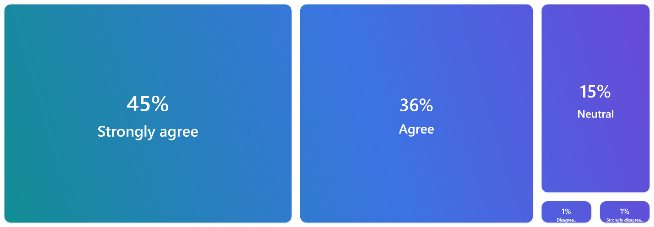
(fig: Self developed)
Result: The survey despite that wide range of participants agree AI enhances the relevance of the marketing content. Above figure shows that, 45% are strongly agreed, 36% are agreed, 15% are neutral, 1% are disagreed and 1% are strongly disagreed.
Discussion: According to the study, 81% of participants agreed (36%) or strongly agreed (45%) that artificial intelligence (AI) improves the relevance of marketing content. This finding is consistent with studies that indicate AI's contribution to better targeting and personalization. According to Hsu et al. (2021), personalised content based on user behavior and preferences is delivered by AI-driven marketing, which raises customer engagement and satisfaction. This illustrates how customers' desire for customized experiences is expanding. According to Park et al. (2021), suggestions driven by AI improve user experience by delivering personalised information, increasing marketing efficacy.
However, 15% of respondents expressed no opinion, which may have been brought about by a lack of knowledge or personal experience with AI-driven marketing. Chen and Li (2022) contend that depending on how knowledgeable a consumer is with technology, their opinions of AI may differ. To close this gap, brands must express the advantages of AI in plain terms.
Just 2% of participants disapproved, most likely due to worries about data privacy or the artificial intelligence (AI)-generated content's lack of human touch. Customers' trust may be damaged by worries that their data isn't being managed securely, according to McKnight et al. (2020). In conclusion, even if AI is widely acknowledged to increase marketing relevance, to win over consumers' mistrust, organizations must ensure transparency, data security, and ethical AI methods.
Question 4
To what extent do you agree that the marketing messages you receive from Amazon are customized to match your personal preferences?

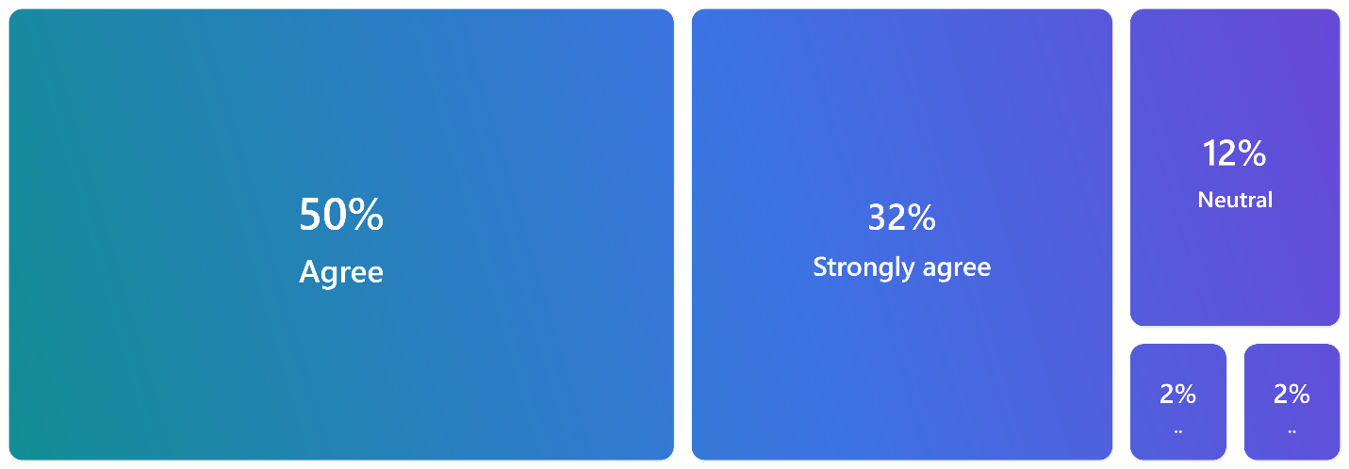
(fig: Self developed)

Result: The survey despites that wide range of participants agree that the marketing messages you receive from Amazon are customized to match your personal preferences. The above figure shows 50% agreed, 32% are strongly agreed, 12% are neutral, 2% are disagreed and 2% are strongly disagreed.
Discussion: The study finds that 82% of participants agree (50%) or strongly agree (32%) that Amazon customizes its marketing messaging to suit their individual interests. This is consistent with studies demonstrating the efficacy of Amazon's AI-driven recommendation system. According to Gao et al. (2020), Amazon generates highly personalised marketing by using AI algorithms to evaluate customer data, including browsing history and previous purchases. In response to the growing need for individualized e-commerce experiences, this customization increases client engagement and loyalty.
According to Chen and Li (2022), AI-driven personalization increases user pleasure and interactivity by making content more relevant. Nevertheless, 12% of respondents had no opinion, which would indicate that not all consumers are aware of or grateful for Amazon's tailored advertising. According to Hsu et al. (2021), some people might not notice much of a difference between personalised and generic content.
A minority (4%) expressed disagreement or strong disagreement, potentially owing to privacy concerns. According to McKnight et al. (2020), some customers may get apprehensive and mistrusting if they think their personal data is being misused.
In conclusion, many participants appreciate Amazon's tailored advertising, although others are unconcerned with data privacy or have no opinion at all. To keep customers' trust, businesses need to put an emphasis on ethical data practices and openness.
Question 5
To what extent do you agree that AI-powered marketing helps Amazon better understand your needs and preferences?
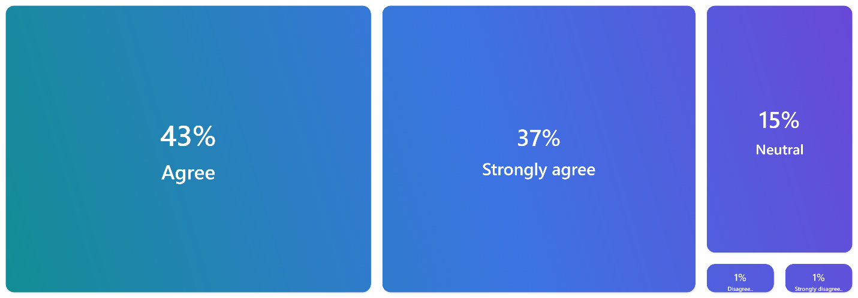
(fig: Self developed)

Result: The survey despites that wide range of participants agree that AI-powered marketing helps Amazon better understand your needs and preferences. The above figure shows 43% agreed, 37% strongly agreed, 15% are neutral, 1% disagreed and 1% strongly disagreed.
Discussion: As per the survey, 80 percent of participants concur (43%) or strongly concur (37%) that Amazon's marketing powered by AI improves its comprehension of their requirements and inclinations. This echoes more extensive studies that demonstrate AI's contribution to e-commerce personalization. Using massive volumes of data, including browsing and purchase histories, AI-driven algorithms can provide highly customized marketing. According to Hsu et al. (2021), artificial intelligence (AI) helps businesses boost customer happiness and loyalty by allowing them to more accurately forecast consumer behavior and tailor their marketing.
The capacity of AI to recognize trends and produce insights enables websites like Amazon to customize the purchasing experience. Its AI recommendation engine, for example, customizes product recommendations based on prior interactions, increasing customer confidence and making the material more relevant (Chen and Li, 2022). 15% of respondents, however, had no opinion, which might indicate a lack of interest or a reduction in data sharing with Amazon that could have an impact on personalization (Gao et al., 2020).
Due to worries about data privacy or apparent errors in AI-driven marketing, a tiny minority (2%) disagreed (McKnight et al., 2020). These people might think AI is unnecessary or invasive.
In summary, even if many participants acknowledge the advantages of AI-powered marketing, resolving privacy and transparency issues is still essential to enhancing personalization and trust.
Question 6
To what extent do you agree that the product recommendations provided by Amazon are relevant to you?
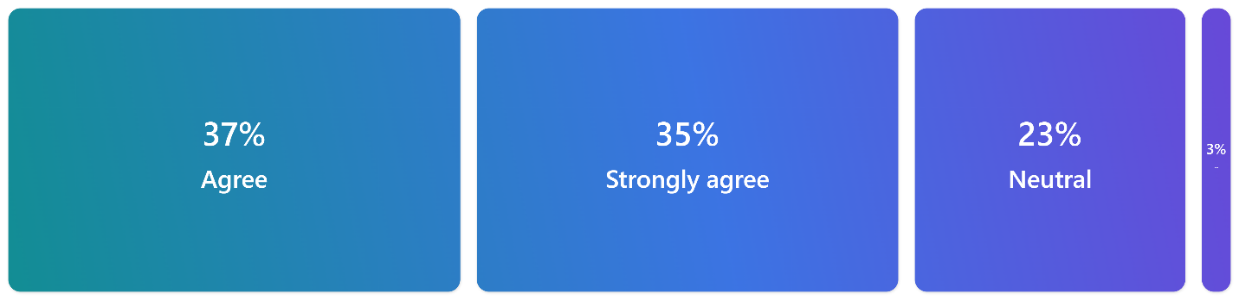
(fig: Self developed)
Result: The survey despite the wide range of participants agree that the product recommendations provided by Amazon are relevant. The above figure shows that 37% of respondents agree, 35% strongly agreed, 23% are neutral and 3% disagreed.
Discussion: 72% of participants in the study felt that Amazon's product recommendations are relevant (37% agreed, 35% strongly agreed), which is consistent with studies on the efficacy of AI-driven recommendation systems in e-commerce. According to Chen and Li (2022), AI's capacity to examine browsing patterns, previous purchases, and user feedback allows for tailored recommendations that raise consumer satisfaction and engagement.
Nevertheless, 23% of respondents expressed no opinion, which may indicate that they don't utilize Amazon's personalised features as much or that they don't think suggestions much improve their purchasing experience. According to Gao et al. (2020), there can be differences in user involvement with AI-driven personalization, which could influence how beneficial these recommendations are seen.
However, 3% of participants disapproved, suggesting that some users think the recommendations are incorrect or useless. This could be the result of data processing mistakes or the difficulty for AI to accurately forecast human behavior (McKnight et al., 2020).
Overall, it is acknowledged that Amazon's recommendation engine is a crucial component of their AI-driven marketing strategy, increasing both revenue and consumer loyalty. Giving users more control over personalization and increasing openness around recommendation generating are two ways that Amazon could increase customer happiness. It would also reduce errors and better match recommendations with user preferences if the system were continuously improved.
Question 7
To what extent do you agree that AI-powered recommendations make it comfortable for you to make purchasing decisions?

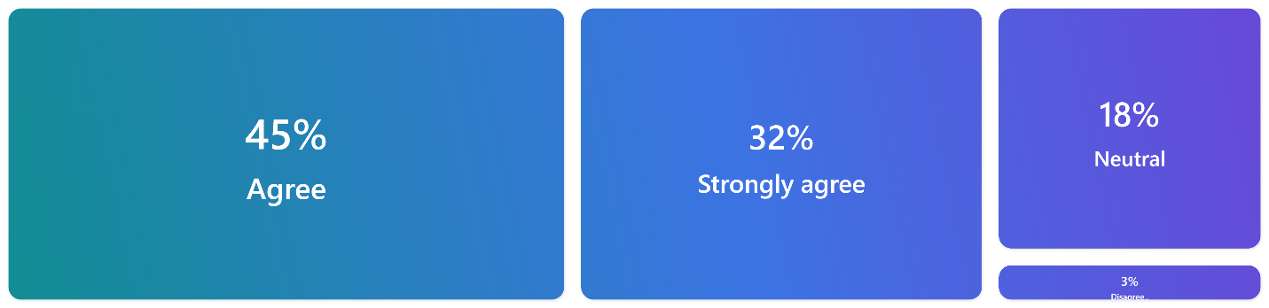
(fig: Self developed)

Result: The survey despite the wide range of participants agree that AI-powered recommendations make it comfortable for you to make purchasing decisions. The above figure shows that 45% agreed, 32% strongly agree, 18% neutral and 3% disagree.
Discussion: The survey found that 77% of participants (45% agreed, 32% strongly agreed) said their confidence was increased while making purchases on Amazon thanks to AI-powered recommendations. This bolsters findings from Hsu et al.'s research from 2021, which shows how AI personalized product recommendations based on user behavior expedite decision-making. By limiting the number of possibilities to those that are most likely to satisfy customer preferences, these recommendations lighten the cognitive load for users—a critical advantage in large online retailers such as Amazon.
By offering personalised recommendations, AI-driven recommendations also resolve the "paradox of choice," making shopping less intimidating (Gao et al., 2020). Nonetheless, 18% of respondents had no opinion, which may indicate that they feel AI has little effect on their purchasing decisions or are more comfortable using Amazon on their own. According to McKnight et al. (2020), not every client interacts with AI advice in the same manner.
A little proportion (3%) disagreed, suggesting that some users don't think the recommendations are meaningful. According to Chen and Li (2022), customers may become less dependent on AI because of repeated or misaligned advice because they become frustrated.
In summary, recommendations driven by AI often increase the trust that customers have in the decision-making process; yet, giving consumers more choice over personalization and enhancing transparency may increase the happiness of those who are left feeling neutral or unsatisfied.
Question 8
To what extent do you agree with the statement: "I am likely to engage with personalized marketing messages (e.g., emails, notifications) from Amazon"?
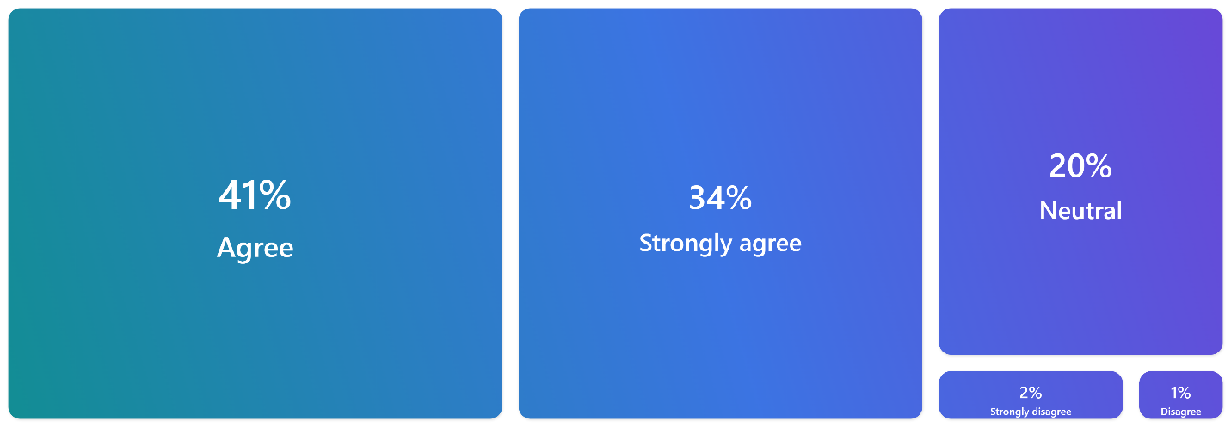
(fig: Self developed)

Result: The survey despite the wide range of participants agrees with the statement: "I am likely to engage with personalized marketing messages (e.g., emails, notifications) from Amazon”. The above figure shows that 41% agreed, 34% strongly agreed, 20% neutral, 2% strongly disagreed and 1% disagreed.
Discussion: Seventy-five percent of respondents (41 percent agreed, 34 percent strongly agreed) said they would probably interact with Amazon's customized marketing communications, like emails and alerts. This demonstrates how well tailored marketing works to draw in customers. According to studies by Hsu et al. (2021), customers respond better to personalised marketing. Amazon uses customer data, such as browsing and purchase history, to tailor material that is more relevant and enticing. Messages that are personalised are more likely to be responded to because they cut through the noise of generic marketing.
A further 20% of respondents indicated they were neutral, which may indicate that some consumers may not view personalization as highly, perhaps as a result of a more transactional attitude to shopping. These customers, according to McKnight et al. (2020), might value functionality or price over individualized attention. Three percent disagreed as well, perhaps because they were worried about their privacy or thought the communications weren't relevant. Too intrusive or repetitive messages can discourage engagement, according to Chen and Li (2022).
Trust is maintained by companies like Amazon by striking a balance between transparency and personalization. Transparency in data usage, as proposed by Park et al. (2021), can foster positive interaction and help consumers see personalised marketing as helpful rather than intrusive.
Question 9
To what extent do you agree with the statement: "I am satisfied with the personalized marketing content provided by Amazon"?
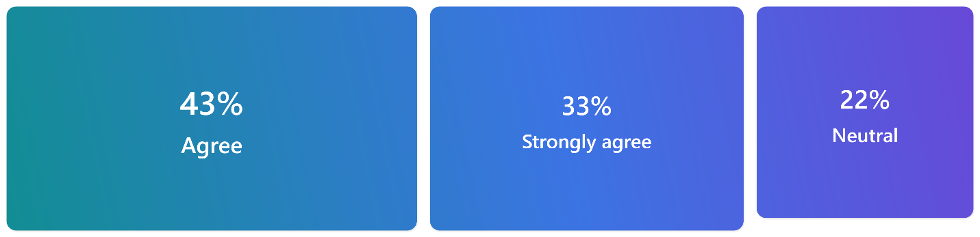
(fig: Self developed)

Result: The survey despite the wide range of participants agrees with the statement: "I am satisfied with the personalized marketing content provided by Amazon". The above figure shows that 43% agree, 33% strongly agree, 22% neutral.
Discussion: According to the study results, 76% of participants are happy with the tailored marketing content that Amazon provides, with 43% agreeing and 33% strongly agreeing. This high level of satisfaction is consistent with studies showing the advantages of customizing offers to each customer's unique interests. According to Hsu et al. (2021), brand loyalty is strengthened via marketing messages that are pertinent to consumer demands.
To enable highly targeted marketing communications, Amazon analyses customer data, including prior purchases and browsing activities, using sophisticated AI and machine learning algorithms. According to Gao et al. (2020), this kind of tailored information makes timely recommendations that increase customer satisfaction and make purchasing more pleasurable.
Nonetheless, 22% of participants showed neutrality, which may mean that even though they think marketing is helpful, their experience may not be greatly improved by it. This perception may be influenced by elements like message overload or frequency fatigue, in which consumers perceive an excessive amount of marketing communications. According to Park et al. (2021), there could be a decreasing return on excessive personalization.
The bulk of replies, despite the neutral ones, show that Amazon successfully strikes a balance between personalization and user interaction. Amazon may give users more flexibility over communication frequency while enhancing message timing and relevancy to sustain high satisfaction levels. Long-term client trust is also greatly impacted by data usage transparency.

Question 10
To what extent do you agree with the statement: "Personalized marketing messages from Amazon influence my purchasing decisions"?

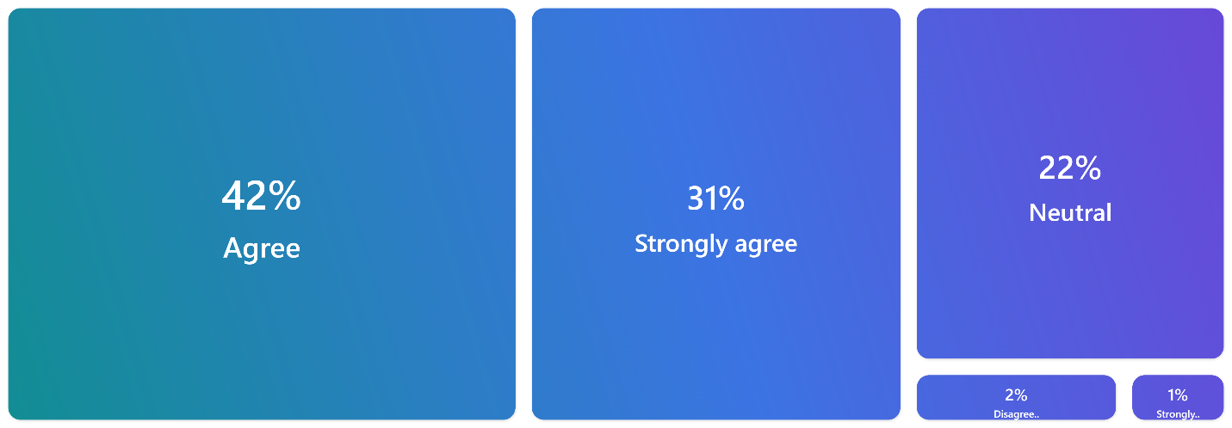
(fig: Self developed)

Result: The survey despite the wide range of participants agrees with the statement: "Personalized marketing messages from Amazon influence my purchasing decisions”. The above figure shows that 42% agreed, 31% strongly agreed, 22% neutral, 2% disagreed, 1% strongly disagreed.
Discussion: According to the study's findings, 73% of participants think that personalised marketing communications from Amazon have an impact on their decisions to buy, with 42% agreeing and 31% strongly agreeing. This illustrates how the value of tailored marketing is becoming increasingly apparent. According to Hsu et al. (2021), in a competitive e-commerce environment, these kinds of messages motivate consumers to act by fostering a sense of relevance and urgency.
Communications that are tailored to an individual's interests and past behaviors tend to be more resonant. According to Gao et al. (2020), relevant marketing builds emotional bonds between consumers and brands in addition to improving the purchasing experience. Effective audience segmentation is made possible by Amazon's use of AI and sophisticated data analytics, guaranteeing that marketing content is customized to customer profiles based on search queries and past purchases. Customers react more favorably to initiatives that take their preferences into consideration, according to Chen and Li (2022).
Nonetheless, 22% of respondents indicated that they were neutral, suggesting that even though they value personalization, they might not consider it to be a deciding factor when making purchases. A tiny percentage (3%) expressed skepticism regarding personalization by disagreeing. Overall, the results show that to improve relevance, reduce message fatigue, and maintain transparency about data usage, Amazon must continuously improve its personalization tactics.
Question 11
How much do you agree with the statement: "I am concerned about the security of my personal data when Amazon uses AI for personalized marketing"?
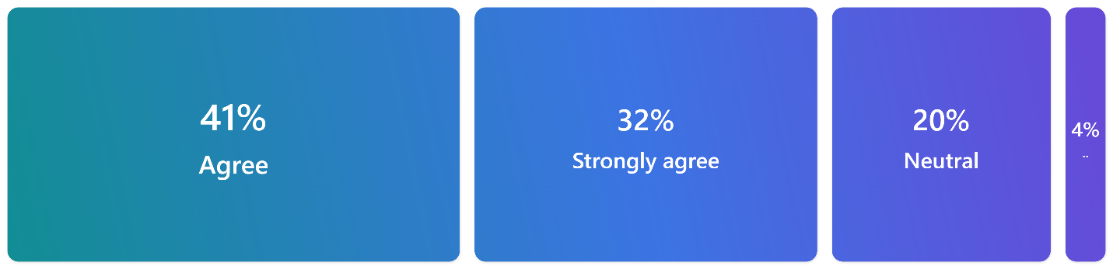
(fig: Self developed)
Result: The survey despite the wide range of participants that agrees with the statement: "I am concerned about the security of my personal data when Amazon uses AI for personalized marketing". The above figure shows that 41% agreed, 32% strongly agreed, 20% neutral and 4% disagreed.
Discussion: According to the survey, 41% of respondents and 32% strongly agree that Amazon's use of artificial intelligence (AI) for personalised marketing raises security concerns for 73% of respondents. As privacy and data security have grown to be prominent issues on digital platforms, this demonstrates a strong worry surrounding data privacy, echoing broader patterns in consumer behavior (McKnight et al., 2020).
This growing concern is a result of a number of factors, including consumers becoming more aware of data breaches and cyberattacks and Stallings (2018) emphasizing the need for strong data security measures, like encryption, to protect sensitive data; AI enhancing marketing personalization but also raising concerns about potential misuse of personal data; and Gefen (2020) asserting that trust is essential for reducing uncertainties in online transactions, especially when it comes to personal data.
A minority of respondents (4%) showed no anxiety, possibly because of prior favorable experiences with the brand, while 20% remained indifferent, maybe because of ignorance of Amazon's data security policies (Hsu et al., 2021). Amazon needs to prioritize transparency, invest in strong security measures, and improve consumer education about data privacy if it wants to win over customers' trust. This will strengthen and improve the relationship with its AI-powered marketing initiatives.
Question 12
How much do you agree with the statement: "The way Amazon handles my data affects my trust in its AI-powered marketing"?

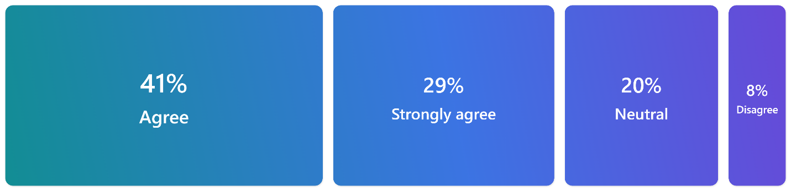
(fig: Self developed)

Result: The survey despite the wide range of participants that agrees with the statement: "The way Amazon handles my data affects my trust in its AI-powered marketing". The above figure shows that 41% agreed, 29% strongly agreed, 20% neutral and 8% disagreed.
Discussion: According to the study, 70% of participants think that Amazon's data handling practices have an impact on their confidence in the company's AI-powered marketing, with 41% and 29% strongly agreeing. This demonstrates how important data management is to gain the trust of customers, especially in AI-driven marketing. According to McKnight et al. (2020), customer participation in digital environments—where personal information is frequently shared—requires trust.
Transparency in data handling is essential since consumers are becoming more conscious of how their data is gathered and utilized. Gefen (2020) observes that a company's commitment to data protection and ethical use boosts confidence. Amazon may boost consumer confidence in its marketing by emphasizing openness and safe data methods.
Although 20% of respondents expressed no opinion, this probably indicates that they were unaware of Amazon's data policy. As shown by Hsu et al. (2021), educating customers about data use may help them transition from ambivalence to trust. On the other hand, 8% of respondents might already feel comfortable with Amazon's data practices due to favorable experiences or assurances on the company's adherence to laws such as GDPR.
In summary, the survey underscores the robust correlation between data handling practices and trust and recommends that Amazon improve openness and data security measures to foster enduring customer loyalty and engagement.
Question 13
How much do you agree with the statement: "Amazon is transparent about how it uses my data to personalize my shopping experience"?
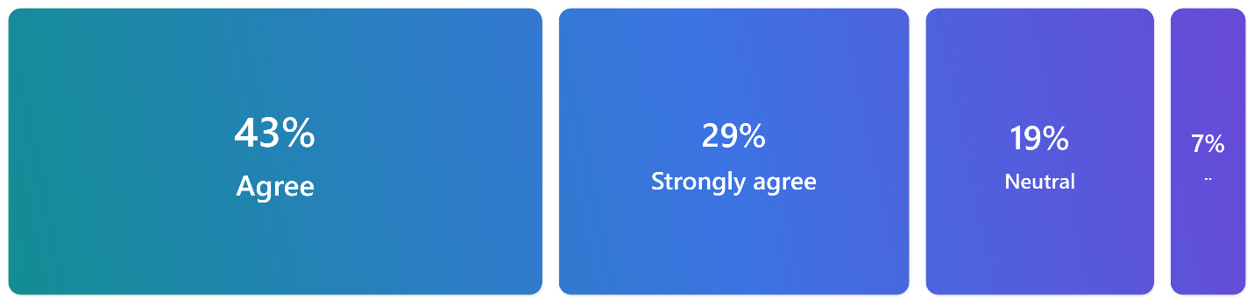
(fig: Self developed)
Result: The survey despite the wide range of participants that agree with the statement: "Amazon is transparent about how it uses my data to personalize my shopping experience". The above figure shows that 43% agreed, 29% strongly agreed, 19% neutral and 7% disagreed.
Discussion: The study indicates that 72% of participants either agree (43%) or strongly agree (29%) that Amazon is open about using data to tailor their purchasing experience. Building trust in digital marketing requires that people have a positive opinion of Amazon's data disclosure methods, which is reflected in the high degree of agreement. Companies that are honest about data gathering and protection reassure customers, which in turn fosters customer involvement and trust (McKnight et al., 2020). Because of its transparency, Amazon's AI-driven marketing is probably more credible because privacy worries are lessened.
Though 19% of respondents expressed no opinion, this could indicate that some users are unaware of or do not completely comprehend Amazon's data practices. Hsu et al. (2021) suggest that enhancing consumer education on data usage may aid in transforming these indifferent reactions into more robust trust. A minority of participants, comprising 7% of the sample, expressed skepticism over Amazon's transparency, potentially because of unsatisfactory past experiences or unclear information. Vacca (2020) emphasizes that addressing customer complaints head-on can aid in lowering mistrust.
Although many respondents have a positive perception of Amazon's transparency overall, improving communication regarding data practices and maintaining openness will ultimately increase consumer trust and fortify customer relationships.
Question 14
How much do you agree with the statement: "I trust Amazon's AI-powered marketing more when it offers benefits that align with my personal needs"?
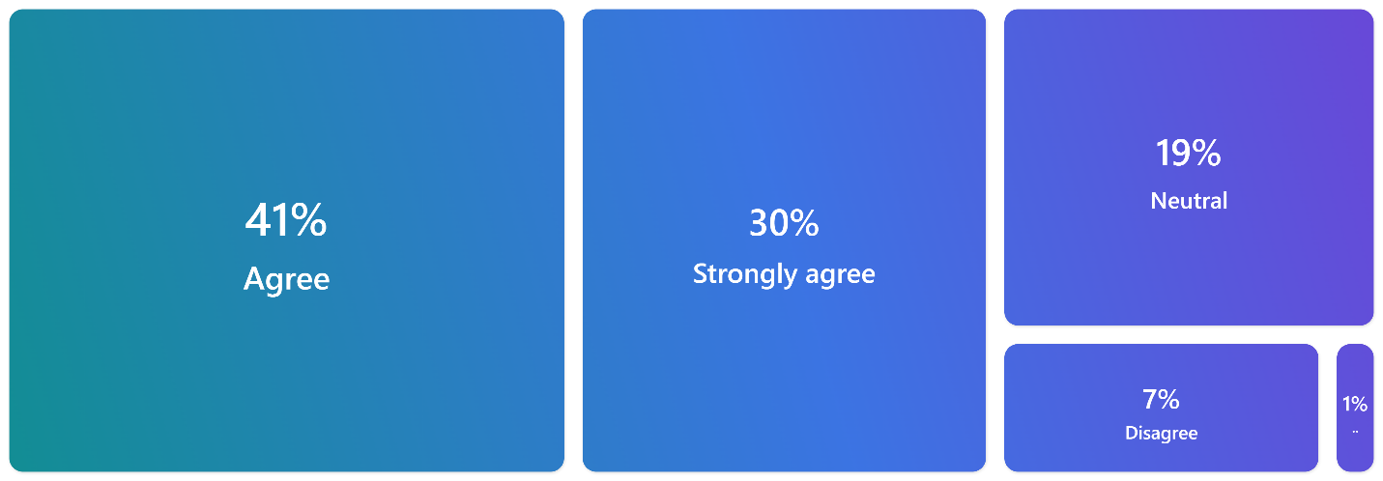
(fig: Self developed)
Result: The survey despite the wide range of participants that agree with the statement: "I trust Amazon's AI-powered marketing more when it offers benefits that align with my personal needs". The above figure shows that 41% agree, 30% strongly agree, 19% neutral, 7% disagree and 1% strongly disagree.
Discussion: As per the survey, 71% of participants either strongly agree (30%) or agree (41%) that they have greater faith in Amazon's AI-driven marketing when it corresponds with their individual requirements. This suggests a substantial relationship between customized perks and client confidence. According to McKnight et al. (2020), users' trust in digital services increases when they perceive a personalised level of value. Personalised marketing from Amazon, such product recommendations and tailored discounts, seems to increase consumer pleasure and trust.
The development of trust in AI marketing is contingent upon perceived benefits. According to Hsu et al. (2021), engagement and trust are raised by personalised services such product recommendations and targeted offers. Customer loyalty appears to be strengthened by Amazon's ability to provide insightful, worthwhile recommendations, particularly when those recommendations result in convenience, cost savings, or efficiency gains.
However, 19% of respondents had no opinion, indicating a chance for Amazon to strengthen its personalization tactics. Building trust requires personalization to bring a visible value, according to Leroi-Werelds (2022). Conversely, 8% showed mistrust, maybe because of unfulfilled expectations or worries about data protection. The necessity to strike a balance between data security and personalization is highlighted by Gao et al. (2020).
In summary, while many respondents trust Amazon's AI marketing when it fulfils their needs, enhancing personalization and resolving privacy issues could increase consumer involvement and confidence even more.
Question 15
To what extent do you agree with the statement: "The perceived benefits of AI-powered personalization (e.g., time savings, convenience) influence my trust in Amazon's marketing practices"?
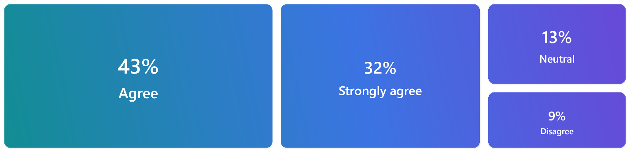
(fig: Self developed)
Result: The survey despite the wide range of participants that agree with the statement: "The perceived benefits of AI-powered personalization (e.g., time savings, convenience) influence my trust in Amazon's marketing practices". The above figure shows 43% agreed, 32% strongly agreed, 13% neutral, 9% disagreed.
Discussion: In the survey, 75% of participants (43 percent agreed, 32 percent strongly agreed) said that they had a greater trust in Amazon's marketing techniques because of the simplicity and time savings that AI-powered personalization offers. This demonstrates the significance of perceived value in fostering customer trust. Customers evaluate a service's worth according to how well it satisfies their unique needs, according to Leroi-Werelds (2022). With their ability to cater to user preferences and provide personalised recommendations, Amazon's AI-powered services seem to build confidence.
Amazon's AI-driven personalization improves customer satisfaction by streamlining the purchasing process and speeding up and streamlining decision-making. According to Hsu et al. (2021), observable advantages like ease help people trust digital systems. Nonetheless, 13% of respondents had no opinion, suggesting that not all users believe these benefits have a major impact on their level of trust. It's possible that this group does not completely appreciate or respect personalization.
However, 9% of respondents disapproved, presumably because of uncertainties about the advantages of AI or worries about data security. According to Park et al. (2021), consumers may be suspicious of AI platforms if they believe privacy is being jeopardized or that the benefits are overstated.
In summary, many participants have faith in Amazon's AI marketing due to its evident advantages; nevertheless, improving personalization and resolving data-related issues could increase customer confidence even more.
Question 16
To what extent do you agree with the statement: "I would be more willing to share my data with Amazon if it resulted in more personalized and beneficial shopping experiences"?
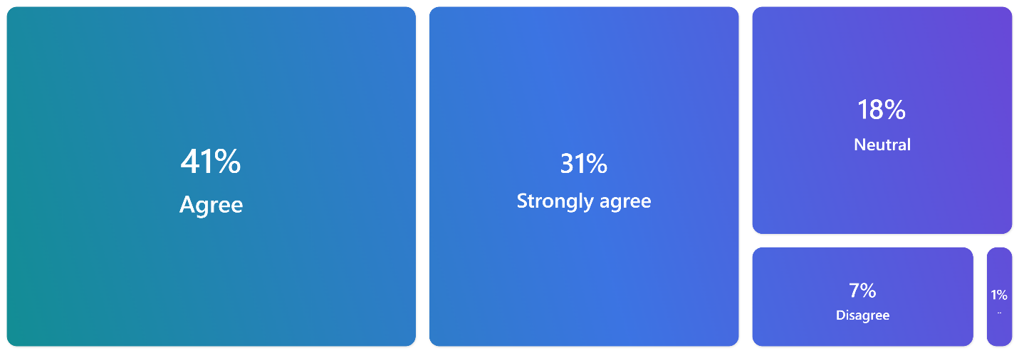
(fig: Self developed)
Result: The survey despite the wide range of participants that agree with the statement: "I would be more willing to share my data with Amazon if it resulted in more personalized and beneficial shopping experiences". The above figure shows that 41% agreed, 31% strongly agreed, 18% neutral, 7% disagreed and 1% strongly disagreed.
Discussion: According to the study, 72% of participants (41% agreed, 31% strongly agreed) would be more inclined to provide Amazon access to their personal information in exchange for more useful and personalised purchasing experiences. This emphasizes how important consumers' perception of value is in determining their willingness to divulge personal information. Effective personalization encourages users to submit data by providing advantages like ease of use and pertinent product recommendations. Consumers assess the value of services based on how effectively they suit their demands, according to Leroi-Werelds (2022), and many participants see personalised benefits as a just reward for providing their data.
According to Hsu et al. (2021), distinct benefits like quicker decision-making and customized recommendations increase consumer trust and involvement and increase the likelihood that they will share information. Nonetheless, 18% of respondents had no opinion, perhaps indicating a need for greater certainty and transparency around the use of data.
On the other hand, 8% of participants said they were reluctant to give their information because they were worried about privacy. According to Park et al. (2021), trust is essential because without faith in the way data is kept, some clients would refrain from sharing it. Gefen (2020) contends that building trust requires openness, and that Amazon needs to give priority to providing unambiguous information about data protection.
In conclusion, even though many respondents are amenable to data sharing for tailored benefits, Amazon must increase security and transparency to allay the worries of customers who are more cautious.

Chapter 5: Conclusion and Recommendations
5.1 Conclusion
Personalised marketing driven by AI has shown to be a very successful way to increase the effectiveness and relevancy of focused marketing campaigns. According to the survey results, customers like AI-driven personalization for its convenience, time-saving features, and more appropriate product recommendations. These elements have a favorable impact on client satisfaction and engagement. However, perceptions of benefits and data security are key factors influencing consumer trust in AI-powered marketing. When it comes to e-commerce sites like Amazon, most customers are happy to divulge personal information if they get something tangible and obvious in exchange, like better shopping experiences. However, many consumers continue to have worries about the way their data is handled, making data security a crucial problem. Maintaining and enhancing trust in AI-driven marketing initiatives requires openness in data handling procedures as well as the ethical use of consumer information.
In conclusion, AI-driven personalization presents a clear route to raising customer satisfaction and engagement levels, but also necessitates a methodical approach to handling privacy concerns related to data. For businesses like Amazon to maintain consumer trust and increase the efficacy of their AI-powered marketing initiatives, they must continue to place a high priority on transparency and security in their data handling procedures.
5.2 Recommendations
Businesses should concentrate on providing distinct, pertinent, and tailored benefits that satisfy customer expectations if they want to optimize the performance of AI-powered customized marketing campaigns. Businesses can improve customer happiness and engagement by providing value in the form of expediency, time savings, and customized advice. To keep consumers trusting AI-driven marketing initiatives, it is imperative to make sure they see these benefits as concrete and directly tied to their personal preferences. Enhancing data usage transparency is one important suggestion. Customers must feel confident in the knowledge that their personal information is being handled responsibly and securely. Businesses should be transparent about the ways in which they secure consumer data and explain to them how this information is used to improve individualized interactions. This could entail informing customers about the security measures in place to safeguard their data as well as providing frequent updates on privacy rules.
To guarantee continued relevance, businesses should also constantly improve their AI personalization strategies in response to client input. This will assist them in filling up any gaps in customer satisfaction, especially with those who are unsatisfied or doubtful of personalization initiatives. Prioritizing data protection, transparency, and value-driven personalization can help businesses fortify their AI-powered marketing strategies and foster enduring trust.
5.3 Limitations
Personalised marketing driven by AI has many benefits, but there are also certain drawbacks to consider. First off, there are serious privacy issues when personal data is used for successful personalization. Because they are afraid about data breaches or misuse, many consumers are still reluctant to share their personal information. Skepticism endures despite initiatives to increase security and transparency, which may restrict the overall effectiveness of AI-driven marketing campaigns. The possibility for over-personalization is another drawback. Personalization can improve the client experience, but there's a thin line between helpfulness and intrusiveness. Customers who feel that their privacy is being violated may find it uncomfortable to see highly targeted advertisements or recommendations that seem overly personalised. This may cause people to lose faith in the AI system and decrease interaction.
Additionally, even with their advancements, AI algorithms are not perfect. They make suggestions based on past behavior and data trends, which may lead to recommendations that are inappropriate or erroneous for some clients, especially those with varied buying histories or shifting preferences. This may reduce the impact of personalization initiatives. Finally, implementing AI-powered marketing plans into practice can be expensive and difficult for organizations, particularly smaller ones with tighter budgets. For some organizations, managing and optimizing these systems may not be financially feasible due to the substantial investment in technology and knowledge required.
5.4 Further research
Future research should examine how AI-driven personalised marketing affects customer behavior over the long run, with a focus on trust and loyalty. Examining the ways in which socioeconomic position and age affect how consumers see AI personalization can yield insightful information. Studies might also look at how cultural variations affect people's perceptions of personalised marketing and data privacy. It would be useful to examine how well different communication techniques contribute to the development of openness and trust. Lastly, studies might concentrate on the moral ramifications of AI in marketing, namely the thin boundary between privacy violation and personalization.

References
Acquisti, A., Brandimarte, L., & Loewenstein, G. (2015). "Privacy and human behavior in the age of information Science”, 347(6221), 509-514.
Awad, N. F., & Krishnan, M. S. (2006). "The personalization privacy paradox: An empirical evaluation of information transparency and the willingness to be profiled online for personalization." MIS Quarterly, 30(1), 13-28.
Agnihotri, R., Dingus, R., Hu, M. Y., & Krush, M. T. (2020). Social media: Influencing customer satisfaction in B2B sales. Industrial Marketing Management, 86, 52-61.
Brown, S. A., & Venkatesh, V. (2005). Model of adoption of technology in households: A baseline model test and extension incorporating household life cycle. MIS Quarterly, 29(3), 399-426.
Braun, V., & Clarke, V. (2019). Reflecting on reflexive thematic analysis. Qualitative Research in Sport, Exercise and Health, 11(4), 589-597.
Boerman, S. C., Kruikemeier, S., & Zuiderveen Borgesius, F. J. (2017). Online behavioral advertising: A literature review and research agenda. Journal of Advertising, 46(3), 363-376.
Chaffey, D., & Ellis-Chadwick, F. (2019). Digital Marketing: Strategy, Implementation and Practice. Pearson.
Creswell, J. W., & Creswell, J. D. (2017). Research Design: Qualitative, Quantitative, and Mixed Methods Approaches. SAGE Publications.
Chen, T., & Li, H. (2022). The impact of AI-powered personalization on consumer trust and engagement: A study in e-commerce platforms. Journal of Interactive Marketing, 54, 102-117.
Davenport, T. H., & Harris, J. G. (2017). Competing in Analytics: The New Science of Winning. Harvard Business Review Press.
Davenport, T. H., & Ronanki, R. (2018). Artificial Intelligence for the Real World. Harvard Business Review, 96(1), 108-116.
Davenport, T., Grewal, D., Bressgott, T., and Guha, A. (2020). The potential impact of artificial intelligence on marketing in the future. 48(1), 24–42, Journal of the Academy of Marketing Science. 10.1007/s11747-019-00696-0 is the DOI.
Davenport, T. H., Guha, A., Grewal, D., & Bressgott, T. (2020). How artificial intelligence will change the future of marketing. Journal of the Academy of Marketing Science, 48(1), 24-42.
Enholm, I. M., Papagiannidis, S., Kautonen, T., & Moisander, J. (2022). "Artificial Intelligence and Value Creation: The Role of Data and Data-Driven Insights in Business Transformation." Journal of Business Research, 141, 156-168.
Gentsch, P. (2019). AI in Marketing, Sales and Service: How Marketers Without a Data Science Degree Can Use AI, Big Data and Bots. Springer.
Gao, J., Fan, L., & Liu, Q. (2020). How AI is transforming e-commerce: The role of perceived benefits in consumer adoption. Computers in Human Behavior, 112, 106475.
Hoffman, D. L., Novak, T. P., & Stein, R. (2013). "The digital consumer." In J. F. Sherry & E. Fischer (Eds.), Handbook of Consumer Psychology (pp. 429-448). Routledge.
Huang, M. H., & Rust, R. T. (2021). A strategic framework for artificial intelligence in marketing. Journal of the Academy of Marketing Science, 49(1), 30-50.
Hsu, C.-L., Lin, J. C.-C., & Lu, H.-P. (2021). AI-driven personalized marketing and consumer trust: A mediation model of perceived benefits. Technological Forecasting and Social Change, 162, 120405.
Huang, M. H., & Rust, R. T. (2021). A strategic framework for artificial intelligence in marketing. Journal of the Academy of Marketing Science, 49(1), 30-50.
Jobin, A., Ienca, M., & Vayena, E. (2019). The global landscape of AI ethics guidelines. Nature Machine Intelligence, 1(9), 389-399.
Jarek, K., & Mazurek, G. (2019). Marketing and artificial intelligence. Central European Business Review, 8(2), 46-55.
Kotler, P., & Keller, K. L. (2016). Marketing Management (15th ed.). Pearson.
Kumar, V., & Gupta, S. (2020). The impact of artificial intelligence on consumer behavior. Journal of Business Research, 117, 336-345.
Kaplan, A., & Haenlein, M. (2020). Rulers of the world, unite! The challenges and opportunities of artificial intelligence. Business Horizons, 63(1), 37-50.
Kumar, V., Rajan, B., Gupta, S., & Pozza, I. D. (2019). Artificial intelligence in marketing: Evolution and future applications. Journal of Business Research, 104, 122-137.
Kim, J., & Lee, K. (2021). Efficiency and performance in AI-driven marketing. Journal of Marketing Analytics, 9(3), 174-189
Kaplan, A., & Haenlein, M. (2020). Rulers of the world, unite! The challenges and opportunities of artificial intelligence. Business Horizons, 63(1), 37-50.
Kietzmann, J., Paschen, J., & Treen, E. R. (2018). Artificial Intelligence in Advertising and Marketing: Using AI to Enhance Customer Relationships. Business Horizons.
Kalakota, R., and Davenport, T. (2019). The application of artificial intelligence in medicine. 94. doi: 10.7861/futurehosp.6-2-94 Future healthcare journal, 6(2)
Kietzmann, J., Paschen, J., & Treen, E. (2018). Understanding the impact of artificial intelligence on marketing. Journal of Marketing Management, 34(5-6), 1-28.
Kim, J., & Lee, K. (2021). Efficiency and performance in AI-driven marketing. Journal of Marketing Analytics, 9(3), 174-189.
Loureiro, S. M. C., Guerreiro, J., & Tussyadiah, I. (2021). Artificial intelligence in business: State of the art and future research agenda. Journal of Business Research, 129, 911-926.
Leroi-Werelds, S. (2022). Creating customer value: The role of benefits in shaping customer satisfaction and loyalty. Journal of Business Research, 139, 125-138.
Liu, X., Singh, P. V., & Srinivasan, K. (2021). Personalized promotions and firm profits in the presence of customer retention. Management Science, 67(4), 2227-2246.
McKnight, D. H., Carter, M., Thatcher, J. B., & Clay, P. F. (2020). Trust in a specific technology: An investigation of its components and measures. ACM Transactions on Management Information Systems, 12(4), 23.
Nair, K., & Gupta, R. (2021). Application of AI technology in modern digital marketing environment. World Journal of Entrepreneurship, Management and Sustainable Development, 17(3), 318-328. https://doi.org/10.1108/wjemsd-08-2020-0099
Pappas, I. O., Kourouthanassis, P. E., Giannakos, M. N., & Lekakos, G. (2017). The interplay of online shopping motivations and experiential factors on personalized e-commerce: A complexity theory approach. Telematics and Informatics, 34(5), 730-742.
Park, Y., Shin, J., & Lee, D. (2021). The role of perceived benefits in the adoption of AI services: An integrated model of user trust and AI capabilities. Journal of Business Research, 123, 423-434.
Stallings, W. (2018). Effective cybersecurity: A guide to using best practices and standards. Addison-Wesley Professional.
Vacca, J. R. (2020). Computer and information security handbook. Elsevier.
Zhang, T., Lu, C., Torres, E., & Chen, P. (2020). Engaging customers through AI-powered customer service: A study of customer satisfaction with virtual agents. Journal of Service Management, 31(3), 393-416.

Appendix
1.I confirm that I have read participant Information sheet.
Yes
No
2.
I confirm that I have read and understood the information sheet for the above study.
Yes
No
3.I understand there are no material benefits for participating.
Yes
No
4.
I have had the opportunity to consider the information, ask questions and have had these answered satisfactorily.
Yes
No
5.I understand that my participation is voluntary and that I am free to withdraw at any time, without giving any reason.
Yes
No
6.I understand that any information given by me may be used in future reports, articles or presentations by the researcher.
Yes
No
7.
I consent for my name and title to be used within this study. Where applicable, I understand that my details will not be anonymous.
Yes
No
8.I agree to be recorded (audio and/or audio-visual video).
Yes
No
9.I agree to take part in the above study.
Yes
No
10.What is you gender?
Woman
Man
Non-binary
Prefer not to say
11.What is your age?
18-24
25-34
35-44
45-54
12.To what extent do you agree AI enhances the relevance of the marketing content you receive?
Strongly agree
Agree
Neutral
Disagree
Strongly disagree
13.To what extent do you agree that the marketing messages you receive from Amazon are customized to match your personal preferences?
Strongly agree
Agree
Neutral
Disagree
Strongly disagree
14.To what extent do you agree that AI-powered marketing helps Amazon better understand your needs and preferences?
Strongly agree
Agree
Neutral
Disagree
Strongly disagree
15.To what extent do you agree that the product recommendations provided by Amazon are relevant to you?
Strongly agree
Agree
Neutral
Disagree
Strongly disagree
16.To what extent do you agree that AI-powered recommendations make it comfortable for you to make purchasing decisions?
Strongly agree
Agree
Neutral
Disagree
Strongly disagree
17.To what extent do you agree with the statement: "I am likely to engage with personalized marketing messages (e.g., emails, notifications) from Amazon"?
Strongly agree
Agree
Neutral
Disagree
Strongly disagree
18.To what extent do you agree with the statement: "I am satisfied with the personalized marketing content provided by Amazon"?
Strongly agree
Agree
Neutral
Disagree
Strongly disagree
19.To what extent do you agree with the statement: "Personalized marketing messages from Amazon influence my purchasing decisions"?
Strongly agree
Agree
Neutral
Disagree
Strongly disagree
20.How much do you agree with the statement: "I am concerned about the security of my personal data when Amazon uses AI for personalized marketing"?
Strongly agree
Agree
Neutral
Disagree
Strongly disagree
21.How much do you agree with the statement: "The way Amazon handles my data affects my trust in its AI-powered marketing"?
Strongly agree
Agree
Neutral
Disagree
Strongly disagree
22.How much do you agree with the statement: "Amazon is transparent about how it uses my data to personalize my shopping experience"?
Strongly agree
Agree
Neutral
Disagree
Strongly disagree
23.How much do you agree with the statement: "I trust Amazon's AI-powered marketing more when it offers benefits that align with my personal needs"?
Strongly agree
Agree
Neutral
Disagree
Strongly disagree
24.To what extent do you agree with the statement: "The perceived benefits of AI-powered personalization (e.g., time savings, convenience) influence my trust in Amazon's marketing practices"?
Strongly agree
Agree
Neutral
Disagree
Strongly disagree
25.To what extent do you agree with the statement: "I would be more willing to share my data with Amazon if it resulted in more personalized and beneficial shopping experiences"?
Strongly agree
Agree
Neutral
Disagree
Strongly disagree

