

Jamie Tavender/ John Apps/ Rhian Pole

Pivot Tables
Compared with the large databases your company may have available, or you may have found on the Internet, an 800-row list is fairly short and simple. Excel can retrieve much larger amounts of data than this, there are just too many records to analyse at a glance and PivotTable reports are one of the best Excel tools for extracting the significance from a large, detailed data set.
The data is organized in list format, similar to how a query returns database records: each column contains similar data, the columns have headings in the first row, and the list isn't interrupted by any blank rows or columns (although blank cells within the data are OK).
Pivot Tables allow us to pivot our data via drag-and-drop to produce meaningful information. This makes Pivot Tables interactive in that once the table is complete we can very easily see what effect moving (or pivoting) our data has on our information. This will become patently clear once you give Pivot Tables a go. Believe me, no matter how experienced you get at Pivot Tables there will always be an element of trial-and-error involved in producing the desired results! What this means is you will find yourself pivoting your table a lot!
We would use a Pivot Table to produce meaningful information from a table of information. Imagine you have a table of data that contains names, addresses, ages, occupations, phone numbers, postcodes etc. With a Pivot Table we could very easily and quickly find out:
- How many people have the same names?
- How many postcodes are the same?
- A count of a particular occupation.
- See only people that match a particular occupation.
- Find out the addresses of people that match a postcode
In fact the list can go on and on!

Perhaps the biggest advantage to using Pivot Tables is the fact that we can generate and extract meaningful information from a large table of information within a matter of minutes. Or perhaps it is because they will not use up a lot of memory from your PC. In a lot of cases we could get the same results from a table of data by using Excels built in functions, but this would take more time and use far more memory. On top of this, if we wanted some new information we can simply drag-and-drop (pivot). We can also opt to have our information update each time we open the Workbook and/or by clicking refresh.
Pivot Charts - In Excel 2000 Microsoft introduced Pivot Charts. These are simply charts that are read from the table created via the Pivot Table Wizard. In fact Pivot Tables are really no longer just Pivot Tables; they are now PivotTables and PivotChart Reports. These two features go hand-in-hand with each other. By this I mean, when you create a Pivot Table you can also create a Pivot Chart at the same time with no extra effort needed on your part. Pivot Charts allow us to create professional interactive charts that were previously not possible without either VBA or using Excel's Controls.
TABLES AND LISTS GUIDELINES FOR PIVOT TABLES
The most important factors when considering using a Pivot Table is to have our data set up in what could be termed as a table and/or list. As our Pivot Table will be basing all its data on this list or table it is vital that we set our tables and lists up in a uniform way.
In the context we are discussing here, a Table is no more than a List (with a heading) with more than one Column of data and a different heading for each column. A List is often referred to in the context of a Table as well. The 'good practice' that applies to setting up a List will aid us greatly when we need to apply a Pivot Table to our Data. When we extract data via the use of Lookup functions or Database functions we can be a little less stringent in how we set up our Table or List. This is because we can always compensate with the aid of a function and probably still get our result.
However, having said this we should always set up our List or Table as well as possible. When we use Excels built-in features they will and do assume a lot about the layout and setting up of your data. They do have a degree of flexibility but more often than not you will find it easier to follow the guidelines for setting up your Table or List.
Let's look at what I believe to be the most important aspects of setting up a Table or List.
• Headings. This is a must! They should always be in the row directly above your data. Never have a blank row between your data and the headings. Make them distinct in some way e.g.; Bold them.
- Leave at least three blank rows above your headings. These can be used for formulas, critical data etc. You can hide the Rows if you wish.
- If you do have more than one List or Table on the same Worksheet leave at least one blank column between your List and Tables. This will aid Excel in recognizing them as separate. However, if the lists and tables are related to each other make them into one large table.
- Avoid blank cells within your data. Rather than leaving blanks for the same data in a column repeat the data as many times as needed.
- Sort your List or Data, preferably by the left most column. This in not so much for Pivot Tables, but for the person reading the data.

Pivot Table Exercises
Having trouble visualizing how to use a PivotTable report to analyse your data? This tutorial shows you how to start with a basic data source and create PivotTable reports that answer common questions about your data. While you can use these techniques for just about any type of source data, the following sections show reports you could use to:
- Compare your salespeople
- Compare your products
- Compare your orders
- Compare your customers
To work directly with these PivotTable reports, Open “Salesperson” this can be located in Moodle ►APPD ►Excel Tutorials.
Compare your salespeople
Start with source data that contains information about your salespeople. Here is some of the source data records used for the reports in this section.
To set up your PivotTable: Click a cell in the source data. On the Insert Tab, Click PivotTable.
Ensure all 800 records and associated headings are selected and Click on OK.
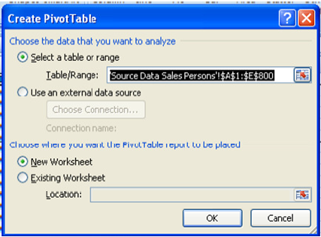
Now you are ready to try the following reports:
- What are the order amounts for each salesperson?
From the Pivot Table Field List Select Salesperson and Order Amount.
The data is now summarised by Salesperson.
Name the worksheet “Order Amounts” return to source data and Click on any cell and then select Insert Tab and Click Pivot Table
- What are the order amounts for salespeople in a specific country?
From the PivotTable Field List Select Country, Salesperson and Order Amount
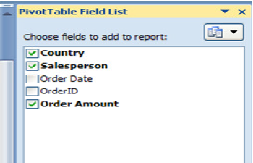
The data is now summarised first by Country and then by Salesperson.
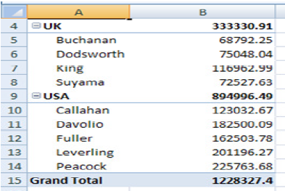
Rename the worksheet “Orders by Country”, return to source data and Click on any cell and then select Insert Tab and Click Pivot Table

- How are salespeople ranked by order amounts?
From the PivotTable Field List Select Salesperson and Order Amount.
To sort the salespeople, click the Salesperson field, click Sort on the PivotTable tab, and then click Descending, and then click Sum of Order Amount in the Using field box.
Rename the worksheet “Orders Sorted”, return to the source data worksheet.

- Who are the top five salespeople?
From the PivotTable Field List Select Salesperson and Order Amount.
To view the top items in a field, right click the Salesperson field; click Filter from the popup menu and then Top 10…
Then select Top 5 Items from the popup form.
These are the top 5 salespersons
NB. To clear the Filter from the last question Right Click on the Filter symbol and clear filters from the salesman field.
Rename the worksheet Top 5 Salespersons, return to source data worksheet.

- How did salespeople perform in a specific quarter?

Create a PivotTable from the source data. Now add the fields in the following order: Order Date, Salesperson and then Order Amount to the Pivot Table Field list. Change the grouping for the Order Date to Quarterly.
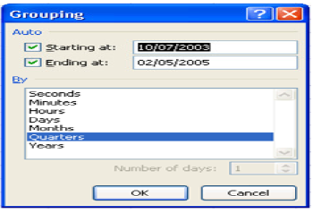
The result of the operation is shown below.
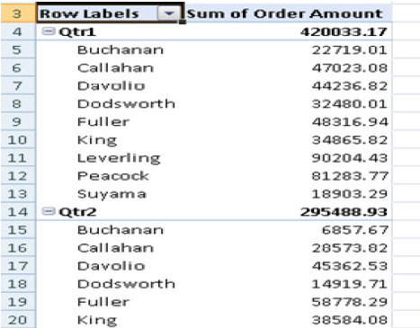
Rename worksheet as “Quarter by Salesperson”

- How does each salesperson's performance vary by quarter?
Create a PivotTable from data source. Now add the fields in the following order: Salesperson, Order Date, and then Order Amount to the Pivot Table Field list.
Rename worksheet as “Salesperson by Quarter”

- What are the details for a specific order amount?
Create a PivotTable from the data source. Now add the fields in the following order: Country, Salesperson, Order Date, OrderID and then Order Amount to the Pivot Table Field list. Rename worksheet as “Order Totals”. Double Click on B6 to reveal the original data.
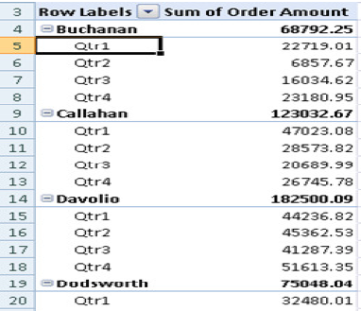
This will open up a new worksheet.
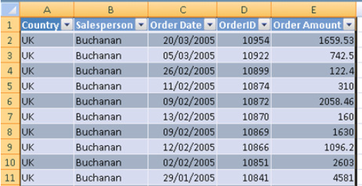
Rename the worksheet “Order Details”
- What bonus amount should each salesperson receive?
All salespeople receive a 10% bonus, but you'd like to award a 15% bonus if they exceed £20,000 in orders per quarter. To create a formula that uses PivotTable data, you can use a calculated field. Create a PivotTable from the data source and select the following fields from the Field List, Salesperson, Order Date and Order Amount, Click the report, click PivotTable Tools and then Options, point to Formulas, and then click Calculated Field. In the Name box, type Bonus Amount. In the Formula box, enter the formula you want. If you want to use data from an existing field in your formula, click the field in the Fields box, and then click Insert Field.
Rename the worksheet “Bonus Amount”
PivotChart Report
A PivotChart report provides a graphical representation of the summarised data from the PivotTable report. To create a PivotChart report By Salesperson” Click on a cell in the PivotTable select type of chart you wish to insert changing the order date (Quarters) to columns in the field list.
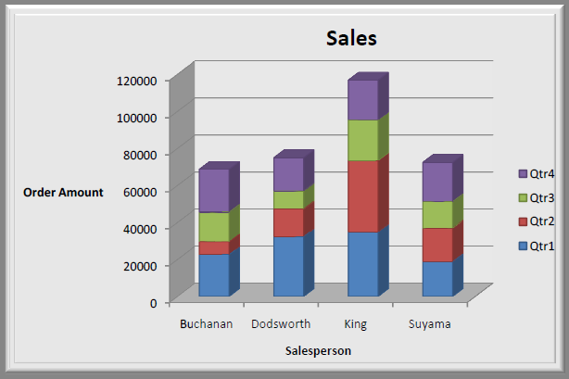
A PivotChart report always has a dependency on a PivotTable report that provides the data to be charted, called the associated PivotTable report. When you make changes to a PivotChart report, its associated PivotTable report reflects the changes.
You can create charts for any of the reports you have created experiment with different chart types.

Compare your products
(Open the file - Moodle ►APPD ► Excel Tutorials ► “Products”)
- What are the sales totals for each category of product?
- What are the sales totals for each product?
- What are the three best-selling products in each category?
- What are the quarterly sales by product?
- How do the sales in the first quarter compare with those in the second?
- What are the average, largest, and smallest Beverage sales subtotals?
- What is the average sale and minimum sale?
Compare your orders
(Open the file - Moodle ►APPD ►Excel Tutorials ► “Orders”)
- How do you view an individual order?
- How many units of each product were sold?
- What's the average unit price of each product?
- What are the ten most expensive products?
Compare your customers
(Open the file - Moodle ►APPD ►Excel Tutorials ►“Customers”)
- What products do your customers purchase, and in which quarter?
- What were the top two products purchased by each customer in the third quarter?
- Who was your top customer in the first quarter?
- Who were the top two customers for each product?

