ASSIGNMENT 1

ENVIRONMENTAL ANALYSIS OF AN INDUSTRY

Modul: The Global Business Environment

Student name: Atanas Ivanov Antonov
Student ID: 2011641
Module Code: LCCB4005

Executive Summary
Environmental analysis is accomplished for the fashion industry in this project. A UK based international fashion brand is chosen, and the pandemic's impact on their business was elaborately described in this part. Porter's five forces, major sources of the business environment, value chain network, microeconomics and macroeconomics' foundations have been used to critically analyse organisations risks and opportunities. This project aims to provide knowledge on Covid 19 impacts on clothing companies and their growth and loss during the pandemic time.

Table of Contents
Introduction 4
Recognition of Major Forces and Impact of Covid 19 in Fashion Industry 4
PESTLE Analysis 5
Reasons behind Engagement in International Trade 9
Assessments of Markets in Action 10
Conclusion 10

Introduction
The fashion industry has been a good source of the economy, yet it has a strong impact on the economy. The fashion sector accounts for 10% of greenhouse gas emissions from carbon gas emissions, yet there are many ways to decrease climate change. Seventy million barrels of oil are used to create polyester fibres in clothes, and enormous pesticides will be described here. Burberry is a popular company in the UK and the world, and how they face loss in this Covid pandemic will be delineated in this project.

Recognition of Major Forces and Impact of Covid 19 in Fashion Industry
External forces help to shape business activities, and there are also general and specific forces. The general forces are economy, society, political, legal, nature and technological conditions. The specific sources are investors, customers, competitors and suppliers and this influence the business environment. The economic and social disruption's major reason is pandemic, and ten million people, are at risk of falling into poverty. Organisations are facing many problems in this situation, and they can use past data to seek solutions. Many people are experiencing job loss, and they face income insecurity. These things also affect mental health, and people are traumatised by this situation (Penttilä et al., 2020).
In the pandemic, people did not go outside for any purposes, and they did not buy clothes that much. Fashion companies face extremely financial losses, and rich people also do not buy clothing products. The Covid 19 impacts society and the economy, and these serious consequences are impacting all local communities. This outbreak affects individual segments of the population, and Covid 19 is certainly detrimental to members of those focus groups in the most vulnerable surroundings. This had even an impact on mobility, and schools, universities and institutions were closed. They do not require dress and uniforms, and even hotels, motels and organisations were also closed.
Retailer and wholesaler fashion companies did not get an order from clients; therefore, they could not make enough money. Many fashion programs, runway, competitions and catwalk functions were closed. Fashion and microfiber in oceans are causing water pollution, which has a strong environmental impact on business. The production and distribution of crops, fibres and garments are increasing, and simultaneously water and soil pollution are highly increasing. The Covid 19 affects the universal fashion industry as governments close down the producing plants through store closures and event cancellation. The government tries to reduce the impact of viruses, yet side by side, organisations cannot do business. For the slow spreading of viruses, the government does not take any other substitutions, and they directly give orders to close down all factories and manufacturing plants. People lose their profession, and it also has a major impact on big brands worldwide.
At this time, the fashion industry faces multiple challenges, and they are waiting to fulfil consumer demands. The new opportunity can be highlighted, which is new masks, hand gloves and covered clothes. Many issues can be founded, which include lack of fabric availability and order cancellation.
Many brands prepare clothes by importing fabrics, and having them restored in the storehouse will benefit from the pandemic. In a lockdown, people emphasise clothes, and all citizens are worried about health conditions. Several distribution channels are not open because retail stores close their doors for customers in the pandemic. Many people buy clothes at special occasions like weddings, parties and get together and jewellery for some festive and celebration purposes. Many events have been cancelled, and many functions are postponed for preventing these viruses. Face masks are trendy these days, and many clothing organisations can see them as an opportunity.

PESTLE Analysis
Eminent and non-eminent fashion companies are in great danger, and they can increase their knowledge and understanding skills. A PESTLE analysis is done in this section, and Porter Five Forces are described below in this project. Burberry can get enough information by doing a PESTLE analysis on certain locations, and they can estimate the important value of their clothing products. This brand's retail sales fell 48.4% to 257 million pounds in the quarter ending June 27. Their comparable store sales were down also 75%, and Burberry has also cut their 5% workforce, equal to 500 jobs. Their cuts include 150 fashion office-based roles only in the UK, and in this pandemic, a very small amount of people shop from their company (Burberryplc.com, 2021).
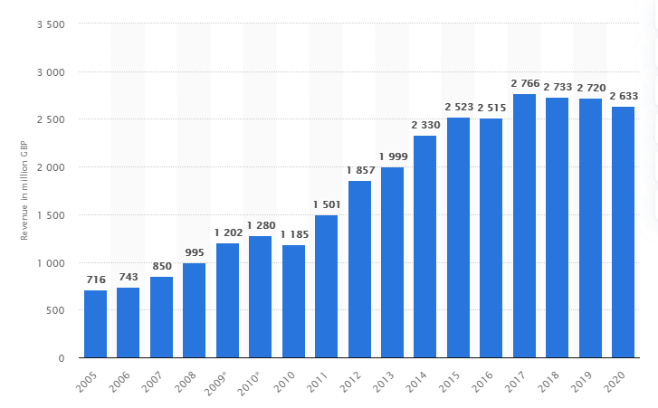
Figure 1: Burberry’s Global Revenue from 2005 to 2020
(Source: Statista.com, 2021)
The organisation can do a PESTLE analysis to identify and evaluate scopes, and after a pandemic, the fashion industry faces huge loss. Political, environmental, social, technological, legal and economic factors included in the PESTLE analytics.
Political Factor
The UK is the most powerful country globally, and there is a modern parliamentary democracy and a constitutional monarchy. The Prime minister is the head of government, and he runs the government after electing for five years. The country's government maintains good relations with strong nations such as the USA. The influential areas are the global economy, military, culture, politics and scientific affairs (Wang et al. 2020).
Economic Factors
The UK is the sixth-largest economy globally, and they are one of the highest GDP holders. Lockdowns put enormous pressure on the treasury, and economic stability is ruined across different industries. The Bank of England pumped an extra 100 million pound to boost the country's economy. Many business tycoons and fashion organisations worldwide have invested in a range of industrial products (Phan, 2021).
Social Factors
The present population is over 68 million, and 74 million people are expected by 2039. Birth is exceeding, and the mortality rate is increasing day by day. This also enhances business opportunities, and Burberry can utilise this to gather capital. They need to recover from this situation, and they can generate a small amount of money in innovation (Stindt et al. 2017). Pleasant income level, education and health care system are a good part of the UK's society (Zahari and Romli, 2019).
Technological Factors
This country has the leading research and development institutes, and they can make good technological inventions. Burberry can use those technological innovations and tools to manage operations. They can try technological incentives, level of innovation, automation, R&D activity. This company will be required to see technological change and increase their technological awareness (Fozer et al. 2017).
Environmental Factors
Many organisations face environmental issues in this country because the government has created multiple rules and regulations to protect nature and maintain sustainability (Johannsdottir and McInerney, 2018). UK's weather and climate are good as well as Burberry will require to check environmental policies. There is a huge amount of pressure from NGOs, and companies must deal with them carefully (Song et al., 2018).
Legal Factors
This country had made an Employment Act in 1996, and there are many discrimination laws, antitrust laws, consumer protection laws. The country released an Equality Act in 2010, and many copyrights, patent, health and safety laws are made to protect human rights.
Porter Five Forces
Porter Five Forces is a certain framework to analyse a company's comparative environment, and the number and rival of a company's powers can be calculated with this. They can find potential new market entrants, suppliers, consumers and substitute products that influence an organisation’s profitability (Pezzutto et al. 2018). This includes five forces such as the threat of substitute products, the threat of established competitors, the threat of new entrants, suppliers' bargaining power, and the bargaining power of buyers. Michael E Porter is the originator of this theory, and he refers to the strong forces as the microenvironment (Varelas and Georgopoulos, 2017).
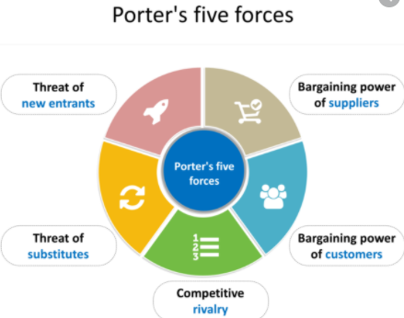
Figure 2: Porter’s Five Forces
(Source: Pezzutto et al. 2018)
Value Chain Network and Porter’s Theory
A value chain model supports a business to allow them identifying related activities, and they should add value to end consumers. This network allows an enterprise to gain margin over the cost of inputs (Smith and Srinivas, 2019). According to Porter, the value chain engages five activities like inbound logistics, operations, outbound logistics, marketing, sales and services (Najib et al. 2020).
Recommendations
Few justified recommendations are described below, and organisation can try to apply this in their work process.
- They will need to understand unique requirements and buying patterns.
- Burberry can decide on their niche, and they can make a business plan.
- They can organise their business, and they can create their design.
- They can start manufacturing face masks, and they can alert people to wear masks.
- The organisation can test their product, and they can ensure employees are properly trained.
- The company will need to change their inventory plans, and it can reward customers for their loyalty.

Reasons behind Engagement in International Trade
Primary and secondary data can be collected to know Burberry's present business conditions. This company's past profit records can be seen from their annual reports, which are secondary information. This organisation can take interviews of people to know what they think about their brand. International trades bring several benefits like producing a narrow variety of goods for the domestic market. They can produce at higher volumes, and they can provide further cost advantages in terms of economies of scale (Roberts et al. 2019). The reasons are decreased dependence, maximises chances of success, enhances efficiency and productivity, economic advantage, innovation and growth. Burberry can take care of administrative tasks, and they can create a business plan. They can also make decisions regarding their market space, and the company will need to rebuild their network (Wu et al. 2017).
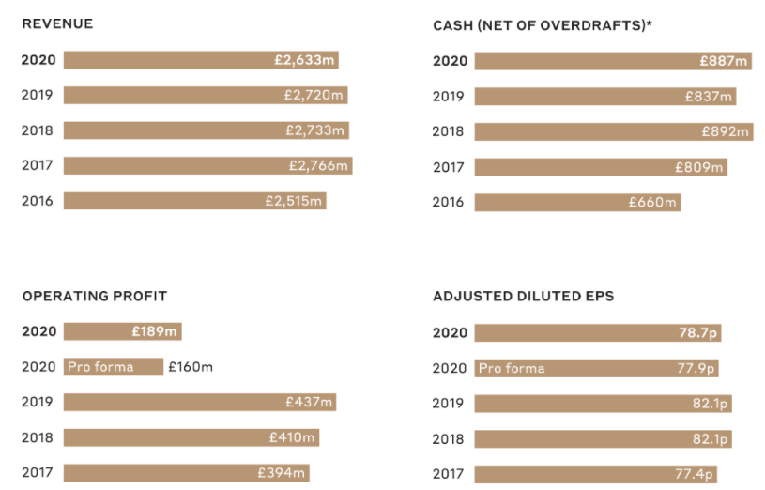
Figure 3: Financial Highlights of Burberry
(Source: Burberryplc.com, 2021)

Assessments of Markets in Action
This company will need to check the market minutely, and they can research micro and macroeconomic foundations. They can use different market structures which influence their firm strategy, long-run and short-run changes. This is extremely crucial to acknowledge major features of the current international economy. There are four types of market structures: pure competition, monopolistic competition, oligopoly, and pure monopoly. The market structure affects the supply of raw materials and products (Pezzutto et al. 2018).
The organisation can increase their discernment regarding microeconomic concepts. Those are marginal utility and demand, diminishing demands and supply, the elasticity of demand, the elasticity of supply, proper market structures and the role of prices and profits in determining resources allocation. To make its microeconomic foundation strong, the organisation can follow a few principles. Organisational people face tradeoffs, and they can estimate the highest and lowest cost of their fashion products.
Rational organisational people can think at the margin as well as they can respond to incentives. Examples are unemployment, interest rates, inflation and GDP. Besides this, the other examples of microeconomics are customer equilibrium, individual income and savings. For gaining a competitive advantage, they can increase economic activity. Besides that, they can sometimes prove economic outcomes. They can look at macroeconomic objectives, which are economic growth, inflation, unemployment and government borrowing.
The main components of macroeconomics are GDP, inflation, employment and economic output. The level of government debt, long-term and short-term effects is the certain factors of this and organisation can make their foundation strong by conventionally using them. Long-run and short-run changes are based on economy, capital and variables. Short runs can be estimated from 1 day to 3-4 months, and long runs can be estimated from 4 to 6 months.

Conclusion
Burberry can develop their business, and they can improve enough in the fashion industry by managing all negative impacts of the coved pandemic. A PESTLE analysis and market assessments are accomplished in this project. Engagement with literacy skills, knowledge and understanding skills, cognitive and intellectual skills are determined in this project. Global Organic Textile Standard will help consumers solve their queries, and organisation can suffer from a lack of funding and complicated supply chains through certification.

Reverences List
Burberryplc.com, 2021 Homepage viewed on 17/04/2021 from <https://www.burberryplc.com/en/investors/annual-report-19-20.html>
Fozer, D., Sziraky, F.Z., Racz, L., Nagy, T., Tarjani, A.J., Toth, A.J., Haaz, E., Benko, T. and Mizsey, P., 2017. Life cycle, PESTLE and multi-criteria decision analysis of CCS process alternatives. Journal of cleaner production, 147, pp.75-85.
Johannsdottir, L. and McInerney, C., 2018. Developing and using a Five C framework for implementing environmental sustainability strategies: A case study of Nordic insurers. Journal of Cleaner Production, 183, pp.1252-1264.
Najib, M., Widyastuti, H., Andrianto, M.S., Septiani, S. and Fahma, F., 2020. Market orientation and service quality as driving forces of business sustainability: evidence from a small coffee shop. Academy of Strategic Management Journal, 19(6), pp.1-8.
Penttilä, K., Ravald, A., Dahl, J. and Björk, P., 2020. Managerial sensemaking in a transforming business ecosystem: Conditioning forces, moderating frames, and strategising options. Industrial Marketing Management, 91, pp.209-222.
Pezzutto, S., Grilli, G., Zambotti, S. and Dunjic, S., 2018. Forecasting electricity market price for end-users in EU28 until 2020—Main factors of influence. Energies, 11(6), p.1460.
Phan, S., 2021. The effect of PESTLE factors on the development of e-commerce. International Journal of Data and Network Science, 5(1), pp.37-42.
Roberts, A., Choer Moraes, H. and Ferguson, V., 2019. Toward a geoeconomic order in international trade and investment. Journal of International Economic Law, 22(4), pp.655-676.
Smith, D. and Srinivas, S., 2019. A simulation-based evaluation of warehouse check-in strategies for improving inbound logistics operations. Simulation Modelling Practice and Theory, 94, pp.303-320.
Song, Y., Wang, H. and Zhu, M., 2018. Sustainable strategy for corporate governance based on the sentiment analysis of financial reports with CSR. Financial Innovation, 4(1), pp.1-14.
Statista.com, 2021 Burberry Business Revenue viewed on 17/04/2021 from <https://www.statista.com/statistics/263885/burberrys-worldwide-revenue/>
Stindt, D., Quariguasi Frota Neto, J., Nuss, C., Dirr, M., Jakowczyk, M., Gibson, A. and Tuma, A., 2017. On the attractiveness of product recovery: The forces that shape reverse markets. Journal of Industrial Ecology, 21(4), pp.980-994.
Varelas, S. and Georgopoulos, N., 2017. Porter's competitive forces in the modern globalised hospitality sector–the case of a Greek tourism destination. J Tour Res, 18, pp.121-131.
Wang, X., Yin, X., Guo, X.T., Wang, Y., Jin, W.Q., Mao, A.J., Lao, L., Zhang, Z.J., Zhang, J. and Xu, S.F., 2020. Effects of the pestle needle therapy, a type of acupoint stimulation, on post-hemorrhoidectomy pain: A randomised controlled trial. Journal of Integrative Medicine, 18(6), pp.492-498.
Wu, J., Ma, Z. and Zhuo, S., 2017. Enhancing national innovative capacity: The impact of high-tech international trade and inward foreign direct investment. International Business Review, 26(3), pp.502-514.
Zahari, A.R. and Romli, F.I., 2019. Analysis of suborbital flight operation using PESTLE. Journal of Atmospheric and Solar-Terrestrial Physics, 192, p.104901.

