

Graduate Diploma in Professional Police Practice

LEVEL 6 - 40 Credits

Workbook title: Competency Based Workbook 1 (DHEP)

6,500 Words

(SOUTH WALES POLICE, GWENT POLICE AND UWTSD)

Learner name:
Levi Williams

Learner’s University Registration Number:
2319934

FACULTY OF BUSINESS AND MANAGEMENT
PUBLIC SERVICE PROGRAMME

Module title: Policing in the Workplace 3 (DHEP)
Workbook Guidance

Please read these notes carefully; they provide essential information.

What is the workbook for?

The purpose of this workbook is to enable learners to demonstrate and provide evidence of how they meet the learning outcomes set by the College of Policing, for the Graduate Diploma programme. Essentially, you are being asked to outline your experiential learning based upon your theoretical understanding in a range of operational situations.

Area of Professional Practice covered, (called elements in your module descriptor):

- Wellbeing and Resilience
- Communication Skills
- Managing Conflict
- Valuing Difference and Inclusion
- Criminal Justice
- Decision making, discretion
- Conducting Investigations
- Criminal Justice (Managing offenders)
- Problem Solving
- Evidence Based Policing
- Maintaining Professional Standards
- Public Protection.

You may wish to use the same incidents as you’ve outlined in the Occupational Competence Portfolio.

How should the workbook be presented?

Blank electronic copies can be found on Moodle of this workbook. You must submit this document electronically therefore it is important that you save your work regularly and upload the final typed version through Turnitin on Moodle.

Word count policy can be found in chapter 7 of the Academic Quality under section 7.7 (this applies to presenting work above and under the specified word count).
(https://www.uwtsd.ac.uk/media/uwtsd-website/content-assets/documents/academic-office/aqh-chapters/chapters---en/Chapter_07_Assessment_Taught_Programmes_Pages_72-79-UPDATED-05-11-2019.pdf)

Reflective practice is a core aspect for your workbooks and although there is a variety of useful resources on Moodle, there is one particular book, that is specifically based on reflective practice in policing, here is a link to one chapter from Selina Copley’s Reflective Practice for Policing Students:
https://moodle.uwtsd.ac.uk/pluginfile.php/298870/mod_resource/content/1/Reflective%20Practice%20for%20Policing%20Students%20-%20Selina%20Copley%20Chapter5.pdf

How is the workbook assessed?

Advice and support about the completion of this workbook will be provided by university staff as part of your initial training day. Your tutor constable and in-force training staff will not be involved in assessing or marking your workbook after it has been submitted.

Dates of workbook submission will be made available during the initial training day and posted on Moodle.

Once submitted your workbook will be assessed and marked independently.

Confidentiality

It is important that no individual can be identified either directly or indirectly from the information in the workbook. Therefore, you must:

- adhere to guidance in the Student Handbook about unfair practice and plagiarism;
- not identify individuals including witnesses, victims or offenders by name;
- not write information that enables any individual to be identified indirectly through the description you provide. This includes references to names, colleagues, places (including hospitals, schools, town, villages, streets) specific incidents which were high profile and could be identified due to past publicity, other professionals or any other personal information including medical or other conditions.
- take personal responsibility for adhering to confidentiality rules.
- not include any dates of any incidents or anything that specifically identifies an actual incident.

The content of this workbook should be your own work. Do not allow anyone else to see your work or use your work for their own submissions.

Please be aware that any content that is deemed to be inappropriate, disrespectful, or abusive will not be tolerated. Following review of any content of this nature the information will be shared with the employer of the student responsible.

Should any health and wellbeing concerns be raised because of disclosures made by the student within this workbook, the employer of the student will be informed.

NOTE

Your workbook will be submitted electronically via Turnitin on Moodle. Guidance on this is in the Student Handbook.

Remember that the workbook is YOUR responsibility you must not rely on the assessor or anyone else to pick up any confidentiality breaches as this is your work and you must accept full responsibility for confidentiality. Meeting all the confidentiality requirements is very important.

Dyslexia and other special circumstances

If you have any condition that you feel may affect your ability to deal with any part of the programme, please see the Student Handbook for further guidance. The University has a Student Services Unit that may be able to help but it is the learner’s individual responsibility to contact them.

Guidance:

- Your workbook must contain the items specified in the table below (clearly identified and in the order given);
- You should use this document to insert your text / answer within each section of this workbook;
- You should upload your completed document as a saved pdf file of this workbook; if this is not possible then a Worddoc file is acceptable. Do not send a scanned file from a photocopier, an apple.dot file or a Microsoft publisher file as Turnitin will not be able to assess them, despite you being able to upload them.

Contents

Workbook | Area of Professional Practice | Word count
Task 1 | Wellbeing and Resilience | 1000
Task 2 | Communication Skills, Managing Conflict, Valuing Difference and Inclusion | 2000
Task 3 | Criminal Justice, Valuing difference and inclusion | 1750
Task 4 | Decision making and discretion, Conducting Investigations and Criminal Justice (managing offenders) | 1750
 | Bibliography
Task 5 | Independent Patrol Status Confirmation | Equivalent 1,500words
Confirmation of Confidentiality and Plagiarism
Confirmed by submission through `Turnitin

Task 1

Relevant areas of the National Policing Curriculum:
Understanding the role of a constable.

Guidance:

Focussing on your initial 6 months of learning and since being attested as a Police Constable, discuss and compare the coping strategies you have applied to develop resilience and minimise stress.

1000 words (+/- 10%: include your actual word count at the end of each section)

ANSWER:

Despite having very differing impacts, both police offices and students face varying degrees of stresses and challenges, and this can have a big impact on their mental health and wellbeing. The (WHO 2023) class stress as a “state of worry or mental tension caused by a difficult situation”. This statement can apply to both students and police officers. It is therefore of vital importance to manage resilience within these roles.
Although I have previously graduated from university, there is evidence that mental health is an increasing challenge for students. According to (Students 2023) there has been a “broad increase in students reporting a mental health condition”.

It has been well documented that policing is a stressful role and creating a resilient mindset before beginning the role was of upmost importance to me. Police officers are faced with traumatic events on an almost daily basis and therefore creating mental strength is a priority. According to (Lancaster et al 2022) “Resilience is central to positive mental health and well-being especially when faced with adverse events”
During this essay I will reflect on how I have personally coped with stresses within the training period, how I have managed these and how these tools I have developed will support me going forward into the role of a police officer and help create a resilient mindset. I will be using (Borton’s 1970) reflective model which uses the idea of “what, so what, now what”, which is the practice of reflecting on a situation by asking what happened, what did you learn, and how will you use this going forward.

As I graduated university over 15 years ago, I was concerned with how I would cope with studies and assignments, and how I would manage with the stress involved. I began with looking at what potential stresses are, and how these could potentially impact me. (Mental health foundation 2022) describes that stress can present itself physically, behaviourally and have an impact on emotions. I therefore needed to not only identify what stresses might be, but also how they might present themselves as a bodily symptom and how this might effect my personal and familial life.

One of the main challenges that I discovered early on within the training period was the amount of information that would given to us. Information that would need to be retained both for the exams and going forward into the role as a police officer. I identified that exams would be a source of stress, I therefore researched how to plan and prepare for exams, one of these being the (NHS 2021) tips on studying and exam techniques. During my research I discovered some great tools such as rewarding myself and taking short breaks. Going forward I will use these techniques when I begin my role as a police officer, especially when there is new learning required or when I am beginning a new role.

One of the other techniques that I discovered was that activity and exercise can help support with stress and create a resilient mindset, especially when faced with “adverse events”. (Lancaster, et al 2022) state that “exercise is strongly correlated to resilience”.

In summary I understood that both as a student and a police officer I will be faced with stress, I discovered that exercise can be a key contributor in tackling stress and so I ensured I regularly exercised such as through gym workouts and daily walks. What I have learned is that when I begin my role as an officer, I need to ensure I maintain this level of activity to support myself both physically and mentally. It will be difficult due to shift patterns and therefore I need to ensure I have a variety of activities available to me even if I am short on time such as walking.

Another key tool I discovered was that having a strong family and friendship circle can be a great support. (Yang et al 2022) states that family relationships are “strongly positively linked to mental health”. I understood that the stress of being a student and as a police officer can be very lonely, and to tackle this I needed to lean on both family and friends. I spent time talking to my family about what challenges I faced and how they can support me. Even talking to them was a great help as it released some of the burden and reassured me that I had a support network available to me. What I learned is that I will need to lean on family for support when I am faced with the challenges of the role as a police officer.

One of the things I did discover was that despite friendships having a positive impact resilience, due to my friendship circle having varying shift patterns and family demands it is not always possible to meet up and talk. One way I combatted this was ensuring I kept in contact through text and emails, but I also looked at other ways I could keep in contact which would also help lessen my stress. What I discovered was that online computer gaming was a great way of reducing stress while also connecting and strengthening my friendship group, despite not physically seeing each other. (Barr et al 2021) conducted a study during the covid 19 pandemic that discovered that not only was online gaming a great way of keeping in touch which friends but as also a form of “escape”.

For myself this was a breakthrough in tackling stress and building a resilient mindset. I understand that I am currently faced with challenges and stress, online gaming has provided a dual support of keeping in touch with friends and as a means of keeping my mind busy. It also provided a great tool for future use because policing will not only be a demanding role but as the shifts are often unsociable, online gaming will provide a way of keeping in touch with friends without physically seeing them.

In conclusion I discovered that stress is something that can present itself in a variety of ways. It is something that will continually affect me, both as a student and as a police officer and there are a variety of tools to help manage these stresses. As I progress into my role as a police officer I need to utilise these tools to help minimise these stresses and help build a resilient frame of mind.

Word count: 1073
Task 2

Relevant areas of the National Policing Curriculum:
Communication Skills, Managing Conflict, Valuing Difference and Inclusion

You must choose a policing incident involving conflict in which you played a significant role with an offender/service user/victim and reflect on what happened.

Critically assess the incident including social and legislative contexts and any relevant cultural, ethnicity and language issues.

Consider the use of effective communication skills that you used within the incident.

Reflecting upon your incident, critically evaluate any theories or models underpinning the causes of conflict within policing interventions. (Examples would include, Betaris Box, The Drama Triangle).

2000 words (+/- 10%: include your actual word count at the end of each section)

ANSWER:

In this essay I will be focusing on an incident that involved conflict, both from the offender and the victim. I will be discussing methods that I used to try and alleviate the situation. I will also be using the (Kolb’s 1984) reflective practice which focuses on an experience, reflecting and learning from that experience and utilising what you have learned going forward.

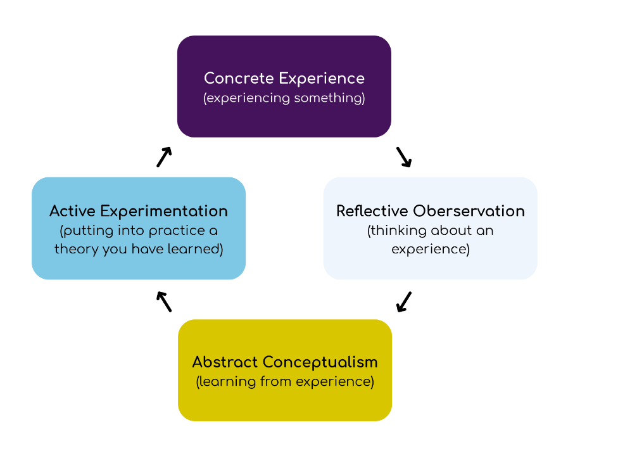

(Piernikarch 2022)

Conflict within Policing is a common experience, and it is something that most if not all police officers expect to experience on an almost daily frequency. In fact, according (Home Office 2021) “In the year ending March 2021 there were almost 37,000 assaults on police officers in England and Wales (including British Transport)”.
It is therefore an expectation that conflict will form part of a considerable number of incidents that officers attend, even if this does not result in physical confrontation there is still the prospect that heightened emotions will lead to a conflict scenario.

It is imperative then that police officers are trained in a variety of methods to de-escalate situations rather than exasperating what is often an already emotionally charged situation. As (College of Policing 2020) states, it is “fundamental that officers are supported in accessing conflict management and de-escalation”. Not only is this methodology imperative in ensuring situations do not result in unnecessary violence but it essential in creating a better public perception that the police are there for the safety of the public and are the ones who are highly trained and able to manage a situation rather than be the catalysts for chaos.
This ideology was very prevalent in one of the occurrences that I attended recently. It involved a situation of public disorder whereby several complaints had been received involving a female who was swearing and threating her neighbours. Officers had already attended the address previously that day and so it was essential that there was a resolution to this matter to ensure public confidence in the police was maintained.

When we attended the address, we were immediately met by a neighbour who was visibly angry. They stated that the subject involved had made threats against them and others within the street and that the police had not resolved the matter earlier. The female was obviously angry and disappointed and was shouting at us to do something about the situation.
Often, it is not only the subject who can be the source of conflict and anger but also potential victims. This is not an uncommon theme and as postured in (Ignatans et al 2019) “Analysis of the Crime Survey for England and Wales identifies anger and annoyance rather than fear as the most common emotional responses to victimisation by crime.” It is unsurprising then that when attending calls officers should be mindful of the reaction of victims as these can often present as displays of anger.

When evaluated from a social and legislative standpoint, there is an argument to be made that the female victim was now herself the one who was causing public disorder and from a legislative context could have been arrested. Socially however, would this have been the best course of action? Would this have done anything to help public confidence in the police and as was quoted above, anger is a very common reaction among victims of crime. We should not always expect victims to be shy and timid, we should expect that heightened emotions will result in a variety of responses.

I therefore empathised with the female victim and ensured her that we would resolve the situation and ensure the safety of everyone was of paramount importance. To do this I understood that I needed to remain calm and in control and not rise to her level of anger. This was something that was taught to us within officer safety and it is often referred to as Betari’s box which as shown in the diagram below is a theorised model that our behaviour and attitude has an effect on those around use and so by becoming angry and aggressive towards the female victim this would have only made her angrier and more aggressive towards me. It was therefore imperative that I spoke in a calm and reassuring manner which helped calm the situation down.

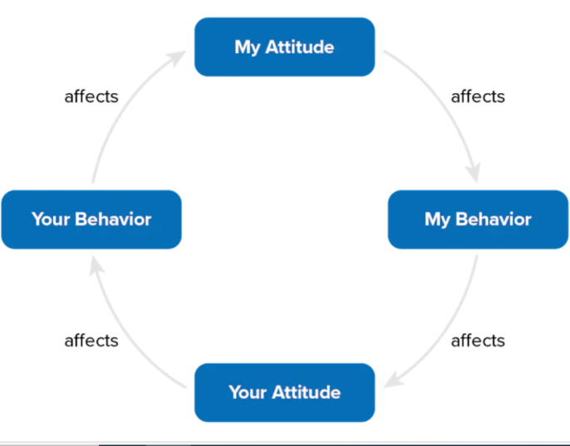

(Mind Tools Content Team 2023)

This was something that I had experienced in training especially in early practical exercises where it is easy to match people’s behaviour and attitudes. As I mentioned earlier about Kolb’s reflective practice, I had learned from my earlier experiences and this scenario gave me the opportunity to put into practice what I had learned.
We entered the premises of the female subject and knocked on her door. We were immediately met by two large dogs. We immediately retreated to the safety of the gate however both the dogs were friendly. Although not conflict per se it is important to appreciate that the environment can be a source of danger for officers. Whether this source is animals, weapons, or dangerous structures; officers must at all times be prepared for the unexpected.

When the female subject did open the door to us to talk, she was very aggressive towards us and towards her neighbours’ making threats towards them and towards us. She was also clearly intoxicated which can have a profound effect on someone’s behaviour. It is something that has been extensively researched. As (Parrott and Eckhardt, 2018) states “There is little debate that alcohol is a contributing cause of aggressive behaviour”. This was therefore another contributing factor that we needed to consider when resolving situation of conflict, and although again I utilised Berati’s box model of thinking, it was not as effective this time and it seemed that the alcohol was a large contributing factor.
There were other factors that could be influencing her behaviour, one of which was that the female was obviously targeting her neighbours and was shouting threats and obscenities towards them. I explained to the neighbours that they could support us by going inside this might help calm the situation down. Often this is described as the (Karpman 1968) drama triangle where there are three parties involved in a conflict situation. The aggressor, the saviour and the victim and often times the conflict continues while all three parties are involved in the situation. By removing the victim from this ‘triangle’ it was my hope that this would help remove a target for the aggression.

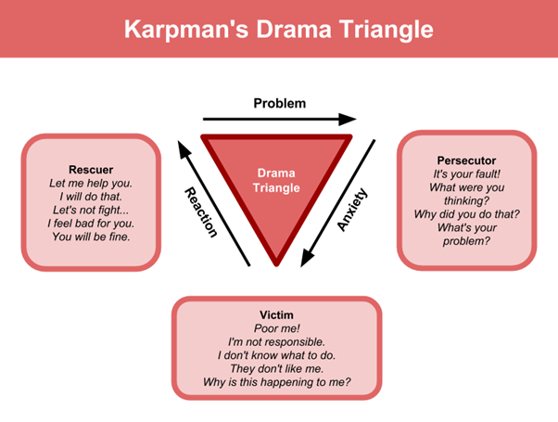

(John, 2021)
When the neighbours had gone back inside this did help alleviate some of the aggression that was displayed, and the female subject did listen to what we were describing to her. We were however in a situation where the law had been broken through a public order offence and the female had already been given an opportunity previous in the day to making aggressive threats and we therefore arrested the female. This exasperated the situation again and she became instantly aggressive. It was important for me at this stage not to equally react (Betari’s box).

She made numerous comments towards us that we were going to use force against her, and it was important that I not only managed my verbal communication but also my non-verbal communication as I remember during conflict management training that this is far more important that what I verbally communicated.

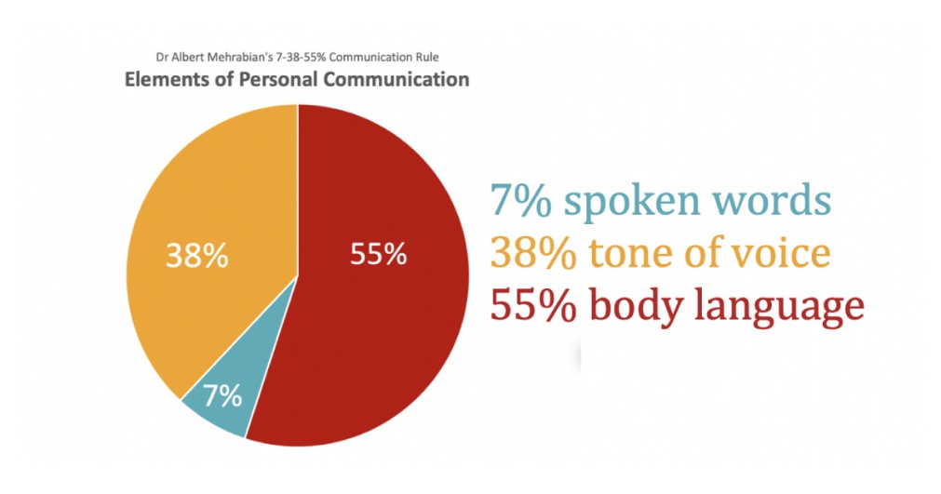

(Owsley, 2014)

As this table shows (taken from a study from a university of California professor, Albert Mehrabian in 1967), body language is by far a more important factor in communication and so I ensured that my stance was non-threatening. I kept my hands away from my equipment and used open handed gestures. I also ensured that I didn’t encroach on the female’s personal space (although taking into account that she was under arrest and needed to ensure she did not attempt to run away from us.)
We made the decision to use handcuffs because she had been aggressive towards us and her neighbours and due to the alcohol in her system, we knew that her behaviour was unpredictable. This was displayed on our way to custody when the female subject again became aggressive towards us and started to attempt to bang her head against the wall of the van. I was sat in the back of the van keeping observations on her so I tried to calm her down by talking to her saying that this wouldn’t help her situation. This was a difficult situation and for the first time since the incident began, I felt like I didn’t have full control of the situation. The journey to custody is something I have experienced with numerous offenders and often times they’re aggressive behaviours are exasperated once they are on their way to custody. This might be because of the closed confines of the van, or it might be the final act resistance before arriving at police custody, though I was unable to find any definitive research on this topic.

On arrival at police custody, we were met with a long wait, although we did not know at the time this would end up being a three hour wait until the female subject could be processed. She was placed inside one of the holding cells which are relatively small. This was a prolonged waiting period, with the weather being warm and so the female subject started to become inpatient and aggressive. In this instance I utilised another model that I had studied during training which was (Thomas & Kilmann 1976) model of conflict management.
In this model they describe that there are five methods of dealing with conflict between two people. One of these methods they describe is compromising. As they state this is the method of a “mutually acceptable solution that partially satisfies both parties.” In this instance this related to the handcuffs. SWP policy is that handcuffs cannot be removed until authorised by the custody sergeant, however as the handcuffs had been placed to the rear of the subject, I agreed to move them to the front where they would be more comfortable. I also obtained a drink for her to ensure that she was as comfortable as she could be in this situation.

I also began speaking to her about day-to-day things such as her dogs as owning a dog myself, I could find common ground with her. Not only was this important to help alleviate the aggression displayed but would also support in the wider scale of the investigation. As is discussed in (Nahouli et al 2022) “building rapport is recommended by the majority of interviewing tools and frameworks that police officers use when interviewing both victims, witnesses and suspects.” Therefore, in order to obtain the most satisfactory outcome from an interview, rather than one with a suspect who is not engaging or one who only answers “no comment” it was important for me be engaging. This is something that when police officers arrive at custody can be easily forgotten because they may feel that the ‘job’ is done.

Overall, this incident gave me a good opportunity to practice many techniques I had learned through training, through previous life experiences, and during incidents where I hadn’t got things quite right. As I mentioned at the beginning, Kolb’s reflective model gave me an opportunity to utilise methods from previous learnings but to also learn from this experience and put it into practice in incidents to come. As is shown above, the model is cyclical and therefore ongoing, and so the learning is ongoing and something I will endeavour to practice throughout my policing career. Although there were no real cultural, ethnic or language issues within this incident, these are things that I have come across and the conflict resolution techniques I have learned and reflected upon have supported me in those occurrences.

Word Count: 1964

Task 3

Relevant areas of the National Policing Curriculum:
Criminal Justice, Valuing difference and inclusion

You must choose a policing incident in which you played a significant role with an offender/ service user/victim and reflect on what happened

Critically explore a policing incident that you have attended and examine how you dealt with competing issues such as legislation, social issues, culture and language.

Consider the victims code of practice and how it was used to support your victim/witness through the criminal justice system.

Your reflection must illustrate your understanding and application of core principles of ethics, equality, diversity and human rights.

1750 words (+/- 10%: include your actual word count at the end of each section)

ANSWER:

Policing is a role that often puts you in a position whereby you must manage a situation involving a victim and an offender at the same time. Sometimes these situations are non-complex such as a simple theft from a shop or an assault with multiple witnesses and obvious injuries to the victim. However, there are times when managing an incident between an offender and a victim are more complex. It is a danger in society that often we see an obvious distinction between who is the victim and who is the offender. As is stated in (Cycj.scotland 2023) this mindset “can lead us to think that a person should be put into either category, and never both”. Yet police officers are tasked with utilising all the tools and models available to us to make a decision that not only best serves those involved but also serves the public interest as a whole.

In this essay I will reflect on an incident whereby I was an involved officer in a situation which involved a victim and an offender however the case could be made that the offender was as much as a victim as anyone else. I will be using Gibbs’s reflective cycle which was developed in 1988 and as shown in the graphic (The University of Edinburgh 2020) the model has 6 stages however some stages may not be as relevant as others in this situation and due to the developing complexities within the incident I may refer back to previous stages.

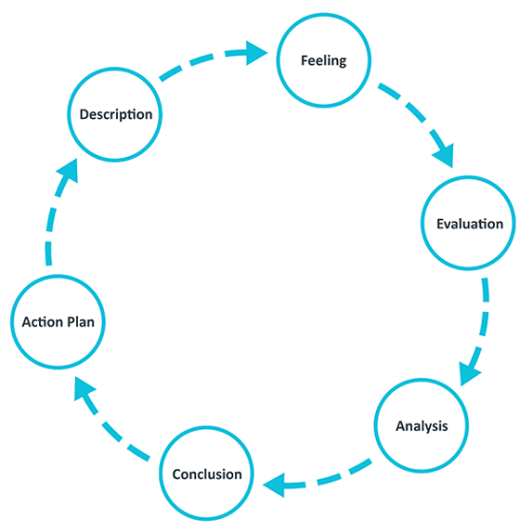

To begin with this situation involved an emergency 999 call to police stating that a mother had called emergency services in regard to her 15 year old son who had become violent, had ripped a door off it’s hinges and had become threatening towards the family. Originally, despite the familial aspect, this case seemed non-complex.

My original feelings were all about the safety of the family and my colleague and I. Not only was I managing the stress response of an increased adrenaline rush but also rapidly thinking of what I may face. As is stated in (College of Policing 2015) in any domestic situation the priority is “Obtaining a full picture of the situation, the family and their previous history enables officers to better deal with the incident, manage the offender and protect any vulnerable people at the address.” However, this is not always possible within the police and often times we are tasked with arriving quickly at an incident and gathering the information required as we go. In this example I entered the address and was greeted by a male matching the description of the offender. Again, my initial feelings were about the safety of all involved. I immediately guided the male into nearby bedroom where my colleague was greeted by the father of the youth, the mother and the young daughter.

As I stayed with the male, my colleague went to speak to the other family members. It was clear from the outset that English was not the first language of the family. This can be increasingly traumatic. As is described in (Team, T.L.S. 2023) “Victims face numerous challenges when seeking help, and one of the most significant but often overlooked barriers is language”. Initially I was considering whether this would not only be an impact to the victim but also in communication with the alleged offender and needed to decide if the communication in English would suffice or if I needed to look at tools available to us such as language line. When managing incidents and supporting victims it is of paramount importance to remember the victim’s code. One of the key aspects is “to be able to understand and be understood” (Victim Support 2021).
As it was, we were able to communicate with the family effectively in English, but it was important to be patient, keep eye contact, and utilise body language. The tips are described in ‌(DTS Language Services 2019) however during my conclusion I will reflect on how I could improve in this aspect.

The other immediate impact I discovered was that the male was severely autistic and had minimal ability to communicate verbally, and often this communication was in his first language rather than English. The few words he did express were “No jail” “knife” and “handcuffs”. He was immediately understandably agitated and distressed. My initial response of an aggressive offender needed to change. Many of the youth’s reactions were in fact displays of distress rather than aggression and could manifest in “physically aggressive behaviour, such as slapping, biting, spitting or hair pulling (National Autistic Society 2020).

Although before this I had limited knowledge of autism, I knew I needed to be patient and calm with the individual, to try and engage and talk in any way possible that may prove effective. Initially this was successful, and the youth was calmer. This then led us to try and look at what support we could offer not only the family but also the youth who at this point was not only the original offender but in the grand scale of things was also a victim.
Both parents were visibly upset by the situation and so initially it was our aim to look at what services were available within the local authority. The family had spoken to us that they had been given respite previously but that this service had stopped. Their son was also no longer at school due to his aggressive outburst. Being that these calls were being made late on a Friday afternoon it was understandable that there would be no expedited response, and it is an unfortunate prospect that support for families in this situation is limited or non-existent. (Manager 2020) stated that “most areas of Wales, children experiencing distress with mental health, emotional wellbeing and behavioural issues are not getting the help they need.” I will discuss in my evaluation what strategies we were able put in place long term.

Again, taking into consideration the victim’s code my focus was being victim led. When speaking to the mum she described that on previous occasions when police had attended, they had taken a stern line with their son, and this helped the situation whereby the police became the disciplinarians and explained to the youth that his behaviour was wrong. On this occasion however this exasperated the situation and led to the youth becoming rapidly distraught. Again, I will speak in my evaluation on this and what I would do in future.

The youth’s aggression was again displayed and due to the limited space in the household we became concerned for the safety of the family and ourselves which led us having to physically restrain the male and arrest him for breach of the peace (BoP). This led to further complexities.
Not only was it necessary to arrest the youth therefore legally depriving him of his liberty but the realistic prospect was that the youth (who in the eyes of the law is a child), did not have mental capacity for his actions and realistically would it ever be in the public interest? Was it better to involve children’s services despite these powers mostly being there to protect children who are at risk of being harmed. I was stuck in a grey area of policing. Realistically, we as the police were probably not the best service to respond. As HM Inspector of Constabulary (Zoë Billingham 2018) said “People in crisis with mental health problems need expert support – support that can’t be carried out in the back of a police car or by locking them into a police cell”.

As the situation became calmer the father agreed to take his son to work with him at his restaurant and the youth was de-arrested. We had resolved the initial response, and our focus became on a longer term strategy. We had liaised with local authority partners, spoken to the victims and begun to put into place a public protection notice (PPN) which would create a task taking all necessary information from the family and the police and liaise with partner agencies to begin to bring in much needed support for the family.

On evaluation of this situation, I believe there are many positives that I can take on board. I was able to remain calm and in a rapidly changing environment. I was able to help maintain the safety of all those involved. However I felt that there were things that didn’t go as well. Taking on board the mum’s advice about being stern when what was presented in front of us differed to this. I also felt a lacking in my knowledge on many levels; from a cultural, language, and a health viewpoint. Considering the that according to ONS data the proportion of people living in Cardiff identifying as Asian was now at 9.7 % (an increase in 10 years from 8.1%) (Census 2021), it is probably a naivety on my behalf that I do not know simple greetings in Islam. I also felt limited in my knowledge on supporting an individual who is diagnosed with a severe mental disability.

On conclusion I feel that despite the complexities and the obvious traumatic circumstances I took away a lot of learnings that I feel would benefit me in future incidents. Considering Gibbs’s cycle, I believe that I need to take a greater understanding of the ethnic diversity within the Cardiff community. As I touched upon earlier (DTS Language Services 2019) describes the need to be culturally sensitive and even simple greetings and understanding cultural norms can have a significant impact on people who speak English as a second language. I also need to develop a greater understanding of supporting someone who is possibly suffering a mental health crisis. The issue is that every situation is different, and training and development has its limits. As is stated in (Leeds Trinity University 2024) “while recruits are trained on policing's challenging aspects, like fatalities, nothing can fully prepare anyone for the reality”.

The reality is that even with the best intentions, sometimes learning as a police officer will always be reactive but this incident did teach me that each incident must be judged on its own merits and to remember that situations are often not black and white; that as an officer discretion and the understanding that victims come in many form.
As I have stated in this essay often the police are not the best response but as stated in (Watt,A et al 2020) “Studies suggests that a proportion of mental health related calls to emergency services are a result of a lack of suitable alternative services, particularly outside typical office hours.”
Overall, in this situation I felt I did all I could. We contacted all the relevant agencies, the family were happy with our response, and there are great learning opportunities that I can take away from this. Despite this I left feeling slightly deflated, knowing that there were no simple answers, and the fact is I may end up being called to the address in the future for a similar call.

Word count: 1850

Task 4

Relevant areas of the National Policing Curriculum:
Decision making and discretion, Conducting Investigations and Criminal Justice (Managing offenders)

You must choose a policing incident in which you played a significant role with an offender/service user/victim and reflect on what happened.

Critically assess a policing incident that you have attended, where you played a significant role with an offender/victim and reflect upon what happened.

Reflect upon your use of the National Decision-Making Model and the Code of Ethics and review this impacted upon your decision making and use of discretion within the incident.

Critically review your responsibilities regarding the provision of CPIA when conducting this investigation.

1750 words (+/- 10%: include your actual word count at the end of each section)

ANSWER:

From a public perception; policing offenders should be an easy task. If an offender does something wrong, they should be arrested, trialled, and sent to prison. In reality, this is often not practical nor in the public interest. There are many disposals available for police and often out of court disposals (OOCD) mean that victims have a greater say in the outcome of a criminal investigation and, “including facilitating greater victim involvement” (Gibson 2021). As I will mention in this essay arresting offenders is not always the correct choice and the idea of discretion and further disposals can be equally, if not more effective.
Again, I will be implementing Gibbs’s 1988 reflective cycle and as before I may focus more on some aspects of that cycle depending on its relevance. The incident I will reflect upon is one involving criminal damage. The call stated that a male had caused damage to a nearby restaurant and that the owner of that restaurant had witnessed it and stopped the male in question. As in a previous incident, the victim and offender were still together in close proximity. My priority when attending this call was for the safety of the member of public and the larger community as a whole; “The first priority of an officer should be to protect all people present from injury or further harm” (COP 2015).

On our way to the scene, I reflected and considered the national decision model (NDM). This is a model of decision making within the police force which helps guide officers to making the correct decision with the information available with the code of ethics being at its centre.

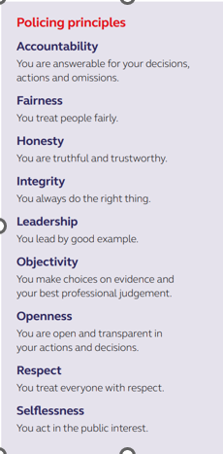
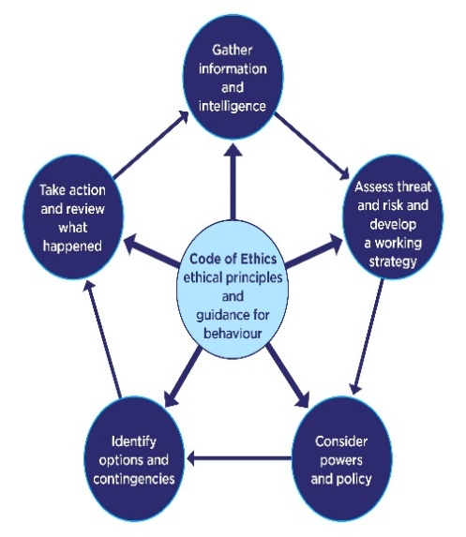
(COP 2013)

(COP 2014)

On our way to the incident, as guided by the NDM I attempted to gather as much information and intelligence as possible on the call we were attending.

Unfortunately, as is often the case the information was vague and only limited. This is often the difficulties officers face when assessing threat and risk, especially in this case where all I knew of the situation was that a male had smashed a window of a nearby restaurant. At this point I did not know if the male was under the influence of any drugs, whether he was using any weapons or what his behaviour may be on arrival of police officers. As I have discussed in a previous essay, it was vital to consider Betari’s box when attending and ensure my behaviour and attitude didn’t affect that of the offender creating a conflict situation. It can be a first response for some to tackle aggression with aggression. (University of Birmingham 2023) suggests that “warrior culture sees police officers’ default to violence and aggression when conflicts arise.” As stated in the code of ethics, leadership is a core principle of the police and I aim to lead by example.

I therefore attended the incident and proceeded to stay calm, ask the victim what had happened while following PACE (1984) guidelines and cautioning the alleged offender. In this instance my colleague spoke with the victim and ascertained what had taken place while I remained with the offender. The victim described that the offender had smashed a window of his restaurant with no obvious motivation. Considering the NDM and the fact a crime had taken place I was well within my rights to arrest the offender. However, as described at the beginning of this essay, often arresting someone and the potential for a court appearance is often not proportional to the crime nor is it inherently in the victim’s interest.

As such discretion was considered. The role of the police officer is not only to react to crimes committed but help play an active role in preventing offenders from re-committing crime. (Wortley 2003) states that “strict adherence to the letter of the law in many cases would be too harsh and justice may be better served by not introducing an offender into the criminal justice process”. The offender in this case therefore had the opportunity of a restorative justice approach whereby he would agree to pay the owner back for the window and it would be dealt with outside of the criminal justice system as long as the offender showed remorse for his actions. Unfortunately, the offender refused to take ownership and be remorseful for what had been done. He stated that he had kicked the window but had not meant to damage it. He did not accept that being reckless can amount to the crime of criminal damage.

Going back to the NDM there is a reason that it is a cycle and not a linear design. We needed to re-evaluate all the information available and within our powers and policies there was still the option to arrest, but after talking to the offender and being able to ascertain his address we felt that a voluntary interview (VA) would instead be the best course of action. We therefore relayed the male to his address and informed him that he would be required to attend a VA the following week.
Originally, we believed the male to be intoxicated but as we spoke, we began to suspect that he may be on the spectrum for autism as well. As police officers, we not only have a responsibility to the victims but PACE (1984) guidelines ensure we also treat suspects lawfully. At this time, we still felt that a VA was the correct course of action. As is stated by (AA Network 2023) “voluntary interviews avoid the costs and risks associated with police custody, including financial, psychological, and physical”.

The other benefit with a VA is it gives time to ensure the investigation is conducted thoroughly without the worry of a custody clock and although there were no bail restriction placed on the male, we were satisfied he would not re-offend before the attendance at a VA. This time also ensured that we were able to liaise with the victim, and as I have discussed in the previous essay, we ensured that the victims codes were met.
On speaking to the victim, he was satisfied that the investigation was being taken seriously by the police, that his needs were being met and that he would receive compensation for the damage.

Part of this investigation was taking a statement from him and also taking photos of the damage. All of which are required to be managed as part of the CPIA process. It is also vital that all lines of enquiry are followed, and relevant exhibited evidence is disclosed. The role of the police is not to find evidence to prove a certain version of events but instead to investigate any and all leads. “The CPIA 1996 is an important part of the system that ensures criminal investigations and trials are conducted in a fair, objective and thorough manner” (Attorney Generals’ Office 2024).

We conducted a thorough CCTV search, spoke to the victim and tasked officers to conduct house to house enquiries. The evidence was such that it still gave no evidence to the contrary of what the victim had stated. Everything that was to be exhibited was given to the solicitors of the offender.
Prior to the VA we were advised that the offender would require an appropriate adult and as such supported him in getting one as he had no family in the nearby area. I have previously spoken about autism and the importance of treating offenders and victims alike with a supportive mindset. Too often than not, offenders with autism within the criminal justice system do not feel they are treated as favourably. As was shown in a study by (Slavny-Cross, R et al 2022)
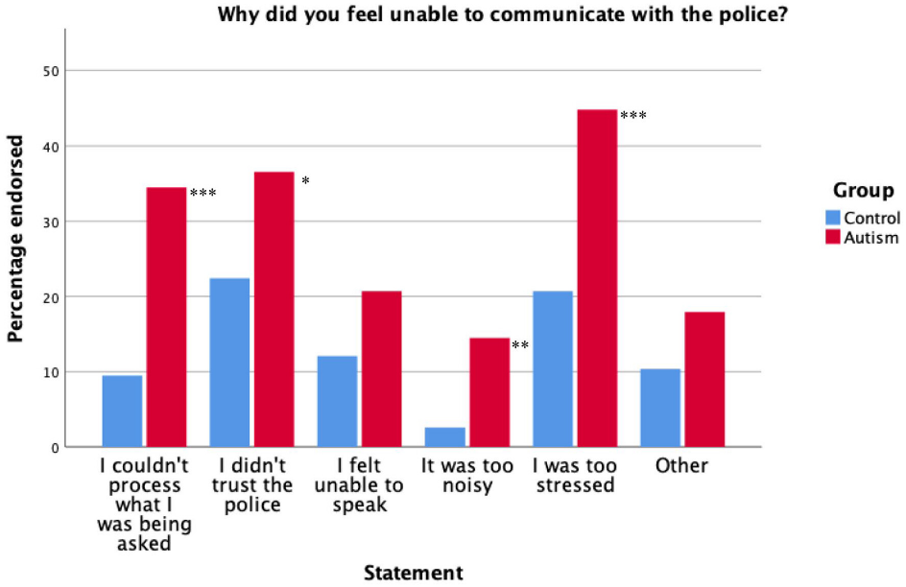

It was therefore vital that I ensure the male understood why he was there, that he understood my questions and felt that he was treated fairly. I ensured this by working with his appropriate adult and solicitor, and ensuring I spoke in a calm and coherent manner.
The outcome of the interview was that the male agreed that his actions were wrong and accepted a conditional caution and repayment of the damages done. Throughout this process we were able to avoid a custodial form of action by utilising discretion and focusing on the needs of the victim rather than an arrest all strategy.
On evaluation of this incident, I felt confident that things went well, and the outcome was the right one. We were able to get compensation for the victim and we avoided a custodial sentence (even if this only involved the custody suite at the station). It was our belief that this would not have been proportional to the circumstance. I believe that the use of OOCD have a benefit within the criminal justice system and it is something that I will actively look to use going forward. This is backed up by (Rowe et al. 2022) where they found in a study that “reoffending rate for OOCDs was lower in comparison to the other disposals that were issued in the relevant period.”
As in a previous incident however I felt that my knowledge and understanding of a person with autism is limited and it is something I need to have a better understanding of. I also felt that although we did identify the male may have had autism, it was not something I was initially considering and could have easily been missed.

In conclusion I need to be more aware of people who are vulnerable who enter the criminal justice system; be they victims or offenders. This incident was my first encounter of working with an appropriate adult and this helped me gain a greater understanding of their role and importance. I also need to ensure that I utilise the NDM in all avenues of my police career. This incident clearly displayed that as a police officer my options and contingencies are vast however it is easy to fall into the trap of arrest anyone and everyone who commits a criminal offence. I understand however that I am young into my career but if I continue to reflect and learn from these occurrences, that I will hopefully be an example as to what the code of ethics are, and the behaviours attached to them.

Word count: 1707

Task 5

Independent Patrol Status confirmation – equivalent to 1,500

This completion of this task shall be confirmed by the employer once independent patrol status is achieved.

Bibliography
The bibliography should only include sources referenced within the workbook using the Harvard referencing system. Information about referencing in written assignments and how to avoid plagiarism can be found on Moodle. It is important that you are aware of the importance of ensuring that the work submitted is your original work.

Attorney Generals’ Office (2024) Attorney General’s Guidelines on Disclosure For investigators, prosecutors and defence practitioners. Available at: Attorney_General_s_Guidelines_on_Disclosure_-_2024.pdf (publishing.service.gov.uk)

Barr, M. and Copeland-Stewart, A. (2021). Playing Video Games During the COVID-19 Pandemic and Effects on Players’ Well-Being. Games and Culture, [online] 17(1). Available at: Playing Video Games During the COVID-19 Pandemic and Effects on Players’ Well-Being - Matthew Barr, Alicia Copeland-Stewart, 2022 (sagepub.com)

Borton, T. (1970). Reach, touch, and teach : student concerns and process education. New York Mcgraw-Hill Paperbacks.

College Of Policing (2013) National Decision Model, College of policing. Available at: https://www.college.police.uk/app/national-decision-model/national-decision-model.

College of Policing (2014) Code of Ethics A Code of Practice for the Principles and Standards of Professional Behaviour for the Policing Profession of England and Wales. Available at: https://www.west-midlands.police.uk/_flysystem/public-sync/inline-files/Code_of_Ethics.pdf.

College of Policing (2015) First response, College of Policing. Available at: https://www.college.police.uk/app/major-investigation-and-public-protection/domestic-abuse/first-response.

College of Policing (2020). New conflict management guidelines released. [online] College of Policing. Available at: https://www.college.police.uk/article/new-conflict-management-guidelines-released.

Cycj.scotland (2023). The Victim-or-Perpetrator Dichotomy harms both those who commit crime and those who suffer it. [online] Children and Young People’s Centre for Justice. Available at: https://www.cycj.org.uk/perpetrators-are-often-victims-dan-johnson/.

DTS Language Services (2019) 7 Simple Tips for Effectively Communicating with Non-English Speaking Patients, DOCUMENT TRANSLATION, AUDIO TRANSCRIPTION, & PHONE INTERPRETATION. Available at: https://www.dtstranslates.com/language-service-provider-lsp/7-simple-tips-for-effectively-communicating-with-non-english-speaking-patients/.

First response (2015) College of Policing. Available at: https://www.college.police.uk/app/major-investigation-and-public-protection/domestic-abuse/first-response#:~:text=to%20be%20provided.-.

Gibson, C. (2021) OUT OF COURT DISPOSALS A review of policy, operation and research evidence. Available at: https://www.sentencingacademy.org.uk/wp-content/uploads/2023/08/Out-of-Court-Disposals.pdf.

Home Office (2021). Annex: Statistics on the number of police officers assaulted in the year ending March 2021, England and Wales. [online] GOV.UK. Available at: https://www.gov.uk/government/statistics/police-workforce-england-and-wales-31-march-2021/annex-statistics-on-the-number-of-police-officers-assaulted-in-the-year-ending-march-2021-england-and-wales.

How life has changed in Cardiff: Census 2021 (2023) sveltekit-prerender. Available at: https://www.ons.gov.uk/visualisations/censusareachanges/W06000015/.

Ignatans, D. and Pease, K. (2019). Are victims of crime mostly angry or mostly afraid? Crime Prevention and Community Safety. doi: https://doi.org/10.1057/s41300-019-00079-1.

John (2021). The Karpman Drama Triangle. [online] MONERE Development Services Limited. The Karpman Drama Triangle - MONERE Development Services Limited

Karpman, S. (1968). Fairy tales and script drama analysis. Transactional Analysis Bulletin, 7(26), 39-43.

Kolb, D.A. (1984). Experiential learning: experience as the source of learning and development. Englewood Cliffs, NJ: Prentice Hall

Lancaster, M.R. and Callaghan, P. (2022). The effect of exercise on resilience, its mediators and moderators, in a general population during the UK COVID-19 pandemic in 2020: a cross-sectional online study. BMC Public Health, 22(1). Available at: The effect of exercise on resilience, its mediators and moderators, in a general population during the UK COVID-19 pandemic in 2020: a cross-sectional online study - PubMed (nih.gov)

Manager, C. (2020) ‘Major change needed’ in mental health and wellbeing care for vulnerable children, Children’s Commissioner for Wales. Available at: ‘Major change needed’ in mental health and wellbeing care for vulnerable children - Children’s Commissioner for Wales (childcomwales.org.uk)

Mehrabian, A. (1972). Nonverbal Communication (1st ed.). Routledge. https://doi.org/10.4324/9781351308724

Mental Health Foundation (2022). How to manage and reduce stress. [online] www.mentalhealth.org.uk. Available at: https://www.mentalhealth.org.uk/explore-mental-health/publications/how-manage-and-reduce-stress.

Mind Tools Content Team (2023). Betari Box. [online] www.mindtools.com. Available at: https://www.mindtools.com/a1uv9ex/betari-box.

National Autistic Society (2020) Distressed behaviour - a guide for all audiences, www.autism.org.uk. Available at: https://www.autism.org.uk/advice-and-guidance/topics/behaviour/distressed-behaviour/all-audiences.
NHS (2021). Tips on preparing for exams. [online] nhs.uk. Available at: https://www.nhs.uk/mental-health/children-and-young-adults/help-for-teenagers-young-adults-and-students/tips-on-preparing-for-exams/.

Owsley, A. (2014). Communication Tip #4: Know Your Non-Verbals! | Life at Leggett. [online] Available at: https://lifeatleggett.com/2014/07/08/communication-tip-4-know-your-non-verbals/.

Parrott, D.J. and Eckhardt, C.I. (2018). Effects of alcohol on human aggression. Current Opinion in Psychology, 19, pp.1–5. Available at: Effects of Alcohol on Human Aggression - PubMed (nih.gov)

Piernikarch, G. (2022). Kolb’s Cycle of Reflective Practice. [online] Cambiana. Available at: https://www.cambiana.com/kolbs-cycle-of-reflective-practice/.

Police recruitment and retention: The UK crisis (2024) Leeds Trinity University. Available at: Police recruitment and retention: the UK crisis — Leeds Trinity University Research Portal

Rowe, M. et al. (2022) ‘Streamlining out-of-court disposals: Assessing the impact on reoffending and police practice’, Criminology & Criminal Justice, p. 174889582210874. Available at: https://doi.org/10.1177/17488958221087492

Slavny-Cross, R. et al. (2022) ‘Are autistic people disadvantaged by the criminal justice system? A case comparison’, Autism, 27(5), p. 136236132211402. Available at: https://doi.org/10.1177/13623613221140284.

Students, O. for (2023). Meeting the mental health needs of students - Office for Students. [online] www.officeforstudents.org.uk. Available at: https://www.officeforstudents.org.uk/publications/meeting-the-mental-health-needs-of-students/#:~:text=4.5%20per%20cent%20of%20full.

Team, T.L.S. (no date) Domestic Violence Assistance Should Not Be Slowed By Language Barriers, blog.languageline.com. Available at: Domestic Violence Assistance Should Not Be Slowed By Language Barriers (languageline.com)

The University of Edinburgh (2020) Gibbs’ Reflective Cycle, The University of Edinburgh. Available at: https://www.ed.ac.uk/reflection/reflectors-toolkit/reflecting-on-experience/gibbs-reflective-cycle.

Thomas, Kenneth & Kilmann, Ralph. (1976). Thomas-Kilmann conflict MODE instrument. 10.1037/t02326-000. (PDF) Thomas-Kilmann conflict MODE instrument (researchgate.net)

University of Birmingham (2023) Police ‘warrior culture’ makes US-style police brutality a UK problem too, University of Birmingham. Available at: https://www.birmingham.ac.uk/news/2023/police-warrior-culture-makes-us-style-police-brutality-a-uk-problem-too.

University of Cambridge. (2022). UK policing: psychological damage among officers heightened by bad working conditions. [online] Available at: University of Cambridge. (2022). UK policing: psychological damage among officers heightened by bad working conditions. [online] Available at: https://www.cam.ac.uk/research/news/uk-policing-psychological-damage-among-officers-heightened-by-bad-working-conditions#:~:text=Sociologists%20surveyed%20thousands%20of%20police.

Victim Support (2021) Victims’ Code, Victim Support. Available at: https://www.victimsupport.org.uk/help-and-support/your-rights/victims-code/.

Voluntary interviews - National Appropriate Adult Network (2023) www.appropriateadult.org.uk. Available at: https://www.appropriateadult.org.uk/policy/voluntary-interviews.

‌Watt, A. and Bagshaw Bsc, R. (2020) BEYOND THE CALL. Available at: https://www.gov.wales/sites/default/files/publications/2020-12/beyond-the-call.pdf.

World Health Organization (2023). Stress. [online] World Health Organization. Available at: Stress (who.int)

Wortley, R. (2003) Measuring Police Attitudes 1 POLICE DISCRETION Measuring Police Attitudes Towards Discretion. Available at: https://discovery.ucl.ac.uk/id/eprint/1301711/1/Wortley_2003_discretion.pdf.

Yang, C., Gao, H., Li, Y., Wang, E., Wang, N. and Wang, Q. (2022). Analyzing the role of family support, coping strategies and social support in improving the mental health of students: Evidence from post COVID-19. Frontiers in Psychology, [online] 13. Available at: Frontiers | Analyzing the role of family support, coping strategies and social support in improving the mental health of students: Evidence from post COVID-19 (frontiersin.org)

‌

‌

‌

‌

‌

‌

‌

‌

‌
‌

‌

‌

‌

‌

‌

‌

CONFIDENTIALITY and PLAGIARISM – confirmed by submission through Turnitin

Please sign to confirm the work submitted is your own work and has not been copied from another.

Signed: …...................

Date: ….......................

