Cover Page
Module Name: Learning In the software solutions
Module Code: ACCA4026-LON
Student Name: ABBAS AHMED
Student ID:2512870
Group: 2

Lecturer’s Name: AMITAVE BANIK

Table of Contents
Introduction 1
Task 1. e-Commerce Website builders or software solutions 1
1.1 WooCommerce 1
1.2 Wix 1
Task 2. Mind-map of contemporary software applications 1
a. Mind mapping and explain the benefits of using mind mapping in business operations 1
b. Create a mind map of contemporary software applications 1
Task 3. Office Applications 1
a. Four office software solutions for business operations 1
MS Word 1
MS PowerPoint 1
MS Excel 1
MS Access 2
b. Practical demonstration of Two Office Features 2
Mail Merge 2
If Statement 2
Task 4. Communication and Collaboration applications 2
a. One contemporary Communication and one Online Collaboration applications/tools 2
MS Outlook 2
MS Teams 2
b. One feature of a freely available Communication (1) and one feature of a Collaboration (1) application 2
MS Outlook 2
Ms Teams 2
Conclusion 2
References 3

Introduction
Communications and collaboration applications are important digital tools

Task 1. e-Commerce Website builders or software solutions

1.1 WooCommerce
<Insert Information here – 250 words> WooCommerce stand out as the leading e-commerce solution for businesses seeking Flexibility and full ownership of their online store. Functioning as a powerful, free plugin For WordPress website, it transforms any standard site into a fully operational online Shop, its open-source nature is its biggest strength. Granting user’s unparalleled control Over every aspect of their digital storefront, from design aesthetics to complex functionality The primary appeal lies in it seamless integration with WordPress, leveraging the platforms ease of use and extensive content management capabilities, merchants can manage product, track inventory process orders, and handle customer data all within the familiars WordPress dashboard. Key feature that makes WooCommerce popular include extensive customization options through a vast library of extensions and themes found in the WooCommerce marketplace. These add- Ons allow businesses to implement advanced functionality. Such as dynamic pricing. Subscription services, or sophisticated shipping calculations, without needing to write code. Furthermore. WooCommerce facilitates Essential e-commerce operations efficiently. It integrates easily with popular payment gateway likes stripe, PayPal. and its own woo payment service, ensuring smooth. Secure transactions. While the core plugin is free user are responsible for hosting costs and domain registration the trade – off is complete ownership and the absence of transaction fees often charged by hosted platforms like Shopify. In summary. WooCommerce is an ideal, scalable choice for entrepreneurs and developers who already use WordPress and require a robust, adaptable platform that can grow alongside their business with minimal creative restrictions. [1]

1.2 Wix
<Insert Information here – 250 words>
Wix is versatile. All -in one cloud- based platform designed to make creating a professional website accessible to anyone, regardless of technical skills, know primarily as user -friendly website builder. Wix has developed a robust set of e-commerce tools under its Wix ecommerce offering, making it a strong competitor for small to medium sized businesses looking to sell products online, the platform excels in ease of use, featuring an intuitive drag- and drop editor that offers total design freedom user can choose from hundreds of designer – made templates or use the WIX ADI (artificial design intelligence) to automatically create a stunning mobile-optimized storefront in minutes. Wix handles the technical complexities of running online store e-commerce plans bundle essential services like secure hosting. SSL. Certificate, payment processing capabilities, and basic marketing tools (like email campaigns and SEO features) merchants can manage inventory, process orders, set up various shipping rules, and handle global tax calculations effectively through a centralized dashboard. The platform also provides powerful built -in omnichannel capabilities allowing users to sell product seamlessly across various channels including Facebook. Instagram. Amazon and eBay, while the free plan is primarily for showcasing a portfolio and does not support e-commerce, Wix offers several dedicated business and e-commerce plans, these paid plans remove Wix branding. Offer custom domains, and unlock essential selling features, Wix is the best suited for entrepreneurs and small businesses owners who prioritize an intuitive , visually focused, all – in one solution without needing the deep , code – level customization required by open – source alternative like WooCommerce , you can explore their offerings and plans on the official WIX website .

Task 2. Mind-map of contemporary software applications
Contemporary software refers to modern software system that are designed to meet current technological social and business needs. These software solutions are highly dynamic. User centric, and integrated with advanced technologies A mind map of contemporary software can be divided into several key branches
Types characteristics. Technologies applications development practices and challenges.
1 types of contemporary software
Contemporary. software includes various categories such as system software. Applications software. Web based software. and mobile applications, cloud-based software like google workspace and Microsoft 365 allows user to access services anytime and anywhere. Mobile applications such as mobile baking apps. health tracking. and social media platforms are also major examples. Additional. Enterprise software like ERP and CRM systems supports business operation efficiently.

2 characteristics
Modern software is known for its scalability. Flexibility. And user-friendly interfaces. It is often cross platform meaning it can run on multiple devices. such as smartphones. Tablets. And desktops. Contemporary software emphasizes real time updates. Automation. Security. And performance optimization. Most system are designed to be modular so that features can be added or updated easily without disrupting the entire.
3 technologies used
Contemporary software relies heavily on advanced technologies. Cloud computing enables storage and processing over the internet. Artificial intelligence (AI) and machine learning (ML) are used for date analysis. Chatbots. Recommendation system. And automation. Big date technologies help manage large volumes of date. While APIS enable software integration, other important technologies include blockchain internet of things (IOT) and cybersecurity tools.
4 applications
The application of contemporary span across many fields. In education. Learning management system and e learning platform support online learning. In healthcare, software assists in patient management. Telemedicine. Diagnostic. In business. Software improves productivity. Decision making and customer service. Social media platforms and entertainment software also play a major role in daily life.

5 developments practices
Modern software is developed using agile and DEVOPS methodologies, which focus on continuous improvement. Collaboration. And fast delivery. Open-source development is also common. Allowing developers to worldwide to contribute user feedback is continuously collected to enhance functionality and usability automation tools are used for testing. Deployment. And maintenance.

6 challenges
Despite its advantages. Contemporary software faces challenges such as security threats. Privacy concerns. High development costs. And rapid technological. Changes developers must constantly update system to protect against cyberattacks and ensure compliance with regulations.

Conclusion
In conclusion. Contemporary software plays a vital role in modern society integration with advanced technologies and wide range of application makes it essential for personal. Educational. Educational. And professional use. A mind map view helps understanding how different components of contemporary software are interconnected. [2]

Mind mapping and explain the benefits of using mind mapping in business operations
Mind mapping is a visual tool that helps organize ideas, information and processes around a central topic. In business operations, mind mapping is widely used to simplify, complex tasks, improve communication, and support effective decision making. By visually displaying relationship between ideas, mind maps help businesses operate more efficiently and strategically.
One key benefit of mind mapping in business operations is improved planning and organization. Business activities often involve multiple tasks, departments, and objectives. Mind mapping allows mangers to break down large goals into smaller, manageable components such as finance, marketing, human resources, and operations. This structured approach helps in setting priorities, allocating resources, and tracking progress more effectively.
Another important benefit is enhanced communication and collaboration. Mind maps present information in a simple and visual format, making it easier for employees to understand roles, responsibilities, and workflows. During meetings or brainstorming sessions, mind mapping encourages participation and idea sharing among team members. This reduces misunderstanding and ensure everyone has a clear understanding of business goals.
Mind mapping also supports better decision making. Business decisions often require analysis of multiple options, risks, and outcomes by organizing information visually, mind maps allow decision makers to compare alternatives clearly and identify possible consequences. This leads to more informed, logical, and confident decision.
In addition, mind mapping improves productivity and time management. Employees can use mind maps to plan daily tasks, manage projects, and meet deadlines efficiently. Visual task list reduce time spent on lengthy documents and help employees focus on important activities. As a result, overall operational efficiency increases.
Another benefit is effective problem solving. when a business faces operational challenges, mind mapping helps identify the root causes, effects, and potential solutions. by exploring different perspectives visually, teams can think creatively and develop practical, long -term solutions rather than temporary fixes.
Finally, mind mapping enhances knowledge management and learning within the organization. It helps store and organize important information such as procedures, training materials, and best practices. This makes knowledge easy to access and share, supporting employee development and continuity in business operations.
In conclusion, mind mapping is a powerful and practical tool for business operation. It enhances planning, communication, decision making. Productivity, problem solving, and knowledge management. By using a visual approach, mind mapping helps business operation more efficiently and achieve their organizational goals. [3]

Create a mind map of contemporary software applications
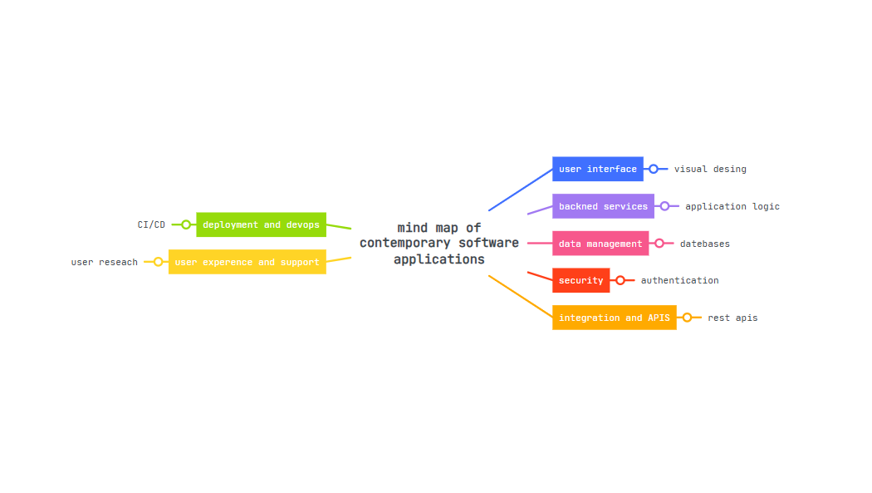

Task 3. Office Applications

Four office software solutions for business Four office software solutions for business
MS WORD
Microsoft word is one of the most widely used office applications developed by Microsoft. it is a ward processing software that allows users to create, edit, format, and print text-based documents. Microsoft word is commonly used in businesses, educational institutions, and personal settings due to its ease of use and wide range of features. it plays an important role in improving productivity and document management in office environments.
One of the primary functions of Microsoft word is documents creation and editing. Users can create various types of documents such as letters, reports, memos, resumes, and assignments. The software provides tools to insert, delete, copy, and modify text easily. feature such as cut, copy, past, undo, and redo make editing fast and efficient. This helps users save time and maintain accuracy while working on documents.
Microsoft word also offers powerful formatting features. users can change font styles, sizes, and colours to enhance document appearance. Paragraph formatting options such as alignment, spacing, indentation, and bullet points help organize content clearly. Styles and themes allow consistent formatting throughout the document, which is especially useful for professional reports and academic work.
Another important feature of Microsoft word is spell check and grammar check. These tools help users identify and correct spelling and grammatical errors automatically. The autocorrect features fixes common typing mistake, while the thesaurus helps improve vocabulary. These tools ensure documents are clear, professional, and error-free.
Microsoft word supports inserting objects and multimedia elements. Users can add tables, charts images, shapes, and hyperlinks to enhance document presentation. Tables are useful for organizing data, while charts help display information visually. Headers, footers, page numbers and watermarks improve document structure and professionalism.
Collaboration is another key advantage of Microsoft word. With cloud integration through Microsoft OneDrive, multiple users can work on the same document simultaneously. Features such as comments and track changes allows users to review edits, suggest improvements, and monitor document revision. This is especially useful un business environments where teamwork and documents sharing are essential.
Microsoft word also provides strong document security and strong options users can protect documents with passwords, restrict editing, and control access. Documents can be saved in various formats such as DOCX, PDF, and TXT, making it easy to share files across different platforms. Automatic saving and backup option help prevent data loss.
In conclusion, Microsoft word is a powerful and essential office application that supports efficient document creation, formatting, collaboration, and management. Its wide range of features makes it suitable for students, professional, and organizations. By simplifying document-related tasks and improving productivity, Microsoft word remains a vital tool in modern office operations. [4]

MS PowerPoint
Microsoft PowerPoint is a popular presentation software developed by Microsoft and included in the Microsoft office suite. It is widely used in business organization, educational institutions, and personal settings to create and deliver presentations PowerPoint enables users to present information in a clear. Structured. And visually appealing manner. Making it an essential office application in modern workplace.
One of the primary functions of Microsoft PowerPoint is creating and organizing presentations using slides each slide can contain text, images, chart. and other elements, allowing information to be presented in a step-by-step format. This slide-based structure helps audiences understand complex ideas more easily. User can add. Delete, duplicate. Or rearrange slides ensuring that presentations follow a logical follow.
Microsoft PowerPoint provides a wide range of design and formatting tools that help user create professional looking presentations. Built in templates and themes allow users to quickly apply consistent layouts. colour schemes, and font across all slides, user can also customize background, font styles and text alignment to suit the purpose of the presentation. These design features enhance the visual appeal and maintain consistency.
Another important feature of PowerPoint is it ability to integrate multimedia elements. User can insert image. Tables charts. Audio. And video into slides into support their content charts and graphs are particularly useful for presenting date and statistics in visual and understandable way. Multimedia elements help capture audience attention and improve communication effectiveness.
Microsoft PowerPoint also supports animations and slide transitions. Animations control how text and objects appear on a slide. While translations manage movement between slides. When used appropriately. These features make presentation more engaging and help emphasize key point, however. Excessive use of animations can be distracting. So, they should be applied carefully.
Collaboration is another key advantage of Microsoft PowerPoint. With cloud integration through Microsoft OneDrive. Multiple users can work on the same presentation at the same time. Features such as comments. Version history. And real time editing allows teams to collaborate efficiently. This is especially beneficial in business environments where teamwork and quick feedback are important.
PowerPoint also includes useful presentations delivery tools. Presenter view allows speakers to see speaker notes. Upcoming slides. And a time while presenting. Presentations can also be saved in different formats. Such as PDF or video. Making them easy to share and distribute.
In conclusion. Microsoft PowerPoint is a powerful and versatile office application that enhances communication and productivity. Its features for slide creation. Design. Multimedia integration. Collaboration. And presentations delivery makes it an essential tool in business and education. By enabling users to present information clearly and professionally. Microsoft PowerPoint plays a vital role in modern office operations. [5]

MS Excel
Microsoft excel is a powerful spreadsheet application developed by Microsoft and including in the Microsoft office suit. Is it widely used in business organisations. Educational institutions. And personal environments for date entry. Analysis. And management. Microsoft excel helps users organize large amounts of date. Perform calculations and present information in a clear and meaningful way. Making it an essential office application.
One of the primary functions of Microsoft excel is date organization and storage. Date excel is arranged in row and columns. Forming worksheets within a workbook. This structured format allows users to enter, edit. And mange date efficiently excel is commonly used for tasks as maintaining financial record. Inventory lists. Employee date. and sales reports. Sorting and filtering tools help user quickly locate and analyse specific information.
Microsoft excel is well know for its calculation and formula capabilities. User can perform simple calculations such as addition and subtraction. As well as complex mathematical. Statistical. And financial operations using built in formula and functions. Common functions such as sum. Average. IF. And VLOOKUP help automate calculations and reduce errors. This improves accuracy and saves time business operations.
Another important feature of Microsoft excels is date analysis and visualization. Excel provides tools such as charts. Graphs. And pivot tablets that helps users analyse trends and patterns in date charts such as bar graphs. Pie charts. And line charts present date visually. Making it easer to understand and interpret. Pivot tablet allows user to summarize large datasets and generate meaningful reports for decisions making.
Microsoft excel also supports date formatting and presentations. User can format cells by changing fonts. Colores. Borders. Number style to improve readability conditional formatting highlights important values. Trends. Or exceptions automatically. These features help present date in a professional and visually appealing manner. Which is especially useful for reports and presentations.
Collaborations is another key advantage of Microsoft excel. With cloud integrations through Microsoft ONEDRIVE. Multiple users can work on the same spreadsheet simultaneously. Features such as comments sharing options. And versions history allows teams to collaborate efficiently. Excel also supports date protection through password security and restricted access. Ensuring date confidentiality.
In addition. Microsoft excel can be integrated with other Microsoft office applications such as word and PowerPoint. Data from excel can be imported into documents and presentations easily. Improving workflow efficiency. Excel also supports exporting files in various formats. Including PDF and CSV. Making data sharing simple.
In conclusions. Microsoft excel is versatile and essential office applications that support data organizations. Calculation. Analysis visualizations. And collaboration. Its powerful features help businesses improve accuracy. Efficiency. And decisions making by enabling users to manage and analyse data effectively. Microsoft excel plays a vital role in modern office operations [6]

MS Access
Microsoft access is database management system (DBMS) developed by Microsoft as part of the Microsoft office suite. It is designed to help users create. Manage. And analyse database efficiently. Microsoft access is widely used in small to medium sized organizations. Educational institutions. And personal projects where structured data storage and retrieval are required.
One of the main functions of Microsoft access is database creation and management. Users can create database to store large amounts of related data. Such as customer records. Employee information. Inventory details. And sales data. Access organizes data into tables, which consist of rows and fields. This structured approach ensures data consistency and reduces duplication.
Microsoft access provides user friendly data entry tools. Forms can be created to make data input easier and more accurate. Forms allow users to enter. Update and view data without interacting directly with tables. This reduces errors and improves efficiency. Especially for users with limited technical knowledge.
Another important feature of Microsoft access is its ability to query data. Queries allow users to retrieve specific information from one or more tables based on defined criteria. For example. A business can use queries to find customers with outstanding payments or products with low stock levels. Queries support decisions making by providing meaningful and targeted information.
Microsoft access also supports report generation. Reports are used to present data in a structured and printable format. Businesses can generate repots such as sales summaries. Employees list. Or financial statements. Reports help management analyse information and communicate results effectively.
Integration with other Microsoft office applications is another advantage of Microsoft access. Data can be imported from or exported to Microsoft excel. Word and PowerPoint. This allows businesses to combine database management with data analysis and presentation. improving overall workflow efficiency.
Microsoft access also offers security and data protection features. Users can set passwords. Restricts access. And control user permissions to protect sensitive date. This ensures that only authorized users can view or modify database information.
In conclusion. Microsoft access is a powerful and flexible office application that supports effective data storge. Management. And analysis its features for tables. Forms. Queries. Report. And integrations make it an essential tool for managing structured information. By improving data accuracy and accessibility Microsoft access plays an important role in modern office operations. [7]

Practical demonstration of Two Office Features

VLOOKUP – VALUE
VLOOKUP searches the first column of a table and returns matching value from another match.

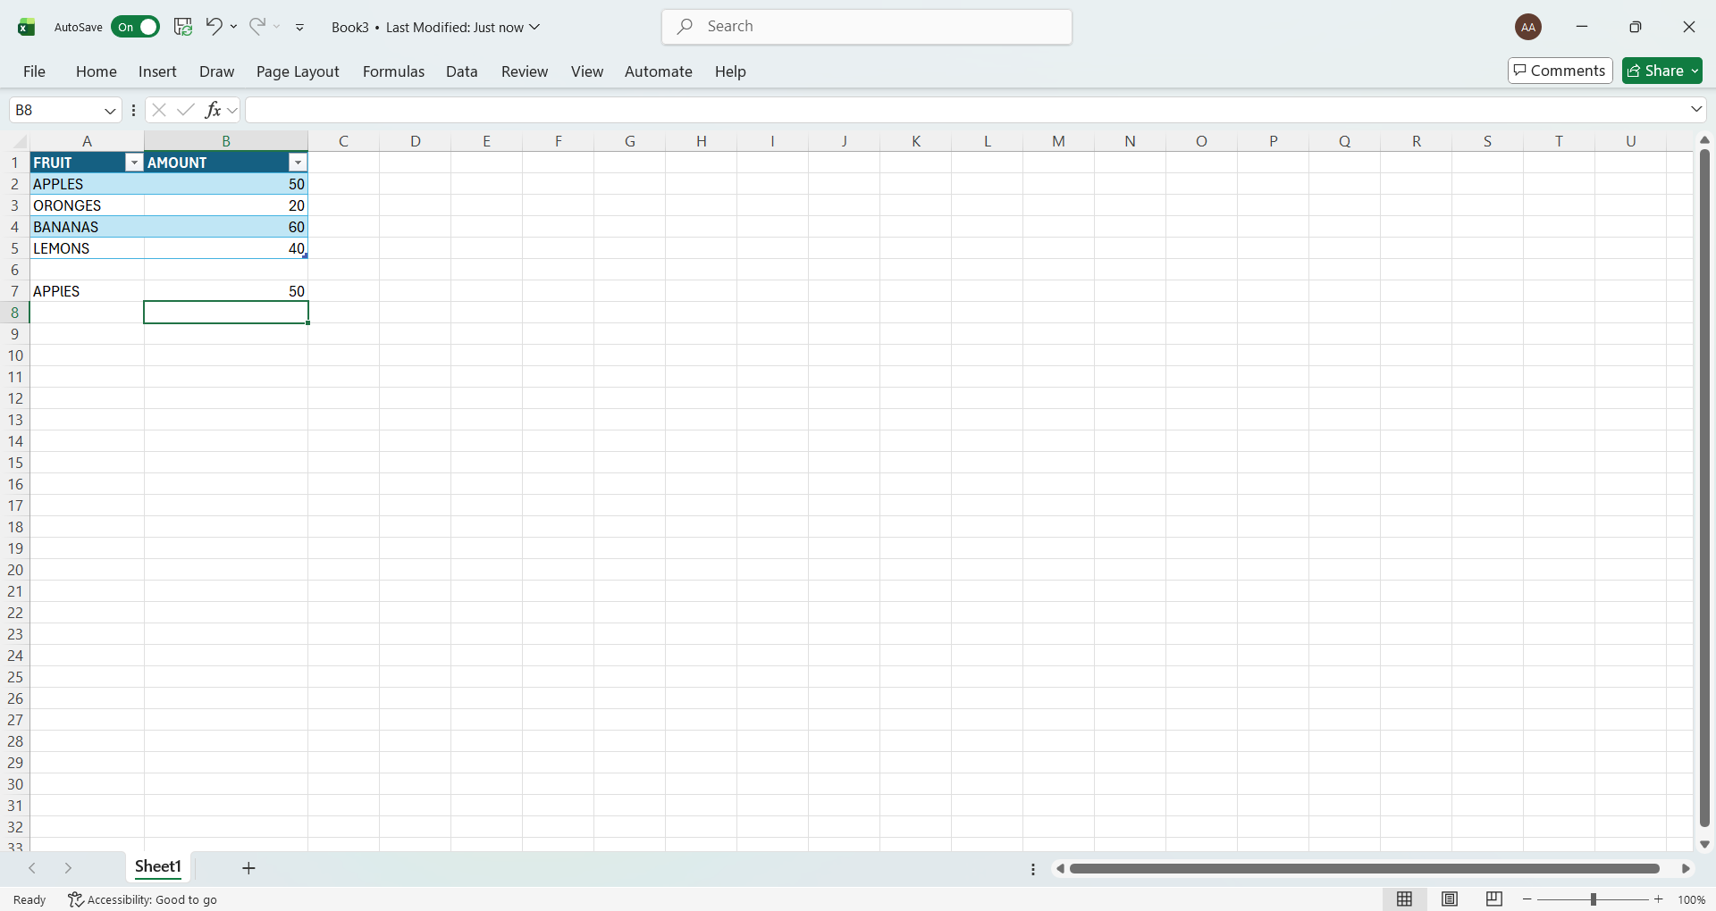
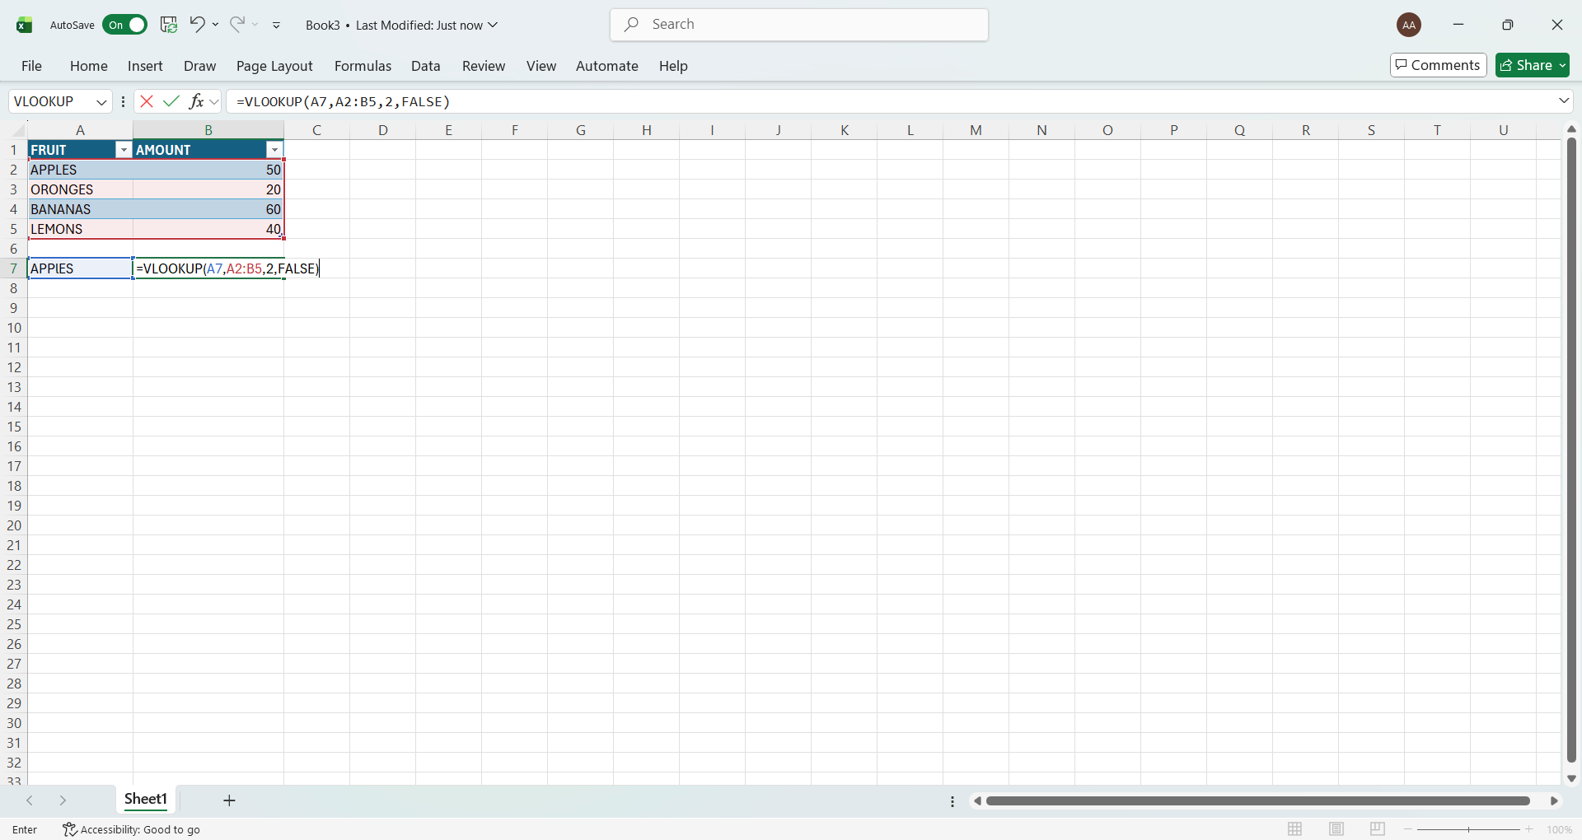
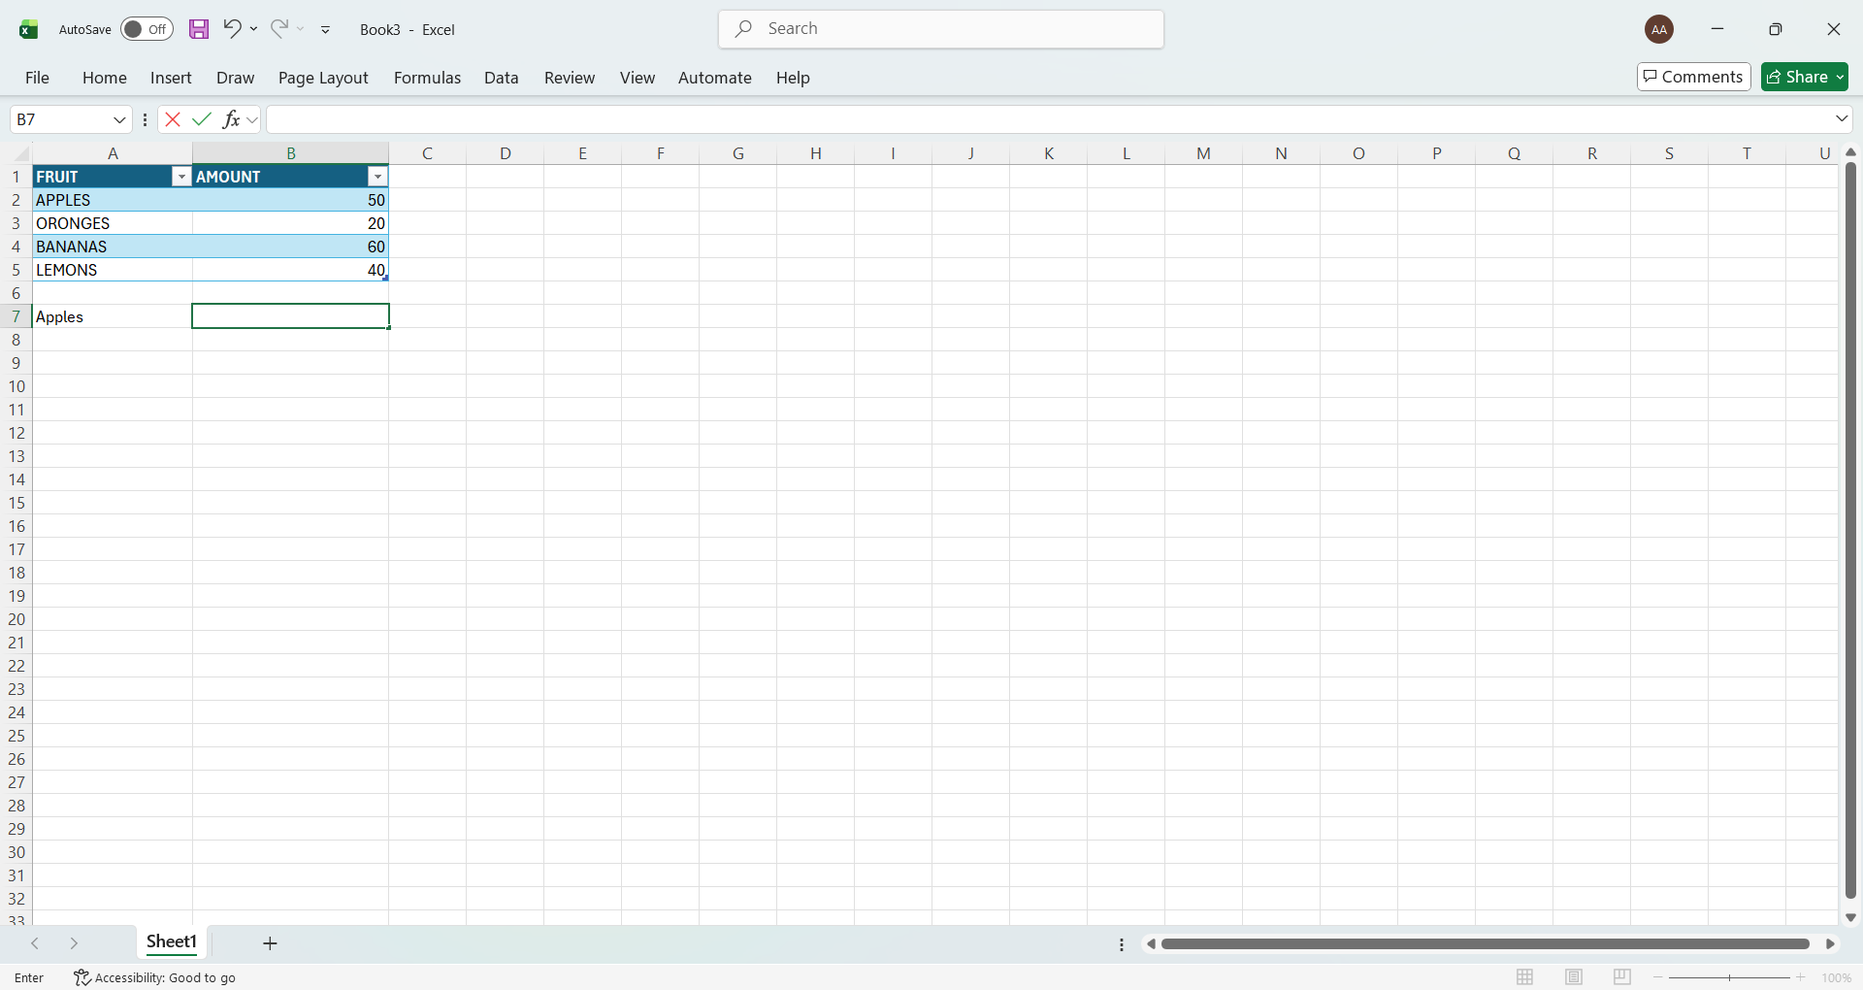

Mail Merge

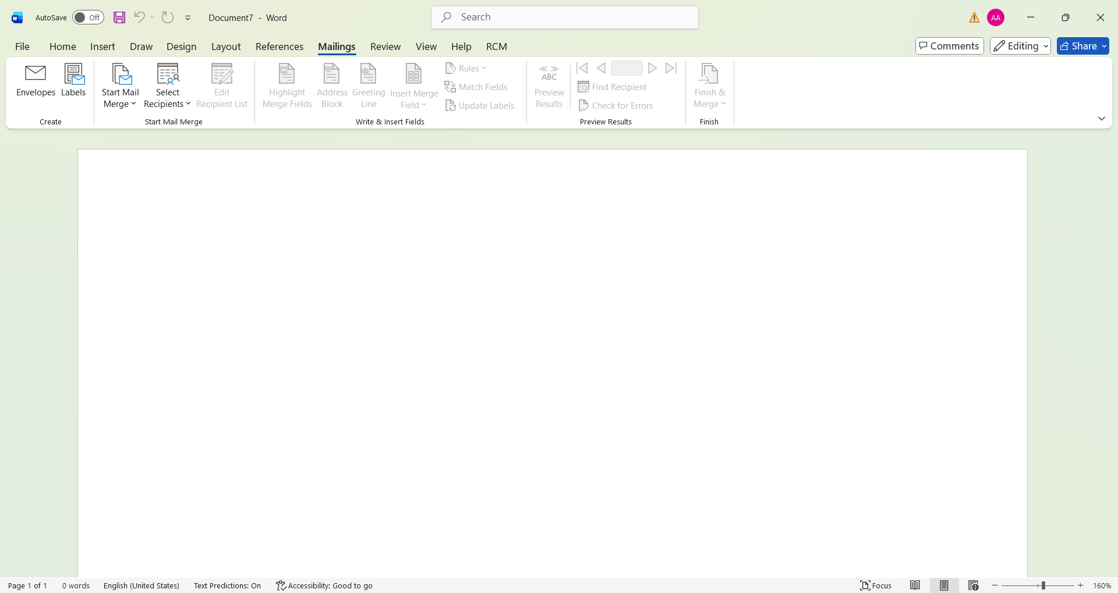
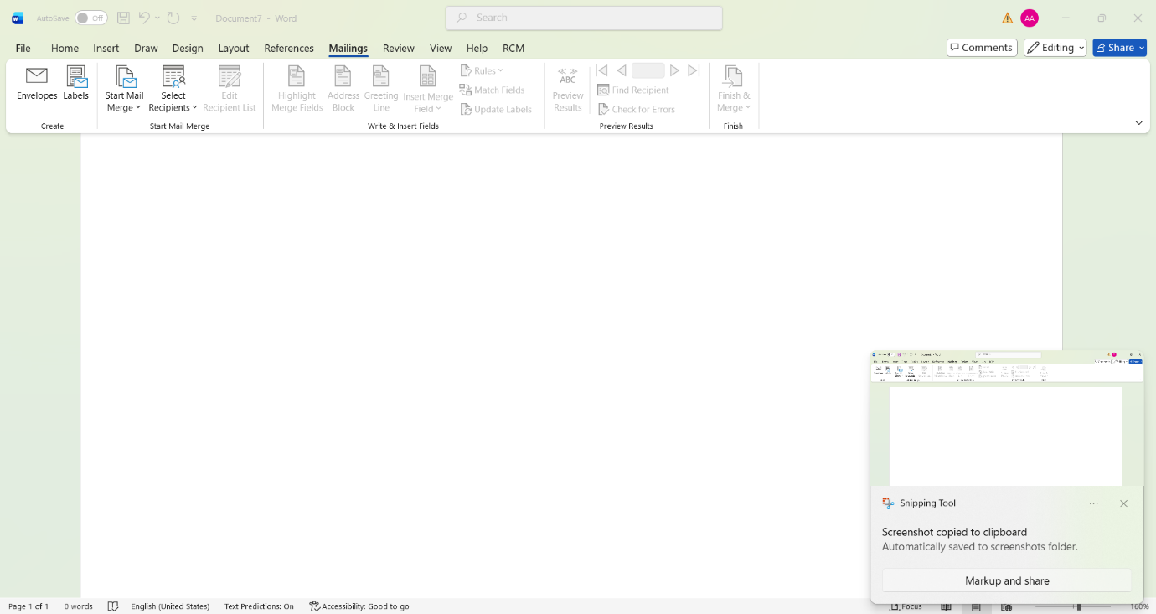
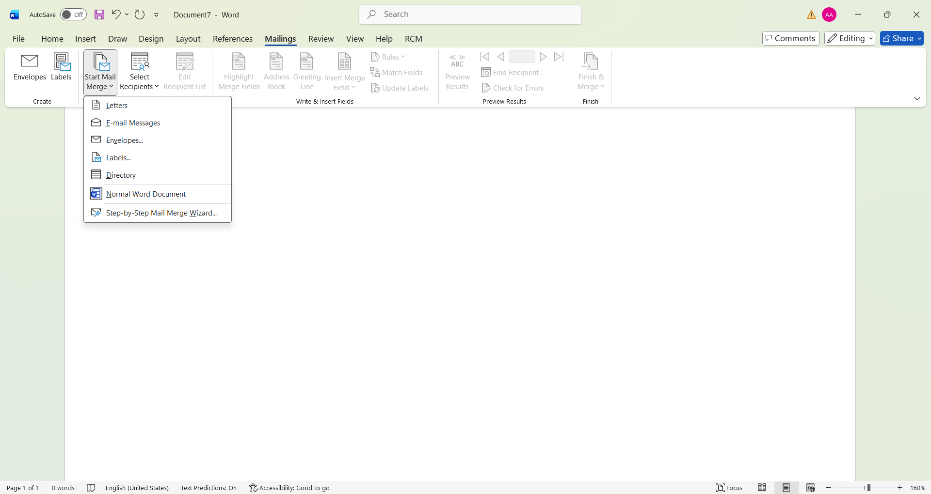
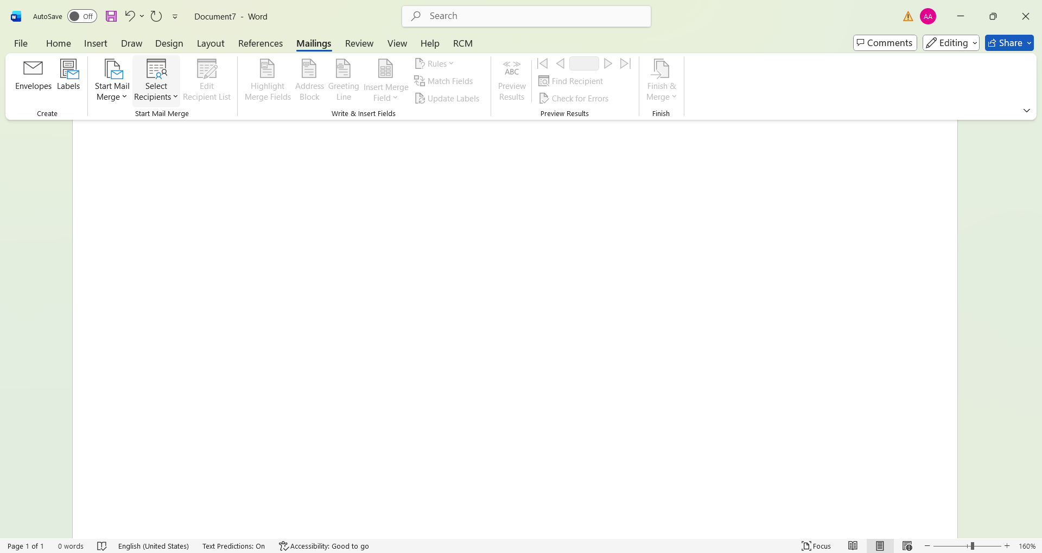
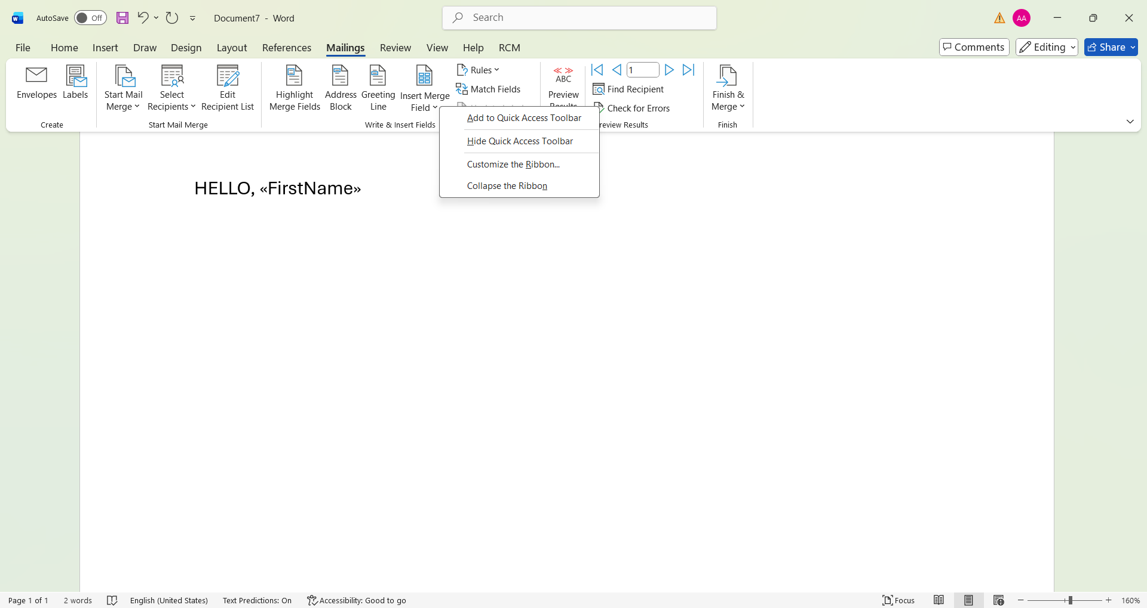
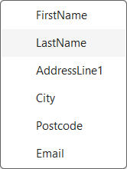
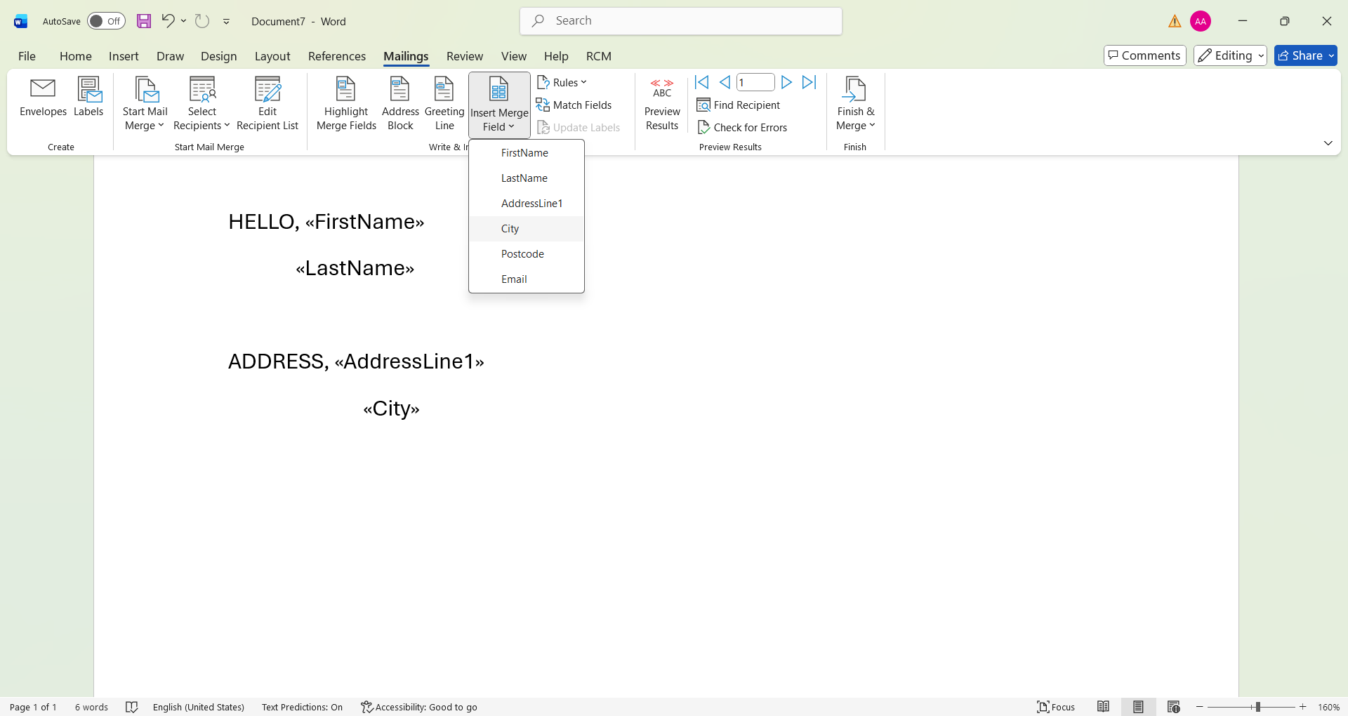
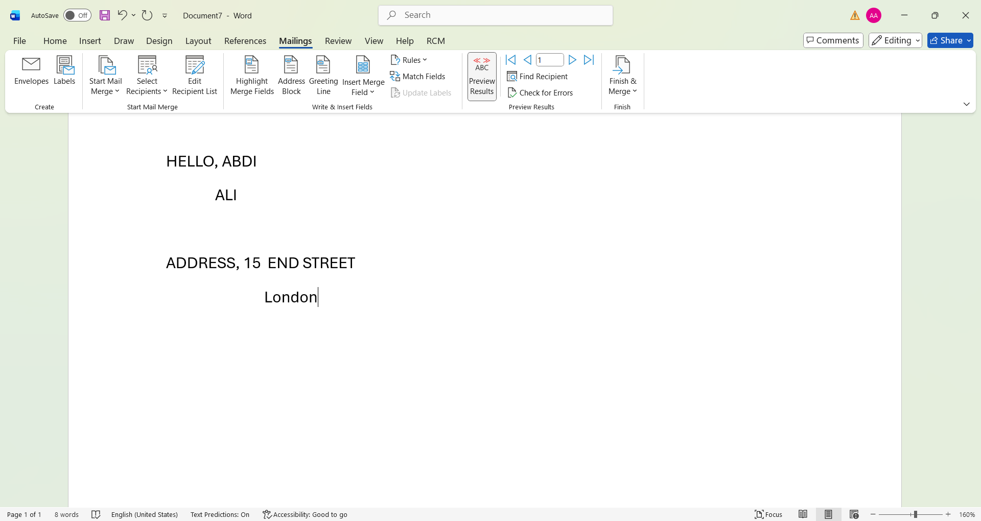

If Statement

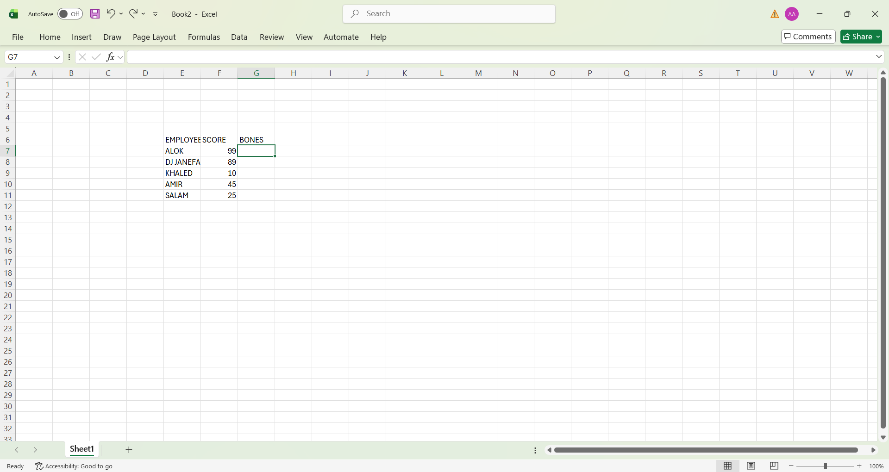
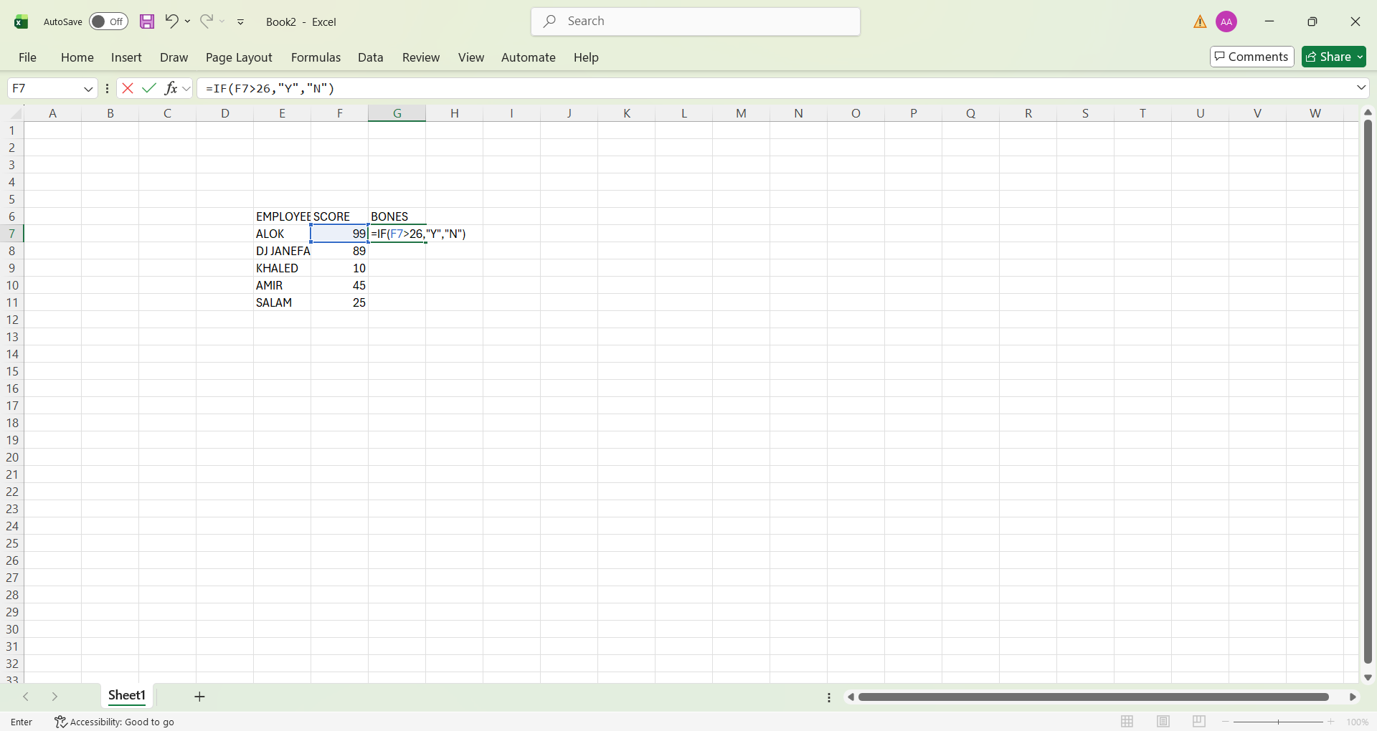
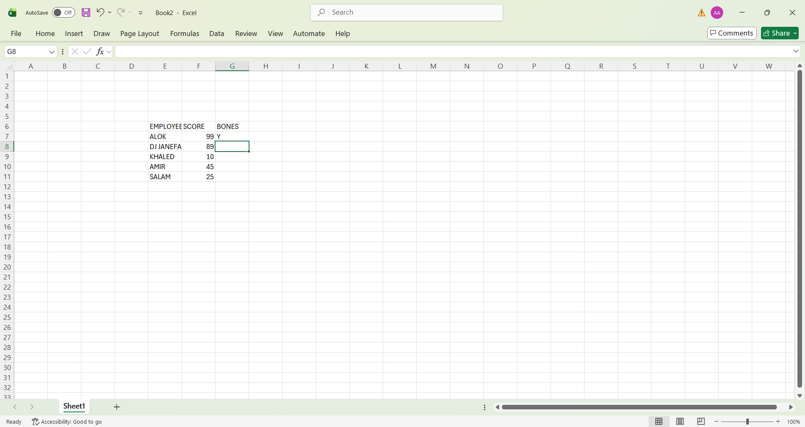
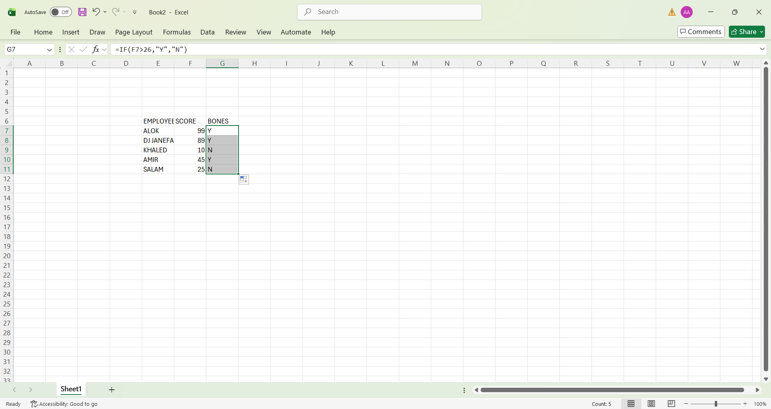

Task 4. Communication and Collaboration applications

One contemporary Communication and one Online Collaboration applications/tools

MS Outlook

Microsoft outlook is a popular communication and collaboration application developed by Microsoft. It is part of the Microsoft office and Microsoft 365 suite and is widely used in businesses. Educational institutions. And organization around the word. Ms outlook mainly functions as an email client. But it also includes tools for calendar management. Contact organization, task scheduling. And collaboration. Making it a complete personal information management system.
The primary function of Microsoft outlook is emailing communication. It allows users to send. Receive. Reply to and forward emails effectively. User can attach documents, images. And other files to emails, making it suitable for professional and formal communication. Outlook provides features such as folders, categories, rules. And search tools that help users organize their inbox and manage large volumes of emails effectively. It also includes spam filtering and security features to protect users from unwanted or harmful massages.
Another important feature of Ms outlook is the calendar. The outlook calendar helps users schedule meetings appointment, and events. Users can set reminders and notifications to ensures they do not miss important activities calendars can be shared with colleagues, allowing teams to review availability and plan meetings easily. Meeting invitations can be sent directly through outlook, and participants can accept or decline the invitation with a single click.
Microsoft outlook also includes a contacts management feature. This allows users to store and manage contact details such as names, email addresses. Phones numbers, and job information. contacts can be grouped and categorized. Making it easer to communicate with specific individuals or teams. In addition. Outlook provides a task management feature that enable users to create to do lists, assign priorities, set deadlines, and track progress. This helps users stay organized and manage their workload effectively.
It terms of collaborations, Microsoft outlook integration smoothly with others Microsoft applications such as Microsoft teams. One drive and SharePoint. This integration allows users to share filles, collaborate on documents, and communicate with team members easily. Shared mailboxes and distributed lists enable teams to mange emails collectively, improving teamwork’s and communications with organizations.
One of the key advantages of Microsoft outlook is its professional and user-friendly interface. It supports both online and offline access. Allowing. Users to read and compose emails even without an internet connection. Outlook also offers strong security features. Including encryption, making it a reliable tool for professional communication, [8]

MS Teams

Microsoft teams is a cloud-based communications and collaborations applications development by Microsoft as part of the Microsoft 365 suite.it is designed to help individuals, teams. And organizations communicate effectively and work together in one digital workplace. Microsoft teams is widely used in businesses, educational institutions. And remote work environments to support teamwork. Online meeting, and collaboration.
One of the main features of Microsoft teams is chat based communication users can send instant massages in one-to-one charts or group conversations message can including text. Emojis, images. Links, and files, making communication fast and interactive. Teams also allows users to organize conversations into channels, which helps keep discussions focused on specific topics, projects, or departments
Another important feature of Microsoft teams is audio and video conferencing, users can host online meetings, virtual classes, webinars, and interviews. Teams support screen sharing, live captions. Meeting recordings. And background effects, which enhance communication, and presentation quality. Meeting links can be shared easily, allowing participants to join from different locations using computers or mobile devices.
Microsoft teams also provide strong collaboration tools. It integrates with Microsoft application such as word, excel, PowerPoint, OneNote, and OneDrive. This integration allows teams members to create, edit, and share documents in real time without leaving the teams’ platform. Multiple users can work on the same document simultaneously, improving productivity and reducing the need for repeated file sharing.
In addition, Microsoft teams include task management and organization features. Tools like planner and to do can be used within teams to assign task, set deadlines, and track progress. Teams also support file storage through SharePoint, ensuring that documents are stored securely and can be accessed by authorized users. Notifications and activity feeds keep users update on important messages and changes.
One of the key advantages of Microsoft teams is its ability to support remote work and online learning. It allows teams and students to collaborate from anywhere in the world. The platform also offers strong security and compliance features, including data encryption and access control, making it suitable for professional and institutional use. Microsoft teams is user-friendly and available on desktop, web, and mobile devices.
In conclusion, Microsoft teams is a powerful communication and collaboration application that combines chat, meetings, file sharing and teamwork tools into a single platform. Its integration with Microsoft 365 applications and its support for remote collaboration make it an essential tool for modern workplaces and educational environments. [9]

One feature of a freely available Communication (1) and one feature of a Collaboration (1) application

MS Outlook
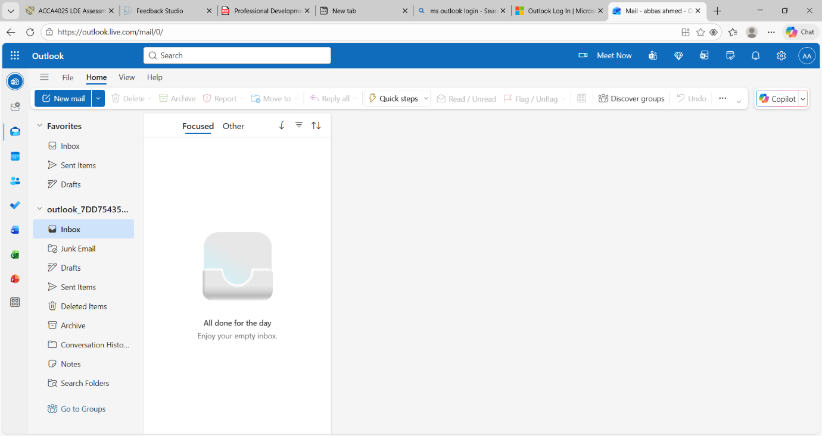
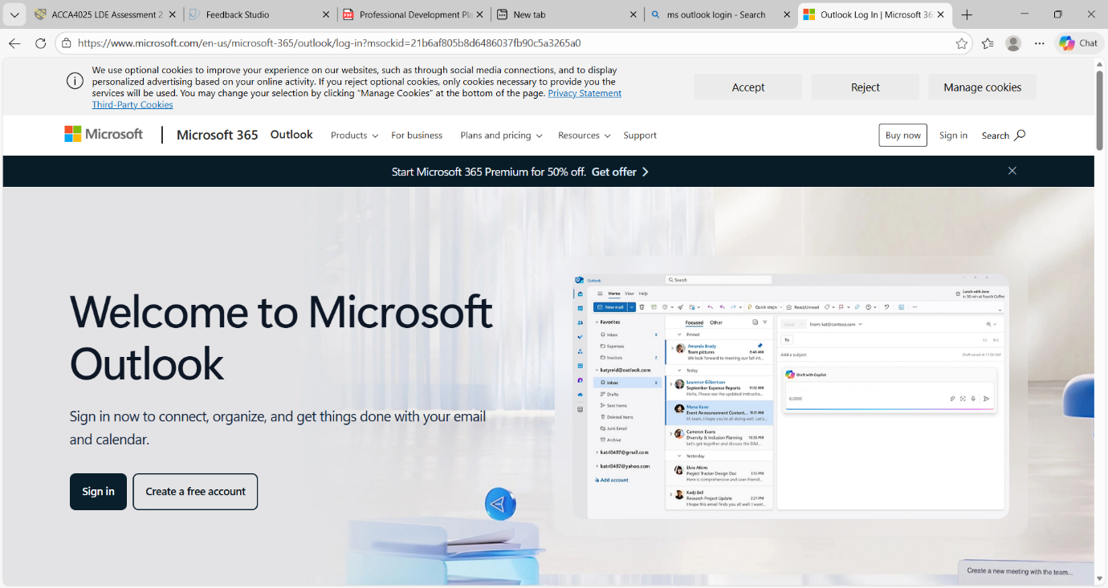

Ms Teams

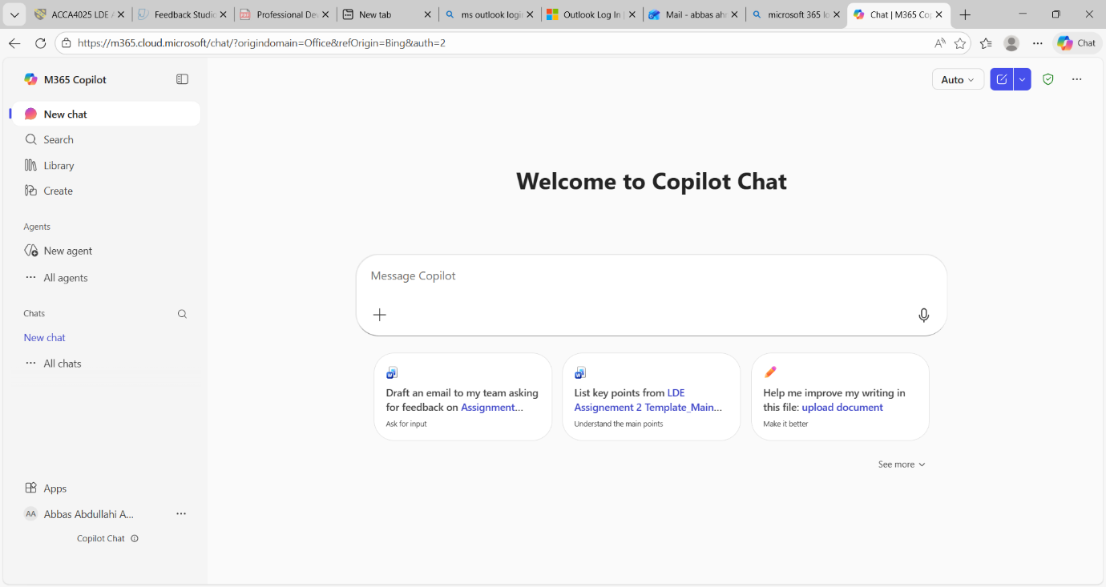

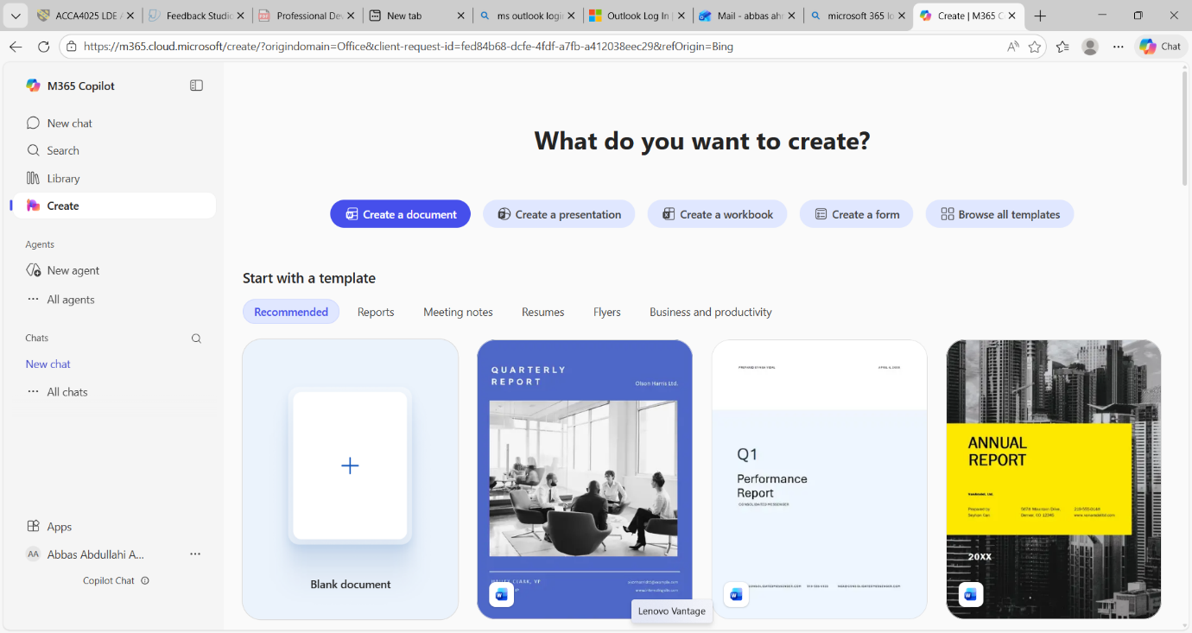

Conclusion
In conclusion communication applications and collaborations applications play a crucial role in todays digital world

Bibliography

[1] | google. [Online].
[2] | p. R. a. m. B. R., 2020. [Online].
[3] | B. a. b. B, 2018. [Online].
[4] | M. corporation, 2023. [Online].
[5] | J. lambert, 2019. [Online].
[6] | J. walkenbach, 2018. [Online].
[7] | p. P>J, 2019. [Online].
[8] | G. shelly, 2019. [Online].
[9] | K. laudon, 2020. [Online].

References

