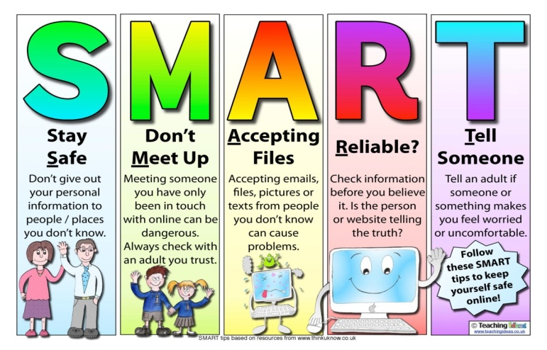





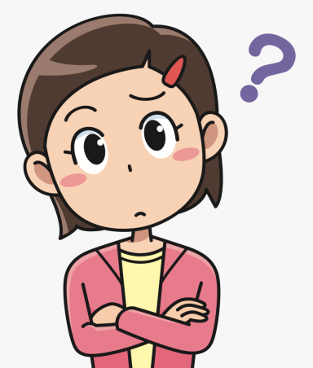
How to protect children and young people
What is E-Safety ?
Teaching children about appropriate and inappropriate behaviour online will allow children and young people to understand how to protect themselves. Children and young people are at risk of :

Promoting e-safety for children and young people

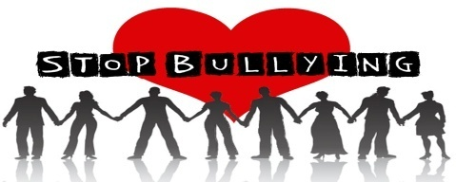
(Thinkuknow.com, 2018)
(Image 2 ,2010)
E-safety is about online and social media and how to teach children and young people the correct way to use the internet in a safe and healthy way.
Cyber bullying - To use social media to torment or insult another. Only add people you know and or report to your school or to an online service you know and trust.

Cyber stalking - The use of the internet to stalk or harass . Prevent by only adding people you know only, and report if this is happening to you.

"Being online is an integral part of children and young people’s lives. Social media, online games, websites and apps can be accessed through mobile phones, computers, laptops and tablets – all of which form a part of children and young people’s online world." (NSPCC,2021)

Obscene or Offensive content- Finding Websites that contain content that is offensive. Prevent by having a site banner set by the parents or teachers and to only vist site you know are safe.

(Image 1 - 2021)
Online predators - To engage in a sexual relationship with an underage minor using social media. Prevent by only adding people you know on social media. (NSPCC, 2021)

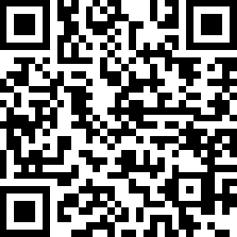
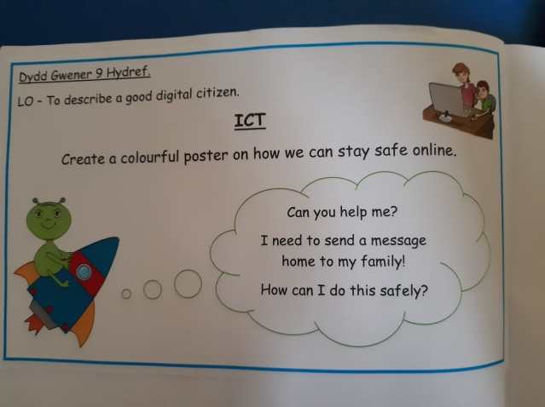
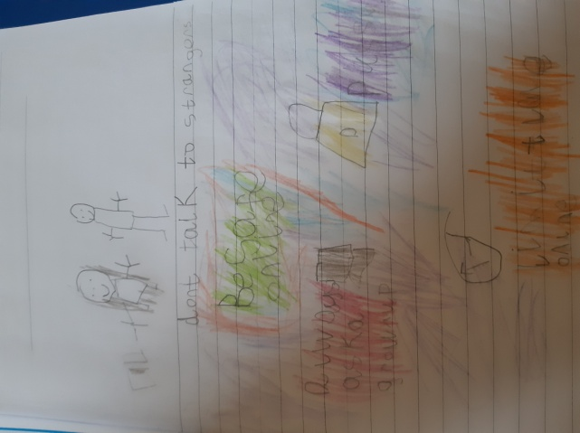
A Child's Protection
Who can you call ?
You have the right to speak and be listened to !!!
The Rights of a Child applies to all children and young people , YES YOU ! and you have a right to be heard and kept safe from danger.
Article 42 states that ' Governments must actively work to make sure children and adults know about the Convention'. and most of all that the act to keep you safe ! (UNICEF, 2021)
E-Safety week in schools where they do work and create posters competition, winners poster used in school for a year. 😊
ICT pupil club taught how to use digital devices correctly and how to stay safe online while learning and playing in a safe environment. Join you schools ICT club today !!
(School A, 2020)

What school do to help and prevent
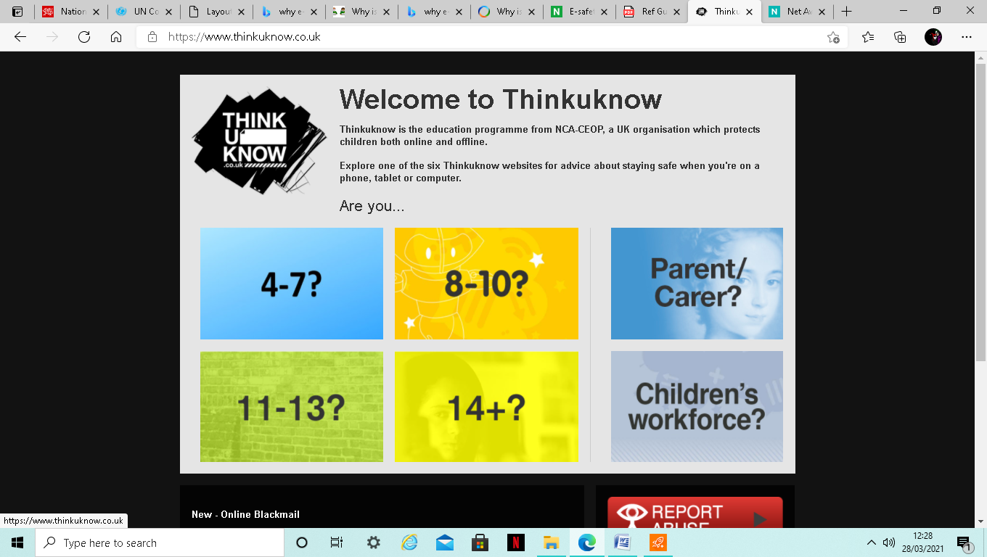
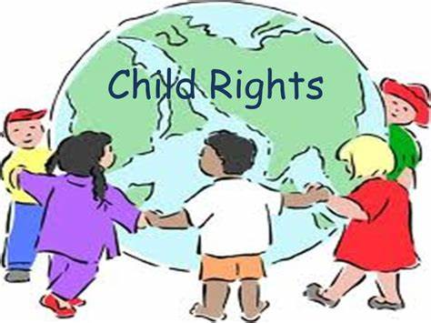
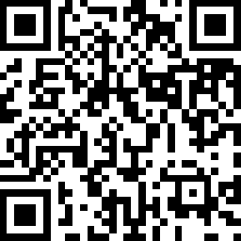
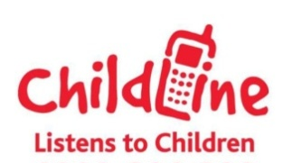
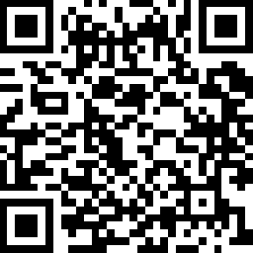

Call : 0800 111 or visit their website by using the QR code .
Speak up and be heard !!
(Image 3, 2018)
Make a report using their website https://www.ceop.police.uk/Safety-Centre/ or use the QR code to access Thinkuknow.
Call : 0808 800 500 or visit their website by scanning the QR code above.
‘ The United Nations Convention on the Rights of the Child 1990 states it is an important agreement by countries who have promised to protect children’s rights. The Convention explains who children are, all their rights, and the responsibilities of governments’(UNICEF, 2020

(School A, 2020)
Referances
CEOP (2021) Report , Available at : https://www.ceop.police.uk/Safety-Centre/( Accessed: 1st March, 2021) .
Childline(2021) Contact us, Available at : Childline | Childline Accessed: 1st March, 2021) .
Image 1 (2021)Available at : Clipart (Accessed:1st March, 2021)
Image 2 (2010) A bully free zone, Available at : Being stern without being too stern | A bully-free Zone, (wordpress.com) (Accessed: 1st March, 2021)
Image 3 (2018) Available at : rithts of a child - Bing images (Accessed: 1st March, 2021)
NSPCC (2021)Contact us, Available at : NSPCC | The UK children's charity | NSPCC( Accessed: 1st March, 2021)
NSPCC(2021) E-Safety for schools , Available at : E-safety for schools | NSPCC Learning (Accessed: 1st March, 2021).
NSPCC(2021) Net-aware , Available at : Net Aware: Your guide to social networks, apps and games (net-aware.org.uk) (Accessed:1st March, 2021)
School A (2020) ICT Safety (Viewed :1st March, 2021) .
Thinkuknow (2018)SMART internet safety, Available at : Thinkuknow - home (Accessed: 1st March, 2021).
Thinkuknow (2020) Welcome to Thinkuknow, Available at :Thinkuknow - home( Accessed:1st March, 2021)
UNICEF(2020) The Convention on the Rights of the Child: The children’s version , Available at : The Convention on the Rights of the Child: The children’s version | UNICEF (Accessed:21st February, 2021).
UNICEF (2021) A summary of the UN Convention on the Rights of the Child, Available at : UNCRC_summary-1_1.pdf (unicef.org.uk) (Accessed: 1st March, 2021)

The leaflet above has discussed the issue of internet safety among children and young people and identifies how the children and young people can be harmed, how to stay smart and safe from the negative influence of the internet. The leaflet also shows children and young people how to stay safe and the types of organisations who are there to help and guide them including schools, the NSPCC, Childline and Ceop. The leaflet includes a section about the interventions schools do to help with internet safety and will be using examples from a south Wales, rural, primary school which will be referred to as school A and compare them to School B which is a Rural nursery and infant school in England. The leaflet looks into the Rights of a child(1990) , pupil voice and government guidelines on how to protect pupils from harmful content on the internet. This leaflet has a target age group of between 11 to 16, this age group is at higher risk from using the internet than any other age group, According to Johnson (2021) investigated that between the years of 2014 to 2018 the daily usage per week consumption of internet from the age of 3 to 15 the highest users were the age group of 12-15 year old having a usage time of between '17 to 20.5 hours'. This statistic and news reports of harmful use of the internet between the ages of 11 to 16 as this age group needs to be informed of inappropriate and appropriate behaviour and how to stay safe on the internet.
E-safety has become a major challenge for children and adults to face every day. The internet is growing and according to the SWGfl:
'The internet, for all its glory and opportunities, does unfortunately feature threats and challenges. These might manifest as online abuse, bullying, threats, impersonation, grooming, harassment or exposure to offensive and/or violent content'(SWGfl,2021).
This growing threat and the growing usage of the internet is why e-safety is a high necessary requirement for children and young people to know about. The acrostic use of the word SMART is used by the to help simplify the types of issues young adults should look out for and be mindful of when using the internet. This Acrostic was used by ThinkuKnow (2018) website ,operated by CEOP, to ensure the safety for children and young people. The Smart Acrostic was created to summarise the fact from Thinkuknow website to help children and young people understand better in a bright and colour way and is used by many schools across the UK. The NSPCC (2021) stated that being online is a 'integral part of children and young people's lives'. They continue to state that the use of 'social media, online games, websites and apps can all be accessed' by using an electronic devise. This shows us getting access to the internet is quick and easy and anyone, anywhere can access it. This then provides a risk of safety for our children and young people wellbeing and protection, as looked upon in the leaflet The United Nations Convention on the Rights of a child (UNCRC, 1992) ensure that all children are safe and that their wellbeing is being maintained.
‘ The United Nations Convention on the Rights of the Child 1990 states it is an important agreement by countries who have promised to protect children’s rights. The Convention explains who children are, all their rights, and the responsibilities of governments’(UNICEF, 2020)

The Rights of a Child Articles 19, 26, 35and 36 all mention the safety of children and young people to from sexual abuse, violence and any other form of exploitation. Dodd (2019) , a reporter from the Guardian newspaper reported that' Children as young as seven are being targeted for grooming, violence and exploitation' this report shows a section of how children and young people are in danger if not kept safe. In the leaflet young people are made aware of the different types of dangers they could be faced with if they are not safe online. These can be from Cyber abuse or bullying, offensive content and online predators. The leaflet make the reader aware of the potential problem and how to report it.
In schools ,under the Health and Safety at work act (1974),' it is the responsibility for everyone in school to ensure that safety is maintained and children are safeguarded' this includes all forms for safety such as internet safety is included(Burnham and Baker, 2010).To achieve this school must put safety into good practice, the leaflet states at schools achieve this by providing E-safety weeks in schools to talk about how to stay safe online. By putting this into good practice, school A achieves this by having all the children create an online safety poster to allow them to learn though a creative way how to stay safe and the signs to look out for while online and to make it more fun ,school A then chooses a winner with the best poster to be displayed around the school for the next year to promote internet safety, This will then allow all children to see and understand e-safety throughout the year. Burnham and Baker (2010, p.176) concludes to state the importance of e-safety for children and young people in school by stating that 'as adults, we have a responsibility towards children and young people to make them aware of the dangers', they continue to report that ' children and parents are required to sign an internet safety agreement with the schools policy for safe internet use. This is put into place with School A( 2021), when a pupil is enrolled in the school the parents must sign a document stating the safe use of the technology and the school also asks if parents are willing to let photos of their children to be uploaded onto the school website for the class pages. This will then allow parents or guardians to know how protected their children and young people are in the school. Much similar to school A , school B (2020) also allows to the internet protection of their children and young people to be a factor by providing an internet safety page on their website which in tales how parents can keep their children's internet safe at home and how they teach it in the schools, they stated that they ;ensure these resources are safe and appropriate' and that parents should be ensure their child's safety online to. Unlike school A, school B does not include class pages upon their website but provides a whole school gallery online so that children are not singled out in their class groups for e-safety reasons, this method of a whole school gallery page is a smart way to hind the identity of the children's year groups online, where as school A singles the children out into classes. School A should ensure the safety of their children by providing a password to enter each class page so that the identities of the pupils are kept safe online. Another way schools teach children about internet safety is thought pupil groups such as ICT clubs, in these clubs pupils are taught how to learn and play with digital devices in the correct manner and are taught about the safe use of online learning and web surfing. The leaflet tell the reader about these clubs and encourages them to join one so they can learn and have fun with the internet in a safe environment. Keeping children safe is a core stage for schools and is an important outline to look upon, children and young people need to be kept safe as it is their psychological need to be safe and secure , this is according to Maslow's hierarchy of need theory concludes and is put into good practice by school, originations, governments and people around the United kingdom (Allen and Gordon, 2011, P. 57).Schools also have to be aware of the safeguarding standards under the Education Act( 2002) which states it is the 'schools duty to exercise and promote safeguarding and welfare for children and put it into good practice' This is why it is to a high standard that e-safety is put into good practice for the schools education and the pupils welfare.
Throughout the leaflet it identifies the problems, what to look out for, how schools can help and on the last page discussed the different outside agencies available to help if the pupils experience any of these online forms of abuse towards themselves or anyone they know. These outside agencies are the NSPCC who are a well known agency that work with lots of organisations such as faith groups, schools, hospitals and sports clubs to 'provide is evaluated at different stages and from different perspectives so we can learn what works best and improve our provision’ (NSPCC learning , 2021). Another agency is Childline who are 'trained staff and volunteers who will listen to you and is genuine, open and friendly' (Childline, 2021) and then we have Ceop's Thinkuknow website where a QR code is available upon the leaflet for quick access to the website. Thinkuknow has been a well known site since 2009 and is a has collaborated with the police force to provide care and safety for online users (Thinkuknow,2021). These website and phone numbers are available upon the leaflet so that children and young people are aware of these organisations and know how to contact them safely and quickly. Being reminded who you can contact and who to trust is developing a child's ecosystem, linking to Bronfenbrenner's Ecological Systems Theory. This will allow children and young people to develop a complex system of relationships affected by multiple levels of the surrounding environment , from immediate settings of family and school to broad cultural values, laws and customs' which will help them develop into adulthood with a safe surrounding of relationships and a safe judgment (Evans,2020).
The use of online activity is continually increasing thought-out the years which requires the younger generations to become aware of it's danger from a young age which is why schools are preparing days such as ICT week and creating ICT clubs for children and young people so they can teach them how to be safe appropriate while online. School are relying more on the use of the internet due to recent events such as the coronavirus outbreak causing schools to close and teach though online learning using systems such as Microsoft teams and Zoom calls. Wales online reporter Wightwick (2020) reported about the online virtual learning for school in Wales and stated ' if you can't protect the system you cannot be safe, There are issues with systems like zoom'. But she continues to say that ' They log into classes online from home with secure pass code which admits only those with access'. Wightwick explains that the systems need to be safe for children and young people to use first before allowing them online which was why pass codes were then given to those students to access the online lessons and letters were distributed to remind parents and students to keep the code confidential due to the risk of other users accessing the virtual lessons. It is always an important task to remind pupils of their right to secrets and safeguarding themselves which is why leaflets ,such as the one above, are created to remind and educate children and young people upon the different types of dangers online, who can help and how to contact them and also why pupils have a right to be safe from online dangers.

References
Allen, S.A, Gordon, P.G(2011) Thinking on special educational needs and inclusion, London: Practical Pre-school books.
Burnham, L.B, Baker , B.B (2010) Support teaching and learning in schools, Essex: Pearson education Limited.
Childline (2021) About childline, Available at : About Childline | Childline (Accessed: 1st March, 2021)
Dodd, V.D (2019) Children as young as seven being enslaved by drug gangs, Available at : Children as young as seven 'being enslaved by UK drug gangs' | Children | The Guardian (Accessed: 1st March, 2021)
Joseph Johnson (2021), Weekly hours of internet consumption by children and young people in the UK 2014- 2018, by age. Available at : • United Kingdom: hours of internet consumption by children by age 2014-2018 | Statista (Accessed: 1st March, 2021).
NSPCC Net Aware, Avaliable at : Net Aware: Your guide to social networks, apps and games (net-aware.org.uk) (Accessed: 1st March, 2021)
NSPCC learning (2021) Children’s services, Available at : Services for children and families | NSPCC Learning (Acccessed: 3rd March, 2021)
Safeguarding in children's education, Education Act 2002, C. 1 , Available at : Welsh Government (Accessed: 21st February) .
School A (2021) Acceptable use of ICT policy (Accessed: 1st March , 2021).
School B(2020) Why e-safety is important. (Accessed: 1st March, 2021).
Evans, O.E(2020) Bronfenbrenner's Ecological Systems Theory, Available at : Bronfenbrenner's Ecological Systems Theory | Simply Psychology (Accessed: 1st March, 2021)
SWGfl (2021), Why is internet safety important?, Available at : Why is online safety important? | SWGfL (Accessed: 1st March, 2021).
Thinkuknow (2018) SMART internet safety, Available at : Thinkuknow - home (Accessed: 1st March, 2021).
Thinkuknow(2021)About Thinkuknow, Available at : About ThinkUKnow | ThinkUKnow (Accessed: 1st March, 2021).
UNICEF(2020) The Convention on the Rights of the Child: The children’s version , Available at : The Convention on the Rights of the Child: The children’s version | UNICEF (Accessed:21st February, 2021).
Wightwick, A.W (2020) How live interactive online lessons work in schools around Wales, Available at : How live interactive online lessons work in schools around Wales - Wales Online (Accessed: 1st March, 2021).

