https://www.petbusinessworld.co.uk/news/feed/industry-profile--burns-pet-nutrition

Industry Profile: Burns Pet Nutrition
11th September 2018
By Sandra Pearce
As Burns Pet Nutrition founder John Burns and his employees prepare to celebrate the company’s 25th anniversary, the business looks back at its journey, plans for the future and what separates it from the competition
Veterinary surgeon and Burns Pet Nutrition owner John Burns has spent the past 25 years campaigning for positive change in the pet food industry. In March, John received a Lifetime Achievement Award in recognition of his long-serving commitment to improve the lives of pets and people through natural pet nutrition. That same month, Burns Pet Nutrition made it on to The Sunday Times Profit 100 League Table for achieving some of the fastest-growing profits in the UK.
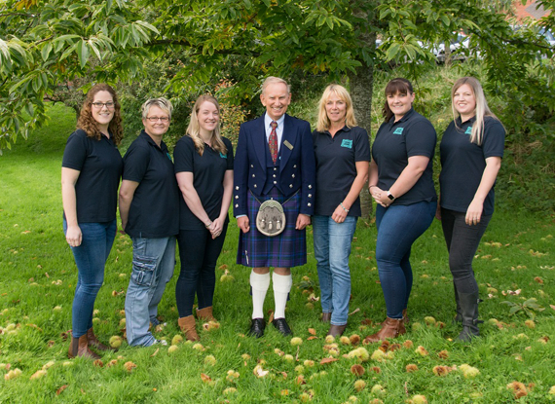
John and his nutrition team
Pioneers of healthy pet food
While working as a vet in general practice, John noticed that many pets were suffering from the same ailments time and time again. From itchy skin to upset digestion, John believed diet to be the primary cause and recommended that his clients feed their dogs home-cooked food to allow the body to function naturally, free from a build-up of toxic waste.
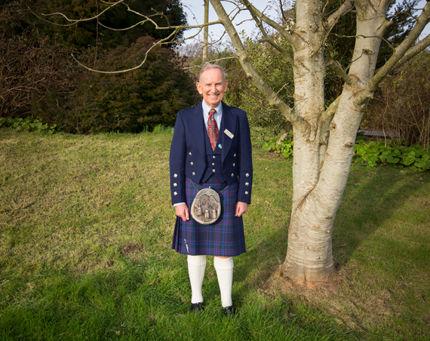
John started out with a vision 25 years ago, and today thousands of pets eat his food
Of course, feeding home-cooked food is a time-consuming business, and back in 1993 there was no commercial equivalent. In fact, the concept was unheard of. Spotting a gap in the market, John set to work creating his own Original recipe of Real Food for Pets based on chicken, brown rice and vegetables. The concept was simple: wholesome, natural ingredients that allow the body to get on with what it does best. The food was a hit, and Burns Pet Nutrition was born, ‘setting the industry standard for others to follow’.
Products that work
Fast forward to 2018, and Burns has eight lines of specialist dry dog food, a treat range, a cat food range and a moist dog food range, Penlan Farm, which is made and produced at its Burry Port factory in West Wales. Many of the eggs and seasonal vegetables used in the moist food range come from the company’s own Penlan Farm.
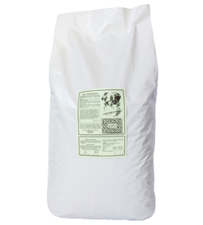
And this is where it all started…
The Original recipe which kickstarted the business is still in production and remains ‘a firm bestseller’. All Burns products are designed to help pets to thrive and contain simple, natural ingredients for all-round health and vitality. John is still at the helm of the business and heavily involved in all areas, most recently bringing the company’s first grain-free Duck & Potato product to market, launched by popular demand in March.
Burns’ diverse clientele of cats and dogs are the ‘true testament to the benefits of the products’. You only have to visit the company’s Facebook page (@BurnsPet) or view the hashtag #PoweredByBurns on Instagram to be greeted by hundreds of pictures of bright-eyed and bushy-tailed pets (and their owners) praising the food.
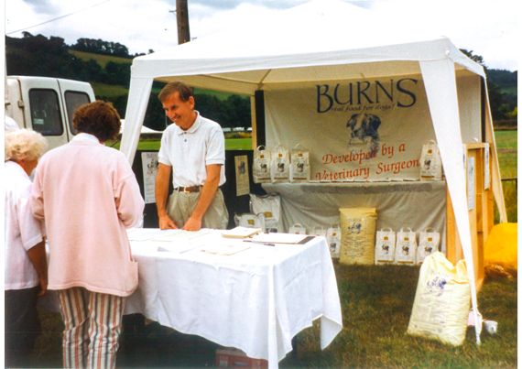
John at the first show with his brand new product
Unrivalled service and support
One of Burns’ main USPs is a commitment to helping customers understand their pet’s dietary needs with the support of professional nutritionists and advice literature.
Burns’ team of nutritionists have more than 50 years’ combined experience. The team offer free nutrition advice to pet owners Monday to Friday via freephone, LiveChat and email, and divide their time between the office and pet shows up and down the country where they meet customers face to face. The team also further their knowledge with courses and training so as to provide ‘the best advice service in the business.’
This personal level of service is backed up by a huge range of supporting literature written by John, which is given free to customers. There are 17 advice guides including The Veterinary Guide to Health and Nutrition and Daily Feeding Amounts.
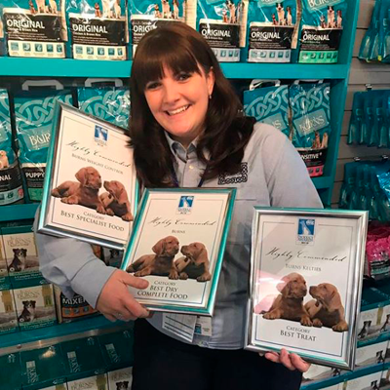
Nutritionist Kirsty Jones shows awards the pet food manufacturer has won
What does the future hold?
Today, Burns has 130 employees across its three pet shops, Kidwelly-based head office, Kilmarnock office, Penlan Farm, Parc Y Bocs farm shop, factory and warehouse. Profits hit £3.9m in 2016 and the family business exports all over the world including Ireland, Hong Kong and Portugal.
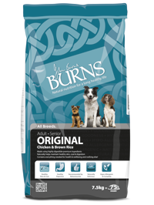
Original recipe is still a best seller today
On a commercial level, the business is looking to expand its global presence and has recently hired export manager Rhian Davies, marketing manager Natalie Moyce and appointed Mark Studdy as key accounts manager.
Expanding the new free-from range is a key focus for the future, as well as increasing toy and small breed product lines.
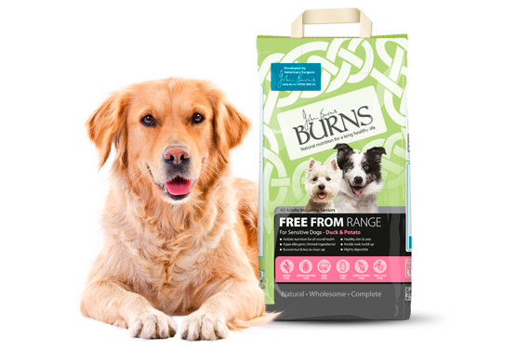
Free-from range was launched due to customer demand
The Burns Pet Nutrition Foundation is expanding its charitable presence in Ireland and a large facility is being built for the local community at Kidwelly, where the Burns head office is located.
John said: “Since pioneering the healthy pet food movement in 1993, we have achieved our goal of creating natural pet food that really works to promote excellent all-round health and even manage pre-existing health problems.
“Today, we have an ever-growing clientele of happy and healthy pets and I couldn’t be prouder. We are in a very strong position because more and more pet owners are realising the importance of healthy nutrition and moving their cats and dogs on to a natural diet.
“It is my dream that one day every cat and dog will consume a natural, healthy diet based on home-cooked food, that allows the body to get on with what it does best. That is what we set out to do back in 1993 and will continue to campaign for long into the future.”
Putting pets and people first
Corporate Social Responsibility is the trendy marketing buzzword of the moment, but at Burns it has been ingrained since day one.
John said: “Today’s consumers are becoming increasingly suspicious of big brands and want to see that their money is being spent wisely and ethically. In this sense we have an advantage over large multi-nationals because although many assume we are a big brand, we are actually an independent, family-run business and always have been.
“Any time a customer makes a purchase, a portion of this is invested back into the community whether that be donating food to a pet rescue centre, funding a grassroots project or helping a child to read.”
The company’s own charity, The Burns Pet Nutrition Foundation, is staffed by an in-house team of six. The charity launched in 2009 and encompasses everything from grassroots projects to one-off donations to company-wide fundraising activities.
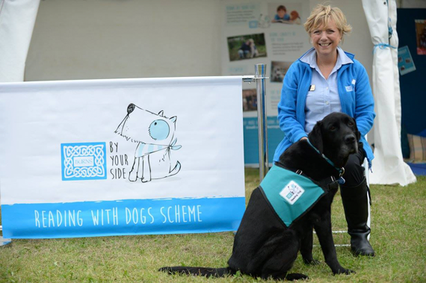
One such initiative is The Burns By Your Side reading-to-dogs project which uses trained volunteers and companion dogs to help children to improve their literacy, communication and confidence skills.
John said: “Literacy is a huge problem in the UK. One in six million children struggle to read and 12 million adults have the reading levels of an 11-year-old. Burns want to change this for the next generation by instilling confidence in children and improving literacy skills through the aid of canine companions and their owners.”
Burns By Your Side is active across West Wales and Cere-digion. There are more than 50 volunteers (and their pooches!) involved and it will launch in Ireland and South Wales.
In addition, Burns also donates a huge amount of food to more than 50 rescue centres across the UK, and offers financial assistance to three animal welfare charities (Dogs for the Disabled, Forever Hounds and UK-German Shepherd Rescue) through its Charity of the Year Programme.
Championing the independent retailer
The independent retailer always comes first and is championed wherever possible, says John. It is significantly more economical for a customer to buy from a trader than from Burns direct, and traders receive exclusive customer benefits such as the loyalty scheme (buy seven bags and get one free.)
Face-to-face rep visits go hand-in-hand with complimentary promotional material such as shelf talkers, The Tailchaser Times, samples and advice literature.
The emphasis on supporting independent pet shop stems from the belief that these businesses give owners a unique, personal level of service that can’t be mirrored by large supermarkets.
Motivated staff
Another element that makes Burns unique is its staff rewards package. These include a 10% annual pension contribution, a daily two-course lunch for £1, a sickness bonus in January, free on-site kennels, 28 days of annual leave (plus bank holidays) and a company car after two years’ service. Enrolling on new courses and job-related training is encouraged and many employees are given the opportunity to travel to the NAVC Conference in Orlando every January.
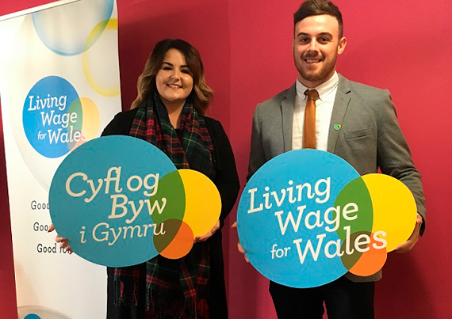
In 2014, Burns became the first pet food company in the UK to become an accredited Living Wage Employer, ensuring that all employees receive a fair wage. In 2015, John was chosen as the Living Wage Champion for the Wales region. All staff earn the minimum of £8.75 per hour. Most earn in excess of this.
John said: “We find that staff are motivated and enthusiastic about working at Burns because they know that they are working for an ethical, transparent company that puts the health and well-being of pets first.”
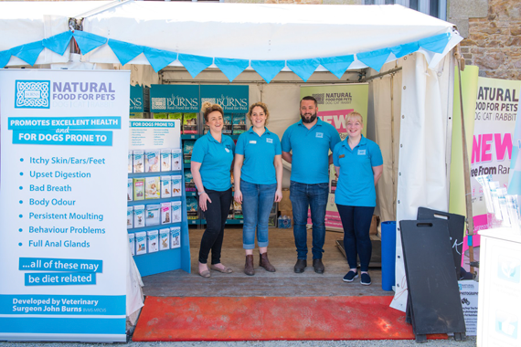
Staff travel hundreds of miles to be at shows across the country…

…and here they are on the Isle of Skye!

