Local Council – Social Services Report
Communication Skills in the workplace – Bmsk4002
Khalil Miah 1709513
2018

Contents
1. Introduction 2
1.1 Background 2
1.2 Purpose 2
2. Employee Engagement 3
2.1 Problem 3
2.2 Recommendation 3
3. Communication 4
3.1 Issues in communication 4
3.2 Recommendation 5
4. Team building & Teamwork 5
4.1 Challenges & Solutions 5
5. Conclusion 6
Appendix 7
Figure 1. 7
References 8

1. Introduction

1.1 Background
The local council has recently revamped its social services. Andrea Jones has newly overtaken as the head of social services following a challenging period for the department and is looking to implement change. The teams are currently being restructured and re-housed under one building. As the new head of social services Andrea is looking to implement change by working with the HR team to foster change and stamp her mark on the department.

1.2 Purpose
The social services department is facing challenges particularly surrounding the teams and team building. This has led to various issues relating to employee engagement, barriers to communication and team cohesion. Consequently, the need for change becomes prominent. This report will look to address issues mentioned in the above and offer recommendations combat these issues in order to help the department stabilise, perform better, maintain a higher standard.

Employee Engagement

2.1 Problem
There is an inclination that employee engagement is disconcerting within the social services. Employee engagement can be defined as psychological state an employee experiences and can often be optimised by their willingness to go ‘the extra mile’ (People Management 2011; Armstrong 2012). There is an implication that a positive experience can foster greater commitment and enhance an organisation’s performance (Caldwell et.al 1990). Supported by Armstrong (2012), suggesting employees perform better when both individual and corporate values align, creating stronger organisational commitment. The premise for greater performance can be attributed to this mutually benefitting relationship created through employee engagement (Coetzee et.al 2014).
In contrast employees may feel disengaged if their opinions are not valued (People Management 2011). An example of this can be found in the social services department as the team seldom held meetings to discuss concerns. The practical implications of employee disengagement must be carefully considered. Caldwell et.al (1990) highlights a serious manifestation of disengagement, which can often result in increased employee turnover, lacklustre performance and absenteeism. All of which the department is experiencing, signifying the need to address issues surrounding employee engagement to enhance and manage organisational performance.

2.2 Recommendation
Appropriate action must be taken to mitigate factors of disengagement and increase organisational performance. There are a couple of methods which can be implemented to achieve this. Firstly, the department can look at ‘champions in employee engagement’, an example of this can be found the retail industry. John Lewis hosts four annual meetings throughout the calendar year in which its partners (employees) from every level may contribute their ideas (John Lewis 2018). A positive outcome of this, is that it creates synergy through this high-level involvement approach. Supported by Armstrong (2012) aligning employee behaviour to organisational goals can foster greater job commitment through employee engagement.
Another course of action is the use of line managers (LM). LM can be seen as influential in employee relations; drawing commitment beyond the contract (Evans 2015). Supported by Bratton and Gold (2012) LMs are key players in implementing HR policies and practices. Therefore, the department should invest in the learning and development of its team leaders as enhancing their capabilities and in turn will increase the departments capabilities.
However, the department faces challenges in adopting greater employee engagement. Signified by Sikora and Ferris (2014), Evans (2015) LMs face increased workload which can often demotivate them to instil strategies successfully. Moreover, periods of organisational change can be disruptive a knock-on effect can leave employees feeling powerless adversely impacting motivation and engagement (Georgiades 2015). Andrea must take careful consideration of employee engagement during this period of change, by working closely with HR and LMs to mitigate risk of disengagement.

3. Communication

3.1 Issues in communication
The department has faced issues in communication with employees often left out of the loop and information conveyed poorly in both written and oral methods. Communication can be defined as a systemic process which people use to interact. Systematic occurs within organism of interrelated parts which can affect one another. Process is a continuing motion which is changing contentiously (Wood 2008). Through this definition it is clear to see communication is vast with many variables involved. When conducted appropriately effective communication can build consensus and create a supportive working environment. As communication is continually moving, failing to address the interrelated parts can lead to miscommunication and potentially disrupt the working culture indicates Wood (2008). Thus, it becomes imperative the department communicates effectively through the appropriate channels to offset risks against the working environment.
Historically, many practitioners have developed models in order to conceptualise communication in an effective, simplified format. A popular model in communication is Shannon and Weaver’s model (see figure 1) which portrays communication as a linear process. Although, this model is generally used to explain communication in telecommunications, it be applied to two person(s) in speech. For instance, information source/transmitter can be a person transmitted either through speech or signals and the signal can be received by the other person verbally or through telecom method (Wood 2008; Armstrong 2012). Noise in telecommunication can be referred to static in the background which can disrupt the intended message. In relation to verbal noise can be environmental factors i.e. traffic in background disrupting the clarity of the message (Wood 2008; Armstrong 2012).
A strength of this model is how communication is offered in simplified systematic process. It offers the transmitter in acknowledging the assembly of the message and how it can be transmitted to the recipient (Armstrong 2012). By acknowledging the recipient, the transmitter formulates the message accordingly which can build a deeper understanding in communication. However, there some inconsistencies with this model. Firstly, Turk (1985) critiques this model citing the over simplification of communication is so extreme it can be deemed as trivial. Secondly, the model follows a linear process in which the receiver only listens and do not send messages (Wood 2008). There is an inclination that senders have a more dominant role, but this is not always the case as communication is constantly flowing (Wood 2008). Supported by Turk (1985) listeners play just as big a part in communication as the speaker. Lastly, as the roles of senders and receivers were scrutinised the model was later adapted by Schramm (1955) to include feedback. Feedback can be deemed as both verbal/ non-verbal and formal/informal (Wood 2008). Schramm’s insight into feedback is important as research confirms accuracy in communication, productivity on-the-job is increased when subordinates give feedback when engaging with supervisory communications and messages (Deal and Kennedy 1999).

3.2 Recommendation
Communication is a key foundation in relationship and relationship building (Wood 2008). The department must look to increase its capabilities in communication by training its employees to deepen their understanding in effective communication. One way of achieving this can be to build interpersonal communication skills within the department. Interpersonal communication can be defined as cognitive process, that allows us the rehearse scenarios and foresee alternative outcomes (Wood 2008). This can be beneficial to the department as relations within the department is at an unsatisfactory level. If individuals are able to understand self-actions when communicating, it can allow them to avoid conflict within a group through reflection, ultimately building stronger relationships.

4. Team building & Teamwork

4.1 Challenges & Solutions
Armstrong (2012) states, teams are an essential component in the functionality of an organisation. The achievement of organisational goals can be determined by the notion that group members are assembled to share a common purpose (Fujishin 2013). The department faces various issues in creating and maintaining group cohesion which is negatively impacting the departments capabilities in achieving its goals. It is important to try understand the reasons behind teams within the department remain at a assembly point without fully achieving their common goal and offer solutions to mitigate issues surrounding teams.
Tuckman (1965) team development model can offer insights group formation and how to get the best out of the team. Originally the model is based off four stages: forming, storming, norming and performing. Tuckman and Jensen (1977) later added a fifth stage adjourning; which relates to disassembly of a team once the common goal is achieved. In the forming stage team members face uncertainty as roles and responsibilities are unclear, members look for guidance from team leaders (Tuckman and Jensen 1977; Armstrong 2012). The social services often throw new employees into cases with little or training. Moreover, there is a lack of leadership as roles are structure within teams are relatively undefined through this period of change. This can already cause a burden to new members in group formation.
Storming; conflict/challenges within groups may occur as members look to assert themselves within the team once the initial forming stage has passed (Tuckman and Jensen 1977). In this stage leadership can be seen as a key component. Leaders can act as facilitator through communication and ease tension within group by focusing the group on the end goal (Armstrong 2012). This strengthens the need for Andrea to solve issues surrounding team structures to create a clearer chain of responsibility.
Norming; at this stage roles and responsibilities become clearer, stronger communication and unity is strong within the group. Social services can achieve this stage through communication and engagement, by facilitating effective communication it can build stronger relationships leading to greater commitment (Tuckman 1965; Turk 1985; Armstrong 2012). Performing; The team has a clear shared vision, high autonomy and is now performing with little interference from leaders (Tuckman 1965). This is the optimal level the social services department hopes to perform at, by adhering to the earlier suggestions the department can go long way in achieving this stage.

5. Conclusion
The department faces many issues surrounding team cohesion, engagement and communication which is negatively impacting the performance of the social services. A key theme developed in this report is the value of communication in all these challenges the department face. For instance, communication is a primary foundation in creating relationships (Wood 2008). Employee engagement creates greater organisational commitment which can result in enhanced organisational performance (Caldwell et.al 1990; People Management 2011). The link to creating increased commitment can be underpinned by communication, by understanding one another it allows individuals to break down barriers and align values (Turk 1985; Wood 2008; Armstrong 2012). Team members are interdependent cogs which share a common goal (Tuckman 1965:77). When the goal becomes distorted it causes conflicts within the group which can affect team performance (Tuckman and Jensen 1977; Armstrong 2012). For a team to reach the performing level it must build strong relationships, which can be facilitated through effective communication, this highlights the value of communication in all areas impacting the social service department. It is important to note communication is a responsible for all, however team leaders play a key role in facilitating engagement within the workplace (Coetzee et.al 2014). Therefore, an important consideration moving forward is to address issues in management roles promptly and give middle management the necessary tools to conduct communication effectively across the board.
(word count: 1.813)

Appendix

Figure 1. 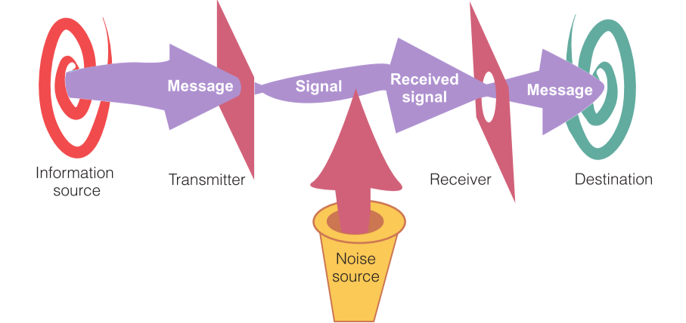
(Turk 1985)

References

Armstrong, M. (2012). Armstrong’s Handbook of Management and Leadership. 3rd Edition. London: Kogan Page.
Bratton, J., & Gold, J. (2012). Human Resource Management Theory and Practice. 5th Edition. London: Macmillan.
Deal, T., & Kennedy, A. (1999). The New Corporate Cultures: Revitalizing the Workplace After Downsizing, Mergers, and Reengineering. Reading: Perseus Books.
Evans, S. (2015). Juggling The Line: Employee Relations. Emerald Insight. [Online] 37(4). Available at: http://dx.doi.org/10.1108/ER-06-2014-0066. [Accessed: 20th April 2016]. Pp.459-74
Caldwell, D., Chatman, J., & O’Reilly, C. (1990). Building Organisational Commitment: A Multifirm Study. Journal of Occupational Psychology. 63. Pp. 245–261
Coetzee, M., Schreuder, D., & Tladinyane, R. (2014). Employees’ work engagement and job commitment: The moderating role of career anchors. SA Journal of Human Resource Management. 12(1). Pp. 1-12.
Fujishin, R. (2013). Creating Effective Groups. 3rd Edition. Rowman & Littlefield: Plymouth.
Georgiades, S. 2015. Employee Engagement in Media Management. Cyprus: Springer
John Lewis. (2018). John Lewis Partnership: About Us. John Lewis. [Online]. Available at: http://www.johnlewispartnership.co.uk/about.html. [Accessed on 29th June]
People Management. (2011). Engage Boosts Business Performance. CIPD. [Online]. Available at: http://www.cipd.co.uk/pm/. [Accessed on 28th June 2018].
Schramm, W. (1955). The Process and Effects of Mass Communication. Urbana: University of Illinois Press
Turk, C. (1985). Effective Speaking Communication in Speech. London: Spon Press.
Tuckman, W.,B. (1965), ‘Developmental Sequence in Small Groups’. Psychological Bulletin. 63
Tuckman, W.,B & Jensen, C.,A.,M. (1977). Stages Of Small Group Development Revisited. Group and Organization Studies. vol.2(4) Pp.419-27.
Wood, T.,J. (2008). Communication In Our Lives. 5th Edition. Boston: Cengage Learning.

