LCBB4004
Marketing Fundamentals Assignment 1
Task 1

Amazon

Lecturer: Tushara Balendran

Student: Georgi Dimitrov 1917423

Table of Contents
Introduction 3
What is Amazon? (Background and history of the company) 4
What do Amazon Plc sell? (Product) 5
How much did products of Amazon Plc cost? (Price) 6
Where will you find the products of Amazon Plc? (Place) 8
How do we promote our products? (Promotion) 9
Conclusion 11
References 12

Introduction
Amazon Plc is amongst the top technology service providing organization. Amazon Plc have a lot of brands of service which are focused on the making the proper services based on different technology. Amongst all the brands, the price of the products may vary in several places. Even after not having any physical stores, there are various online presence of Amazon Plc as well. On the other side, their website also have four sections and each of these sections are dedicated for each of the products. By the help of their app, the customers can get the suggestions of the customized products based on their choices of shopping, and so on.

What is Amazon? (Background and history of the company)

Founded back at 1994 by Jeff Bezos as an online bookshop, Amazon became on of the leading

organization in the technology industry. They are engaged with the production, manufacturing, sales, and development of the different products, and technology services. Amazon Plc is a public limited company registered under the London Stock Exchange (Funk et al., 2016). They are already operating across the world with the
operating income of £14.5 billion. As the result of it, Amazon is amongst the top technology production organization. They are one of the leading service provider of the cloud services in the world and they are solely depending on the marketing strategies and operations. In Amazon Plc, there are more than 1,225,000 employees at the end of 2020. On the contrary, they had a revenue of the £280.1 billion by the end of the fiscal year of 2019. Amazon Plc also had a brand value of the £300.8 billion in 2019. Thus, this blog will be covering the entire discussion from the side of Amazon Plc.

What do Amazon Plc sell? (Product)
E-commerce: Amazon Plc have products of a lot of brands which are focused on the providing with proper products to targeted customers for various aspects (Tong et al., 2020). All the e-commerce services of Amazon are swift and which provide with effectiveness and comfort on several places.
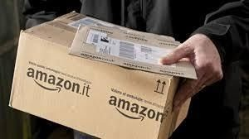
In this way, e-commerce services of Amazon Plc are becoming successful at providing with the comfortable and effective service.

We provide you with the right e-commerce services service.
Consumer electronics: Amazon Plc has also been providing with the Consumer electronics products. We are producing Consumer electronics for the commercial and personal usage.
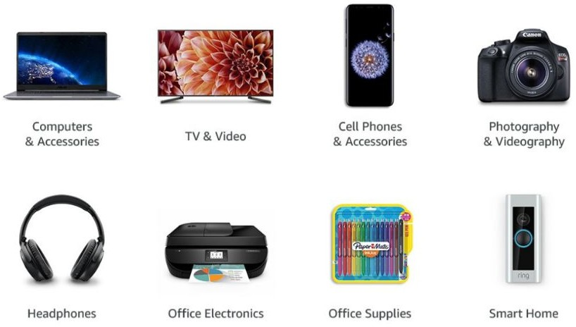
If you are looking for Consumer electronics which seems updated but cheap, you must try the Consumer electronics products of Amazon. We are providing with the effect products for both home and personal usage.

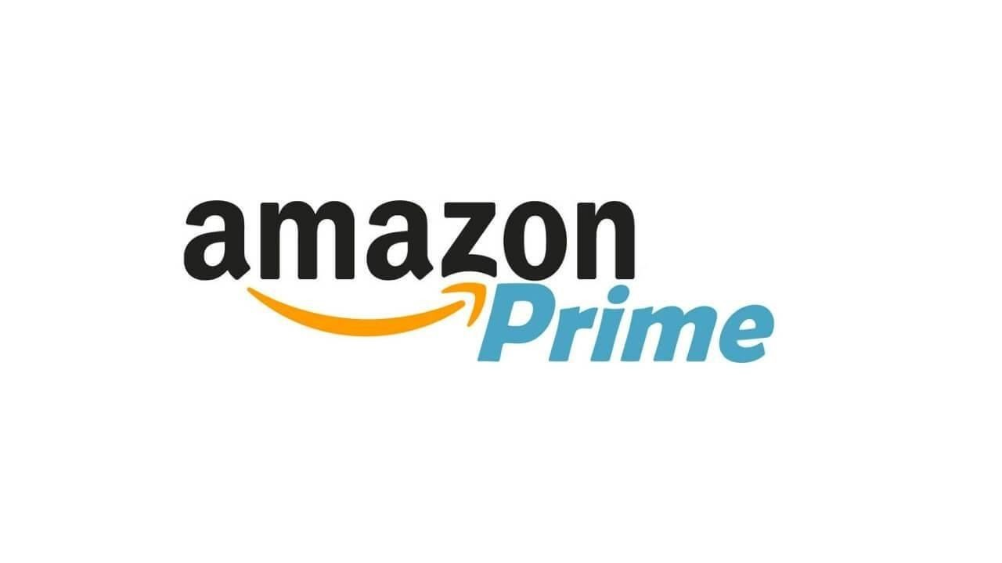
Please visit our website: https://www.amazon.co.uk/
Cloud services: Amazon Plc produce the best cloud services throughout the UK. There are various services such as streaming service, apps services, and so on (Al-Surmi et al., 2020).

Thus, all the services associated to the cloud are produced by Amazon Plc.

Accessories for home appliances: We are also bringing a lot of sports accessories for the home appliances. All of these accessories are very much flexible and suitable for the users of any age.
Features of the product: Our products are renowned for being higher in quality. Apart from that, our products also possess the effective characteristics. We are producing the products and accessories which will be very much comfortable for the individuals who are using it.
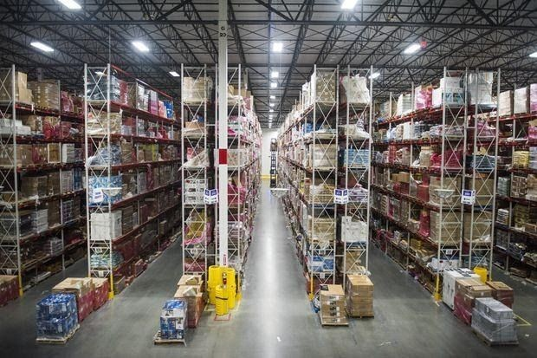
After that, our product is relatively coping up with market trends that are available in the industry. On the other side, all of our products are also having various wide range. Because of having this wide range of feature, our products are relatively acceptable to the customers. So, these are the main features that are associated with the products of
Amazon Plc which can make a very strong impact on the marketing related performance (Sinha and Sheth, 2018).

How much did products of Amazon Plc cost? (Price)
E-commerce: Our most sold service is the E-commerce and we always try to keep the competitive pricing strategy. We have huge range of products and this product range is being useful for the individuals who are interested in the online shopping. Amongst all the brands, the price of the products may vary in several places (Lo and Campos, 2018). Here, the price of these products stay between £1 and £5000 based on the competitive pricing strategy.

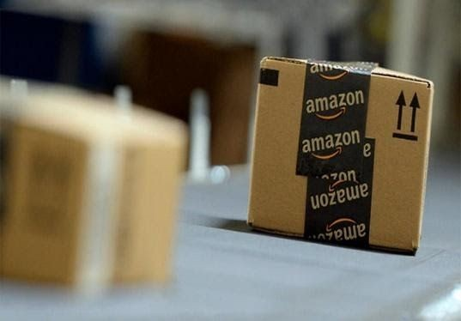
Make preorder of the products of Amazon Plc on: https://www.amazon.co.uk/
Consumer electronics: While fixing the pricing of Consumer electronics, we are using the cost plus pricing. Our Consumer electronics are relatively more costly than others’ because we focus on the quality mostly. Here, the
least price of our Consumer electronics is between £40 and £60. At most, the price of the

Consumer electronics of Amazon Plc can be more than £300. All the products of Amazon Plc cost more than any contemporary products (Saura et al., 2019).
Cloud services: We are also providing with a lot of other cloud services such as online streaming services, and so on. The price of each of these items may vary from the price of other items. However, in the category of the cloud services, the lowest price range is £2 where the highest price range can be more than £600 as well (Baena, 2016). In order to fix the price, competitive pricing strategy is being used by the Amazon Plc right now.
Accessories for home appliances: There are a lot of Accessories for home appliances and we are producing all of these accessories. Here, to fix the price of these accessories, competitive pricing strategy is being used significantly.
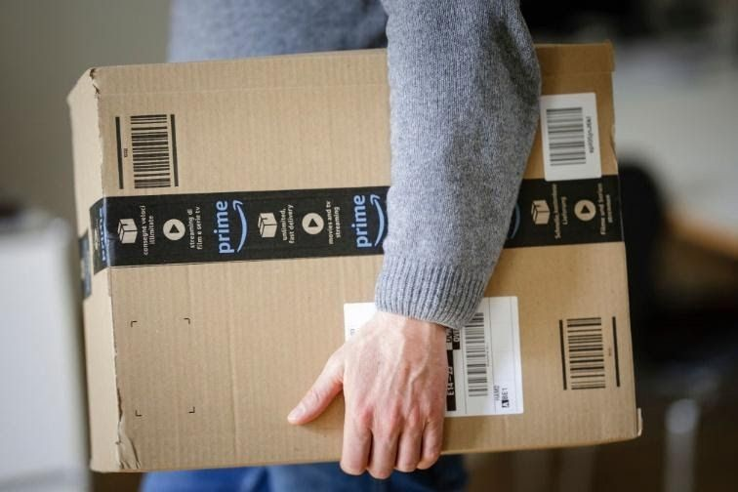
Thus, the price of the accessories is between £15 and £500. To fix the price of these accessories, competitive pricing is being used to act properly compared to any other competitors (Lo and Campos, 2018).

Where will you find the products of Amazon Plc? (Place)
The product of Amazon Plc can be found on various places. We have warehouse, storehouse, and strong website. All of these storehouses are situated on various places. In London, Amazon Plc has storehouse which is situated at 1 Principal Place, Worship Street. London. EC2A 2FA. On the other side, Amazon Central King’s Cross is situated at 2 Cloch Road Faulds Park PA19 1BQ.
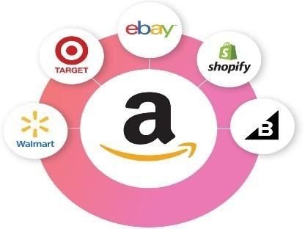
Amazon Factory Store is situated at Amazon Distribution Depot Unit 2, London Distribution Park RM18 7AN (Sinha and Sheth, 2018). So, these are the main physical locations that are available for Amazon Plc. So, all of these are the leading physical stores which are situated near London. Apart from all these physical

stores, there are various online presence of Amazon Plc as well. They have various websites, apps, and other social media presence too.
We have a website for online order and the link of our website is given following: https://www.amazon.co.uk/
You can also reach us by using your websites and it can be very much important for online order system as well. Thus, our website can also be interpreted in various languages as well. On the other side, the website also have four sections and each of these sections are dedicated for each of the products. In these sections, proper kind of celebrity endorsements are also available. For ordering, a shopping cart option is also present here (Baena, 2016).
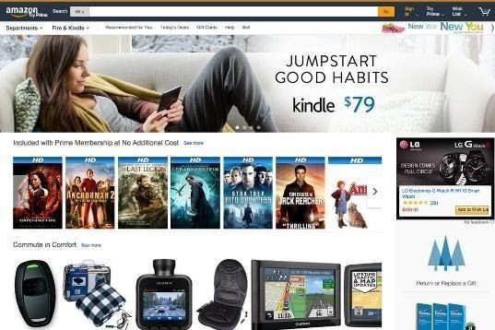
On the contrary, the website of Amazon Plc has the instant blogging option where customers can easily talk to the executives of Amazon Plc to claim warranty or any other prospects. The web platform of Amazon Plc is also interactive which includes the video links of each of the products.
As the result of it, a proper kind of interaction is being possible on the websites of the Amazon Plc. After that, Amazon Plc also has an app which has various interactive tools and messaging contents. The app of Amazon Plc has customized system for the best user experience (Saura et al., 2019).
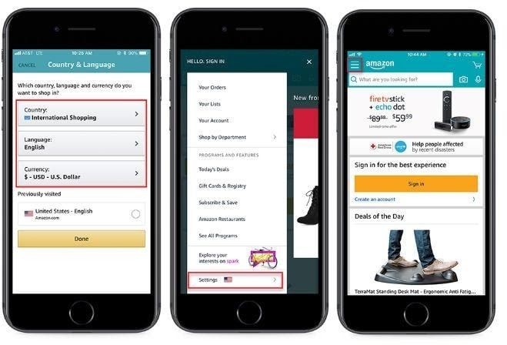
By the help of this app, the customers can get the suggestions of the customized products based on their choices of shopping, and so on. On the contrary, the app also provides with alert on any kind of new offers and launch of the products. So, these are the main places where you can get our products.

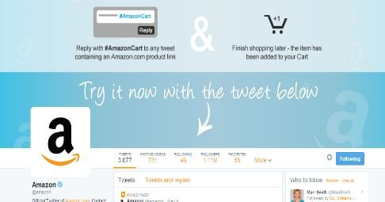
Our app link: https://play.google.com/store/apps/details?id=com.amazon.mShop.android.sh opping&hl=en&gl=US

And, https://www.amazon.com/gp/mas/get/amazonapp

How do we promote our products? (Promotion)
Promotion indicates the ways of reaching the target customers. We are producing the promotion method so that we can reach the customers in easier manner. In order to reach the customers, we are using the online and offline advertisement system. Here, we are using the TV advertisement to reach the customers. In order to do that, video contents are being created.

Based on creating the video contents, we are launching these on the YouTube, social media as well as on the television. We are also using the celebrity endorsement for the promotion of our products (Saura et al., 2019). In different types of areas, we have endorsed a lot of celebrity. Based on the
celebrity endorsement, Amazon Plc is becoming able to reach and meet the targeted customers. Apart from the celebrity endorsement, Amazon Plc is also focusing on the online promotion too. In order to work on that, they are also using the social media tools. Amazon Plc has active presence on the facebook, twitter, instagram, and other pages.
By the support of these pages, we are becoming able to reach the required customers. We are also using the instant messaging system to interact with customers. We use the email marketing
to inform customers about the new products. Amazon Plc has

the newsletter services and these services are being useful for reaching the information about the new products (Baena, 2016).
On the contrary, Amazon Plc is also using the newspaper advertisement to inform about any new kind of products. They are sponsoring a lot of different events and these events are being the largest tool for promotion in Amazon Plc. This is how, we are working to reach the target customers of Amazon Plc. In this way, we are being able to promote our products significantly.

Conclusion
In Amazon Plc, we are providing with the consumer electronics for home and office usage purpose only. We are also producing the products and accessories which will be very much effective for the individuals who are using it. Because of having this wide range of feature, our products are relatively acceptable to all the customers. All the products of Amazon Plc cost more than any contemporary products. To fix the price of the accessories of Amazon Plc, competitive pricing is being used to act properly compared to any other competitors. The web platform of Amazon Plc is also interactive which includes the video links of each of the products.

References

Al-Surmi, A., Cao, G., and Duan, Y. (2020). The impact of aligning business, IT, and marketing strategies on firm performance. Industrial Marketing Management, 84, 39-49.
Baena, V. (2016). Online and mobile marketing strategies as drivers of brand love in sports teams. International Journal of Sports Marketing and Sponsorship.
Freeman, R.E., (2010). Strategic management: A stakeholder approach. Cambridge university press.
Funk, D., Funk, D. C., Alexandris, K., and McDonald, H. (2016). Sport consumer behaviour: Marketing strategies. Routledge.
Goi, C.L., (2019). A review of the marketing mix: 4Ps or more?. International journal of marketing studies, 1(1), p.2.
Graham, H., (2018). Marketing strategy and competitive positioning. Pearson Education India.
Kotler, P. and Armstrong, G., (2010). Principles of marketing. Pearson education.
Lancaster, G., & Withey, F. (2016). Marketing fundamentals. Routledge.
Lo, F. Y., and Campos, N. (2018). Blending Internet-of-Things (IoT) solutions into relationship marketing strategies. Technological Forecasting and Social Change, 137, 10-18.
Saura, J. R., Palos-Sanchez, P. R., and Correia, M. B. (2019). Digital marketing strategies based on the e-business model: Literature review and future directions. In Organizational Transformation and Managing Innovation in the Fourth Industrial Revolution (pp. 86-103). IGI Global.
Sinha, M., and Sheth, J. (2018). Growing the pie in emerging markets: Marketing strategies for increasing the ratio of non-users to users. Journal of Business Research, 86, 217-224.
Tong, S., Luo, X., and Xu, B. (2020). Personalized mobile marketing strategies. Journal of the Academy of Marketing Science, 48(1), 64-78.
Visser, M., Sikkenga, B., & Berry, M. (2019). Digital Marketing Fundamentals: From Strategy to ROI. Routledge.

