Here we are faced with issues regarding the manufacturing production process at a company creating free standing pillar drills. Production is split into two distinct parts, firstly the sand-casting process which creates the initial component of the drill and secondly a vertical milling machine is used to create the mounting holes, top surface and main tube holes. Each process is carried out by two operators each working independently of each other. The company have compiled a “defect data” table (Figure A) cataloguing the different process defects each operator encounters on each shift. By analysing and extrapolating upon the provided date as well as using a range of business improvement techniques , inferences will be made to establish a prioritised corrective plan to reduce future issues within the business. As can be seen in Figure B, Reason’s Swiss Cheese model indicates how easily mistakes and errors can occur throughout a process, if the proper check and controls are not in place, conversely it also illustrates how a well-structured management and layered improvement plan can reduce and eliminate many of the defects encountered. However firstly, the raw defect data must be looked at in closer detail to help guide and inform the later analysis.
Through looking at the broken down data in Figure’s C, D with 124 defects detected out of the total 197 across the two machines, “surface finish” is the most commonly occurring defect the company faces, equating to 63% of the total defects where as “blow hole issues” occurred on 43 occasions and “Improper shape” was found in 20 of the manufactured pieces, amassing 22% and 10% respectively. By implementing and examining the Parato charts in Figure E it becomes apparent that these three previously mentioned issues contribute to 95% of the total defects recorded and if we are to establish a prioritised corrective plan focusing on reducing or eliminating the total defects this company faces, these three areas, must be the of main concern
While looking at the other manufacturing errors that occur, “defective finish” and “other issues” contributed 12 total issues which equates to only 6% of the entire recorded defects. With further analysis of Figure C regarding individual operator error contributions, we see operator 2 recorded a total of 73 issues compared to 48 from Operator 1 which amasses to 60% of the total errors from the sand casting method, in addition to this 48 out of that total were deemed to be surface errors, 22 more than his college working on the same machine.
Although you must take into account the potential for mechanical/ machine error, it becomes apparent in regards to “surface finish” on machine 1 human error may play a large roll in the cause of these errors. Alternatively both operators have the same number of issues in regards to “ blow hole defect” which indicates that potentially there is a machinery or systems failure
While applying the same standard to Machine 2, from figure C it is apparent that, across the board both operators record similar figures, operator B recording 43 while Operator A totalling 33, which would suggest due to the similarity of errors produced by each member that a mechanical/ machinery issue could well be the root cause of the manufacturing errors. Although operator 2’s total errors are marginally higher there aren’t significant discrepancies’ between each individual defect which allows for the previously stated conclusion.

A further avenue of statistical analysis can be taken by looking in more depth at the individual occurrences, on the days and the shift patterns issues are detected. While looking at Figure F we see that the average number of daily mistakes is 32.38, as can be seen in the table, Wednesdays recordings were an anomaly with 54 defects while compared to the other working days, accounting for 27% of the total mistakes. With further investigation into the root causes of the defects there will be an attempt to establish why this is later.

The final aspect of data analysis to consider is whether there is a correlation between the shift pattern (AM/PM) and number of errors, as can be seen from Figure F, the figures are fairly consistent between the morning and evening shifts, with 102 errors across the week in the morning and 95 in the evening, from this it is reasonable to conclude that he shift pattern does not actively contribute to the total number of errors, it could however passively contribute, this will be discussed further as deeper analysis is examined.

The next step in the analysis is to try to establish why and how the human errors have occurred in this process and establish ways to reduced them, in his book “Human error reduction” (Rodríguez Pérez, 2018) states that the current attitude to human error are that they are “symptoms of a deeper cause”, this is a statement echoed by several academics including C Pallerosi who states “ “it is the probability of a person not to fail on the accomplishment of a required task (action), when demanded, in a given period of time, under adequate environmental conditions and with available resources to perform it”. Following on from this the Five Whys analysis technique has been applied to Operator B on Machine 1 in Figure H (Several assumptions have been made in relation to the company) to potentially establish the reasoning for his increased errors, as can be seen the true root cause for his errors is due to the lack of training he has received since joining the business comparatively to his co-worker who can be seen making far less mistakes.
This leads us to question company policy and whether there were proper measures in place from an organisational standpoint I.E. training manuals, writing codified safe practice and adequate supervision/ management. Again referring to Figure B it would be fair to argue that because these have not been properly implement the company have set themselves on, as Reason said himself "a trajectory of accident opportunity”.

As a result, it is important to discuss potential long and short term fixes that can be implemented companywide in order to reduce defect number, it is important to note although Operator B Machine 1 has been the primary focus, these corrective actions should be implemented across the company to not only reduce current defect numbers but to safeguard for the future. Firstly the practice of operators working independently of each other in the completion of tasks should be overhauled and a collaborative system should be put into place, where operators inspect each other’s work, Michel Bauldin Suggests in Lean Assembly “successive inspection is a viable alternative to self-inspection. Instead of trying to find fault with his or her own work, each assembler does it on the work done at the previous station. This usually provides enough psychological distance for it to be effective”. Leading on from this a re-evaluation of the company training and supervisory systems. A new training regime which would provide training to all operators and supervisors on correct use of machinery and correct working procedures would prove beneficial for all departments. On top of this having a central accessible document system that allows all members of staff to refer back and assess knowledge will allow for continued personal development. A potential long term solution implemented over a course of months/years would be to change the business model to one that employs the Total Quality Management principles which as Deming, Juran and Ishikawa write “discipline and philosophy of management which institutionalizes planned and continuous… improvement … and assumes that quality is the outcome of all activities that take place within an organization; that all functions and all employees have to participate in the improvement process; that organizations need both quality systems and a quality culture.” Here companywide people are engaged with the process and contribute to the creation of a quality product these ideals are strived for and achieved through management commitment , Employee Empowerment, Fact Based decision Making, Continuous Improvement and Customer Focus .

Now that the influence of human error has been discussed it is important to look at the machinery/ Operational aspect of process, specifically the Sand Casting ( Machine 1) and the Vertica Milling Machine (Machine 2). To sandcast, “Sand is used to define the cavity inside a mould. In addition, sand is used to make any cores that are contained in the mould. The molten metal solidifies in the cavity between the interior of the mould and the exterior of the core.”In Material and Process in Manufacturing DeGarmo states that 90% of casting in the US is the green sand method, as such we will assume this is the method used here. This form of casting had short lead time and relatively inexpensive equipment costs production, however its well-known drawback Is the surface finish it produces as “the wet sand has a high moisture content, low strength and air permeability, the castings can easily have the porosity, coarse, sticky sand and sand expansion defects”. From this we see that the surface defects (74) encountered on Machine 1 are most likely a result of the manufacturing process and are arguably unavoidable using the current method . The blow hole defect for Machine 1 (34) are again likely due to the process, blow holes occur in casting when “moulding sand has too much water, poor ventilation, sand core has bad drying, pouring temperature is too low or pouring too fast”, this again leads us to question human input along with the machinery and equipment being used.

There are several corrective actions that could be taken to resolve these issues, depending on the resources available for the company to allocate, by continuing to use the current sand casting method but improving the quality of the sand for example, a resin sand, due to its fast hardening and the drying strength produces a much smoother surface finish than alternative sand casting methods. However this method is more labour intensive as this type of sand requires pre mixing with chemicals and is a far slower production process. Other potential alternatives would be to introduce a different casting system, again this would depend on Company resources as Pressure Die Casting and Investment casting do producer excellent surface finishes however they are both considered to be a far costlier method and may not be suitable for the production scale of this business.
Again without further information on how defects are caused by the Vertical Pillar Drill, certain conclusions and inferences must be draw, to do this the FMEA diagram in figure I has been used to asses where and how the issues arise and how to correct them. Again here there are references to human error, which will undoubtably be corrected with the updated training approach, alternatively by “mistake proofing” the process, an improvement technique developed by Shigeo Shingo, in this instance you could put limits on the vertical milling machine to restrict the operators input into the process, and as a result reducing defects. Two potential implementations of this method could be to restrict how the sand cast mould can be placed into the machine or have pre-set angles or speeds depending on which part of the milling process being carried out, these will increase operator accuracy and in turn reduced defects.
Another key area highlighted by the FMEA in Figure I is the need for the implementation of a preventative maintenance plan would maximise efficiency and reduce production costs. If we again examine Figure F and consider what lars Bader wrote in his ISE article “ A proper program finds problems early rather than waiting for disaster”, through implementing a preventative maintenance schedule/system we could in theory stop production on a Wednesday morning carry out the required system checks and maintenance schedule ( for example changing drill bits tightening machine chucks) we could in theory reduce defect numbers with minimally invasive stops not dramatically reducing production.

To conclude Figure J in you can see a prioritised action plan consisting over several potential corrective measures that will help to reduce the number of defects this production line is encountering, these range from relatively straight forward changes that can be done inhouse in a short period of time to changes that will require planning and preparation to implement potentially over the course of several months. These measures must be reviewed internally for suitability within the company; weighing the cost time and resource against the potential upside of implementation.

.

Bibliography

Bader, L. (2018). The importance of preventative maintanence. ISE.

Baudin, M. (2009). Lean assembly. New York, NY: Productivity Press.

DeGarmo, E. (2003). Materials and processes in manufacturing. Hoboken, N.J.: Wiley.

Dhillon, B. (2018). Engineering Maintenance. US: Tritech Digital Media.

Tachiki, Dennis. (2008). TQM IN JAPAN Deming, Juran and Ishikawa. JICA Project Briefing Paper.

Groover, M. (n.d.). Fundamentals of modern manufacturing.

Scribd. (2019). Advantages and Disadvantages of Different Casting Processes | Casting (Metalworking) | Building Engineering. [online] Available at: https://www.scribd.com/doc/112847186/Advantages-and-Disadvantages-of-Different-Casting-Processes [Accessed 18 Apr. 2019].

Of, B. and Improvement, P. (2019). How to avoid human mistakes in production? The lean approach. - QualityInspection.org. [online] QualityInspection.org. Available at: https://qualityinspection.org/human-mistakes-lean/ [Accessed 18 Apr. 2019].

Reason J. Managing the risks of organizational accidents. Aldershot: Ashgate; 1997

Tubis A, Nowakowska M (2016).Human Factor in Technical Systems and in Supply Chain

http://www.iitg.ac.in/engfac/ganu/public_html/Metal%20casting%20processes_1.pdf
http://www.metal-technologies.com/docs/default-source/education/sandcasting.pdf?sfvrsn=fd11cd02_2
http://www.iron-foundry.com/
https://www.custompartnet.com/wu/milling

Appendix
Figure A
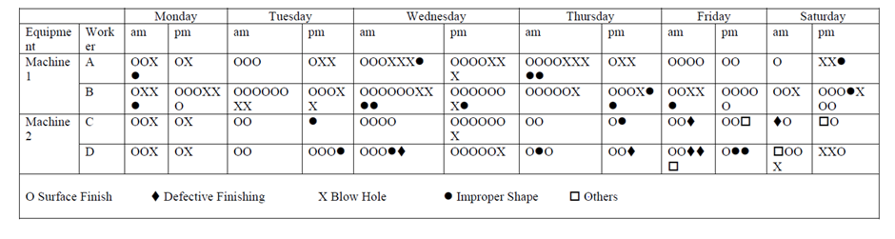

Figure B

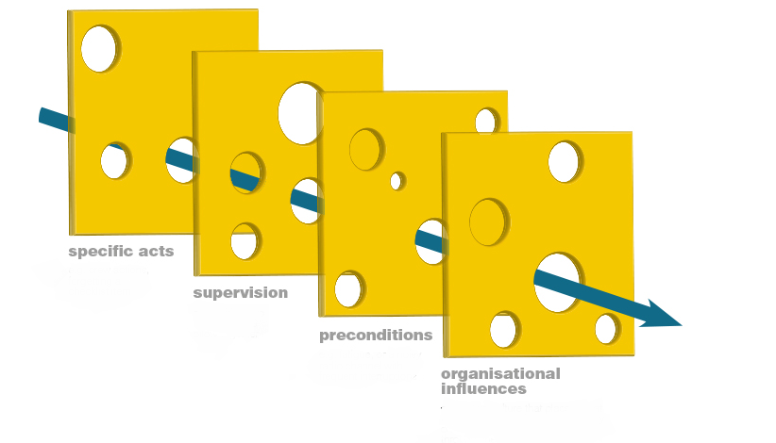
Defect
Process

Figure C

Machine 1 -Sand casting | Surface finish | defective finish | blow hole issue | improper shape | other | total defects
Operator 1 | 26 | 0 | 17 | 5 | 0 | 48
Operator 2 | 48 | 0 | 17 | 8 | 0 | 73
Machine 2 -milling | Surface finish | defective finish | blow hole issue | improper shape | other | total defects
Operator 1 | 24 | 2 | 3 | 2 | 2 | 33
Operator 2 | 26 | 4 | 6 | 5 | 2 | 43
Total Errors | 124 | 6 | 43 | 20 | 4 | 197

Figure D

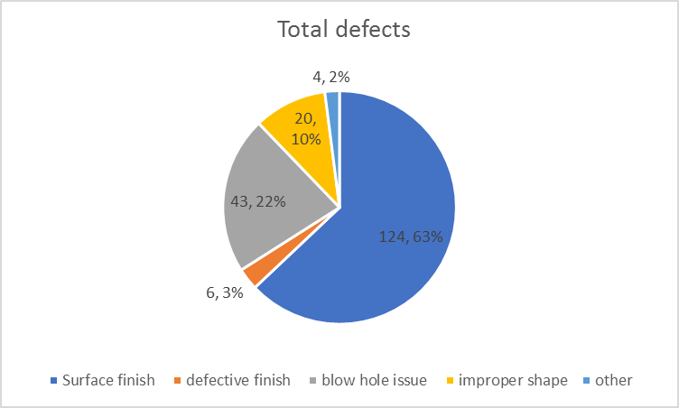

Figure E

Figure F

Total Errors Day to day | Number of Errors | Percentage | Surface errors | Defect finish | Blow hole | Improper shape | Other
Monday | 26 | 13% | 14 | 0 | 10 | 2 | 0
Tuesday | 28 | 14% | 20 | 0 | 6 | 2 | 0
Wednesday | 54 | 27% | 37 | 1 | 11 | 5 | 0
Thursday | 34 | 17% | 20 | 1 | 7 | 6 | 0
Friday | 30 | 15% | 20 | 3 | 2 | 3 | 2
Saturday | 25 | 13% | 13 | 1 | 7 | 2 | 2
Average Number of issues per day | 32.38

Figure G

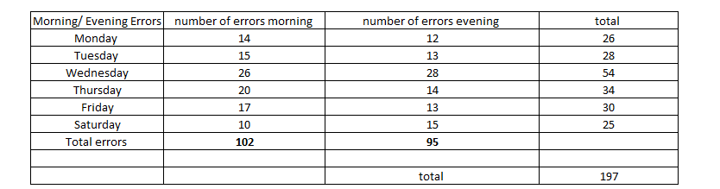

Figure H

  - Why has Operator B made so many more Errors than his Co-Worker on the same Machine?

Operator B joined the Company later than Operator A and has received comparatively less training

- Why Has Operator B received less training than his counterpart?

Recently, training and upskilling employees within Operator B’s department hasn’t been a priority

- Why has there been less focus on training in Departments ?

Management have released Companywide mandates have been put out informing supervisors to focus more on product output than on the job training

  - Why has management decided to focus more on production output than training?

Mandate has come from head office due to a change in company policy

- Why has there been a policy change?

During a review of production rates and comparisons to other competitors it was established with current trends a new approach was required

Figure I



Issue and corrective measure | Responsible party/s  Before and After | Timespan for implementation | Additional comments | Expected Results
Retraining and upskilling staff- including practice of quality checks Introduction of a Competency assessments and demonstrably competent requirement | Human Resources,  Management,  Team Leaders  Newly introduced competency assessors | Monthly reviews for first six months,  Quarterly audits continuing on results,  Ongoing Competency assessor checks | Will require engagement from all levels of organisation to be achieved, | Less defects as a result of human error  More
Implement preventative maintenance plan of machinery | Management  Team Leaders  Head Engineers ( mechanical, electrical) | Immediate review of current maintenance plans and reports, Implement |  | Less defects due to mechanical issues, will allow for early detection of potential errors-
Update and codified training manuals, easily accessible to all staff on centralised system | Managers  Process specialists  Team Leaders | 15/6/19- First review of updates  15/8/19 continued review of process | Will require review of current training material  Will require involvement of new competency assessors | With easier access for all employees, standards will improve and human error will decrease
Long term corrections |  | Long term correc
Consider and review potential casting alternatives  i.e. Resin Sand alternative forms of casting | Management  Outside specialist  Procurement  Logistic department | Immediate review and investigation into alternatives | Cost and time of implementing changes must be carefully weighed up against number of defects | Dramatically improved surface quality, greater understanding in short term of causes for surface area defect
Review and implementation of Mistake proofing machinery in the production process | Management  Chief Engineer  Production specialist  Consultation with outside parties | Immediate review |  | Less defects as a result of human error, increased productivity,
Adopt a Total Quality Management operational system | Upper Management – Implementation  All employees- Continued engagement | 14/04/2020  Bi-weekly meetings to discuss and further implementation | Long-term steady implementation required to achieve desired results | Have improved companywide engagement with the primary driving focus to produce a quality product
Figure J
Short Term Correction Plan

Reason J. Managing the risks of organizational accidents. Aldershot: Ashgate; 1997
Rodríguez Pérez, J. (2018). Human error reduction in manufacturing.
Rodríguez Pérez, J. (2018). Human error reduction in manufacturing.
Pallerosi C. 2008. Confiabilidade Humana: Nova metodologia de Análise Qualitativa e Quantitativa. 6o Simpósio Internacional de Confiabilidade. Florianópolis, Brasil.
Reason J. Managing the risks of organizational accidents. Aldershot: Ashgate; 1997
Baudin, M. (2009). Lean assembly. New York, NY: Productivity Press.
Baudin, M. (2009). Lean assembly. New York, NY: Productivity Press.
Tachiki, Dennis. (2008). TQM IN JAPAN Deming, Juran and Ishikawa. JICA Project Briefing Paper.
http://www.metal-technologies.com/docs/default-source/education/sandcasting.pdf?sfvrsn=fd11cd02_2
DeGarmo, E. (2003). Materials and processes in manufacturing. Hoboken, N.J.: Wiley.
http://www.iron-foundry.com/foundry-sand.html
http://www.iron-foundry.com/iron-casting-defects.html
Bader, L. (2018). The importance of preventative maintenance. ISE.

