Impart of Virtual Learning Environment (VLE)
Student name: Lizzy Jest Esienna
Student ID: 2113584
Module Title: BMSW4003
Lecturer Name: Soban Sadiq

Tables of Contents:
Introduction…………………………………….………….…............ 3
Methodology……………………………………….…….………........ 3
Data collection method…………………………….….…...……...3
Aims…………………………………….………………….………....….... 3
Research Objective..................................................…… 4
Characteristics of the Virtual Learning Environment
Impacts of VLE on Students ………………………………….…. 4
The sample
Quantitative……………………………………………………………... 5
Qualitative…………………………………………….…………………. 5
Evaluation of Primary data and Discussion………………. 6
Ethical Consideration………………………………………………... 6
Designed Questionnaire………………………………………….… 6
Tabulation of Data in Likert Scale………………………………. 10
Secondary Data
Evaluation of Secondary data ………………………………………10
Discussion of secondary data ……………………………………….11
Limitation………………………………………………………………..……11
Conclusion……………………………………………………………….……11
Reference………………………………………………………………..……12

Introduction:
The virtual learning environment VLE is initiated for the purpose of the students to become the active passive learners. It is form of a vital element which is increasingly for the development of the critical skills into the personal development of the students (Melissa Ng Less Yen, 2020). Such kind of active learning with the students promotes the skill thinking critical ask the word to become the essential for the transfer or use of the knowledge of the classroom. That kind of knowledge in which a student will receive within the classroom, the acquisition amongst their lives, is critical thinking is to be taught (Abd Ghani, 2018). This research is focused on the impact of virtual learning environment VLE on the students.

Research Aim
This research aims to examine all the impacts of the virtual learning environment VLE all the students around United Kingdom.

Research Objectives
- To improve the students’ skills digitalisation regarding the workplace, which is based on virtual learning environment.
- To progress the awareness regarding the importance of such analysis of Virtual learning environment.
- To improve the add environment of learning amongst list all the students in “University of Wales Trinity Saint David London Campus.”

Rationale
Change in the culture of learning is the main issue amongst students these days. This change has been occurred due to the well-trained teacher and implementation of new and advancement technologies within universities. This has been ensured that all the students have a lot of materials to get on the internet. That is why they do not make such kind of research related to their relevant field (Ward, and Abubacker, 2018).

Literature Review
Elements of Virtual Learning Environment
The components of virtual learning environment which are related to the course syllabus of the students. On the information related about the course subject to the credits, prerequisites, the registration and the payment of the physical session and not information related to the contact for the instructor (Pirnau, et al, 2020). The essential content of the virtual learning environment is a complete course of distance learning applications. This usually includes all the material such as Copy on the lecture in the system of text or video or audio presentations and visual presentation for the support (Al-Azawei, and Al-Masoudy, 2020). The self-assessment and quizzes are also considered the analogue devices normally scored automatically (Do Carmo, et all, 2020).

Impacts of VLE on Students
The virtual learning environment has recently emerged as one of the most critical topics in the education sector (Al-Azawei, and Al-Masoudy, 2020). In an educational sector, a student experience all the learning styles in the classroom in terms of lecturers is completely dependent on how well it is to be taught by them. The type of teaching in a virtual learning environment fit with the individual learning styles. Much higher education institutions are increasingly lacking and fragmenting in cohesion and unity (Majid, and Hasim, 2019). Virtual learning environment seemed to significantly improve the student’s engagement in the relevant topic and the student’s satisfaction while learning new things (Jones, et al, 2018). Learning environment has avoided range of its positive impact in terms of research sectors. (Abd Ghani, 2018). (Dissanayake and Alahakoon, 2020).
VLE also opened in promoting the accommodation and the reflections of the students in the field of their learning ability. However, Virtual Learning Environment is also being helping all the students to get the confidence whilst using their knowledge and the digital skills (Singh, et al, 2019). It also enhances the skills to explore more related to the relevant topic to the develop the students’ further understanding. (Ward, and Abubacker, 2018).
Virtual learning seemed to significantly improve students’ satisfaction/engagement and recall. A total of 40 students attended the teaching sessions. The student group taught using the VLE had higher mean scores for retention than the didactic group; however, this was not statistically significant. Eimear Ryan et al. J Med Imagining Radiate Sci. 2019 Sep.

Data Collection Methods
Data collection is a process of collecting information from all the relevant sources to find answers to the research problem, test the hypothesis (if you are following deductive approach) and evaluate the outcomes. Data collection methods can be divided into two categories: secondary methods of data collection and primary methods of data collection.
Quantitative
data is often used when the data needs to be quantified by the researcher, answering questions like “what”, “how many” and “how often”. This type of data is frequently used to compare findings scientifically, math calculations and for final statistical analysis.
Qualitative
Qualitative data is information that cannot be counted, measured or easily expressed using numbers. It can be collected from text, audio and images and shared through data visualisation tools. It compares the ‘full picture’ of the data collected, allowing researchers a more in-depth view into the data they have researched or collected, while simultaneously telling us the reasons and explanations between variables, something that quantitative data is unable to produce.
Sample and the Sample Size
Numerous respondents participated in the data collection process, which accord the sample size. In the responses of fifteen students in University of Wales Trinity Saint David London Campus. The sample techniques of non-probability considers as the eradication of any kind of biasness in the perceptions and the assertions. This kind of sample techniques has selected in non-probability sampling research sectors. Selecting this kind of technique is because of the topics that are involved in analysing the improvement and the impact of VLE on the students. (Do Carmo, et al., 2020).
Ethical Consideration
The participation of the people in the voluntary and virtual environments allows for the implementation and investigation of the research related to VLE. By doing the educational research regarding VLE, it has been found that the involvement of the students in researching This study addresses classic as well as the ethical problems in the context of educational research in virtual worlds. It also discusses how the technological aspects have created new ethical quandaries in privacy protection, informed consent, and identification of the recent effectiveness of the certain topic (Pirnau, et al., 2020).
Analysis and discussion
Primary Analysis
Designed Questionnaire
Do you find useful resources Moodle?

Would you recommend Moodle to other students from a different university in case they did not know about it?
Did you find Moodle hard to use?
Did you feel Moodle should provide more information and research points? For example, PDF`s books, reports to your studies.
Did you find Moodle as an interesting VLE to support your studies?
How often do you use the Moodle?
How satisfied are you when using the virtual learning environment {Moodle) of this university (UWTSD)
Do you agree with the statement that the information provided in the Moodle is useful, well organised and easy to find and understand? To what extent do you agree with the statement?
How would you describe your experience using Moodle? {In a scale of 1 to 5 where 5 is extremely satisfying)
How likely are you to recommend Moodle to your friend where 1 is not recommended and 5 is fully recommended?

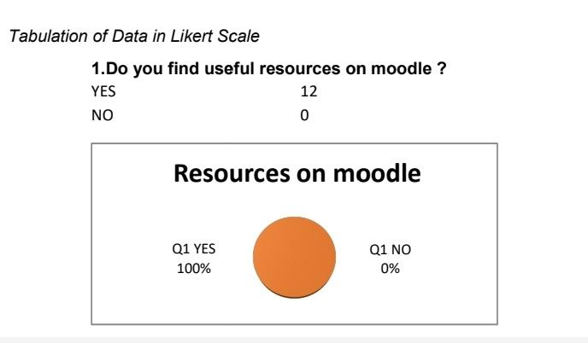
Most students are happier with the Moodle resources and find it useful to main university for management and maintain their service as well so particularly.
Would you recommend Moodle to other students from a different university in case they did not know about it? 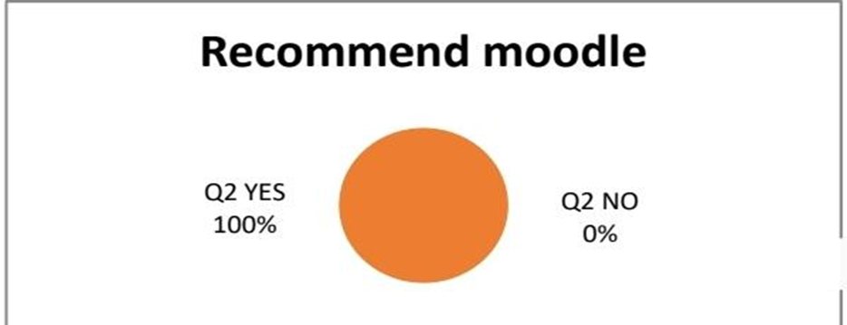

A lot of students are in line of recommend to other studen in other universities about the Moodle, in the seince that they love the their university and would use it to study.
Did you find the Moodle hared to use?
Yes 2
No 10
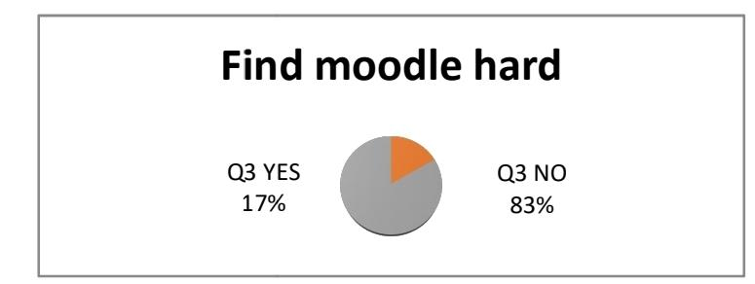
Within 12 students, 2 students said no and 10 said yes. My opennion of 2 student while says no, university should get ore of the them, can find also in the moodle.
Did you feel Moodle should provide more information and research points? For example, PDF`s books, reports to your studies.
9 YES
8 NO
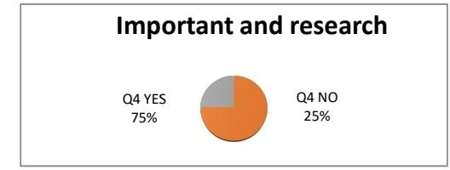
75% students agreed on the need of information needed in the Moodle, so at the end most university provided more information and research of the helpful for students.
How would you describe your experience using Moodle? {In a scale of 1 to 5 where 5 is extremely satisfying)
1………………………………0
2………………………………0
3………………………………5
4……………………………….3
5……………………………….4

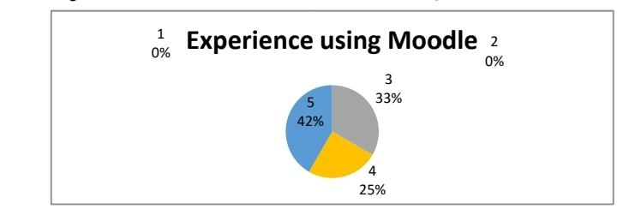
Data confirm that 5 people said they have satisfised experience. While other are not sure of their satisfaction, With the analysis topic the main thing for me, is to ask the university to put more easier information on the Moodle for the students.

How likely are you to recommend Moodle to your friend where 1 is not recommended and 5 is fully recommended?
1………………………………0
2……………………………….3
3……………………………….0
4……………………………….5
5…………………………………4

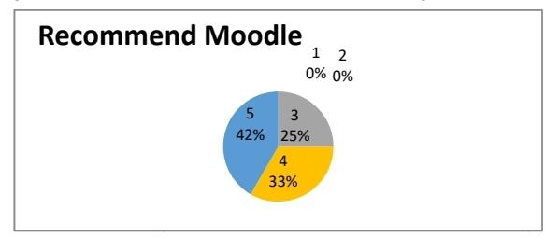
Secondary Data
Is a data that import sources from other that already been mad ready by primary data and make available for other researchers.
Evaluation of secondary data.
Secondary data neither available to an accuracy when carrying out a research problem. In a second way secondary data offer a lot of options, (which save you money and time as then primary data). There are some problems connected to it. but still very helpful evaluated.

Discussion of secondary data.
As discussed from the analysis, these finding have also been supported by Maiti and Kayal (2017) in which the researchers articulate that nowadays due to the increase in the use of mobile devices students are well aware about the digitalization helping the employee to reach their personal best whilst also climbing up in the ladder of success. Since the aim was to learn about the final year students and their concerns regarding maintaining professional work life ethics whilst also balancing their employability.
Limitation.
Some students questioned during the primary data may have answered based on their current module not their overall experience.
Conclusion.
In conclusion, the whole study cantiled a deep discussion of how students in their final years face a new dilemma in the light of the fast pace of globalization and digitalization which in most case go hand in hand. It was found that most final year students feel like they have insufficient digital skills which may be helping in increasing their choices of employment while also ensure their personal working efficiency and productivity has been maintained at the highest level. When either of these goes hand in hand with other as the aim of ensuring that productivity increases and add value to overall employability factor. Many why, it is an understanding of a digital marketing has become clear.

References:
xzAbd Ghani, F., 2018. Teachers attitudes towards VLE and its relationship with their teaching
performance (Master's thesis, Kuala Lumpur: International Islamic University
Malaysia, 2018).
Al-Azawei, A. and Al-Masoudy, M., 2020. Predicting Learners' Performance in Virtual
Learning Environment (VLE) based on Demographic, Behavioral and Engagement
Antecedents. International Journal of Emerging Technologies in Learning
(iJET), 15(9), pp.60-75.
Dissanayake, D.M.R.S. and Alahakoon, A.M.Y.S., 2020. The Impact of Virtual Learning
Environment on Teaching English as a Second Language.
Do Carmo, Ê.P., Klock, A.C.T., de Oliveira, E.H.T. and Gasparini, I., 2020, July. A study on
the impact of gamification on students’ behavior and performance through learning
paths. In 2020 IEEE 20th International Conference on Advanced Learning
Technologies (ICALT) (pp. 84-86). IEEE
Eimear Ryan et al. J Med Imagining Radiat Sci. 2019 Sep.
https://research-methodology.net/research-methods/data-collection
Last updated June 22/2022
What is Quantitative Data? How to Collect and Analyze It | FullStory
https://www-techtarget-com.cdn.ampproject.org/v/s/www.techtarget.com/searchcio/definition/qualitative-data?amp_js_v=a6&amp_gsa=1&amp=1&usqp=mq331AQKKAFQArABIIACAw%3D%3D#aoh=16618003270460&referrer=https%3A%2F%2Fwww.google.com&amp_tf=From%20%251%24s&ampshare=https%3A%2F%2Fwww.techtarget.com%2Fsearchcio%2Fdefinition%2Fqualitative-data
https://www.formpl.us/blog/secondary-data15/01/2020
2022 Rupprecht Consult- Forschung & Beratung GmbH
https://www.bing.com/ck/a?!&&p=7305d0dd7ce9b1cfJmltdHM9MTY2MTk5MDQwMCZpZ3VpZD0zODY0YzUzZC1jYzAwLTZkYWMtMTM0Mi1kNGY4Y2QzODZjNDgmaW5zaWQ9NTI5Ng&ptn=3&hsh=3&fclid=3864c53d-cc00-6dac-1342-d4f8cd386c48&u
Taekke.J. and Paulsen.M.2017. Digitalisation of education: The theory of the three waves, the centre for Internet Research.

