Strategic Business Plan

Table of Contents
Task B: Evaluation Report 3
Evaluating business idea and motivational factors 3
Identifying and explaining five entrepreneurship skills, traits, and behaviours and their importance for the Businesses 4
SWOT analysis 5
An extensive market research PEST analysis 6
References 9

Task B: Evaluation Report

Evaluating business idea and motivational factors
The new business will be an online store of pharmacy delivering products and medicines in the pharmaceutical to the doorsteps by using the technology of drones which is rising in the market today. The purpose of the business will be centred around the aerial delivery of the products. The mission of the company is to provide quick and efficient delivery of medicine through the routes. Products supplied by the business will be delivered on the same day. The business idea will be highly beneficial for the healthcare sector as it holds high speed and capacity to supply products. It is much much-needed solution, especially in this industry with the supply chain shortage can be witnessed. By adopting this technology waiting lines for the patient to buy medicines can be reduced acting as the major motivating factor to start this business. Intellectual property laws will also be considered to ensure that a strong identity and recognition of the company is created in the UK market. The structure of the new business will be the sole proprietor in which only an individual will be liable for all the debts and profits of the company. Choosing this structure is important in terms of getting permission to fly drones in UK territory.
The motivating factor to start such a business is the fact that the drone market is increasing and gaining immense popularity. As drones are operated without the interference of human beings it is the most versatile tool to be used in delivering medicines in the market (Oigbochie et.al 2021). Another interesting factor is that drones have a high ability to carry out medical supplies such as vaccines, medicines and even blood improving the overall healthcare services and their transportation infrastructure. Medical drones are highly advantageous. Additionally, this business offers a high amount of profitability serving a huge base of generating higher incomes. Considering the growth of drones as a market opportunity and especially the fact that the market is not fully developed can help collect a wider base of clients and consumers from different healthcare departments. The uniqueness of the market and the specific target audience already set in the health sector of the UK is another motivation for starting this business. The business will be solving the problem of the nation and will give back to the community on some other level creating a significant impact.

Identifying and explaining five entrepreneurship skills, traits, and behaviours and their importance for the Businesses
Entrepreneurial skills are recognized as all those skills which are associated with the individual starting a new business. These skills are important for promoting growth and competitiveness in the market. The key entrepreneurship skills are as follows:
- Communication trait is one such essential skill needed for effectively collaborating with the potential stakeholders and key shareholders of the (Pardo-Garcia and Barac, 2020) If the entrepreneur is easily able to communicate their vision and mission to customers, creditors, mentors, and peers, it is highly likely that the business will succeed in the market.
- The business management skill or behaviour of the entrepreneur is also needed for meeting the overall goal-framed businesses. Managing key operations in the various departments is needed to generate the best output from all the functions (Galvão et.al 2020) This skill involves multitasking, making critical decisions, and delegating responsibility to the subordinates working. These skills are also important for the management of all the tasks in the company starting from planning to generation of revenues.
- Critical thinking is another trait that is indeed important for objective analysis of the information and conclusion which is the rationale towards the policies of the company. Employers with critical thinking skills are usually confident about the decision taken as this is done by logically connecting ideas and scrutinizing information and inconsistencies within the business.
- Another important behaviour, trait or skill of entrepreneurs is problem-solving which is needed for facing challenges and unexpected situations (Reyad et.al 2019). The exceptional behaviour of a leader to solve problems of the business ensures that the goal of the company is completed within the stipulated time frame.
- Financial skills or the trait of the entrepreneur to handle resources, investment and calculate rate of interest holds utmost importance. In addition, there is a high need for the entrepreneur to know about budgeting software and accounting acting as the key traits in the business.
The skills determined above will be useful for starting a new business and improving the healthcare offerings in the market. As the market struggles with the maintenance of the supply chain, this will help to create a perfect supply line. The entrepreneur with this skill will be playing a key role in anticipating the demand for such drones by the healthcare sector. Furthermore, these skills are important for rewarding businesses with profits and grabbing new opportunities in the market. Additionally, the innovative technologies can only be communicated to the right stakeholders including government, communities, pharmaceutical firms, caregivers and NGOs by making use of the communication skills determined above. Another trait and behaviour of the entrepreneur is business management which will be used in the production of such drones and at the same time involving professionals in healthcare to improve the safety of the patients and also reduce the accident levels. The efficiency of the business can be increased by working on traits, behaviour and skills determined.

SWOT analysis
Table 1: SWOT Analysis
Strengths  - The professional qualification in social media marketing will create a huge impact on the growth of the business.  - Another important strength is the ability to work with the team by actively listening and communicating with them.  - Risk taker ensuring the right business opportunities are grabbed.  - I am highly creative often impressing clients with new perspectives of different brands. | Weaknesses  - Not having high experience in the field of Search engine optimisation.  - Procrastination can also be witnessed as another weakness.  - Lack of knowledge in operating financial software.
Opportunity  - A need for social media marketing for the start of almost all businesses today can create unique opportunities for me to utilise technical skills.  Taking training and internships can be useful to taste new ideas and products serving as an opportunity to start a new business. | Threat  - The rise of Automation technology to handle social media channels can become a threat for me to utilise my skills.  - Higher level of competition due to availability of higher level of professionals  The rising costs of starting a new business in the market can be a threat  Increasing globalisation and higher legislative framework are other threats to using my skills in social media

An extensive market research PEST analysis
PEST analysis is an acronym for political, economic, social and technological factors which are external in nature but have a high impact on the profitability of the company (Cox, 2021). The PEST analysis of the UK is as follows:
Political:
The political stability of the UK is very important for starting a new business. The UK has maintained good relationships with different countries creating a positive impact on the business (Cox, 2021). With the European Union, the UK has managed to establish a free trade agreement. It helped the company to become more productive and grow in its manner. The strongest political alliance of the UK is with the Western world including the USA. The laws of the country including the Equality Act of 2010 and the Employment Act of 1996 further ensure that businesses are developing with the correct political framework in the country (Business Management and Marketing, 2023).
Economy:
The GDP of the UK in 2022 stands at around 2.27 trillion British Pounds which witnessed a growth size it increases of approximately 94.6 billion pounds compared to 2021 (Statista. 2023). The landscape of the UK is further attracting higher FDI in the consumer market and is acting as the top destination for tourists. The inflation rate of the UK in October 2023 is 4.6% higher than the other comparable economies decreasing the purchasing power of the consumer and this can act as a threat to business (UK parliament, 2023).
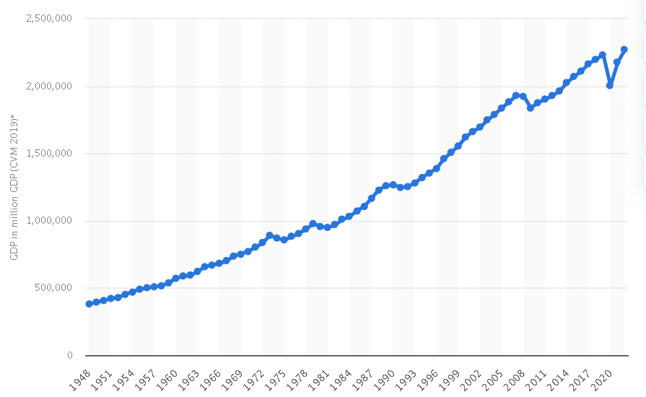
Figure 1: Gross domestic product of the United Kingdom from 1948 to 2022.
(Statista. 2023)
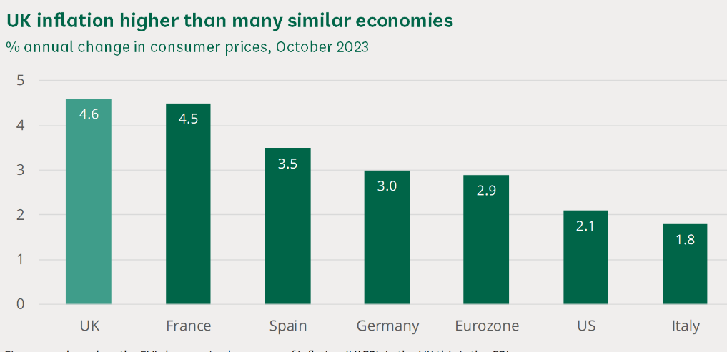
Figure 2: Rising cost of living in the UK
(Source: UK parliament, 2023)
Social:
As per the National Statistics Office the total population of the UK in 2039 will be around 74 million acting as the major consumer market and creating new opportunities in healthcare, real estate, insurance and many others (Business management and marketing. 2023). Population diversity is another social factor of the UK that makes sure that business with different products and series enters the consumer market and expands it. The literacy rate is further 99% and citizens are comprised of highly educated people for the growth and success of the business at a higher level.
Technological:
The UK is highly advanced in terms of technology. Science and technology are the departments ensuring the competitive edge in the market. The tech industries of the UK add a lot to its revenue. The development of technology is mainly done to bridge the gap between the poor and rich class citizens pervading across the country. According to the Guardina study, businesses in the UK are attracting a record investment of around 15 billion dollars in 2022 (Business Management and Marketing, 2023).

References
Business management and marketing. 2023. [Online] PESTLE Analysis of UK. Available through: <. https://swotandpestleanalysis.com/pestle-analysis-of-uk/ > Accessed on: [20th November 2023]
Cox, J., 2021. The higher education environment driving academic library strategy: A political, economic, social and technological (PEST) analysis. The Journal of Academic Librarianship, 47(1), p.102219.
Galvão, A., Marques, C. and Ferreira, J.J., 2020. The role of entrepreneurship education and training programmes in advancing entrepreneurial skills and new ventures. European Journal of Training and Development, 44(6/7), pp.595-614.
Oigbochie, A.E., Odigie, E.B. and Adejumo, B.I.G., 2021. Importance of drones in healthcare delivery amid a pandemic: Current and generation next application. Open Journal of Medical Research (ISSN: 2734-2093), 2(1), pp.01-13.
Pardo-Garcia, C. and Barac, M., 2020. Promoting employability in higher education: A case study on boosting entrepreneurship skills. Sustainability, 12(10), p.4004.
Reyad, S.M.R., Musleh Al-Sartawi, A., Badawi, S. and Hamdan, A., 2019. Do entrepreneurial skills affect entrepreneurship attitudes in accounting education?. Higher Education, Skills and Work-Based Learning, 9(4), pp.739-757.
Statista. 2023. [Online] Gross domestic product of the United Kingdom from 1948 to 2022. Available through: <. 2023. [Online] topic name. Available through: <https://www.statista.com/statistics/281744/gdp-of-the-united-kingdom/#:~:text=The%20gross%20domestic%20product%20of,economy%20was%202.18%20trillion%20pounds.> Accessed on: [20th November 2023]
UK parliament. 2023. [Online] Rising cost of living in the UK. Available through: <.https://commonslibrary.parliament.uk/research-briefings/cbp-9428/#:~:text=International%20comparisons%20of%20inflation&text=In%20October%202023%2C%20the%20UK's,%25)%20and%20Italy%20(1.8%25).> Accessed on: [20th November 2023]

