

COMPONENT 1

Name: Adenike Kuku-Ogunfeibo
Module Code: BMHP5014
Student Number: 2329249
Lecturer Name: Alice Grayton

Task 1 – Concept Map 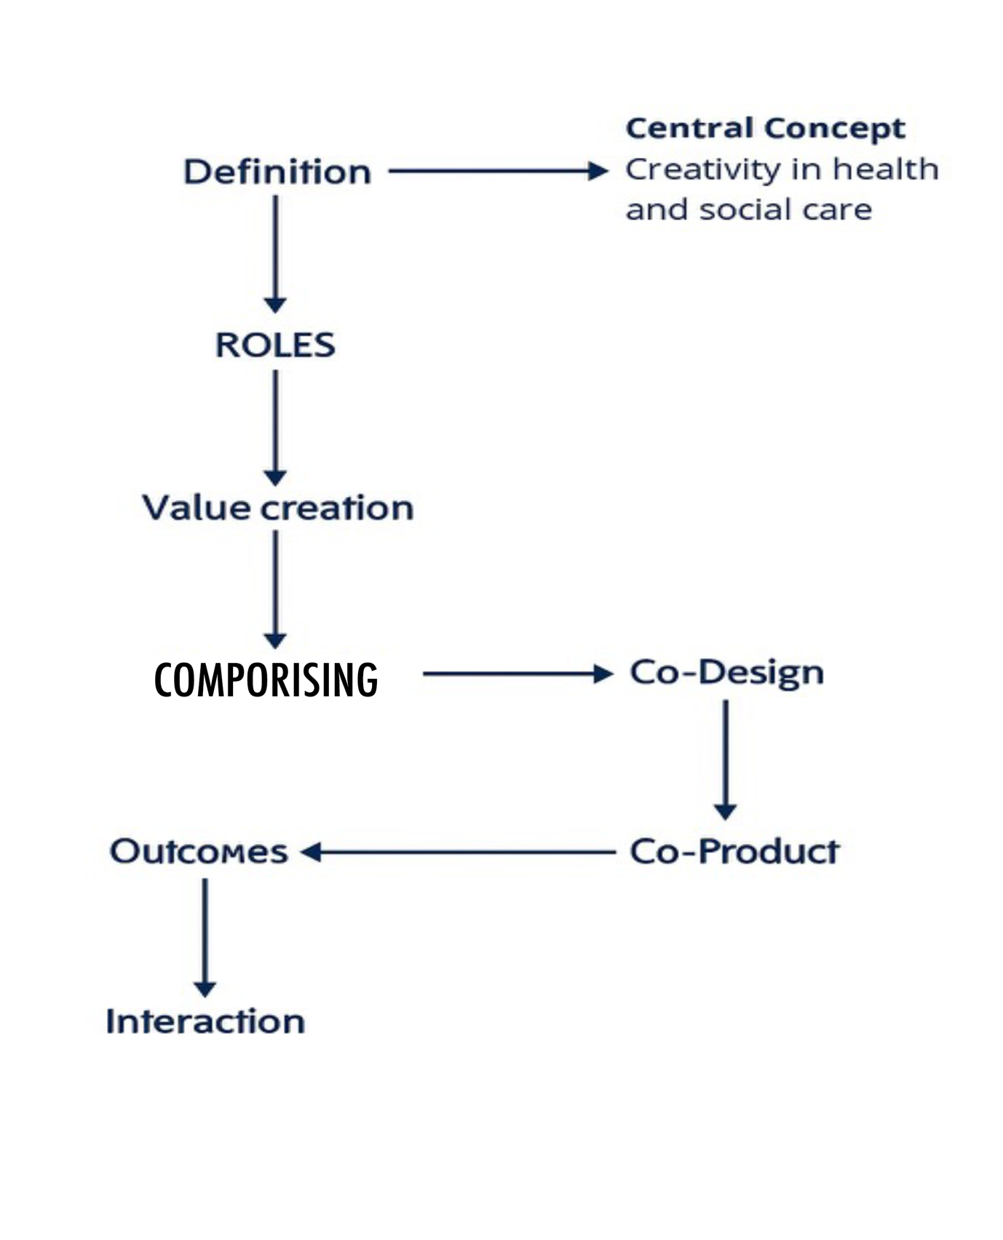

Concept Map: Creativity, Value Creation, and Health and Social Care Improvement

Creativity is the use of new ideas, innovative thinking, and imagination to address issues and raise the standard of social and health care services. It involves analyzing how healthcare is provided, how doctors engage with patients, and how systems may function more effectively. Innovative methods, including co-design workshops or digital innovations, assist both staff and clients in coming up with better ways to address community needs (Langley et al., 2020). Value Creation
In social and health care Value creation is the process that generates benefits that have value for patients, staff members, and the public. Better patient outcomes, greater effectiveness in use of resources, and increased service user satisfaction are some of these advantages. Enhancing health and wellbeing in a way that is equitable, long-lasting, and important to service patients is the target.
Creativity contributes to value creation by introducing innovative methods that increase effectiveness, reduce waste, and improve patient understanding. For example, creative problem-solving can lead to new models of community-based care that are both cost-effective and person-centered like Improves coordination and convenience for patients, reducing duplication of services and costs. (Vakkuri & Johanson, 2022).
Health and Social Care Improvement
Enhancing service quality, accessibility, and safety are the main goals of improvement in the service sector. It involves ongoing assessment and creative care practices. To develop new strategies and systems that address increasing demands, health and social care improvement relies on innovative thinking. The creation of value through innovative concepts makes services more impactful and long-lasting.
Interactions Between Concepts
Creativity drives value creation by producing innovative solutions. Value creation supports improvement by ensuring that new ideas lead to real, measurable benefits. In turn, promoting progress and the process of improving care encourages ongoing creativity to adjust to emerging challenges. Collectively, these components create a cycle in which innovation fosters value, which in turn supports further advancements in social and health services.

References
Langley, J., Wolstenholme, D., & Cooke, J. (2020) Exploring the value and role of creative practices in research co-production. Evidence & Policy.
Vakkuri, J. & Johanson, J. (2022) Value creation mechanisms in a social and health care innovation ecosystem – an institutional perspective. Journal of Management and Governance.

Task 2 - Self-Reflection of Group Activity

Component 1
During our group exercise, I used both divergent and convergent thinking to come up with innovative ways to enhance Mrs. Thompson's quality of life. Divergent thinking was used to generate a variety of concepts, such as meal delivery services, home modifications, telemedicine support, social visits, and community fitness initiatives.
Initially, I felt slightly overwhelmed by the number of ideas, but also excited to explore different perspectives. I enjoyed working in teams with other classmates, working together with teammates, as it encouraged creativity and empathy for Mrs. Thompson’s situation.
We came up with over 15 suggestions throughout our brainstorming session. I made a significant contribution by proposing and integrating two or more different strategies to produce a single, more effective solution, setting up social and emotional support, such as helping her visit the doctor because her physical health was deteriorating, going to the community to reduced loneliness, and making sure she had a walker or frame, a property free of hazards, and adequate lightning.
This exercise broadened my knowledge of convergent thinking as a method of narrowing ideas to the most workable and efficient solutions, and divergent thinking as a means of promoting free-thinking without fear of critique.
My goal is to utilize more structured brainstorming tools (like mind mapping) in the future to better arrange thoughts and make sure that everyone's input is recorded. To make better decisions.
All things considered, I was crucial to the development of the ideas and the evaluation of the risks, which resulted in a comprehensive strategy.
Reference:
Gibbs, G. (1988). Learning by Doing: A Guide to Teaching and Learning Methods. Oxford: Oxford Polytechnic.

Task 3 - Case Study of a UK innovation

Introduction
NHS England started the COVID Oximetry @home (CO@h) service to remotely monitor COVID-19 patients in the community during the pandemic. Finding early indicators of decline, particularly "silent hypoxia," was intended to help determine whether to seek care and enable prompt hospitalization if necessary. Primary care physicians and community health teams oversee monitoring, (Sherlaw-Johnson et al., 2022).NHS system planners are in charge of resource utilization, and patients are isolated at home. By bringing monitoring into patients' homes, to lessen preventable serious disease and hospital load.
Creativity and innovation
The innovative thinking of care delivery under pandemic restrictions gave rise to the Covid Oximetry at home service. By moving surveillance into the house. The innovative method collected clinical data every day by combining digital communication (phone calls or smartphone reporting) with basic hardware (pulse oximeters). The local team employed diagnostic methods to identify issues based on the oxygen saturation levels that patients took at home. (Herlitz et al., 2023).
One innovation was tailoring deployment models to the local setting. This allowed for flexibility in digital inclusion by allowing patients to send readings via phone in some places and via an app in others. In addition, the service relied on cooperative relationships, as GP federations, NHS England, Academic Health Science Networks, and local clinical commissioning groups co-designed training, escalation channels, governance, and protocols.
Innovative solutions were used to overcome obstacles; phone reporting channels were maintained for patients without cell phones. To overcome physician mistrust regarding remote monitoring, CO@h employed feedback looping. (Herlitz et al., 2023). The initiative changed the reactive system that was in place to a proactive hybrid approach, allowing clinicians to intervene sooner rather than waiting for patients to get worse. In essence, innovation was found in redefining the place of care by combining affordable gadgets, digital connectivity, to transform houses into virtual monitoring centers.
COVID Oximetry @home (CO@h) produced quantifiable advantages. Every 10% increase in program coverage was linked to moderate in-hospital mortality reductions and up to 2% lower mortality (though these results were not always statistically significant), according to an evaluation conducted throughout England. In general, patients expressed satisfaction with the service and a sense of security. By enabling safe home monitoring, the invention reduced the stress on hospital capacity and may have decreased the need for intensive care units and emergency hospitalizations. The CO@h initiative contributed to more effective resource usage throughout the NHS and enhanced access, patient safety, and satisfaction by allowing earlier identification and escalation.

References
Sherlaw-Johnson, C. et al. (2022) The impact of remote home monitoring of people with COVID-19 using pulse oximetry (COVID Oximetry @home): a national study. BMJ Open / PLOS / PMC.
Herlitz, L. et al. (2023) Patient and staff experiences of using technology-enabled remote monitoring for COVID-19. Journal of Telemedicine & Telecare.

Task 4 - Research Task
Inequitable Access to Mental Health Services in the UK
Despite the NHS providing healthcare free at the point of use, people from ethnic minorities and deprived backgrounds continue to experience inequitable access to mental health services. Compare to white British background. Cultural stigma, language barriers, and mistrust in statutory care contribute to poorer engagement and outcomes. Ignorance about how to Structural inequalities within the system further compound these disparities, leaving vulnerable populations underserved and continuing mental health inequities (Henderson, 2025; Sutton et al., 2024). Culture beliefs can influence how mental health is perceived.
According to (Henderson, 2025) the study, interpersonal, established, and basic racism are the main causes of these inequalities. Reduced trust and involvement result from institutional racism when services are designed and delivered in ways that do not take into account the cultural realities of minority groups of people are prevented from getting help by the cultural stigma associated with mental illness, which is affected by different community beliefs. Communication and language barriers further limit dignity, and social and economic hardship is especially common among ethnic minorities. Henderson thinks that attempts to achieve true equality in mental healthcare will fail if racism, stigma, and poverty are not addressed.
Sutton et al. (2024) conducted an organized mapping review examining 152 UK studies on inequalities in adult mental health access. The review finds persistent inequalities including long waiting times, high eligibility thresholds, and under-resourced services. It highlights that traditional healthcare access models overlook the specific challenges of mental health, such as involuntary care and pervasive stigma. Sutton et al. conclude that structural reform focused on reducing eligibility barriers, improving service capacity.
Mental health practitioners should review current approaches to assessment and treatment that are destigmatizing and promote open and inclusive practice.
Therefore, according to this two research, Actions to reduce inequalities should address barriers to population groups’ abilities to seek and reach services such as stigma-reducing interventions, and re-designing services and pathways.
References
Henderson, J. (2025) Barriers and challenges of people from ethnic minorities and ethnic groups accessing and using UK mental health services: a critical discussion. Journal of Mental Health and Social Inclusion.

Sutton, M., et al. (2024) Understanding inequalities in access to adult mental health services in the UK: a systematic mapping review. BMC Health Services Research, 24(30).

Task 5 - Podcast
Record a two-minute Podcast introducing your idea for component 2 using https://www.rev.com/onlinevoicerecorder

Task 6 - NHS Leadership Framework Analysis

All UK health and social care staff are expected to work in line with the NHS Leadership Framework, which emphasises that leadership is a shared responsibility rather than a position. It highlights that anyone can demonstrate leadership behaviours that support organisational success.
The framework identifies seven domains, establishing direction, creating the vision, delivering the strategy, working with others, demonstrating personal qualities, managing services, and improving services each supported by specific components and behaviours relevant across roles and disciplines.
Leadership should reflect shared values and contribute positively to the broader health and care system, including patients, service users, staff, and partners (Leadership Academy, 2011). By providing a common language and structure, the framework strengthens leadership competency, promotes quality care, supports teamwork, and encourages continuous improvement.
CREATING A VISION in health and social care: Description & benefits
Creating a vision involves developing a clear, values driven, and future focused direction for services. This includes engaging shareholders, staff, and patients in shaping how the organisation will respond to present and early healthcare challenges. Leaders should discuss future service needs, analyse internal and external trends, and ensure support with wider system importance and core NHS values (Leadership Academy, 2012).
In practice, an NHS leader uses this domain to inspire innovation by outlining a shared direction and encouraging contributions from frontline staff, social care partners, and service users. This inclusive approach builds ownership, supports idea making, and strengthens partnership. Benefits include a shared purpose, improved motivation, better integration across health and social care, and co-designed change leading to enhanced care quality, innovation, and viable improvement.

References
NHS Leadership Academy (2011) The Leadership Framework. NHS Institute for Innovation and Improvement.
NHS Leadership Academy (2012) Leadership Framework – Self-assessment Tool. Coventry: NHS Institute for Innovation and Improvement.

Task 7 - Self-Reflection Journal Entry

During this session, my understanding of creativity and value creation in the health and social care (H&SC) sector has significantly increased. I've learnt that creativity is necessary for bringing about significant change and enhancing care outcomes, and it extends beyond innovation or problem-solving using convergent and divergent thinking. Fullan (2016) emphasises the idea of "unchangeable leadership," which fosters the attributes of adaptation and ongoing learning that are essential for creating a thoughtful and innovative care environment. This realisation has inspired me to see creativity as a collaborative process that enables professionals and service users to work together to find better solutions.
Furthermore, I've realised that developing long-term value in H&SC contexts requires strong, moral leadership. Anderson (2013) contends that while ineffective leadership can harm organisational culture and limit advancement, effective leadership promotes trust, motivation, and engagement. The significance of communication, empathy, and authenticity in professional practice has been confirmed by this understanding. Studying Situational Leadership as well, Leadership that Transforms, this provides a better understanding of transactional leadership and contingency leadership.
By putting these teachings into practice, I hope to improve care delivery by creating an environment where ethical leadership and innovation flourish. I can help my organisation develop a more creative, caring, and values-driven culture by leading with integrity and encouraging teamwork.

References
Anderson, A.R. (2013) Good Leaders Are Invaluable To A Company. Bad Leaders Will Destroy It. Available at: www.forbes.com/sites/amyanderson/2013/01/14/good-leaders-are-invaluable-to-a-company-bad-leaders-will-destroy-it/ (Accessed: 4 January 2024).
Fullan, M. (2016) Indelible Leadership: Always Leave Them Learning. Thousand Oaks: Corwin Press.

