Ford Dagenham Restaurant Project
Student Name:Andrei Rosu
Student number:2018579
Module title and code:BMSW5104 Managing Projects in the organisation
Lecturer Name: Alfred Mensah
Assigment Title: Managing Projects in the organisation

Executive Summary
This project aims at solving the catering problem at Ford Dagenham. Ford Dagenham is a branch of Ford Motor Company and is located in Dagenham, London. The company's staff are facing a challenge when it reaches lunchtime as most staff congest the local area in search of food. The problem has also resulted in a higher rate of staff absenteeism. Therefore, as a group of four project experts, we propose opening Ford Dagenham Restaurant, which will solve the described catering issue faced by Ford Dagenham. The title of this project is "Opening of Ford Dagenham Restaurant for Ford Dagenham Company Staff." The project will have three objectives. The first objective is to develop a 6-month plan for establishing Ford Dagenham Restaurant to reduce congestion issues caused by Ford Dagenham staff. The second objective is to create an engaging experience for Ford Dagenham staff to sample the restaurant's food and drinks for health benefits. The last objective is to achieve Sponsor/Client satisfaction after the project. This project is expected to begin on 1st April 2023 and end on 9th September 2023 with a total budget of £200,000. The restaurant will be located in Dagenham, London. At the end of the project, we will have the restaurant's sample meals, drinks, special offers and coupons provided by the sponsor/stakeholder. The restaurant will allow the Ford Dagenham staff to comfortably enjoy their breakfast and lunch to reduce congestion in the local area and the high absenteeism rate. Documents for the scope of a project will be drafted and approved by the project’s sponsor, director, the manager, and any other interested parties. It will include all metrics for measuring performance and quality assurance checklists for all deliveries. The project will be considered a success if it is provided, carried out, and finished on schedule and without exceeding the budget. This is when the client will be satisfied and grant their formal permission.
Table of Contents
Executive Summary 2
Case Study Overview 4
Project Scope 5
Collection of Requirements 6
Stakeholder Analysis – Roles & Responsibilities 6
Project Deliverables 7
Constraints 9
Project Assumptions 9
Work Breakdown Structure (WBS) 9
Success Criteria 11
Project Schedule and Milestones 11
Cost Management Plan (Budget) 13
Communications Management Plan 15
Risk Management Plan 17
Project Resources 20
Project Close-out and Conclusion 22
References 24
Appendices 25

Project Title
Opening of Ford Dagenham Restaurant for Ford Dagenham Company Staff
Stakeholders
- Owner/sponsor: Ford Dagenham
- Project director: Andrei Rosu
- Project manager: Andreea Scorpie
- Budget and finance officer: Olga Alui Gheorghe
- Project planning officer & Operations officer: Gheorghe Alui Gheorghe

Case Study Overview
Ford Dagenham is a branch of Ford Motor Company and is located in Dagenham, London. Since its inception in 1931, the plant has produced over 10.5 million vehicles and more than 39 million engines (Archive, 2022). The company employs over a thousand individuals, including managers, accountants, and production staff. Both the corporate headquarters and the production plant share the same massive land. Unfortunately there is currently no onsite catering. For Ford Dagenham to solve the catering crisis, they need a project plan. The company wants to reduce the number of employees who leave at lunch, which is currently causing congestion in the area around the office. Since the company views corporate social responsibility (CSR) as an integral part of its operations, it hopes to help its staff adopt healthier lifestyles in the hopes that this would reduce absenteeism. Therefore, as a group of four project experts, we propose opening Ford Dagenham Restaurant, which will solve the described catering issue faced by Ford Dagenham.

Project Scope
The title of this project is “Opening of Ford Dagenham Restaurant for Ford Dagenham Company Staff.” The project will have three objectives. The first objective is to develop a 6-month plan for establishing Ford Dagenham Restaurant to reduce congestion issues caused by Ford Dagenham staff. The second objective is to create an engaging experience for Ford Dagenham staff to sample the restaurant's food and drinks for health benefits. The last objective is to achieve Sponsor/Client satisfaction after the project’s completion. The reason for developing this project is to solve the catering issue at Ford Dagenham. Ford Dagenham experiences a challenge with staff congestion issues in the local during lunch hours. The company also experiences staff absenteeism as a result of challenges caused by accessing catering services. Therefore, the opening of Ford Dagenham Restaurant will solve the described catering issues faced by Ford Dagenham.
This project will involve opening Ford Dagenham Restaurant starting 1st April 2023 and ending 9th September 2023 with a total budget of £200,000. The restaurant will be located in Dagenham, London. At the end of the project, we will have the restaurant’s sample meals, drinks, special offers and coupons provided by the sponsor/stakeholder. The restaurant will allow the Ford Dagenham staff to comfortably enjoy their breakfast and lunch to reduce congestion in the local area and the high absenteeism rate. Documents for measuring the scope of a project will be drafted and approved by the project's sponsor, director, the manager, and any other interested parties. It will include all metrics for measuring performance and quality assurance checklists for all deliveries. When the project goes through its lifecycle and the planned scope is achieved, managers of the project's objectives and stakeholders/sponsors will know what is being done with regard to expensed resources and whether or not expectations of stakeholders/sponsors are being met. The project will be considered a success if it is provided, carried out, and finished on schedule and without exceeding the budget and the client is satisfied.

Collection of Requirements
For the launch of the Ford Dagenham Restaurant, we will implement a strategy to collect requirements by first classifying the deliverables into project and product-related categories, then conducting interviews, surveys, and document analysis to determine what is needed, and finally putting that need into action. The tools and techniques utilised to get crucial understanding of the project and product requirements will include focus group interviews between the key stakeholders and client and staff surveys with a sample population of one hundred Ford Dagenham employees (Cook et al., 2021). The project team will analyse the information gathered and organise the survey results and the requirements in order to set priorities and assign responsibility. Acceptance criteria and document analysis will be developed to determine whether a requirement has been met. After a need has been identified, it will be documented and communicated to the appropriate team member and the applicable stakeholder. The Requirements Traceability Matrix links the established and documented demands of the project to the elements that are part of the project's scope and work breakdown structure (Duraisamy and Atan, 2013). Check Appendix A for the Requirements Traceability Matrix.

Stakeholder Analysis – Roles & Responsibilities
The table below shows the stakeholders for this project and their various responsibilities.
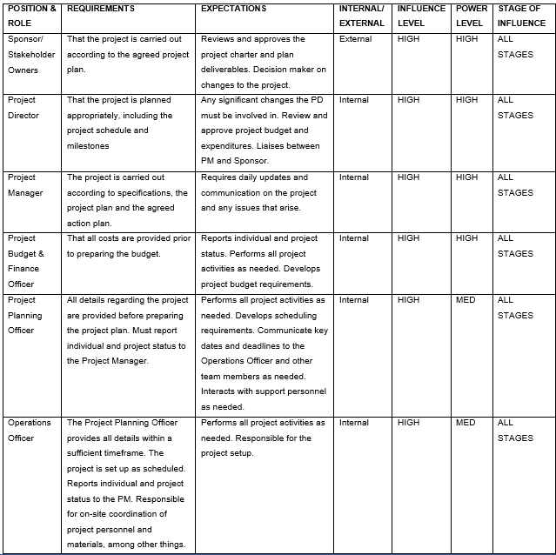

Project Deliverables
The project requirements or deliverables will be as identified in the table below;
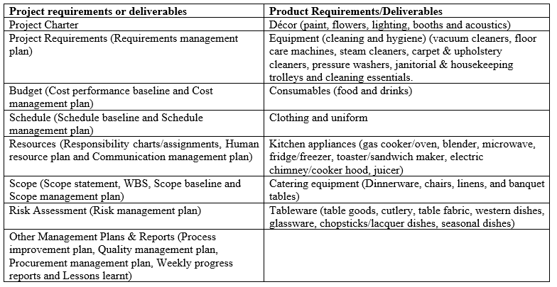
Exclusions
- The project sponsor will provide food, drink, free samples, special promotions, and full-time workers.
- The project sponsor will be responsible for ensuring quality of food, beverage, and other sample.
- The project sponsor shall also describe prices of the expected products.

Constraints
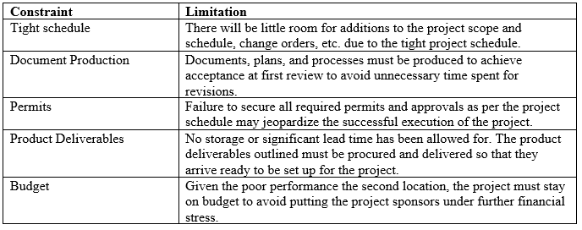

Project Assumptions
- The Ford Dagenham Restaurant's workforce, including its cashiers, chefs and waiters, will be provided by the sponsor. This means that we need to quickly recruit and train new employees for this project.
- The sponsor will give free samples of their delicious food, beverages, and other things. However, if we need more materials for the project, we will have to make a purchase from a separate firm, which is counter to the project's goals.

Work Breakdown Structure (WBS)
We will use the following WBS to facilitate the Ford Dagenham Restaurant's delivery successfully. This WBS is a tree structure view.
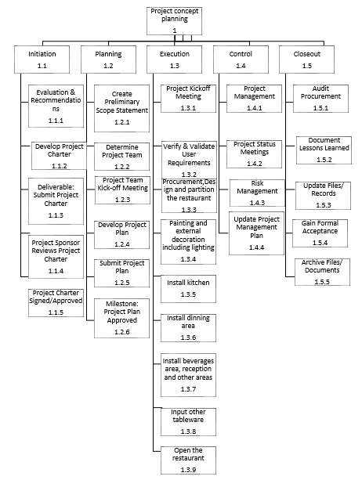

Success Criteria
The project will be deemed a success when the client is delighted with the outcomes of the project and grants their formal permission after it has been finished on time and within budget.

Project Schedule and Milestones
The following schedule outlines the key events, tasks, and deliverables that make up a project, as well as when they are expected to get underway and wrap up. The schedule is planned as linkages between activities and dependencies, based on resource allocation and duration. Timeline components are tightly linked to the organisational framework for getting the work done.
Level | Resource/task Name | Team Lead | Duration | Start | Finish
1 | Project concept planning | Project director | 3 days | 1st April 2023 | 3rd April 2023
1.1 | Initiation
1.1.1 | Evaluation & Recommendations | Project director | 3 days | 4th April 2023 | 6th April 2023
1.1.2 | Develop Project Charter | Project director | 11 days | 7th April 2023 | 17th April 2023
1.1.3 | Deliverable: Submit Project Charter | Project director | 3 days | 18th April 2023 | 20th April 2023
1.1.4 | Project Sponsor Reviews Project Charter | Project director | 3 days | 21st April 2023 | 23rd April 2023
1.1.5 | Project Charter Signed/Approved | Project Sponsor | 3 days | 24th April 2023 | 26th April 2023
1.2 | Planning
1.2.1 | Create a preliminary Scope Statement | Project manager | 3 days | 27th April 2023 | 29th April 2023
1.2.2 | Determine Project Team | Project manager | 8 days | 30th April 2023 | 1st May 2023
1.2.3 | Project Team Kick-off Meeting | Project manager | 3 days | 2nd May 2023 | 4th May 2023
1.2.4 | Develop Project Plan | Project manager | 7 days | 5th May 2023 | 11th May 2023
1.2.5 | Submit project plan | Project manager | 3 days | 12th May 2023 | 14th May 2023
1.2.6 | Milestone: Project Plan Approved | Project director | 8 days | 15th May 2023 | 22nd May 2023
1.3 | Execution
1.3.1 | Project Kick-off Meeting | Project manager | 3 days | 23rd May 2023 | 25th May 2023
1.3.2 | Verify & Validate User Requirements | Project manager | 7 days | 26th May 2023 | 1st June 2023
1.3.3 | Equipment procurement and Design and partition of the restaurant | Budget & finance officer and Planning officer | 8 days | 2nd June 2023 | 9th June 2023
1.3.4 | Painting and external decoration, including lighting | Operations officer | 8 days | 10th June 2023 | 17th June 2023
1.3.5 | Install kitchen | Operations officer | 6 days | 18th June 2023 | 23rd June 2023
1.3.6 | Install dining | Operations officer | 14 days | 24th June 2023 | 7th July 2023
1.3.7 | Install beverages area, reception and other areas | Operations officer | 18 days | 8th July 2023 | 25th July 2023
1.3.8 | Input other tableware | Operations officer | 6 days | 26th July 2023 | 31st July 2023
1.3.9 | Open the restaurant | Project manager | 3 days | 1st August 2023 | 3rd August 2023
1.4 | Control
1.4.1 | Project Management | Project Manager | 4 days | 4th August 2023 | 7th August 2023
1.4.2 | Project Status Meetings | Project Manager | 3 days | 8th August 2023 | 10th August 2023
1.4.3 | Risk management | Project Manager | 6 days | 11th August 2023 | 16th August 2023
1.4.4 | Update Project Management Plan | Project Manager | 3 days | 17th August 2023 | 19th August 2023
1.5 | Close-out
1.5.1 | Audit Procurement | Budget and finance officer | 6 days | 20th August 2023 | 25th August 2023
1.5.2 | Document Lessons Learned | Project Manager | 3 days | 26th August 2023 | 28th August 2023
1.5.3 | Update Files/ Records | Project Manager | 3 days | 29th August 2023 | 31st August 2023
1.5.4 | Gain Formal Acceptance | Project Sponsor | 6 days | 1st September 2023 | 6th September 2023
1.5.5 | Archive Files/ Documents | Project Manager | 3 days | 7th September 2023 | 9th September 2023

Cost Management Plan (Budget)
The final cost plan for the Ford Dagenham Restaurant will be delivered on September 9th, 2023 and will include a description of all the resources, space, material, and equipment required to finish the project. As a baseline, we've allocated £200,000 for this project.
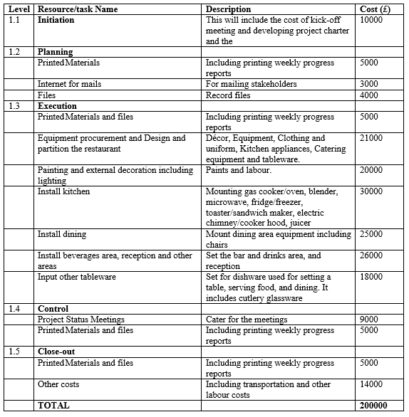
Cost Control
The Project Budget & Finance Officer will be accountable for cost management. He will provide tracking sheets with each and every quote and invoice generated by the project team. He also be in charge of adding each expense to the cost baseline. The officer will use many methods of tracking, such as earned value management, to keep track of budgeted, earned, and actual spending. A system will be put in place to track all costs.

Communications Management Plan
The following are the stakeholder communication requirements.
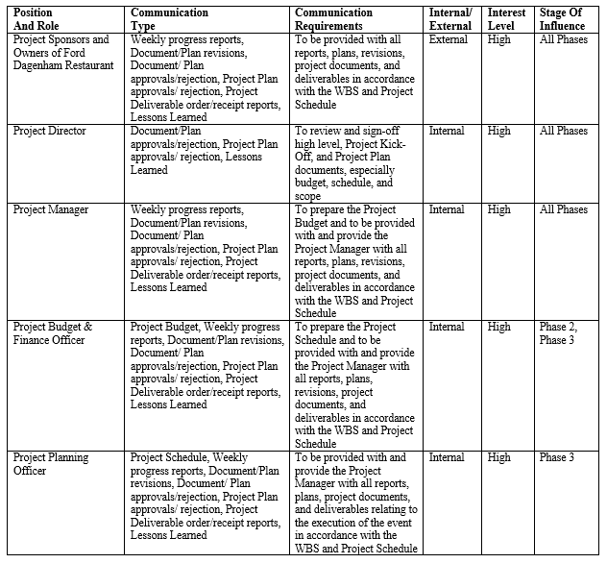
The following is the information to be communicated.
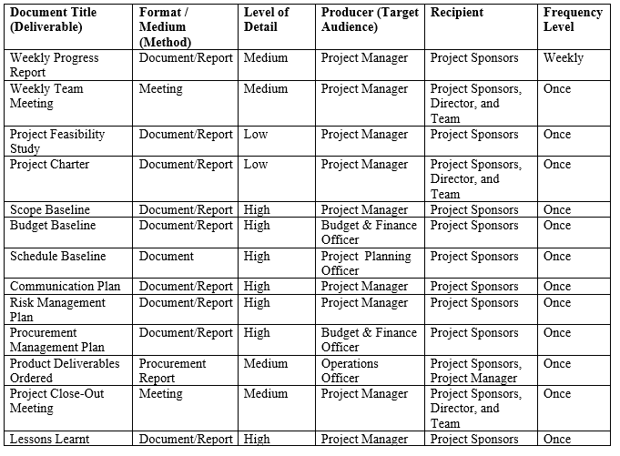
Below is a table that explains when it is appropriate to utilise email, phone calls, and other forms of communication depending on the nature of the work at hand.
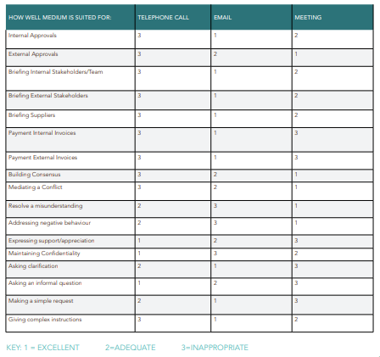

Risk Management Plan
The goal of the Risk Management Plan is to identify possible problems that might delay or thwart the opening of the Ford Dagenham Restaurant and then create a strategy to deal with them (Rodrigues-da-Silva and Crispim, 2014). Using what we learned from previous similar projects, we sat down with key players to interview, then used that information along with a combination of brainstorming and discussion to identify the most pressing risks that needed to be factored into the project's final outline. After carefully identifying and analysing each potential risk, we came up with targeted measures to eliminate them. Should the threats materialise, we will do all in our power to ensure adequate measures are implemented to counteract them. Every member of the staff has been briefed on the necessary procedures and reminded that they must be completed on time as it has been determined that all potential threats will materialise on the day of the event. The Project Manager will be on-site, will be the one to whom all employees report, and will keep the Stakeholders informed. The risk breakdown structure will be as shown below;
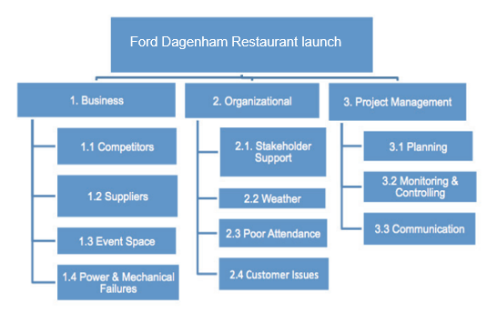
The table below details how we came to our conclusions on the various risks and the categories into which they fall. The table assesses the validity of doing the quantitative risk analysis method.
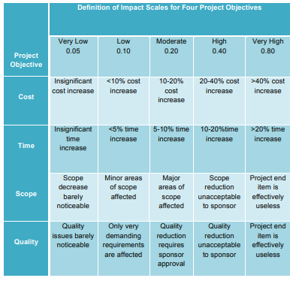
In determining the likelihood of each risk described below, the Risk Breakdown Structure was consulted. The colour red represents a very high risk, the colour yellow represents an intermediate risk, and the colour green represents a very low risk.
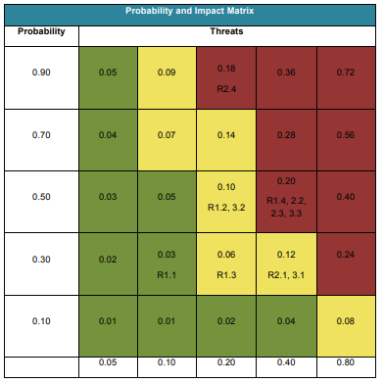
Each risk associated with the event prompted the Project Manager and the Project Team to brainstorm possible preventive actions. When more information about possible threats becomes available, an updated risk assessment and strategy for mitigating such threats will be established and included into the event's ongoing preparations. All project risks will be managed and controlled within the bounds of the triple constraints (time, scope and cost). Time is the most significant constraint that may be imposed on the four highlighted risks. The project team will analyse each new risk that arises to determine whether or not the current mitigation strategy is still the best option. The Project Manager will be informed of any threats and will keep the Stakeholders informed as necessary.

Project Resources
Human Resource
Ford Dagenham Restaurant Project success relies on everyone doing their part to realise its goals. Each team member needs a clear grasp of their role and how to proceed with the project in order to do their part well. The RAM chart below depicts the relationship between project responsibilities and team members by outlining who is responsible for what and how they are involved in the project (Shrahily et al., 2022). The Project Manager must examine and approve any proposed changes to assigned tasks. Any changes proposed will adhere to the project's established protocol for handling such requests.
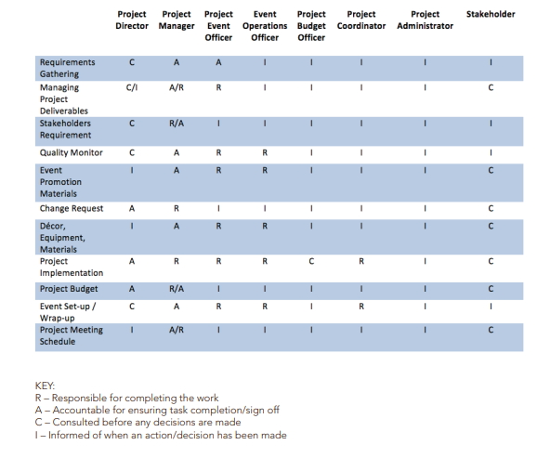
We have enough staff on hand with the necessary skill sets across the board in order to launch the Ford Dagenham Restaurant. We employ a three-staged approach to planning and reporting to guarantee that the best possible personnel are available to work on projects when they are due. Our approach to project management differs from that of most other professionals in the industry since, rather than relying on outside consultants, we choose to build up our own in-house team of experts in the subject. Although everyone on staff will have specific tasks assigned to them based on their areas of expertise and their own goals for professional growth, they may sometimes be asked to work together on a single task. The Project Manager may make this three-stage technique more manageable by creating a project resource histogram before Phase 1 is complete and by adding resources into the project schedule as soon as possible.
Focus will be placed on those team members identified by the Project Director and Project Manager as essential for the duration of the project before Phase 1 is completed. A report detailing this information will be sent to the project's backers and other interested parties. Instilling faith that sufficient means are at hand to guarantee the project's success is central to the purpose of this correspondence. The project resource histogram and the resource-loaded schedule will be referred to if they are available at this early stage to aid and make this stage practical.
The Project Manager is responsible for putting together a Phase Resource Requirements Report at least a week before the beginning of each new phase. After this report is finished, you'll know that everything you need to start working on the designated phase of the project is on hand and ready to go. Moreover, the Project Manager will utilise this report to rally the troops and keep them focused on the mission at hand as the project progresses. As we move into this next phase, the Project Manager will examine the resource histogram and resource loaded schedule to make the most informed decision possible about how to allocate the project's limited resources. Feedback on individual performance will also be provided using the Project-Close-out Resource Release Report.

Project Close-out and Conclusion
The Project Manager will compile a Project Close-out Resource Release Report for each employee throughout phase 4 of the project. The Project Manager may utilise this report as an opportunity to provide helpful feedback to team members based on their performance throughout the phase of the project lifecycle being reported on. The specific needs for this input will be discussed in further depth in the next paragraph. The Project Manager will discuss the individual's impressions of the project, how it met or failed to meet the individual's professional development goals, and how the Project Manager would recommend the individual for future work. The project will end with signing of the client acceptance/project completion form.

References
Archive. 2022. Ford Dagenham at 80. [Online]. Available at: https://web.archive.org/web/20100824105738/http://www.ford.co.uk/AboutFord/News/CompanyNews/2009/Dagenham80 [Accessed 17th March. 2023].
Cook, J.A., Baldwin, M., Cooper, C., Nagra, N.S., Crocker, J.C., Glaze, M., Greenall, G., Rangan, A., Kottam, L., Rees, J.L. and Farrar-Hockley, D., 2021. Focus groups. In Patch augmentation surgery for rotator cuff repair: the PARCS mixed-methods feasibility study. NIHR Journals Library. Available at: https://www.ncbi.nlm.nih.gov/books/NBK568182/
Duraisamy, G. and Atan, R., 2013. Requirement traceability matrix through documentation for scrum methodology. Journal of Theoretical & Applied Information Technology, 52(2), pp.154-159. http://www.jatit.org/volumes/Vol52No2/5Vol52No2.pdf
Rodrigues-da-Silva, L.H. and Crispim, J.A., 2014. The project risk management process, a preliminary study. Procedia Technology, 16, pp.943-949. Available at: https://doi.org/10.1016/j.protcy.2014.10.047
Shrahily, R., Medjdoub, B., Klalib, H., Chalal, M. and Alwetaishi, M., 2022. Managing construction site communication using the responsibility assignment matrix (RAM) system. International Journal of Construction Management, 22(15), pp.2966–2986. https://doi.org/10.1080/15623599.2020.1837717

Appendices
Appendix A: Requirements Traceability Matrix
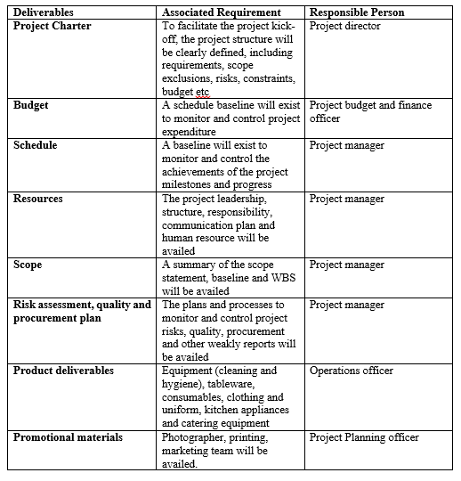

Appendix B: Task 1- Pitching of Project Management Plan (Group Presentation)


