Financial Management
BMMB7013

Date of Submission: 18th December 2020

Course Title: Strategy Management
Course Code: BMMB7013
Student name: Ji Yu
Student Number: 2006525
Report Title: Tesla Strategic Management Analysis
Date of Submission: 18th December 2020

Tesla Strategic Management Analysis
Abstract
Tesla Automobile Company, as the world's top independent manufacturer of pure electric vehicles, is developing at an amazing speed, and its strategic management model is thought-provoking. By analyzing Tesla's product positioning, SWOT analysis, related strategy analysis and market strategy analysis. Through market positioning, user experience pursuit and brand thinking, this paper analyzes Tesla's overall strategic thinking, and finally puts forward all kinds of challenges that Tesla is facing at present, and what aspects still need to be done better.

1.Introduction
1.1 Company Profile
Tesla Automotive is a famous brand,which produces and sells parts of electric vehicles .The company was set up in 2003 and its head was in Silicon Valley, California.It was also Founded by silicon valley engineer and veteran fan martin,whose investor is Space X founder musk,.What we know that is the world's first electric car company Tesla is using lithium-ion batteries, which is now producing only pure electric vehicles rather than hybrid vehicles^{[1]}. With its unique shape, efficient acceleration, good handling performance and advanced technology, the car becomes the fastest and most fuel-saving car on the highway.As the figure1,it is the latest appearance of Tesla cars.
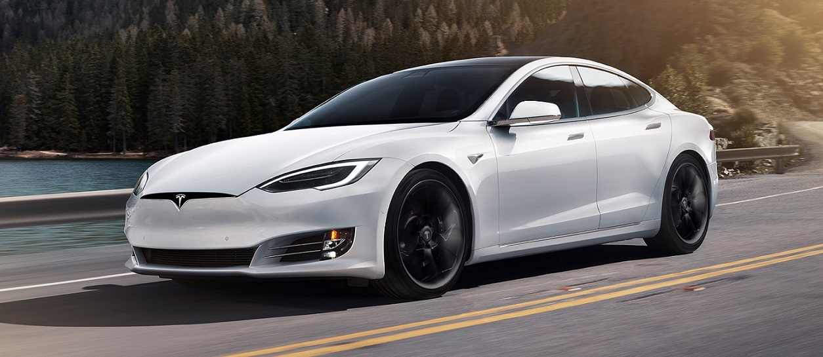
Figure 1.The latest appearance of Tesla cars
Tesla is the continuation of American innovation ability. Tesla raises people’s attention specially and the innovative spirit of the United States is reflected in the business thinking way^{[2]}. It also indicates that the innovation ability of the United States still has great potential a long time. First of all, from analyzing the national main strength of the USA. American management scholar whose name is Michael Porter set up the popular "diamond model" in 1990:" factor condition "," demand condition "," supporting company "and" enterprise strategy "four elements, which all decide the cause of a certain industry's competitive advantage^{[3]}. The author believes that if the diamond model and the four elements are extended from a higher perspective Go, form the main strength of a country or region^{[4]}. If the above diamond model is used to study the main strength of the United States, it is obvious that the exploration and innovation spirit formed by the history, culture, race and institutional design of the United States since the founding of the United States for more than 230 years has constructed the innovation ability of the United States. This is the main strength of the United States. No one economy or country can match this innovation. The main strength of the USA transform from the practical level to the political cause, economic and cultural levels of social activities and governance, and continues to affect the world. Although the United States has been widely weakened in the world in recent years, the overall strength curve of the United States is within a foreseeable time There is still no systematic downward trend. Looking at Tesla's model, it is another promotion and innovation of American traditional manufacturing industry. Looking back on the national innovation ability of the United States, it led the rapid development of the world, especially the manufacturing industry, after World War II. The rise of economies represented by Japan after the 1960s and 1970s diluted the main strength of American industries. However, since entering the new 21th technological times, the creative competence of America has once again led the global economic development, and a group of multinational companies represented by America have acted as the protagonists of innovation^{[5]}. Towards the end of the first decade of the new century, the economies represented by the United States are themselves in the governance system Management failure, and then triggered the global financial crisis^{[6]}.
Tesla,which is from Silicon Valley, inherits Silicon Valley's innovative genes and is another great example in the field of traditional vehicle manufacturing after IBM、 varies of creative American smart companies, such as Microsoft, Google, eBay、 Amazon, Facebook、 Apple and so on^{[7]}. Tesla's many new models are also catering to the innovative strategy of the United States government on science and technology innovation, and has won the strong support of the United States government. Therefore, Tesla is born not by accident, but by necessity. It is also a typical example of American innovation in the return of manufacturing and upgrading of traditional industries^{[8]}. Why would Tesla advance vehicle market in America?There are some words can be said to break the sky: the core feature of parts integration is far greater than the substitute of components. The core competitiveness of Tesla so far is its unique system integration ability.
1.2 Development history
About the development of Tesla, At the beginning of Tesla, Eberhard worked with AC Propulsion, No factory mode. 2004, Musk investment, Require the right to decide all matters. Between 2004 and 2007, Musk keeps financing, For ROADSTER research and development, As of January 2009, Tesla raised more than $187 million^{[9]}. 2010, Tesla's acquisition of the new United car factory, Build into the production base of electric vehicles. June 2010, On the Nasdaq stock market, Tesla is the only one independent manufacturer of pure electric vehicles in America. Tesla made its first profit in 10 years in May 2013 with its first-quarter results for fiscal year 2013. On the afternoon of February 19,2014, Tesla issued a 2013 email to shareholders. In the fourth quarter, Tesla achieved record car sales,which are around more than $2 billion each year, according to mail.In June 2018, Tesla built its 10000th super charging station around the world^{[10]}.
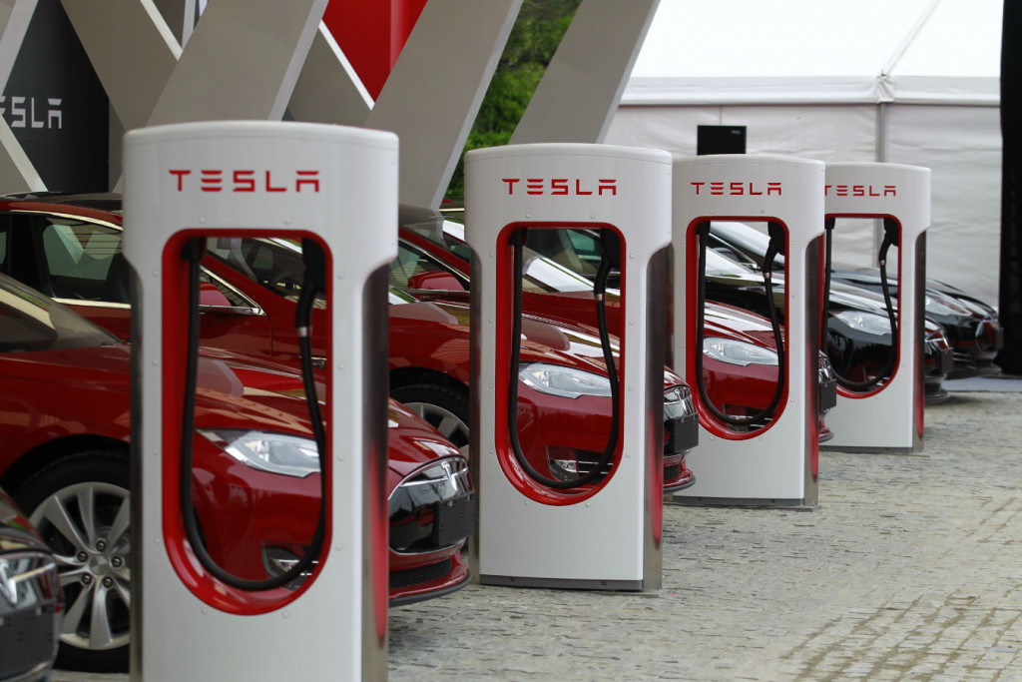
Figure 2.Tesla motors’ global charging stations

1.3 Product positioning
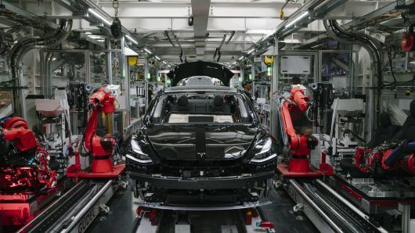
Figure 3.Tesla car processing site

Tesla, which carries the genes of high-tech enterprises from Silicon Valley, gradually extends from the high-end market to the low-end market^{[11]}. Early to the rich as the target group, cut into the high-end market.From Brad Pitt, George Bruni, Schwarzenegger to Google's two founders, A lot of global wealth buy Tesla's production models,which determine its global competence.Later on, after gradually gaining market recognition, under the impetus of technological innovation and market maturity, the low-end market models were gradually introduced.The $50,000 model model X and the $30,000 economy car "Gen III", will capture the mass market.
In fact,Tesla's products are cool and practical. The automation integrity atmosphere is known as the world's greatest luxury cars,which use 75 minutes full of electricity to run 480 kilometers, and the highest speed of 200 kilometers per hour, the lowest configuration of more than $7 W, the highest configuration of about $10 W^{[12]}. Tesla car and the same market positioning series of products, sales growth rate, performance steadily rising space.
1.4 Business model
It has taken many ink for Industry and researchers to analyze Tesla's wonderful strategic model. Tesla has always pursued the enterprise ideal of providing electric vehicles to the market at affordable prices and transforming the world into electric. Tesla has five proud basic operating capabilities to ensure current and future sustainable development. Tesla is the only advanced electric vehicle brand in the world, creating the unique brand context of Tesla^{[13]}. In fact ,the performance of its market is also very useful to analyze its strategy. 2013 cumulative sales of Tesla is far higher than BMW, Mercedes-Benz and other luxury car brands. Partner is Tesla's unique shipment Camp advantage. Tesla's competitive advantage mainly comes from the system integration innovation^{[14]}. It fully realizes the function of vehicle mobile interconnection. The unique dashboard screen in the vehicle is the iconic core component, becomes the center of information collection and manipulation which is controlled in Tesla vehicle, and has excellent man-machine interaction system. terminal customers buy cars to be provided one-stop financing services,which is financial growth of Tesla. In China, under the distortion of various interest groups, auto financial services soon encountered regional auto industry regulation and control. On Tesla's website, anyone who wants to own a Tesla S and cash-strapped car can tap the tiny links —— financing on the page.
On the marketing model, Tesla also has the same work as the new 3 C product models such as Apple iPhone、 Xiaomi mobile phone, that is, fully grafted Internet technology, introducing the most popular 020 direct mode, so that consumers can enjoy the shopping experience, transaction convenience and value enjoyment when buying Tesla. Tesla's business model has a lot to do with apple's iPhone, and the industry calls tesla "apple of the world "^{[15]}. In fact, hiring Apple executives responsible for new product design is Tesla’s plan to join the management team. In Tesla's internal cognition, the development track of electric vehicle and the mobile phone the evolution trajectory is coincident. It can be said that Tesla is really doing cars as consumer electronics.From thinking in culture and value cause, supporting an enterprise business model is a main thing that should be the main values or corporate culture of the company^{[16]}. It is believed that corporate culture of Tesla is the company's unique treasure and largest asset,whose basic elements are "quick action, special can not do, continuous innovation, shareholder thinking, everyone one ". Tesla's initial results also confirmed the role of the above corporate culture, especially the continuous innovation, dedicated to the cultural essence of the first, enabling 7000 employees of Tesla to work together,which achieve the world's first luxury electric vehicle.That is the real commercial landing of the sedan car.

2.SWTO Analysis
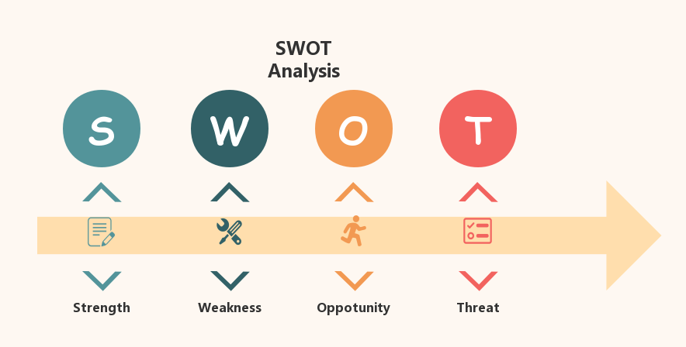
Figure 4.SWOT analysis diagram

2.1 Strength：
Technology advantage, Tesla car has upgraded electric vehicle battery technology and transmission system differential voltage gearbox technology,which is so vital that other vehicle companies do not have.Therefore,in my opinion, higher safety and driving is Tesla’s unique feature than the same grade car.
There is a complete industrial vehicle chain, like California, Tesla built hundreds of charging stations.So that the customer's electric vehicle charging problem can be solved.
There are larger internal combustion engine modules in Tesla cars comparing with traditional cars Space. Tesla has three useful versions and three battery charging methods, allowing customers to have different driving experiences.In fact,Tesla also has a luxury configuration comparing to Mercedes-Benz, BMW no less.

2.2 Weakness：
Tesla's profit has a high risk, not that Tesla ca n' t make a profit, but that it has less ability to take risks. If demand for electric vehicles fluctuates slightly, or there is a delay in production, Tesla cars may be at great risk.
As we all known that the stability of the battery is not fully to be verified useful and the safety of vehicle is not very stable. In November 2013, Tesla three consecutive misfires have evaporated nearly 28% of its market value, so it has one battery compared to other electric vehicles,which has some fixed advantages, but far from enough public standards.
Marketing network bearing capacity is not good, service in China can not keep up. Although vehicle costs are really high, but for most consumers to buy such a high-end car, they think its price is lower than the same type of car.That might result in low profit margins.

2.3 Opportunity
From selling cheap and normal models, the main target of the Tesla is to build an automated plant that produces millions of orders of magnitude a year,to benefit ordinary people from electric vehicles.
Tesla's SUV model is based entirely on the characteristics suv electric drive,what people really want is that Tesla decides to build the world's largest battery charging plant in 2017 ,the total number of batteries produced in one year will exceed that of lithium-ion electricity for all uses worldwide in 2013 total pool output.
Group into China and Europe, where demand is strong and the Chinese government is targeting new energy vehicles and there is some support.

2.4 Threat：
Technical:Competitors will be technically anti-superior, The overall battery electric system and transmission system technology of Tesla is a main position in the vehicle industry, but other companies are also acquiring this technology. It is conceivable that once other companies invent this kind of technology and Tesla fails to develop more effective new technology, people will worry about Tesla's future and its market will be vague.
Price: compared with other brands of electric vehicles, the price does not have an advantage.
Capital: can't get the strong capital that big car market have, and these companies are also getting enter the electric vehicle market. (GM's Chevrolet Volt and Nissan Leaf both plan to work with Tesla Pull the S car on line at almost the same time. )

3.Analysis of 4Ps Marketing Strategies in Tesla
Tesla target market is a group with rich consumption level. Further, Tesla's target customer base is environmentalists who love luxury cars or technology.
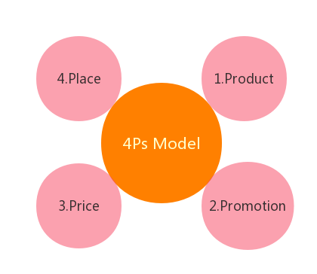
Figure 5.4Ps Model

3.1 Product strategy
It is known that the biggest feature of Tesla is "green ", an electric vehicle that can effectively reduce global carbon emissions. The vehicle body is made of light aluminum and reinforced with boron steel to some extent reduce the unnecessary energy consumption of the car and ensure its performance. A variety of people usually like to buy luxury goods, but they want to be more environmentally friendly,so Tesla is the best choice for this group.

4.2 Promotion strategy
Tesla has taken a different approach to advertising. Instead of traditional advertising, Tesla has adopted a new advertising strategy to promote its products through social media, blog forums, etc. Musk has written a blog to introduce the Tesla's new efficient vehicle technology and the rapid development of their cars.He often updates the latest car information every month to let the target customers know every step of the company and so on. From the special internet way of promoting its cars for lots of target consumers,Tesla has also established experience stores and shopping malls.

4.3 Price strategy
The price of the Tesla basic model is $71070. The US subsidized Tesla electric vehicles, which cost $7500 a lot to lower its purchase price, to a large extent to impress wealthy young Americans. Tesla does not use gasoline more cost-effective than buying luxury cars at the same price.

4.4 Place Strategy
The 4S stores of Tesla are located in a famous shopping center or shopping street,which is convenient for people nearby. No matter which exhibit store, there will generally be only one car to visit by the store experts to introduce the knowledge of electric vehicles.Because of Tesla cars are so popular that there are not enough demands for people.We need to book several months in advance,which is necessary to buy. This strategy was adopted because it once said "our technology is special our products are special so our stores must be special ."
4.Strategic analysis:
4.1 Relevant strategy analysis

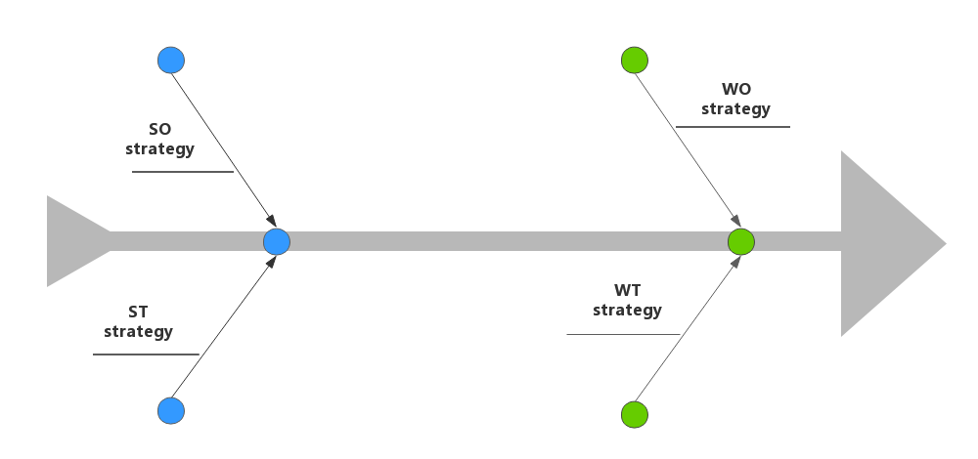
Figure 6.Four strategy models
4.1.1 SO strategy
First, to ensure the smooth implementation of the third phase of the super factory project and quickly occupy the market; second, continue to increase R & D investment, cooperate with the world's top companies in battery and automotive intelligence, and strive to be in the leading position in core technology.
4.1.2 ST strategy
Firstly, management: There are scientific management of high technology, quantitative production to achieve standardized management design department sense of vehicle manual system. It can increase customer preference to products.Secondly,It can contribute the construction of current team, and it also can set up a overall plan for enemy repayment. Thirdly, marketing: It can speed up the upstream sales chain construction,and it also can establish loyal partners.

4.1.3 WO strategy
Firstly, while expanding production, we should pay close attention to market dynamics, both research and production, have greater flexibility. Secondly, it can actively develop new models according to market dynamics to meet different needs and reduce enterprise risk; third, Extend core technology, such as battery production services. Fourth, improve the level of automobile intelligence, change the traditional attribute of automobile traffic, automobile becomes a creative internal collection, even a part of the whole body.
4.1.4 WT strategy
Firstly, it can close contact with electric vehicle peers, in order to establish a vehicle mechanism of information integrity. Secondly,it can slow down the speed of expansion, grasp the market dynamics, and quickly solve the problems what it had encountered. Thirdly,There is the introduction of financial instruments for Tesla to ensure that the company temporarily get out of the crisis.So it can be prevented from varies of risks.

4.2 Market strategy analysis:
Throughout the market, Tesla has always adhered to the "three-step" development strategy. The first stage is mainly high-end, high-performance, sports niche market, the second stage is mainly close to the high-end market of luxury brands such as Mercedes-Benz and BMW, and the third part is mainly low-cost economic mass market.

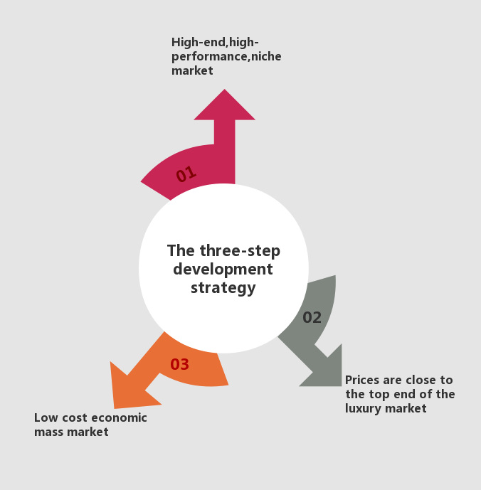
Figure 7.The three-step development strategy

4.2.1 Market Positioning
Detroit thinking believes that electric vehicles are replacing the traditional fuel vehicle power system with battery-driven, whose trend is necessary and the selling point of the product is the low cost of battery use, environmental protection, cleanliness, economic and so on.Therefore,it is the choice of most people. But the product has limited mileage and mediocre performance because of the problem of battery. The goal of traditional automobile companies to do electric vehicles is economic and environmental protection. To minimize costs, they do not think of how products can surprise users.
Tesla is a cost-free car,which pursuit to plan the best performance for consumers, it also employ more people to product more attractive comfort as the goal. As a result, Tesla cut from luxury cars, solve the problem of electric vehicle endurance, as well as the weight of steel frame structure, improve acceleration, make it quieter, highlight "acceleration, quiet ," The three luxury car characteristics of the highest speed are high enough to surprise users to the maximum extent. Tesla approach, completely contrary to the traditional goal of electric vehicles. Tesla from the high-end entry, subversive electric vehicles can only low-price, low-performance strange circle. Reverse operation, and the same kind of competition, to build a good car thinking will be electricity moving cars to create a heart-warming feeling, this is the Tesla strategy.
Actually, Tesla this kind of high-end luxury electric vehicle model, completely accords with the market pull rule. Because any new high-tech product, such as mobile phones, refrigerators, color TV sets, was not initially marketed to the mass market, but was relatively more expensive, sold to high-income people and then to the market masses.
4.2.2 Experience Pursuit
Tesla is the pioneer of building cars in the way of Internet thinking and the way of smart computers. Do Tesla have core technology? Batteries are integrated with laptop batteries, charging piles are assembled with other people's solar energy, tire suppliers are Yokohama rubber, lithium battery suppliers are Panasonic, and network support is Zambo network. The software is the 3 D design software of France Dassault system Company. Tesla only the overall modeling design is completely self-developed, its core competitiveness lies in the control of battery and motor technology, rather than the traditional vehicle driving mechanism. Tesla is the best in software (battery control systems and great experience control), and the hardware part to the partner (battery original and chassis, etc). Tesla choose the product route from high to low, it proves to the world that if the current lithium electric material can be applied to the limit, it can produce the product that meets the consumer's demand. With the advanced power management system and other technical advantages, the products to meet the market demand have been produced on the basis of the current battery material level. Its perfect concept of "whole industry chain service" fundamentally dispels consumers' concerns about purchase and use. Leverage the development of the industry.
4.2.3 Brand Thinking
Tesla innovation is not only reflected in products manufacture, but also in marketing sales. Tesla store follows Apple's retail strategy,which is experiencing products, educating users, providing relevant advice for consumers, building a car company culture, and ultimately building a famous brand in the hearts of consumers^{[17]}. To have a better experience, in addition to development, design, manufacture, sales, Tesla install charging piles for users at designated locations, charging stations are only for Tesla owners to use free of charge forever.
⬤ when all the car companies are working with the four stores in S hurry to sell cars, almost every company's salespeople are selling in a desperate way to get a higher commission, The staff in the Tesla store are not salespeople, but product experts, who do n' t work for commission, and the store's product experts don' t have a cent reward for serving users. These product experts, all you have to do is show the product. Hope that when people enter the Tesla store, feel the sincerity of car building. Catch people's attention through eye-popping products in shopping malls and other high-flow shopping places, after further introduction and test drive^{[18]}, let people
Fall in love with this car, this is the core of Tesla marketing strategy.
Tesla is to use brand thinking to do the market, is to use the Internet thinking to do the product. They put the user's experience at the top of the list, giving the user a perfect solution to all the problems that the product may encounter in advance, and "subdue" the customer.

5. Tesla Motors Challenges and Outlook
5.1 Challenges
Tesla is an energy and electric vehicle company in the United States. It is one of the leaders of the world electric vehicle industry and the highest market share of the world electric vehicle industry^{[19]}. Its slogan is to accelerate the transformation of sustainable energy in the world, and the vision is to accelerate the global transition to sustainable energy. First, the development trend of Tesla pure electric vehicle is mainly manifested in the following aspects: first, the development and application of Tesla pure electric vehicle need to be tested and analyzed in different electric modes, electric vehicle It is a big challenge in itself^{[20]}, and at the level of practical application, we must fully consider the needs of customers and the feelings of different groups should insist on better collection of feedback. Second, in the development of Tesla pure electric vehicle, it is necessary to strengthen the joint venture R & D in order to provide guarantee for the supply and product sales in different countries.
At present, Tesla is not only a technology research and development company,but also a famous electric car manufacturer.The future of Tesla is bright,which needs to complete the transformation of industrialization^{[21]}. Roadster verified the electrical drive system, but didn't have the ability to validate its mass-car production: Roadster just have a lotus car on it.
Power drive system and complete the final assembly and commissioning, only manual workshop production Organizational form. Model S used a lot of new materials such as aluminum alloy and carbon fiber^{[22]}, which made it impossible.Some new technologies that have not been widely used in the automotive industry are needed in the production line.A new process, such as aluminum alloy spot welding, further increases the difficulty of production of the Tesla organization of large-scale vehicles .
 Parts procurement, supply chain management may also be the Tesla's biggest headache (procurement is small and often subject to special requirements). Build self-built, self-owned sales network will increase the cost of Tesla and slow the expansion of sales outlets, and even legal risks.
⬤ Now, Tesla too single, Customers and their products are not sustainable, How to achieve popularity, scale, sustainable development or also a headache^{[23]}. On the one hand, Claiming to push the Volkswagen, But on the other hand, April 2013, Because of poor sales, Poor endurance, Tesla also canceled sales kwh、40 entry-level models for $50,000. October 2010, Because of the potential fire hazard on the battery line, Tesla recalled 439 Roadster electric vehicles, About a third of the 1300 vehicles at the time. Then there were few recalls, Besides, Model S the market time is not long, There has not been a recall problem. But there are occasional reports of battery decay, There is still time to further verify.
It needs to invest in the exhibition hall and after-sales service center of sales terminal: according to the development mode of traditional vehicle enterprises, most of the capital investment of automobile enterprises is concentrated in the early production and market propaganda^{[24]}. Downstream stores and after-sales maintenance plants are responsible for dealer investors, and dealers mostly need advances to ensure cash flow. But Tesla broke the pattern, like Apple's own sales showroom and maintenance center. But the cost of car experience showrooms and maintenance centers is not an order of magnitude higher than that of digital products such as Apple. The investment cost of a car 4 S store is at least 30 million, even if Tesla's showroom standards are reduced. But it also costs millions.The infrastructure is inadequate, especially in China, where the resistance to individual charging piles is high, and
Can not copy the model in the United States: most consumers in the United States have independent villas, fixed parking spaces, a single family charging pile installation stakeholder, Tesla to invest only in public charging stations. And in china, Tesla also pays attention to home charging, because most consumers live in buildings, parking spaces in residential areas are tight and involve multiple interests, even if some new residential areas allow the installation of charging piles, but also through the power grid, residential property, fire departments and so on.
5.2 Advice
(1)Increase the number of off-line physical stores, increase the number of offline experience stores, so that more consumers can directly understand contact with Tesla electric vehicles, can more directly let consumers experience Tesla's high-quality products, It is the most effective way to conquer customers with practical experience^{[25]}. The increase of offline physical stores is also a reflection of the strength of the enterprise itself, which can also easily solve the problems of consumer after-sales service, reduce the concerns of consumers to buy cars, and increase the recognition and trust of customers to Tesla.
(2) Strengthening technological innovation Tesla is the leader in the electric vehicle industry, and strengthening scientific and technological innovation is mainly in the following aspects: First, reducing Low vehicle and battery costs make it easier for electric vehicles to enter people's lives; second, strengthen the development of battery technology, strengthen quality, make up for existing shortcomings, increase battery life, safety performance and charging speed, and solve the concerns of most people about electric vehicle battery problems.
(3) Price-preferential activities are now well developed in the global economy. Countries such as China, India and the United States are car consumers One of the key markets for fees, but now Tesla's price is OK compared to ordinary electric vehicles, but it does n' t have much advantage over existing fuel vehicles, doesn't necessarily enter the consumer's preferred list, and lacks an advantage in price.

6.Reference
[1]Liu Ke. Tesla super charging pile opens up new space [N]. Capital chase Financial Investment News 2020-12-03(001).
[2]Zhong He.The Future Market of New Energy Vehicles[J].Consumption guide ,2020(11):53-55.
[3]Birth of Tesla's first car [J]. Worldwide Wealth Life ,2020(19):50-52.
[4]Tesla plans to produce 550,000 cars in China next year[J].Smart City ,2020,6(21):10.
[5]Du Sha.Software Defines Cars as a Future Trend Cars and carry industry revolution[J].Automobiles and Accessories ,2020(15):46-49.
[6]Wu Wei. Tesla’s push from "wolf" to "fish" has pushed Chinese car companies to upgrade their technology [N]. Economic reference ,2020-09-18(005).
[7]Du Sha. Tesla won the top market value of global car companies, and the pressure and attack behind the "elephant turn" of traditional car companies [J]. Cars and Accessories ,2020(13):44-45.
[8]Tesla, is it a bubble or a future[J]. Chinese Business Sector ,2020(07):118-121.
[9]Zheng Yuting. Hsu Ho-yi: Tesla is here. How can China's new energy vehicles grow steadily [J]. CPPCC China ,2020(14):64-65.
[10]Tesla Motors Canada ULC;Patent Issued for Method And System For Determining Concentration Of Electrolyte Components For Lithium-Ion Cells (USPTO 10804562)[J]. Computers Networks &Communications,2020.
[11]Qi Fangming. A Study on the Marketing Strategy of Tesla Automobile Brand in China [J].Hebei Enterprise 2020(10):115-116.
[12]Yang Zhongyang. Does Tesla be a catfish or a shark[N].Economic Daily ,2020-10-16(009).
[13]Zhou Wuying. Tesla becomes the "target" of the global car [N]. Economic Reference ,2020-10-09(007).
[14]Zhao Hongxia, Tian Meng. SWOT Analysis and Enlightenment of Tesla's Entry into Chinese Market[J]. Chinese Business Theory ,2020(21):12-14.
[15]Li Xuefeng. Tesla's Mission [N]. The Tesla Securities Times ,2020-08-27(A05).
[16]Xie Yiqing, Xu Hailong, Dong Xing. The impact of transnational direct investment on regional economy under the global value chain —— Take Tesla Super Factory into Shanghai as an example [J].World Economic Bulletin 2020(04):31-46.
[17]Liu Xiaolin. Tesla Threat and Self Breakthrough: New Energy Cars Farewell to Childhood [N]. Economic Observer ,2020-06-29(026).
[18]Liu Zhiyu. A Study on the Purchase Intention of Tesla Automobile Consumers Based on Customer Perceived Value [D].Tianjin University of Finance and Economics ,2020.
[19]Wang Jing. Considerations on Tesla's Destructive Innovation Strategy [J]. Modern Marketing 2020(04):25-27.
[20]Liu Wenxin. Responsibility and Recall from the Perspective of Tesla Pride China Consumer News 2020-11-10(002).
[21]Lie Wen.Insufficient force of Tesla Growth[N].Bank of China Insurance News 2020-10-29(008).
[22]Liu Ge. A new force in car building can not become the mainstream of electric vehicles[N]. China Business News 2020-09-07(E04).
[23]Wang Liang. Alternative Tesla in Car Circle[N].International Business Daily ,2020-08-21(007).
[24]Zhang Linyu. After I bought Tesla I bought Tesla[J]. Operator (Automotive Business Review),2020(05):175-180.
[25]Jia Haiguo. An Analysis of the Influence of Tesla on the Development of China's New Energy Automobile Industry [J]. Time Motor ,2020(09):87-88.

