A critical evaluation and the identification of next teaching and learning steps focusing on a case study of an individual learner or groups of learners, based on an observed critical incident

Contents

- Introduction
- The role of critical reflection
- Observation school & class context
- Critical incident linked to Donaldsons four purposes
- Literature review
- Reflection/evaluation & what next
- Conclusion

Introduction

Identifying a critical incident and next steps based on an individual or group of learners will be the focus of this essay. Following a discussion about the role of reflection in teaching will highlight the links to the professional standards for teaching and its importance for teachers own professional growth within the classroom. A brief description of the school will be discussed to provide a bit of background context in which the critical incident was observed. This will lead to a discussion of the critical incident highlighting how it links to the four purposes and an Area of Learning and Experience. It is also important to note the term ‘critical incident’ means that an experience has been observed and reflected upon. It is during the reflection process that meanings, values, and emotions can be assigned to the experience. As a result, the significance of the event is evaluated making it ‘critical’ (Tipp, 2012). Upon reflecting on the critical incidents two key areas will be focused on, these are child led learning and health and wellbeing. Drawing upon literature within these areas will provide a deeper understanding of their significance in the classroom and learning experiences, whilst also signifying limitations and conflicting ideas which teachers should be mindful of. Finally, a reflection and evaluation of the importance of reflection, the critical incident observed and what the literature suggests will be considered to discuss the next steps going forward in my own teaching practices.

The role of critical reflection

Reflective practice plays a vital role in the teaching profession. Teaching as a profession is constantly changing and developing which means it is important to draw upon theories which underpin what teachers do and why. The teaching profession, particularly in Wales, has undergone big reforms in recent years with the curriculum for Wales being introduced in September 2022. Teachers that constantly reflect on their practices make room for new ideas to be generated and innovative solutions to occur (Welsh Government, 2020c). As a result, teachers ensure their pedagogy and practices are aligning with the professional teaching standards for Wales, engaging in professional growth through critical reflection (Welsh Government, 2019).

Furthermore, the purpose of reflective practice is to learn from experiences in the classroom, aiming to improve practices. Drawing on the ideas of Dewey (1938), teachers need to be aware that every experience shapes an individual which means the quality of an experience will impact later ones. Thus, to be reflective as a teacher, there is a need to go beyond the surface level of what happened. Inevitably, teachers will come to the profession with their own set of values and beliefs created through cultures and experiences outside of the classroom. Therefore, critically reflecting on experiences in the classroom can highlight preconceived assumptions teachers may bring with them into their practice (Bassot, 2016).

According to Tripp (2012, P.9), the process of reflecting leads the teacher to ask questions about their experience such as “what happened, and what allowed or caused it to happen?”, thus, enabling a deeper understanding of the experience to develop once it has occurred. Drawing on this understanding, the teacher adapts their pedagogy accordingly to meet student’s needs. This corresponds to Gibbs reflective cycle (See appendix 2) where teachers follow a process to reflect on their practices after they have occurred (Gibbs, 2005). However, this somewhat contrasts with the ideas of Schon (1983) who believes teachers also draw upon reflection in practice and reflection on practice. Reflection in practice means the teacher reflects and adapts in the moment, questioning everyday actions that we cannot explain but just know how to do. Furthermore, reflection in the moment enables the teacher to recognise “situations of uncertainty, instability, uniqueness and value conflict” (Schon, 1983, p.50) resulting in them adapting their approaches accordingly in the situation as they occur. However, similar to Gibbs reflective practice, Schon suggests teachers need to reflect after the event has occurred too. During this process the teacher reflects on their experience in the classroom, asking questions of their practice, drawing upon research, and exploring deeper enquiries of thought to continually develop their professional learning (Welsh Government, 2019).

Observation School & Class Context

Taking steps to minimise any harm or risks to participants is important when undertaking any form of research or observation. Therefore, following the guidelines set out by BERA (2018) in the ethical guidelines for educational research, the school’s name and any participants involved in the observation will remain anonymous.

The observation took place in a school within an urban area of South Wales. The school caters for children aged between 3-11 years old, operating with 14 single year classes and 4 nursery classes as reported by Estyn (2017). The school has an above average number of students eligible for free school meals at 31%; with the national average being 19%. Furthermore, Estyn (2017) reports that 31% of students have been identified as having additional learning needs, again 10% higher than the national average.

The critical incident observed happened early in the day between 9:30am – 10:15am in a year 1 class when the children were happy and full of energy. The classroom was spread out across several areas, including art, computers, construction, breakfast area and dedicated outdoor space. Whilst there were several activities the children could choose to participate in, there was a common theme running through all of them (in this case the theme was home). The children could freely move between areas choosing to go outside or stay inside to do various activities. Whilst no explicit instructions were observed from the teacher, it is assumed that some form of instruction was given prior to our arrival as the lesson had already begun and the children knew what to do.

Critical incident linked to Donaldson’s four purposes

Keeping in line with BERA (2018) all participants observed will remain anonymous only being referred to as teacher or children.

The critical incident observed occurred in the outdoor area of the classroom involving six children and a teacher. Two children decided to balance ramps against a pallet to race a car and train (one plank had a road on, the other had a train track). The teacher noticed what they were doing so proceeded to help the children assemble the planks, it was also at this point four other children decided to come and see what is going on. The planks were initially placed at different heights which led to a conversation between the teacher and students.

Teacher: “Is one of them (pointing at a toy car and train) going to be faster if one plank is higher?”
Children: “Yes”
Teacher: “What can we do to make them equal?”
Children: “Put them at the same height”
(The children proceeded to place the planks at equal levels. The teacher then asked each child individually)
Teacher: “Who do you think will win the train or the car?”
Each child took it in turns to give an answer with a mixed set of answers.
Teacher: “Let’s find out”
The teacher tested their idea using the ramps by letting the car and train go at the same time. However, the train did not move (the teacher held the train in place).
The teacher then reinforced prior knowledge by asking
Teacher “What do trains travel on?”
Children: “Tracks”
Teacher: “Is the train on the track?”
Children: “No”
The children realised this and proceeded to move the train to the plank with a track on it. The children tested their theory again (this time the children let them go) and acknowledged that both the train and car reached the bottom at the same time.

Drawing upon the four purposes proposed by Donaldson (2015) highlights two key areas at play in this instance; ambitious, capable learners (are questioning and enjoy solving problems) and enterprising, creative contributors (connect and apply their knowledge and skills to create ideas and products) (Welsh Government, 2020b). The incident observed discretely demonstrates the way in which the teacher draws upon their prior knowledge to enhance the children’s learning, thus, making it a critical incident. Whilst the teacher asks questions to prompt the children to think critically about the situation, the children can recognise and apply experienced knowledge to the situation (placing the car and train on the right pieces of wood). By working cooperatively, the children also carry out a form of research in which they test their hypothesis (will the car or train reach the bottom first?). It is during this process the children are meeting the target of “using their understanding and knowledge to predict effects” (Welsh Government, 2020a), as stated in progression step 2 of the Science and technology area of learning and experience (AoLE). Therefore, the teacher is incorporating both the four purposes of the curriculum with an AoLE within this critical incident.

Literature review

For this critical incident there are many areas of exploration in relation to theories, however, the focus will be on two areas: child-led learning and health and wellbeing. The literature will draw on key theorists in the respective areas and how may impact on the learning environment.

Child led learning
Child led learning is becoming more widespread in schools with a focus on letting the children decide what activities they want to participate in, for example, play, construction, painting, and role playing to name a few. Therefore, providing children with a rich and diverse learning environment is vital as they are greatly influenced by their immediate surroundings. However, this is not without caution. As Gascoyne (2018) states, whilst the teacher may plan activities with certain outcomes in mind for example scientific inquiry, maths and numeracy or literacy, they risk prioritising certain learning opportunities over others. As a result, the teacher may be drawn to certain activities but miss “teachable moments” that occur naturally (Gascoyne, 2018, p.153).

The concept of child-led learning stems from the ideas of sociocultural theory focusing on a child’s psychological development over time. The theory is associated with the psychologist Lev Vygotsky who acknowledged the social processes involved in children’s learning. It is through these social interaction’s that children learn about cultural values, beliefs, and problem-solving strategies from more knowledgeable others within society and education, known as the zone of proximal development (Mercer and Littleton, 2007). When applied in a school setting, children can be given a range of activities designed to get them to talk and engage with others, thus, allowing for the more knowledgeable other to share their ideas with less knowledgeable others as demonstrated in the critical incident (Mercer and Littleton, 2007). This process allows both participants involved to either reinforce prior knowledge or develop new knowledge and understanding. It is for this reason that Vygotsky believed talk is important in any activity because, whilst forming sentences is important for speech development, talk also helps form thought too (Barlett & Burton, 2016). It is through these thoughts that problem solving can be conducted.

Vygotsky’s ideas were also developed upon by Jerome Bruner who coined the term scaffolding. It is during scaffolding that the teacher guides the learner by providing a demonstration of new work or showing the children how a problem can be solved. Overtime, the teacher can begin to leave the children to practice these new skills in groups and eventually independently (Smidt, 2011). As Vygotsky acknowledges, the more knowledgeable other plays a key role in this situation but it is through demonstration and practice that the child can build upon their skills and independence.

Moreover, whilst Vygotsky notes the importance of peer interaction with more knowledgeable others in learning and development, a theory by Jean Piaget known as cognitive development puts an emphasis on the interactions between peers of similar intellectual abilities (Mercer and Littleton, 2007). His theory acknowledges four stages of development. These are sensorimotor (birth to 2 years), pre-operational (2-7years), concrete operational (7-11 years) and formal operational (12 onwards) (Hanfstingl, Benke and Zhang, 2019). It is believed that as children progresses through each stage their intelligence will change as they grow. Thus, acknowledging that children need to be able to construct a view of the world and not just acquire knowledge.

However, both Vygotsky and Piaget’s theories have their limitations and conflicting ideas. A big drawback of Vygotsky’s work is that most people read the translated version which subsequently leads to his ideas being lost in translation (Gredler 2012). Furthermore, some may argue that Vygotsky’s ideas about a child’s learning and talk being influenced through culture and social interactions is obvious to any observer because humans are social by nature (Newman and Latifi, 2021).

Another limitation surrounds Vygotsky’s zone of proximal development. It could be said that not a lot is known about whether a child’s zone is the same across different learning areas or whether different individuals and the size of the zone changes over time (Fox and Riconscente 2008). As a result, it is not made explicitly clear whether the zone accounts for the child’s particular learning needs, their capability, or their motivation to do various tasks regardless of the input from a more knowledgeable other.

Another limitation of the zone of proximal development is the idea that language proceeds thought. It could be argued that a child’s thought process can develop before they are able to talk. For example, a child may not be able to name an object but can retrieve the object when asked, showing they understand what it is (Newman and Latifi, 2021). However, this notion contradicts with Piaget. In Piaget’s theory it is believed that whilst a child may participate in an activity with a more knowledgeable other, it does not have the same desired affect that Vygotsky believed. Piaget believed the problem of working with more knowledgeable others leads to them to impose their views onto the less knowledgeable rather than broadening the others learning experience calling this a form of social constraint (Matusov and Hayes, 2000).

However, Piaget’s theory also has its limitations. Whilst he depicts four stages of development he fails to explain or acknowledge why “development from one stage to the next occurs” (Lourenco 2016, p.124). He also neglected cultural influences on cognitive development, choosing to focus a child’s intellectual growth as an individual and not the influence of the Western culture in which they lived. Furthermore, it could also be argued his theory focuses too much on a typical child rather than recognising individual differences between children and different motivational levels between individuals to perform a task (Fox and Riconscente, 2008).

Health and Wellbeing
Health and wellbeing make up one of the six areas of learning and experience introduced in the new curriculum for Wales. The purpose of health and wellbeing in an educational setting is to understand how physical, mental, emotional, and social well-being needs are interconnected and how they impact a child’s learning ability. Thus, a holistic approach to the way teaching is carried out enables health and well-being to flow freely through learning experiences. As literature suggests, if a child is provided with “health as a resource” (Underdown, 2007, p.5) they are far more likely to feel content in themselves and more open to new learning experiences.

Drawing on a humanistic approach, it is believed that people are shaped though their actions and ability for free choice. This approach is linked to the psychologist Abraham Maslow who proposed the idea of a hierarchy of needs (See appendix 4). The five basic needs proposed by Maslow are “physiological needs, safety, love, esteem and self-actualisation” (Stoyanov, 2017,p.27). For a child to reach their higher order of needs, first their basic needs must be met. In the context of the classroom, this means providing children with a safe environment where they can develop a sense of belonging and further their knowledge. However, as Bronfenbrenner acknowledges in the ecological system, there are many layers within a child’s relationship network which can directly influence them. Therefore, the quality of the relationships and the environment in an educational setting are important as it is believed these will shape an individual’s behaviour throughout life (Bronfenbrenner, 1979). Moreover, understanding the relationship between behaviour and wellbeing is vital for a teacher as they need to be aware of external factors surrounding the child. As both Maslow and Bronfenbrenner suggest, being in a safe space and having a sense of belonging helps the child develop both in knowledge and sense of self.

Furthermore, providing children with the opportunity to engage in outside spaces allows them to explore more real-world experiences they may come across in their everyday lives (Waite, 2011). Thus, impacting upon their sense of belonging to the wider world and promoting their wellbeing. 3

However, there are limitations to both Maslow’s and Bronfenbrenner’s theories. Whilst it might be acceptable to agree that basic needs should be met before higher order needs, some have argued that this is not always the case. Stoyanov (2017) and Louca et al. (2021) suggests that many people experience poverty and a lack of shelter but still feel a sense of belonging within their community, thus an inverse correlation to Maslow’s proposed idea. Equally, it could be argued that an extra layer exists to Bronfenbrenner’s theory in which an individual can also influence themselves.

Furthermore, it is argued that the hierarchy of needs is based upon a western ideology and is too simplistic in its approach. It’s simple approach discounts for other factors that impact on society such as recession and war. This means that whilst someone may feel safe within one need, other basic order needs have not been met (Louca, Esmailnia and Thoma 2021). Similarly, in Bronfenbrenner’s model, it is hard to establish whether those who do not have strong ecological systems in place will lack in developmental areas. Therefore, it is hard to determine whether lived experiences determine how people react to others, for example if a child’s parents and teacher have a negative relationship, this does not mean the child will have a negative relationship with their parents or their teacher (Manning, 2017).

Reflection/evaluation & next steps

Schon’s reflective practice I believe best fits with the critical incident I observed. In this reflective model there are two approaches, reflection in action and reflection on action (Tan, 2020). Upon evaluating the critical incident, I believe the teacher involved at the time used reflection in action to acknowledge the children wanting to race the vehicles, thus, turning it into a learning opportunity to test their scientific knowledge and understanding.

Drawing on Schon’s reflection on action allowed me to acknowledge the significance of child led learning, in which the children choose what they want to explore and the teacher acts as a facilitator of knowledge. Through the literature review I was able to establish how children need to be given the opportunity to explore their surroundings in a rich, diverse, and meaningful way. As a result, I want to consider my own classroom set up and the types of activities I provide them to encourage their natural curiosity and learning opportunities. Highlighted by Gascoyne (2018) and Schon (1983), I want to allow natural learning opportunities to occur and act in the moment to develop understanding, for example building toy cars and getting the children to enquire about who’s car will go the furthest or counting how many wheels they have. I believe this type of approach will allow me to subtly incorporate different learning opportunities within the AoLE’s whilst encouraging aspects of the four purposes.

Furthermore, using Schon’s idea of reflection on action led me to explore Vygotsky’s idea of the zone of proximal development within my literature review. It is during this review I established that this approach is beneficial to all participants involved as they either reinforce prior knowledge or develop a new understanding. However, I realise that this approach may also have its limitations as the literature surrounding Piaget highlights a form of social constraint with the more knowledgeable other imposing their own opinions onto the less knowledgeable, therefore, limiting the opportunity for deeper understanding and opinions to be formed. As a result, I feel I need to be mindful that I am letting the children explore their environment and drawing upon the professional standards for teaching and leadership (PSTL) to ensure I do not impose my own views onto the learners. This means I will “seek, listen to and take account of the views of learners in order to engage and encourage them as active participants in their own learning” (Welsh Government, 2019).

Another area of exploration that arose from this critical incident was the impact of wellbeing on the child and their learning. Drawing upon Maslow’s hierarchy of needs helped me understand the complexity of needs that can impact on a child. Upon reflection, I had not considered the impact of the child’s wider network and how this may affect the child’s ability to learn. Research linked to Maslow (Stoyanov, 2017) and Bronfenbrenner (Bronfenbrenner, 1979) has made me question my own practice in the classroom and consideration for the quality of the relationships I build with pupils in my own classroom. Moving forward in my own development I want to ensure I am meeting the professional standards for “working with in school colleagues” and “supporting and developing others” to ensure we all provide a safe environment, develop good quality relationships, and create a sense of belonging for both pupils and staff (Welsh government, 2019).

Conclusion

To conclude, reflection is an important part of any teachers practices within a classroom. The two key reflective models drawn upon were the those of Tripp and Schon. Tripp acknowledges a process of reflection to deepen understanding and create an opportunity to adapt practices, whilst Schon further highlights the importance of reflection in action as well as reflection on action, meaning both models allow a teacher to develop professionally as a practioner in Wales, meeting the professional standards for teaching. The critical incident observed in this instance appeared to be simple at surface level. However, by using the reflective models a deeper understanding was developed highlighting key areas of exploration, child led learning and health and wellbeing. It was through the exploration of literature that these areas highlighted the implications on learners and a need for rich and diverse experiences within educational settings. Drawing upon key theorists such as Vygotsky and Piaget made it clear that there are many aspects at play when a child is learning, such as their cultural context, background and experiences which can all impact on what might appear to be a simple learning activity in the classroom. Furthermore, Maslow’s hierarchy of needs and Bronfenbrenner’s ecological systems drew attention to the complexity of a child’s basic needs. Their models highlight the importance of meeting these needs for the learner to be successful in participating in a learning environment. Finally, acknowledging my own reflection of the critical incident highlighted key areas I would like to develop in my own teaching practices. Through the literature review I was able to discover how my own preconceived ideas may have an impact on the way I teach and why it is important to constantly reflect. By regularly reflecting on my practices, not only will I meet the professional standards and, but I will aim to provide learners with rich and meaningful learning opportunities.

References

Barlett, S. and Burton, D. (2016) Introduction to Education Studies. 4th ed. London: SAGE.

Bassot, B. (2016) The Reflective Practice Guide: An Interdisciplinary Approach to Critical Reflection. New York: Routledge.

British Educational Research Association [BERA] (2018) Ethical Guidelines for Educational Research. 4th ed. London. https://www.bera.ac.uk/researchers-resources/publications/ethical- guidelines-for-educational-research-2018

Bronfenbrenner, U. (1979) ‘Contexts of child rearing: Problems and prospects’ The American psychologist, 34(10), pp.844-850.

Dewey, J. (1938) John Dewey: Experience & Education. New York: Free Press.

Donaldson, G. (2015) Successful Futures. Independent Review of Curriculum and Assessment Arrangements in Wales. Available at: https://gov.wales/sites/default/files/publications/2018-03/successful-futures.pdf. (Accessed: 06 October 2022).

Estyn. (2017). A report on Cadoxton Community Primary. Available at: https://www.estyn.gov.wales/system/files/2020-08/Cadoxton%2520Community%2520Primary.pdf (Accessed: 06 October 2022).

Fox, E. and Riconscente, M. (2008) Metacognition and Self-Regulation in James, Piaget, and Vygotsky. Educational Psychology 20(4), pp.373-389.

Gascoyne, S. (2018) Messy Play in the Early Years: Supporting Learning through Material Engagements. London: Routledge.

Gibbs, T., Brigden, D. and Hellenberg, D. (2005) ‘Encouraging reflective practice’. South African Family Practice. 47(7), p.5-7. DOI: 10.1080/20786204.2005.10873254

Gredler, M.E. (2012) Understanding Vygotsky for the Classroom: Is It Too Late? Education Psychology 24, pp.113-131.

Hanfstingl, B. Benke, G. and Zhang, Y. (2019) ‘Comparing variation theory with Piaget’s theory of cognitive development: more similarities than differences?’ Educational action research, 27(4), pp.511-526. DOI:10.1080/09650792.2018.1564687

Louca, E. Esmailnia, S. and Thoma, N. (2021) ‘A Critical Review of Maslow’s Theory of Spirtuality’, Journal of Spirituality in Mental Health, DOI: 10.1080/19349637.2021.1932694

Lourenco, O.M. (2016) ‘Developmental stages, Piagetian stages in particular: A critical review’ New ideas in psychology, 40, pp.123-137.

Manning, R.F. (2017) ‘Place-Consciousness and Bronfenbrenner’s Ecological Systems Model: A Discussion of Recurring Issues that Undermine the Teaching of Indigenous Histories in New Zealand and Australian Schools’. The Australian journal of indigenous education, 46(2), pp.148-159.

Matusov, E. and Hayes, R. (2000) ‘Sociocultural critique of Piaget and Vygotsky’ New ideas in psychology, 18(2), pp.215-239.

McLeod, S. (2007) Maslow’s Hierarchy of Needs. Available at: https://www.simplypsychology.org/maslow.html (Accessed: 12th Oct 2022).

Mercer, N. and Littleton, K. (2007) Dialogue and the development of children’s thinking a sociocultural approach. London: Routledge.

Newman, S. and Latifi, A. (2021) Vygotsky, education, and teacher education. Journal of education for teaching, 47(1), pp.4-17. DOI: 10.1080/02607476.2020.1831375

Schon, D.A. (1983) The reflective practitioner: how professionals think in action. New York: Routledge.

Smidt, S. (2011) Introducing Bruner: a guide for practitioners and students in early years education. London: Routledge.

Stoyanov, S. (2017) An Analysis of Abraham Maslow’s A theory of human motivation. London: Routledge.

Tan, C. (2020) Revisiting Donald Schon’s notion of reflective practice: a Daoist interpretation. Reflective practice, 21(5), pp.686-698. DOI: 10.1080/14623943.2020.1905307

Tripp, D. (2012) Critical incidents in teaching: developing professional judgement. Classic ed. New York :; Abingdon, Oxon ;, Routledge.

Underdown, A. (2007) Young children’s health and well-being. New York: Open University Press.

Waite, S. (2011) Children learning outside the classroom: from birth to eleven. London: SAGE.

Welsh Government. (2019) Professional standards for teaching and leadership. Available at: https://hwb.gov.wales/api/storage/19bc948b-8a3f-41e0-944a-7bf2cadf7d18/professional-standards-for-teaching-and-leadership-interactive-pdf-for-pc.pdf (Accessed: 05 October 2022).

Welsh Government. (2020a) Area of Learning and Experience Science and Technology. Available at: https://hwb.gov.wales/curriculum-for-wales/science-and-technology/descriptions-of-learning/ (Accessed: 14th October 2022).

Welsh Government. (2020b) Developing a vision for curriculum design. Available at: https://hwb.gov.wales/curriculum-for-wales/designing-your-curriculum/developing-a-vision-for-curriculum-design/#curriculum-design-and-the-four-purposes (Accessed: 02 Nov 2022).

Welsh Government. (2020c) Introduction to Curriculum for Wales Guidance. Available at: https://hwb.gov.wales/curriculum-for-wales/introduction (Accessed: 04 October 2022).

Appendices (1000 words)

Appendix 1: The Four Purposes

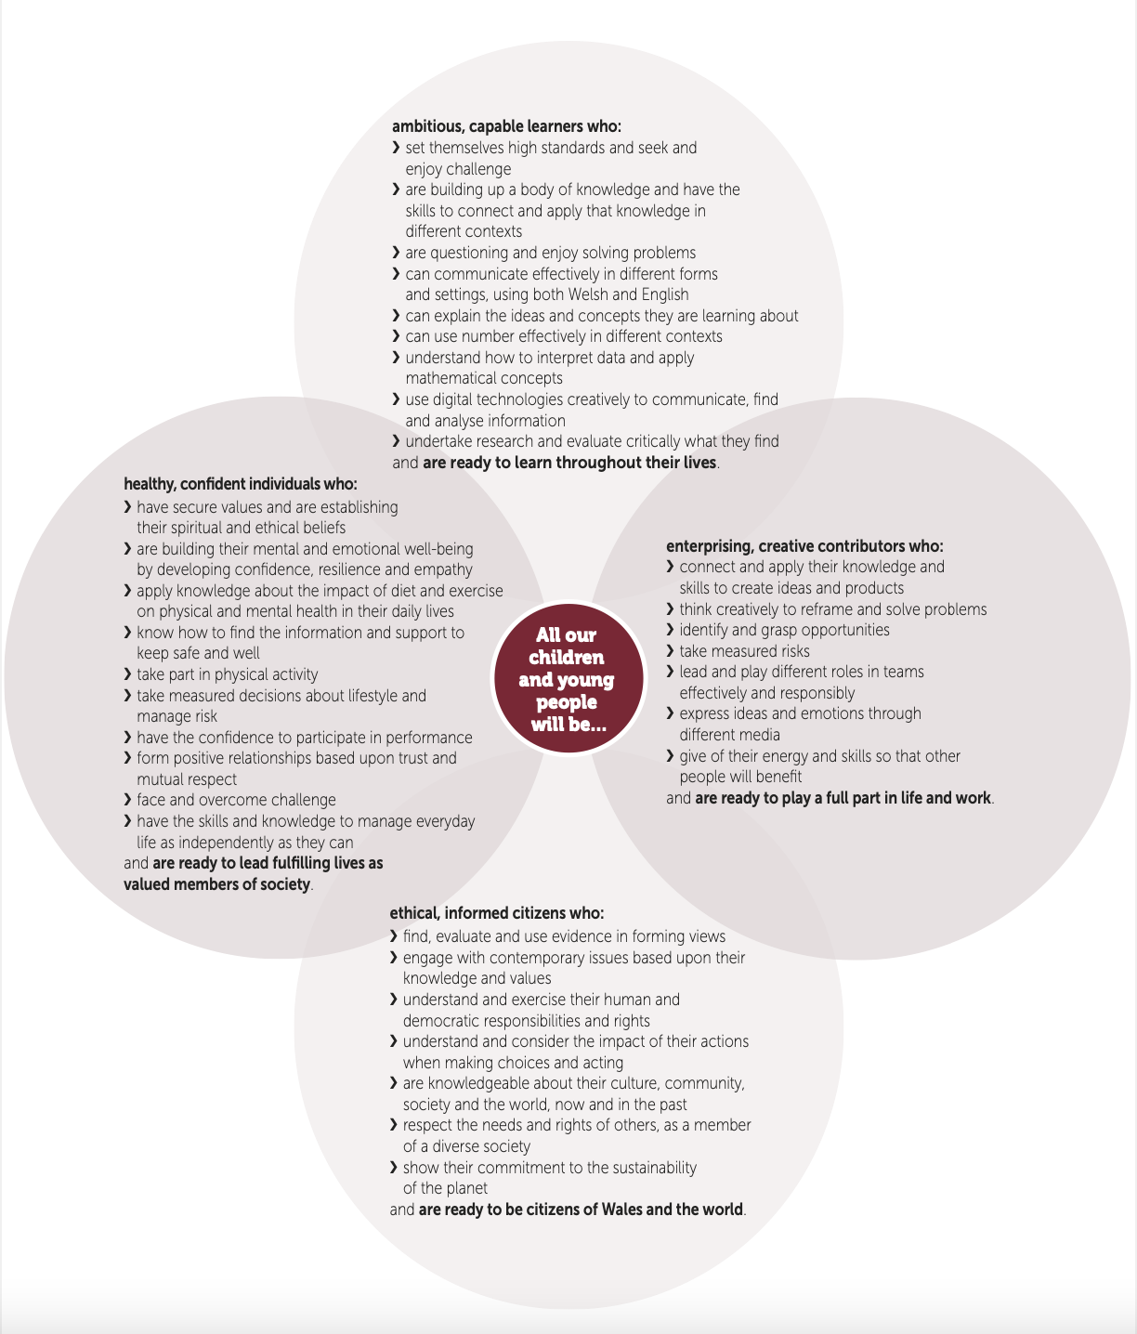

Donaldson, G. (2015) Successful Futures. Independent Review of Curriculum and Assessment Arrangements in Wales. Available at: https://gov.wales/sites/default/files/publications/2018-03/successful-futures.pdf. (Accessed: 06 October 2022).
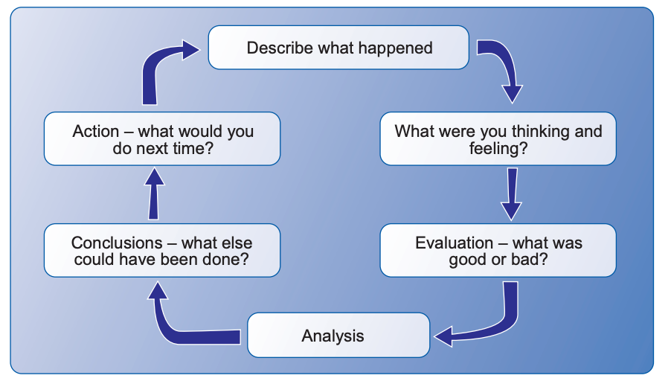
Appendix 2: Gibb’s reflective cycle

Gibbs, T., Brigden, D. and Hellenberg, D. (2005) ‘Encouraging reflective practice’. South African Family Practice. 47(7), p.5-7. DOI: 10.1080/20786204.2005.10873254

Appendix 3: Observation/field notes

Appendix 3A:
Date and time, year group:
26/09/2022 9:30am – 10:00am Year 5
Where and When: Context of the observation – subject/AOLE, general classroom context
Science: Food Safety.
Children sat at tables watching the teacher and looking towards the board.

What happened: a detailed description of the critical incident (the more detail the better to refer to in your later work)
The teacher instructed the children to go to certain areas of the classroom if they liked a particular food. They did this several times so the children were spread out across the room. This then led to a discussion about why they wouldn’t eat a ‘bad’ food (chicken nuggets) all the time even though they like it. The children then proceeded to shout out some of their answers, fattening, make you feel sluggish etc. This then enabled the teacher to emphases the need for nutrition and a balanced diet rather than just eating ‘bad’ food all the time just because we like it.

Areas of possible exploration: what you think could be” under the hood” in these incidents? What avenues of research could you consider?

Child led approach – letting the children move around the room, would this work for a student with a physical disability? – chairs & table in the way
Could this embarrass some students that did not like any food the teacher instructed to go and stand in an area. May just join for fear of being isolated/left out.
Could this be sensory overload because some children were shouting out their answers?
Are certain behaviours being reinforced? – the loudest gets the most attention?

Albert Bandura’s theory – Social Learning theory: The children are watching and reacting to what the other children are doing to evaluate whether their own thoughts and ideas have aligned with their peers.

Maria Montessori’s theory – Montessori theory – children learn best in the environment that has been prepared to enable them to do things for themselves.

Notes: any details you can note (is it a busy environment, is it after lunch, are there lots of distractions, are directions made explicit - the more you can refer to the better here)

Conversational style Q&A.
One interruption from a student dropping off paperwork from another teacher but the children remained engaged and quiet when they had entered the room.
Mix of answering, putting hand up and teacher using lollipops with names on – everyone had a go at sharing their ideas.
Relaxed atmosphere.
We as observers were sat at the back of the classroom which means we had a different view/perspective to what the teacher was seeing.

Appendix 3B:
Date and time, year group:
27/09/2022 9:30-10:15am Year 1
Where and When: Context of the observation – subject/AOLE, general classroom context

Subject: exploratory play – building houses out of various materials.
Context: Year 1 dedicated outside learning space with lots of natural resources.
AOLE – mix of Health & Wellbeing and Science & Technology.

What happened: a detailed description of the critical incident (the more detail the better to refer to in your later work)

The children decided they wanted to use the wooden planks as ramps for cars and train toys to go down. The teacher seen this and helped them assemble the wooden planks. One plank had a road on and the other had train tracks. The children lent the wooden planks against a pallet by the wall. The planks were not level with each other which led to a conversation with the teacher:
Teacher: “is one of them going to be faster if it is high?”
Children: “yes”
Teacher: “what can we do to make them equal?”
Children: “put them at the same height”
The children then placed the planks at equal level. The teacher then asked each child individually
Teacher: “who do you think will win the train or the car” and each child gave an answer
The children then tested the idea using the ramps by letting the car and train go at the same time. However, the train did not move.
The teacher then reinforced prior knowledge by asking what do trains travel on?
Children: “tracks”
Teacher: “is the train on the track”
Children: “no” – proceeds to move the train to the track on the other wooden plank
Tries the same theory again, this time both the car and train reach the bottom at the same time.
Teacher: “what do cars travel on?”
Children: “the road”.
Teacher: “that’s right”
Children proceed to put the car on the road.

Areas of possible exploration: what you think could be” under the hood” in these incidents? What avenues of research could you consider?

Child-led approach – the teacher is asking questions, but students are giving their own ideas on the causes of why one may be slower/faster than the other. The children are also given the opportunity to draw upon previous knowledge by asking them if they know what trains drive on.

Sociocultural theory (Vygotsky) – children are learning problem solving strategies from the more knowledgeable members of society – in this instance the teacher.

Piaget - theory of cognitive development – children are reinforcing learning that takes place in the environment around them. Children are taking an active role in the learning process, performing mini experiments, making observations, and learning about the world.

Maslow – humanist approach – realising self-actualisation through learning

Montessori’s theory – children learn best in an environment that has been prepared to enable them to do things for themselves.

Hidden curriculum – had the teacher not asked all the children for input, they may have caused some children to feel left out or not wanted because the children had chosen to take part in that activity.
Reinforcing western ideology
Teaching respect for other pupils’ opinions which is learnt though the social interaction with others.

Questions:
Why did the teacher only work with a small group?
Why are they asking questions?
Why are they letting the children move the car and train to the road or track?

Linking to areas of the 4 purposes curriculum.

Ambitious capable learners – developing their confidence in their own knowledge and being able to work as a group to identify possible areas of exploration, testing out their theory (car or train getting down the ramp first).

Ethical, informed citizens – respecting each other opinions as thoughts.

Healthy, confident individuals – being confident enough to participate in the group activity – willingly choosing to be involved.

Notes: any details you can note (is it a busy environment, is it after lunch, are there lots of distractions, are directions made explicit - the more you can refer to the better here)

Children are moving freely from inside to outside. Can pick what area they want to explore and what they want to do.
Activity took place first thing in the morning not long after starting school.
Whilst no explicit directions were given – we arrived after the lesson had already begun so we may have missed this information because the children knew what they had to do.

Appendix 3C:
Date and time, year group:
27/09/2022. 11-12pm. Year 6
Where and When: Context of the observation – subject/AOLE, general classroom context

Subject: Mathematics
AOLE: addition, subtraction, adding and take away negative numbers
Classroom context: mix of digital areas, groups working around tables (look likes splats, not convention square or rectangle tables) and some children working independently.

What happened: a detailed description of the critical incident (the more detail the better to refer to in your later work)

The teacher started by asking the children can you describe different methods of addition? The children responded with things such as “a number line”, “counting on our fingers”, “write it out” and “long addition”. This then prompted the teacher to ask, “how do you know if you have forgotten a step?” to which they replied saying “ask a friend”, “ask the teacher”, “check back over your work” and “work the sum out backwards”. As the discussion progressed the teacher related the next question to the other areas of learning they had been doing about Europe and America. The teacher asked, “what tips would you give someone from Europe and America if they wanted to do addition?”, the children responded with things such as “remember to line your numbers up in the column”, “if there is a decimal point make sure that is in the same column”, “ask your teacher for help if you’re not sure”, “ask a friend for help” and “check on a number line”. This last question prompted the teacher to ask, “what if we have a negative number?” to which the children went a bit quiet. Seeing this, the teach wrote out a number line from -6 up to 6 and gave them the sum -6 add 9. They then demonstrated how you could draw ‘jumping lines’ from -6 to 3 which is add 9.
The teacher then put equations on the board, the first column in blue, the second in green and the third in red, progressing in difficulty without the children really noticing. The teacher then gave the children free choice to decide which column they think they should work on, reminding them that if they are finding it too easy then they should challenge themselves to the next column. They also made it known to the children that it doesn’t matter if they get it wrong but it's about challenging yourself and having a go.

Areas of possible exploration: what you think could be” under the hood” in these incidents? What avenues of research could you consider?

Social collaboration plays a key role in this situation with the teacher getting the children to engage in conversation to demonstrate their understanding. In the process of this, the children are feeding off each other’s ideas further adding to their social experience allowing them to make connections to what is being taught.
Relates to Vygotsky – learning is a social process

Behaviourism is also at play in this situation. The teacher has all the children sat down on the floor facing them and the board. This allows the teacher to be in control and guiding the learning.
Relates to B.F.Skinner’s theory because the children are first shown how to do addition in a previous lesson. This is then reinforced and challenged further, asking the children for their input and ideas.

Questions:
Why did the teacher have the children giving their thoughts and opinions?
Why is it useful to ask what tips they may give to someone from another country about how to add? – does this demonstrate a deeper understanding because they understand themselves and are able to guide someone else through the process too?

Notes: any details you can note (is it a busy environment, is it after lunch, are there lots of distractions, are directions made explicit - the more you can refer to the better here)

The children had just come in from a morning P.E session.
The classroom walls consisted of quite mute colours, greys, dark red/brown colours nothing too vibrant which could cause sensory overload. Each child has a photo of themselves in black and white on the walls.
The teacher had put on some calming music in the background.
Directions were given clearly and concisely by the teacher, asking the children question to ensure they understand the task set.

Appendix 4: Maslow’s Hierarchy of needs
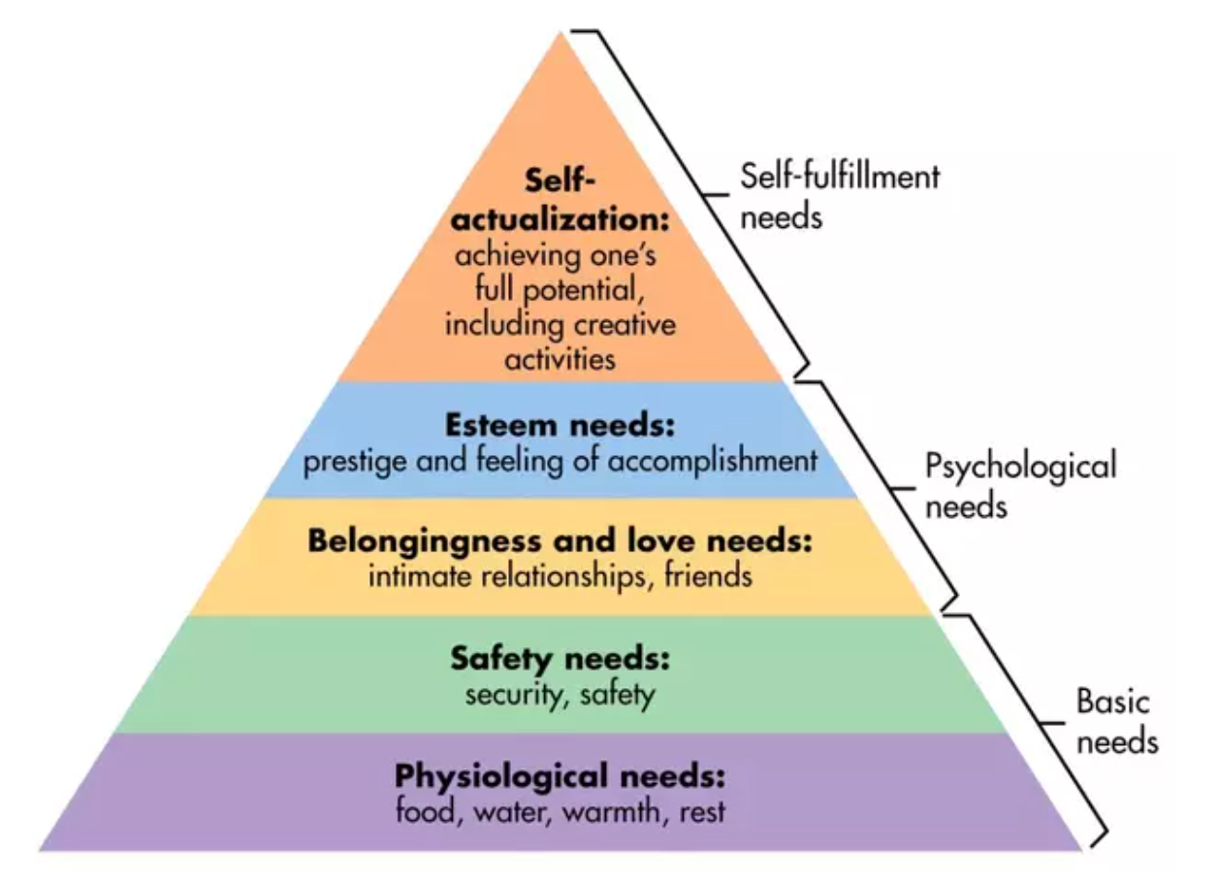
McLeod, S. (2007) Maslow’s Hierarchy of Needs. Available at: https://www.simplypsychology.org/maslow.html (Accessed: 12th Oct 2022).

